The first function I looked at this week was WHERE. This can be used if you were needing to show a list of customers living in a certain City or Zip Code. I chose to give the PostalCode the alias as I have dealt with a few customers who will argue with pretty much anything. If someone is asking to have a list of Zip Codes, than that is what they want. Yes both are the same, but if someone has not heard this phrased as a Postal Code, they can get pretty upset. I dealt with something similar but the customer was telling me our system needed to state Town and not City as the location was not big enough to be determined a city. Unfortunately at the time, I had no way to change that, a manager had to be transferred the call in order to make the customer understand the package would arrive at the correct location. After that, it was decided not to email pictures of the customer file to the customers.

The second function I looked at was IN. For this example, I was looking to show all Customers in the City of London. I also used the Alias of Location for the address. This function can be very beneficial when you are looking to pull all customers/orders from a single location. This cold be used with a Country, State, City or PostalCode, really any column that will give you the information that is being needed.

The third function I wanted to show was Select Distinct. This function will allow you to pull all of the data, but show you specifically which customers belong to the item you are looking at. In this example, I pulled Customers who are from Mexico. I only pulled the CustomerID, CustomerName (changed to Business via Alias), ContactName and Country. This can be another way to pull needed information out of your database. This would show you specific details about customers from Mexico, but you could also look at any column within your database to return information. For example, if you are looking to find customers at a certain address, you would update your statement to include the physical address (Location) and then use Location = “123 Main St”. This would pull out all of the customers who are located at 123 Main St.

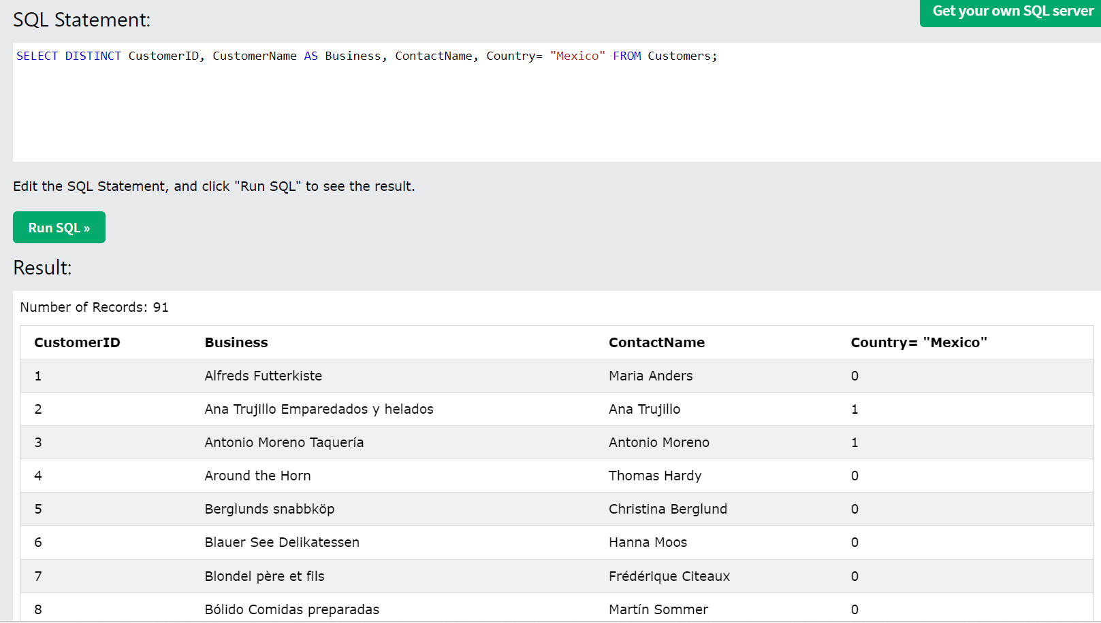

All of these are great ways to be able to use your database effectively. Understanding how to manipulate the information entered in can put you far ahead of someone who does not fully comprehend the tools that are being taught to us.