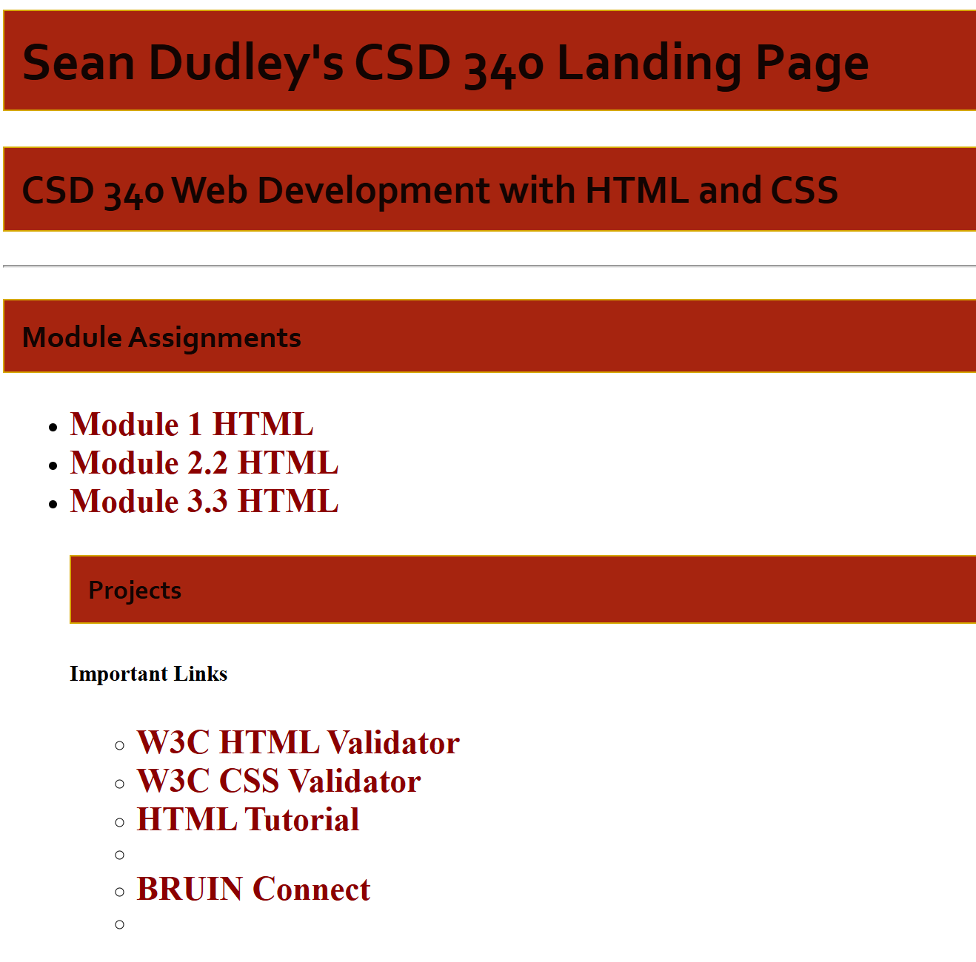


I will be restarting this assignment after I am feeling better. Have not been able to make any changes that have helped, all color has now faded from my 3.3, haven’t been able to line up my columns. I am throwing in the towel because it is so late.

