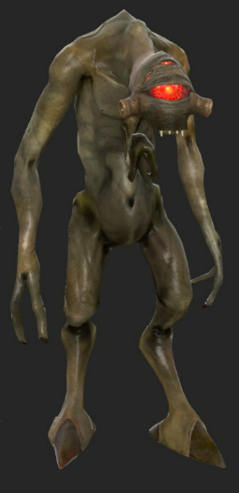
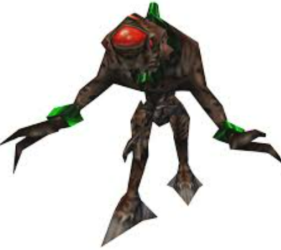

The Alien slave (1998 – Alien enemy) -- The Vortigaunt(2004 – Human Ally)

https://www.youtube.com/watch?v=RwtI1bLXSsg



The Houndeye (1998 – Alien enemy)
https://www.youtube.com/watch?v=SECNGjngzDk

