1. How to show the clock in the cisco packet tracer.

* In the cisco packet tracer, we first change the user mode from normal to privileged mode. And the type command shows and types clock and the last detail will then show the clock detail. ie. show clock detail.

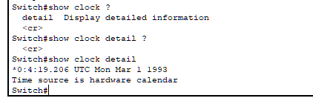

Figure: Shows the clock

1. How to set the clock.

* In the privileged mode type command clock followed by set then type it in order hh: mm: ss and then type the month day and year. ie. clock set 6:49:00 March 15 2023.

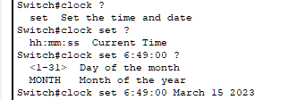

Figure: Set clock detail

1. How to set the password.

* From privileged mode change it to configure mode. And then type enables command, type the password anything, and press enter. ie. enables password cnlab.

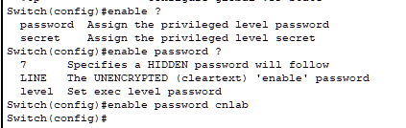

Figure: Set password



Figure: Set password

1. How to see the logbook.

* At first login enable by using the password. After entering privileged mode then type the command show followed by running-config. ie. show running-config.

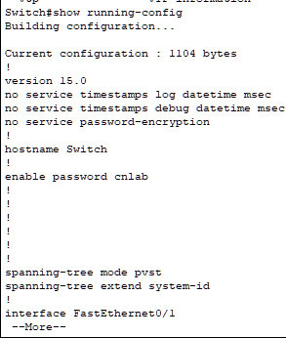

Figure: Logbook including user password

1. How to disable passwords.

* To disable the password type the command “no” in front of the password command (enable password). ie. no enable password



Figure: Disable password

1. How to set secure passwords.

* To set secure passwords it has almost the same command as set a password but in the previous we did not select anything but this time we have to select the secret command in configure mode. ie. enable secret cnlab.

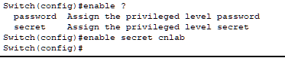

Figure: Set secure password

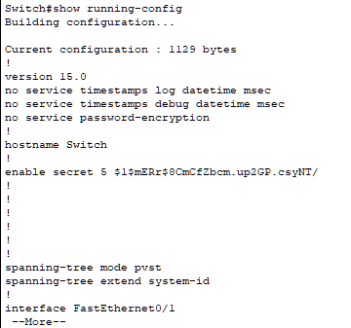

Figure: Logbook after set secure password