1. How to save the setting in Cisco Packet Tracer.

* At first stay in privileged mode then type copy running-config startup-config command to save the setting.

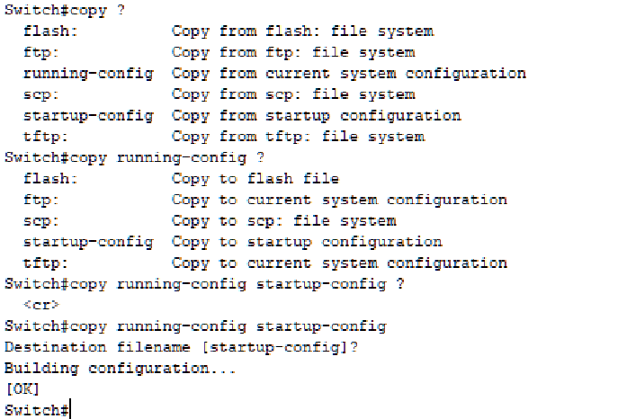

Figure: Save the setting

1. How to change the hostname.

* At switch to configure mode. Then type hostname and type the word. i.e hostname sagar.

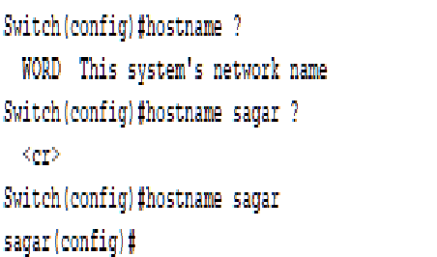

Figure: Set hostname

1. How to set the banner and how to see it.

* At first stay in configure mode then type banner and motd and type the sentences with opening capital or small “c” and close the sentence with capital or small “c”. i.e banner motd C This is the secure network, don’t try to hack it C.

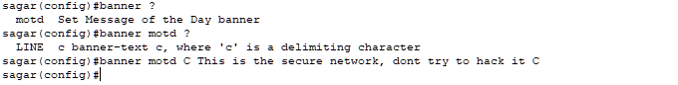

Figure: Set banner

To see the banner at first exit from the configure mode and stay in the privileged mode. Then type show followed by running-config. i.e show running-config.



Figure: To see the banner



Figure: Display Banner

1. How to undo this setting.

* Write no to this command. It will automatically undo this command. i.e no banner motd.



Figure: To undo banner

For undo hostname. i.e no hostname sagar.



Figure: To undo hostname