Freight Rate Prediction — Approach, Validation and Results
Machine Learning Engineer Assessment. All figures in this report are generated by the repository code; a Figure Book with every chart (EDA, model comparison, robustness checks, diagnostics) is provided separately.

Summary
The labelled data covers 1 Jan – 31 Oct 2025 and the loads to predict are 1 Nov – 31 Dec 2025. This is therefore a forecasting problem: the model must price loads on dates later than anything it was trained on. Validation was designed to reproduce exactly that, and model choice was driven by it.
Item | Result
Validation | 3 rolling-origin folds: train on all earlier months, score the next 2 calendar months
Candidates compared | 21 (7 algorithm families × 2 structures, linear models, baseline, 4 ensembles), identical folds, rows and metrics
Chosen model | Ridge regression on log(rate) for the drivers that must extrapolate (distance, equipment, weight, market index, quarter-end, trend) + equal-weight average of LightGBM, XGBoost and Extra Trees trained on the Ridge residual
Expected error on ALL loads | MAPE 3.98%, MAE $93 (mean of 3 folds, 28,890 loads). This is the realistic figure if every load is scored: it includes the 1.4% of labels at 2–5× or 0.2–0.5× the expected rate, which no model can anticipate.
Error on normal loads | MAPE 1.61%, MAE $39, bias +0.33% (28,488 loads, anomalous labels excluded); 98% of loads within ±5%
Reference points (normal / all loads) | LightGBM alone 2.71% / 5.00%; rate-per-mile baseline 4.64% / 6.92%

1. Key findings from the data
- Disjoint in time. 48,000 labelled loads and 12,000 loads to predict, with no date overlap (Figure 1). A random split would mix same-day market conditions into training and hide the forecasting problem.
- Distance dominates. A power law: rate ∝ distance^0.87, so rate per mile falls with distance. Holding other factors fixed, Reefer is associated with a ~13% and Flatbed a ~8% higher rate than Dry Van; weight has an elasticity of 0.08. These are Ridge coefficients from the final model: associations, not causal effects.
- Market index. market_index has a strong 7-day cycle (Wed–Thu peak) around a slow regime that rises Jan–May and falls Aug–Sep (Figure 2). In validation it sits in a narrow low band that is fully inside the training range.
- Unseen cities. 8 cities in validation.csv never occur in training; 1,447 validation loads (12%) touch one. City name therefore cannot be a feature; lanes are described by coordinates, distance and circuity.
- Coordinates are synthetic. Each city has one consistent coordinate pair, and the distance column agrees with them (median road ÷ straight-line distance 1.18). But they are not the real locations: compared with approximate real coordinates for 18 well-known cities they are displaced by a median of ~144 miles (Phoenix by ~395). They are treated as dataset-internal location signals, never joined to external geographic data.
- Weak signal. quote_signal adds little (linear coefficient 0.008; a weak U-shape only in the tails).
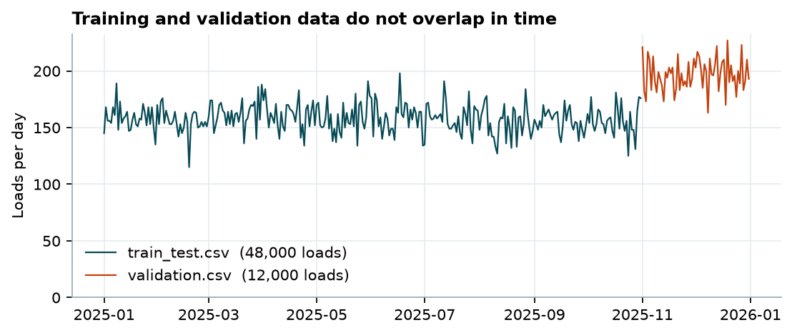
Figure 1. Loads per day in each file.
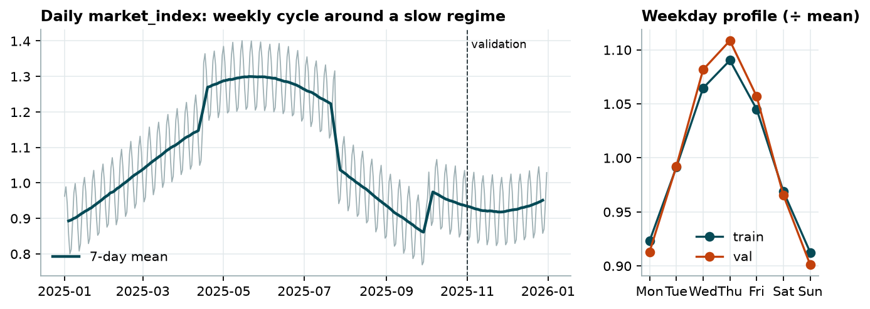
Figure 2. Daily market_index and its weekday profile.

2. Data-quality issues and how they were handled
Issue | Extent | Evidence | Treatment
Anomalous posted_rate labels | 677 rows (1.4%) | Ratio to a robust (Huber) log-linear expectation: normal loads within ±19%, then an empty gap, then two clusters at 0.2–0.5× and 2–5×. Any threshold from 1.2× to 2.2× flags exactly the same rows (Figure 3). Spread evenly over months, equipment and distance; their features look normal. | Called anomalous (likely entry/unit errors, not proven). Excluded from training; the detector is re-fitted inside each fold on training months only. Metrics reported with and without them.
Negative weight | 292 train / 145 validation | Magnitudes match normal loads (median 31,822 lb) | Absolute value + indicator
Missing weight | 300 train / 165 validation | Evenly spread: 0.4–0.8% in every month | Native NaN handling (LightGBM/XGBoost) + missing flag; otherwise equipment median from Jan–Apr training rows only (before the first evaluation window, so no fold sees a statistic from its own future)
Missing market_index | 374 train / 249 validation | Within-day spread is tiny (std 0.025) | That day's median market_index. Feature values only; train and validation share no dates, so validation rows never change a training-date value
Weight cap | 2.5% at exactly 47,500 lb | Spike at the maximum in both files | Kept (plausible cap)
Synthetic coordinates | all cities | See section 1 | Used only as internal location signals
Duplicates, unknown categories, conflicting coordinates | none | Checked | —

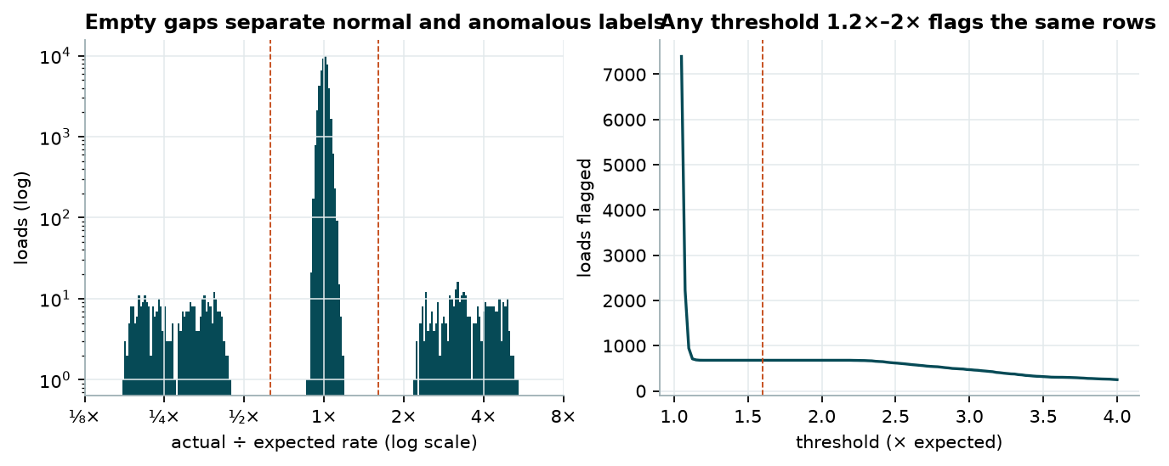
Figure 3. Left: actual ÷ expected rate. Right: rows flagged vs threshold — a flat plateau, so the threshold choice does not matter.
Does removal help? Training with them included raises CV MAPE from 1.61% to 2.54% on normal loads and from 3.98% to 4.91% on all loads. Removing them helps on both.

3. Validation approach and data split
Rolling-origin (expanding-window) cross-validation. Every fold trains on all months before a cut-off and scores the next two calendar months — the same 2-month horizon as the real task (Jan–Oct → Nov–Dec).
Fold | Training period | Evaluation period | Training rows (after removing anomalies) | Evaluated: all / clean
1 | 1 Jan – 30 Apr | 01 May – 30 Jun | 18,835 | 9,696 / 9,571
2 | 1 Jan – 30 Jun | 01 Jul – 31 Aug | 28,406 | 9,671 / 9,538
3 | 1 Jan – 31 Aug | 01 Sep – 31 Oct | 37,944 | 9,523 / 9,379
Final | 1 Jan – 31 Oct | 1 Nov – 31 Dec (validation.csv) | 47,323 | 12,000 (unlabelled)

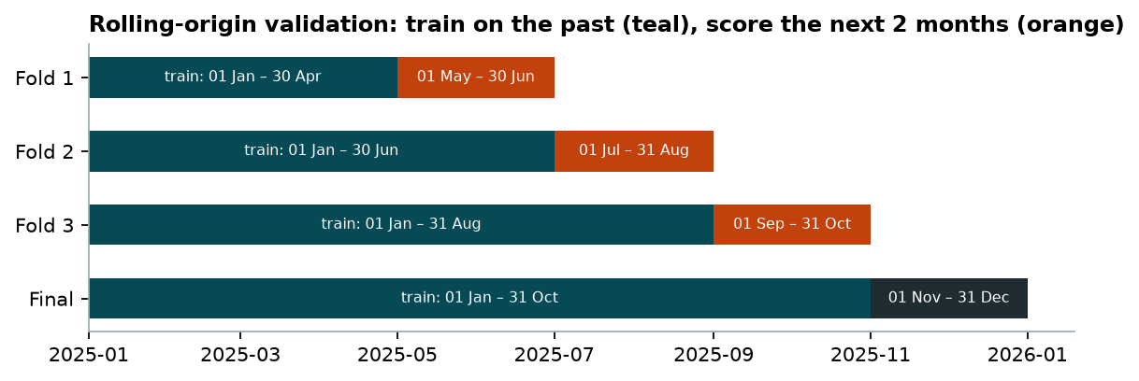
Figure 4. Validation design (dates inclusive).

Why this design
- Not random. Random K-fold would let the model see loads from the same days it is scored on, hiding the time trend and market shifts and overstating accuracy for Nov–Dec. Every fold here is scored strictly on the future.
- Three different regimes. Three folds cover different market conditions: rising (May–Jun, includes a quarter end), falling (Jul–Aug) and recovering (Sep–Oct, includes a quarter end). Fold 3 is the most recent and closest to the target period, so it gets extra weight when choosing between close candidates.
- No leakage. Anything that uses labels — the anomaly detector, the Ridge stage, the tree stage, blending weights — is fitted only on that fold's training months. Feature imputation uses only feature columns. Every candidate model uses the same rows in every fold.
- Metrics. Metrics are on the dollar scale (predictions are exponentiated). Two evaluation subsets: clean labels (primary: excludes anomalous labels as flagged by the fold's own detector) and all labels (secondary). Fold-mean and pooled values are both saved; they agree to 0.01 points.
Definitions (y = actual, ŷ = prediction, n loads): MAE = mean |ŷ − y|; RMSE = √mean (ŷ − y)²; MAPE = 100 × mean |ŷ − y| / y; Bias = 100 × mean (ŷ − y) / y, so positive bias = over-prediction. A MAPE of 1.6% is an average; it does not mean every load is within that (69% are within 2% and 98% within 5%, see diagnostics).

4. Model selection
Candidate families were chosen to cover the standard options for tabular regression: a rule-of-thumb baseline, linear models (Ridge on log(rate), and a Gamma GLM with log link, built for positive skewed targets), instance-based (k-nearest neighbours), bagged trees (Random Forest, Extra Trees), gradient boosting (LightGBM, XGBoost, HistGradientBoosting) and a neural network (MLP). Each non-linear learner was run two ways:
- Direct: the algorithm predicts log(rate) from all features, including a time-trend feature.
- Hybrid: Ridge carries the drivers that must extrapolate (distance, equipment, weight, market index, quarter-end ramp, linear trend); the algorithm learns only the Ridge residual from features without absolute time (coordinates, circuity, weight, market index, quote signal, equipment, calendar position).
Hyper-parameters were set once from standard defaults, not tuned per fold; tuning on three folds would mostly fit noise.
Model | MAPE (mean of folds) | MAPE fold 3 | MAE | Bias | MAPE all labels
Ensemble: LightGBM + XGBoost + Extra Trees | 1.61% | 1.39% | $39 | +0.33% | 3.98%
LightGBM — hybrid (Ridge + LightGBM) | 1.68% | 1.40% | $41 | +0.41% | 4.05%
XGBoost — hybrid (Ridge + XGBoost) | 1.67% | 1.38% | $40 | +0.34% | 4.04%
Extra Trees — hybrid (Ridge + Extra Trees) | 1.66% | 1.54% | $40 | +0.25% | 4.04%
Random Forest — hybrid (Ridge + Random Forest) | 1.65% | 1.52% | $40 | +0.30% | 4.03%
LightGBM — direct | 2.17% | 1.95% | $51 | -0.65% | 4.51%
XGBoost — direct | 2.26% | 2.00% | $53 | -0.83% | 4.59%
Random Forest — direct | 2.67% | 2.29% | $65 | -1.14% | 4.99%
Ridge (log-linear) | 2.83% | 2.77% | $60 | +0.22% | 5.19%
Gamma GLM (log link) | 2.83% | 2.76% | $60 | +0.28% | 5.19%
Baseline: median $/mile | 4.64% | 3.82% | $106 | -2.34% | 6.92%

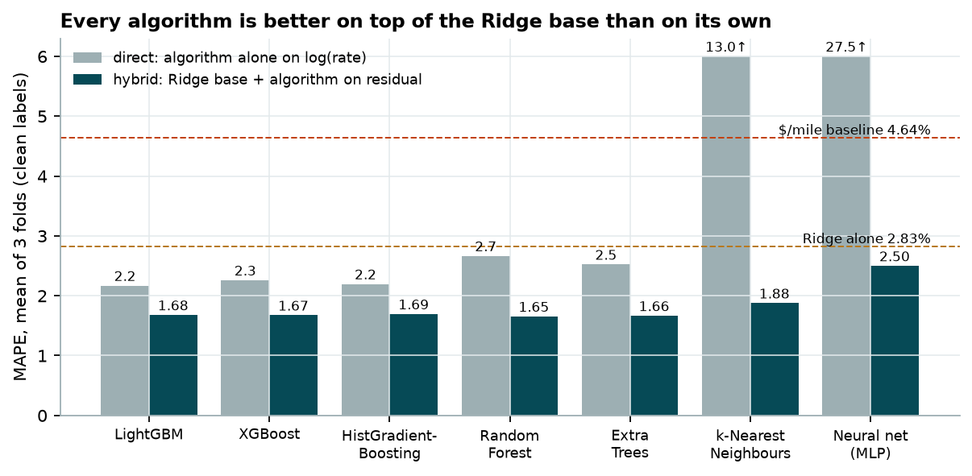
Figure 5. Every algorithm is more accurate on top of the Ridge base than on its own.
Why hybrid wins. Tree models cannot extrapolate: given a time feature, they predict the same level for every date after their last split, so direct trees under-predict later months (bias -1.1% to -2.9% in folds 1 and 3, all five tree learners). Ridge carries the level forward; the trees learn only patterns that repeat. This is the single largest design decision, worth 0.5–1.0 points of MAPE.
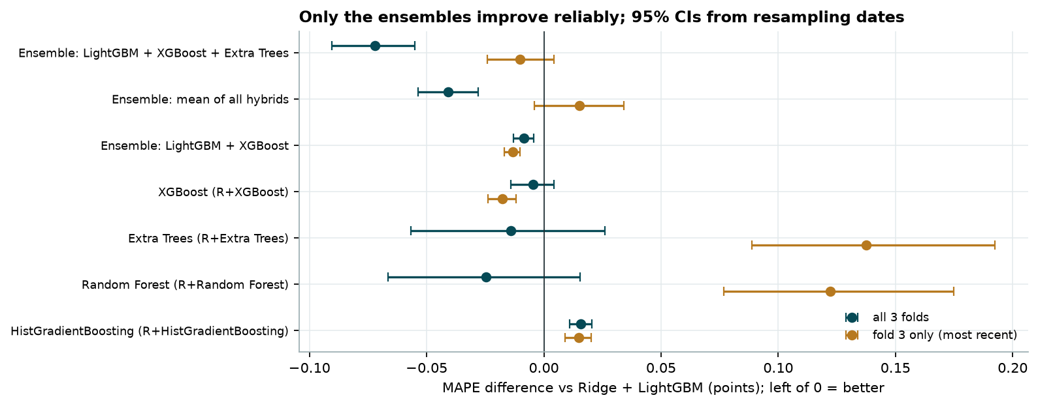
Figure 6. Difference vs Ridge + LightGBM with 95% bootstrap intervals (whole dates resampled).
Is the ensemble worth it? Averaging LightGBM, XGBoost and Extra Trees residual models improves MAPE by 0.072 points over all folds (95% CI -0.090 to -0.055; better on 73% of dates) and is no worse on the most recent fold (-0.010, CI -0.024 to +0.004). Boosting and randomised bagging make different errors, so averaging cancels some. Single learners are tied with LightGBM or worse on fold 3. A learned stacking ensemble (non-negative weights from earlier folds) was worst of the ensembles: with 2–3 folds the weights over-fit.
Selection rule: best mean MAPE across folds, unless significantly worse on the most recent fold. The chosen ensemble (1.61%) beats the single-LightGBM version (1.68%); the gain is modest ($2.0 MAE) for ~3× training time. Caveat: picking the best of 21 candidates on the same folds makes the winner's score slightly optimistic; the size of the gaps between tiers is far larger than that effect.

5. Results of the chosen model
Evaluation window | n (clean) | MAE | RMSE | MAPE | Bias | MAPE all labels
Fold 1: May-Jun | 9,571 | $33.8 | $49.5 | 1.39% | -0.02% | 3.68%
Fold 2: Jul-Aug | 9,538 | $50.8 | $76.1 | 2.04% | +1.50% | 4.34%
Fold 3: Sep-Oct | 9,379 | $32.0 | $46.0 | 1.39% | -0.48% | 3.92%
Mean of folds | 28,488 | $38.9 | $57.2 | 1.61% | +0.33% | 3.98%

Fold 2 is weakest: trained on Jan–Jun only, the fitted trend was too steep (10.8%/yr vs 7.6%/yr with all data), so Jul–Aug was over-predicted by 1.5%. Errors also grow within each 2-month window (about 1.3% MAPE in the first two weeks to 1.8% in the last two), so late-December predictions are expected to be less accurate than early-November ones.
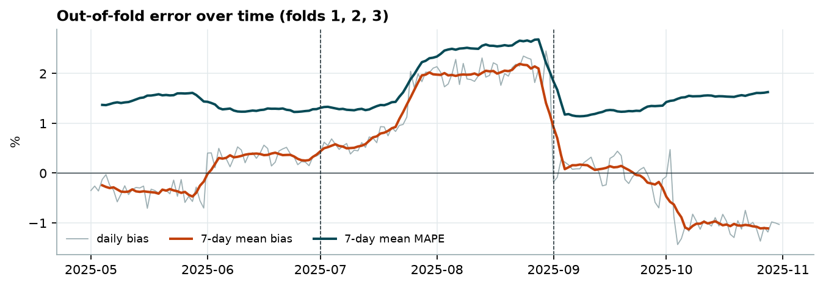
Figure 7. Out-of-fold error over time.

6. Robustness checks
Question | Check | Result | Verdict
Is stage 2 trained on optimistic (leaky) residuals? | Train the tree stage on random 5-fold out-of-fold Ridge residuals instead | Residual correlation 0.99997; fold MAPE changes ≤ 0.003 pt | No issue; 8 coefficients on 15k–47k rows cannot memorise
How much does the trend assumption matter? | Continue the trend at k × slope after training end (k = 0…1.5); remove it entirely | No trend term: 2.64%. k = 0…1.5: 1.57–1.72%; helps fold 3, hurts fold 2 | Trend term essential (sets the current level); extrapolation k = 1 kept, not tuned
What does the 0.97 R² mean? Does it carry forward? | Per-date effects → 3-term regression; refit on Jan–Aug, predict Sep–Oct | In-sample R² 0.97. Out of sample: 0.98% RMSE vs 2.16% naive | 0.97 is descriptive (in-sample); structure does carry 2 months forward
Can it price cities it has never seen? | 5 draws: remove all loads touching 8 random cities from fold-3 training | MAPE +0.13 pt on average (1.46–1.53%) | Small cost; evidence (not proof) for the 8 real unseen cities
Does removing anomalous labels help? | Train with vs without them | Clean: 2.54% → 1.61%; all: 4.91% → 3.98% | Remove
Does December depend on validation market data? | Price the December lane with training-only market inputs | Mean $843 (submitted) vs $843 (training-only) | Barely; see section 7

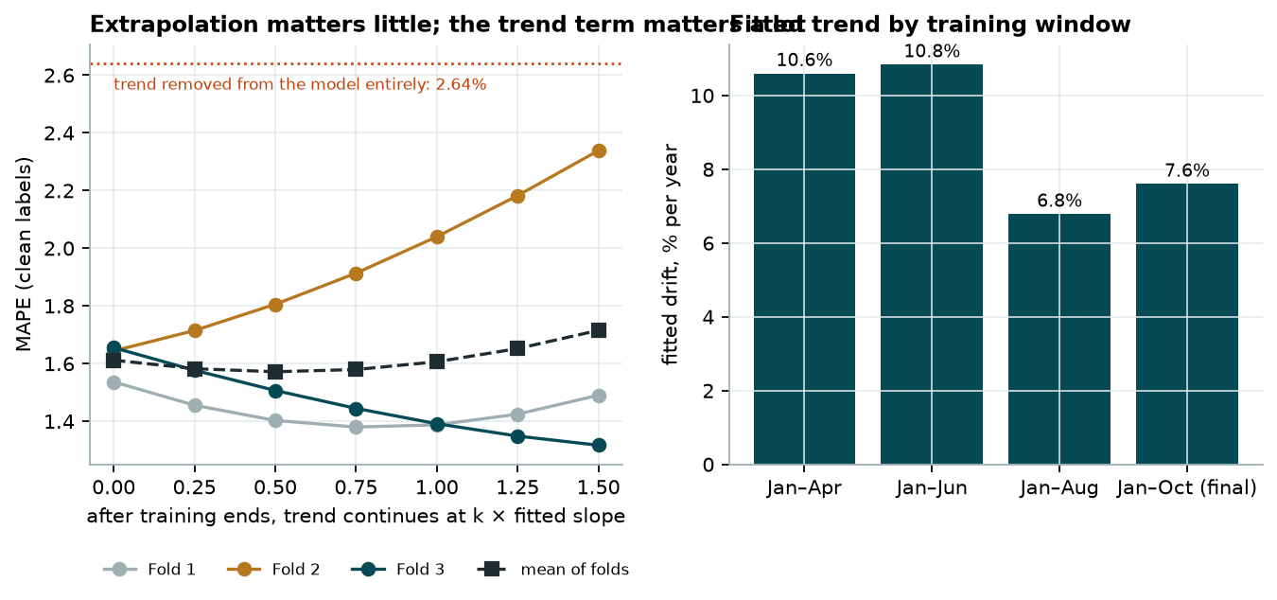
Figure 8. Trend sensitivity (left) and fitted drift by training window (right).
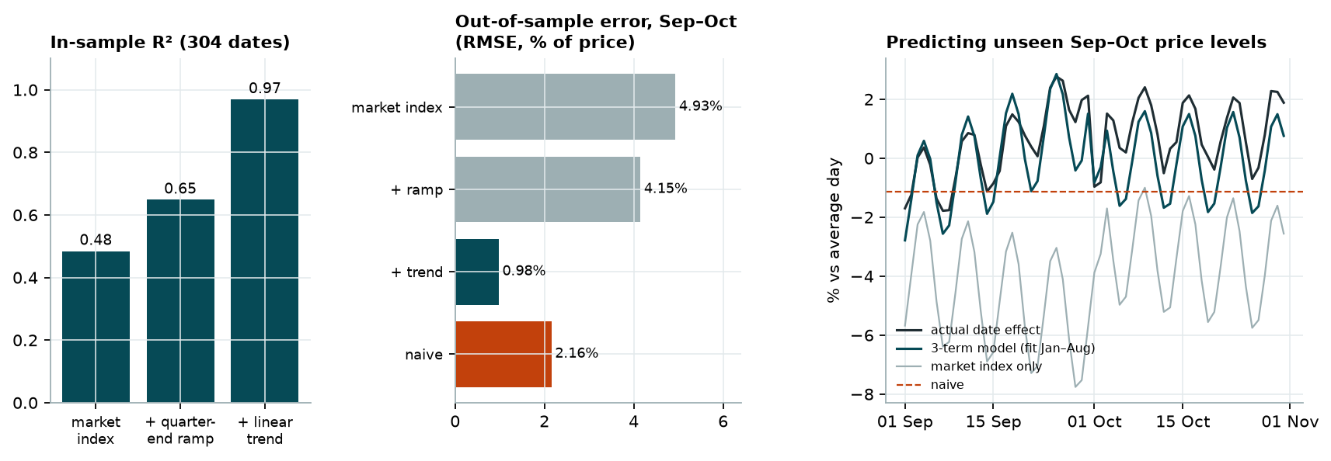
Figure 9. The date effect: in-sample R², and out-of-sample error on unseen Sep–Oct dates.
How the R² is computed: (1) regress log(rate) on load features plus one indicator per date (304 dates, clean labels); the indicator coefficients are per-date price levels; (2) regress those 304 levels on log(daily market_index), the quarter-end ramp and a linear trend. 0.97 is the ordinary in-sample R² of step 2. It describes the history; it is not proof that the same relationship holds in Nov–Dec.
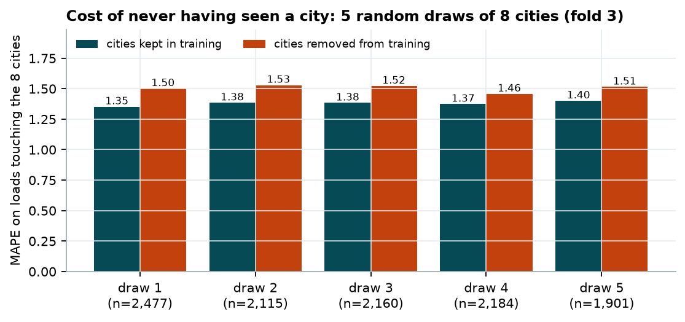
Figure 10. Unseen-city stress test, 5 random draws.

Unseen-city test: exact design
- Data. Fold 3 only (train 1 Jan – 31 Aug, evaluate 1 Sep – 31 Oct), using training data only. validation.csv is never used, since it has no labels.
- Cities. For each draw, 8 cities are sampled at random (seed 42) from the 64 training cities. They are NOT the 8 real unseen validation cities (Allentown, Charlotte, Chicago, Jackson, Knoxville, Laredo, Norfolk, San Diego), which cannot be scored. So the test measures generalisation to unseen cities in general, not to those specific ones.
- Removal. Every training load whose pickup OR delivery is one of the 8 cities is removed before fitting (the anomaly detector is also re-fitted without them).
- Evaluation. Only clean Sep–Oct loads touching at least one of the 8 cities are scored. The number differs from the 1,447 validation loads because it depends on which cities are drawn.
- Comparison. The same loads are also predicted by a model trained WITH those cities. The difference isolates the cost of never having seen a city. (Ordinary fold-3 MAPE on all clean loads: 1.39%.)
Draw | Held-out cities | Loads scored | MAPE, cities seen | MAPE, cities removed | Cost
1 | Tulsa, Washington, San Antonio, Memphis, Toledo, Hartford, Bakersfield, New York | 2,477 | 1.35% | 1.50% | +0.15 pt
2 | Houston, New York, Jacksonville, Green Bay, Baton Rouge, Reno, Las Vegas, Charleston | 2,115 | 1.38% | 1.53% | +0.14 pt
3 | Tulsa, Atlanta, Cincinnati, Salt Lake City, Little Rock, Harrisburg, San Francisco, Bakersfield | 2,160 | 1.38% | 1.52% | +0.14 pt
4 | Chattanooga, Harrisburg, Phoenix, Tucson, Salt Lake City, Savannah, Green Bay, Mobile | 2,184 | 1.37% | 1.46% | +0.08 pt
5 | Fresno, St. Louis, Fort Wayne, New Orleans, Green Bay, Harrisburg, Syracuse, Salt Lake City | 1,901 | 1.40% | 1.51% | +0.11 pt

Interpretation: the model loses 0.08–0.15 points of MAPE on loads touching a city it has never seen. This is evidence that the coordinate-based features let it generalise to new cities. It does not prove that coordinates alone cause this, or that the 8 real validation cities behave the same way.

7. Fixed December prediction chart
Produced by the provided score.py from data/december_chart_inputs.csv: Lexington → Fort Wayne, 360 miles, Dry Van, 32,000 lb; only the date changes.
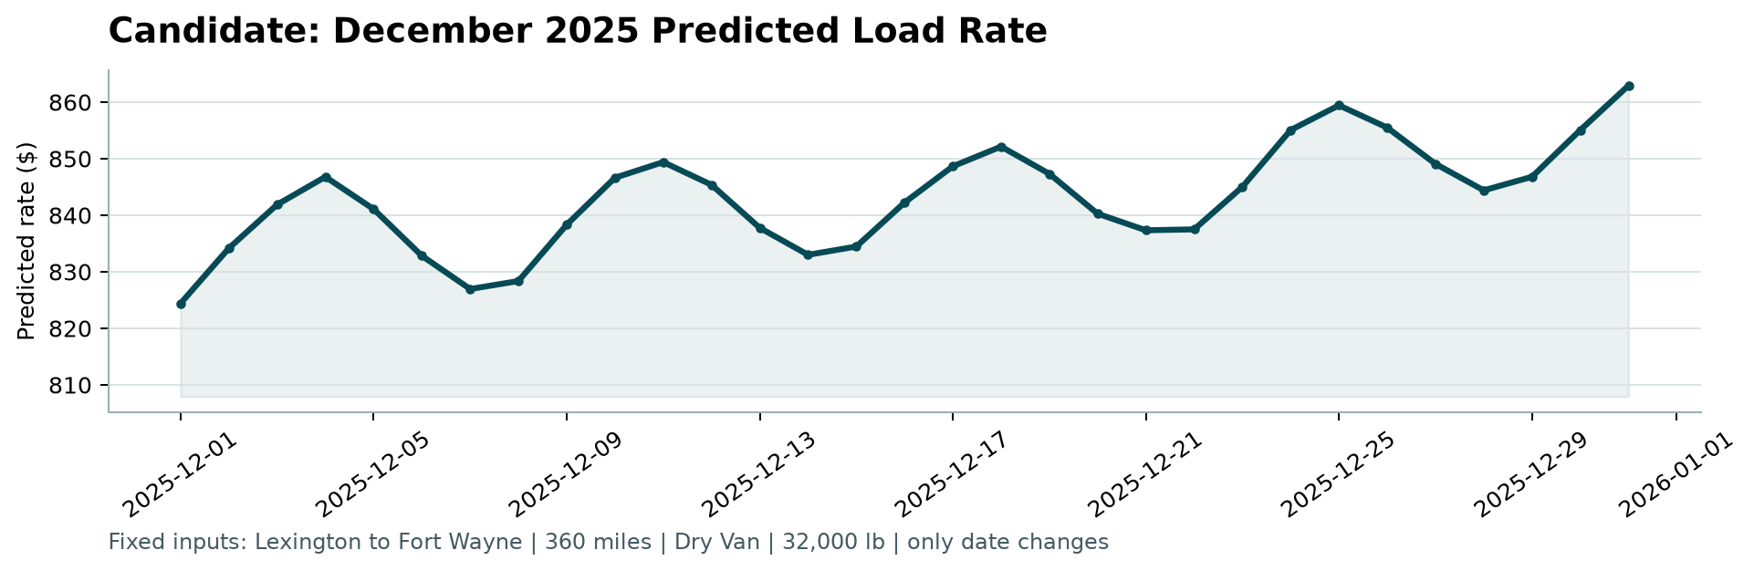
Figure 11. Output of score.py.
Inputs. The chart file has no coordinates, market_index or quote_signal. Coordinates come from the city lookup. market_index and quote_signal are the medians of the values supplied in validation.csv for each December date: these are input features provided by the assessment, and no label is used. The values used are saved in outputs/december_inputs_used.csv. The instructions do not say whether these supplied feature values may be used for the chart; if only the seven chart columns are allowed, scenario B in Figure 12 (training data only) is the alternative, and it gives nearly the same curve.
Shape. The weekly market cycle drives the 7-day wave; the quarter-end ramp and trend lift prices into year end ($825 → $861). For reference, the 21 Dry Van loads on this lane in training ranged $758–$934.
Christmas. Christmas Day is priced at $859, the 2nd highest of the 31 days (peak $861 on 31 Dec). That is not learned holiday behaviour: 25 Dec 2025 is a Thursday (the weekly market peak is Wed–Thu) and late December is in the quarter-end window, where the data shows rates rising in March, June and September. The training data contains no Christmas, so whether holiday demand pushes rates up or down cannot be checked. Treat late-December values as the least certain part of the chart.
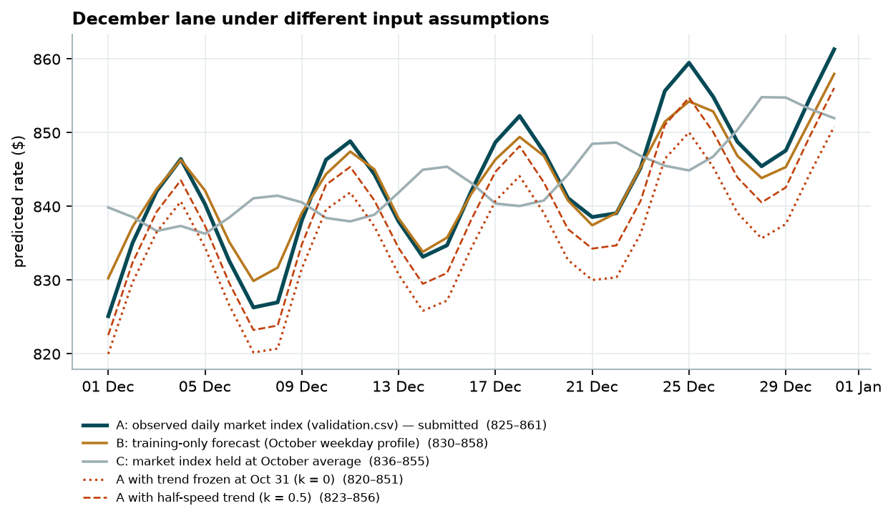
Figure 12. The same lane under alternative assumptions. B and C use training data only.
Sensitivity. If the December market_index were not available, a forecast from October's weekday profile gives almost the same curve (mean $843 vs $843). Freezing the trend at 31 October lowers prices by about 0.9%. All scenarios lie within a ~5% band. These are model predictions under stated assumptions, not forecasts with known accuracy: no December appears in the training data, so Christmas/New-Year effects cannot be learned.

8. Limitations and next steps
- Time. Less than one year of history and no prior December; the trend and quarter-end effect are assumed to continue. Re-estimate monthly; error grows over a 2-month horizon, so frequent retraining helps.
- Distance shape. Short hauls are under-predicted by ~0.5% and the longest over-predicted by ~0.8%; a distance spline in the Ridge stage would address this.
- Anomalies. If the anomalous labels have a known cause (e.g. unit or per-mile entry), they could be corrected instead of dropped.
- Uncertainty. Prediction intervals (quantile models or conformal prediction on the time folds) would be more useful for pricing than a point estimate.
Reproduce: python -m pip install -r requirements.txt; python -m src.train; python -m src.compare; python -m src.eda; python -m src.checks; python -m src.diagnostics; python score.py --predictions validation_predictions.csv --december-predictions data/december_chart_inputs.csv; python make_report.py; python make_figure_book.py

