# Abstract

# Introduction

# Experimental

## Set-up

The experimental procedure consisted firstly of selecting a real space to approximate and optimize. The space chosen was the laboratory shared by the authors. The dimensions of the selected room and of notable furnishings within it were measured and abstracted to a grid format. The measurer used his best judgement to assign a suitable amount of reserved space to appropriate objects. Table 1 describes the room and furnishings.

|  |  |  |  |  |  |  |
| --- | --- | --- | --- | --- | --- | --- |
| **Object** | **Width** | **Depth** | **Reserved Space** | **No. in Room** | **Total Area** | **Total Area (Reserved Included)** |
| Room | 40 | 20 | - | - | 800 | - |
| Desk | 5 | 2 | 3 | 16 | 160 | 400 |
| Shelf | 3 | 1 | 4 | 2 | 6 | 30 |
| Cabinet | 3 | 2 | 2 | 3 | 18 | 36 |
| Couch | 6 | 2 | 3 | 1 | 12 | 30 |
| Table | 4 | 2 | 3 | 3 | 24 | 60 |
| Door | 4 | 0 | 4 | 2 | 0 | 32 |

The doors in the last row are located along the lower wall, with their left edges at positions 0 and 14, approximately where they are in the physical room. They are not moveable while the optimizer runs.

The reserved area of the objects makes a great deal of difference: when the actual occupied area is considered, it takes up 27.5% of the room’s space; when the reserved space is included, this increases to 69.5%.

For an empty room of these dimensions, the taxicab distance metric has an objective function value, or score, of 0.02155625, which forms an upper bound on the quality of the solutions the algorithm finds. This value is used to normalize the scores in the rest of the experimental section.

## Tests

The two most significant hyperparameters for the operation of the algorithm are the number of fireflies initialized and the number of iterations. For a simple set-up consisting of 10 desks (with no other furniture or doors), both the number of fireflies and the number of iterations was varied (in each case, the non-varied parameter was held at 10). For each hyperparameter test, the final configuration of the room, the value of the objective function for that final value, and the runtime was recorded. The numerical findings are available in Tables 2 and 3. Figure X+1 and X+2 display the final room configuration for the best performing row of Tables 2 and 3 respectively; Figure X is an example of an initial random configuration; the room configurations for the other rows are available in the project’s GitHub, in the Paper/configures directory.

Table 2



Table 3



For 10 desks and 10 iterations, the runtime of the algorithm appears to grow exponentially with the number of fireflies: doubling the fireflies increases the runtime by a factor between 5 and 10. Doubling the fireflies also appears to improve the final solution by approximately 3%; this trend continues until the point at which the runtimes become large enough to render testing impractical. Increasing the number of fireflies corresponds to improving the exploration of the algorithm.

For 10 desks and 10 fireflies, the runtime of the algorithm appears to grow linearly with the number of iterations. Improvement is initially substantial compared to doubling the number of fireflies, 6% rather than 3%. However, increasing the number of iterations corresponds to improving the exploitation of the algorithm, and this improvement tapers off as the number of iterations grows and local minima are found. Indeed, the performance of last row is worse than the preceding row.

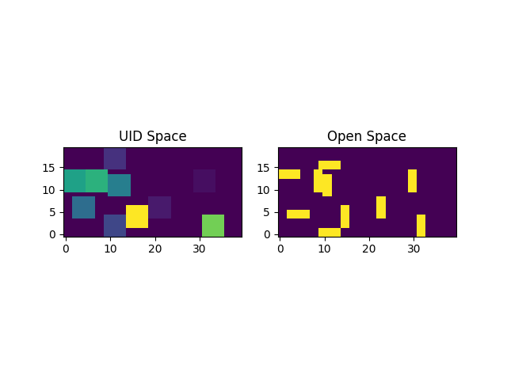

Figure X. Initial random configuration.

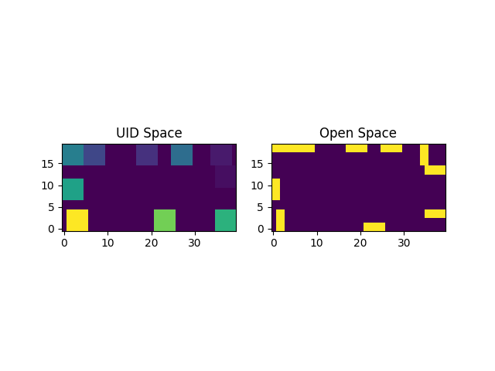

Figure X+1. Final configuration for 10 desks, 160 fireflies, and 10 iterations.

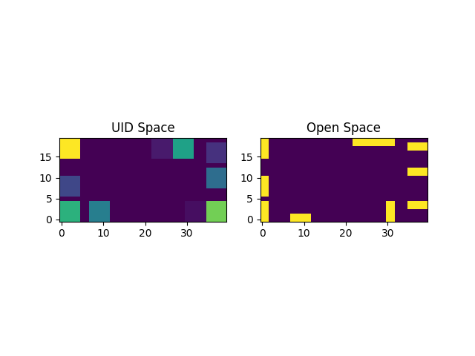

Figure X+2. Final configuration for 10 desks, 10 fireflies, and 640 iterations.

For each figure, UID Space displays the reserved space of every object and assigns each object a distinct color. Open Space displays the true space taken up by each object.

To give the reader a sense of what a change in the score means visually, the normalized score for the random configuration of Figure X is 0.122934184. The improvement between Figure X and Figures X+1 and X+2 corresponds to an approximately 67% increase in the score.

The algorithm adopts and exploits the strategy of moving objects to the walls; for these tests, the number of objects is not large enough for this naïve strategy to break down.

However, there are significant spatial problems present in these solutions: in Figure X+1, the top right corner of the room is cut off; in Figure X+2, the lower right corner is not cut-off, but the route to it is circuitous. More subtly, the algorithm does not appear to always favor rotating objects with their broadside along the wall, which would be considered more optimal by the high-level roundness metric discussed in part III.A.

The next task involves evaluating the performance of the algorithm as the complexity or “busyness” of the room increases. This is more difficult to test objectively than a simple increase in parameters; Table 4 illustrates the strategy adopted in this paper.

Table 4. Each entry indicates how many of its column’s furnishing was present in its row’s complexity test.



For each complexity test, 20 fireflies were initialized and the algorithm ran for 30 iterations. Figures Y, Y+1, and Y+2 display the final room configuration of each complexity test.

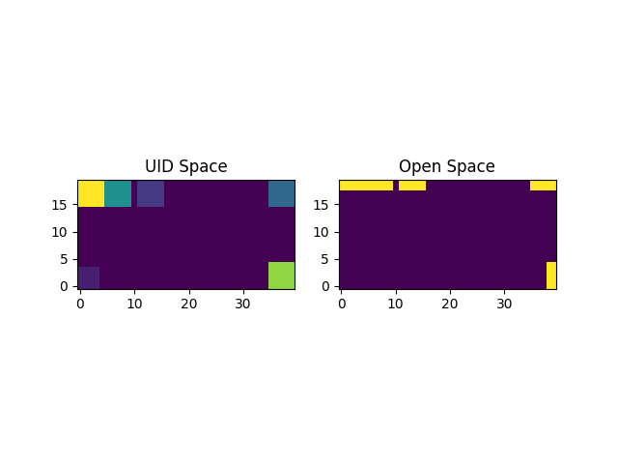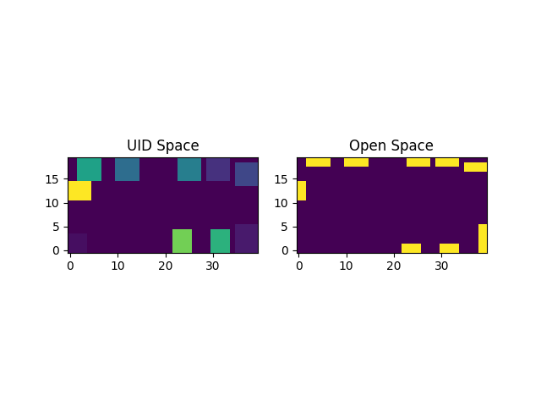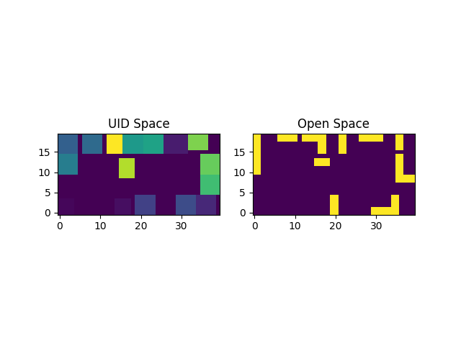

The number of furnishings in Complexity 3 was large enough that the Algorithm abandoned the strategy of simply moving all objects against a wall.

The Cabinet and Shelf columns in Table 4 are conspicuous by the 0s present in all rows, and the number of desks never rises higher than 16. When the complexity of the room rose above the level of Complexity 3, the algorithm tended to stall out in the initialization stage. This is due to the increasing difficulty of finding random configurations which do not suffer from conflicts.

Figure Y+3 visualizes the change in solution quality as the algorithm runs.

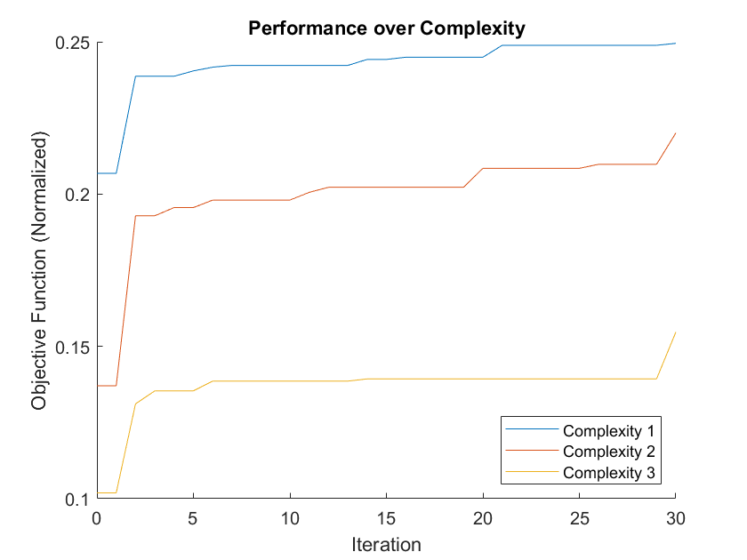

A final and more general experiment was performed to assess the algorithm as a whole. The results are summarized in Table 5. The furniture consisted of 10 desks, a couch, and the two doors for these tests.

Table 5.



The expectation is that a combined approach, in which both the number of fireflies and iterations is above 10, should perform better than those tests performed at the beginning of this section. However, the normalized score for the last two columns of Table 5 are significantly lower than those of Tables 2 and 3. This is explained by the increased complexity of the room setup in this set of experiments: the score of an initial randomized configuration for this setup is only 0.107712, considerably lower than that of the original run of experiments.

# Conclusion

In this paper, the problems of furniture arrangement and algorithmic searches were explored; in the intersection of the two, a tool was created to assist with

1. Future Work
   1. Different objective function
      1. Maybe push objects to the wall better
   2. Test alpha and beta hyperparameters
   3. Wall objects
   4. Walking space contiguity
   5. Prevent stalling of set-up
   6. More complex algorithm
   7. More complex and comprehensive constraints.