Loading the mcs file

1. Generate the bit file
2. Open the constraint file and add the following statement

set_property BITSTREAM.CONFIG.SPI_BUSWIDTH 1 [ current_design]

The bus width must be changed accordingly to the no of data lines that are to be used.

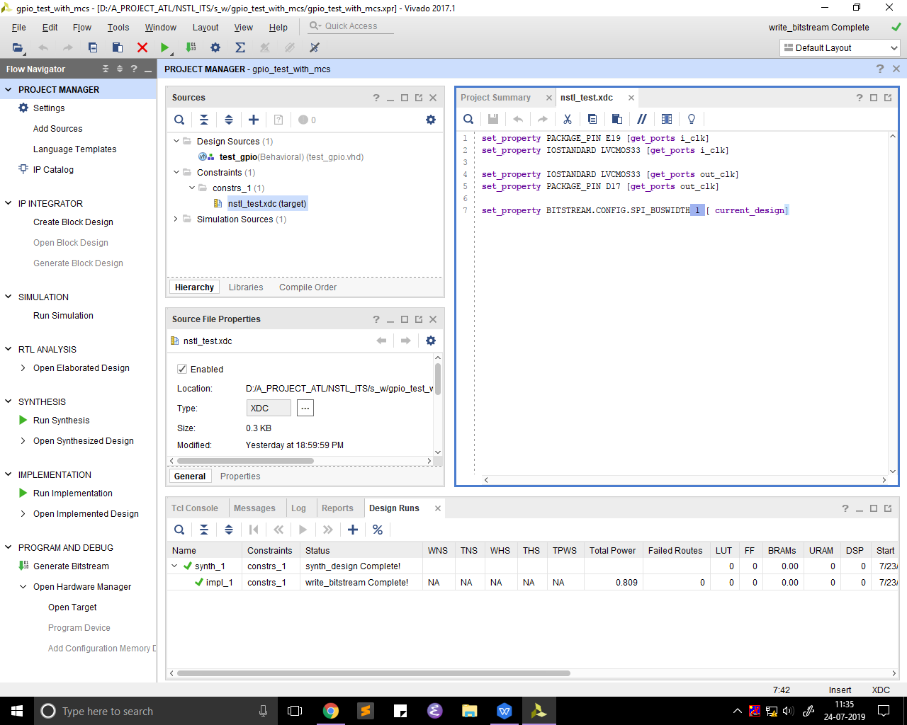

1. Open the hardware
   1. 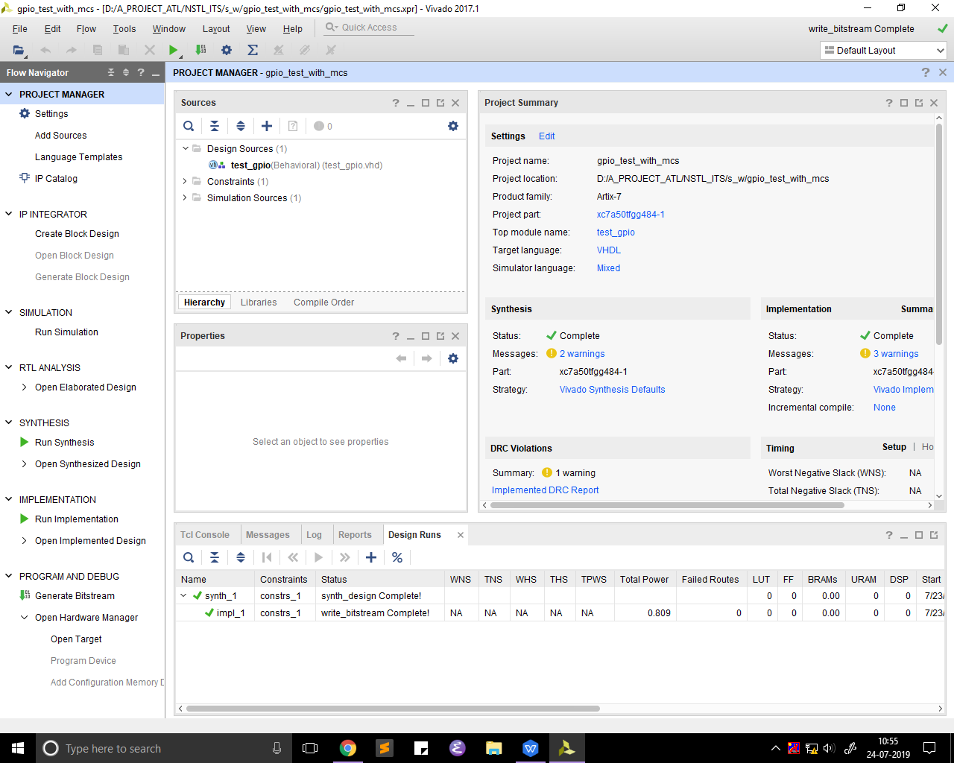
2. Open hardware manager
   1. 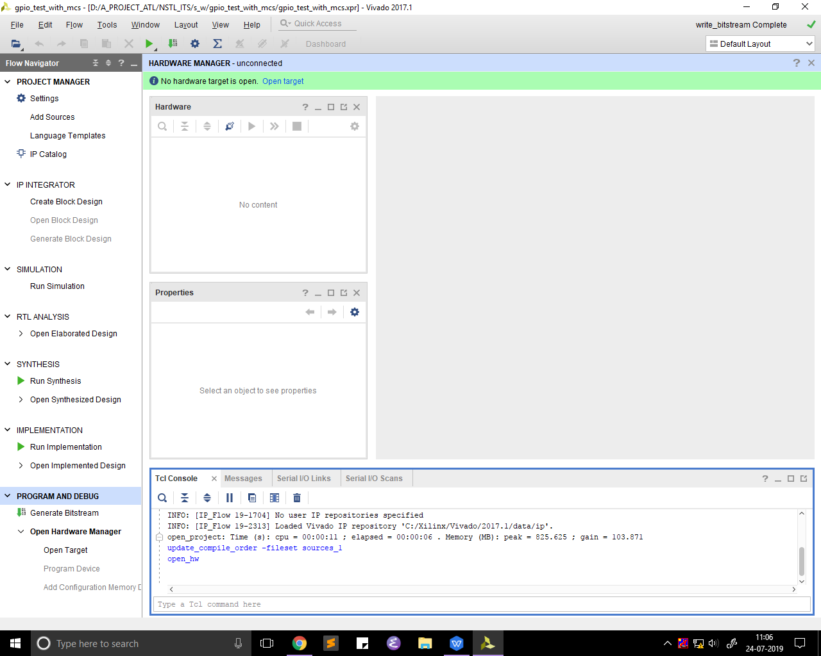
3. Open target and click on auto connect
   1. 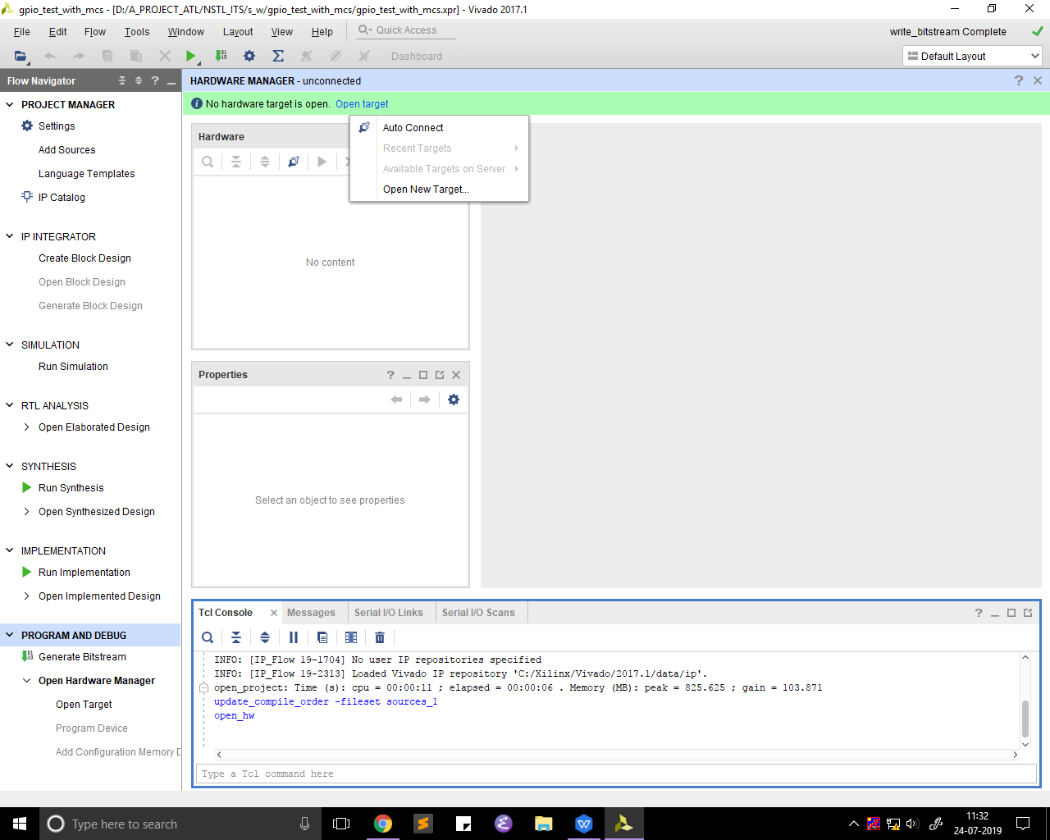
4. Go to tools -> generate memory config file
   1. 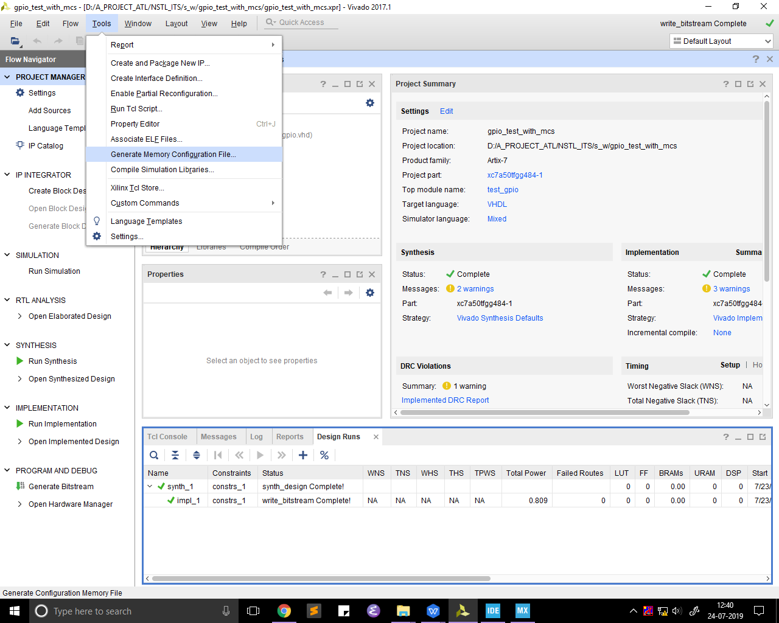
5. After the memory configuration file is open a window pops up . the memory part has to be enabled and the flash memory device is selected and the respective part number.
   1. 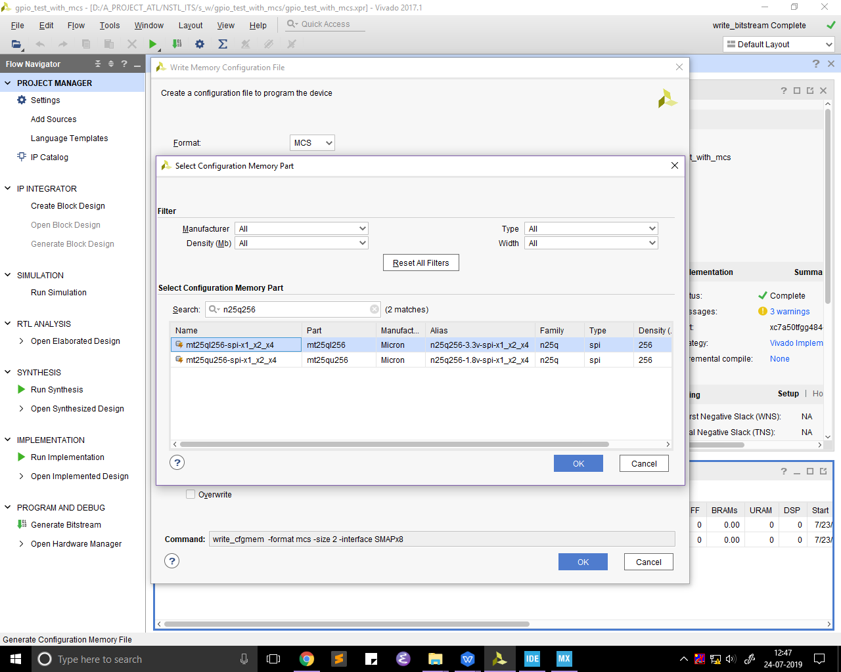
6. Below the memory we have a new file name option we have to specify a filename with which the mcs file is saved with.
   1. 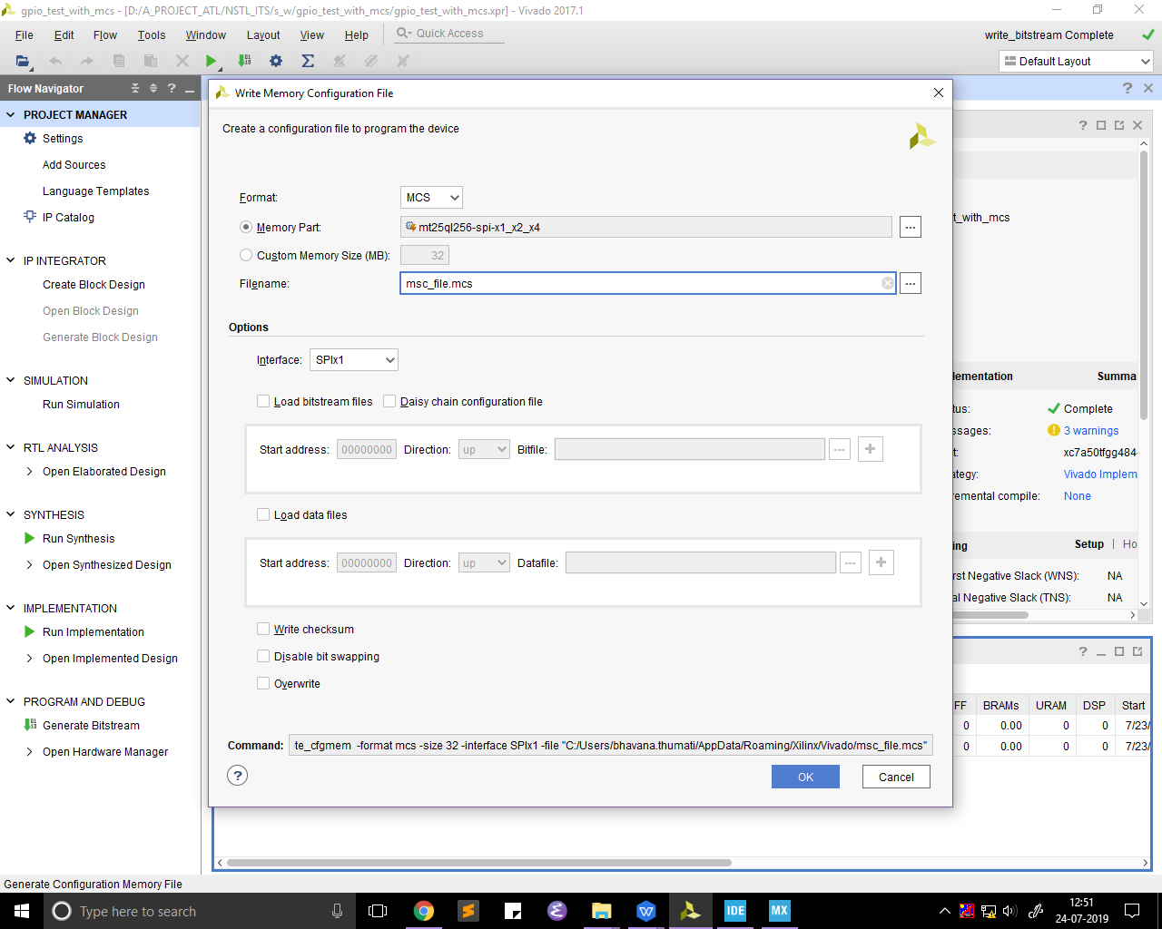
7. Below this a a options section we will have to specify the interface weather it is 1 wire interface or a four wire interface. This width is same as the width mention in the constraint file . The width choose is 1 so we don’t change anything here but we have options .
   1. 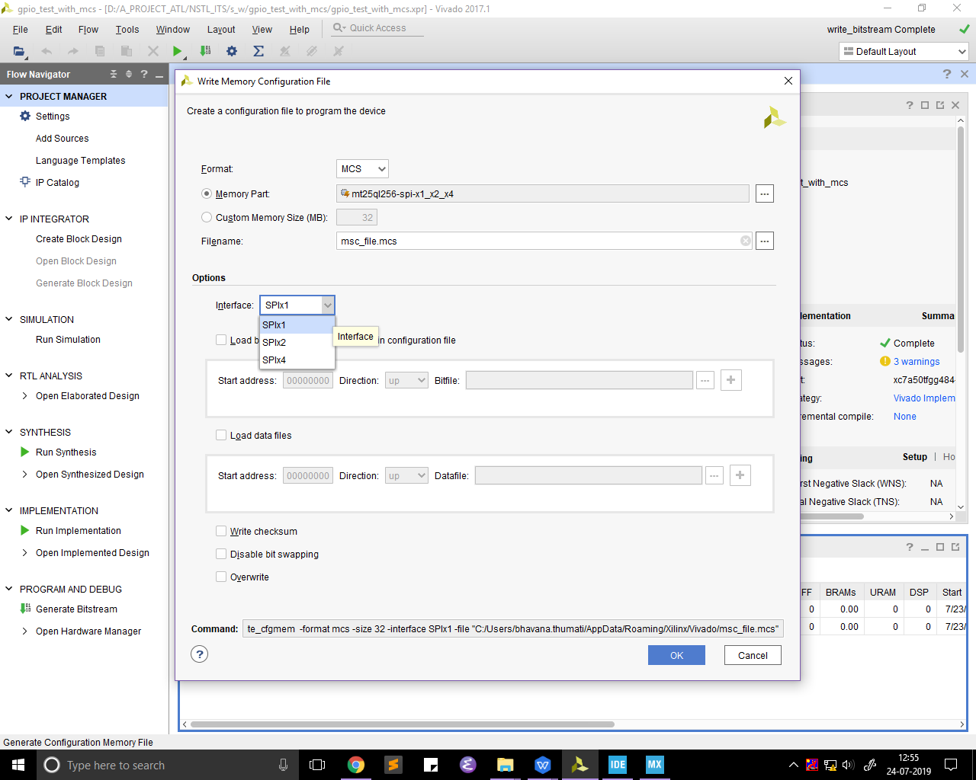
8. To generate the mcs file we need to provide the bit file . the load bit stream must be enabled. And the bit file must be given in the path.
   1. 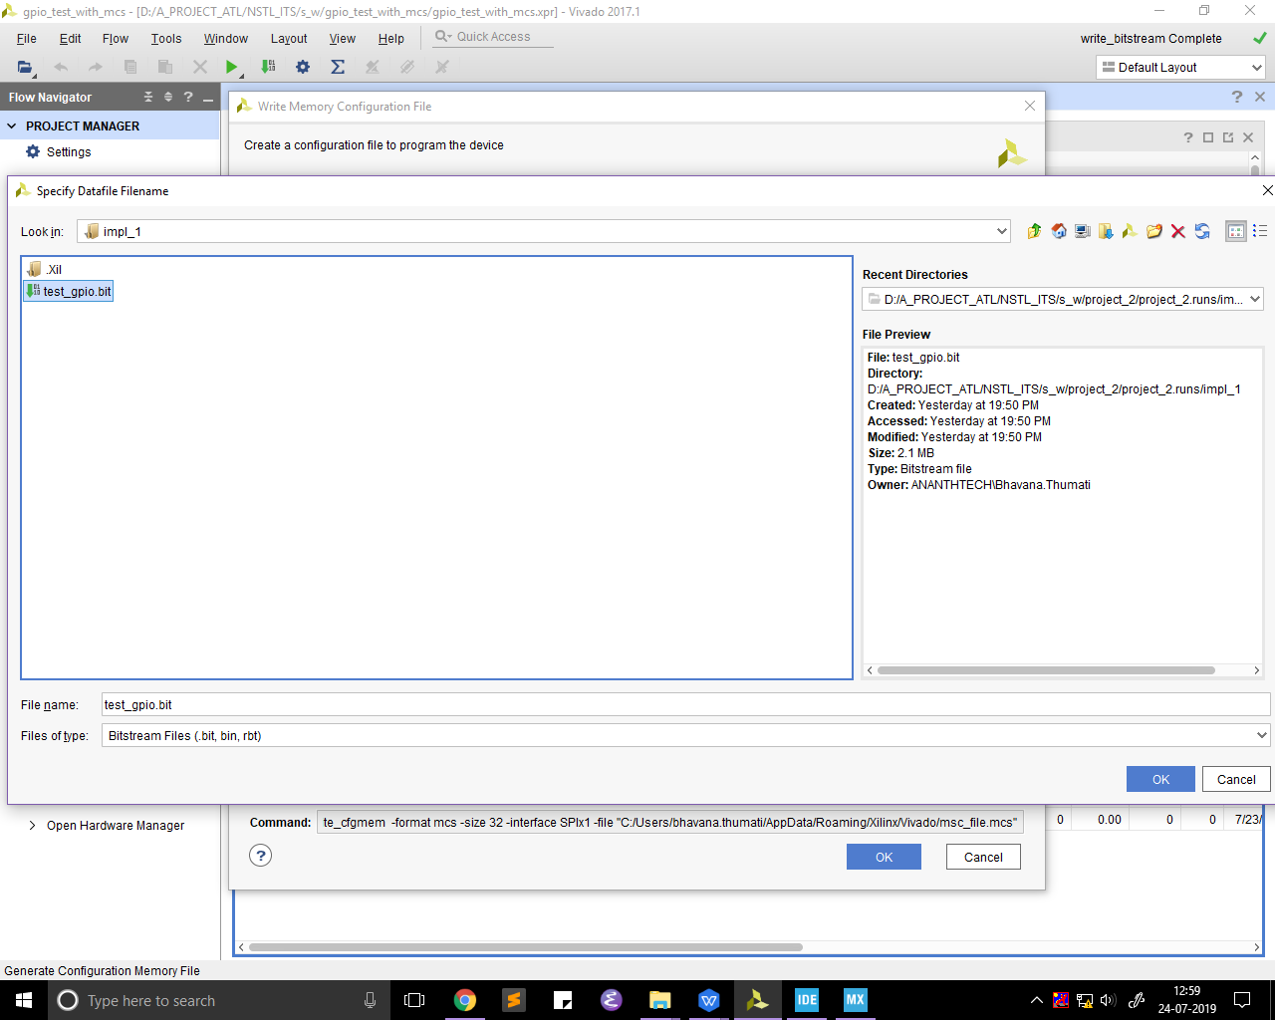
   2. 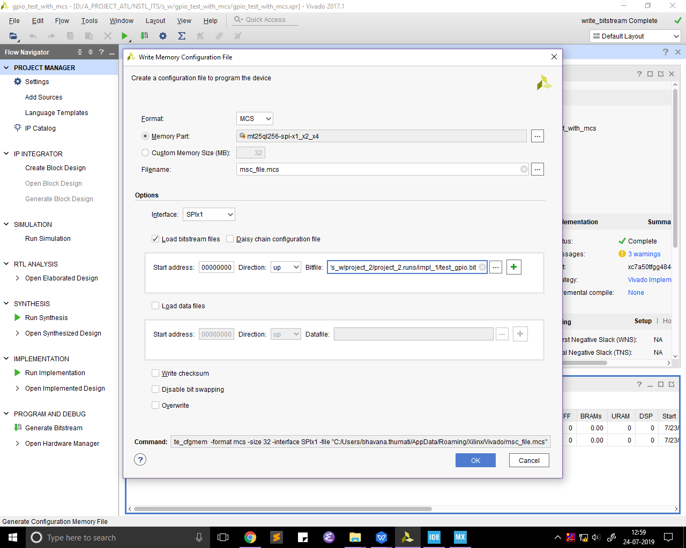
9. On clickling ok the mcs file will be generated.
   1. 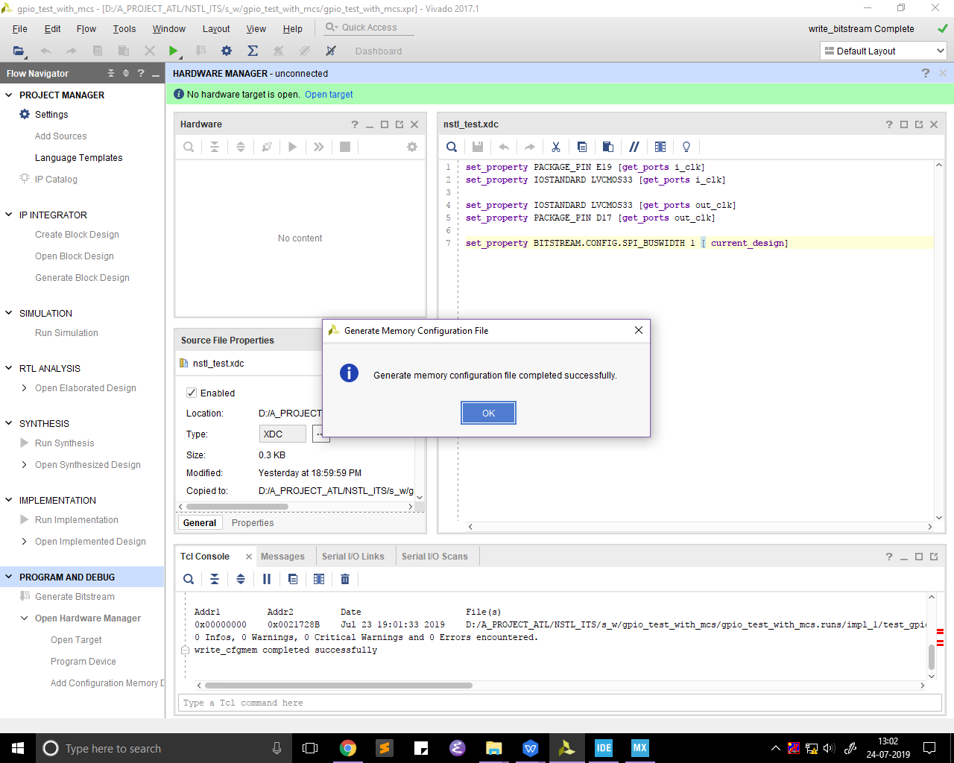
10. Click on ok and close the project . you will go back to the home window

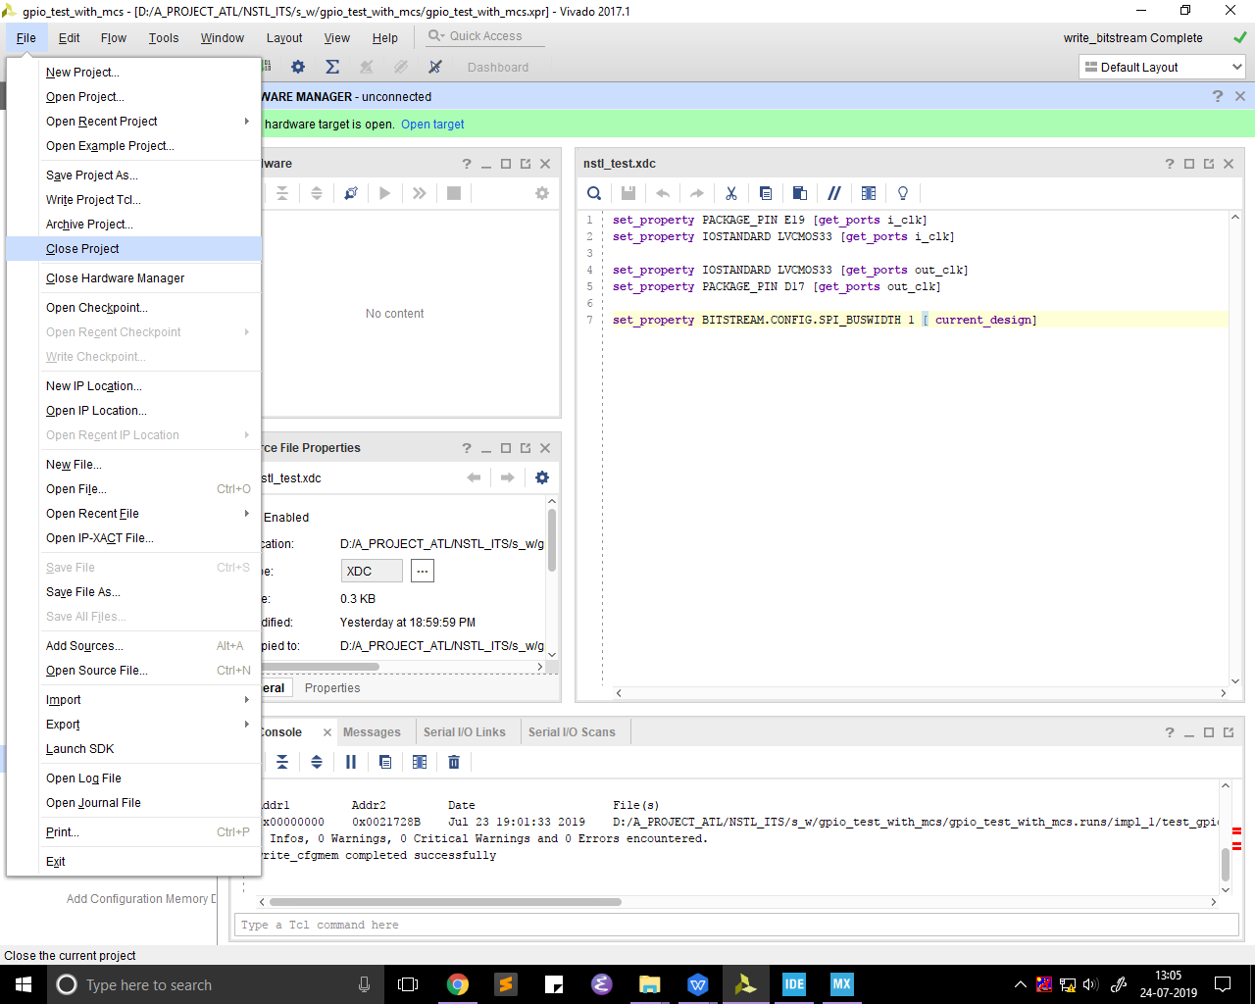

1. From the home page go to the open hardware manager

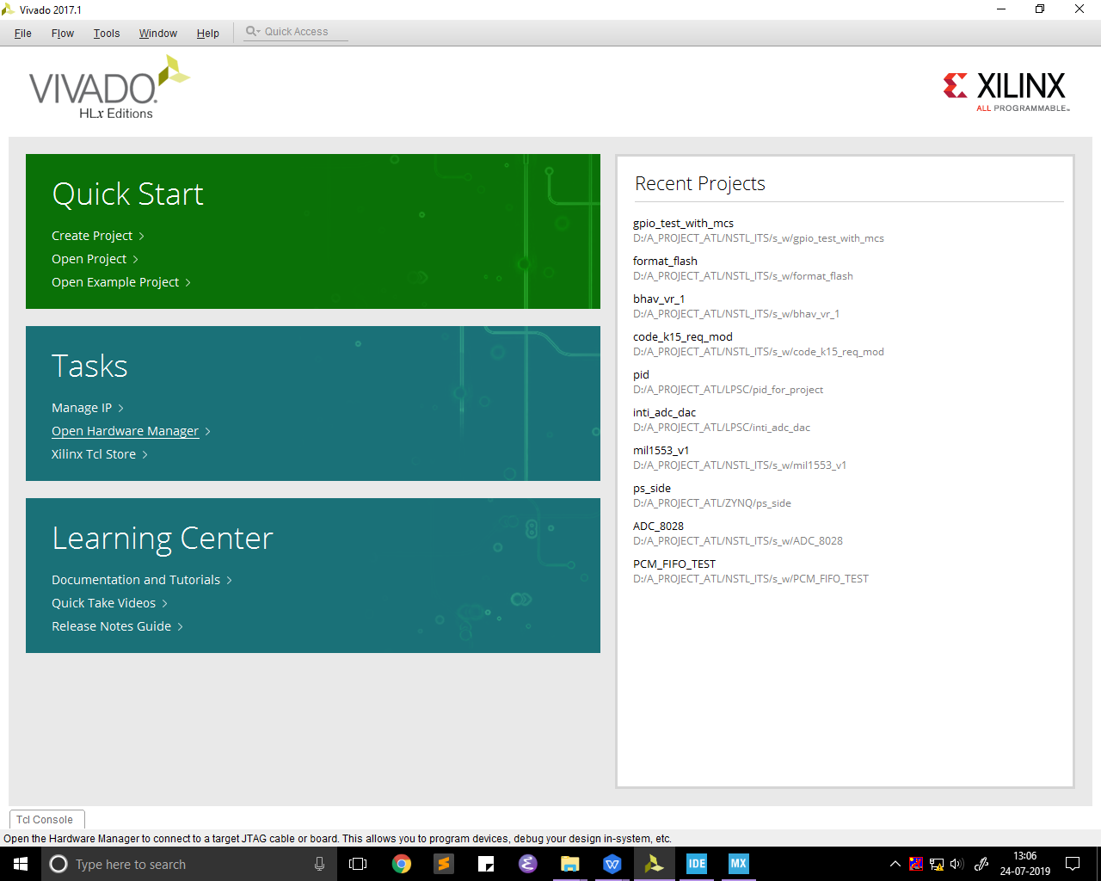

1. Click on open target ->auto connect

At this state the device must be turned on and the jtag must be connected

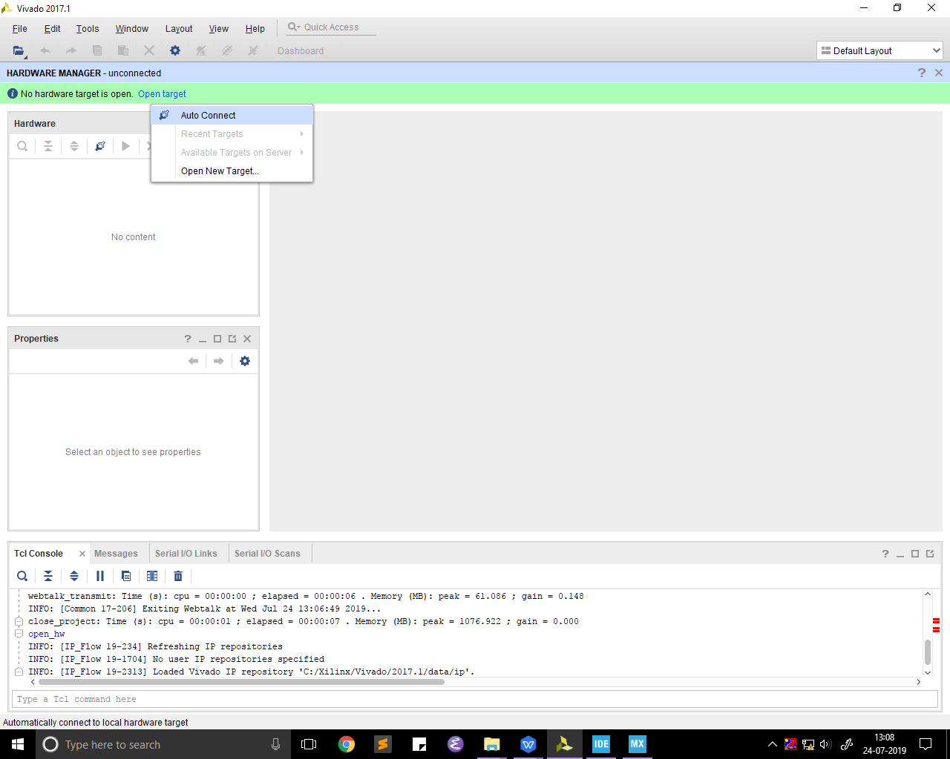

1. V
   1. 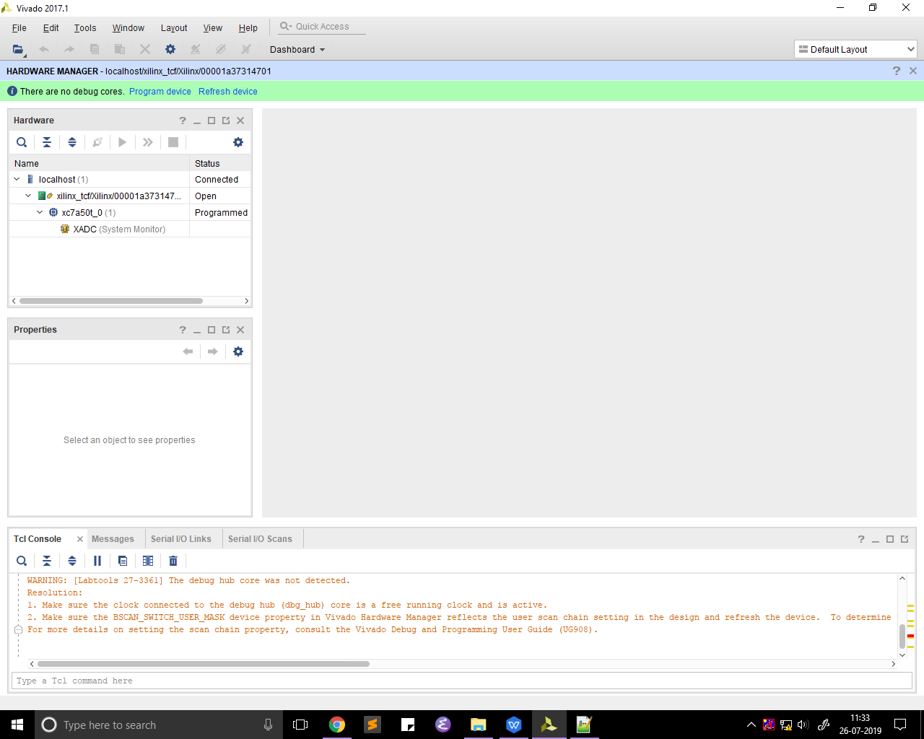
2. V
   1. 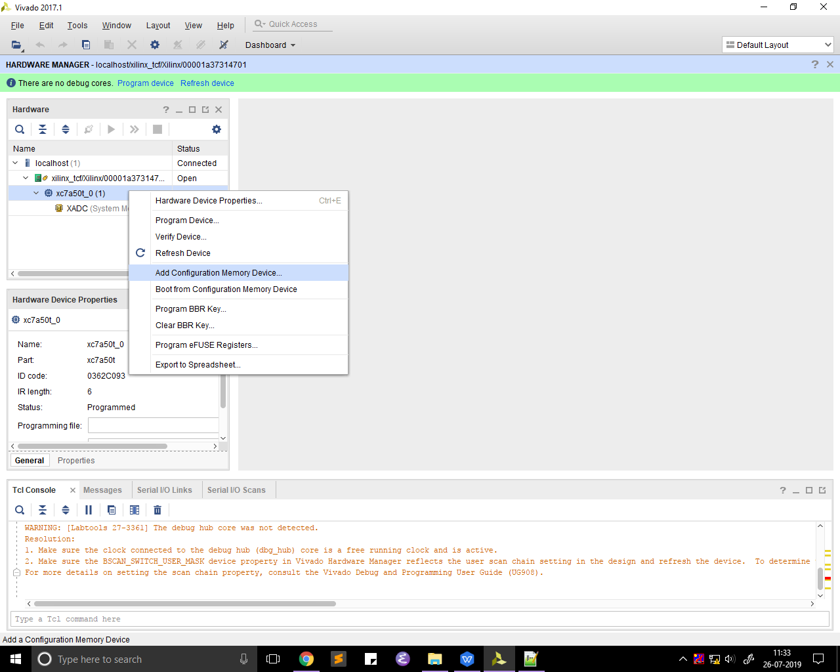
3. V
   1. 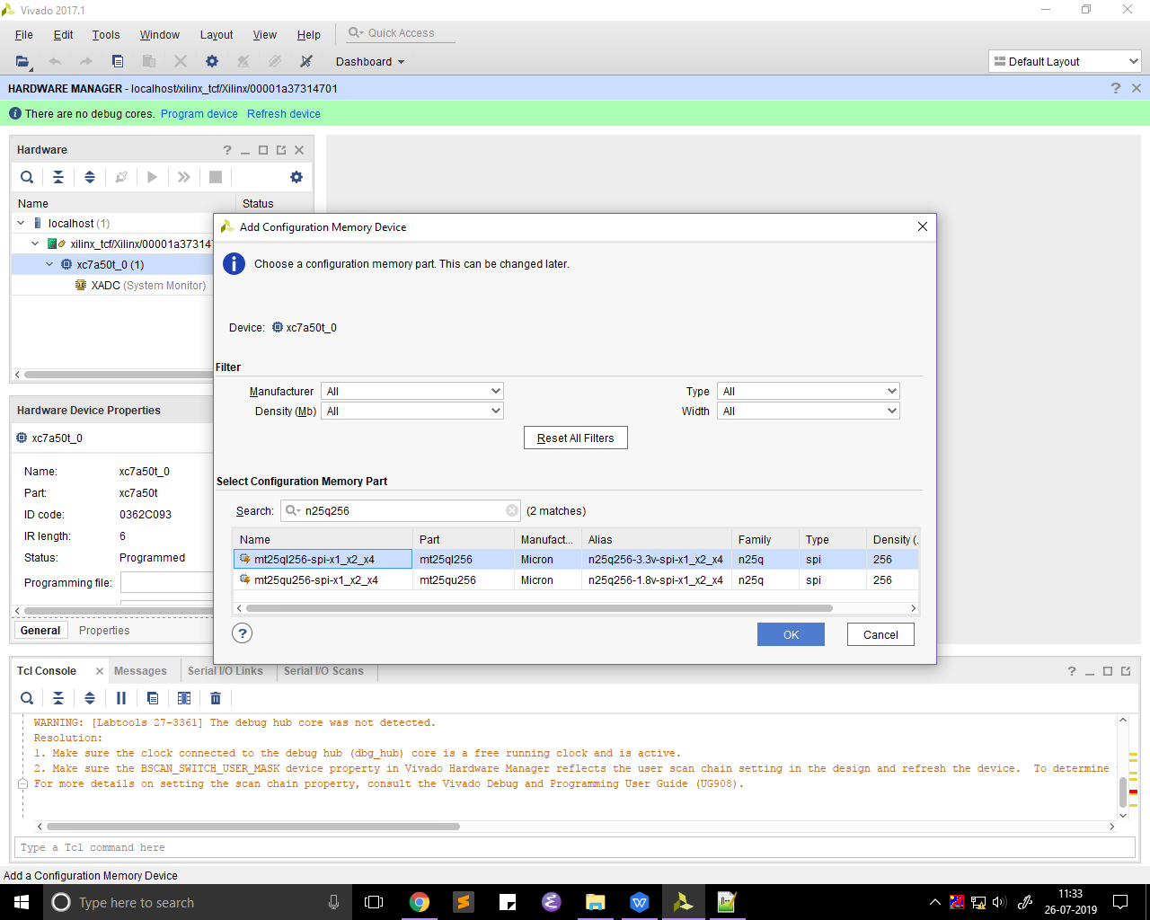
4. V
   1. 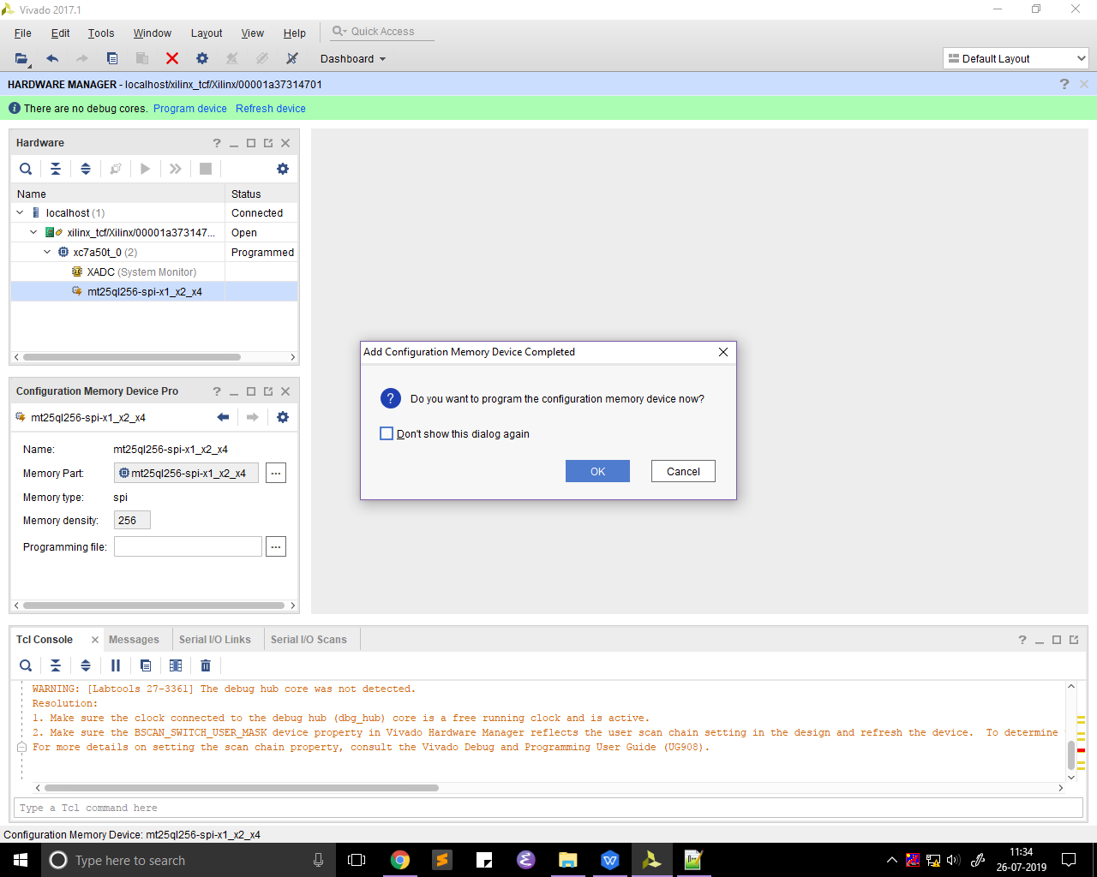
5. V
   1. 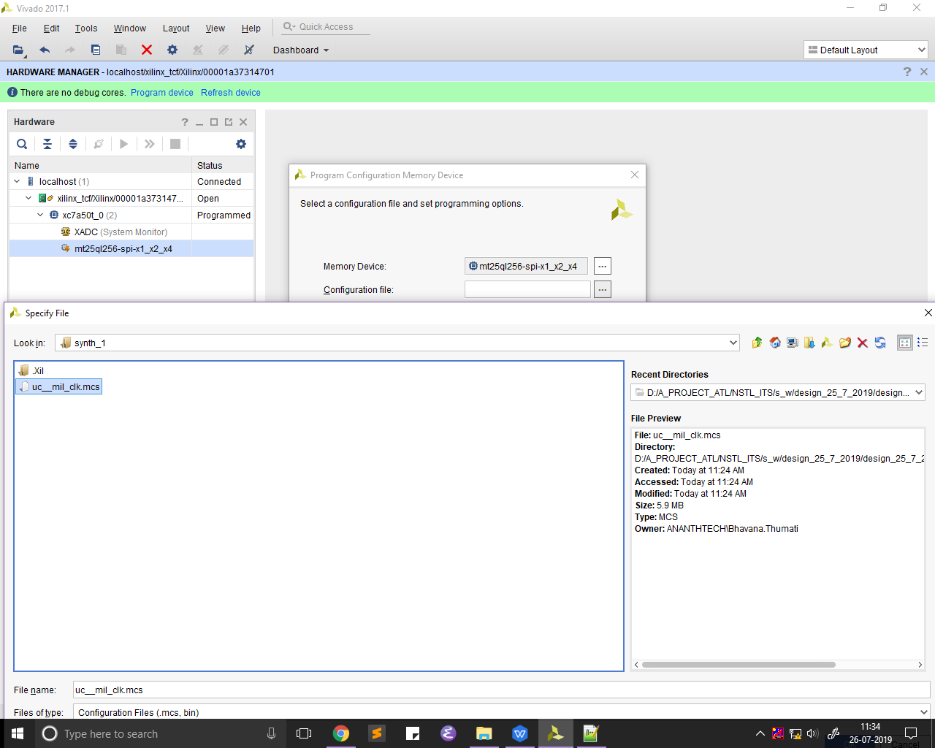
6. V
   1. 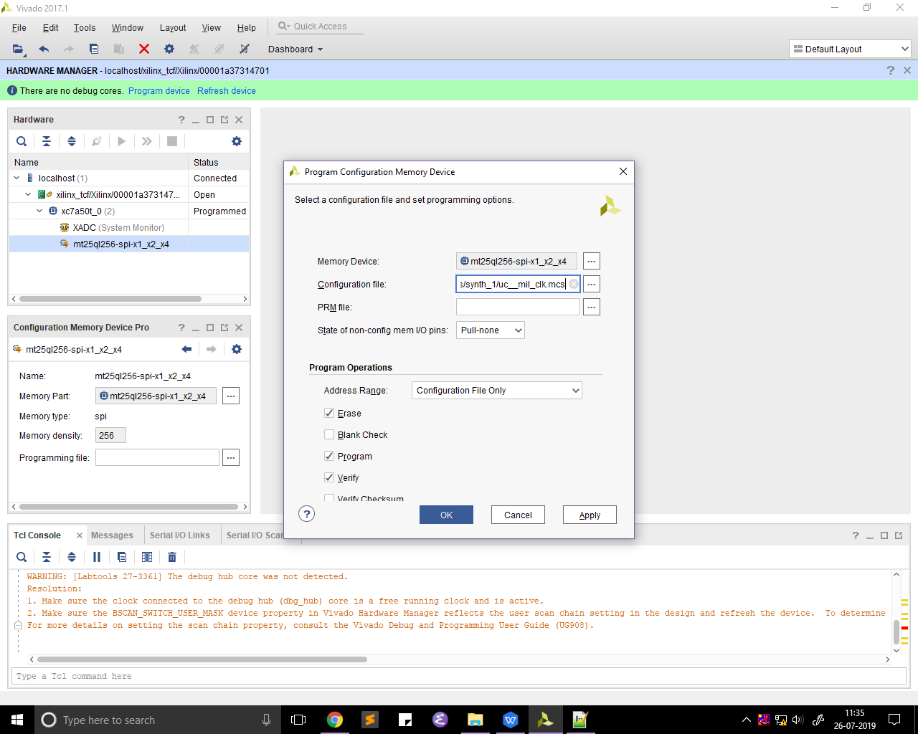
   2. 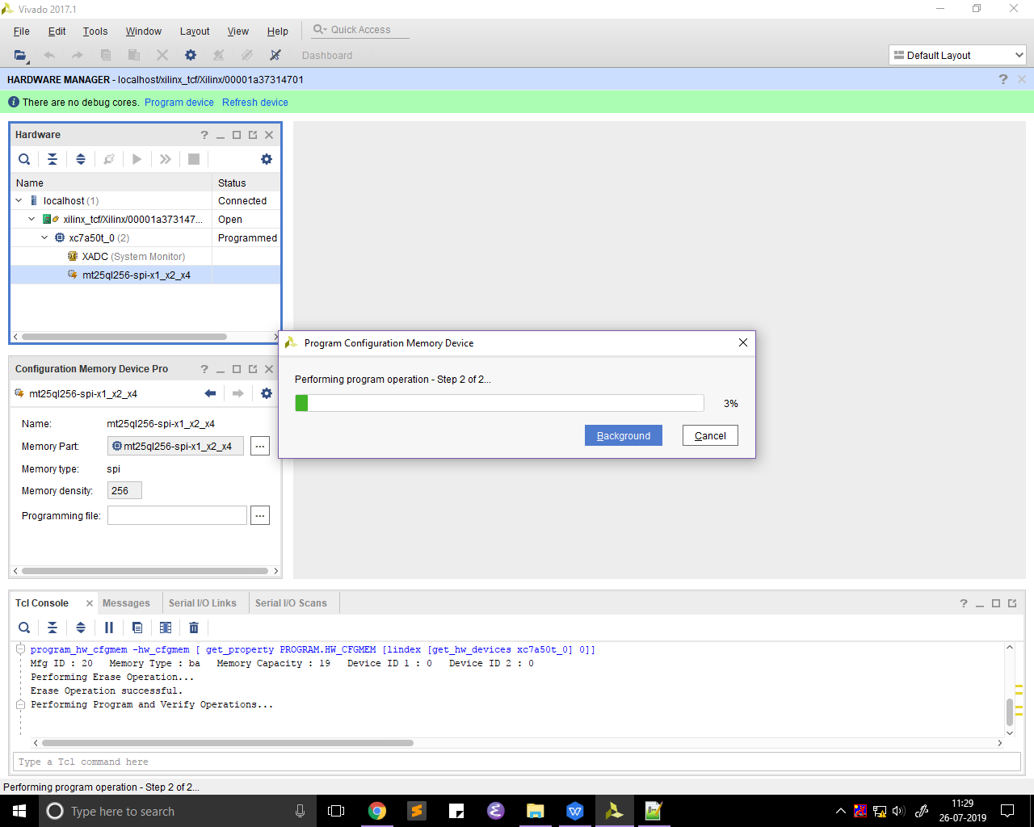
7. V
   1. 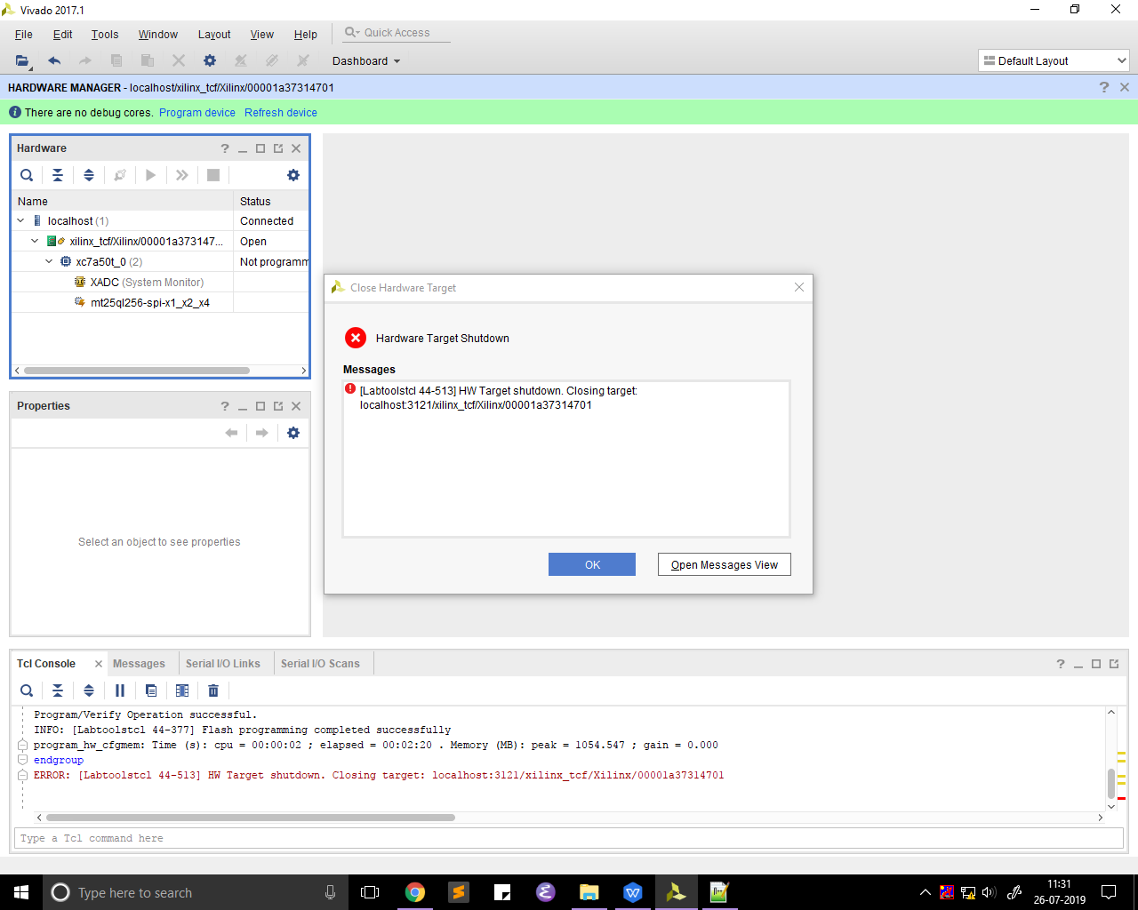
8. Turn the power off and remove the jtag connection and then turn the power on again .