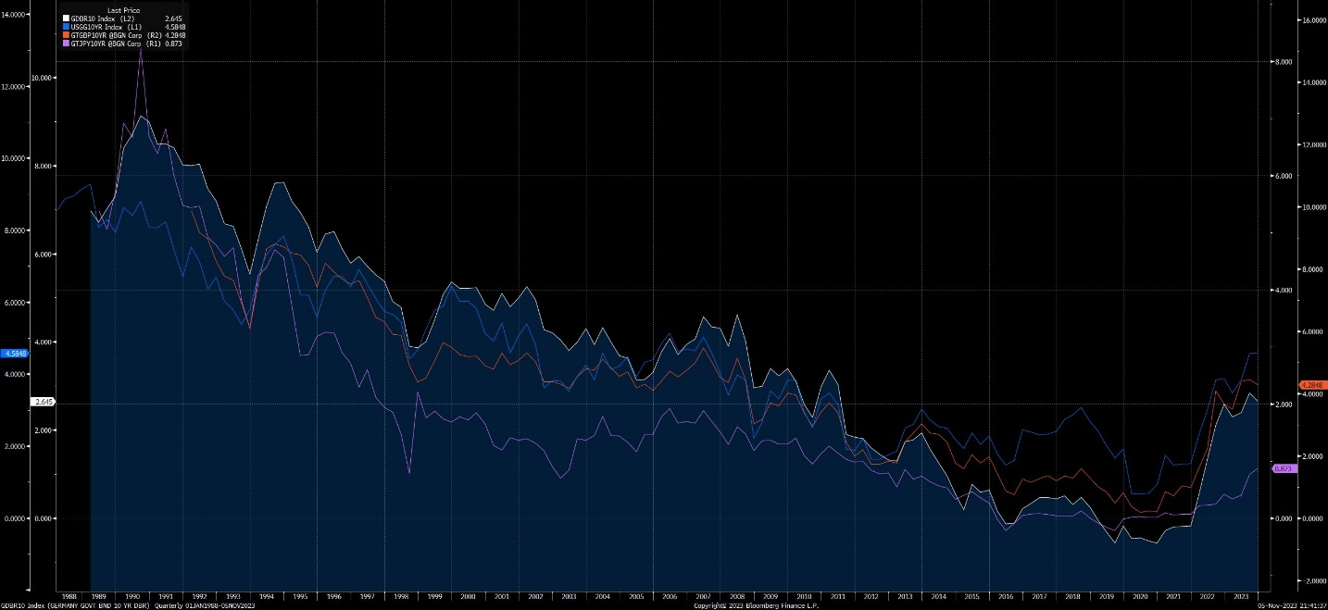

Correlating yields for US, GB, JPY, GER for 10yr Treasury Bonds, (relative currency):

* Ideas:
  + Take look at the other G7 countries/ other countries around this range of GDP/geopolitical environment

Correlating yields for Bloomberg’s gov bond indices by regions:

LEGATRUU – Global Aggregate

LBUSTRUU – US Aggregate

LAPCTRJU – Asian Pacific Aggregate

LP06TREU – Pan Euro Aggregate

EMUSTRUU – EM USD Aggregate

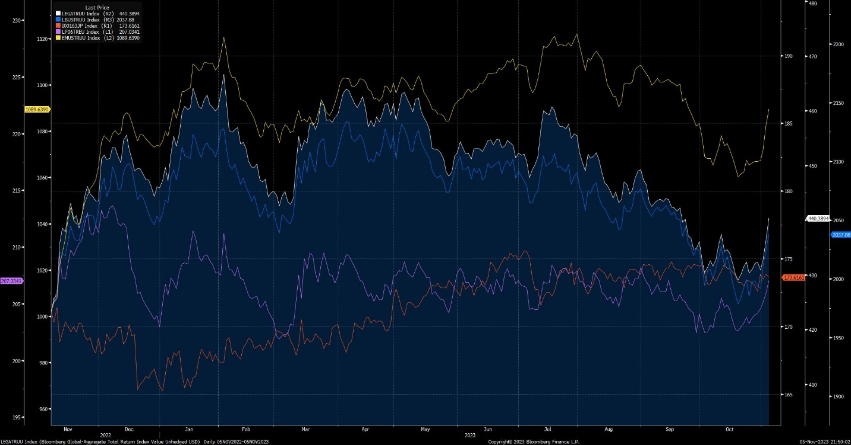

**Note:**

Bloomberg breaks down bond data as follows:

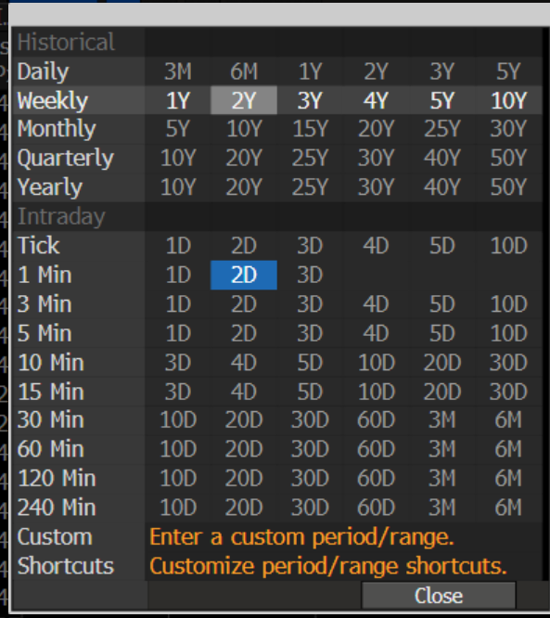

* Could go into the intraday, 1 minute tick rate for time series

**NOTE:**

* This is yield and not price, a measure of return an investor can expect from holding bond to maturity
* **How does order of integration, ARIMA, and stationarity play a role?????????**

**TODO:**

1. Out of 16 possible pairs, only 1 seems conclusively co-integrated:
   1. Interesting fact: **cointegrated I(1) pairs x= stationarity of OLS of resulting series**
      1. **i.e.** coint(GB, GER) = true but stationarity(GB – Beta * GER) = false
   2. Check for co-integration on a shorter time period (such as 240 min for past 6 months)

Graph for OLS for co-integrated pairs, **blue** is the cointegrated and stationary passed, for GB and JPY, the rest are “cointegrated” but their linear combination is somehow non-stationary

Results for Indices -> 4 cointegrated but none of their linear combinations were stationary, note the discrepancy between the cointegration tests. This is due to normalizing for date differences across the Time series. The blank graphs were the pairs that were not even cointegrated

1. Backtesting on the GB:JPY pair’s time series:
   1. ***GB 10yr - 3.153806293353844 * JPY 10yr***
   2. Try basic backtesting with 2000 to 11/2/2023 as training period, then from 11/3/2023 to today 11/10/2023 as testing period
   3. Find more optimal training/test split, likely over shorter time period, potentially also check for 240 min or intraday 5 min tick rate, try many
2. Rewrite the jupyter notebook as python function scripts to minimize data collection overhead
3. Juypter notebooks explainers on:
   1. Stationarity
   2. Cointegration
   3. Orders of Integration
   4. ARIMA
4. Consider practical implications of shorting/longing bond yields, exact mechanisms, and any constraints such as slippage, liquidity, transaction cost, etc.