Do LLMs Actually Reason About Wordle?
A Contamination-Resistant Benchmark for Multi-Turn Constraint Tracking

Daniel Yu
CS5100: Foundations of AI
August 13, 2026
Individual Project

1. Introduction
This project began from a simple question about logical reasoning in general-purpose transformer language models. Modern LLMs can write substantial programs and solve difficult mathematics problems, yet many of those successes are hard to separate from learned patterns, tool use, or benchmark familiarity. Wordle provides a deliberately simple sanity check: can a powerful model reliably carry forward a small set of explicit constraints that a human player can manage almost mechanically? Each turn adds positional, membership, exclusion, and duplicate-letter constraints, so the model must preserve and execute prior information rather than answer a single isolated prompt.
Wordle is also useful because the evaluation trajectory can be made comparatively resistant to direct memorization. Historical Wordle vocabulary is not guaranteed to be absent from training data, so this benchmark does not assume that it is contamination-free. Instead, it compares named and unnamed versions of the same frozen historical games and adds a dynamic-256 condition whose legal candidate pool is freshly generated and frozen per instance. The goal is to reduce the possibility that success is explained by familiar Wordle answers and to test constraint solving on explicit game states that are unlikely to have appeared verbatim during training.
Final solve rate alone is insufficient for this purpose. A model can fail because it proposes an illegal word, violates an earlier clue, chooses a low-information guess, ranks a weaker candidate first, or fails to repair an invalid proposal. The benchmark therefore evaluates those behaviors independently using a deterministic local engine.

Motivation and Research Questions
Prior work establishes Wordle as a useful interactive language-model environment. LMRL Gym treats Wordle as a multi-turn decision task in which later actions depend on earlier observations [1], while Wordle Arena evaluates modern models on new daily puzzles to reduce contamination concerns [2]. This project builds on both ideas but focuses more narrowly on exact constraint execution and controlled comparisons.
- RQ1: How does multi-turn word-constraint reasoning vary across frontier and legacy language models?
- RQ2: How much does recognizing the task as Wordle improve performance?
- RQ3: Does changing Wordle from a fixed historical answer distribution to dynamically generated candidate spaces reduce frontier-model saturation?
- RQ4: How does changing from direct inference to explicit reasoning effort affect performance?

2. Background

Related Work
LMRL Gym provides a broader benchmark for multi-turn reinforcement learning with language models and includes Wordle among tasks that require sequential decision making under partial information [1]. Wordle Arena evaluates many LLMs on daily Wordle puzzles and reports outcome-oriented measures such as win rate and attempts, providing a contamination-resistant comparison over time [2]. The present benchmark extends these directions by freezing identical instances for paired model comparisons, introducing named-versus-unnamed task recognition and dynamic candidate spaces, and instrumenting every action for legality, exact clue consistency, information gain, and repair behavior.

AI/ML Concepts Used
The system evaluates pretrained LLM inference rather than fine-tuning. Multi-turn reasoning is represented by reconstructing the complete public game state on every stateless request. Constraint satisfaction is checked by exact replay: a candidate is consistent only if treating it as the secret reproduces every previous feedback row. Strategic search is measured by expected information gain over the feasible secret set, and paired bootstrap resampling is used for uncertainty when two treatments share exact game IDs.

3. Methodology

Tools, Models, and Data
The benchmark is implemented in Python 3.11+ with uv. Model inference uses the OpenAI Responses API for GPT-4o, GPT-5, and GPT-5.6. Runs use asynchronous requests with bounded concurrency and record token usage, latency, model identifiers, and estimated cost. Pandas, PyArrow, Parquet, and DuckDB support the analysis layer, with processed tables feeding a local results portal.
Historical evaluation uses the frozen original 2022 Wordle lists: 2,315 possible answers and 10,657 additional accepted guesses. The same 150 historical secrets are reused for named and unnamed conditions. The dynamic vocabulary is built from SCOWL level 60 American English intersected with the wordfreq common/small vocabulary, normalized to lowercase five-letter ASCII words, with the historical 2,315 answer words removed. Each dynamic game freezes a 256-word pool, secret, and pool order that are reused across models.
Dataset links: project data/manifests; SCOWL; wordfreq
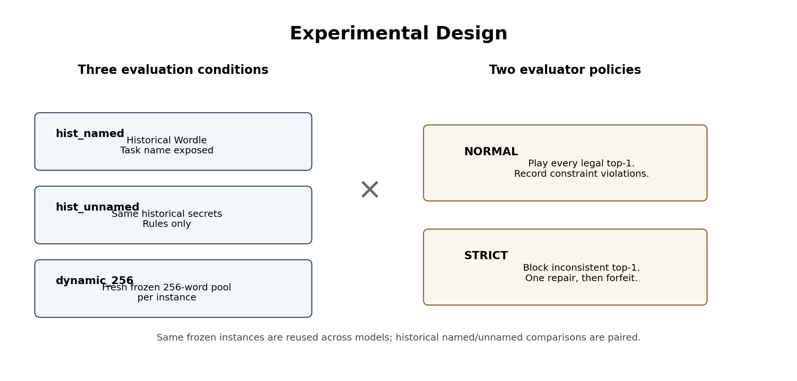
Figure 1. Experimental conditions and evaluator policies.

Game Protocol and Validation
Each game has at most six decision rounds. A fresh prompt is reconstructed every turn from the rules, current round, and complete accepted public history. The model returns three ranked guesses; only top-1 is eligible to play, while top-2 and top-3 are retained to diagnose search and ranking. The local two-pass Wordle scorer handles repeated letters and is authoritative for all feedback.
Action validity and constraint consistency are separate. A candidate x is constraint-consistent exactly when score(x, g_i) equals the recorded feedback r_i for every prior played guess g_i. In NORMAL mode, every structurally and lexically legal top-1 is played even if inconsistent, allowing the benchmark to observe recovery. In STRICT mode, an inconsistent top-1 is rejected, one repair attempt is allowed, and a failed repair forfeits the round without new feedback.
Constraint consistency: score(x, gᵢ) = rᵢ for every previous played row i
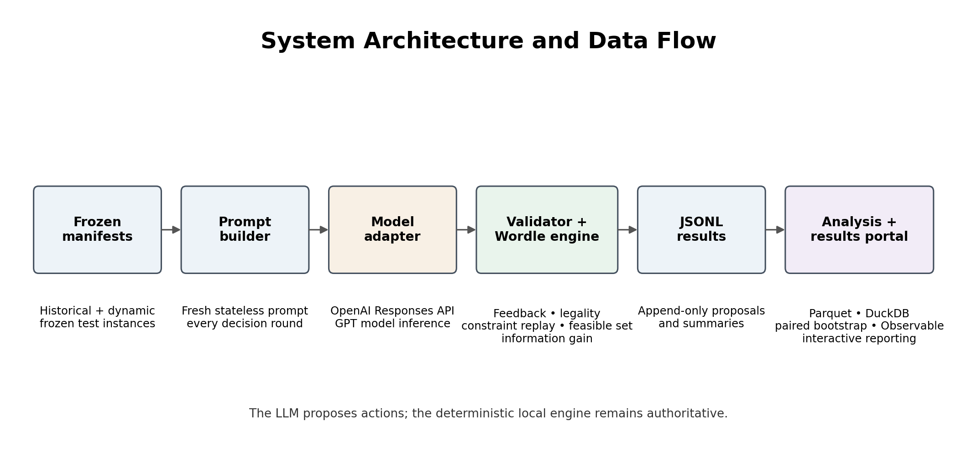
Figure 2. End-to-end benchmark architecture.

Metrics and Statistical Analysis
Primary outcomes are Solve@6 and mean decision-round score, with unsolved games scored as 7. Constraint fidelity is measured by Action Valid@1, Constraint Consistent@1 (CC@1), and Strict Valid@1. Strategic quality uses normalized information-gain efficiency and regret. Additional diagnostics include repair success, forfeits, repeated guesses, constraint violations by clue age, latency, reasoning tokens, and cost. Paired contrasts use 10,000 game-level bootstrap resamples and 95% confidence intervals when exact game IDs are shared.

4. Results
The processed snapshot contains all 1,350 normal-mode games across the three OpenAI models and three conditions. Strict coverage is complete only for GPT-5; GPT-5.6 has 96 completed dynamic strict games and no historical strict results, while GPT-4o strict coverage is too incomplete for generalization. Accordingly, normal-mode comparisons are final for this snapshot, whereas cross-mode strict conclusions are limited to complete or explicitly provisional cells.
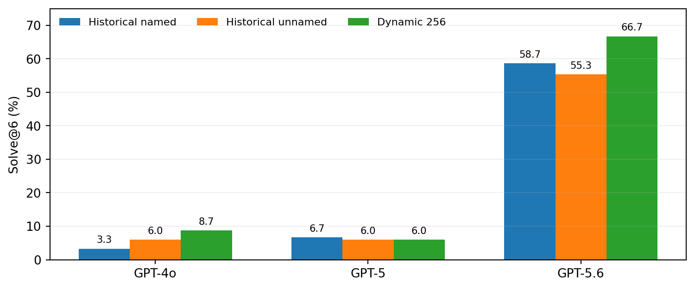
Figure 3. Normal-mode Solve@6 across model generations and conditions (150 games per cell).
The clearest model result is a discontinuity rather than a smooth generation trend. GPT-5.6 solves 58.7% of historical named, 55.3% of historical unnamed, and 66.7% of dynamic games. Relative to GPT-5, these are gains of 49.3–60.7 percentage points, with all paired 95% confidence intervals well above zero. By contrast, GPT-5 does not materially outperform GPT-4o in any condition: the paired differences range from -2.7 to +3.3 points and all intervals include zero.
Model | Hist named | Hist unnamed | Dynamic | Hist named CC@1 | Hist named IG eff.
GPT-4o | 3.3% | 6.0% | 8.7% | 20.9% | 0.624
GPT-5 | 6.7% | 6.0% | 6.0% | 24.8% | 0.637
GPT-5.6 | 58.7% | 55.3% | 66.7% | 49.7% | 0.765
Constraint consistency is the most severe behavioral bottleneck. Round 1 is trivially consistent because there are no prior clues; by round 3, historical CC@1 falls to about 3–7% for GPT-4o and GPT-5, and by rounds 4–6 it is near zero. GPT-5.6 retains substantially more consistency, but even it is only about 19–26% consistent in later historical rounds. Violation rates are also relatively flat across clue age, suggesting broad failure to perform exact replay rather than a clean pattern in which only old clues are forgotten.
Dynamic-256 did not uniformly reduce Solve@6. GPT-4o is numerically better dynamically, GPT-5 is unchanged, and GPT-5.6 performs best in the dynamic condition. However, dynamic legality is clearly harder: Action Valid@1 falls to 79.8%, 57.9%, and 83.3% for GPT-4o, GPT-5, and GPT-5.6 respectively. GPT-5 is especially anomalous: more than half of logged dynamic suggestions are outside the supplied pool, its repeated-guess rate reaches 15.6%, and its information-gain efficiency falls to 0.549.
Naming the task Wordle also does not produce the expected improvement. GPT-5 and GPT-5.6 show no statistically clear normal-mode naming effect. GPT-4o is the only complete contrast whose confidence interval excludes zero, and the effect is in the opposite direction: named performance is 2.7 percentage points lower than unnamed.
Strict enforcement confirms the anticipated feedback-starvation mechanism more clearly than a universal solve-rate penalty. Complete GPT-5 strict runs forfeit more than four rounds per game and play only about 1.25–1.61 guesses per game, yet its Solve@6 penalty is not statistically distinguishable from zero because both normal and strict performance are already near the floor. GPT-5.6 is strong enough for the interaction to become visible: in 96 paired dynamic games, normal Solve@6 is 63.5% versus 35.4% strict, a provisional 28.1-point penalty (95% CI 17.7–38.5).
The planned medium-reasoning treatment has not yet produced evaluation results, so RQ4 remains unanswered in this report.

5. Discussion
Several results diverged from the original expectations. The prediction that newer models would scale monotonically was only partly confirmed: GPT-5.6 is dramatically stronger, but GPT-5 and GPT-4o form a similarly weak tier. This suggests that the ability measured here may emerge discontinuously rather than improving smoothly with model generation. GPT-5.6 also improves both CC@1 and information-gain efficiency, indicating that its solve-rate gain is not merely better vocabulary recall; it is also better at preserving evidence and choosing informative actions.
The expected dynamic-256 degradation was contradicted at the task-success level. The dynamic pool does make action generation harder, especially for GPT-5, but it simultaneously reduces the initial secret space from 2,315 historical answers to 256 candidates. For GPT-5.6, the smaller search space appears to outweigh the unfamiliar vocabulary and pool-adherence burden. This is an important design lesson: “out of distribution” and “harder” are not equivalent when the treatment changes both lexical familiarity and hypothesis-space size.
The naming hypothesis was also not supported. Explicitly saying “Wordle” neither reliably improves GPT-5 nor GPT-5.6, and GPT-4o performs slightly worse when the task is named. One plausible explanation is that naming activates conventional Wordle priors or opening heuristics that do not align with this benchmark’s exact protocol, but the result is model-specific and should not be generalized into a claim that naming is harmful.
The strict-mode hypothesis was more nuanced. The expected mechanism is clearly present: inconsistent proposals trigger failed repairs, forfeited rounds, and feedback starvation. However, a large Solve@6 drop can be hidden when normal performance is already extremely low. GPT-5 illustrates this floor effect, whereas the provisional GPT-5.6 dynamic result exposes the large penalty once the base solver is strong enough. Therefore strict mode should be interpreted as a stress test of exact cumulative constraint execution, not simply a harder version of normal Wordle.
Most importantly, the data supports the project’s motivating concern. GPT-4o and GPT-5 can produce legal-looking words almost perfectly on historical Wordle while failing exact clue replay after only a few turns. The problem is not simply that they do not know Wordle rules; they often fail to execute a small, explicit set of constraints consistently. GPT-5.6 substantially reduces this gap but does not eliminate it. This makes simple multi-turn constraint tasks a useful complement to much harder coding or mathematics benchmarks because they expose a different failure mode that is easy for a human to audit.
Limitations remain. Strict results are incomplete for GPT-4o and GPT-5.6, dynamic and historical instances are not semantically paired, later-round consistency curves are affected by survivor selection, and no medium-reasoning evaluation is yet available. These limitations prevent final claims about the overall enforcement penalty or reasoning-effort effects.

6. Conclusion
This project shows that a simple Wordle environment can reveal weaknesses that are obscured by more impressive headline capabilities. GPT-5.6 is a major step forward over GPT-4o and GPT-5, but the improvement is discontinuous rather than monotonic; naming Wordle does not reliably help; dynamic candidate spaces are not automatically harder; and exact multi-turn constraint consistency remains imperfect even for the strongest model. The strongest provisional strict result also shows that enforcing cumulative consistency can impose a large performance penalty through repair failure and feedback starvation.
The main achievement is therefore not a Wordle leaderboard but a reproducible method for decomposing model behavior into task success, legality, exact constraint execution, strategic information seeking, and self-correction. A key lesson from the completed analysis is that benchmark difficulty must be interpreted mechanistically: a treatment can make one component harder while making another easier, and floor effects can hide real interaction costs. This was an individual project.
Individual contribution: I completed all project work.

AI Use Acknowledgment
I used AI tools as assistants for brainstorming tradeoffs, reviewing implementation plans, suggesting metrics and caveats, helping draft specifications and prose, and accelerating some coding and visualization iteration. I made the research decisions, designed and implemented the benchmark, ran and verified the experiments, reviewed AI-generated suggestions, interpreted the data, and remain responsible for all conclusions and claims in this report.

7. References
[1] M. Abdulhai, I. White, C. V. Snell, C. Sun, J. Hong, Y. Zhai, K. Xu, and S. Levine, “LMRL Gym: Benchmarks for Multi-Turn Reinforcement Learning with Language Models,” Proceedings of the 42nd International Conference on Machine Learning, PMLR 267, pp. 126–153, 2025. https://proceedings.mlr.press/v267/abdulhai25a.html
[2] C. Liu, “Wordle Arena for LLMs,” Wordle Arena Project, 2026. https://drchangliu.github.io/WordleArena/
[3] ThGreatExplorer, “Wordle LLM Benchmark — source code, frozen data, manifests, and analysis outputs,” GitHub repository. https://github.com/ThGreatExplorer/wordle_llm_benchmark
[4] K. Atkinson, “SCOWL (Spell Checker Oriented Word Lists).” https://wordlist.aspell.net/
[5] R. Speer, “wordfreq: access a database of word frequencies.” https://github.com/rspeer/wordfreq

