Documentation of the program code

Plasma

Author: Ansor Taghoev

Data: 9.12.2024

# History of technical documentation

**Author**

| Fac. No | Name | E-mail |
| --- | --- | --- |
| 273222034 | Ansor Taghoev | ansor.tagaev101@gmail.com |

**Version history**

| Version | Data | Author | Description |
| --- | --- | --- | --- |
| v1 | 27.11.2024 | A. Taghoev | User case 4 |
| v2 | 8.12.2024 | A. Taghoev | User cases 1, and 12 |

# Content

1 Introduction 4

2 Detailed design 4

2.1 Class diagramm 4

2.2 Sequence diagram 4

2.3 Sample user interface 4

3 TestinG 4

4 desiGnS 4

# Introduction

This documentation covers the implementation of the following user stories:

1. **As a Customer, I want to be able to browse all files of a project inside my local environment.**
   * The user can view project files in a hierarchical or list view, navigate through folders, and access file details such as name, type, and size. Error messages are displayed if any files cannot be accessed.
2. **As a Customer, I want to have dark/white mode for the interface.**
   * The user can toggle between dark and light modes, with the selected mode applied across all UI components and persisting across sessions.
3. **As a Customer, when I create a new project, I want to have templates for popular languages.**
   * The user can choose language-specific templates for creating new projects, which populate the project with editable files. Alternatively, users can open, edit, and save files across local and remote environments, with synchronization between both locations.

# Detailed design

## Class diagram

User cases 1 and 4

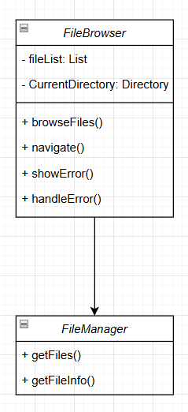

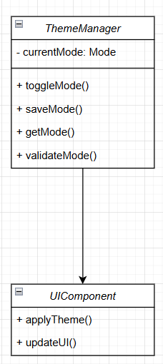

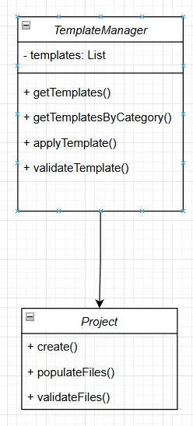

User Case 12

## Sequence diagram

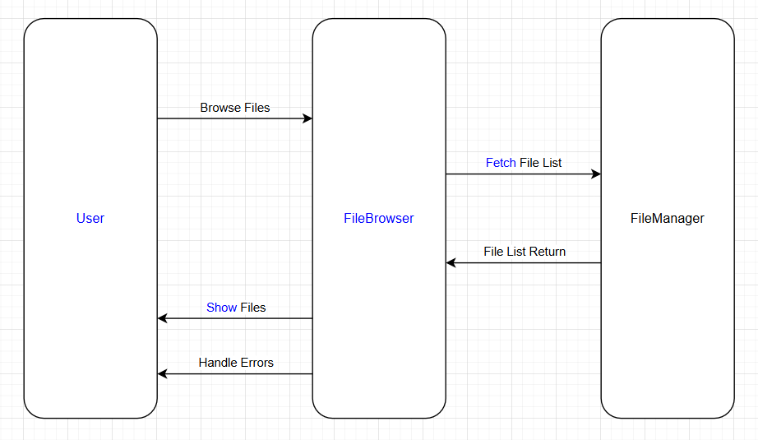

User Case 1

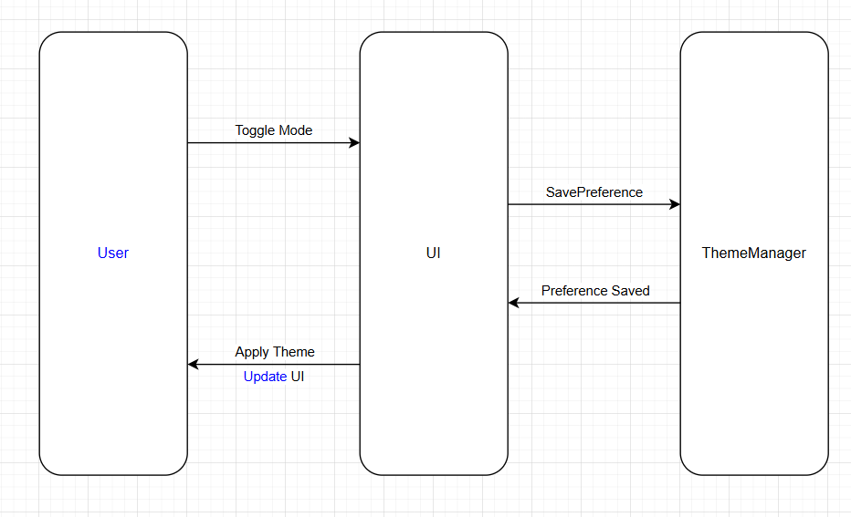

User Case 4

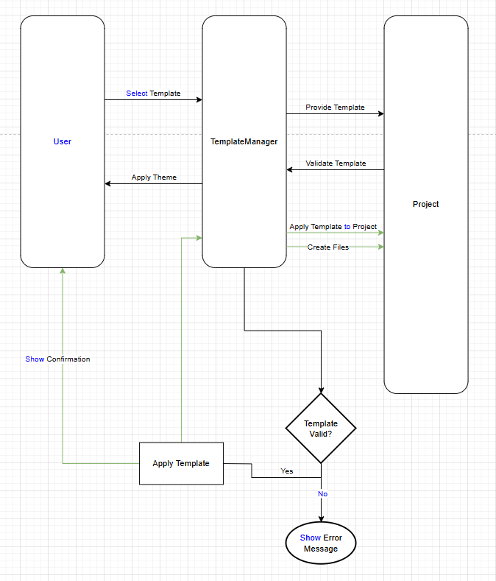

User case 12

## Sample user interface

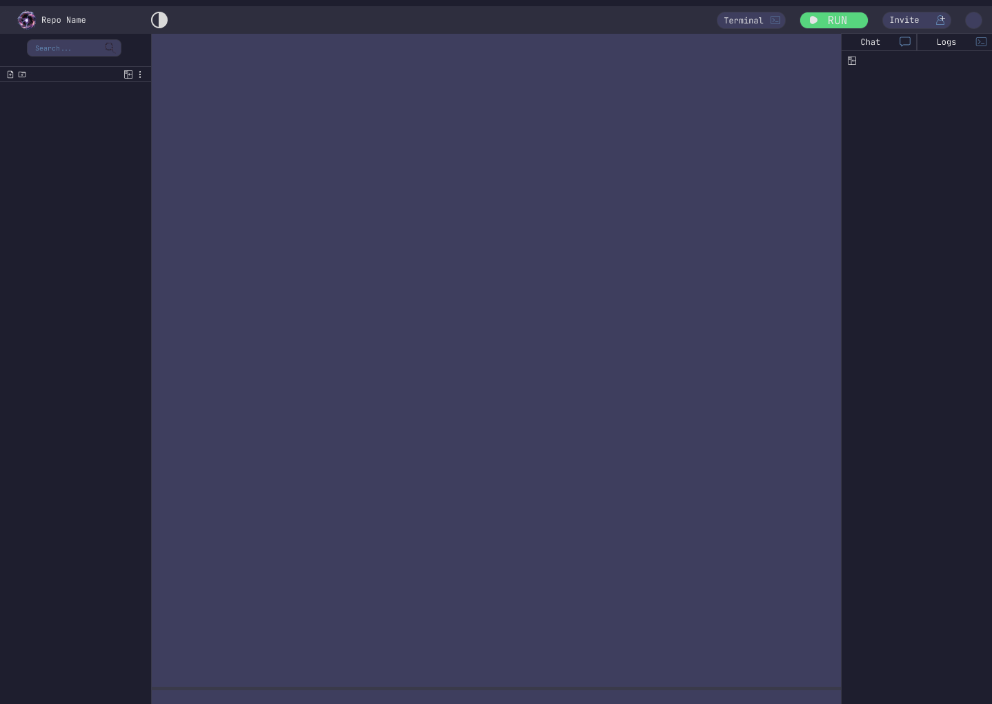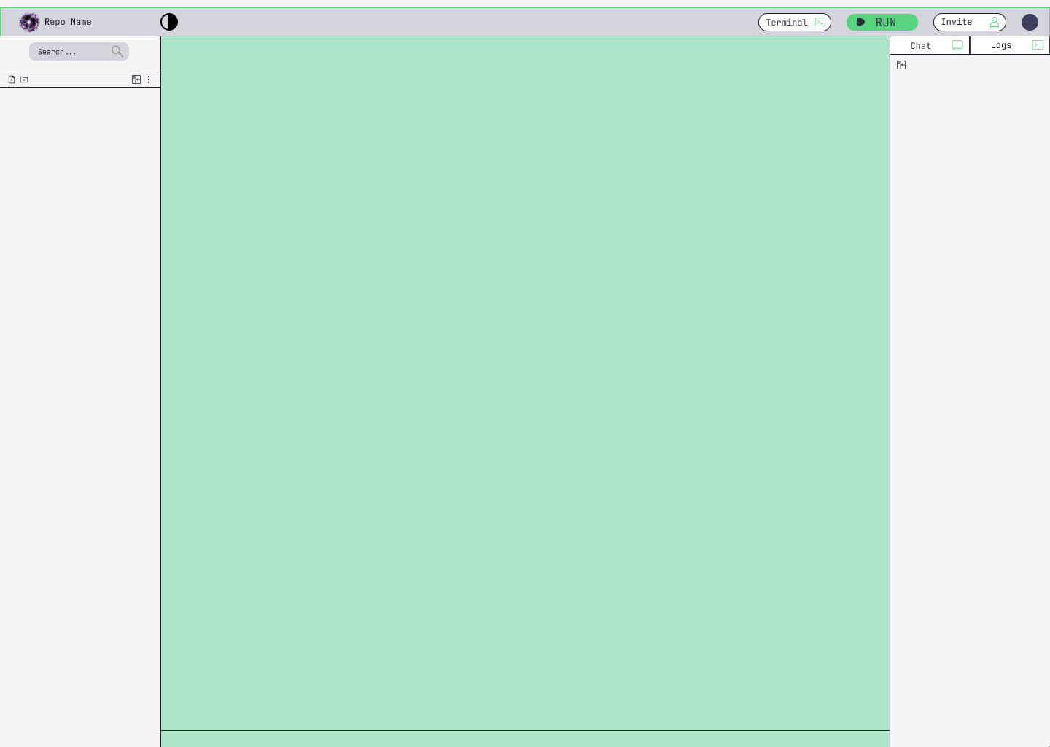

User case 4

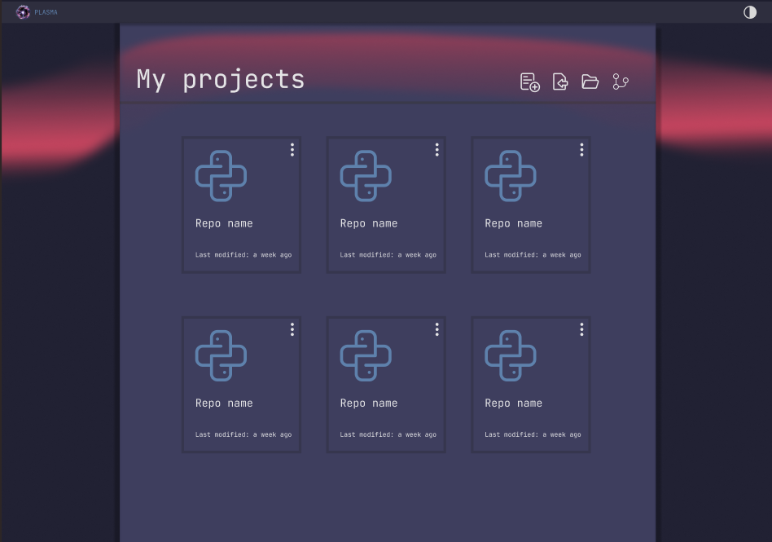  
User Case 1

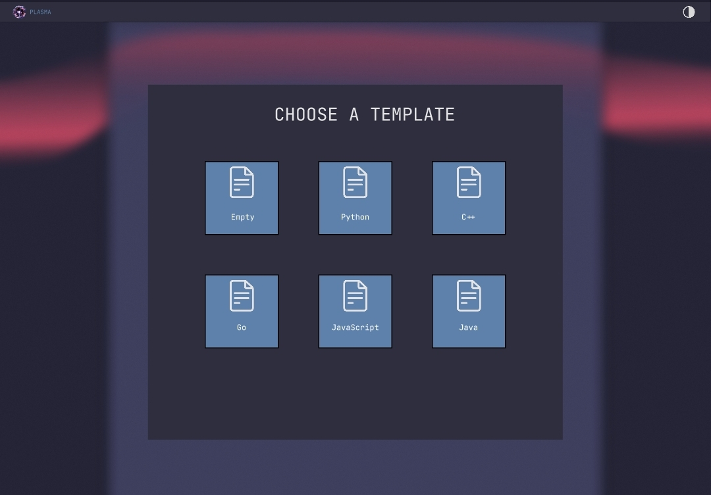

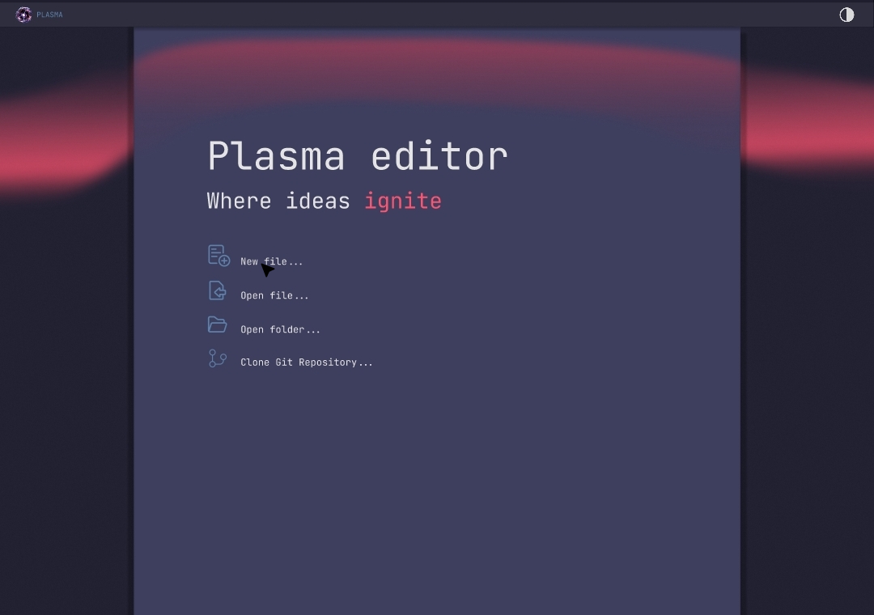

User Case 12

# Testing Test Scenarios Browse Files

**Scenario:** The user browses files in the local environment.

* + **Criteria:** File list is displayed correctly, including file name, type, and size.

#### Toggle Dark/Light Mode

**Scenario:** The user toggles between dark and light modes.

* + **Criteria:** The selected mode applies to all UI components and persists across sessions.

#### Project Templates

**Scenario:** The user creates a project using a language-specific template.

* + **Criteria:** The selected template populates the project with relevant files.

# Designs

