Documentation of the program code

**Plama**

Author: Kiril Shyian

Data: 18.11.2024

*Operator notes:*

*All instructional text is displayed in blue font colour in the template. These should be deleted prior to the document being distributed for review and approval.*

*Update text within square brackets which is placeholder text with relevant text.*

**History of technical documentation**

**Author**

| Fac. No | Name | E-mail |
| --- | --- | --- |
| 273222008 | Kiril Shyian | kshiyan@tu-sofia.bg |

**Version history**

| Version | Data | Author | Description |
| --- | --- | --- | --- |
| v1 | 18.11.2024 | Kiril Shyian | User story 2 |
| v2 | 21.11.2024 | Kiril Shyian | User story 9 and 14 |

**Content**

**1** **Introduction 4**

**2** **Detailed design 4**

2.1 Class diagram 4

2.2 Sequence diagram 4

2.3 Sample user interface 4

**3** **Testing 4**

# Introduction

*This documentation concerns user stories number 2, 9 and 14.*

# Detailed design

## Class diagram

## Sequence diagram

*User story number 2: Create and login user*

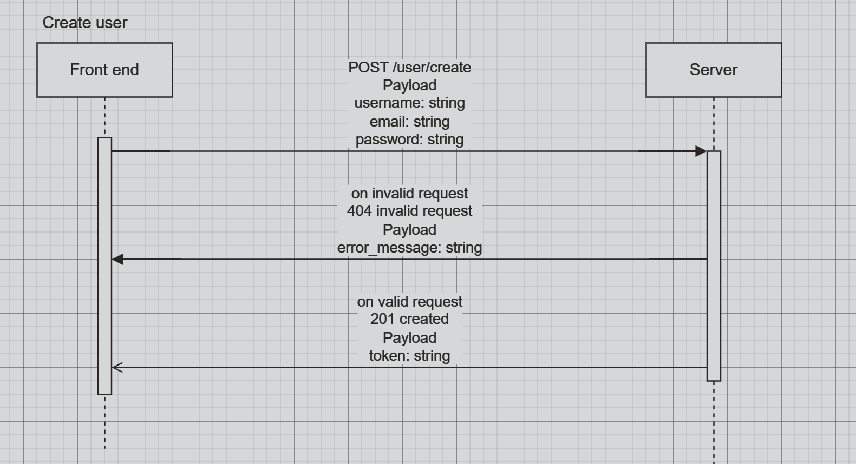

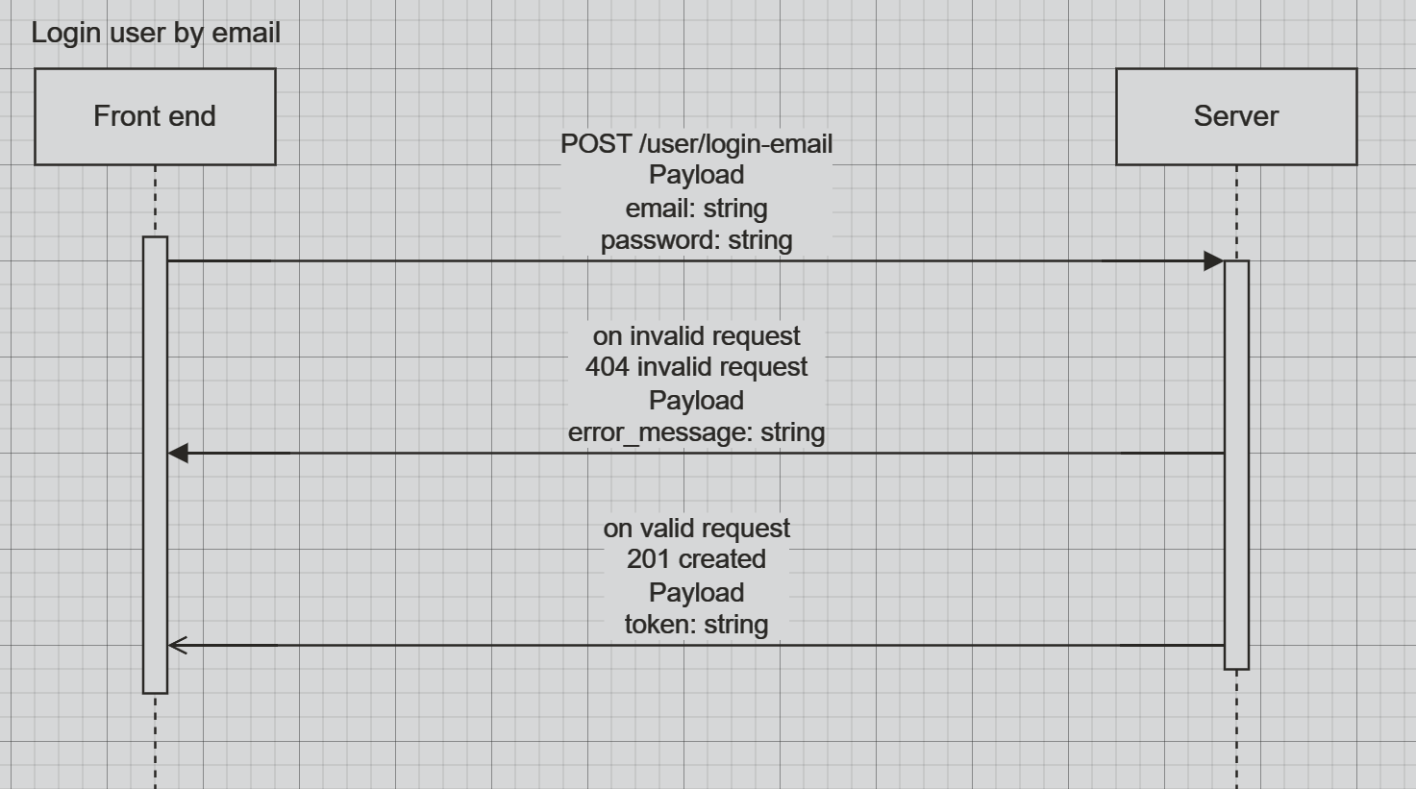

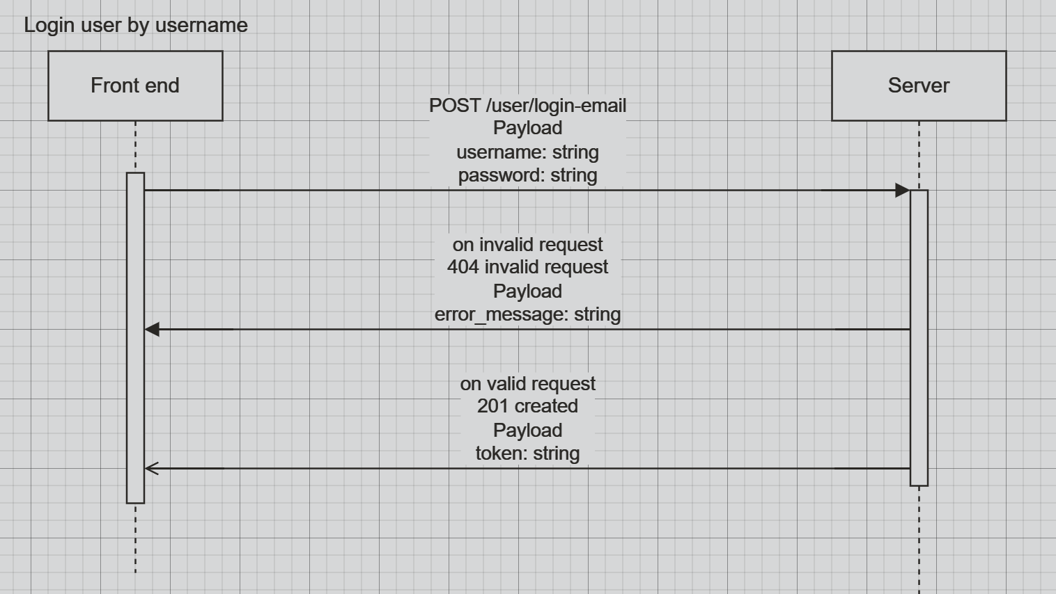

*User story number 9: Synch editor and User story number 14: Marker  
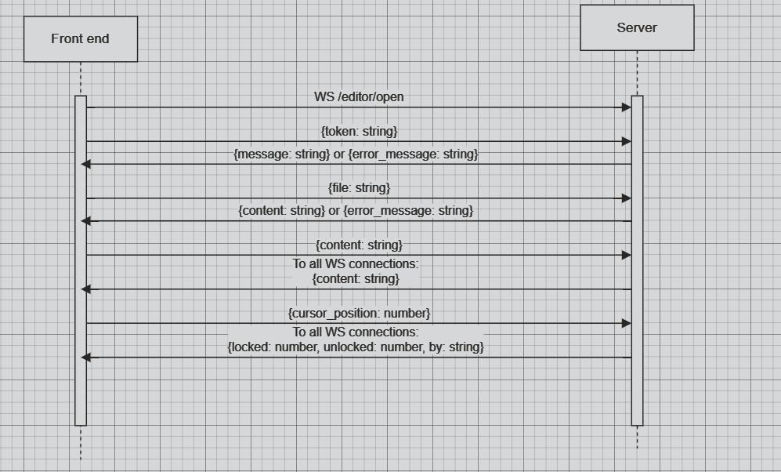*

## Sample user interface

*/user/create*

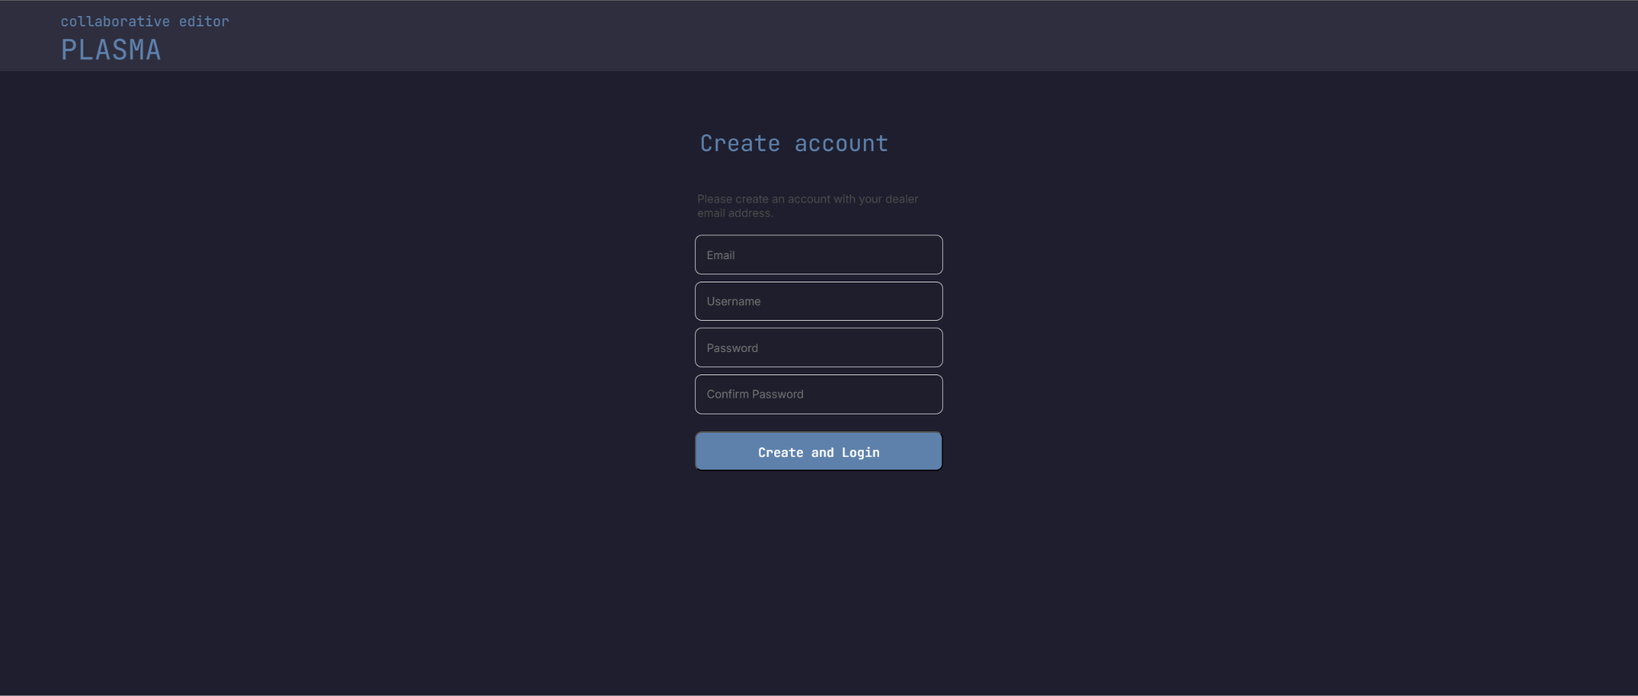

*/user/login*

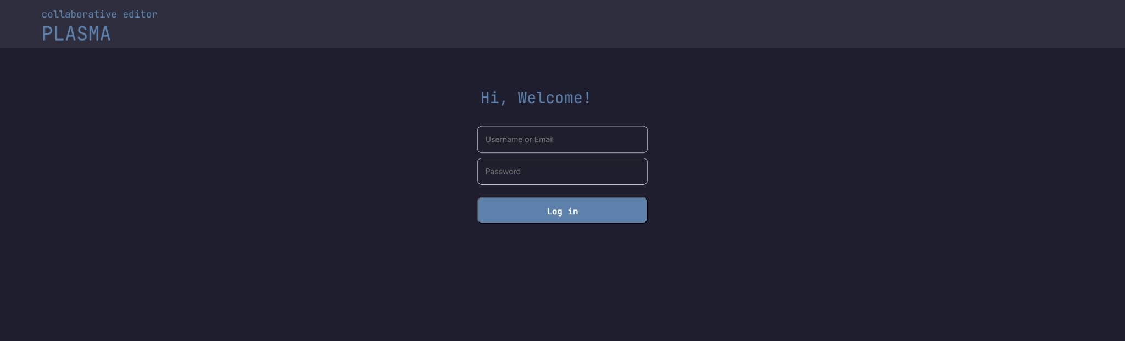

*/editor   
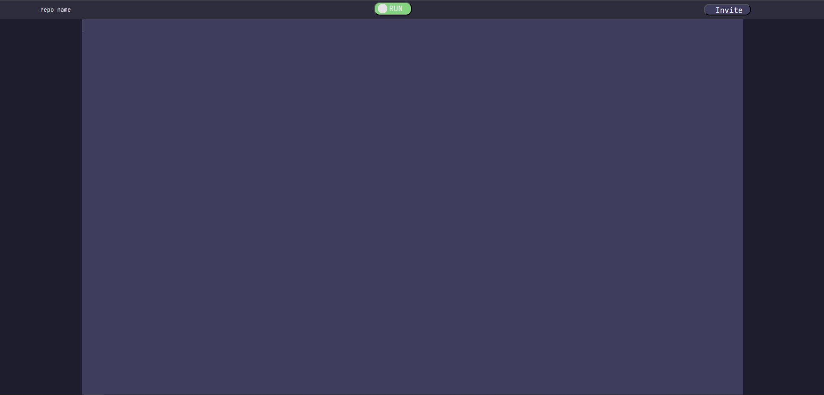  
/editor with content*

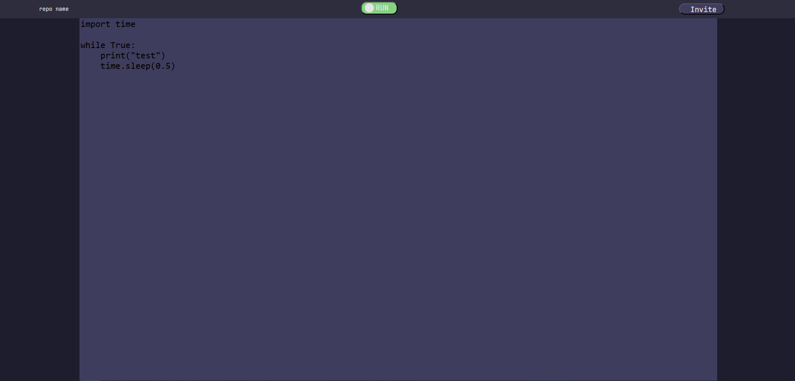

*/editor with content and user line indicator  
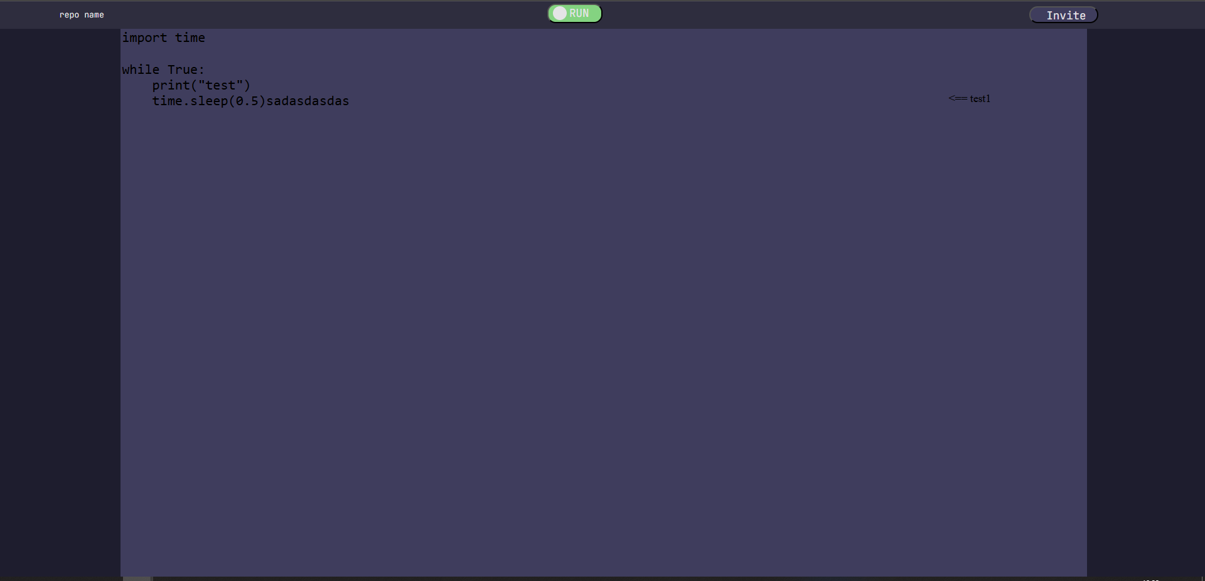*

# Testing

*Testing of user stories number 2, 9, 14 is done by automated tests located in folder /code/tests  
