Wetland Class Transitions, Water Storage, and Vegetation Condition in the Latrobe-Gippsland Region, Southeastern Australia, 2005-2022

Abstract
Wetland extent is commonly mapped from satellite imagery, but aggregate extent figures can obscure transitions among wetland classes and conflate ecological change with classification error. This study mapped nine wetland and non-wetland classes across the Latrobe-Gippsland region of southeastern Victoria, Australia, for seven anchor years between 2005 and 2022, and assessed whether observed change was associated with water-storage or vegetation-condition variability by class. Classification used a Random Forest classifier applied to a 94-band per-pixel feature stack derived from Landsat surface reflectance, with generalisation performance estimated by 5-fold spatial-block cross-validation. Overall accuracy ranged from 72.1% to 77.0% (kappa 0.681-0.738). Class-level transitions were decomposed into gain, loss, swap, and net change. Terrestrial water storage anomaly (TWSA, from GLDAS GWS_tavg) and vegetation condition (MODIS EVI) were extracted per class for each anchor year, and the satellite-derived storage trend was compared against 44 groundwater-monitoring bores with computable multi-year trends.Wetland extent was stable at landscape scale while class-level turnover was substantial: swap accounted for 61.2-99.5% of total change per class per interval. Over the full period, Non-wetland gained 16,350 ha, Marsh lost 5,029 ha, and Swamp lost 12,712 ha. The regional TWSA trend was positive and directionally consistent with the bore records, which include both deepening and shallowing trends; no evidence of broad groundwater depletion was found. Marsh showed the strongest unadjusted association between vegetation condition and water storage (Spearman rho = 0.786, p = 0.048, n = 7), but this did not survive Benjamini-Hochberg correction across the 18 class-level tests (adjusted p = 0.605) and was sensitive to individual years under leave-one-out resampling. No water storage-vegetation relationship is reported as confirmed. Classification accuracy was weakest for Saline and Salt Marsh, and class-specific results for these two classes should be treated with caution.
Keywords: wetland classification; Random Forest; spatial-block cross-validation; intensity analysis; terrestrial water storage anomaly; MODIS EVI; Google Earth Engine

Table of Contents
1. Introduction 6
2. Materials and Methods 7
2.1 Study Area 7
2.2 Data Sources 8
2.3 Analytical Framework 9
2.4 Landsat Preprocessing and Feature Engineering 10
2.5 Wetland Reference Data and Classification Scheme 11
2.6 Random Forest Classification 11
2.7 Spatial-Block Cross-Validation and Accuracy Assessment 11
2.8 Wetland Change and Transition Analysis 12
2.9 Water Storage and Groundwater-Bore Analysis 12
2.10 Vegetation Condition 13
2.11 Water Storage and Vegetation Condition Relationships 13
3. Results 13
3.1 Classification Accuracy 13
3.2 Wetland Extent and Class Transitions 15
3.3 Water Storage by Wetland Class 19
3.4 Vegetation Condition by Wetland Class 21
3.5 Water Storage and Vegetation Condition Relationships 21
3.6 Annual Trends for the 2022 Wetland Footprint, 2003-2022 23
4. Discussion 25
4.1 Landscape Stability Versus Class-Level Dynamics 25
4.2 Hydrological Context 26
4.3 Vegetation Differences Among Wetland Classes 27
4.4 Evidence for Groundwater-Vegetation Coupling 27
4.5 Implications for Wetland Monitoring 28
4.6 Limitations and Future Research 28
5. Conclusion 29
References 30
Appendices 32
Appendix A: Wetland Schema Crosswalk 32
Appendix B: Pixel-Level Class Persistence 33
Appendix C: Feature Importance and Multicollinearity 33
Appendix D: Change Intensity Analysis 34
Appendix E: Water Storage Trend Slopes by Class 36
Appendix F: Full Numeric Transition Matrices 36

List of Tables
Table 1:Data sources used in this study. 8
Table 2:Classified area (hectares) of each wetland class in the Latrobe-Gippsland study area across the seven anchor years. 17
Table 3:Mean terrestrial water storage anomaly (GLDAS GWS_tavg) by wetland class across the seven anchor years. 19
Table 4:Mean vegetation condition (MODIS EVI) by wetland class across the seven anchor years 21
Table 5:Class-level Spearman rank correlations between remote-sensing indicators (area or EVI) and terrestrial water storage anomaly, 2005-2022 (n = 7 anchor years), tested by exact permutation with Benjamini-Hochberg false discovery rate correction across all 18 tests 22
Table 6: The ten CIFOR-to-schema crosswalk mappings, with confidence rating and justification. 33
Table 7:Number of distinct wetland classes occupied per pixel across the seven anchor years, 2005-2022. 33
Table 8:Theil-Sen trend slope of terrestrial water storage anomaly by wetland class, 2005-2022. 36
Table 9:Full transition matrix (hectares), 2005 to 2022. 37
Table 10: Full transition matrix (hectares), 2010 to 2013. 37
Table 11: Full transition matrix (hectares), 2016 to 2018. 37

List of Figures
Figure 1:Location of the Latrobe-Gippsland study area, southeastern Victoria, Australia, with an inset locating the region within Australia. 7
Figure 2:Analytical workflow used in this study. 10
Figure 3: Overall classification accuracy across the seven anchor years, 2005-2022. 14
Figure 4:Per-class producer's accuracy, mean and range across the seven anchor years, 2005-2022, ordered from strongest to weakest. 15
Figure 5:Classified wetland extent for the Latrobe-Gippsland study area across the seven anchor years (2005, 2010, 2013, 2016, 2018, 2020, 2022). Non-wetland is shown in grey. 16
Figure 6:Wetland class area by anchor year, 2005-2022. Non-wetland excluded for scale. 17
Figure 7:Full-span transition matrix, 2005 to 2022, in hectares on a log1p scale. 18
Figure 8:Terrestrial water storage anomaly by wetland class, seven anchor years, 2005-2022. 20
Figure 9:Borehole count and median borehole trend by wetland class and anchor year. 20
Figure 10:Vegetation condition (MODIS EVI) by wetland class, seven anchor years, 2005-2022. 21
Figure 11:Annual terrestrial water storage anomaly by wetland class, 2003-2022, using the fixed 2022 classification. 23
Figure 12:Annual vegetation condition (MODIS EVI) by wetland class, 2003-2022, using the fixed 2022 classification. 24
Figure 13:Mean EVI against mean terrestrial water storage anomaly by wetland class, 2003-2022, with per-class linear trend lines. 25
Figure 14:Per-band Gini importance: top 20 bands (left) and summed importance by feature family (right). 34
Figure 15:Pairwise correlation across all 94 predictor bands (left) and the 20 bands with the highest variance inflation factor (right). 34
Figure 16:Interval-level change intensity across the six anchor-year intervals, 2005-2022, against the six-interval mean annual rate. 35
Figure 17:Category-level change intensity: mean gain and loss as a percentage of class extent per year, averaged across the six intervals. Saline excluded. 36

1. Introduction
Wetlands provide water supply, flood attenuation, water-quality regulation, carbon storage, and habitat, and a recent global review of 861 studies across 175 countries reported these services consistently wherever wetlands occur (Wood et al., 2024). Wetland extent and condition respond to changes in both surface-water and groundwater regimes, which makes long-term monitoring difficult. Apparent change in a mapped wetland may reflect genuine ecological or hydrological change, seasonal inundation variability, or classification error, and these are not readily separated from mapped extent alone.
Satellite remote sensing is the standard basis for wetland mapping at regional scale. The Landsat archive supports multi-decadal comparison at 30 m resolution, and Random Forest classification implemented in Google Earth Engine is now a routine approach for this task (Breiman, 2001; Gorelick et al., 2017; He et al., 2026). Long time-series applications are well established: a study in Gansu Province, China, tracked wetland change across eight periods between 1987 and 2020 and reported a net decline in wetland area of roughly 30%, driven mainly by conversion of marsh to grassland and forest (Zhang et al., 2024).
Most such studies report change in total wetland extent. Aggregating to a single extent figure can obscure transitions among wetland classes, since gains in one class may offset losses in another while total area appears unchanged. It also conflates two different sources of apparent change: genuine conversion, and misclassification at boundaries between spectrally similar classes. The latter is a persistent difficulty in wetland mapping, particularly among structurally similar, seasonally inundated classes (Mahdavi et al., 2018; Mahdianpari et al., 2020).
Many wetland types are groundwater-dependent, sustained wholly or partly by discharge from underlying aquifers rather than by surface inflow alone (Kløve et al., 2011). Continental-scale mapping shows that identifying such systems requires integrating diverse spatial and expert-derived data, since no single dataset measures groundwater dependence directly (Doody et al., 2017). Groundwater decline reduces discharge to wetlands and can alter vegetation distribution, diversity, and structure, although a systematic review found this relationship frequently site-specific and confounded by other factors (Glanville et al., 2023). Wetland class, water storage, and vegetation condition are therefore best assessed together rather than separately.
Studies that examine class-level wetland transitions alongside hydrological and vegetation indicators, while explicitly accounting for spatial validation and classification uncertainty, have received comparatively limited attention. In Australia, groundwater-dependent ecosystems have been mapped nationally (Doody et al., 2017), but continental mapping characterises where dependence exists rather than how wetland class, water storage, and vegetation condition change together at a given location.
The Latrobe-Gippsland region of southeastern Victoria offers a useful case for this question. The Latrobe Valley has hosted large-scale brown coal mining for over a century, and mine dewatering has measurably altered local groundwater levels, producing a cone of depression around at least one former mine void (Victorian Department of Energy, Environment and Climate Action, 2020). At state scale, GRACE satellite gravity data and a network of 1,395 bores indicated groundwater depletion across Victoria from the early 1990s into the 2000s (Tregoning et al., 2012). How individual wetland classes in this region have changed, and whether hydrological and vegetation responses differ among them, has not been examined directly.
This study asks how multi-source satellite observation and spatial analysis can separate landscape-scale wetland change from class-level transition and classification uncertainty, and what the associated hydrological and vegetation variability shows. It makes three contributions: a multi-temporal wetland classification framework validated by spatial-block cross-validation; quantification of wetland-type transitions using gain, loss, swap, and intensity analysis; and an assessment of water-storage and vegetation-condition variability across wetland classes, including whether their relationships provide evidence of hydro-ecological coupling.

2. Materials and Methods

2.1 Study Area
The study area is the Latrobe-Gippsland statistical area, covering 41,553 km² of southeastern Victoria, Australia, and extending from the Latrobe Valley in the west to the eastern Gippsland coastline (Figure 1). It spans inland river valleys, the Gippsland Lakes system, and the coastal margin.
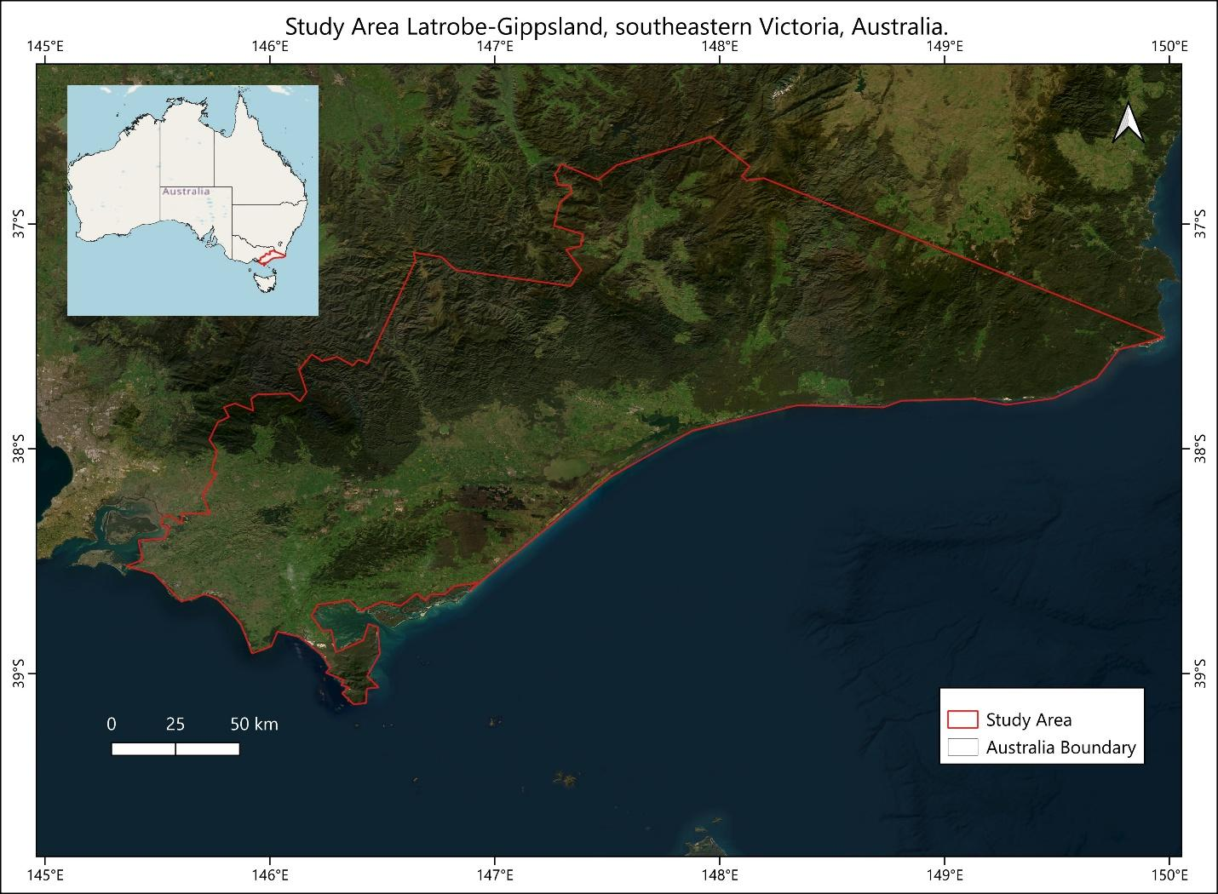
Figure 1:Location of the Latrobe-Gippsland study area, southeastern Victoria, Australia, with an inset locating the region within Australia.
The region has a temperate maritime climate. At East Sale, near the centre of the study area, mean annual rainfall for 1943-2026 is 592.2 mm, distributed fairly evenly through the year: the driest months are February and July (40-41 mm) and the wettest is November (63.9 mm). Mean temperatures range from a January maximum of 25.6°C to a July minimum of 3.3°C (Bureau of Meteorology, 2026). River systems drain south and east into the Gippsland Lakes, a large interconnected lagoon system that forms the hydrological focus of the eastern part of the study area.
Wetlands in the study area span freshwater, estuarine, and coastal regimes. Inland freshwater Marsh and Swamp are the two most extensive wetland classes. Flooded Flat and Permanent Water occur between these and the estuarine and coastal classes, Saline, Mangrove, Salt Marsh, and Tidal Flat, which are concentrated around the Gippsland Lakes and the coastline. This range of hydrological settings motivates the nine-class schema described in Section 2.5.
Four aquifer systems intersect the study area: the Western Port Basin, the Latrobe Valley, the Eastern Gippsland Basin, and the Seaspray region of the Gippsland Basin (Jasechko et al., 2024). The Latrobe Valley system underlies the area of long-standing brown coal mining where dewatering has altered local groundwater levels. The remaining three are less directly affected by mining and provide regional context for comparison.

2.2 Data Sources
Seven data sources were used: satellite imagery, topographic data, two wetland reference products, hydrological and vegetation indicators, and ground-based groundwater records (Table 1).
Landsat surface-reflectance imagery provided the spectral bands and indices used for classification, drawn from the Landsat 5(TM), 7(ETM+), 8 (OLI), and 9 (OLI-2) missions depending on anchor year. For each anchor year (2005, 2010, 2013, 2016, 2018, 2020, 2022), a composite was built from cloud-, cloud-shadow-, and snow-masked pixels aggregated across the full calendar year. The Shuttle Radar Topography Mission (SRTM) provided elevation, slope, and aspect.
Two wetland reference products, GWL_FCS30D (Zhang et al., 2024) and the CIFOR global wetland typology (Gumbricht et al., 2017), were crosswalked to build the classification schema and reference samples. GLDAS provided GWS_tavg, used here as a terrestrial water storage anomaly (TWSA). MODIS provided EVI as the vegetation-condition indicator. Ground-based comparison used 44 groundwater-monitoring bores with a computable multi-year trend from the Bureau of Meteorology Water Data Online service, clipped to the study-area boundary, together with four aquifer-system boundaries retained from Jasechko et al. (2024) for spatial reference only.

Table 1:Data sources used in this study.
Data | Type | Spatial resolution / scale | Temporal coverage | Source
Landsat | Surface reflectance | 30 m | Annual composite, 7 anchor years (2005-2022) | USGS Landsat Collection 2 Level-2 (missions 5, 7, 8, 9), via Google Earth Engine
SRTM | Topography | 30 m | Static (acquired February 2000) | NASA/USGS Shuttle Radar Topography Mission, via Google Earth Engine
GWL_FCS30D | Wetland reference product | 30 m | Annual, 2000-2022 | Zhang et al. (2024b); accessed via SAT-IO (GEE Community Catalog)
CIFOR Global Wetland Types | Wetland reference product | 232 m | Static (single reference map) | Gumbricht et al. (2017)
MODIS EVI | Vegetation condition | 250 m | Annual composite, 2003-2022 | NASA MODIS MOD13Q1, via Google Earth Engine
GLDAS GWS_tavg | Hydrological storage (terrestrial water storage anomaly) | 0.25° (~25 km) | Monthly, 2003-2022 | NASA GLDAS Noah Land Surface Model, via Google Earth Engine
Groundwater monitoring bores | In-situ groundwater level | Point locations | Variable per bore (4-43 years; most concentrated 2018-2022) | Bureau of Meteorology, Water Data Online
Aquifer system boundaries | Aquifer extent (vector) | Polygon boundaries | Static (spatial reference only) | Jasechko et al. (2024)

2.3 Analytical Framework
Figure 2 summarises the workflow: data acquisition and preprocessing, feature engineering, reference-data construction, Random Forest classification, spatial-block validation, wetland-transition analysis, water-storage and groundwater-bore analysis, vegetation analysis, and statistical assessment of the relationship between water storage and vegetation condition. Each stage is described in the subsections below.
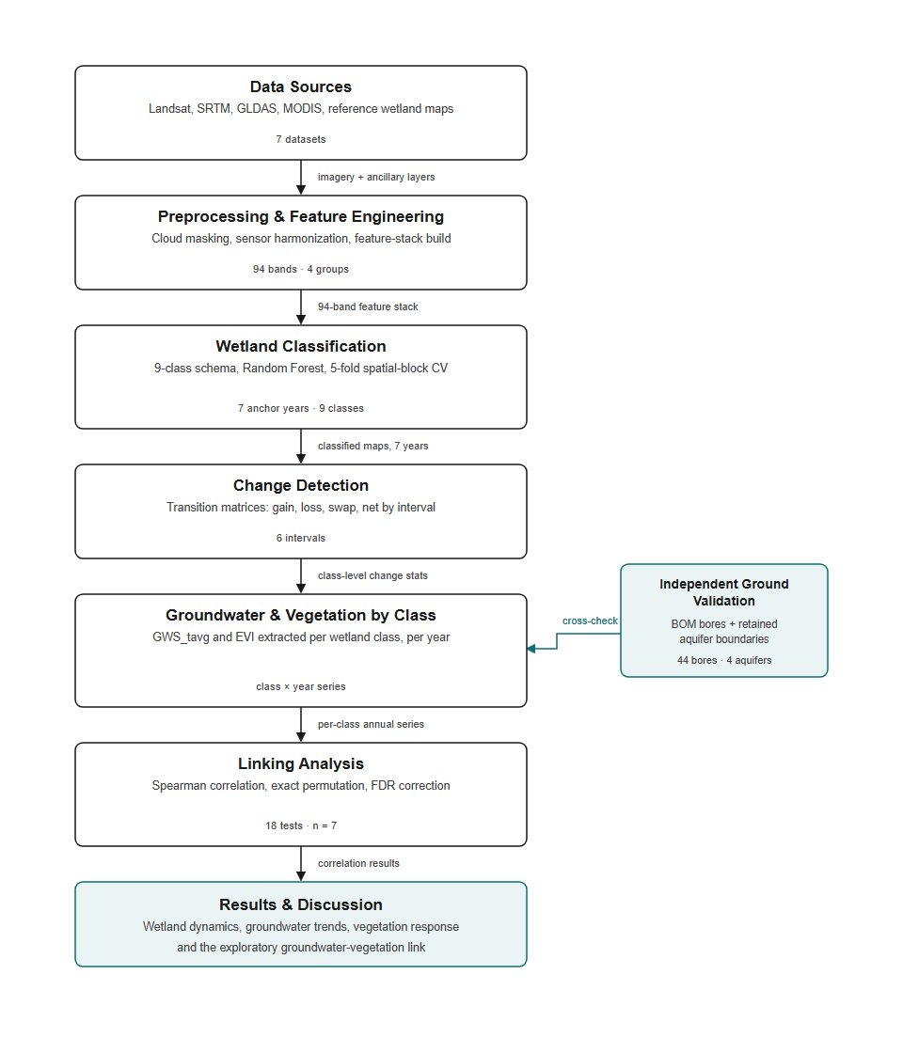
Figure 2:Analytical workflow used in this study.

2.4 Landsat Preprocessing and Feature Engineering
Landsat imagery was assembled separately for each anchor year and processed in the Google Earth Engine Code Editor. Each year's imagery was masked for cloud, cloud shadow, and snow. Imagery for 2005, 2010, and 2013 came from Landsat 5 and 7, whose Collection 2 Level-2 products number their surface-reflectance bands differently from Landsat 8 and 9, so sensor-specific band mappings were applied to align both generations onto a common schema before feature engineering.
A 94-band per-pixel feature stack was then built from the cleaned composites, in four groups: 16 tide and water-level bands (surface reflectance plus a tide index and a modified water index, computed separately for low-tide and high-tide composites); 50 phenology bands, from 10 spectral and index variables summarised at five percentiles across the year; 25 grey-level co-occurrence matrix (GLCM) texture bands (Haralick, Shanmugam, & Dinstein, 1973); and 3 topographic bands (elevation, slope, aspect) from SRTM.

2.5 Wetland Reference Data and Classification Scheme
Pixels were classified into nine classes: Non-wetland, Permanent Water, Swamp, Marsh, Flooded Flat, Saline, Mangrove, Salt Marsh, and Tidal Flat. The schema was built by crosswalking GWL_FCS30D and the CIFOR global wetland typology (Gumbricht et al., 2017) onto a single consistent set of classes. The two products were combined because no single available product covers the study area at both the resolution and the thematic detail this study requires (Yang et al., 2017). The resulting crosswalk is an author-defined mapping rather than an adopted external standard.
Where the two source datasets disagreed at a location, GWL_FCS30D took precedence, as the higher-resolution and more regionally validated of the two; CIFOR filled the remaining gaps. Each of the ten CIFOR-to-schema mappings was assigned a confidence rating reflecting how closely the two systems define that class (Appendix A). Nine of the ten were rated High or Medium-High. The tenth, CIFOR's “Arid Marshes” mapped onto Saline, was rated Medium and flagged when the crosswalk was constructed.

2.6 Random Forest Classification
A Random Forest classifier (Breiman, 2001) was applied to the 94-band stack described in Section 2.4, using the scheme in Section 2.5. It was implemented with 100 trees, default parameters, and a fixed random seed, and trained independently for each anchor year.
Two distinct sets of models were produced. The cross-validation models described in Section 2.7 were used only to estimate generalisation performance; they were not used to produce any mapped output. A separate final classifier was trained on the complete reference dataset, pooled across the whole study area, and this classifier alone generated the classified maps used in the change analysis.
Two checks were run on the final classifier to assess whether the 94-band stack was justified for this study rather than simply inherited from Zhang et al. (2024a). First, per-band Gini importance was extracted and used to rank all 94 bands by their contribution to classification. Gini importance is biased toward groups of correlated predictors, inflating or splitting their apparent importance relative to an equally informative but less correlated band (Strobl, Boulesteix, Zeileis, & Hothorn, 2007), so the ranking is reported descriptively rather than as a feature-selection criterion. Second, pairwise Pearson correlation and the variance inflation factor (VIF) were computed across all 94 bands from the pooled training samples. Bands exceeding the conventional VIF > 10 threshold (O'Brien, 2007) were retained: a high VIF does not by itself justify removing a predictor, and removal would depart from the published feature stack this study otherwise follows.

2.7 Spatial-Block Cross-Validation and Accuracy Assessment
Generalisation performance was estimated by 5-fold cross-validation using spatial blocks rather than individual pixels. Neighbouring pixels within a wetland are rarely independent, so a per-pixel random split would allow near-identical training and test pixels to fall on either side of the split and inflate apparent accuracy. Assigning whole blocks to training or test avoids this leakage, following established guidance for spatially structured data (Roberts et al., 2017). The study area was divided into a 5 km grid and whole grid cells were assigned at random to one of five folds. Each fold served once as the held-out test set while the remaining four trained the model, so every reference sample was classified exactly once by a model that had not seen it during training.
Stratified sampling was applied within each fold, targeting up to 500 reference samples per class, subject to class availability. Stratification was used so that rarer classes were represented in the assessment rather than being overwhelmed by the much larger Non-wetland class. Actual sample counts varied by class, and Saline in particular fell far short of this target.
For each year, a pooled confusion matrix was built across all reference samples, cross-tabulating each sample's predicted class, taken from the fold in which it was held out, against its reference class. Correct classifications fall on the diagonal; off-diagonal cells separate omission error (a class's reference samples assigned elsewhere) from commission error (other classes' samples assigned to it). Overall accuracy and Cohen's kappa (Congalton, 1991) were computed from the pooled matrix and, separately, within each fold, so the spread across folds could be reported alongside each year's point estimate.
Kappa is reported as a secondary statistic. It corrects for agreement expected by chance, which overall accuracy does not, but recent accuracy-assessment literature cautions against using it as the primary basis for comparing thematic-map accuracy (Foody, 2020) and recommends a fuller assessment protocol (Stehman & Foody, 2019). Overall accuracy and per-class producer's accuracy are treated as primary. Producer's accuracy is reported per class because the omission error it reflects propagates into area and area-change estimates (Olofsson et al., 2020).

2.8 Wetland Change and Transition Analysis
Transitions between consecutive anchor years were cross-tabulated from the classified rasters across six intervals between 2005 and 2022. Each transition was masked to the study-area boundary and converted to hectares using a latitude-corrected pixel area. Following Pontius et al. (2004), each interval was decomposed into gain, loss, swap (area exchanged between two classes in both directions), and net change, which separates directional conversion from reciprocal exchange.
The anchor years are unevenly spaced, at 5, 3, 3, 2, 2, and 2 years apart, so raw hectare totals are not directly comparable across intervals. Intensity analysis (Aldwaik & Pontius, 2012), which annualises each interval, is therefore reported alongside the gain/loss/swap decomposition (Appendix D). As a check on pixel-level stability, the number of distinct classes each pixel was assigned across the full anchor-year sequence was computed directly from the classified rasters (Appendix B).

2.9 Water Storage and Groundwater-Bore Analysis
Water storage was represented by GWS_tavg from GLDAS, a modelled terrestrial water storage anomaly (TWSA), extracted as a per-pixel zonal mean for each class in each anchor year. TWSA integrates surface, soil, and subsurface storage at approximately 25 km resolution and is a broad hydrological indicator rather than a direct measurement of groundwater. It was used because continuous bore monitoring does not cover the full study area; groundwater-specific interpretation rests on the bore records described below.
The TWSA trend was compared against groundwater-monitoring bores from the Bureau of Meteorology Water Data Online service. A global, pre-filtered extract (Jasechko et al., 2024) was considered but rejected, because its records are restricted to deepening trends by construction and so cannot register disagreement with a stable or recovering satellite trend; this constraint is discussed further in Section 4.6. Of 111 Water Data Online stations within the study-area boundary, 44 had a sufficient annual record, at least four years, to compute a Theil-Sen trend slope. This set includes both deepening and shallowing bores.
Both bore and aquifer sources report trends in depth to groundwater, where a positive value indicates a deepening water table and a negative value a shallowing one (Bureau of Meteorology, 2026b). This is the inverse of the TWSA convention, in which a rising value denotes increasing stored water, so a sign inversion was applied wherever the two were compared. The bore records span a shorter and more recent window than the 2005-2022 anchor years and overlap them only partly, so the comparison functions as a directional consistency check rather than a formal validation.
The four aquifer-system polygons retained from Jasechko et al. (2024) are used only for the spatial overlap check, not for trend comparison, since their trend values are directionally constrained by the same filtering.
As a complementary analysis, TWSA was also extracted annually across 2003-2022 using the 2022 classified map as a fixed zonal template rather than each year's own classification. Because class boundaries shift between years, this series describes conditions over the land currently occupied by each class, across the full available record, rather than the conditions of each class as mapped in that year. It answers a different question from the anchor-year analysis and is reported separately. Zonal means for this series were computed at 90 m rather than 30 m to keep processing tractable across 20 years.

2.10 Vegetation Condition
Vegetation condition was represented by MODIS EVI, extracted as a per-pixel zonal mean for each class in each anchor year. EVI was preferred over NDVI because it resists saturation in the dense or partially inundated canopies characteristic of several classes here, conditions under which NDVI sensitivity flattens (Huete et al., 2002). EVI was also extracted using the fixed-2022-footprint method described in Section 2.9.

2.11 Water Storage and Vegetation Condition Relationships
For each class, two Spearman rank correlations were computed: class area against TWSA, and class EVI against TWSA, using every anchor year with a real observation for both variables (2005-2022, n = 7). All nine classes had real observations for both variables in all seven years, so no class was excluded on data-availability grounds.
P-values were computed by exact permutation rather than the asymptotic approximation, which is a large-sample method and is not reliable at n = 7. Permutation tests remain well-powered at small samples and non-standard significance levels (Noguchi, Konietschke, Marmolejo-Ramos, & Pauly, 2021). Every possible re-ordering of one series was enumerated, at most 5,040 permutations for n = 7, and the p-value is the exact fraction of those re-orderings whose correlation is at least as extreme as observed (Good, 2005).
Eighteen tests were run in total: area and EVI, separately, against TWSA, for each of the nine classes. A Benjamini-Hochberg false discovery rate correction (Benjamini & Hochberg, 1995) was applied across all 18 p-values jointly. Any test with an unadjusted p below 0.05 was additionally examined by leave-one-out, recomputing the exact p-value with each year dropped in turn, to establish how far the result depends on a single year.

3. Results

3.1 Classification Accuracy
Overall accuracy from the pooled cross-validated confusion matrix (Section 2.7) ranged from 72.1% to 77.0% across the seven anchor years, with kappa between 0.681 and 0.738. Accuracy was relatively stable from 2005 to 2020, at 74.4-77.0%, and fell to 72.1% in 2022, the lowest of the series. The spread across folds did not widen in that year: the fold-level standard deviation was 3.8 percentage points in 2022, within the 2.5-4.1 point range observed across all seven years (Figure 3).
Per-class producer's accuracy was consistently high for Non-wetland (94.7-95.9%), Permanent Water (85.3-91.8%), and Mangrove (81.9-85.5%). Tidal Flat was comparable across the series (83.2-88.6%), reaching its lowest value in 2022. Swamp (56.4-63.5%) and Marsh (63.0-66.6%) were the weakest of the seven well-supported classes. Flooded Flat varied most widely, from 65.7% to 87.7%, also reaching its minimum in 2022 (Figure 4).
Two classes performed substantially worse. Saline returned at most five reference samples in the pooled set in any year, against a target of 2,500, and recorded zero correct classifications in every year. Salt Marsh, despite a full reference sample, reached only 37.1-46.0%. Class-specific results for Saline and Salt Marsh are accordingly reported separately throughout and should be treated with caution.
The lower accuracy in 2022 is associated with a specific shift in the confusion matrix. The proportion of Flooded Flat reference samples classified as Permanent Water rose from 1.1% in 2016 to 17.8% in 2022, and Tidal Flat misclassification into Flooded Flat rose from 5.6% to 8.9% over the same comparison. This coincides with documented flooding in the region: the Bureau of Meteorology issued flood warnings for the Latrobe River after heavy rainfall on 13-14 October 2022, during the broader 2022 south-eastern Australia floods (Bureau of Meteorology, 2022). Each anchor year is classified from a full calendar-year composite, so the 2022 composite includes this period.
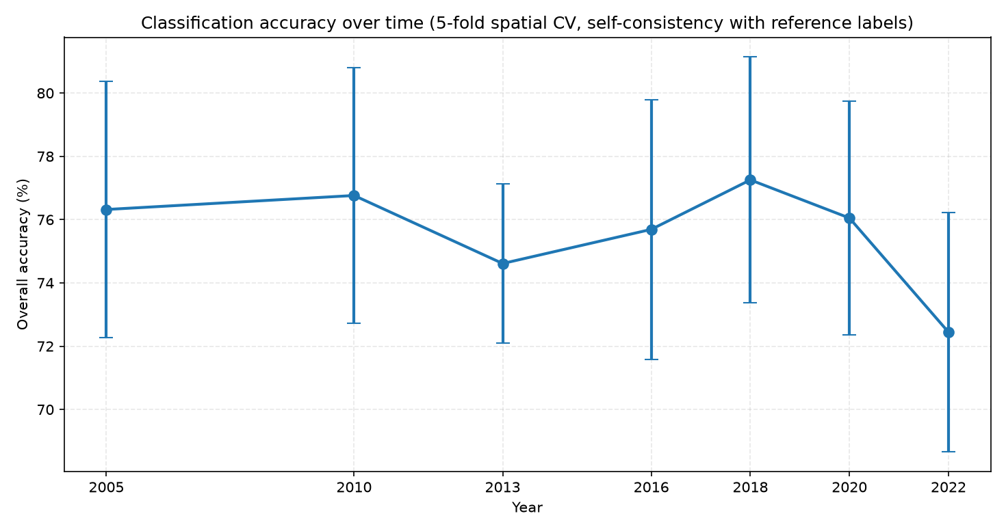
Figure 3: Overall classification accuracy across the seven anchor years, 2005-2022.

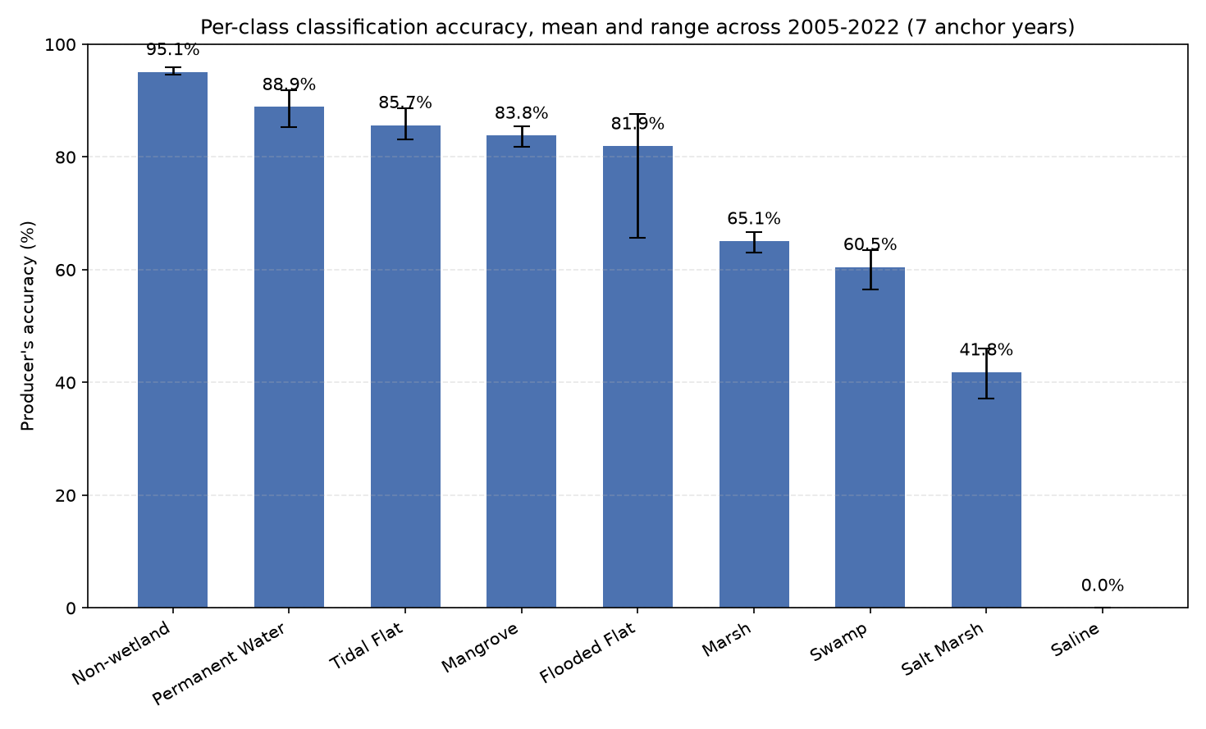
Figure 4:Per-class producer's accuracy, mean and range across the seven anchor years, 2005-2022, ordered from strongest to weakest.
Per-band Gini importance from the final classifier (Section 2.6) was led in every anchor year by elevation, with a mean importance of 147.7, despite topographic variables comprising only 3 of the 94 bands. The 50 phenology bands together contributed the largest share of total importance, 55.0%, but no single phenology band outranked elevation individually.
The multicollinearity check (Section 2.6; supporting figures in Appendix C) found 165 band pairs with a Pearson correlation of 0.9 or above, and 74 of the 94 bands exceeding VIF > 10. High-VIF bands were concentrated among percentile composites of the same underlying variable, such as the five NDVI or mNDWI percentiles, and among paired GLCM contrast and variance bands. Elevation's own VIF was 1.9. Since Gini importance is biased toward correlated predictor groups (Strobl et al., 2007), elevation's high and largely unshared importance, and the phenology group's high but internally redundant cumulative importance, are consistent with this redundancy structure.

3.2 Wetland Extent and Class Transitions
The classified extent of each class across the seven anchor years is shown in Figure 5 as a single consolidated panel, with Non-wetland rendered in grey so the wetland classes remain distinguishable.

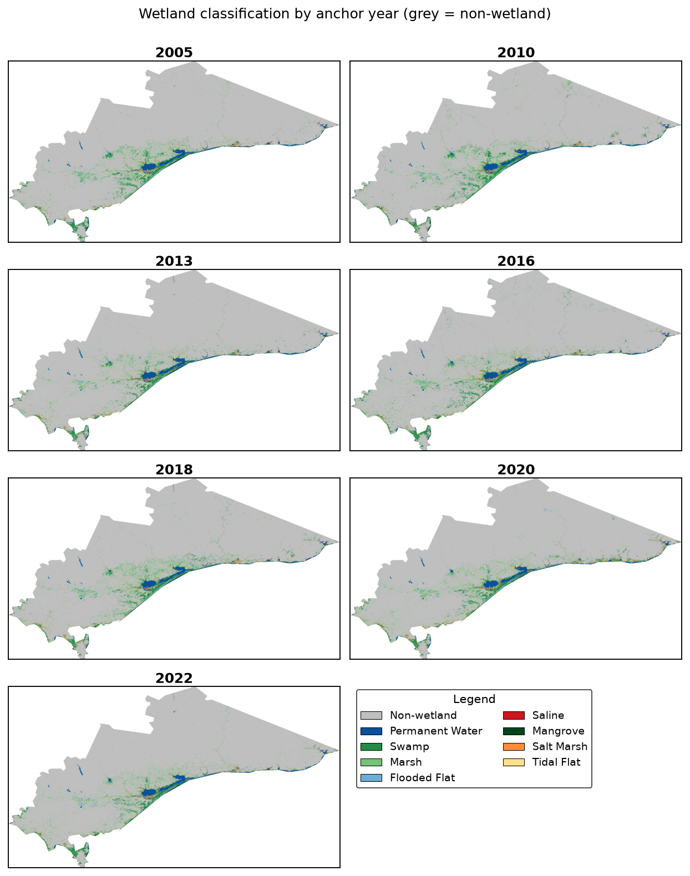
Figure 5:Classified wetland extent for the Latrobe-Gippsland study area across the seven anchor years (2005, 2010, 2013, 2016, 2018, 2020, 2022). Non-wetland is shown in grey.
Table 2 gives the classified area of each class at each anchor year, and Figure 6 charts the eight wetland classes; Non-wetland is excluded from the chart only, since its area exceeds any individual wetland class by one to two orders of magnitude. Marsh and Swamp were the two largest wetland classes throughout, and both varied substantially within the period rather than following a steady trend. Marsh ranged from a 2013 low of 105,162 ha to a 2018 peak of 155,249 ha before easing to 128,901 ha in 2022. Swamp ranged from a 2013 low of 92,928 ha to a 2016 high of 119,350 ha before declining to 91,897 ha, its lowest value, in 2022. Salt Marsh showed the largest relative swing of any well-supported class, from a 2010 low of 22,801 ha to a 2020 peak of 37,206 ha, a 63% increase. Saline was negligible in six of seven years, at 0.1-0.4 ha; the 2005 value of 18.0 ha is an outlier, consistent with classifier noise given the near-absence of Saline reference data (Section 3.1).

Table 2:Classified area (hectares) of each wetland class in the Latrobe-Gippsland study area across the seven anchor years.
Year | Non-wetland | Permanent Water | Swamp | Marsh | Flooded Flat | Saline | Mangrove | Salt Marsh | Tidal Flat
2005 | 3,761,359.5 | 67,533.7 | 104,608.5 | 133,930.0 | 19,274.8 | 18.0 | 13,278.0 | 31,149.6 | 9,427.6
2010 | 3,755,498.7 | 69,019.7 | 116,378.7 | 138,406.5 | 16,650.0 | 0.3 | 12,489.9 | 22,800.7 | 9,335.2
2013 | 3,805,365.7 | 70,924.0 | 92,928.3 | 105,161.6 | 15,333.4 | 0.1 | 12,339.8 | 29,480.8 | 9,045.9
2016 | 3,770,365.7 | 71,176.1 | 119,349.6 | 114,741.4 | 15,077.8 | 0.3 | 9,918.7 | 29,039.1 | 10,910.9
2018 | 3,738,181.6 | 71,331.3 | 103,201.9 | 155,248.8 | 18,379.5 | 0.2 | 11,671.9 | 32,791.3 | 9,773.1
2020 | 3,748,725.1 | 68,850.1 | 97,602.7 | 146,727.6 | 18,729.0 | 0.3 | 11,113.6 | 37,205.5 | 11,625.9
2022 | 3,777,709.3 | 71,200.1 | 91,896.5 | 128,900.8 | 18,817.1 | 0.4 | 11,745.9 | 31,572.3 | 8,737.1

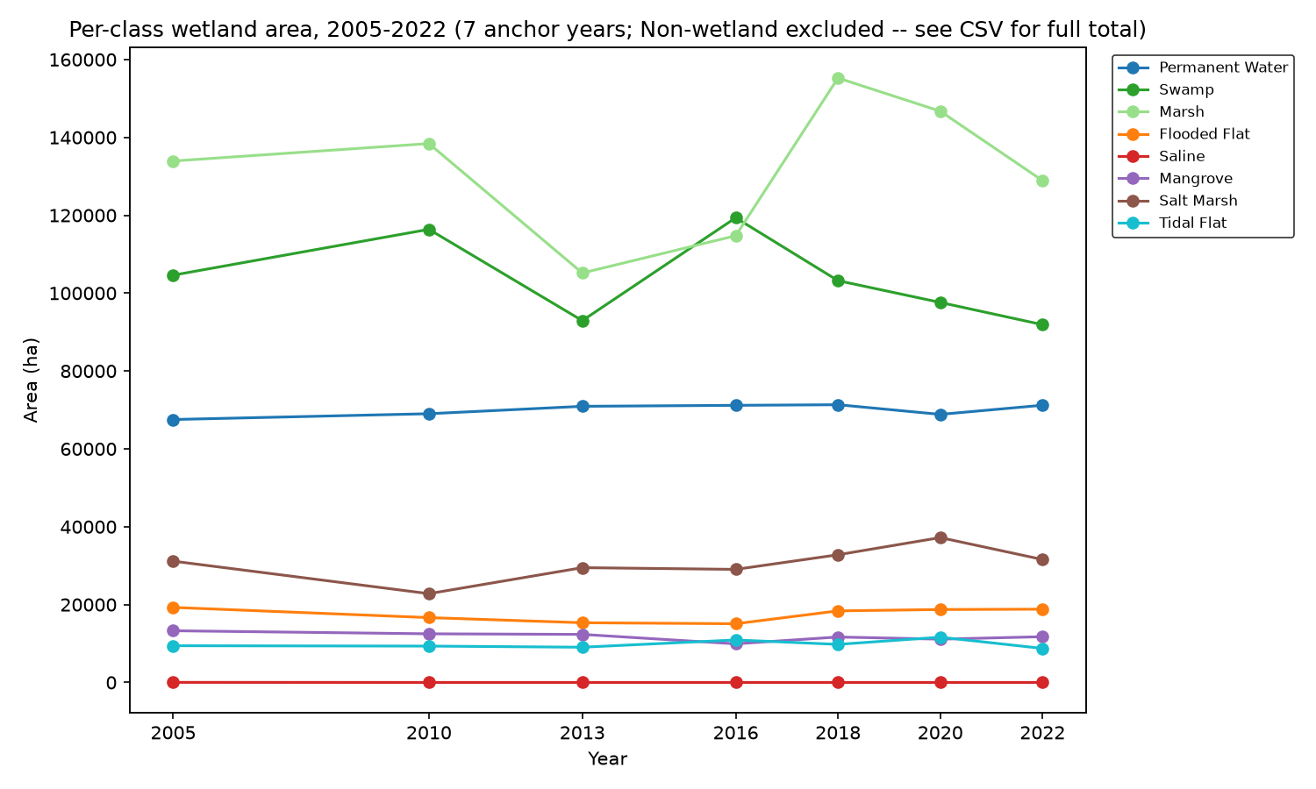
Figure 6:Wetland class area by anchor year, 2005-2022. Non-wetland excluded for scale.
Decomposing each interval into gain, loss, swap, and net change gives the central result of the change analysis. Across all six intervals, and for every well-supported class other than Saline, most apparent change is swap rather than net change. Swap accounted for 61.2-99.5% of total change per class per interval, with most classes between 75% and 95%. The most extreme case is Flooded Flat in 2020-2022, where swap accounted for 99.5% of change: a net change of 88 ha against 16,735 ha of total change. The class occupied a nearly identical area at both dates while a substantial area was exchanged with adjacent classes.
Three cases showed comparatively more net change. Flooded Flat in 2016-2018 had 61.2% swap, the lowest proportion recorded. Non-wetland in 2010-2013 had 71.6% swap and that interval's largest net change, 49,867 ha. Marsh in 2016-2018 had 67.7% swap with a net change of 40,507 ha, the largest recorded for any class in any interval and the clearest instance of directional conversion in the dataset. Saline showed no meaningful transitions in any interval.
Over the full 2005-2022 span, Non-wetland is the clearest net gainer at +16,350 ha, from 187,074 ha of total change that was 91.3% swap. Marsh is the clearest net loser at -5,029 ha, from change that was 96.5% swap, and Swamp also registers a net loss of 12,712 ha. In every case the net figure is small relative to the total area exchanged.
Pixel-level turnover was concentrated at class boundaries. This coincides with the redundancy documented in the predictor stack (Section 3.1), where 74 of 94 bands exceed VIF > 10 and many of the highest-VIF bands are the spectral and textural features used to separate visually and hydrologically similar classes. Predictor redundancy of this kind may contribute to classifier instability at those boundaries; the present analysis does not partition observed turnover between classification instability and genuine exchange.
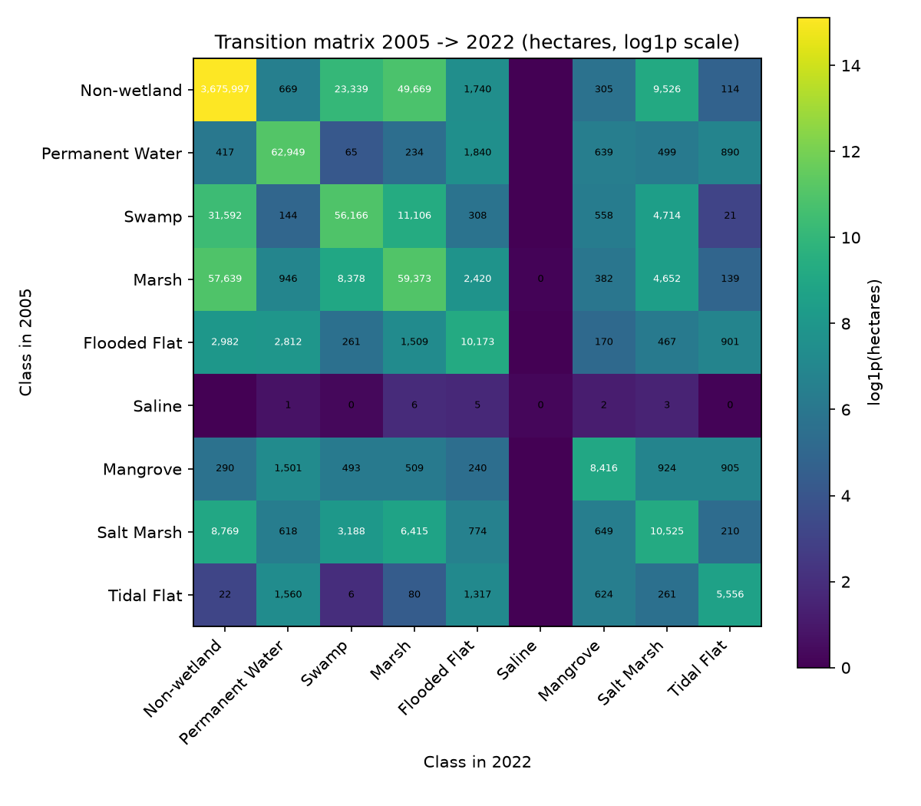
Figure 7:Full-span transition matrix, 2005 to 2022, in hectares on a log1p scale.
Full numeric transition matrices for the full span and two representative intervals are given in Appendix F.

3.3 Water Storage by Wetland Class
The AOI-wide TWSA trend over the anchor years was positive, at +4.25 units per year, indicating stable to increasing stored water. The median bore trend was -0.0753 m per year (n = 44), within a band of ±0.1 m per year treated here as stable, and the bore set includes both deepening and shallowing records. The satellite-derived storage trend is therefore directionally consistent with the available bore records, and neither indicates broad groundwater depletion over the periods each source covers. The aquifer polygons give a mean of +0.0271 m per year, but their source data are restricted to deepening records by construction and are not treated as independent evidence of the trend.
TWSA coverage is complete for all nine classes across all seven anchor years, since every anchor year postdates the GLDAS coverage start of 1 January 2003. Among the most extensive classes, Non-wetland and Marsh both show a generally rising trend with a dip around 2018, and Permanent Water follows a similar pattern at a lower level. All nine classes trend toward increasing storage over the period (Table 3, Figure 8; per-class slopes in Appendix E).

Table 3:Mean terrestrial water storage anomaly (GLDAS GWS_tavg) by wetland class across the seven anchor years.
Year | Non-wetland | Permanent Water | Swamp | Marsh | Flooded Flat | Saline | Mangrove | Salt Marsh | Tidal Flat
2005 | 603.3987 | 473.4140 | 453.8055 | 515.4130 | 510.0435 | 505.0522 | 431.5683 | 499.1086 | 528.8878
2010 | 607.7564 | 479.3206 | 477.5497 | 531.0308 | 521.4711 | 466.0260 | 451.3135 | 498.5282 | 533.0482
2013 | 625.7611 | 500.3415 | 496.1744 | 561.6874 | 540.1558 | 546.0674 | 485.8515 | 521.8817 | 564.9471
2016 | 650.1022 | 513.3784 | 506.0786 | 566.7151 | 549.0776 | 566.2531 | 498.4769 | 531.1827 | 550.0433
2018 | 615.3483 | 496.2586 | 490.4897 | 539.4156 | 542.1033 | 481.9699 | 478.2118 | 511.3018 | 541.4439
2020 | 636.8512 | 506.4112 | 492.2215 | 558.4980 | 562.9430 | 499.2187 | 482.4183 | 532.0110 | 568.3149
2022 | 682.7493 | 541.0472 | 501.1259 | 593.2834 | 581.4593 | 613.5053 | 493.4506 | 561.6650 | 579.4118

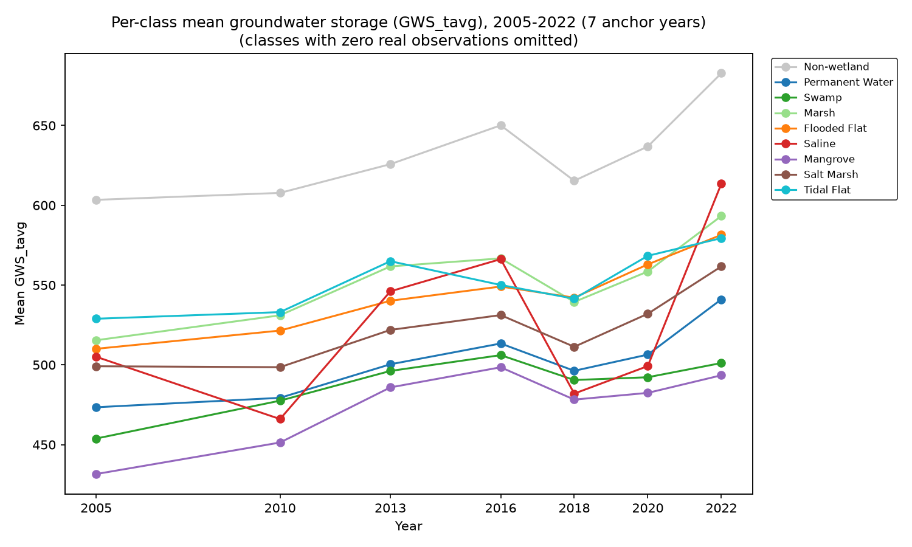
Figure 8:Terrestrial water storage anomaly by wetland class, seven anchor years, 2005-2022.
Joining each of the 44 bores to the class in which it falls, separately for each anchor year, shows uneven coverage. No bore falls within Permanent Water, Saline, Mangrove, or Tidal Flat in any anchor year, and Flooded Flat contains one bore in one year only. Most bores fall within Non-wetland (26-31 across the series) and Marsh (7-14), with Swamp and Salt Marsh containing 1-4 each. Each bore contributes a trend computed from its own multi-year record rather than an annual reading, so a change in a class's bore count between anchor years reflects reclassification of the underlying pixel, not new or relocated bores (Figure 9).
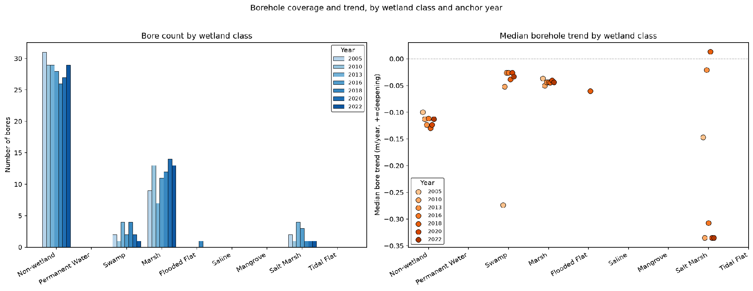
Figure 9:Borehole count and median borehole trend by wetland class and anchor year.
As a spatial check, 18.5% of pixels in the study area fall within one of the four mapped aquifer-system boundaries, and this share varies by class. Marsh has the highest overlap in every anchor year, at 61.5-73.8%, followed by Swamp at 44.4-55.2% and Salt Marsh at 40.0-52.3%. Permanent Water has the lowest of any well-supported class, at 7.1-8.4%. The reported Saline overlap of 82.7-100% is not meaningful, corresponding to at most six pixels in any year.

3.4 Vegetation Condition by Wetland Class
EVI coverage is complete for all nine classes across the seven anchor years. Non-wetland and Marsh showed the highest values throughout, at 0.351-0.401 and 0.315-0.409 respectively, and Permanent Water the lowest, at 0.039-0.052. Marsh reached a local minimum in 2018 (0.315) and a series high in 2022 (0.409). Swamp followed a broadly similar pattern, with its lowest value in 2020 (0.296) and recovery by 2022 (0.347). Flooded Flat, Mangrove, and Tidal Flat remained within narrow bands across all seven years (Table 4, Figure 10).
Table 4:Mean vegetation condition (MODIS EVI) by wetland class across the seven anchor years
Year | Non-wetland | Permanent Water | Swamp | Marsh | Flooded Flat | Saline | Mangrove | Salt Marsh | Tidal Flat
2005 | 0.373197 | 0.040793 | 0.321390 | 0.330578 | 0.170878 | 0.257363 | 0.130510 | 0.313768 | 0.109207
2010 | 0.375929 | 0.038817 | 0.308486 | 0.336818 | 0.176316 | 0.425734 | 0.146346 | 0.273447 | 0.118470
2013 | 0.374851 | 0.039710 | 0.312500 | 0.350523 | 0.155439 | 0.418824 | 0.138789 | 0.301558 | 0.107791
2016 | 0.390684 | 0.052077 | 0.323763 | 0.374838 | 0.169097 | 0.451216 | 0.144358 | 0.316433 | 0.112271
2018 | 0.365626 | 0.047457 | 0.306172 | 0.315301 | 0.187320 | 0.424268 | 0.140619 | 0.297767 | 0.129793
2020 | 0.351111 | 0.041310 | 0.296443 | 0.379054 | 0.172012 | 0.475979 | 0.149290 | 0.281493 | 0.120648
2022 | 0.400839 | 0.042428 | 0.347412 | 0.409302 | 0.168472 | 0.450941 | 0.138465 | 0.316729 | 0.120084

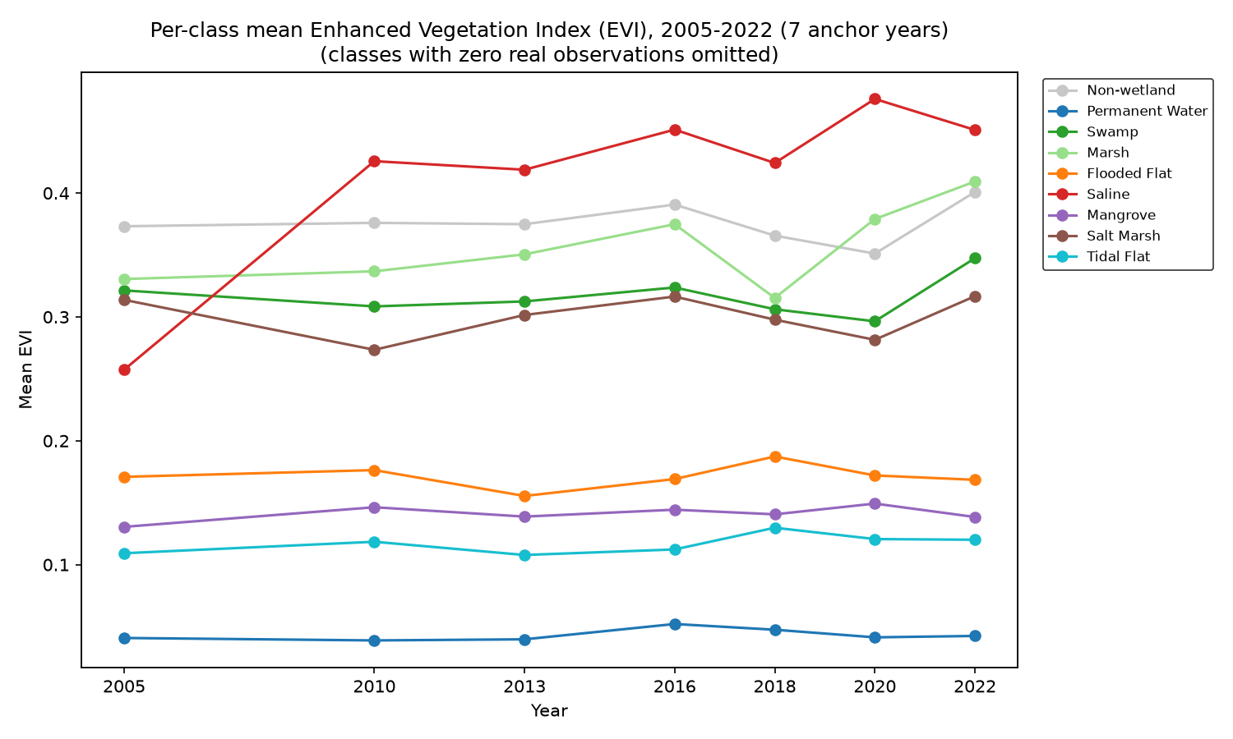
Figure 10:Vegetation condition (MODIS EVI) by wetland class, seven anchor years, 2005-2022.

3.5 Water Storage and Vegetation Condition Relationships
All 18 class-level tests were run, since TWSA and EVI coverage is complete for every class across all seven anchor years (Section 2.11). The lowest unadjusted p-value was for Marsh EVI against TWSA (rho = 0.786, p = 0.048, n = 7). Mangrove area against TWSA was next (rho = -0.714, p = 0.088). After Benjamini-Hochberg correction across all 18 tests, neither is significant at p < 0.05, with adjusted p = 0.605 for both. Marsh was the only test with an unadjusted p below 0.05 and was therefore examined by leave-one-out: dropping any single year shifts the p-value between 0.058 and 0.175. No other test approaches significance, with all remaining unadjusted p-values above 0.19. Full results are given in Table 5.
Marsh therefore shows the strongest exploratory temporal association between vegetation condition and TWSA of any class, but the association does not survive correction for multiple testing and is sensitive to individual years. No relationship between water storage and vegetation condition is reported as confirmed for any class.
Separately, Marsh also has the highest spatial overlap with mapped aquifer boundaries of any class in every anchor year (Section 3.3). This is a different form of evidence from the temporal correlation, not an independent statistical test of the same hypothesis, and the two are not combined into a joint significance claim.
Table 5:Class-level Spearman rank correlations between remote-sensing indicators (area or EVI) and terrestrial water storage anomaly, 2005-2022 (n = 7 anchor years), tested by exact permutation with Benjamini-Hochberg false discovery rate correction across all 18 tests
Wetland class | Test | n (years) | Spearman ρ | p (exact) | p (FDR-adj.) | FDR rank
Non-wetland | area vs TWSA | 7 | 0.3929 | 0.3956 | 0.7121 | 10
Non-wetland | EVI vs TWSA | 7 | 0.4643 | 0.3024 | 0.6048 | 8
Permanent Water | area vs TWSA | 7 | 0.5000 | 0.2667 | 0.6048 | 6
Permanent Water | EVI vs TWSA | 7 | 0.5714 | 0.2000 | 0.6048 | 3
Swamp | area vs TWSA | 7 | -0.2143 | 0.6615 | 0.8505 | 13
Swamp | EVI vs TWSA | 7 | 0.4643 | 0.3024 | 0.6048 | 8
Marsh | area vs TWSA | 7 | -0.5357 | 0.2357 | 0.6048 | 4
Marsh | EVI vs TWSA | 7 | 0.7857 | 0.0480 | 0.6048 | 1
Flooded Flat | area vs TWSA | 7 | 0.0000 | 1.0000 | 1.0000 | 18
Flooded Flat | EVI vs TWSA | 7 | -0.2143 | 0.6615 | 0.8505 | 13
Saline | area vs TWSA | 7 | 0.2594 | 0.6024 | 0.8505 | 12
Saline | EVI vs TWSA | 7 | 0.1429 | 0.7825 | 0.8803 | 15
Mangrove | area vs TWSA | 7 | -0.7143 | 0.0881 | 0.6048 | 2
Mangrove | EVI vs TWSA | 7 | 0.1071 | 0.8397 | 0.8891 | 17
Salt Marsh | area vs TWSA | 7 | 0.5000 | 0.2667 | 0.6048 | 6
Salt Marsh | EVI vs TWSA | 7 | 0.5357 | 0.2357 | 0.6048 | 4
Tidal Flat | area vs TWSA | 7 | -0.1429 | 0.7825 | 0.8803 | 15
Tidal Flat | EVI vs TWSA | 7 | 0.2500 | 0.5948 | 0.8505 | 11

3.6 Annual Trends for the 2022 Wetland Footprint, 2003-2022
This section reports TWSA and EVI extracted annually across 2003-2022 using the 2022 classified map as a fixed zonal template (Section 2.9). Because class boundaries shift between years, these series describe conditions over the land currently occupied by each class rather than the conditions of each class as mapped in earlier years. They answer a different question from the anchor-year analysis and are not a longer-record version of it.
All eight well-supported classes show a positive linear TWSA trend across the record, from +1.58 units per year for Tidal Flat to +3.37 units per year for Non-wetland, with a shared decline to a minimum around 2006-2009 followed by a sustained rise from 2010. The pattern holds across classes regardless of absolute storage level (Figure 11).
EVI shows no comparable directional trend. Six of the eight classes have a near-zero or weakly positive annual trend, between +0.00006 and +0.00156 EVI units per year, while Flooded Flat (-0.00092) and Permanent Water (-0.00007) decline weakly. The relative ordering of classes, with Non-wetland and Marsh highest and Permanent Water lowest, matches the anchor-year result in Section 3.4 (Figure 12).
Plotting the two series against each other by class gives a positive Pearson correlation for seven of the eight classes, from r = 0.082 for Permanent Water to r = 0.746 for Non-wetland and r = 0.710 for Marsh. Flooded Flat is the exception, at r = -0.362. These correlations are descriptive. They were not adjusted for multiple testing or assessed by permutation, and because they are computed over a fixed class footprint they do not test the same hypothesis as the anchor-year analysis in Section 3.5 and do not corroborate it (Figure 13).
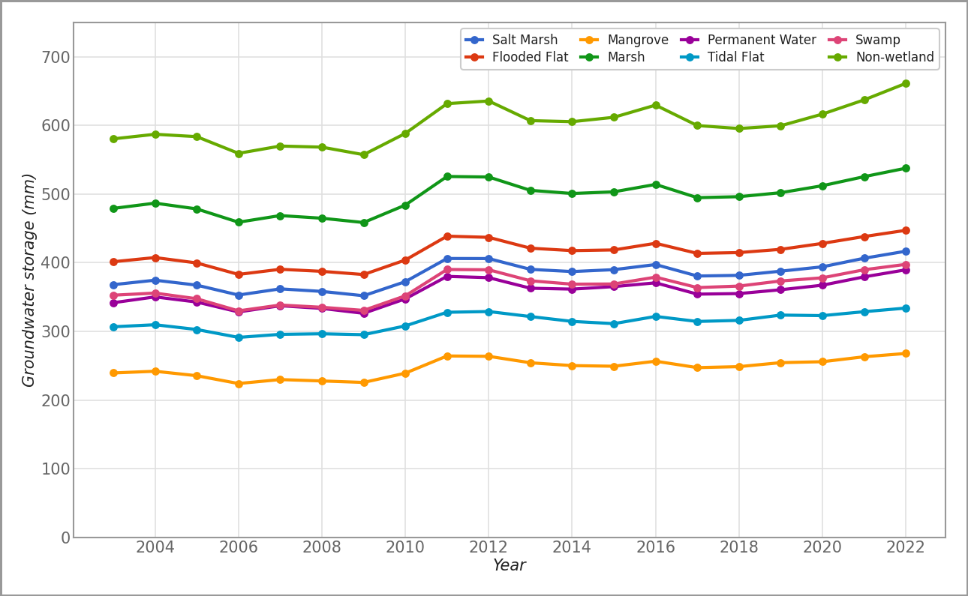
Figure 11:Annual terrestrial water storage anomaly by wetland class, 2003-2022, using the fixed 2022 classification.
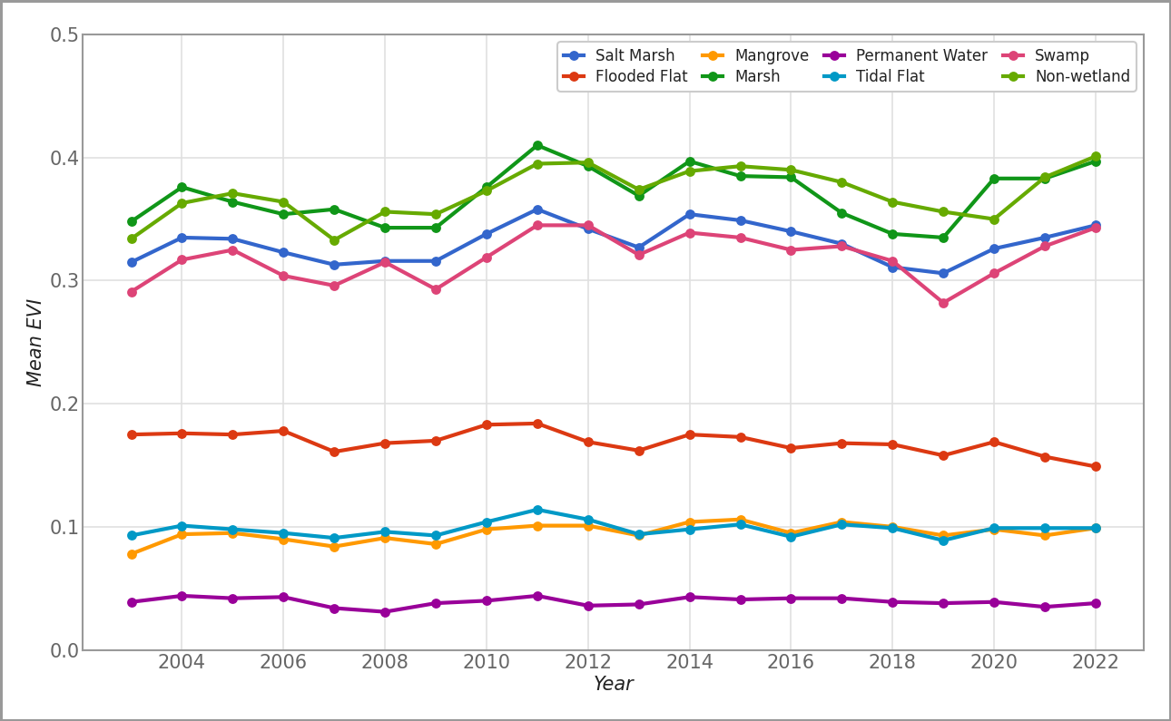
Figure 12:Annual vegetation condition (MODIS EVI) by wetland class, 2003-2022, using the fixed 2022 classification.

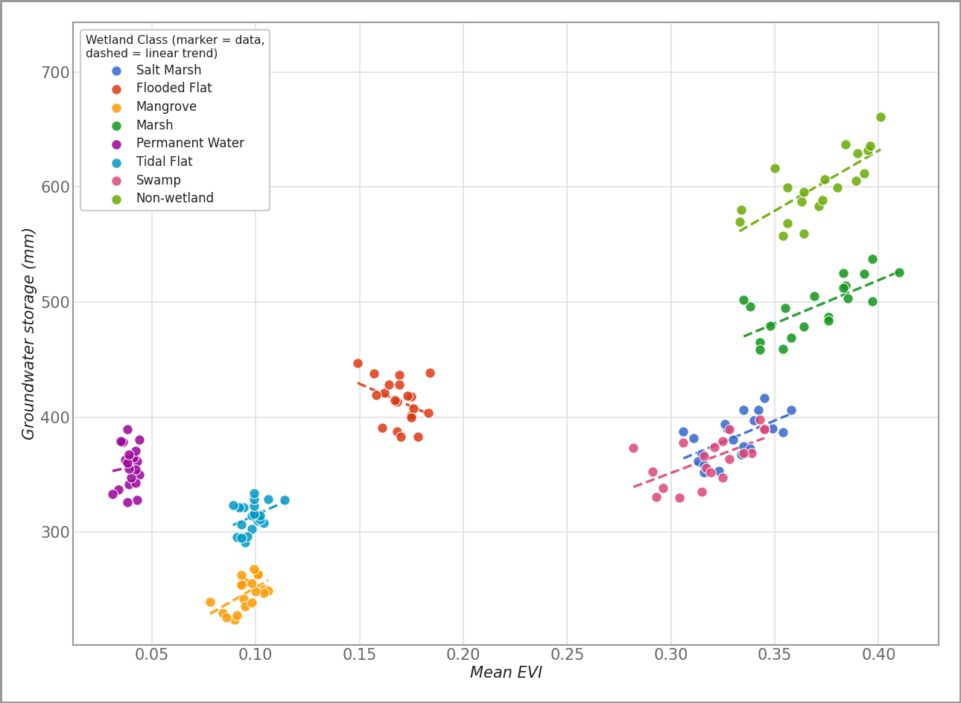
Figure 13:Mean EVI against mean terrestrial water storage anomaly by wetland class, 2003-2022, with per-class linear trend lines.

4. Discussion

4.1 Landscape Stability Versus Class-Level Dynamics
The dominant pattern in this landscape is stability of total wetland extent alongside substantial exchange between classes. Swap accounted for the large majority of change in almost every class and interval, and net figures over the full span are small relative to the areas exchanged. A single extent statistic for this region would show little happening; the class-level decomposition shows a landscape in continuous local reorganisation.
This distinction matters for how change statistics are read. Which classes appear as net gainers or losers depends on the start and end years chosen, because within-period variation is large relative to net difference. Marsh illustrates this directly: it records the largest single-interval net change in the dataset, +40,507 ha in 2016-2018, yet a net loss of 5,029 ha over the full span. Neither figure alone describes the class's behaviour.
Three explanations for the observed turnover are worth separating. The first is genuine ecological or hydrological conversion between classes. The second is real but reversible variation, particularly at margins where inundation state shifts between years, which produces reciprocal exchange rather than directional change. The third is classification error, which is not evenly distributed: it concentrates at boundaries between spectrally similar classes, and the redundancy in the predictor stack reported in Section 3.1 means some proportion of the observed turnover may reflect classification instability at those boundaries. This analysis quantifies the turnover but does not partition it among these three sources, and no such partition is claimed.
The spatial pattern is consistent with the second and third explanations contributing substantially. Turnover concentrates at wetland margins and around the Gippsland Lakes, while the interior Non-wetland matrix is largely static. Elevation was the single most influential predictor in every anchor year, which is consistent with topography exerting first-order control on where water accumulates (Sørensen, Zinko, & Seibert, 2006); topographically transitional margins are the zones least stable under both real hydrological variability and classification.
The comparison with longer records is informative. Zhang et al. (2024), using the same classifier and platform over 33 years in Gansu Province, reported roughly 30% net wetland decline with substantial inter-class reclassification alongside it. The present study finds the reclassification but not the net decline over a shorter, unevenly spaced 17-year span. This is consistent with net change of that magnitude becoming detectable over multi-decadal rather than sub-two-decade horizons, though the two settings differ in climate, land use, and classification accuracy, so the comparison is indicative only.
Classification performance varied by class in ways consistent with the wider literature. Non-wetland, Permanent Water, and Mangrove, the three most reliably classified, are also the most spectrally and structurally distinct from their neighbours here. Swamp and Marsh, the weakest of the well-supported classes, are herbaceous or semi-woody seasonally inundated types whose cover and moisture signals grade into one another and into Flooded Flat rather than presenting sharp boundaries. Spectral similarity among structurally related wetland classes is a recurring source of error across this literature (Mahdavi et al., 2018; Mahdianpari et al., 2020; He et al., 2026), so this pattern is expected rather than anomalous.
The two weak classes have different causes. Saline failed for a sampling reason: with two to five reference samples available in any year against a target of 500, there was insufficient training data for the class to be learned, consistent with the established dependence of class-specific accuracy on class-specific training sample size (Foody, Mathur, Sanchez-Hernandez, & Boyd, 2006). Its Medium-confidence crosswalk mapping (Section 2.5) compounds this. Salt Marsh had a full reference sample and a different likely constraint: salt marsh vegetation characteristically forms narrow, fine-grained patches, often narrower than a 30 m Landsat pixel, which is a documented source of salt-marsh misclassification (Routhier, Moore, & Rock, 2023). If that is the operative constraint here, it would not be resolved by additional training data at this resolution.
The 2022 accuracy dip is of a different kind again. It is confined to one year and one class pair, tracks a dated hydrological event, and does not widen the spread across folds. Rather than indicating a general decline in classifier reliability, it illustrates that a full calendar-year composite carries the hydrological conditions of that year into the classification, and that anomalous years will therefore produce anomalous class boundaries where classes are separated primarily by water presence.

4.2 Hydrological Context
The evidence indicates broadly stable to increasing water storage across the study area over the period examined, with no indication of sustained depletion. The satellite-derived TWSA trend is positive, and the median bore trend sits within the band treated here as stable. These two are directionally consistent, which is the appropriate strength of claim: they are different measurements at different scales over partly overlapping windows, and agreement between them supports the interpretation without constituting independent replication of it.
The bore comparison carries more evidential weight than its sample size suggests, because the bore set is directionally unconstrained. It contains both deepening and shallowing records, so agreement with a stable-to-rising satellite trend was not guaranteed by the data's construction. The aquifer-polygon values cannot serve the same function: their source records are restricted to deepening trends, so they can only ever agree with a declining signal and cannot register disagreement. They are used here for spatial reference only, and the earlier characterisation of three mutually confirming sources overstated what the aquifer data can support.
TWSA and groundwater are also not interchangeable. GWS_tavg is a modelled storage anomaly integrating surface, soil, and subsurface water at roughly 25 km resolution, so it is a coarse indicator of regional water balance rather than a measurement of aquifer level. The class-level TWSA differences reported in Section 3.3 are best read as reflecting the broader hydrological settings in which each class sits, since a 25 km cell will typically span several classes. Groundwater-specific inference in this study rests on the bore records.
The regional finding of no depletion contrasts with the state-wide depletion reported for Victoria over 2003-2012 from GRACE and a 1,395-bore network (Tregoning et al., 2012). Several explanations are possible and cannot be separated here: genuine improvement in regional conditions between the two windows, the difference between wetland-focused and state-wide sampling, or the different periods covered. The result should not be read as evidence that the state-wide trend has reversed. It is, however, notable alongside the documented localised drawdown associated with mine dewatering in the Latrobe Valley, and suggests the wetland-dominated parts of this study area behave differently from the actively mined zones.
Bore coverage is the main constraint on this interpretation. Bores are concentrated in Non-wetland and Marsh, with Swamp and Salt Marsh lightly covered and four classes containing no usable bore in almost any year. Groundwater conditions in those four classes are therefore not independently verified at all, and the stable regional picture should not be assumed to hold uniformly within them.

4.3 Vegetation Differences Among Wetland Classes
Vegetation condition differed consistently among wetland classes and broadly reflected their contrasting hydrological settings. The classes with the highest and most variable EVI, Non-wetland, Marsh, and Swamp, are those with substantial vegetated cover and the greatest variation in extent. Classes defined by more constant water cover or by sparse vegetation, particularly Permanent Water but also Flooded Flat, Mangrove, and Tidal Flat, show correspondingly low or stable signals. This ordering is stable across all seven anchor years and reproduces in the independent annual series, which supports it as a real property of the classes rather than an artefact of any single year.
Marsh and Swamp both dip around 2018-2020 and recover by 2022. The anchor-year TWSA series drifts upward over the same period, but the annual series in Section 3.6 shows no comparable long-term EVI trend in any class despite a clear upward TWSA trend across the same record. Vegetation condition in this landscape therefore appears more responsive to inter-annual variation than to the multi-year storage trend, which is one reason a seven-point series is poorly suited to detecting a slow coupling if one exists.

4.4 Evidence for Groundwater-Vegetation Coupling
Marsh showed the strongest exploratory temporal association between vegetation condition and water storage of any class, at rho = 0.786 with an unadjusted p of 0.048 across seven anchor years. That association did not survive Benjamini-Hochberg correction across the 18 class-level tests, with an adjusted p of 0.605, and leave-one-out resampling shifted the p-value between 0.058 and 0.175 depending on which year was dropped. No relationship between water storage and vegetation condition is confirmed for any class by this analysis.
The small number of temporal observations limits the ability to distinguish a weak underlying relationship from sampling variation. With n = 7, a real but moderate coupling and a chance arrangement of seven points are not separable by these data, and the FDR correction across 18 tests, which is necessary given the number of comparisons, further reduces what can be detected. The negative result here constrains what can be claimed; it does not establish that no relationship exists.
The direction of the strongest associations is nonetheless consistent with expectation. Marsh, an extensive freshwater class with substantial vegetated cover, and Mangrove, concentrated at the groundwater-sensitive coastal margin, are the two classes where a storage signal would most plausibly appear first if present (Glanville et al., 2023). Marsh also has the highest aquifer overlap of any class in every anchor year. That overlap is spatial evidence of a different kind from the temporal correlation, and the two are not independent tests of a single hypothesis, so they are reported alongside one another rather than combined.
These weak and non-significant class-level relationships are consistent with the wider literature. A systematic review of 140 studies found groundwater-vegetation relationships frequently site-specific and confounded by other factors (Glanville et al., 2023), which suggests that a longer observation record, rather than a different statistical treatment of this one, is the more likely route to a confirmatory result.

4.5 Implications for Wetland Monitoring
The central methodological implication is that wetland extent alone is an insufficient monitoring statistic for this landscape. A programme tracking total extent here would have reported stability across 17 years while substantial class-level reorganisation went unrecorded. Gain, loss, swap, and intensity decomposition, applied at class level, is what makes that reorganisation visible, and is inexpensive once classified maps exist.
Monitoring design should also account for where classification is weakest. The classes with the least reliable mapping are not randomly distributed: they are the sparse classes and those with sub-pixel structure. Reporting class-specific accuracy alongside class-specific change, and excluding classes that fall below a stated threshold from change interpretation, prevents the least reliable estimates from carrying the same weight as the rest.
For hydrological monitoring, the existing bore network cannot support class-level inference across the full wetland typology. Four classes contain no usable bore in almost any year, so detecting early groundwater stress in Permanent Water, Flooded Flat, Saline, Mangrove, or Tidal Flat would require new instrumentation rather than reanalysis of existing records. Obtaining an aquifer-level trend product that is not directionally filtered would be a lower-cost improvement, and would allow the aquifer data to function as evidence rather than as spatial reference.
Finally, the Marsh association is worth continued observation rather than action. It is the strongest signal in the dataset and is supported spatially by aquifer overlap, but a longer record is the direct way to determine whether it strengthens into a detectable relationship.

4.6 Limitations and Future Research
Classification uncertainty. Accuracy was adequate but not high, at 72.1-77.0% overall, and varied by class. Saline and Salt Marsh performed poorly and their class-specific change statistics are not reliable. The 2022 estimates for Flooded Flat and Permanent Water warrant additional caution given that year's flooding, though the effect is confined to one year and one class pair and does not undermine the landscape-level findings. The predictor stack, adopted from Zhang et al. (2024a) rather than selected for this study, contains substantial redundancy, with 74 of 94 bands exceeding VIF > 10. Following O'Brien (2007) these were retained, since a high VIF alone does not justify removal, but the per-band importance ranking should be read as indicative rather than as a clean measure of independent contribution (Strobl et al., 2007), and the redundancy may contribute to instability at spectrally similar class boundaries.
Hydrological data limitations. TWSA is a modelled storage indicator at approximately 25 km resolution, coarser than the wetland classes it is summarised over, and is not a groundwater measurement. The bore comparison uses 44 stations with a computable trend from 111 candidates, over a window that is shorter and more recent than the anchor-year span and overlaps it only partly, so it supports a directional consistency check rather than formal validation. Bore coverage is uneven across classes, with four classes unrepresented. The aquifer-boundary dataset is directionally filtered to deepening records and is therefore used for spatial reference only; obtaining an unfiltered equivalent would remove this constraint. The aquifer boundaries are also a coarse global product rather than a local survey, so the overlap percentages are a plausibility check rather than a precise measure.
Temporal and statistical limitations. The anchor-year analysis rests on seven observations per class. This supports an exact, small-sample-appropriate test but provides little power to detect a class-level correlation surviving correction across 18 tests, which is what was observed. The anchor years are unevenly spaced, which is why intensity analysis is reported alongside raw change totals. The annual fixed-footprint analysis covers 20 years but describes a single fixed class footprint rather than each year's mapped classes, so it provides temporal context and cannot substitute for the anchor-year test.
Future work follows from these constraints in three directions: extending the anchor-year series as further years become available, to increase temporal power directly; obtaining unfiltered aquifer-level trend data and denser class-representative bore coverage, to allow groundwater inference across the full typology; and characterising the boundary zones where turnover concentrates, ideally with finer-resolution imagery, to separate reversible inundation variability from classification instability and from genuine conversion.

5. Conclusion
Wetland extent in the Latrobe-Gippsland region was stable at landscape scale between 2005 and 2022, but this stability masked substantial reorganisation among classes. Swap accounted for most change in nearly every class and interval, and net change was small relative to the area exchanged. Which classes appear to gain or lose depends on the years compared, so single-interval net figures should not be treated as descriptions of long-term trajectory.
Terrestrial water storage across the region trended stable to increasing over the same period, and this was directionally consistent with 44 groundwater bores whose records include both deepening and shallowing trends. There is no evidence of broad groundwater depletion in the wetland-dominated parts of the study area, though bore coverage is absent for several classes and the finding cannot be extended to them.
Vegetation condition differed consistently among classes in a pattern reflecting their hydrological settings. Marsh showed the strongest exploratory association between vegetation condition and water storage, but it did not survive correction for multiple testing and was sensitive to individual years. No groundwater-vegetation relationship is confirmed by this analysis.
For monitoring, the practical implication is that class-level transition analysis reveals dynamics that aggregate extent statistics conceal, and should be reported alongside accuracy estimates that identify which classes can bear interpretation. Resolving whether the Marsh association reflects a real coupling will require a longer observation record and groundwater data distributed across the full wetland typology rather than concentrated in its two most extensive classes.

References
Aldwaik, S.Z., & Pontius, R.G. Jr. (2012). Intensity analysis to unify measurements of size and stationarity of land changes by interval, category, and transition. Landscape and Urban Planning, 106(1), 103-114.
Benjamini, Y., & Hochberg, Y. (1995). Controlling the false discovery rate: a practical and powerful approach to multiple testing. Journal of the Royal Statistical Society Series B, 57(1), 289-300.
Breiman, L. (2001). Random forests. Machine Learning, 45(1), 5-32.
Bureau of Meteorology (2022). Flood warnings for Victoria, October 2022. Australian Government.
Bureau of Meteorology (2026a). Climate statistics for Australian locations: East Sale, station 085072. Australian Government.
Bureau of Meteorology (2026b). Water Data Online: groundwater level time series. Australian Government.
Congalton, R.G. (1991). A review of assessing the accuracy of classifications of remotely sensed data. Remote Sensing of Environment, 37(1), 35-46.
Doody, T.M., Barron, O.V., Dowsley, K., Emelyanova, I., Fawcett, J., Overton, I.C., Pritchard, J.L., van Dijk, A.I.J.M., & Warren, G. (2017). Continental mapping of groundwater dependent ecosystems: a methodological framework to integrate diverse data and expert opinion. Journal of Hydrology: Regional Studies, 10, 61-81.
Foody, G.M. (2020). Explaining the unsuitability of the kappa coefficient in the assessment and comparison of the accuracy of thematic maps obtained by image classification. Remote Sensing of Environment, 239, 111630.
Foody, G.M., Mathur, A., Sanchez-Hernandez, C., & Boyd, D.S. (2006). Training set size requirements for the classification of a specific class. Remote Sensing of Environment, 104(1), 1-14.
Glanville, K., Sheldon, F., Butler, D., & Capon, S.J. (2023). Effects and significance of groundwater for vegetation: a systematic review. Science of the Total Environment, 875, 162577.
Good, P.I. (2005). Permutation, parametric, and bootstrap tests of hypotheses (3rd ed.). Springer-Verlag.
Gorelick, N., Hancher, M., Dixon, M., Ilyushchenko, S., Thau, D., & Moore, R. (2017). Google Earth Engine: planetary-scale geospatial analysis for everyone. Remote Sensing of Environment, 202, 18-27.
Gumbricht, T., Roman-Cuesta, R.M., Verchot, L., Herold, M., Wittmann, F., Householder, E., Herold, N., & Murdiyarso, D. (2017). An expert system model for mapping tropical wetlands and peatlands reveals South America as the largest contributor. Global Change Biology, 23(9), 3581-3599.
Haralick, R.M., Shanmugam, K., & Dinstein, I. (1973). Textural features for image classification. IEEE Transactions on Systems, Man, and Cybernetics, 3(6), 610-621.
He, Y., Li, M., Tang, X., & Ren, P. (2026). Remote sensing-based detailed wetland classification: a review of advances from 2020 to 2025. Frontiers in Remote Sensing, 7, 1852249.
Huete, A., Didan, K., Miura, T., Rodriguez, E.P., Gao, X., & Ferreira, L.G. (2002). Overview of the radiometric and biophysical performance of the MODIS vegetation indices. Remote Sensing of Environment, 83(1-2), 195-213.
Jasechko, S., Seybold, H., Perrone, D., Fan, Y., Shamsudduha, M., Taylor, R.G., Fallatah, O., & Kirchner, J.W. (2024). Rapid groundwater decline and some cases of recovery in aquifers globally. Nature, 625, 715-721.
Kløve, B., Ala-aho, P., Bertrand, G., Boukalova, Z., Ertürk, A., Goldscheider, N., Ilmonen, J., Karakaya, N., Kupfersberger, H., Kværner, J., Lundberg, A., Mileusnić, M., Moszczynska, A., Muotka, T., Preda, E., Rossi, P., Siergieiev, D., Šimek, J., Wachniew, P., Angheluta, V., & Widerlund, A. (2011). Groundwater dependent ecosystems. Part I: hydroecological status and trends. Environmental Science & Policy, 14(7), 770-781.
Mahdavi, S., Salehi, B., Granger, J., Amani, M., Brisco, B., & Huang, W. (2018). Remote sensing for wetland classification: a comprehensive review. GIScience & Remote Sensing, 55(5), 623-658.
Mahdianpari, M., Granger, J.E., Mohammadimanesh, F., Salehi, B., Brisco, B., Homayouni, S., Gill, E., Huberty, B., & Lang, M. (2020). Meta-analysis of wetland classification using remote sensing: a systematic review of a 40-year trend in North America. Remote Sensing, 12(11), 1882.
Noguchi, K., Konietschke, F., Marmolejo-Ramos, F., & Pauly, M. (2021). Permutation tests are robust and powerful at 0.5% and 5% significance levels. Behavior Research Methods, 53, 2712-2724.
O'Brien, R.M. (2007). A caution regarding rules of thumb for variance inflation factors. Quality & Quantity, 41(5), 673-690.
Olofsson, P., Arévalo, P., Espejo, A.B., Green, C., Lindquist, E.J., McRoberts, R.E., & Sanz, M.J. (2020). Mitigating the effects of omission errors on area and area change estimates. Remote Sensing of Environment, 236, 111492.
Pontius, R.G., Shusas, E., & McEachern, M. (2004). Detecting important categorical land changes while accounting for persistence. Agriculture, Ecosystems & Environment, 101, 251-268.
Roberts, D.R., Bahn, V., Ciuti, S., Boyce, M.S., Elith, J., Guillera-Arroita, G., Hauenstein, S., Lahoz-Monfort, J.J., Schröder, B., Thuiller, W., Warton, D.I., Wintle, B.A., Hartig, F., & Dormann, C.F. (2017). Cross-validation strategies for data with temporal, spatial, hierarchical, or phylogenetic structure. Ecography, 40(8), 913-929.
Routhier, M.R., Moore, G.E., & Rock, B. (2023). Assessing spectral band, elevation, and collection date combinations for classifying salt marsh vegetation with unoccupied aerial vehicle (UAV)-acquired imagery. Remote Sensing, 15(20), 5076.
Sørensen, R., Zinko, U., & Seibert, J. (2006). On the calculation of the topographic wetness index: evaluation of different methods based on field observations. Hydrology and Earth System Sciences, 10(1), 101-112.
Stehman, S.V., & Foody, G.M. (2019). Key issues in rigorous accuracy assessment of land cover products. Remote Sensing of Environment, 231, 111199.
Strobl, C., Boulesteix, A.L., Zeileis, A., & Hothorn, T. (2007). Bias in random forest variable importance measures: illustrations, sources and a solution. BMC Bioinformatics, 8, 25.
Tregoning, P., McClusky, S., van Dijk, A.I.J.M., Crosbie, R.S., & Pena-Arancibia, J.L. (2012). Assessment of GRACE satellites for groundwater estimation in Australia. Waterlines Report, National Water Commission, Canberra.
Victorian Department of Energy, Environment and Climate Action (2020). Latrobe Valley Regional Rehabilitation Strategy: water in the Latrobe region. Technical report.
Wood, K.A., Jupe, L.L., Aguiar, F.C., Collins, A.M., Davidson, S.J., Freeman, W., et al. (2024). A global systematic review of the cultural ecosystem services provided by wetlands. Ecosystem Services, 70, 101673.
Yang, H., Li, S., Chen, J., Zhang, X., & Xu, S. (2017). The standardization and harmonization of land cover classification systems towards harmonized datasets: a review. ISPRS International Journal of Geo-Information, 6(5), 154.
Zhang, J., Liu, X., Qin, Y., Fan, Y., & Cheng, S. (2024a). Wetlands mapping and monitoring with long-term time series satellite data based on Google Earth Engine, Random Forest, and feature optimization: a case study in Gansu Province, China. Land, 13(9), 1527.
Zhang, X., Liu, L., Zhao, T., Wang, J., Liu, W., & Chen, X. (2024b). Global annual wetland dataset at 30 m with a fine classification system from 2000 to 2022. Scientific Data, 11, 310.

Appendices

Appendix A: Wetland Schema Crosswalk
The nine-class schema was built by crosswalking ten CIFOR wetland-typology classes onto GWL_FCS30D, with GWL_FCS30D taking precedence where the two disagreed. Nine of the ten mappings were rated High or Medium-High confidence. The tenth, CIFOR's “Arid Marshes” mapped onto Saline, was rated Medium and flagged when the crosswalk was constructed; Saline subsequently proved the weakest class in classification accuracy (Section 3.1).
Table 6: The ten CIFOR-to-schema crosswalk mappings, with confidence rating and justification.
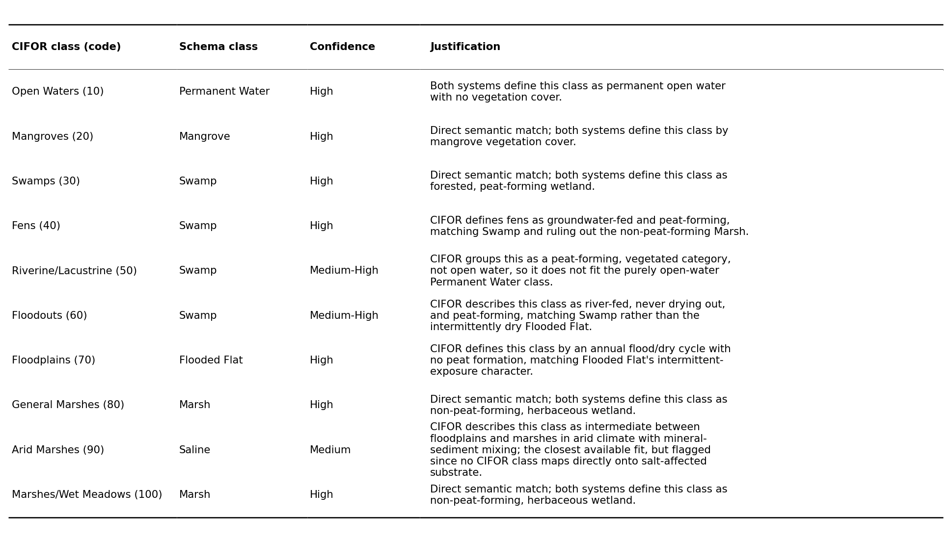

Appendix B: Pixel-Level Class Persistence
As a check on pixel-level stability, the number of distinct classes assigned to each pixel across the full seven-anchor-year sequence was computed from the classified rasters, restricted to the study-area boundary. This uses distinct-class-count per pixel rather than annual-resolution oscillation analysis, which would require a consecutive annual classified sequence that this anchor-year design does not provide.
Within the study area, 86.44% of pixels were classified identically in all seven anchor years. Of the remainder, 10.66% took exactly two distinct classes across the period, and pixels cycling through four or more classes account for 0.30% of the study area. This degree of single-class persistence is consistent with the swap-dominated pattern reported at interval resolution in Section 3.2, and indicates that the observed turnover involves a boundary-concentrated subset of the landscape rather than the study area generally.
Table 7:Number of distinct wetland classes occupied per pixel across the seven anchor years, 2005-2022.
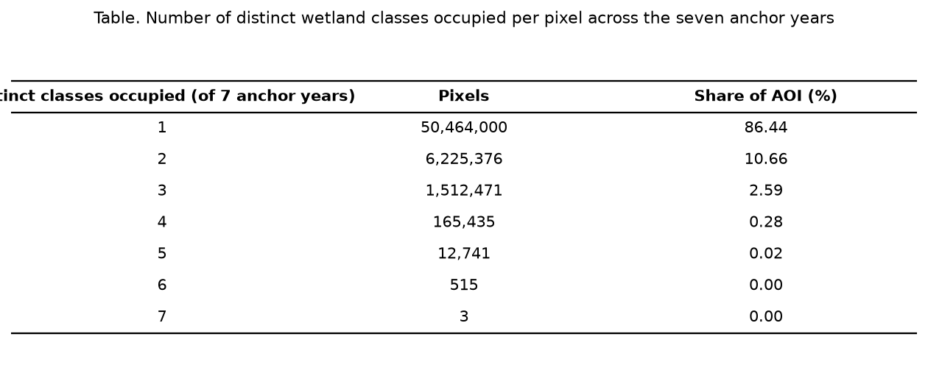

Appendix C: Feature Importance and Multicollinearity
Supporting detail for the feature-importance and multicollinearity results in Section 3.1. Figure 14 shows the per-band Gini importance ranking from the final classifier (Section 2.6), reporting both the top 20 individual bands and importance summed by feature family. Figure 15 shows the full 94 x 94 pairwise correlation structure underlying the multicollinearity check, alongside the 20 bands with the highest variance inflation factor.
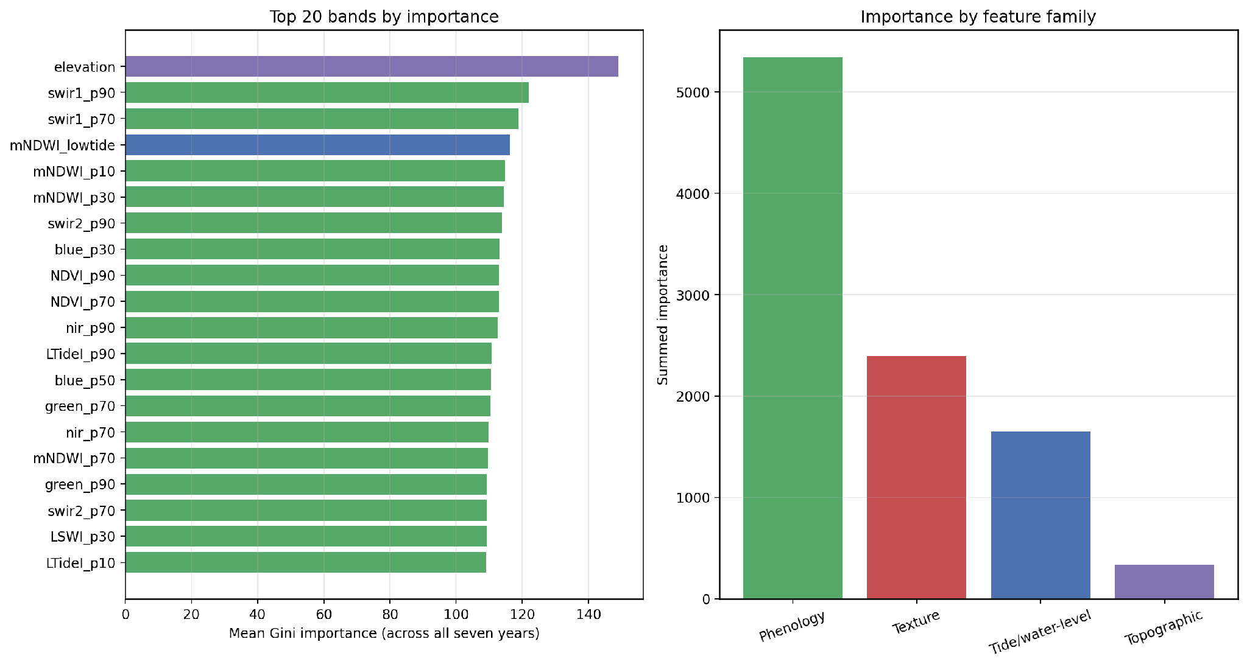
Figure 14:Per-band Gini importance: top 20 bands (left) and summed importance by feature family (right).
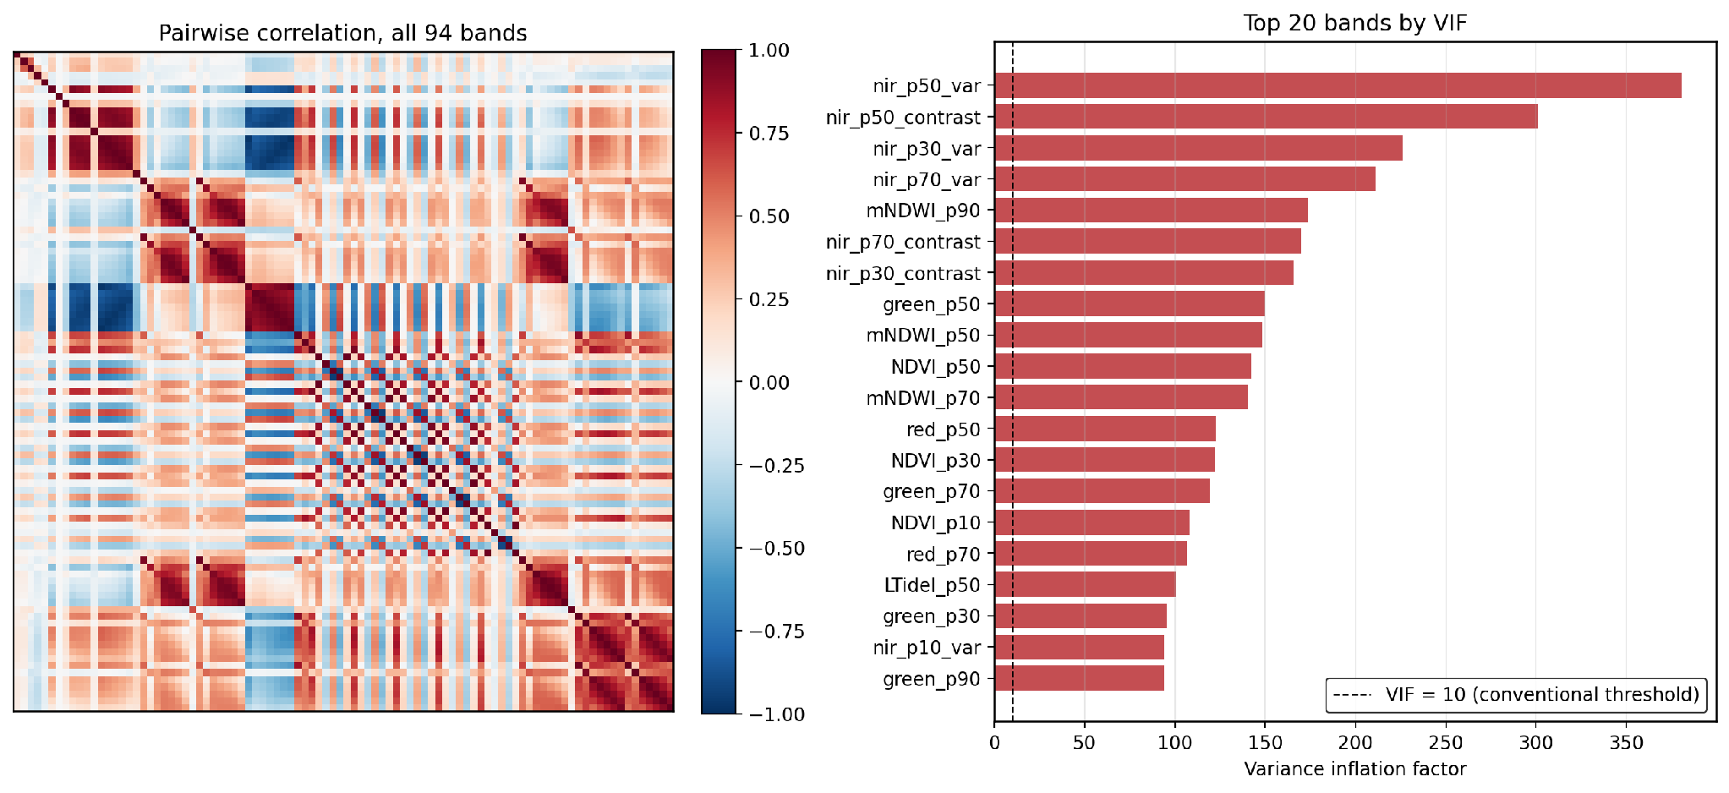
Figure 15:Pairwise correlation across all 94 predictor bands (left) and the 20 bands with the highest variance inflation factor (right).

Appendix D: Change Intensity Analysis
Intensity analysis (Aldwaik & Pontius, 2012) separates two questions. The interval-level test asks whether each interval changed faster or slower than a uniform annual rate; the category-level test asks whether each class's gain and loss intensity is high or low relative to its own extent. This complements the gain/loss/swap decomposition in Section 3.2, which addresses composition rather than pace.
At interval level (Figure 16), the three shortest and most recent intervals, each of two years, changed faster than the six-interval mean rate of 2.20% of the study area per year, and the three longer, earlier intervals changed slower. The longest interval, 2005-2010, is the slowest of the series. Because interval length and the faster/slower split align this closely, the pattern is at least as consistent with an averaging effect of interval length as with genuine acceleration, and is not interpreted as a trend.
At category level (Figure 17), averaged across the six intervals, Salt Marsh and Marsh show the highest gain and loss intensity relative to their own extent, and Non-wetland, by far the largest class, the lowest. This is consistent with the boundary-concentrated pattern described in Sections 3.2 and 4.1. Saline is excluded from Figure 17, since a percentage-of-extent measure is uninformative for a class of near-zero extent.
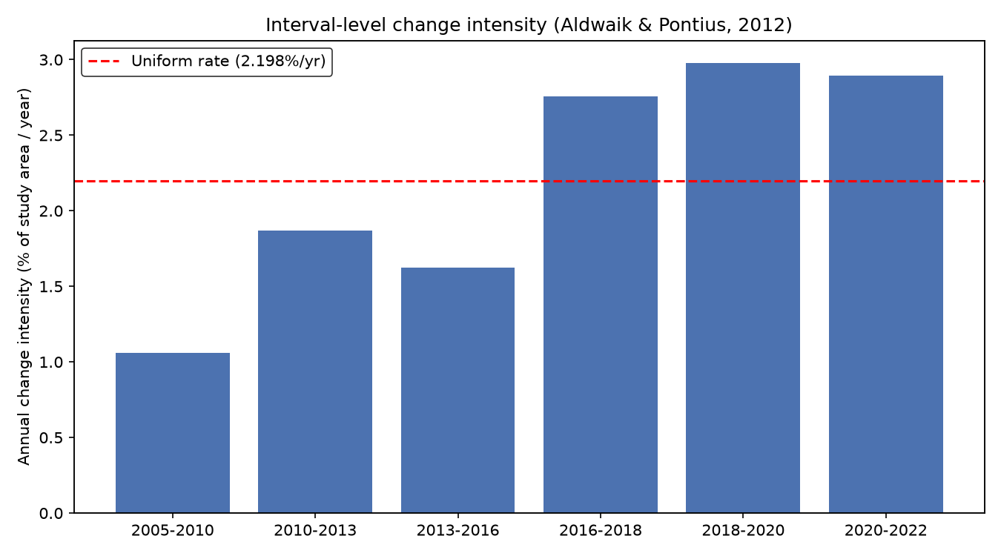
Figure 16:Interval-level change intensity across the six anchor-year intervals, 2005-2022, against the six-interval mean annual rate.
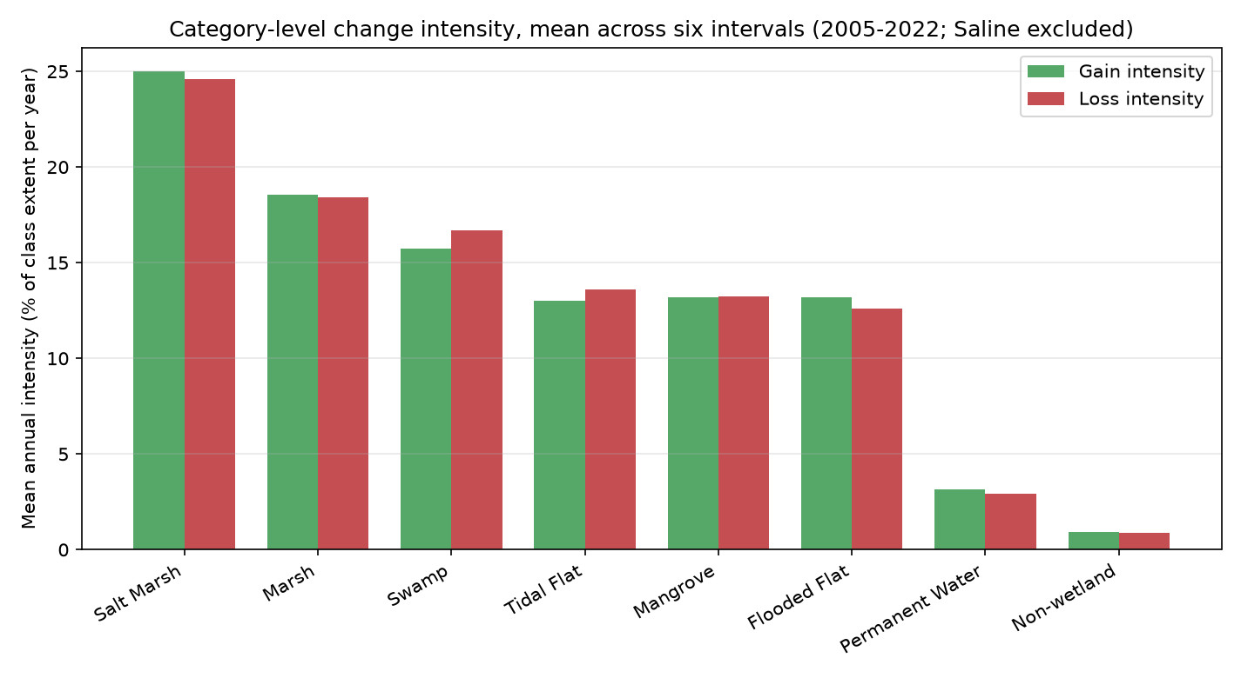
Figure 17:Category-level change intensity: mean gain and loss as a percentage of class extent per year, averaged across the six intervals. Saline excluded.

Appendix E: Water Storage Trend Slopes by Class
Supporting detail for the class-level storage trends in Section 3.3. Table 8 gives the Theil-Sen slope of TWSA over the seven anchor years for each class, with the number of years carrying a real observation. All nine classes have a complete seven-year record, since every anchor year postdates the GLDAS coverage start, so all class-level trends rest on equal footing.
Table 8:Theil-Sen trend slope of terrestrial water storage anomaly by wetland class, 2005-2022.
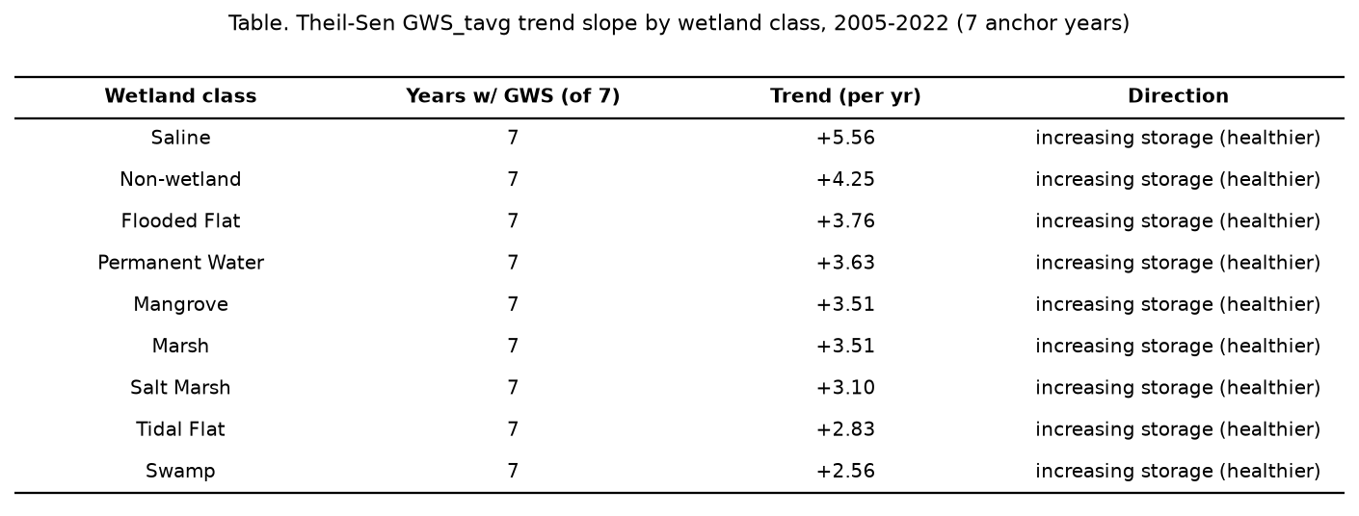

Appendix F: Full Numeric Transition Matrices
Full class-to-class transition matrices in hectares, supporting Section 3.2: the full anchor-year span, and two representative intervals discussed in the text, 2010-2013 and 2016-2018. Row labels denote each class in the earlier year and column labels in the later year, so the diagonal reports area remaining in the same class and off-diagonal cells the area exchanged between each pair. The remaining four interval matrices are available in the accompanying data export. Class abbreviations: NW = Non-wetland, PW = Permanent Water, SW = Swamp, MA = Marsh, FF = Flooded Flat, SA = Saline, MG = Mangrove, SM = Salt Marsh, TF = Tidal Flat.
Table 9:Full transition matrix (hectares), 2005 to 2022.
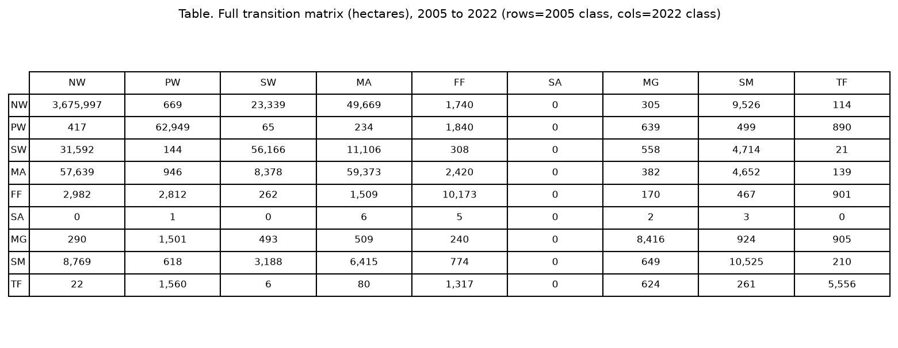
Table 10: Full transition matrix (hectares), 2010 to 2013.
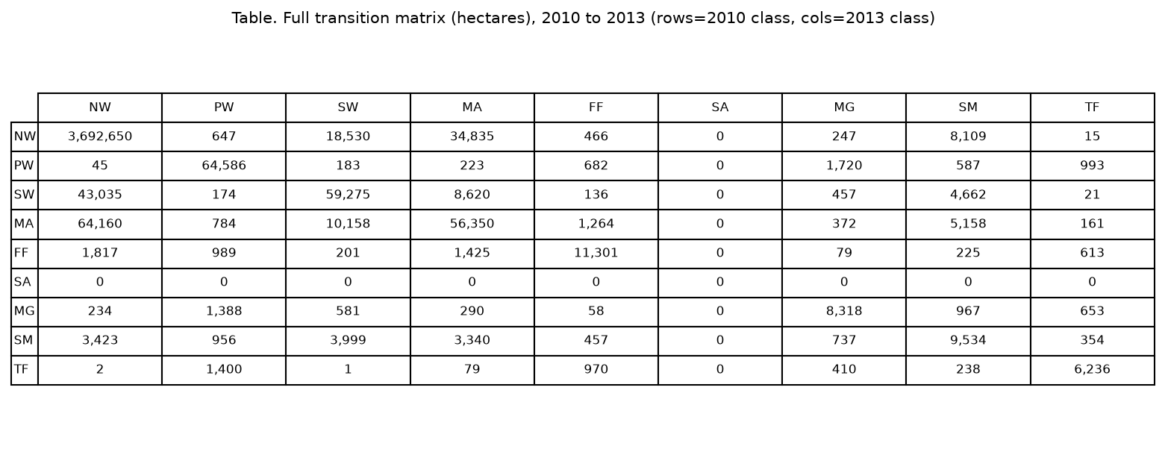
Table 11: Full transition matrix (hectares), 2016 to 2018.
