Exercise 1a Flashing Leds

**Implementations:**

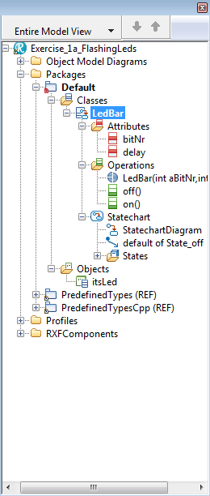

**Methods:**

on()

LPC_GPIO2->FIOSET |= (1 << bitNr);

off()

LPC_GPIO2->FIOCLR |= (1 << bitNr);

**Statecharts:**

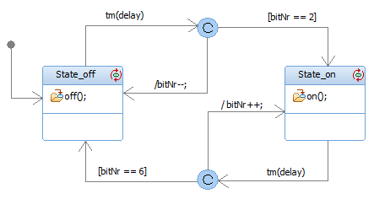

Exercise 1b Moving Light

**Implementations:**

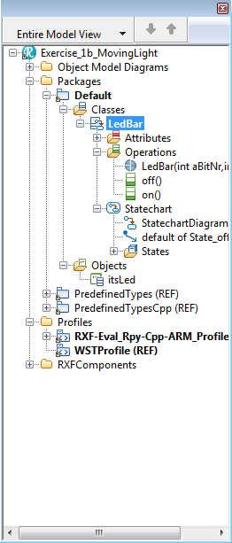

**Methods:**

on()

LPC_GPIO2->FIOSET |= (1 << bitNr);

off()

LPC_GPIO2->FIOCLR |= (1 << bitNr);

**Statecharts:**

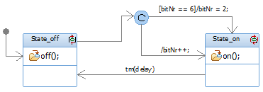

Exercise 2 Dynamic Delay

**Implementations:**

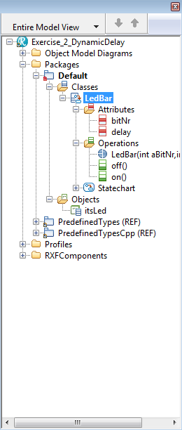

**Methods:**

on()

LPC_GPIO2->FIOSET |= (1 << bitNr);

off()

LPC_GPIO2->FIOCLR |= (1 << bitNr);

**Statecharts:**

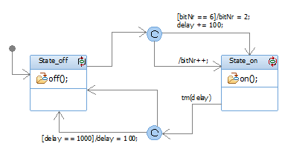

Exercise 3 LedWithPoti

**Implementations:**