

Quick Installation Guide
Release 1.3

17 October 2006

Jens Kupferschmidt (Leipzig)
Kathleen Krebs (Hamburg)

Introduction
This guide describes the installation of the demo distribution of the MyCoRe sample application software DocPortal. The goal is to demonstrate how the software works. After the installation you get a complete running system to work off line on your own computer. The installation should be very easy for non-IT-specialists. For installing a production server system we recommend to read the DocPortal documentation and the MyCoRe documentation. You can install this demo distribution under Linux or Microsoft Windows.
The software uses three system ports for the communication. Port 8291 for the web application, port 8298 for the HSQLDB access and port 8299 for the file upload. To test the editor system you must use the login of a user (see table). To administrate the system use the user administrator with alleswirdgut too.
User | Password
author1A | author1A
author2A | author2A
author1B | author1B
author2B | author2B
editor1A | editor1A
editor2A | editor2A
editor1B | editor1B
editor2B | editor2B
reader1A | reader1A
reader1B | reader1B
gast | none

Preconditions for MS Windows
To install and run the demonstration you need only a current JDK (Java Developer Kit form Sun) installation version 1.5.0 or higher. This software you can download from the SUN Java web pages:
http://java.sun.com/j2se/1.5.0/download.jsp
To install it follow the instruction and/or run the downloaded *.exe file. Follow the installation instructions dialogue. After the successful installation, set the system environment variable JAVA_HOME with the system configuration tool.
Start - Settings  Control Panel
System  Advanced  Environment Variables
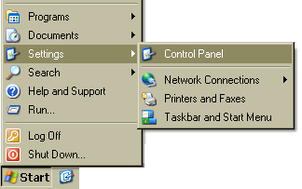
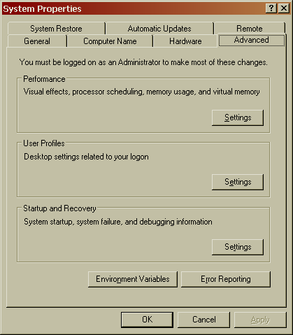
 New (system variable)
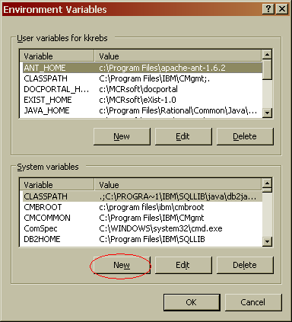
Add the entry:
JAVA_HOME
C:\Programme\Java\jdk1.5.0_05\jre
and press OK.

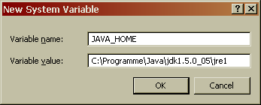
Preconditions for Linux
The default installation under Linux is planned for the user mcradmin with the home directory /home/mcradmin. Add this user to your system with the /bin/bash UNIX shell. Install the JDK package from your Linux distribution. You should install the XPDF- and OpenOffice-packages for text extracting too.
Set the environment (if not automatic) for the user mcradmin with
export JAVA_HOME=/usr/lib/java

Installation and test DocPortal
The installation is the same for all Operation systems. It depends that you have been installed the Java Kit 1.5.x or higher. Download the distribution docportal-installable-yyyyMMdd.jar form our web page or take the distribution media like CD. yyyyMMdd is the date of the distribution.
Start the installation with double click to the *.jar file or with java -Xmx1024m -Xms1024m -jar docportal-installable-yyyyMMdd.jar .

Language selection
At first select the language for the installation dialogue. It is not the language default for the application!
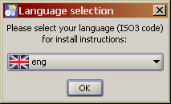

Welcome
Now you get a welcome window. Click next.

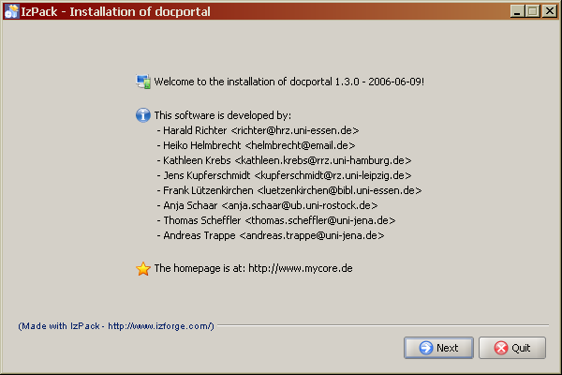
ReadMe
The ReadMe text show you some short information about this installation.

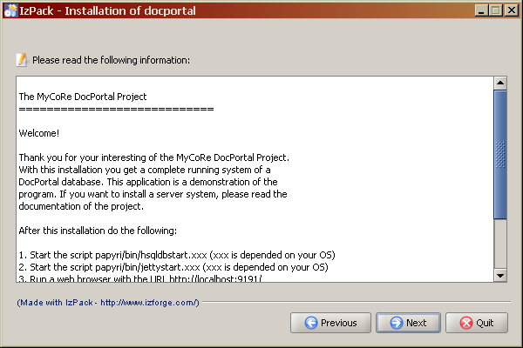
Licence
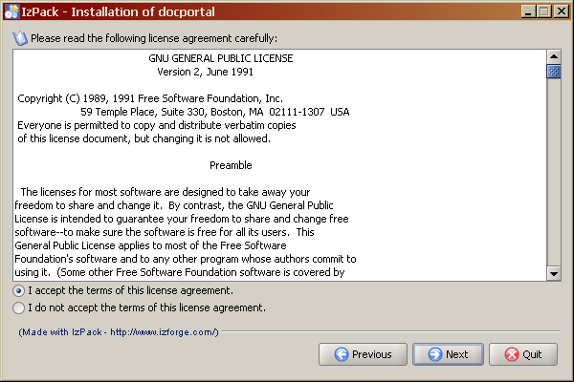
As next step you must agree the licence of the software. All own software of this project is under the GNU Public License.

Select the install path
With the next window you can select the installation path. This will be write to your installed data.

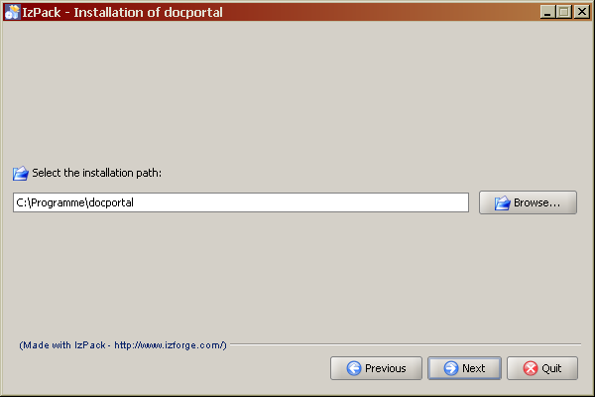
Select the packages
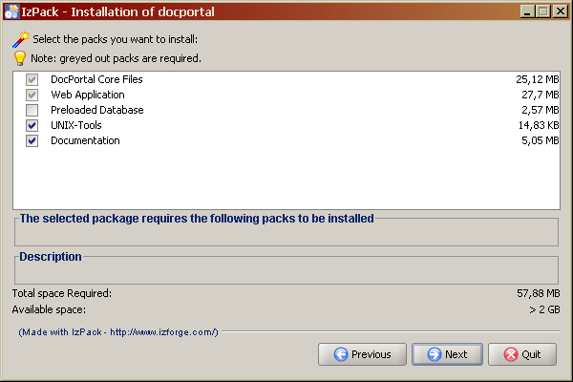

If you agree the license you can select the packages for the installation. On the first installation you must select the Preloaded Database too. If you install a newer version of an distribution please save your data and do not select the Preloaded Database package!

Installation
If you have select the packages and click next the installation will be start. It show you the following window.

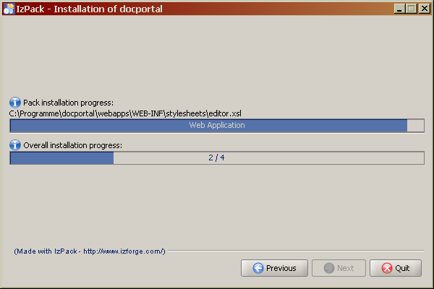
Finish
The installation is finished now. Don't push the 'Generate an automatic installation script' button. See the next chapter for running the system.
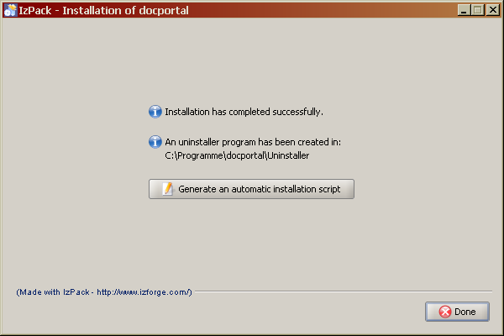

Run the system
After a successfully installation you can run the system. This steps you must do each time to run the software on your own computer. In the bin directory you can find command scripts for your operating system. This can be *.sh for UNIX, *.cmd for Windows. Do the following steps:
- start the HSQLDB with bin/hsqldbstart.xxx and let it run
- start the Jetty servlet engine with bin/jettystart.xxx and let it run
- open the Web browser and enter the URL http://localhost:8291/
For Windows user Shortcuts are installed. You can start the HSQLDB-Server and Jetty over the shortcut menu.

Other tools
To use the full text search for documents you should install the XPDF- and OpenOffice-programs on your system.

Installing sample data
For testing the installation DocPortal provide some sample data blocks. Available are the following packages form the MyCoRe download page:
Package | Description
defaultsamples-installable-yyyyMMdd.jar | Some little data samples like images, text and so on
audiosamples-installable-yyyyMMdd.jar | Audio samples as content
videosamples-installable-yyyyMMdd.jar | Video samples as content (large)
theses-installable-yyyyMMdd.jar | Some theses about MyCoRe as content
kochbuch-yyyyMMdd.jar | Teddies Kochbuch von U. Reber as content
The installation is the same like DocPortal. Attention! You must have run the HSQLDB and Jetty server. Otherwise you can get errors. After installation the process will load the data automatically. Search after install for data like 'author is Jens'.
In next month we will add more sample data packages too.

Contact
You can contact the developers of the project under the email address mycore-user@lists.sourceforge.net. Before you do this would you first consult the complete documentation to find solutions of your problem!
Have a lot of fun!

included in the distribution or you visit http://www.mycore.de/
tested under SuSE 9.3
tested under Windows XP
in German: Systemsteuerung --> System --> Erweitert --> Umgebungsvariable --> Neue System Variable
or the path of the Java installation
http://www.mycore.de/content/main/download.xml
http://www.foolabs.com/xpdf/
http://de.openoffice.org/

