**Single Nucleotide Polymorphisms – a primer**

Single Nucleotide Polymorphisms (also known as SNPs) are single base variants that are commonly seen in genomes of the general human population. The following diagram shows two copies of a section of chromosome for an individual (one inherited from mother and one from father). The forward and reverse strands are presented.

Forward

[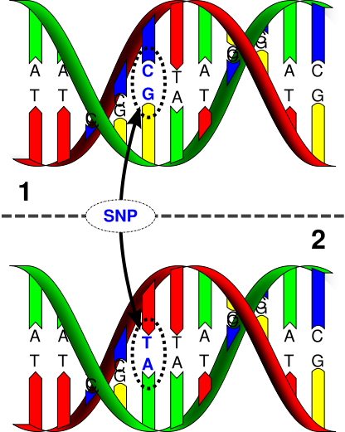](http://upload.wikimedia.org/wikipedia/commons/2/2e/Dna-SNP.svg)

Forward

Reverse

Reverse

In the diagram you can see that at one base-pair position the genetic code looks different across the two chromosomes copies in comparison to the other bases in that region. This is an example of a SNP.

Specifically this is a C/T SNP or G/A SNP - depending on whether we focus on the forward or reverse strand – but for argument’s sake we will take the forward strand so we will describe it as C/T SNP here.

A given SNP usually has 3 combinations of letters, or “alleles”. Each combination of alleles makes up a different “genotype”. Here are the three genotypes for a C/T SNP.

T/T

C/T (or T/C equivalent)

C/C

Some of these genotypes will be more common in the general population than others.

The values for each SNP can be provided as numerical representation of the genotypes – coded to reflect the number of rare alleles (or “minor alleles”) an individual carries, say. For example, if the “C” allele for the SNP above is present in 25% of the population whereas the T allele for the SNP occurs in 75% of the population, then the “C” allele is the minor allele (with a minor allele frequency of 0.25) and the following genotypes are coded as follows:

T/T = 0 (common homozygote)

T/C = 1 (heterozygote)

C/C = 2 (rare homozygote)

So an individual with the genotype C/C will be coded as 2, for example, as they carry two copies of the minor ‘C’ allele at that SNP site.