Name: Diotangshu Dey

Roll No: 20CS8018

Assignment 5

1. Code:

*#include* <iostream>

using namespace std;

class Complex {

private:

float real, imag;

public:

Complex(float r = 0, float i = 0) {

real = r;

imag = i;

}

Complex operator+(Complex const &cmplx) {

Complex res;

res.real = real + cmplx.real;

res.imag = imag + cmplx.imag;

*return* res;

}

Complex operator-(Complex const &cmplx) {

Complex res;

res.real = real - cmplx.real;

res.imag = imag - cmplx.imag;

*return* res;

}

Complex operator*(const Complex &cmplx) {

Complex res;

res.real = real * (cmplx.real + cmplx.imag);

res.imag = imag * (cmplx.real + cmplx.imag);

*return* res;

}

Complex operator !() {

Complex res;

res.real = real;

res.imag = -1 * imag;

*return* res;

}

Complex operator/(Complex cmplx) {

Complex res;

res.real = real;

res.imag = imag;

float d = cmplx.real*cmplx.real + cmplx.imag*cmplx.imag;

res = res * (!cmplx);

res.real/=d; res.imag/=d;

*return* res;

}

bool operator==(const Complex &cmplx) {

Complex res;

*if* (res.real == cmplx.real && res.imag == cmplx.real) {

*return* true;

} *else* {

*return* false;

}

}

bool operator!=(Complex cmplx) {

Complex res;

*if* (res.real == cmplx.real && res.imag == cmplx.real) {

*return* false;

} *else* {

*return* true;

}

}

Complex operator=(const Complex &cmplx) {

Complex res;

res.real = cmplx.real;

res.imag = cmplx.imag;

*return* res;

}

int operator[](int i) {

*if* (i == 0)

*return* real;

*else* *if* (i == 1)

*return* imag;

*else* {

cout << "Index Out of bounds";

*return* -1;

}

}

friend istream & operator >> (istream &in, Complex &cmplx){

cout << "Enter Real Part ";

in >> cmplx.real;

cout << "Enter Imaginary Part ";

in >> cmplx.imag;

*return* in;

}

friend ostream &operator<<(ostream &out, const Complex &cmplx) {

*if*(cmplx.imag >= 0)

out << cmplx.real << "+i" << cmplx.imag;

*else*

out << cmplx.real << "-i" << -cmplx.imag;

*return* out;

}

void show() {

cout<<endl<<real<<"+i"<<imag<<endl;

}

};

int main() {

Complex c1, c2;

cout << "Enter value of c1: ";

cin >> c1;

cout << "Enter value of c2: ";

cin >> c2;

cout << "Sum is : " << c1 + c2 << endl;

cout << "Difference is : " << c1 - c2 << endl;

cout << "Product is : " << c1 * c2 << endl;

cout << "Division(c1/c2) is : " << c1 / c2 << endl;

cout << "Conjugate of c1 is " << !c1 << endl;

cout << "Conjugate of c2 is " << !c2 << endl;

cout<<"c1[0] = "<<c1[0]<<", c1[1] = "<<c1[1]<<endl;

}

Output:

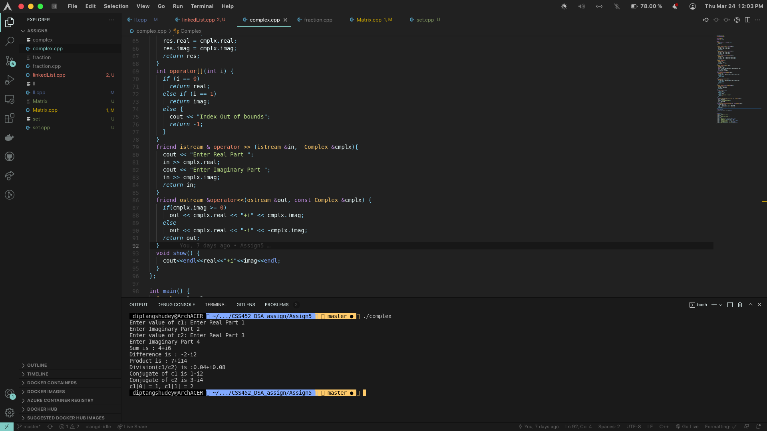

2. Code:

*#include* <iostream>

*#include* <algorithm>

*#include*<cstdlib>

using namespace std;

int lcm(int a, int b) {

*return* (a*b/__gcd(a,b));

}

class fraction {

private:

int num, deno;

public:

fraction() {

num = deno = 1;

}

fraction operator+(const fraction &frac) {

fraction res;

res.num = (num * frac.deno) + (deno * frac.num);

res.deno = deno * frac.deno;

res.deno = res.deno / __gcd(res.num, res.deno);

res.num = res.num / __gcd(res.num, res.deno);

*return* res;

}

fraction operator-(const fraction &frac) {

fraction res;

res.num = num * frac.deno - deno * frac.num;

res.deno = deno * frac.deno;

res.deno = res.deno / __gcd(res.num, res.deno);

res.num = res.num / __gcd(res.num, res.deno);

*return* res;

}

fraction operator*(const fraction &frac) {

fraction res;

res.num = num * frac.num;

res.deno = deno * frac.deno;

res.deno = res.deno / __gcd(res.num, res.deno);

res.num = res.num / __gcd(res.num, res.deno);

*return* res;

}

fraction operator/(const fraction &frac) {

fraction res;

res.num = num * frac.deno;

res.deno = deno * frac.num;

res.deno = res.deno / __gcd(res.num, res.deno);

res.num = res.num / __gcd(res.num, res.deno);

*return* res;

}

fraction operator*() {

fraction res;

res.deno = res.deno / __gcd(res.num, res.deno);

res.num = res.num / __gcd(res.num, res.deno);

*return* res;

}

bool operator==(const fraction &frac) {

*if* (num * (lcm(deno, frac.deno) / deno) ==

frac.num * (lcm(deno, frac.deno) / frac.deno))

*return* true;

*else*

*return* false;

}

bool operator!=(const fraction &frac) {

*if* (num * (lcm(deno, frac.deno) / deno) ==

frac.num * (lcm(deno, frac.deno) / frac.deno))

*return* false;

*else*

*return* true;

}

bool operator>(const fraction &frac) {

*if* (num * (lcm(deno, frac.deno) / deno) >

frac.num * (lcm(deno, frac.deno) / frac.deno))

*return* true;

*else*

*return* false;

}

bool operator<(const fraction &frac) {

*if* (num * (lcm(deno, frac.deno) / deno) >

frac.num * (lcm(deno, frac.deno) / frac.deno))

*return* false;

*else*

*return* true;

}

fraction operator=(const fraction &frac) {

fraction res;

res.num = frac.num;

res.deno = frac.deno;

*return* res;

}

int operator[](int a) {

*if* (a == 0)

*return* num;

*else*

*return* deno;

}

friend istream & operator >> (istream &in, fraction &frac){

cout << "Enter Numerator Part ";

in >> frac.num;

cout << "Enter Denominator Part ";

in >> frac.deno;

*return* in;

}

friend ostream &operator<<(ostream &out, const fraction &frac) {

*if*(frac.deno * frac.num >= 0)

out << frac.num << "/" << frac.deno;

*else*

out << -abs(frac.num) << "/" << abs(frac.deno);

*return* out;

}

};

int main() {

fraction f1, f2;

cout << "Enter Fraction 1: " << endl;

cin >> f1;

cout << "Enter Fraction 2: " << endl;

cin >> f2;

cout << "Sum is : " << f1 + f2 << endl;

cout << "Difference is : " << f1 - f2 << endl;

cout << "Product is : " << f1 * f2 << endl;

cout << "Division(f1/f2) is : " << f1 / f2 << endl;

cout<<"f1[0] = "<<f1[0]<<", f1[1] = "<<f1[1]<<endl;

*return* 0;

}

Output:

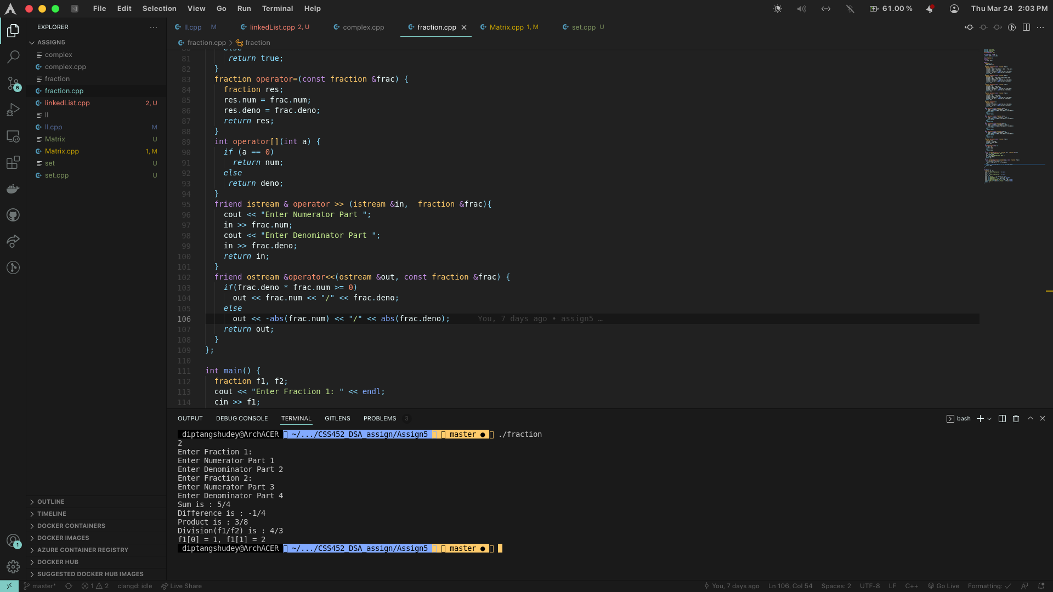

3. Code:

*#include* "bits/stdc++.h"

using namespace std;

class Matrix

{

int **a;

int r, c, t;

public:

Matrix()

{

r = 0;

c = 0;

t = -1;

a = new int *[r];

}

Matrix(int R, int C)

{

r = R;

c = C;

t = -1;

a = new int *[r];

*for* (int i = 0; i < r; i++)

{

a[i] = new int[c];

}

}

Matrix(const Matrix &M)

{

r = M.r;

c = M.c;

t = -1;

a = new int *[r];

*for* (int i = 0; i < r; i++)

{

a[i] = new int[c];

*for* (int j = 0; j < c; j++)

{

a[i][j] = M.a[i][j];

}

}

}

bool checkEqualOrder(const Matrix &M)

{

*if* (M.c == c && M.r == r)

*return* true;

*return* false;

}

Matrix operator+(const Matrix &M)

{

*if* (checkEqualOrder(M))

{

*for* (int i = 0; i < r; i++)

{

*for* (int j = 0; j < c; j++)

{

a[i][j] += M.a[i][j];

}

}

}

*return* *this;

}

Matrix operator-(const Matrix &M)

{

*if* (checkEqualOrder(M))

{

*for* (int i = 0; i < r; i++)

{

*for* (int j = 0; j < c; j++)

{

a[i][j] -= M.a[i][j];

}

}

}

*return* *this;

}

bool checkMulOrder(const Matrix &M)

{

*return* c == M.r;

}

Matrix operator*(const Matrix &M)

{

*if* (checkMulOrder(M))

{

Matrix M2(r, M.c);

*for* (int i = 0; i < r; i++)

{

*for* (int j = 0; j < M.c; j++)

{

*for* (int k = 0; k < c; k++)

{

M2.a[i][j] += a[i][k] * M.a[k][j];

}

}

}

*return* M2;

}

*return* *this;

}

void Copy(const Matrix &M)

{

delete[] a;

a = new int *[M.r];

r = M.r;

c = M.c;

*for* (int i = 0; i < r; i++)

{

a[i] = new int[c];

*for* (int j = 0; j < c; j++)

{

a[i][j] = M.a[i][j];

}

}

}

bool Compare(const Matrix &M)

{

*if* (r == M.r && c == M.c)

{

*for* (int i = 0; i < r; i++)

{

*for* (int j = 0; j < c; j++)

{

*if* (a[i][j] != M.a[i][j])

*return* false;

}

}

*return* true;

}

*else*

*return* false;

}

Matrix operator!()

{

*for* (int i = 0; i < r; i++)

{

*for* (int j = i; j < c; j++)

{

int t = a[i][j];

a[i][j] = a[j][i];

a[j][i] = t;

}

}

*return* *this;

}

int *operator[](int x)

{

*if* (x >= r)

{

t = -1;

*return* NULL;

}

t = x;

*return* a[x];

}

int operator[](long x)

{

*if* (x > c || t == -1)

{

cout << "Out of Bounds access!" << endl;

exit(1);

*return* 2e-5;

}

*return* a[t][x];

}

bool operator==(const Matrix &M)

{

*return* Compare(M);

}

bool operator!=(const Matrix &M)

{

*return* !Compare(M);

}

void operator=(const Matrix &M)

{

Copy(M);

}

friend ostream &operator<<(ostream &x, const Matrix &M)

{

*for* (int i = 0; i < M.r; i++)

{

*for* (int j = 0; j < M.c; j++)

{

x << M.a[i][j] << " ";

}

x << endl;

}

*return* x;

}

friend istream &operator>>(istream &x, Matrix &M)

{

*for* (int i = 0; i < M.r; i++)

{

*for* (int j = 0; j < M.c; j++)

{

x >> M.a[i][j];

}

}

*return* x;

}

};

int main()

{

int r1, r2, c1, c2;

cout << "Enter order of first matrix:";

cin >> r1 >> c1;

cout << "Enter order of second matrix:";

cin >> r2 >> c2;

Matrix M1(r1, c1), M2(r2, c2);

cout << "Enter first Matrix:\n";

cin >> M1;

cout << "Enter second Matrix:\n";

cin >> M2;

cout << "The 1<st Matrix is : \n";

cout << M1;

cout << "The 2nd Matrix is : \n";

cout << M2;

Matrix M3(r1, c1);

M3 = M1 + M2;

cout << "The Addition of 2 matrices is : \n";

cout << M3;

Matrix M4(r1, c1);

M4 = M1 - M2;

cout << "The Difference of 2 matrices is : \n";

cout << M4;

Matrix M5(r1, c1);

M5 = M1 * M2;

cout << "The Product of 2 matrices is : \n";

cout << M5;

cout << "Inversion of a matrix is : \n"

<< (!M1) << endl;

*if* (M1 == M2)

{

cout << "The Matrices are equal!" << endl;

}

*else*

{

cout << "The Matrices are not equal!" << endl;

}

cout << "Enter subscript as row followed by column :\n";

int x, y;

cin >> x >> y;

cout << "Output: " << M1[x][y] << endl;

cout << "Copying M1 to M2:";

M2 = M1;

cout << "M2: \n"<< M2 << endl;

*return* 0;

}

Output:

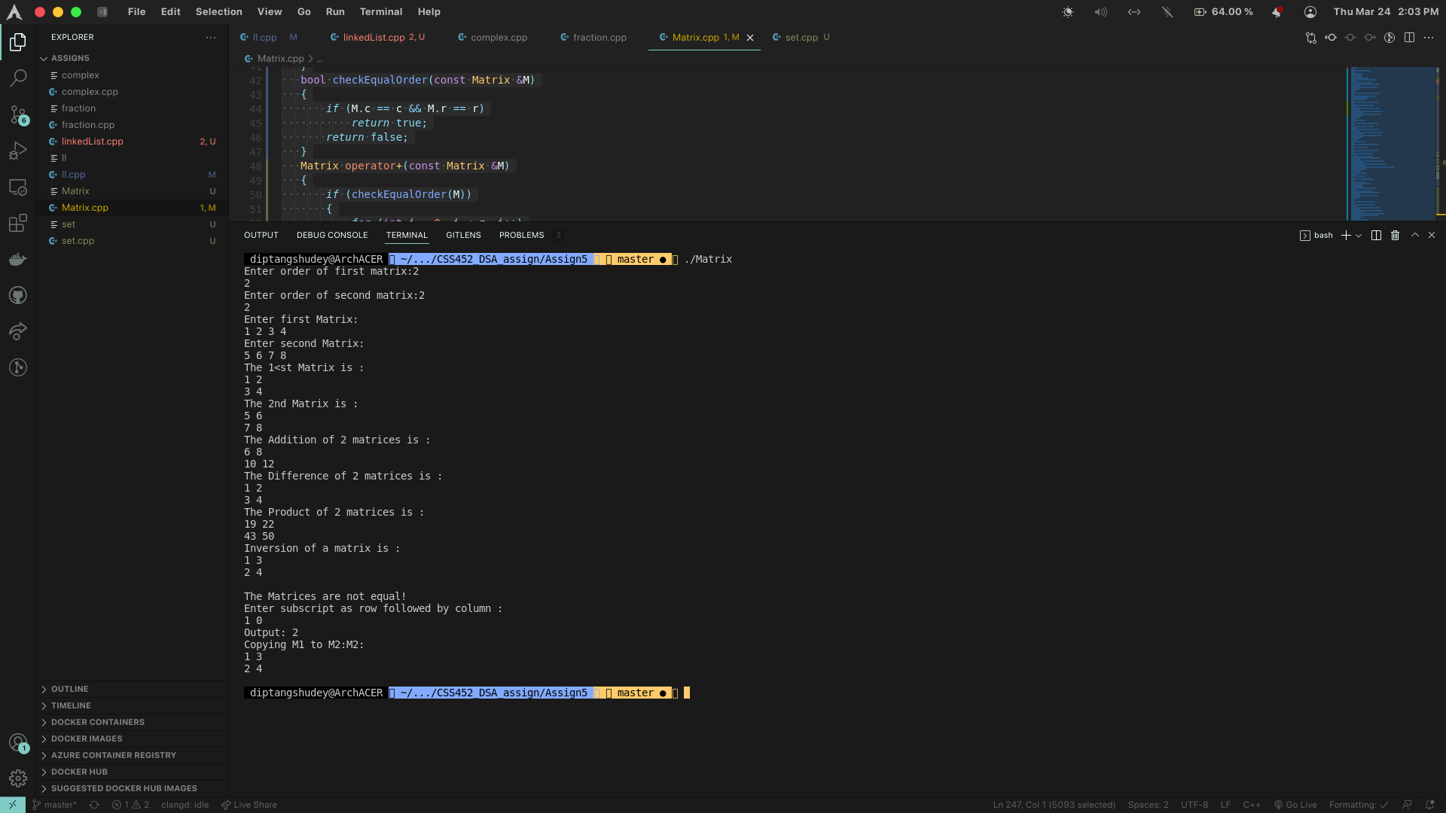

4. Code:

*#include* <iostream>

*#include* <vector>

using namespace std;

class Set {

private:

vector<int> val;

public:

Set operator+(const Set &s) {

Set res, tmp;

tmp.val = val;

Set t1 = tmp - s;

res.val.insert(res.val.end(), t1.val.begin(), t1.val.end());

res.val.insert(res.val.end(), s.val.begin(), s.val.end());

*return* res;

}

Set operator-(const Set &s) {

Set res;

*for* (int i = 0; i < val.size(); i++) {

res.val.push_back(val[i]);

*for* (int j = 0; j < s.val.size(); j++) {

*if* (val[i] == s.val[j]) {

res.val.pop_back();

*break*;

}

}

}

*return* res;

}

Set operator*(const Set &s) {

Set res;

*for* (int i = 0; i < val.size(); i++) {

*for* (int j = 0; j < s.val.size(); j++) {

*if* (val[i] == s.val[j]) {

res.val.push_back(val[i]);

*break*;

}

}

}

*return* res;

}

bool operator<(const Set &s) {

*if* (val.size() <= s.val.size()) {

int count = 0;

*for* (int i = 0; i < val.size(); i++) {

*for* (int j = 0; j < s.val.size(); j++) {

*if* (val[i] == s.val[j]) {

*break*;

count++;

}

}

}

*if* (count == val.size())

*return* true;

*else*

*return* false;

}

*else* {

*return* false;

}

}

bool operator<=(const Set &s) {

*if* (val.size() <= s.val.size()) {

int count = 0;

*for* (int i = 0; i < val.size(); i++) {

*for* (int j = 0; j < s.val.size(); j++) {

*if* (val[i] == s.val[j]) {

*break*;

count++;

}

}

}

*if* (count == val.size())

*return* true;

*else*

*return* false;

}

*else* {

*return* false;

}

}

bool operator>(const Set &s) {

*if* (val.size() >= s.val.size()) {

int count = 0;

*for* (int i = 0; i < s.val.size(); i++) {

*for* (int j = 0; j < val.size(); j++) {

*if* (val[j] == s.val[i]) {

*break*;

count++;

}

}

}

*if* (count == s.val.size())

*return* true;

*else*

*return* false;

}

*else* {

*return* false;

}

}

bool operator>=(const Set &s) {

*if* (val.size() >= s.val.size()) {

int count = 0;

*for* (int i = 0; i < s.val.size(); i++) {

*for* (int j = 0; j < val.size(); j++) {

*if* (val[j] == s.val[i]) {

*break*;

count++;

}

}

}

*if* (count == s.val.size())

*return* true;

*else*

*return* false;

}

*else* {

*return* false;

}

}

bool operator==(Set &s) {

*if* (val == s.val)

*return* true;

*else*

*return* false;

}

bool operator!=(Set &s) {

*if* (val == s.val) {

*return* false;

} *else* {

*return* true;

}

}

friend istream &operator>>(istream &in, Set &s) {

int n;

cout << "Enter Number of elements for the set: ";

in >> n;

cout<<"Enter the values: \n";

*for* (int i = 0; i < n; i++) {

int t;

in >> t;

s.val.push_back(t);

}

*return* in;

}

friend ostream &operator<<(ostream &out, const Set &s) {

*for* (int i = 0; i < s.val.size(); i++) {

out<<s.val[i]<<" ";

}

*return* out;

}

};

int main() {

Set s1, s2;

cout << "Enter values for s1: \n";

cin >> s1;

cout << "Enter valus for s2: \n";

cin >> s2;

cout << "Union of s1 and s2: " << s1 + s2 << endl;

cout << "Difference of s1 and s2: " << s1 - s2 << endl;

cout << "Intersection of s1 and s2: " << s1 * s2 << endl;

*return* 0;

}

Output:

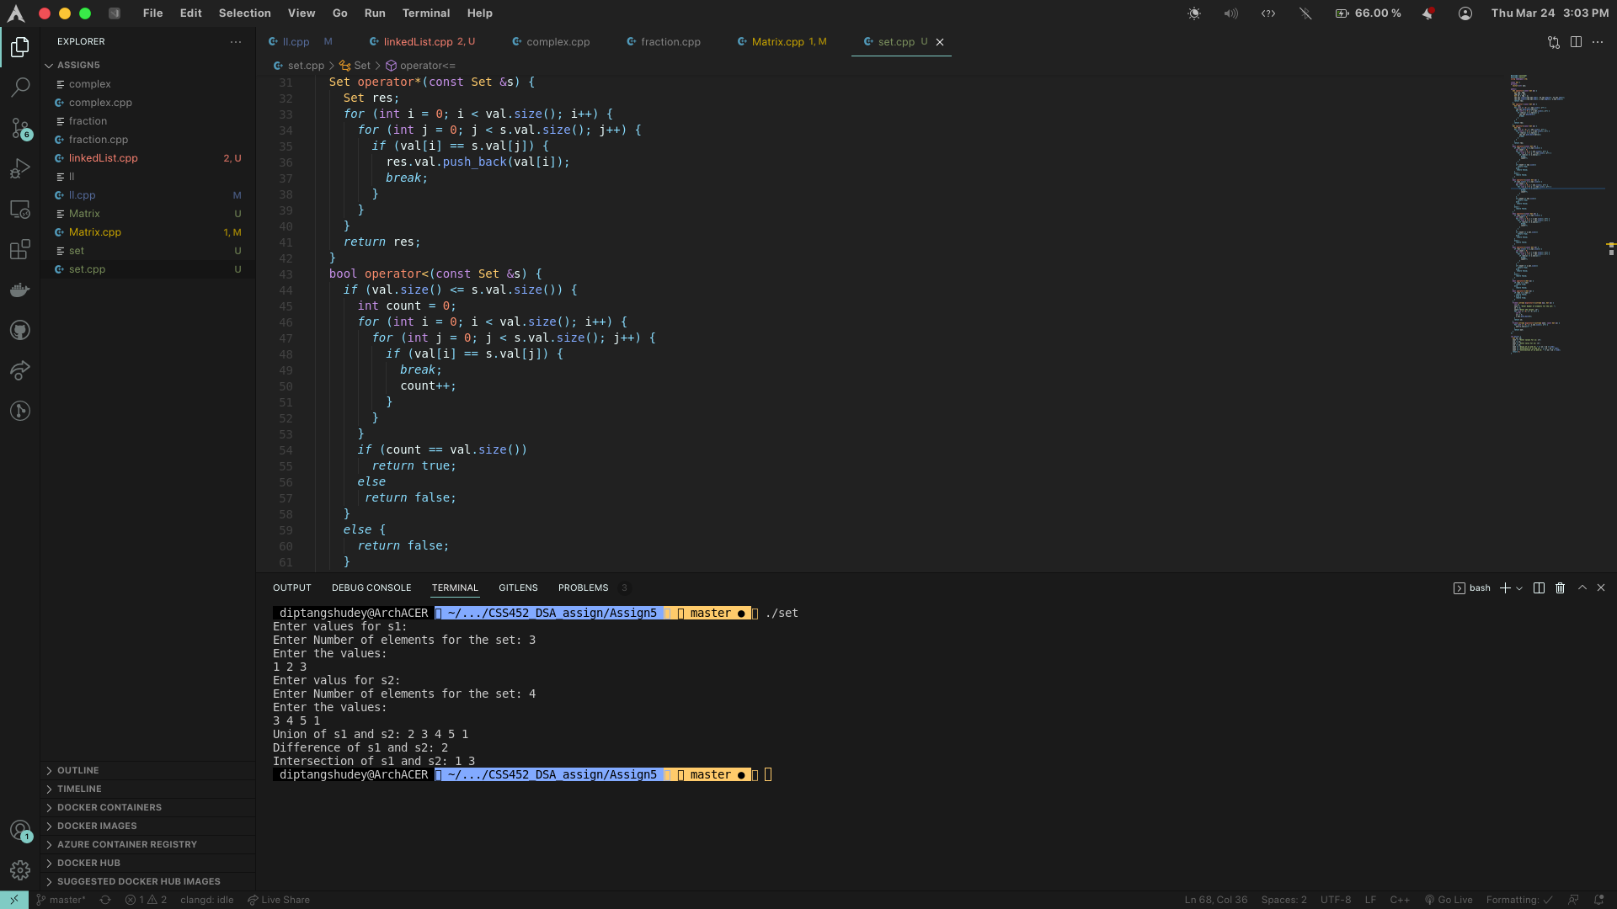

5. Code :

*#include* <iostream>

using namespace std;

class Node

{

public:

int data;

Node *next_link;

static Node *avail;

Node(int, Node *);

Node(const Node &);

void *operator new(size_t size);

void operator delete(void *p);

void display();

};

Node::Node(int x = 0, Node *nd = NULL)

{

data = x;

next_link = nd;

}

Node::Node(const Node &nd)

{

data = nd.data;

next_link = nd.next_link;

}

void *Node::operator new(size_t size)

{

void *p;

*if* (avail == NULL)

{

p = ::operator new(size);

}

*else*

{

p = avail;

avail = avail->next_link;

}

*return* p;

}

void Node::operator delete(void *p)

{

Node *t = (Node *)p;

t->next_link = avail;

t->data = 0;

avail = t;

*return*;

}

Node *Node::avail = NULL;

void Node::display()

{

cout << data;

}

class list

{

private:

Node head;

static list lstat;

public:

list()

{

head.data = 0;

head.next_link = NULL;

}

list(const list &ll)

{

head.data = ll.head.data;

Node *p = ll.head.next_link;

*if* (p == NULL)

{

head.next_link = NULL;

}

*else*

{

Node *q = &head;

*while* (p != NULL)

{

Node *temp = new Node(p->data);

q->next_link = temp;

q = q->next_link;

p = p->next_link;

}

}

}

~list(){

Node *p = head.next_link;

*while* (p != NULL)

{

Node *temp = p;

p = p->next_link;

delete temp;

}

head.data = 0;

}

list &operator+(const list &ll){

static list lstat;

lstat.~list();

lstat = *this;

Node *p = &lstat.head;

*while* (p->next_link != NULL)

{

p = p->next_link;

}

Node *q = ll.head.next_link;

*while* (q != NULL)

{

p->next_link = new Node(q->data);

q = q->next_link;

p = p->next_link;

}

lstat.head.data = head.data + ll.head.data;

*return* lstat;

}

list &operator!(){

*if* (head.data < 2)

{

*return* *this;

}

static list lstat;

lstat.~list();

lstat.head.data = head.data;

Node *p = head.next_link;

*while* (p != NULL)

{

lstat.head.next_link = new Node(p->data, lstat.head.next_link);

p = p->next_link;

}

*return* lstat;

}

bool operator==(const list &ll){

*if* (this == &ll)

{

*return* true;

}

*if* (head.data != ll.head.data)

{

*return* false;

}

Node *p = head.next_link;

Node *q = ll.head.next_link;

*while* (p != NULL)

{

*if* (p->data != q->data)

{

*return* false;

}

p = p->next_link;

q = q->next_link;

}

*return* true;

}

list &operator=(const list &ll){

*if* (this == &ll)

{

*return* *this;

}

this->~list();

this->head.data = ll.head.data;

Node *p = &(this->head);

Node *q = ll.head.next_link;

*while* (q != NULL)

{

p->next_link = new Node(q->data);

p = p->next_link;

q = q->next_link;

}

*return* *this;

}

int operator[](int index){

*if* (index >= head.data)

{

*return* -1e5;

}

Node *p = head.next_link;

int i = 0;

*while* (p != NULL)

{

*if* (i == index)

{

*return* p->data;

}

i++;

p = p->next_link;

}

*return* 1e-5;

}

friend ostream &operator<<(ostream &os, list &ll){

Node *p = &(ll.head);

p = p->next_link;

*while* (p != NULL)

{

p->display();

os << "-->";

p = p->next_link;

}

os << "NULL\n";

*return* os;

}

friend istream &operator>>(istream &is, list &ll){

cout << "Enter no. of nodes: ";

is >> ll.head.data;

Node *p = &ll.head;

*while* (p->next_link != NULL)

{

p = p->next_link;

}

*for* (int i = 0; i < ll.head.data; i++)

{

Node *temp = new Node();

is >> temp->data;

p->next_link = temp;

p = p->next_link;

}

*return* is;

}

};

int main(void)

{

list l1;

cin >> l1;

list l2;

cin >> l2;

cout << "List 1 : " << l1 << endl;

cout << "List 2 : " << l2 << endl;

cout << "Concatinating 2 lists :" << l1 + l2 << endl;

cout << "Reversing the list : " << (!l1) << endl;

*if* (l1 == l2)

{

cout << "Lists are equal\n";

}

*else*

{

cout << "Lists are not equal\n";

}

cout << "Index 1 of 1st list is : " << l1[1] << endl;

}

Output:

