Name: Diptangshu Dey

Roll No: 20CS8018

CSC-453 Signals Processing Laboratory Assignment

Lab Assignment - 2:

**# Q. 2a. Unit step signal**

import matplotlib.pyplot as plt

import numpy as np

x = np.arange(-5., 5., 0.1)

y = []

for i in x:

if (i >= 0):

tmp = 1

else:

tmp = 0

y.append(tmp)

plt.plot(x, y)

plt.show()

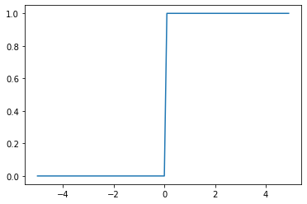

**# Q 2b. Unit impulse signal**

import matplotlib.pyplot as plt

import numpy as np

x = np.arange(-5., 5.)

y = []

for i in x:

if (i == 0):

tmp = 1

else:

tmp = 0

y.append(tmp)

plt.stem(x,y)

plt.show()

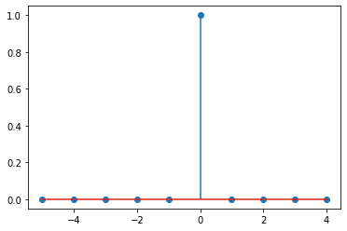

**# Q 2c. Ramp Signal**

import matplotlib.pyplot as plt

import numpy as np

x = np.arange(-4., 10., 0.1)

y = []

for i in x:

if (i >= 0):

y.append(i)

else:

y.append(0)

plt.plot(x,y)

plt.show()

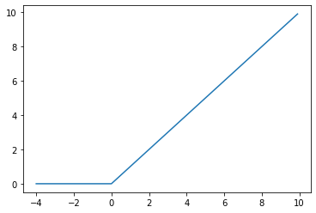

**# Q 2d. Periodic Sinosudal Sequence**

import matplotlib.pyplot as plt

import numpy as np

Ts = 50

x = np.arange(100)

y = np.sin(2 * np.pi * x / Ts)

plt.plot(x, y)

plt.show()

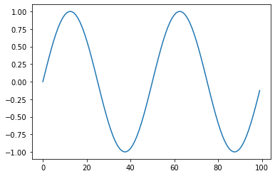

**# Q 2e. Periodic Rectangular Pulse**

import matplotlib.pyplot as plt

import numpy as np

from scipy import signal

x = np.linspace(0, 100, 100, endpoint = True)

y = signal.square(2 * np.pi * 4 * x)

plt.plot(x, y)

plt.show()

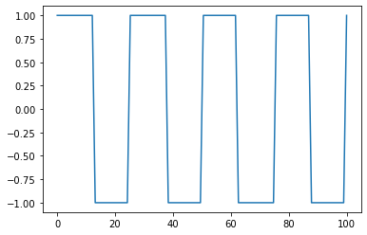

**# Q 2f. Asymmetric Sawtooth Waveform**

import matplotlib.pyplot as plt

import numpy as np

from scipy import signal

x = np.linspace(0, 100, 100, endpoint = True)

y = signal.sawtooth(2 * np.pi * 4 * x)

plt.plot(x, y)

plt.show()

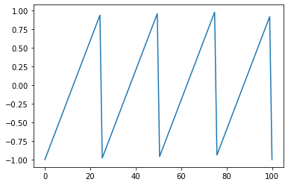

**# Q 2g. Periodic Gaussian Pulse**

import matplotlib.pyplot as plt

import numpy as np

from scipy import signal

t = np.linspace(-1, 1, 200)

i, q, e = signal.gausspulse(t, fc=3, retquad=True, retenv=True)

plt.plot(q)

plt.show()

