Usecase documentation

Tartalom

Formatting 3

Initial ordering 3

Basic order 3

Diagram 3

Description 3

Examples 3

Modifying orders 3

Basic modification 3

Diagram 3

Description 3

Examples 3

Reserve table 3

Basic reservation 3

Description 3

Diagram 4

Examples 4

# Formatting

Headline 1 for separating functionality

Headline 2 for individual usecases

Headline 3 for separating diagram and examples and description

# Initial ordering

## Basic order

### Description

### Diagram

### Examples

# Modifying orders

## Basic modification

### Description

### Diagram

### Examples

# Reserve table

## Basic reservation

### Description

* Customer orders a table for 1 person.
* There is a free table for 1 person.
* The order is sceduled to an acceptable timeslot.

### Diagram

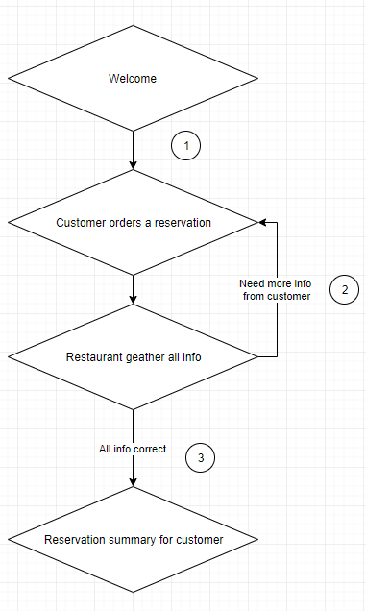

### Examples

1: Examples for customer reactions for welcome:

* I’d like to have a dinner tonight
* …

2: Examples for customer giving more info:

* It will be 3 person
* …

3: Examples for customer reaction for…. TBD