Student Housing App Project Analysis

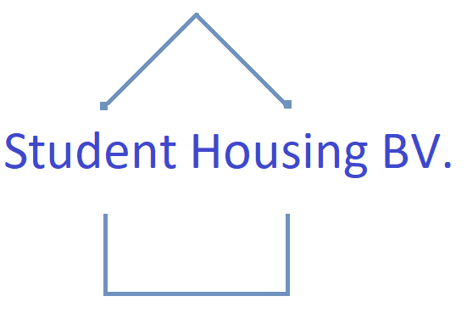

Mentor: Mark Madsen

Contributors: Kovács, Kovács G., Gürcan, Kaan K, Zhao, Guanyu G.

Date: 12.07.2020

Version 2.05

|  |  |  |
| --- | --- | --- |
| Kovács, Kovács G. | G.Zhao |  |
| 4081323 | 4081625 |  |
| k.kovacs@student.fontys.nl | g.zhao@student.fontys.nl |  |

## Summary

This document serves as an analysis of the current problems the software engineering team at Student Housing BV faces in solving the complaints made by clients of the company. In preparation for the meeting due to take place on Monday morning to commence the development phase of the project, assessments of risk, our target users/stakeholders, and the implementation of our software solution have all been compiled. Our stakeholders- those in the Student Housing BV management team, seek a comprehensive and accessible platform with little need for software maintenance. This aligns somewhat with our goals to cater to the young students that compose our userbase through a comprehensive and easy-to-use application.

## Serving user needs

As our company is entirely dedicated to the provision of housing to students, these will also serve as the end-users of the Student Housing BV application. Students, largely being much younger than the general population, are more familiarized with the use of software applications and can therefore generally be expected to be able to engage with elements of the Student Housing BV application without too much “hand-holding”. Even so, our team should focus on mitigating overly cluttered interfaces and make an easy-to-use app for assisting our renters in their day-to-day lives.

## Implementing user-oriented solutions

We, Student Housing BV, own different buildings where students (our clients) can stay during their study in the Netherlands. For some time now we are receiving complaints from our clients related to:

* Appointed persons not assisting in cleaning the shared facilities.
* Difficulties coordinating grocery shopping.
* Failure to such arrange shopping such as toilet paper, dish soap, etc.
* Garbage disposal is not done on time
* Unannounced parties, gatherings, etc.

We want to offer our clients a software solution to better arrange their day-to-day lives and interactions with their housemates and hopefully reduce the amount of issues they face. We will build a windows forms application where our clients can record and see agreements made between them, but also the possibility to see the house rules and file complaint anonymously. Every so often we will have one of our employees go by the buildings to update the rules and gather any complaints. Our team is also looking into the implementation of several extra options such as making a cleaning schedule and creating shopping lists for collectively used items.

The windows forms application will have the following functionalities:

* A tab including a timetable. All student house members can be assigned tasks every week (add/remove functionality is included).
* An agenda on which you can see the current date and upcoming events.
* A tab which shows all house rules (means to update the house rules is also included)
* A tab on which you can record/see agreements that have been made between the student house members.
* A tab in which you can file and see complaints anonymously.
* A button on the file complaint tab which gathers/removes complaints from a list (Optional: storing gathered complaints in a file).
* A database to store necessary information (Optional).
* Connecting the Arduino to enhance security with a secret passcode (Optional).

|  |  |
| --- | --- |
| Absolute Due date | **Project activity** |
| 04th Dec 10 P.M | Deliver project analysis document  Deliver gantt chart |
| 18th Dec 10 P.M | Adding these functionalities:   * A tabpage which includes a timetable. All student house members can be assigned tasks per week (add/remove functionality is included). * An agenda on which you can see the current date * A tabpage which shows all house rules (means to update the house rules is also included) * A tabpage on which you can record/see agreements that have been made between the student house members. * A tabpage in which you can file and see complaints anonymously. * A button on the file complaint tabpage which gathers/removes complaints from a list (Optional: storing gathered complaints in a file) * A tabpage where you can either login to an admin or student profile and manage profile info/house rules depending on permissions. * Direct e-mail contact with housing company |
| 16th Dec 10 P.M | Adding these functionalities:   * A database to store necessary information (Optional). * Connecting the Arduino to enhance security with a secret passcode (Optional).   Present and discuss implemented application (interim version)  Refactor and extend application based on feedback |
| 18th Dec 10 P.M | Continue implementation of application based on feedback  Start working on the report and presentation |
| 08th Jan 10 P.M | Deliver application(Group) Deliver report(Group) Deliver presentation(Group) |
| 15th Jan 10 P.M | Present the deliverables of our project(Group)  Evaluate work done(Group) |

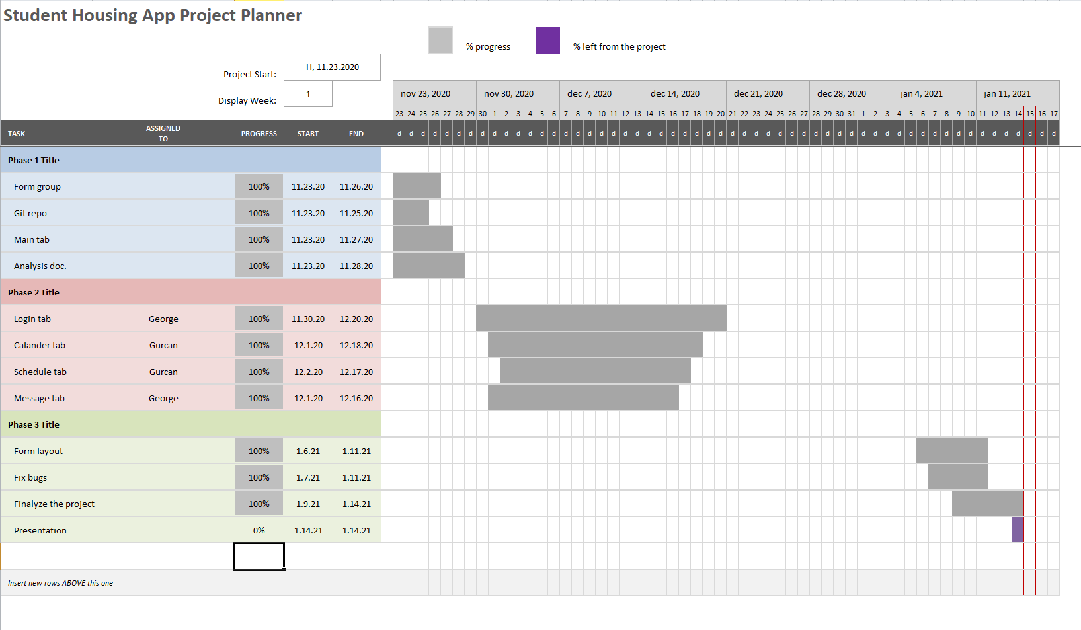

## Risk Assessment

These risks might occur:

1. **Project team misunderstands requirements,** even though we have tried to make sure everyone knows/understands what has to be done and be aware of the constraints. Sometimes misunderstandings still occur.
2. **Users have inaccurate expectations,**  it can be the case that a client has different expectations of what the product should be, due to a poorly written project plan.
3. **Impacted individuals aren't kept informed**,when a change has been made to the project, group members should know, else issues might occur.
4. **Decisions are incomplete**,when a discussion has been held about a topic, the decision should be properly justified to continue the project, otherwise the project will get stuck quickly after.
5. **Project team lack structure to complete work,** when the project team is ill organized and all work is subdivided with some of it missing. It might occur that some of the work is not delivered. We as a group are accountable.
6. **Delays which impact the project**, it is possible that some of the required knowledge is missing at the moment you start the delivery and run into some delays.
7. **Failure to follow methodology,** when we are not following the described steps we can run into trouble during the project track. It can be the case that we move to quickly or we move to slowly.
8. **Lack of management or control**, without a project organization you will run into some problems along the way. At least one person should keep track if all requirements are met.
9. **Tenants fail to utilize the application effectively to solve issues amongst themselves**, in order for the app to work the way it’s meant to, a basic level of cooperation is expected from every tenant.

|  |  |  |  |
| --- | --- | --- | --- |
| Risk | Probability | Impact | Mitigation |
| 1 | Unlikely | Extremely harmful | Everyone should know what is required for this project, if not, referring back to the project reader frequently will prevent most of this risk. |
| 2 | Highly unlikely | Extremely harmful | Our group leader () and the project leader (Mark Madsen) should discuss our general progress, the quality and the expectations of our work. |
| 3 | Likely | Harmful | Project members should report frequently on their current status of their tasks. |
| 4 | Likely | Harmful | When decisions are made, these should be documented. |
| 5 | Unlikely | Extremely  harmful | The team is responsible for all deliverables, deliverables might not get delivered so we have to check the planning frequently. |
| 6 | Likely | Extremely harmful | When something gets delayed, the team should find an appropriate solution. Communicate your solution with the project leader. |
| 7 | Unlikely | Harmful | When we don’t follow the methodology, delays might occur. Referring back to the project analysis will help prevent this. |
| 8 | Unlikely | Harmful | The project plan is created to give structure of the management. Keeping track of our current status in general, will help significantly. |
| 9 | Likely | Harmful | Provide incentives for cooperation or mandatory checkups on the app in order to attempt to force students to at least view complaints and concerns from their comrades. |

If one of these risks occur, we should to contact our project leader and find a way to recover from the problems.

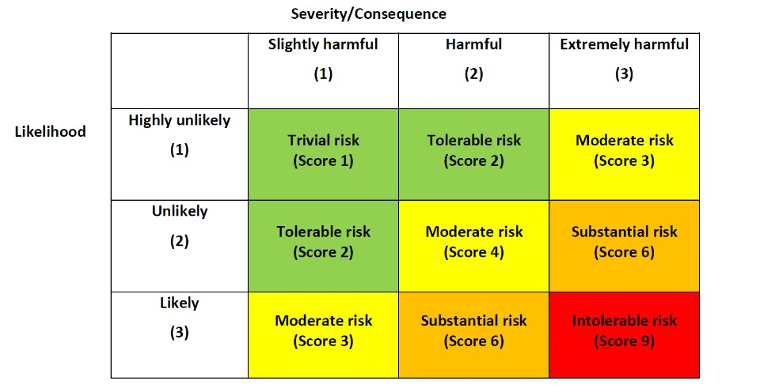

https://management.simplicable.com/management/new/130-project-risks

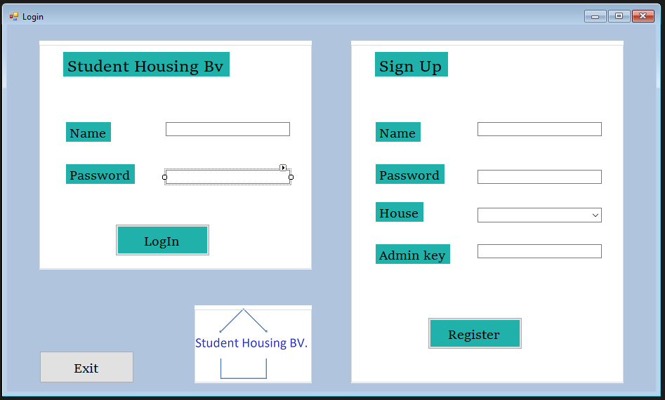

Different solutions for a login a screen

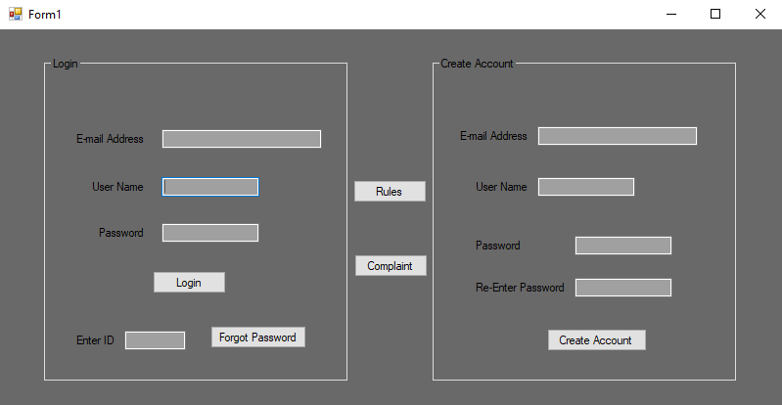

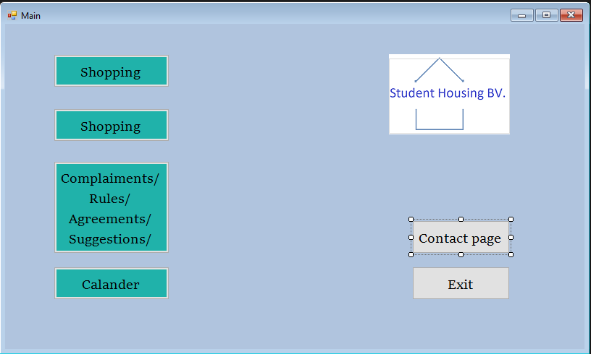

After logged in there is a main page where the user could navigate through the different pages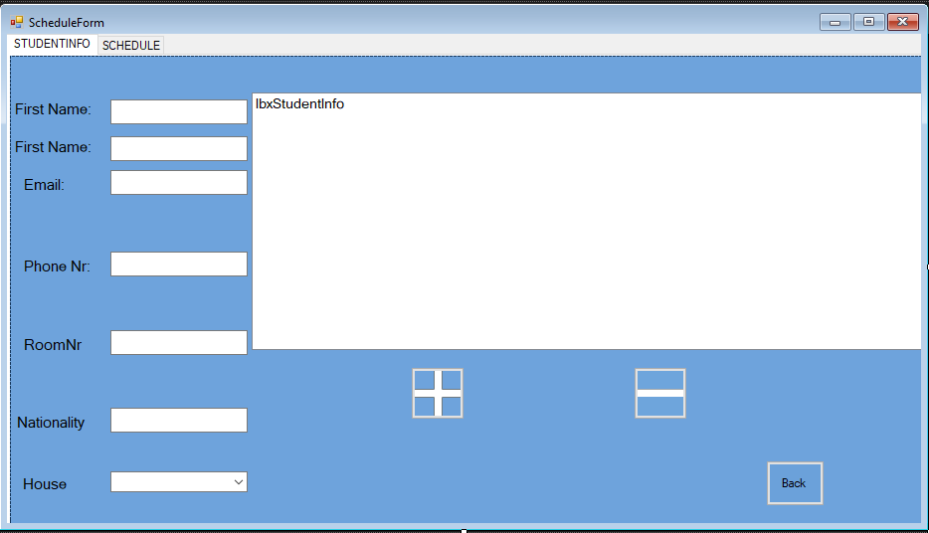

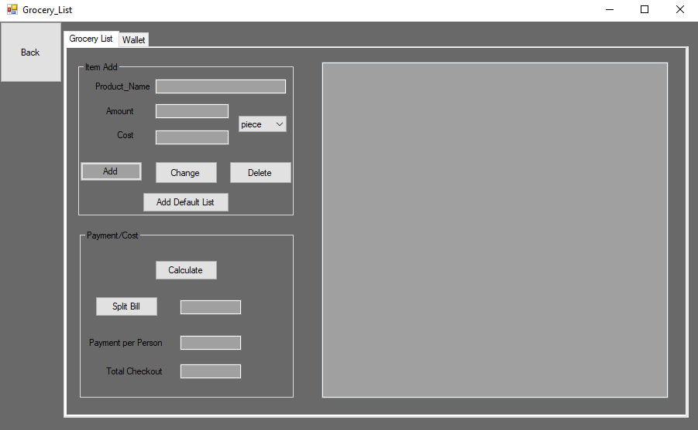

These are the pages with different designee, there are several different pages for each one of the task