## **Project Report**

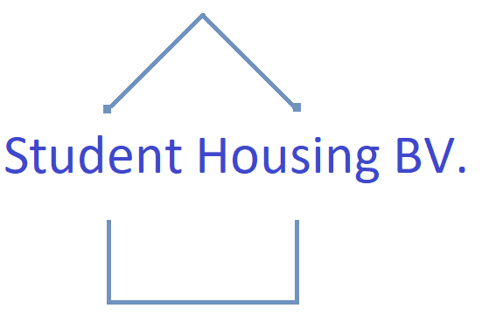

Mentor: Mark Madsen

Contributors: Kovács, Kovács G., Gürcan, Kaan K, Zhao, Guanyu G.

Date: 12.07.2020

## Introduction

This report serves as a summation of Student Housing B.V.’s work and experiences, the process of creating the Student Housing app, the resulting product that has been created, and the team’s reflection on their collaboration and general attitude towards the project as a whole.

## Background

Student Housing B.V. is a company dedicated to adequately providing students with great quality housing at affordable prices. In order to facilitate efficient and amicable interactions amongst tenants and also between our tenants and apartment managers, we have endeavored to create an app for that very purpose. We have had several weeks for the development process and are now presenting the results.

## Addressing Issues

The complaints that Student Housing B.V. received that prompted the creation of the app are as follows:

* Appointed persons not assisting in cleaning the shared facilities.
* Difficulties coordinating grocery shopping.
* Failure to such arrange shopping such as toilet paper, dish soap, etc.
* Garbage disposal is not done on time
* Unannounced parties, gatherings, etc.

Offering our clients a software solution meant creating an application that better arranges their day-to-day lives and interactions with their housemates and hopefully reduces the amount of issues they face.

## Process & Results

We were asked to create an application for student housing. The app should be able to handle all the common problems and situation which can come up in a student house. We just started to work as soon as we got the project and the progress was good. We had a few issues during the project and sometimes we did not really understand the next step. Even with these difficulties, communication was good during these few weeks, so for every issue that came up, we managed to solve it quickly and efficiently. We had a meeting with the project manager every week, which was helpful since he was monitoring our progress and giving us feedback/encouragement to continue development. The results of the app and the final version does not just fulfill the basic requirements laid out by our project managers, but also contains extra features in addition to the basic requirements. The final version is ready to use, thanks to the great group work and learning we did along the way.

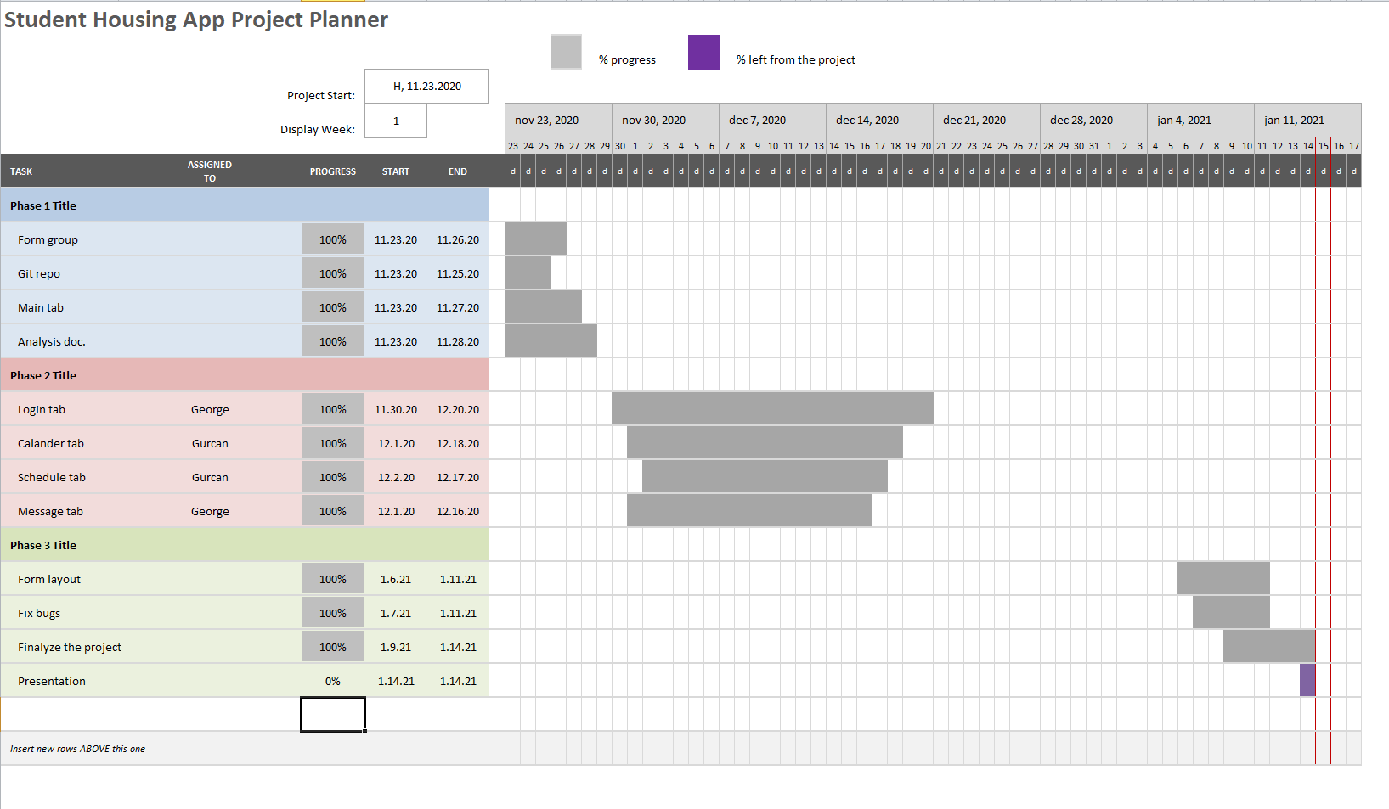

*Gantt chart showing an updated list of our group’s tasks and in what timeframe they were successfully completed in.*

## Conclusion and Recommendations

We came to the conclusion that working individually in separate project files and compiling everything in one final project file afterwards, is not ideal because it takes way more effort to make changes eventually. Making big changes to the final project file will be more error prone than just working in one project file from the start. We are lucky that this project isn’t that big, so we were still able to compile all of our separate project files into one final project file without too much extra effort.

We also realized that putting unfinished and duplicate/unfinished files in the final project file creates a confusing development environment and hinders collaboration, so it’s important to avoid uploading these to the group’s master repository. The use of comments was also encouraged as it helps the other programmers on the team to better and more quickly understand your code.

We did run into several communication issues over the course of the project, but we managed to quickly recover from them. We recommend using git branches and merging all new updates to one specific project file in the future projects, to prevent all of our previously discussed hassle.

We recommend to decide beforehand what the plan for your project will be and to stick to it. Try to think as much ahead as possible about how you want to implement your project so you can maybe prevent some risks beforehand and start implementing the basics. After that’s been done, you can start implementing additional features else it will be difficult to manage your project and you will miss deadlines.

## Evaluation& Reflection

**REFLECTION**: Our experiences in the development of the housing project was bit challenging in the beginning, but as time went on, we gained more confidence to work collaboratively to develop the app. Thanks to our project manager Mark Madsen, we were given many pointers and tips whilst the development process was underway. In our group we largely managed to maintain effective communication, an environment of support in which no member was left to finish his tasks alone, and we all collaborated in coming up with improvements and new ideas for each section of the app, in order for the project to be finished successfully and before the deadline.

**EVALUATION:**

**Gurcan**- In charge of taking care of the scheduling and user detail submission sections of the app-creating an interactive task schedule. He also contributed in class where tenants can add compliments about unorganized parties and other events. He also assisted in the creating of the presentation in his submission of slides regardless his works.

**George** – Tasked to create a login and register tab along with GUI element layout for those forms. Burdened with the job of creating our form for the submission and updating of complaints, house rules, and agreements amongst tenants, he created several classes for this purpose and created a basic GUI layout for their implementation into the app. He organized the designee of the app.