Helpdesk Simulation
Ticket Portfolio
Week 1 — IT Support Investigation, Troubleshooting and Customer Communication
Candidate: Thabang Norman Lesotho
This portfolio documents five completed Zendesk ticket logs from the selected Microsoft 365 and Network & Performance support scenarios. The ticket evidence is based on the supplied screenshots, not on the sample ticket wording in the playbook.

Portfolio overview
The project instructions require two selected scenario groups, a minimum of five completed Zendesk tickets, clear investigation and troubleshooting records, research and tools used, professional customer communication, and a resolution or escalation outcome. This portfolio follows that structure.
Selected scenario 1 | Microsoft 365 & Common Helpdesk Issues — Teams and OneDrive support
Selected scenario 2 | Network & Performance Support — Wi-Fi, IP and DNS connectivity
Completed tickets | Five ticket records
Ticket distribution | Two Microsoft 365 tickets and three network/connectivity tickets
Evidence method | Zendesk screenshots arranged in support-process order within each ticket

Ticket order
- Ticket 1 — OneDrive Keeps Asking Me to Sign In — Question #36
- Ticket 2 — Microsoft Teams Showing “You’re Offline” Despite Internet Connection — Question #38
- Ticket 3 — Laptop Connected to Wi-Fi but Showing “No Internet Access” — Question #40
- Ticket 4 — Unable to Access Certain Websites — Question #35
- Ticket 5 — Wi-Fi Keeps Disconnecting — Question #39

Documentation note
The scenario guide provides sample issues and recommended evidence points. The records below use the actual tickets and actual troubleshooting shown in the supplied Zendesk screenshots. Where a root cause is not explicitly confirmed in the screenshots, it is described as a working diagnosis rather than presented as a fact.

TICKET 1

OneDrive Keeps Asking Me to Sign In — Question #36
Scenario group | Microsoft 365 & Common Helpdesk Issues
Evidence order | Screenshots are arranged from initial report to investigation, troubleshooting, confirmation, and closure.

Issue summary
The customer reported that OneDrive repeatedly requested sign-in. After signing in successfully, the prompt returned and file synchronization stopped.

IT Support Technician view

Investigation and findings
- The issue was specific to OneDrive on the customer’s device.
- The repeated prompt occurred during normal use and was linked to files no longer syncing.
- The customer later confirmed that signing out and signing back in resolved the issue.

Troubleshooting performed
- Requested information about when the issue started, any error message, what the customer was doing when the prompt appeared, and troubleshooting already attempted.
- Instructed the customer to right-click the OneDrive taskbar icon, open Settings, select Account, sign out, and sign back in.
- Asked the customer to confirm whether the sign-in prompt returned and whether files were syncing normally.

Research and technical reasoning
The evidence supports a local OneDrive account-session or authentication-state problem. The screenshots do not confirm a tenant-side account or licensing fault, so the documentation records the local sign-out/sign-in repair as the successful first-line resolution.

Tools and systems used
- Zendesk ticket conversation and internal notes
- OneDrive taskbar icon and Account settings
- Windows desktop sign-out and sign-in workflow

User-friendly explanation
OneDrive is like a courier that needs a valid delivery badge before it can move files between the computer and the cloud. Signing out and back in issued a fresh badge so the courier could continue working.

Everyday analogy
The response acknowledged the repeated prompts, requested the relevant diagnostic details, provided clear steps, and confirmed the resolution after the customer reported that OneDrive was working normally.

Customer communication
OneDrive was repeatedly losing or rejecting its active sign-in session. After the customer signed out and signed back in, the prompt stopped appearing and files resumed syncing.

Resolution or escalation
Resolved at first line. The customer confirmed that the sign-in prompt stopped and file synchronization returned to normal. No escalation was shown in the ticket.

Screenshot evidence — chronological order
The upload filenames are not chronological. The sequence below follows the support workflow shown in the Zendesk conversation. Each caption identifies the purpose of the screenshot in the ticket record.
Evidence 01 — Original customer report
image_(25)_1789115069285.png
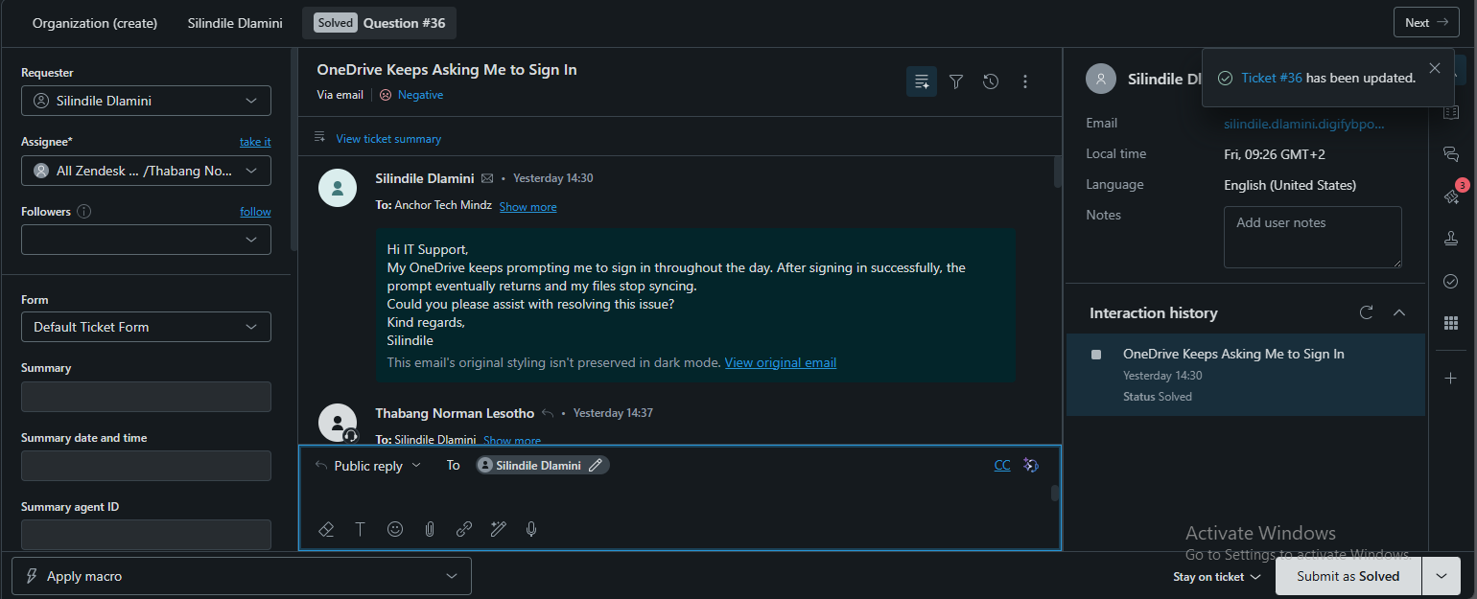
Evidence 02 — Technician acknowledgement and investigation handover
image_(34)_1789115069291.png
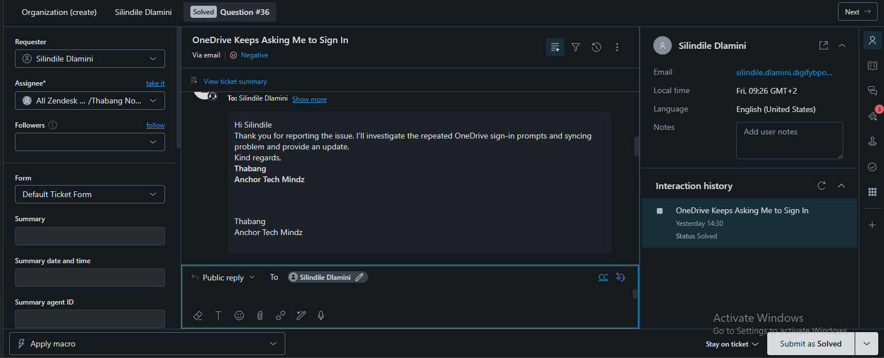
Evidence 03 — Request for additional diagnostic information
image_(31)_1789115069289.png
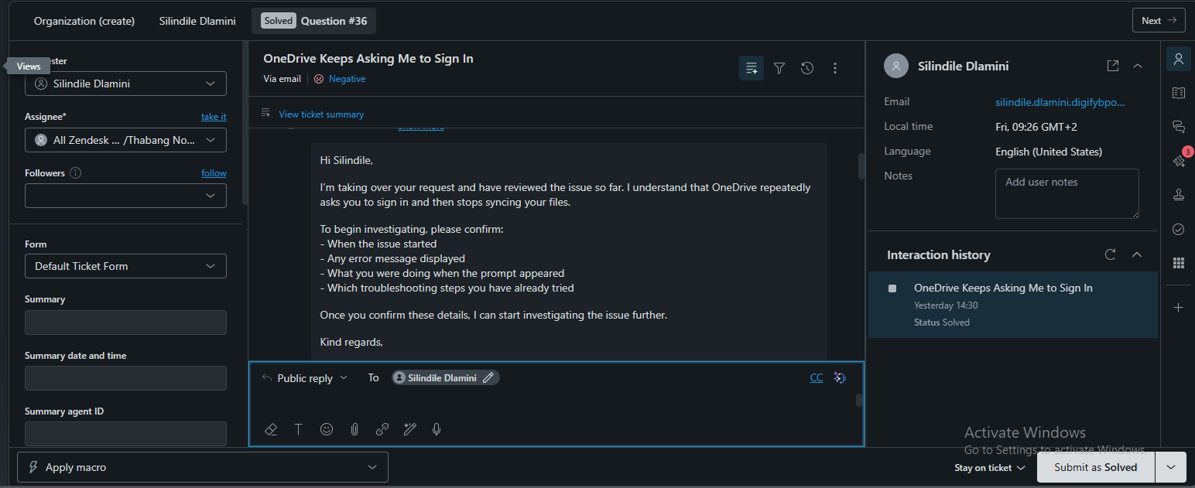
Evidence 04 — Internal issue summary
image_(32)_1789115069289.png
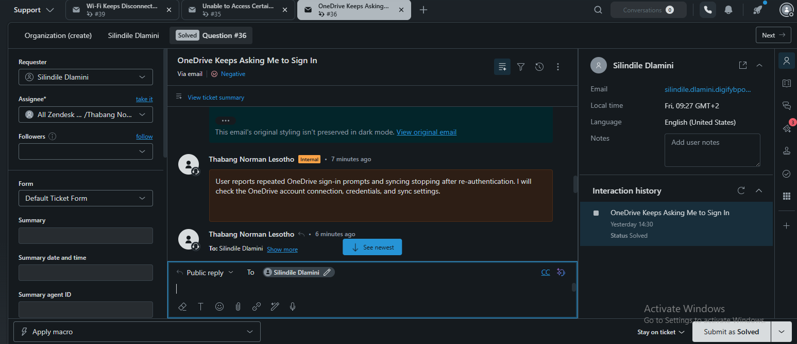
Evidence 05 — Customer follow-up confirming the prompt continued
image_(33)_1789115069290.png
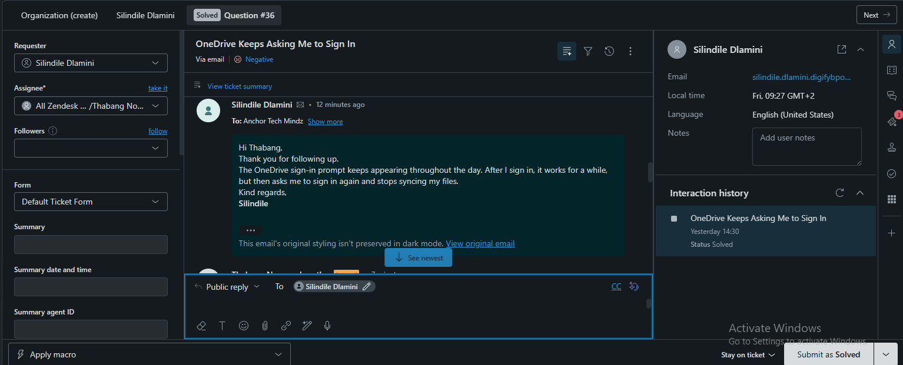
Evidence 06 — Public troubleshooting instructions: sign out and sign back in
image_(26)_1789115069286.png
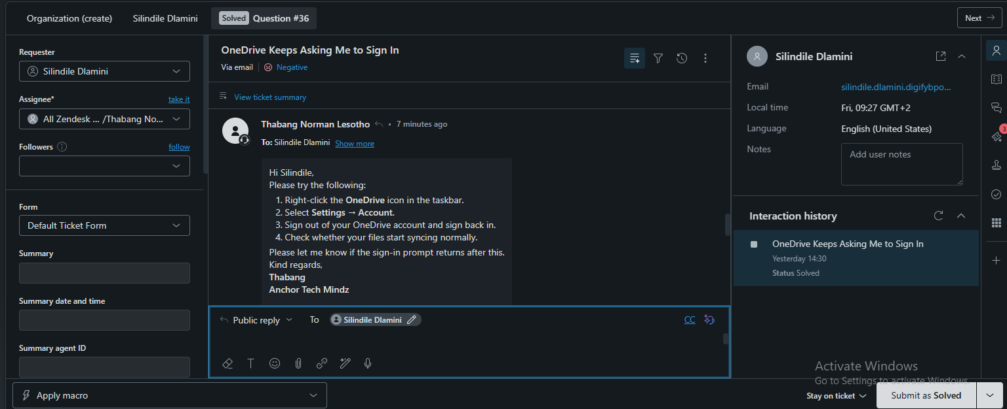
Evidence 07 — Internal note recording that the first attempt had not yet resolved the issue
image_(30)_1789115069288.png
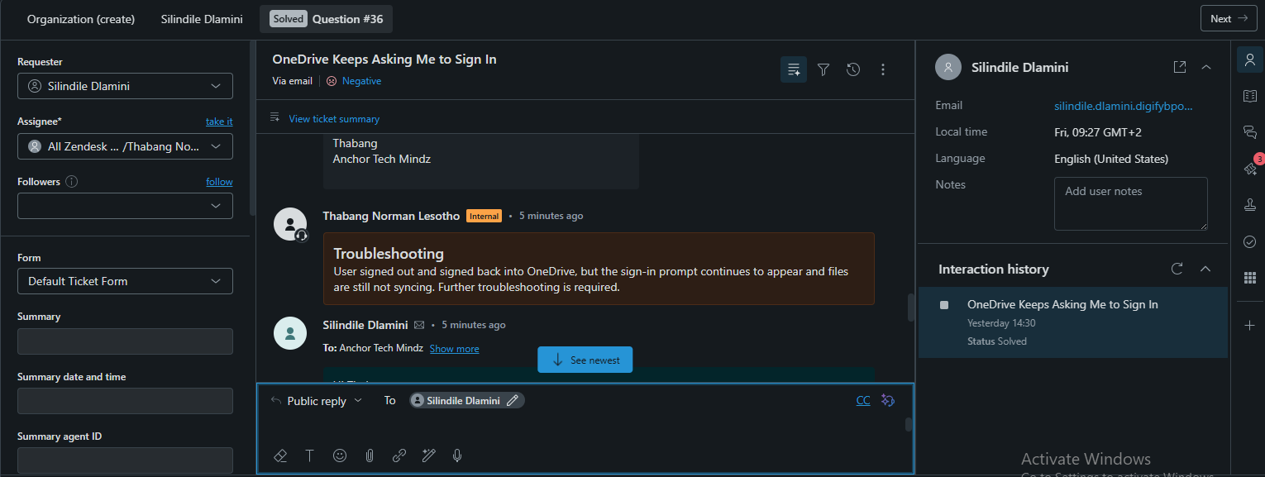
Evidence 08 — Customer confirmation that OneDrive was working normally
image_(29)_1789115069288.png
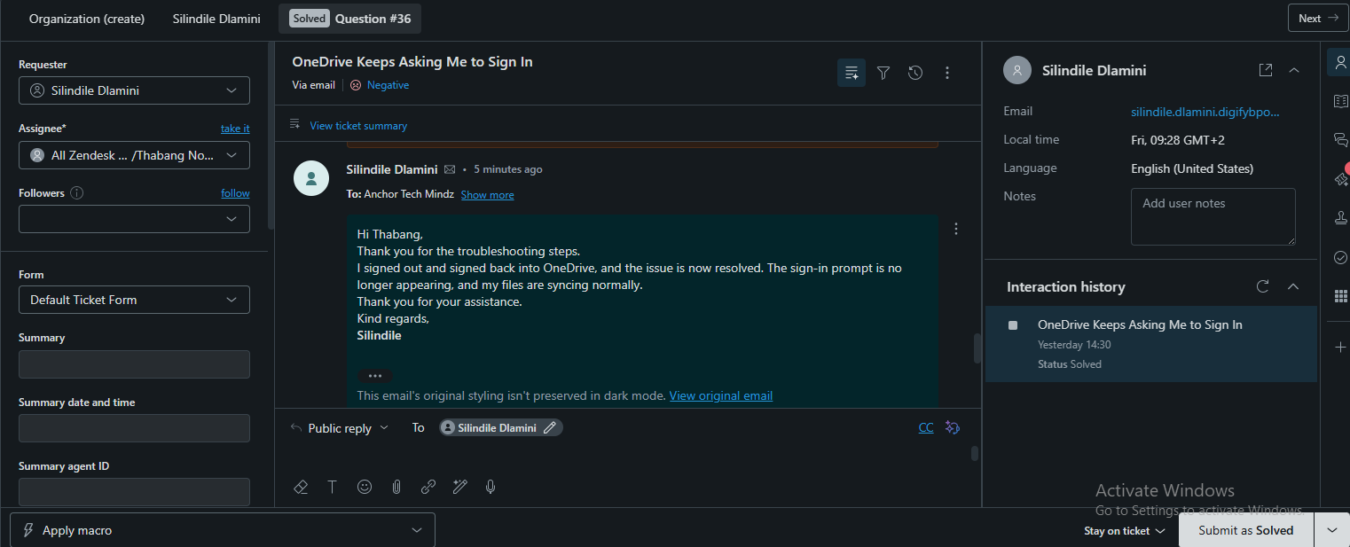
Evidence 09 — Internal resolution note
image_(28)_1789115069287.png
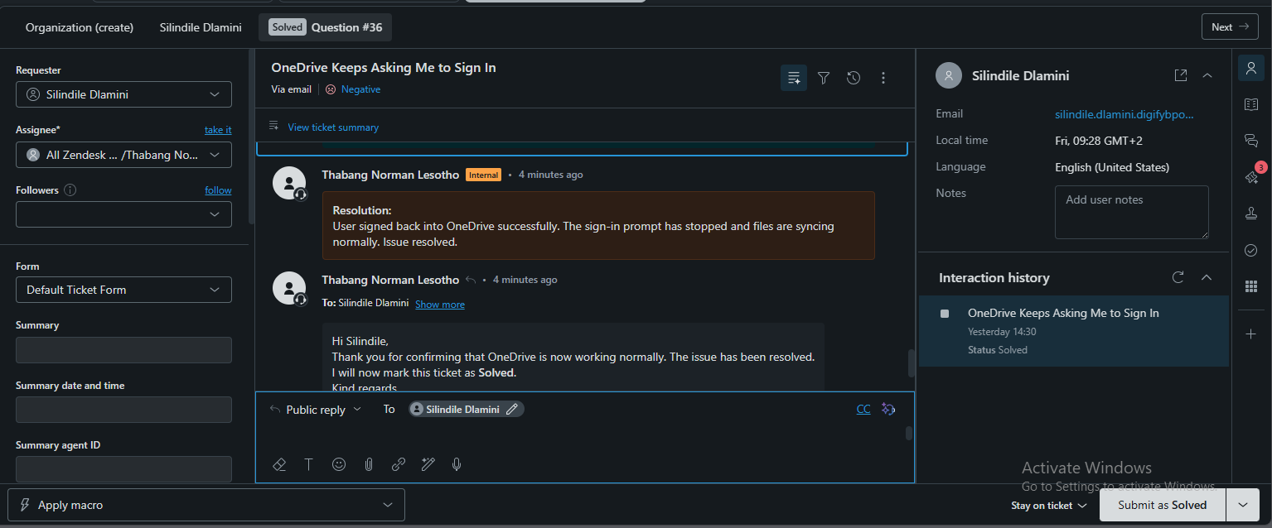
Evidence 10 — Final customer-facing closure message
image_(27)_1789115069286.png
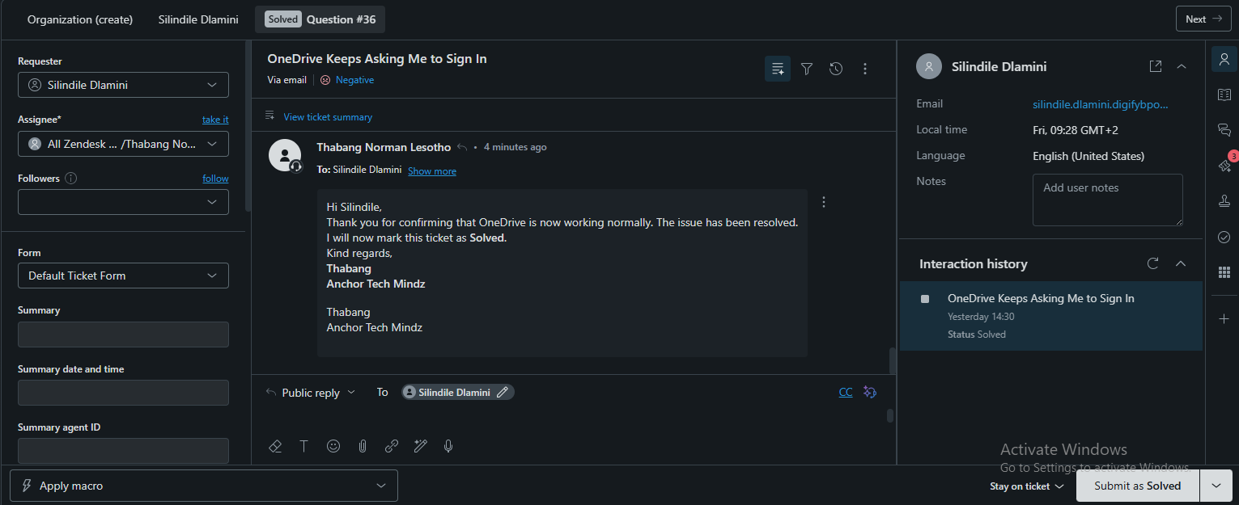

TICKET 2

Microsoft Teams Showing “You’re Offline” Despite Internet Connection — Question #38
Scenario group | Microsoft 365 & Common Helpdesk Issues
Evidence order | Screenshots are arranged from initial report to investigation, troubleshooting, confirmation, and closure.

Issue summary
The customer reported that Microsoft Teams showed “You’re offline” even though the computer was connected to the internet. Messages and recent conversations were not updating.

IT Support Technician view

Investigation and findings
- The customer had already restarted Teams and signed out and back in without resolving the issue.
- The failure affected Teams communication and access to recent conversations or shared files.
- The customer later confirmed that Teams was working properly after the additional troubleshooting steps.

Troubleshooting performed
- Requested confirmation of when the issue started, whether the desktop app, web app, or both were affected, the exact error message, and previous steps attempted.
- Asked the customer to fully quit Microsoft Teams and restart the computer.
- Instructed the customer to reopen Teams, sign out, and sign back in.
- Asked the customer to test Teams in a web browser.
- Directed the customer to use Windows application settings to open Microsoft Teams Advanced options and select Repair.
- Requested a retest of messages and shared files after reopening Teams.

Research and technical reasoning
The troubleshooting focused on separating a Teams application problem from a general internet problem. The steps progressed from restarting the application and session to repairing the installed Teams application.

Tools and systems used
- Zendesk ticket conversation
- Microsoft Teams desktop application
- Microsoft Teams web access
- Windows Settings > Apps > Installed apps > Microsoft Teams > Advanced options

User-friendly explanation
This is like having a working phone signal while one messaging app is stuck offline. The phone can still connect generally, but that app needs to be restarted or repaired so it can reconnect to its own service.

Everyday analogy
The technician acknowledged the customer’s previous attempts, gathered targeted information, provided a clear escalation path from simple to more advanced steps, and confirmed the outcome once the customer retested Teams.

Customer communication
The internet connection was available, but Teams was not maintaining a working connection to its service. Restarting, re-authenticating, testing the web version, and repairing the application addressed the Teams client rather than treating the whole network as unavailable.

Resolution or escalation
Resolved at first line. The customer confirmed that Teams was working properly and the ticket was closed as solved.

Screenshot evidence — chronological order
The upload filenames are not chronological. The sequence below follows the support workflow shown in the Zendesk conversation. Each caption identifies the purpose of the screenshot in the ticket record.
Evidence 01 — Original customer report
image_(46)_1789115220311.png
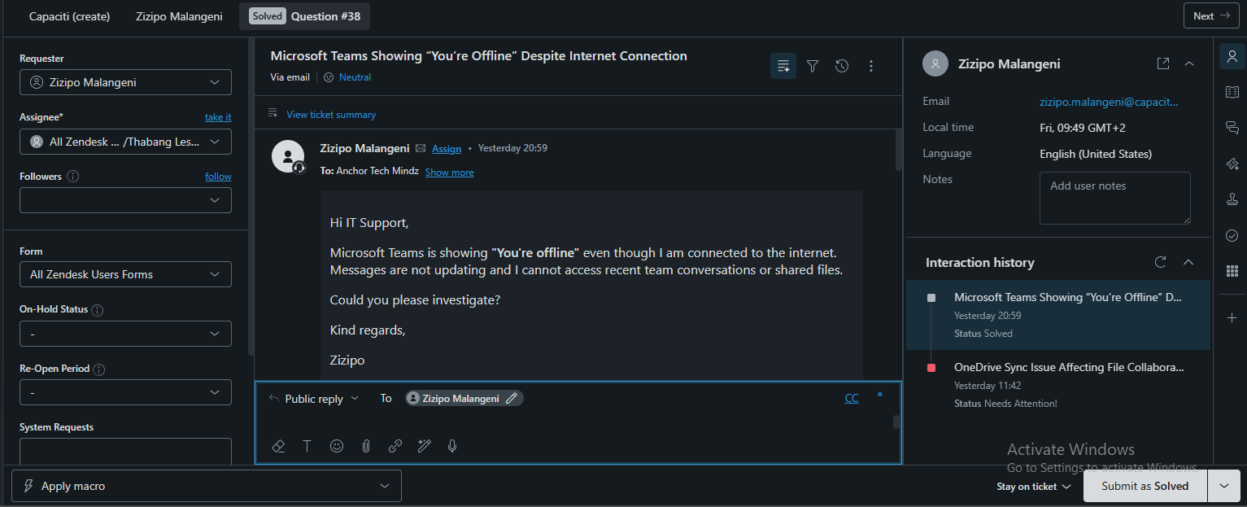
Evidence 02 — Technician acknowledgement and request for diagnostic details
image_(48)_1789115220312.png
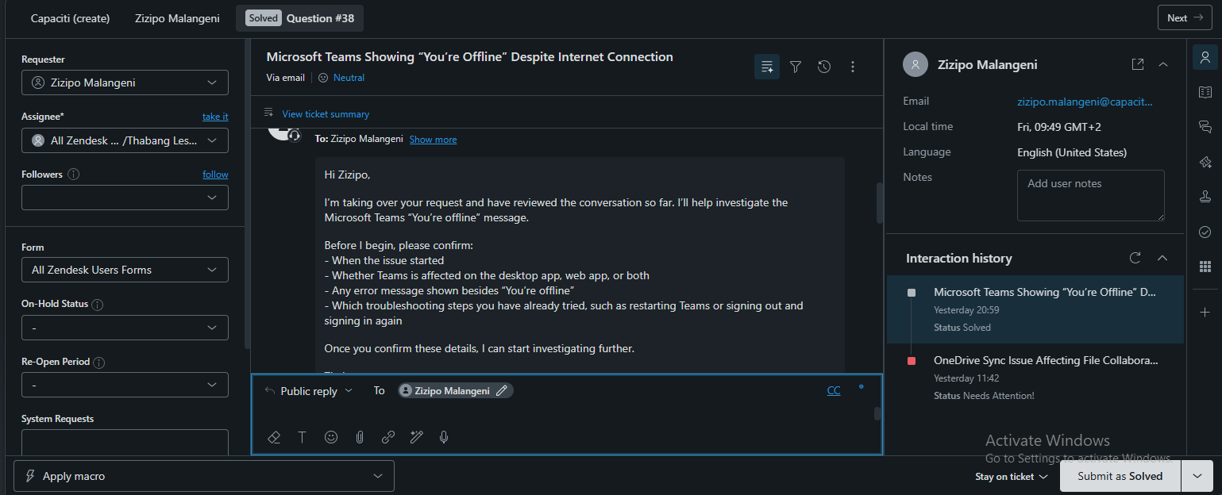
Evidence 03 — Customer confirms previous troubleshooting had not worked
image_(49)_1789115220313.png
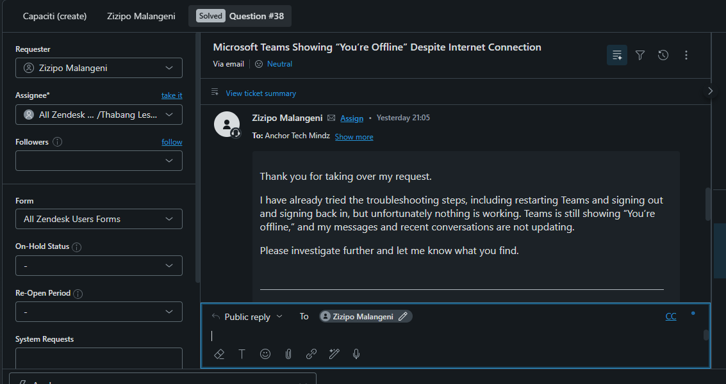
Evidence 04 — Public troubleshooting steps
image_(51)_1789115220314.png
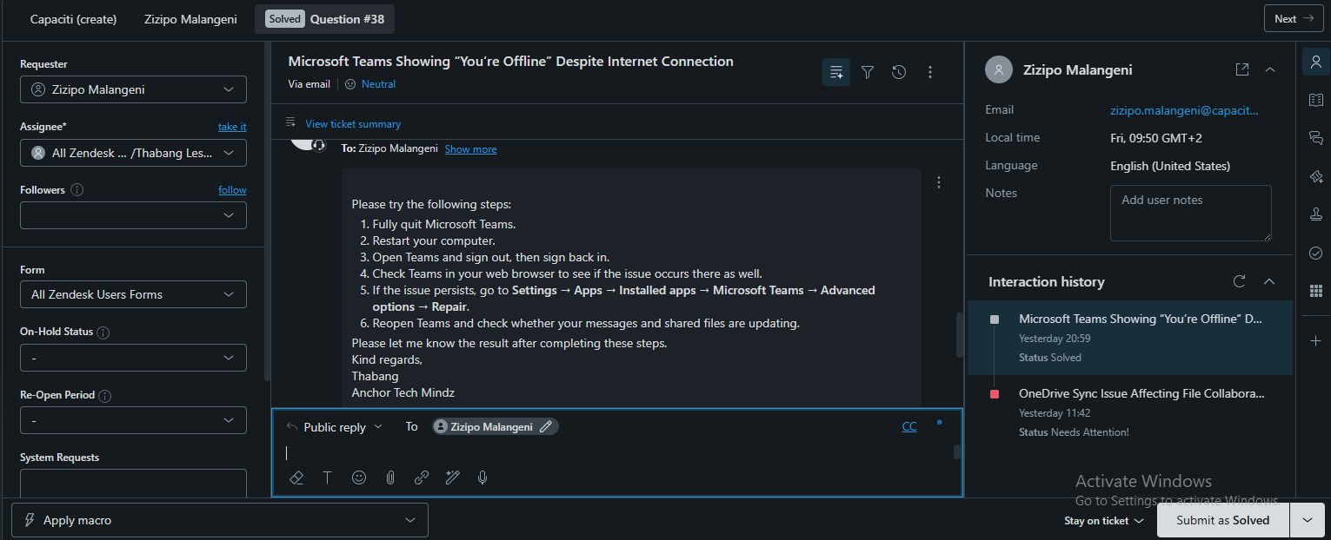
Evidence 05 — Customer confirms Teams is now working
image_(50)_1789115220314.png
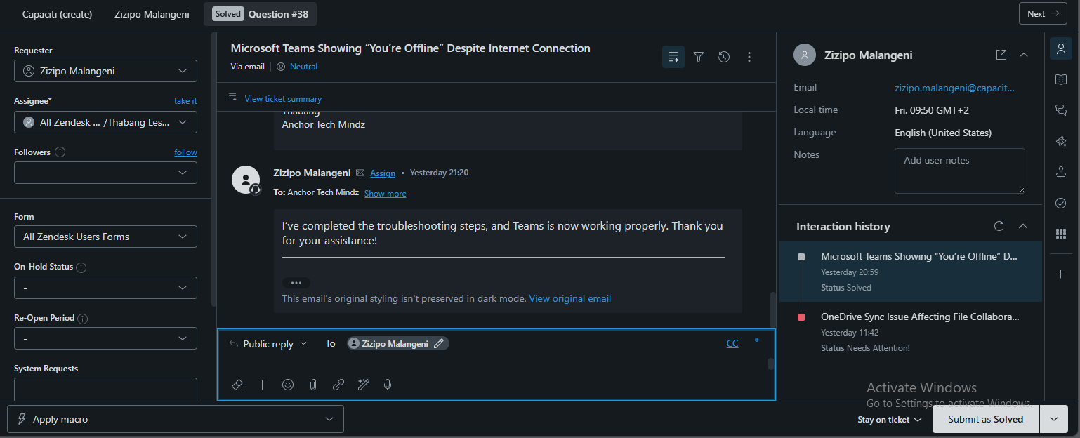
Evidence 06 — Final customer-facing closure message
image_(47)_1789115220312.png
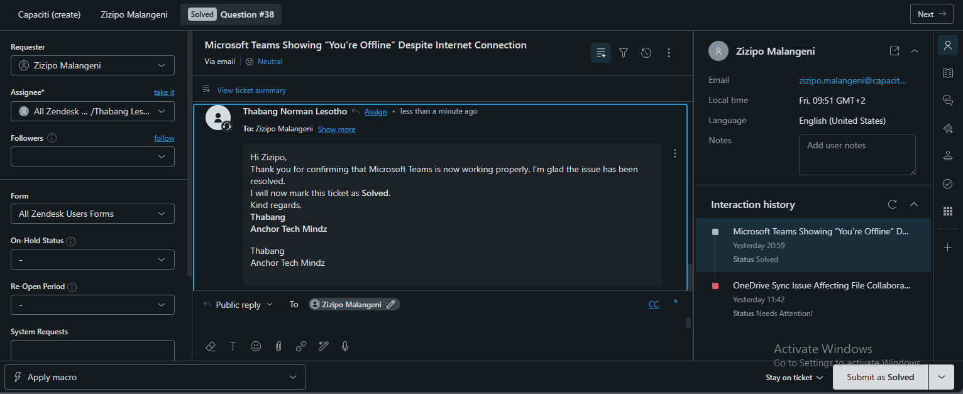

TICKET 3

Laptop Connected to Wi-Fi but Showing “No Internet Access” — Question #40
Scenario group | Network & Performance Support
Evidence order | Screenshots are arranged from initial report to investigation, troubleshooting, confirmation, and closure.

Issue summary
The customer reported that a Dell Latitude 5420 connected to the office Wi-Fi but displayed “No Internet, secured.” Websites, cloud services, Microsoft 365 applications, and other work resources could not be accessed.

IT Support Technician view

Investigation and findings
- The issue began that morning and occurred intermittently.
- Other devices on the same office Wi-Fi could access the internet normally.
- The customer had already restarted the laptop, reconnected to Wi-Fi, and moved closer to the wireless access point.
- The issue was therefore isolated to the laptop rather than treated as a network-wide outage.

Troubleshooting performed
- Confirmed the laptop model, start time, frequency, affected devices, exact error message, and steps already attempted.
- Disconnected from the office Wi-Fi and reconnected.
- Opened Command Prompt and ran ipconfig /flushdns.
- Ran ipconfig /release.
- Ran ipconfig /renew.
- Restarted the laptop.
- Reconnected to the office Wi-Fi and tested the internet connection.

Research and technical reasoning
The troubleshooting targeted a device-specific IP or DNS state. Releasing and renewing the IP lease refreshed the laptop’s network configuration, while flushing DNS removed cached name-resolution data. The screenshots show a successful customer retest after these steps.

Tools and systems used
- Zendesk messaging conversation
- Windows Wi-Fi connection
- Command Prompt
- ipconfig /flushdns
- ipconfig /release
- ipconfig /renew

User-friendly explanation
A Wi-Fi connection is like arriving at a hotel. Connecting to the Wi-Fi gets you into the lobby, but the laptop still needs a valid room number and a working directory to receive deliveries. Releasing and renewing the IP address is like checking in again with the correct room assignment.

Everyday analogy
The technician moved from automated initial guidance to a human investigation, collected the device-specific facts, explained the next step, and provided a numbered command sequence. The customer was asked to retest and then confirmed that the connection was working.

Customer communication
The laptop was connected to the wireless network but was not successfully completing internet access. Refreshing the local DNS cache and renewing the network address restored connectivity.

Resolution or escalation
Resolved at first line. The customer confirmed that the internet connection was working again. The ticket record also shows a 5/5 satisfaction rating.

Screenshot evidence — chronological order
The upload filenames are not chronological. The sequence below follows the support workflow shown in the Zendesk conversation. Each caption identifies the purpose of the screenshot in the ticket record.
Evidence 01 — Initial messaging conversation and customer report
image_(35)_1789115069292.png
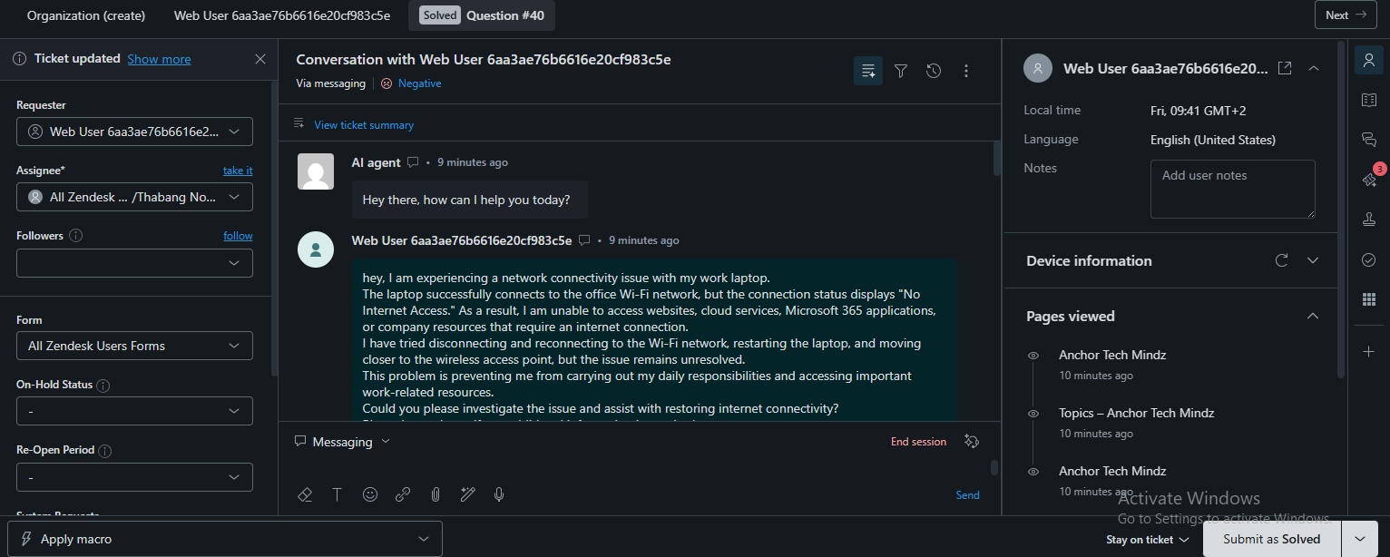
Evidence 02 — Automated initial troubleshooting guidance
image_(40)_1789115069296.png
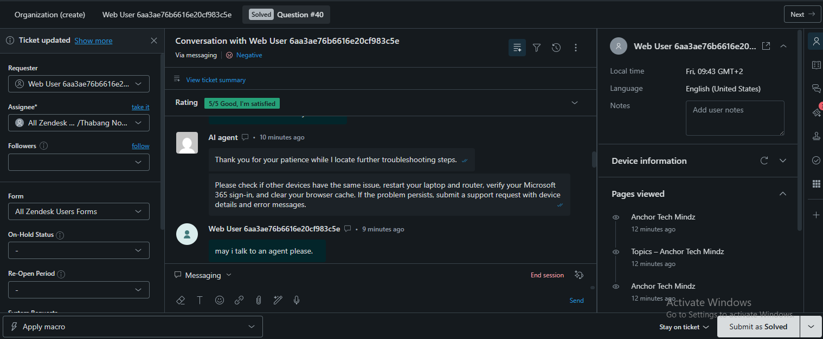
Evidence 03 — Customer requests assistance from a technician
image_(37)_1789115069294.png
Evidence 04 — Technician requests device and connectivity details
image_(44)_1789115220309.png
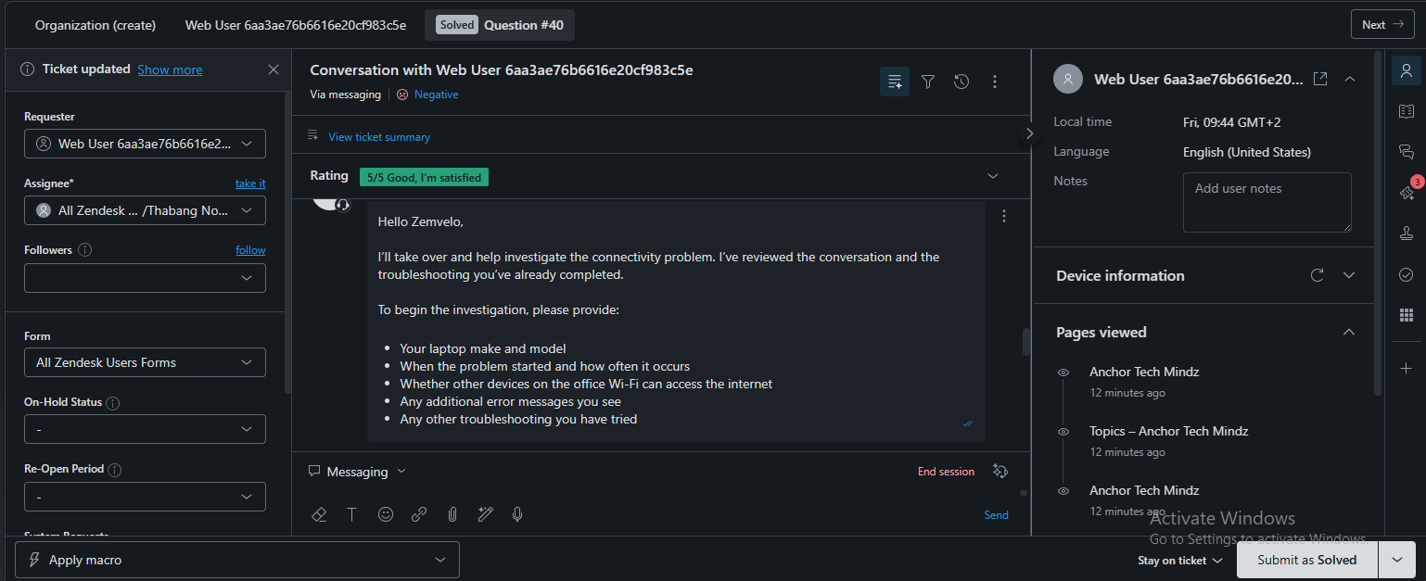
Evidence 05 — Customer provides the connectivity problem statement
image_(45)_1789115220310.png
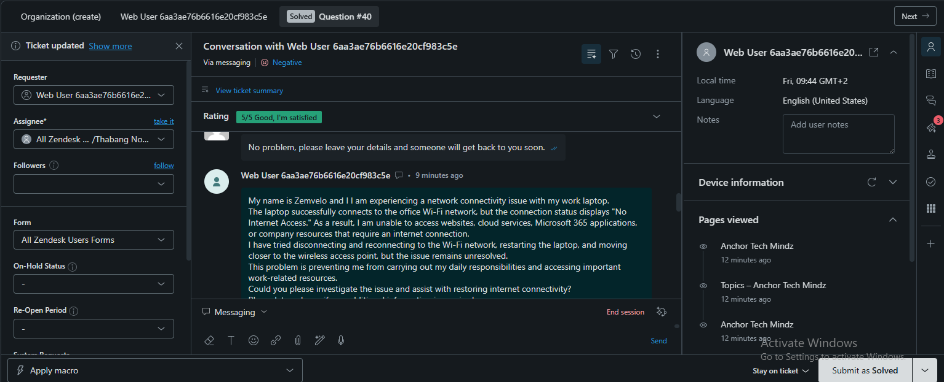
Evidence 06 — Customer provides the device, timing, error, and previous troubleshooting details
image_(43)_1789115220309.png
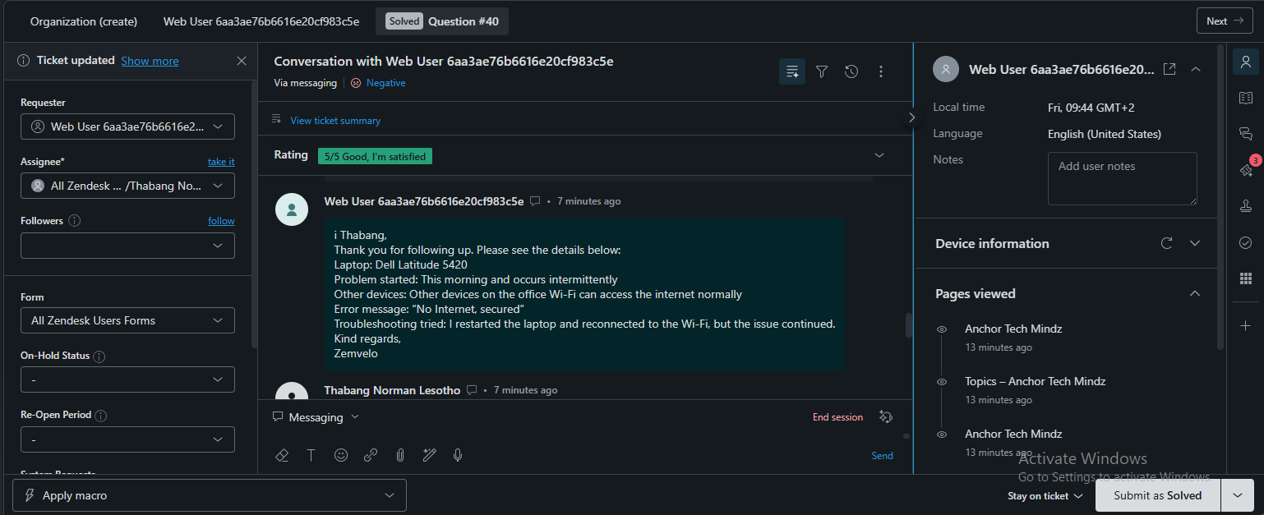
Evidence 07 — Technician confirms the diagnosis direction and summarizes the facts
image_(42)_1789115220308.png
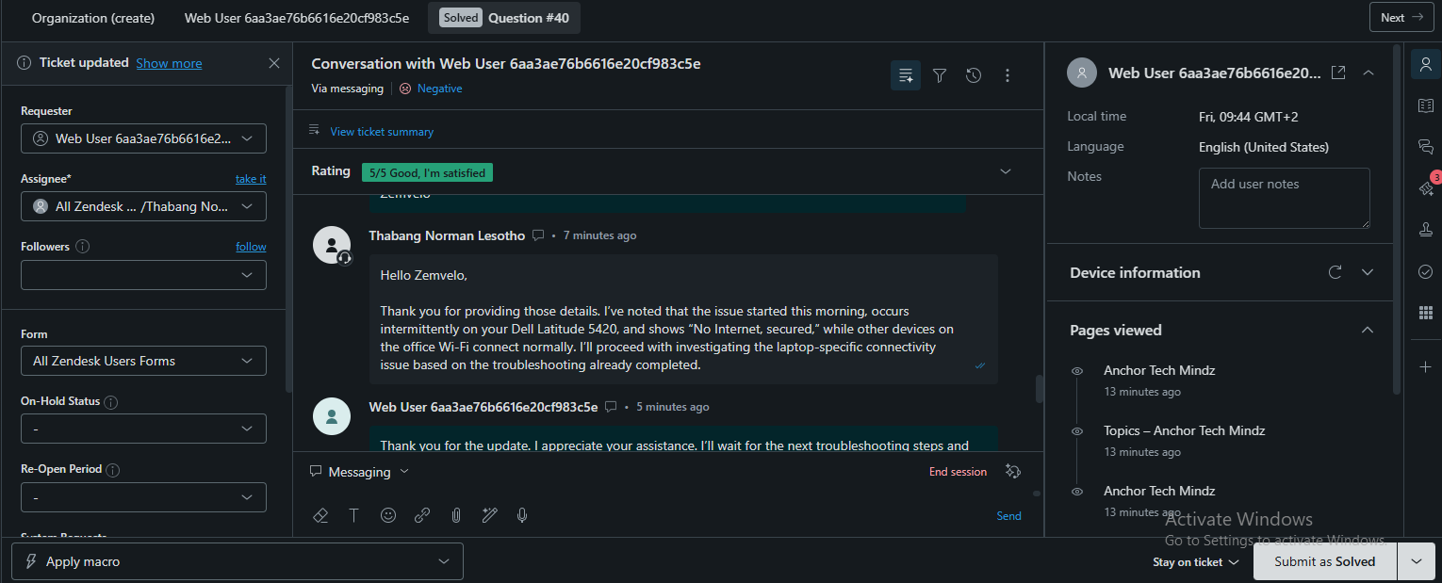
Evidence 08 — Technician provides the final command-based troubleshooting steps
image_(41)_1789115069297.png
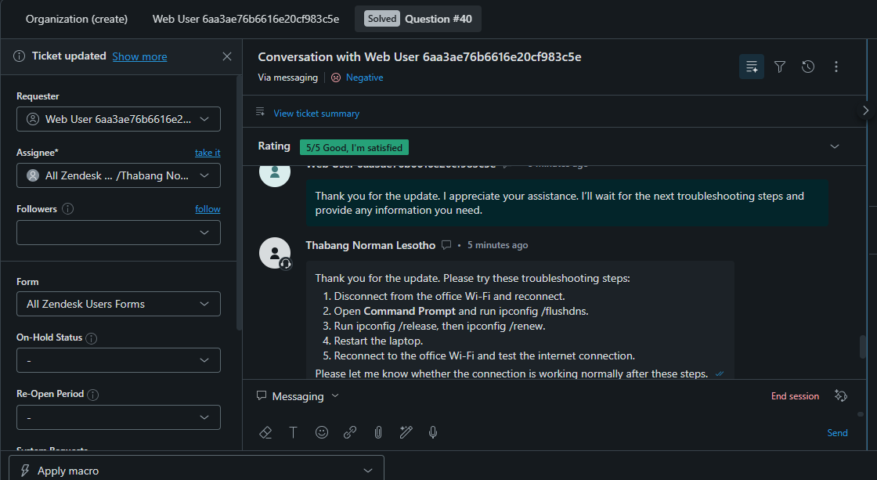
Evidence 09 — Customer confirms the connection is working and technician closes the request
image_(39)_1789115069295.png
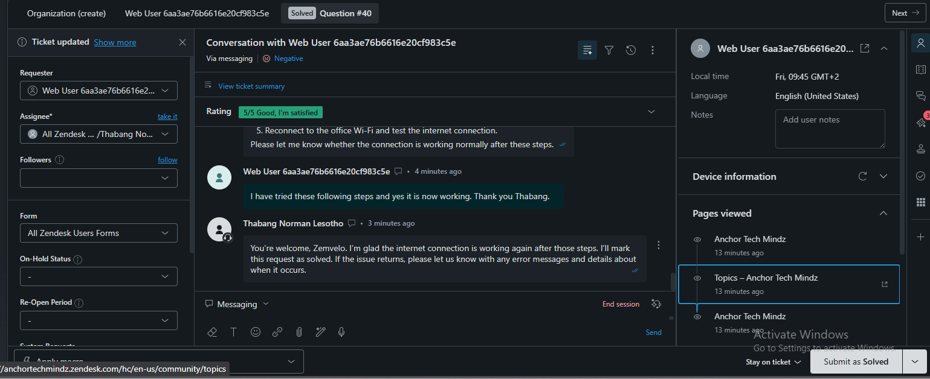
Evidence 10 — Ticket record showing the 5/5 customer rating
image_(36)_1789115069293.png
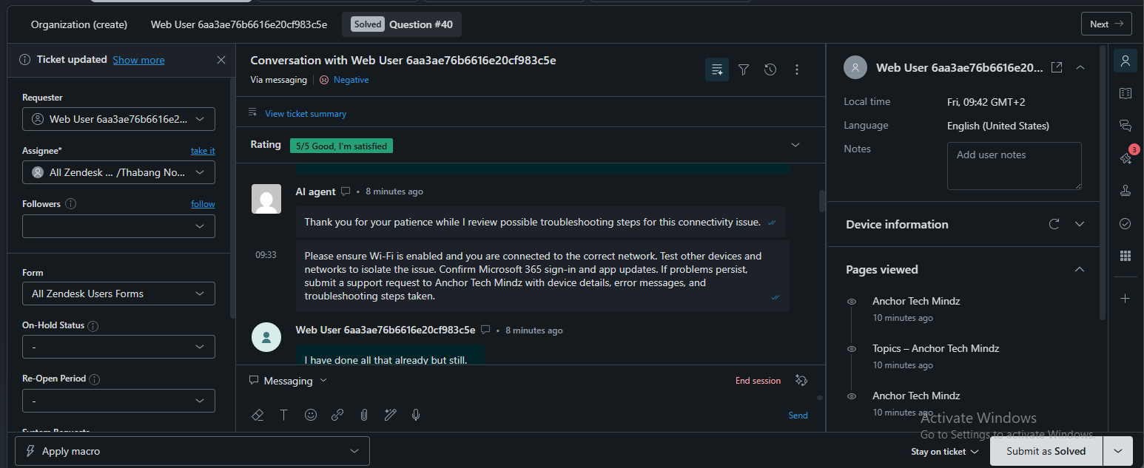
Evidence 11 — Conversation view showing the earlier troubleshooting exchange
image_(38)_1789115069295.png
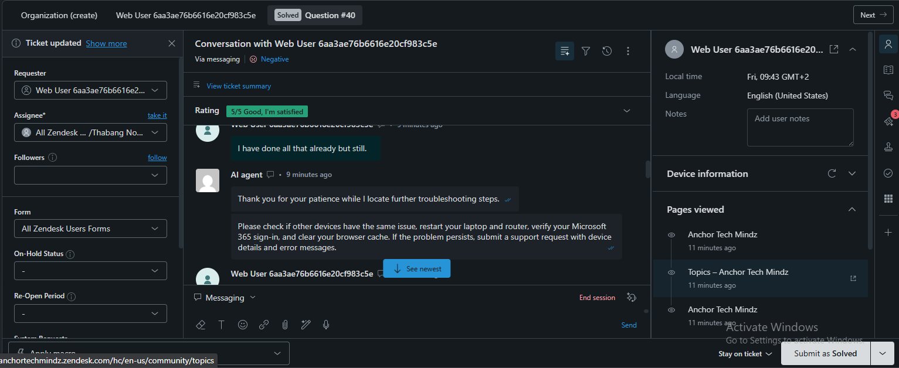

TICKET 4

Unable to Access Certain Websites — Question #35
Scenario group | Network & Performance Support
Evidence order | Screenshots are arranged from initial report to investigation, troubleshooting, confirmation, and closure.

Issue summary
The customer could access some websites but could not access Microsoft Teams and SharePoint reliably. The affected Windows laptop displayed “This site can’t be reached,” while other devices on the same Wi-Fi network could access the services normally.

IT Support Technician view

Investigation and findings
- The problem appeared limited to specific work-related websites and the customer’s laptop.
- Other websites and other devices on the same Wi-Fi were working.
- The customer reported that Microsoft Teams features other than the affected SharePoint-related access were functioning normally.
- The initial checks did not resolve the problem, so DNS and network configuration became the main investigation path.

Troubleshooting performed
- Requested the affected websites or URLs, error message, frequency, affected devices, and previous troubleshooting.
- Confirmed whether the issue affected the laptop only or multiple devices.
- Tested Microsoft Teams and SharePoint to identify whether the issue was specific to work-related websites.
- Checked whether other websites could be accessed normally.
- Reviewed the laptop’s browser, network, and DNS configuration.
- Flushed the DNS cache and refreshed the network configuration.
- Retested Microsoft Teams, SharePoint, and the affected work resources.

Research and technical reasoning
The evidence points to a laptop-specific DNS or network-resolution issue rather than a general internet outage. The resolution note explicitly records that DNS cache and network configuration were refreshed using ipconfig /flushdns, ipconfig /release, and ipconfig /renew.

Tools and systems used
- Zendesk ticket conversation and internal notes
- Microsoft Teams and SharePoint
- Web browser error message
- Windows network configuration
- Command Prompt
- ipconfig /flushdns
- ipconfig /release
- ipconfig /renew

User-friendly explanation
DNS is like a phone’s contact list. You may be able to call some people, but if one contact has an outdated number, that person cannot be reached until the contact information is refreshed.

Everyday analogy
The technician used staged communication: first gathering facts, then explaining the investigation, then reporting that the first checks had not resolved the issue, and finally confirming the resolution after the customer retested.

Customer communication
DNS translates a website name into the network address needed to reach it. In this case, general browsing worked, but the laptop was failing to reach certain work-related destinations. Refreshing the DNS and network configuration corrected the local lookup or connection state.

Resolution or escalation
Resolved at first line. The customer confirmed that Microsoft Teams and SharePoint were loading normally and that the work-related resources were accessible again.

Screenshot evidence — chronological order
The upload filenames are not chronological. The sequence below follows the support workflow shown in the Zendesk conversation. Each caption identifies the purpose of the screenshot in the ticket record.
Evidence 01 — Initial technician request for affected websites and diagnostic details
image_(10)_1789114943990.png
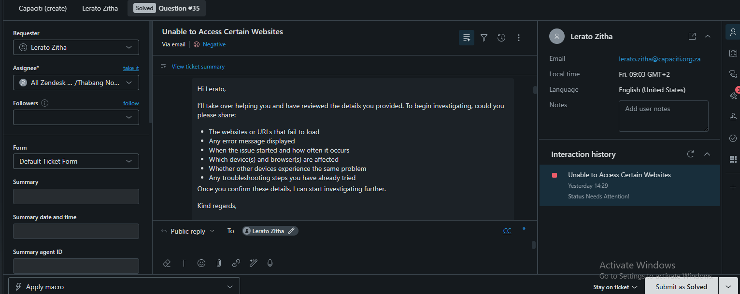
Evidence 02 — Customer reports the checks were completed but the issue remained
image_(20)_1789114943995.png
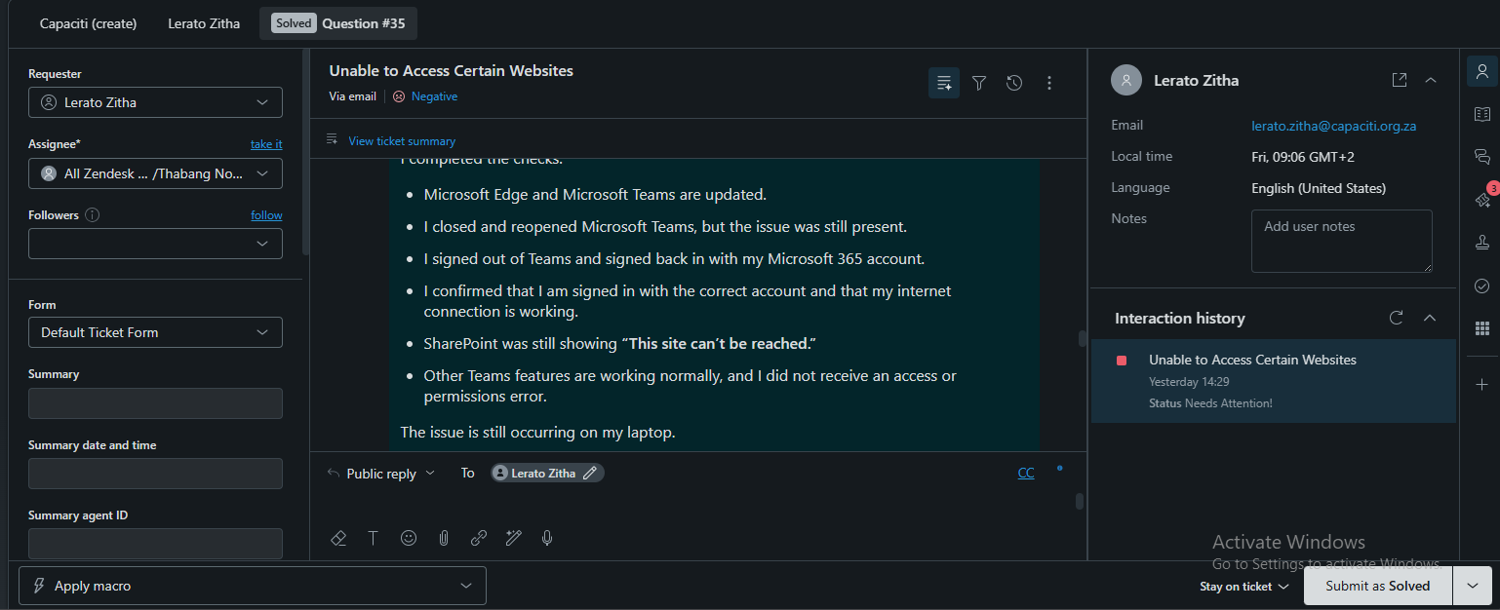
Evidence 03 — Internal initial investigation
image_(19)_1789114943994.png
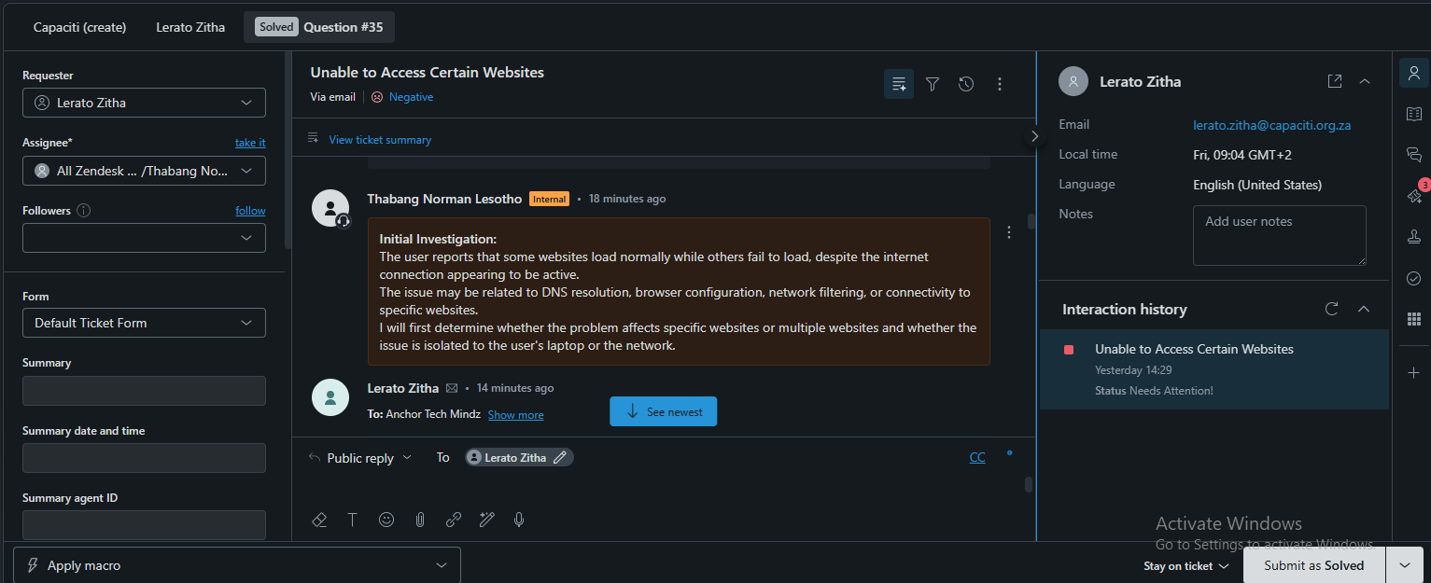
Evidence 04 — Technician explains the next investigation phase
image_(17)_1789114943994.png
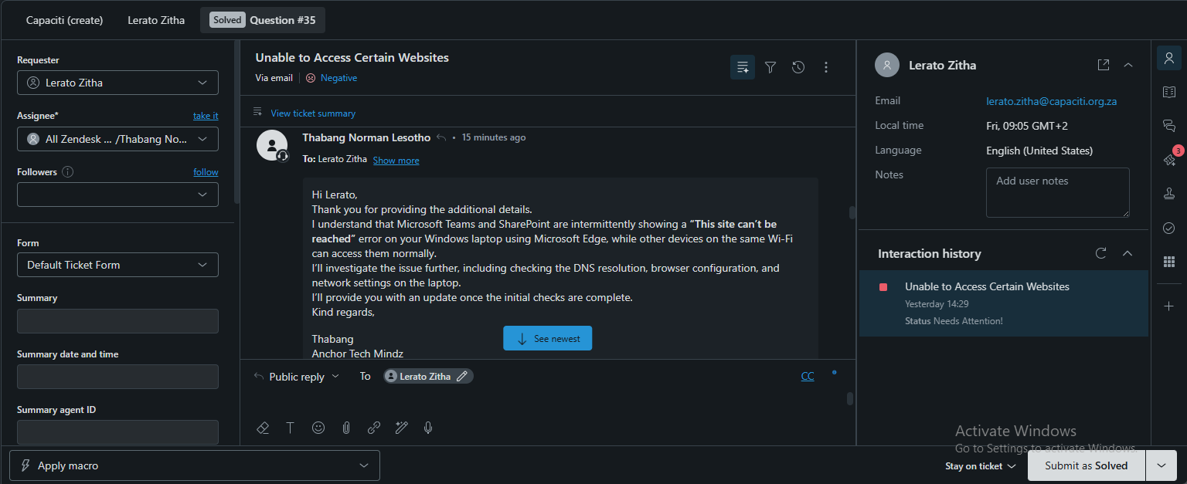
Evidence 05 — Internal research into DNS, browser, and network causes
image_(24)_1789115069285.png
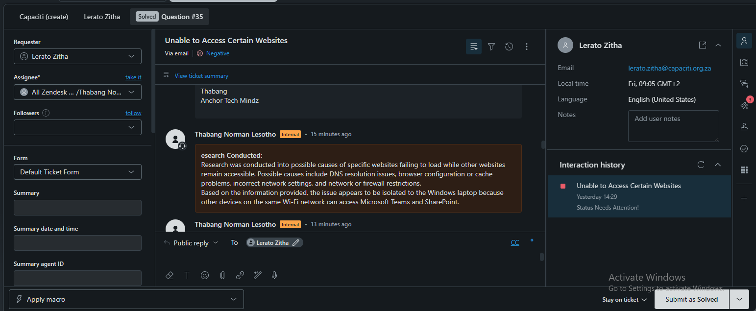
Evidence 06 — Internal troubleshooting record
image_(23)_1789115069284.png
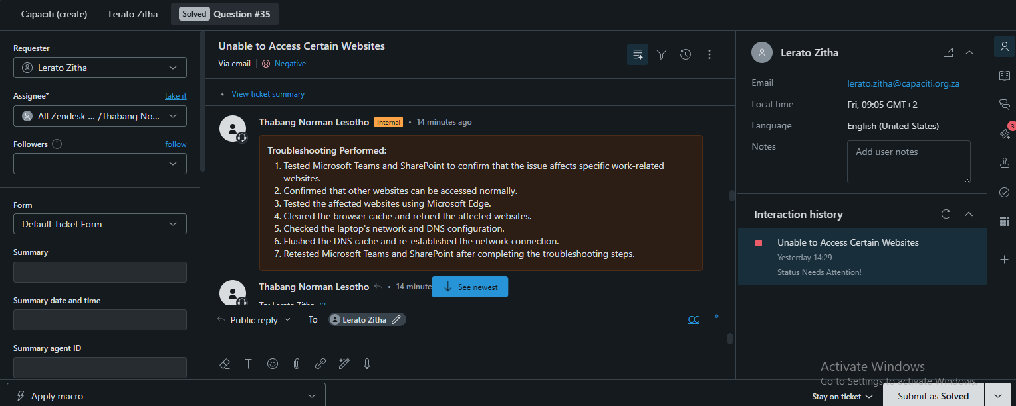
Evidence 07 — Public troubleshooting instructions for Microsoft Edge, Teams, and SharePoint
image_(22)_1789115069283.png
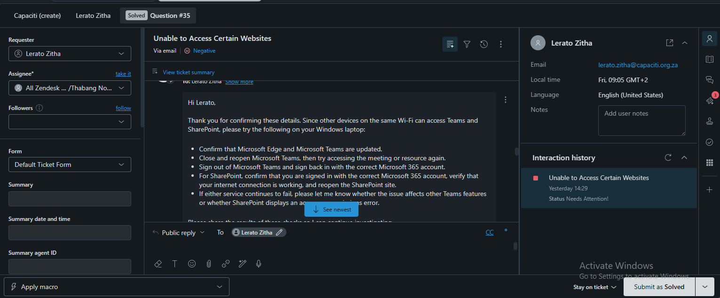
Evidence 08 — Technician follow-up: refresh DNS and network configuration
image_(21)_1789115220307.png
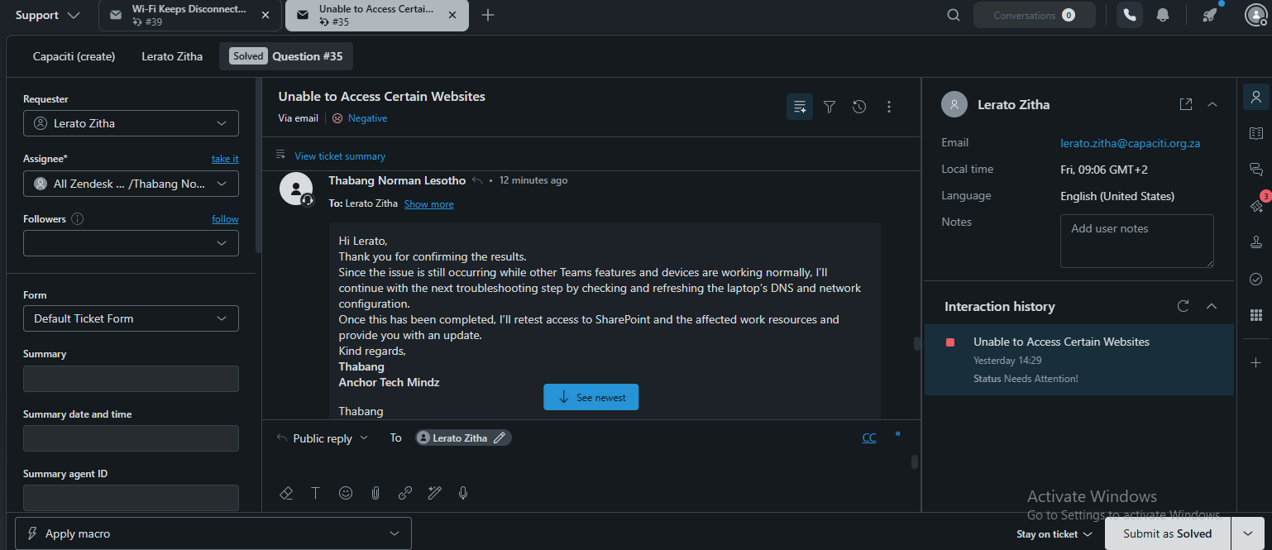
Evidence 09 — Internal note: initial troubleshooting did not resolve the issue
image_(16)_1789114943993.png
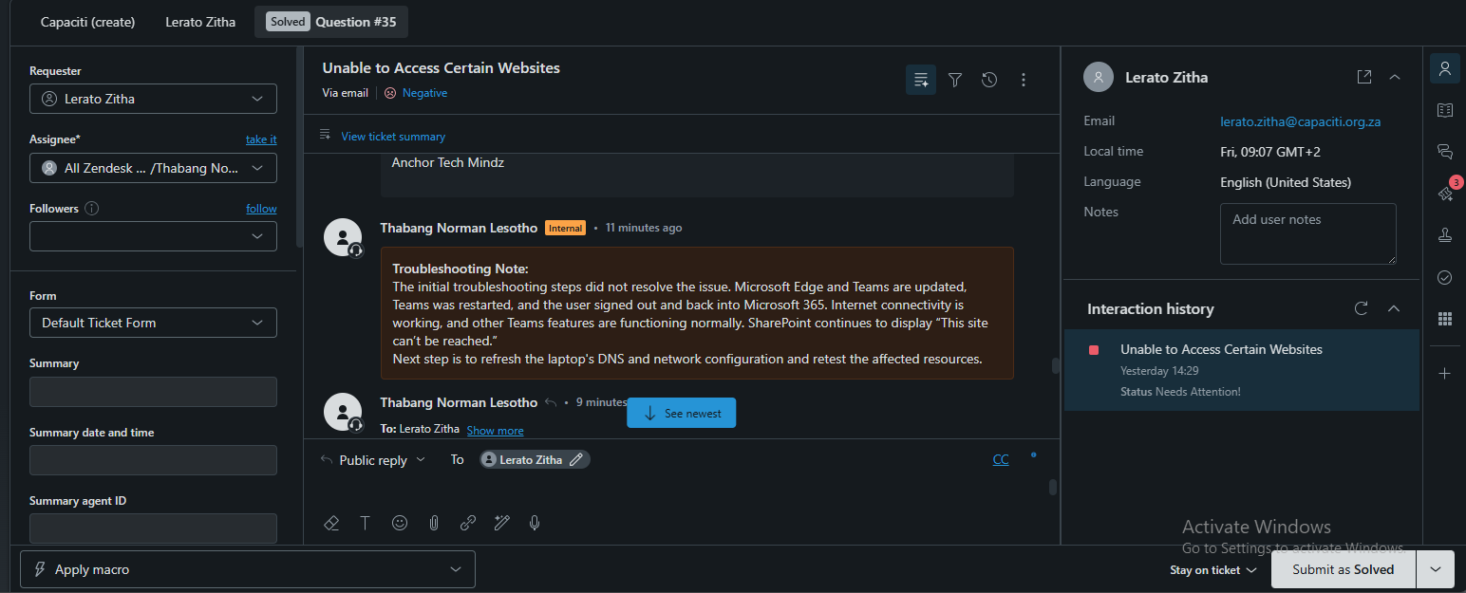
Evidence 10 — Internal resolution note
image_(14)_1789114943992.png
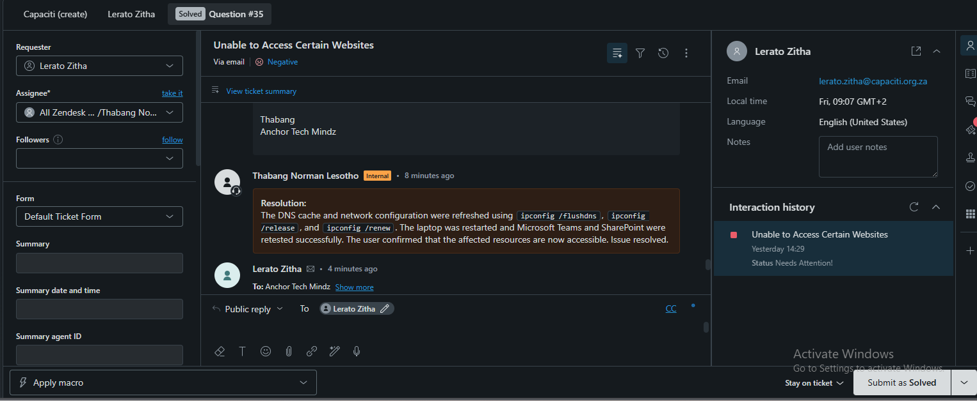
Evidence 11 — Customer confirms the issue has been resolved
image_(13)_1789114943991.png
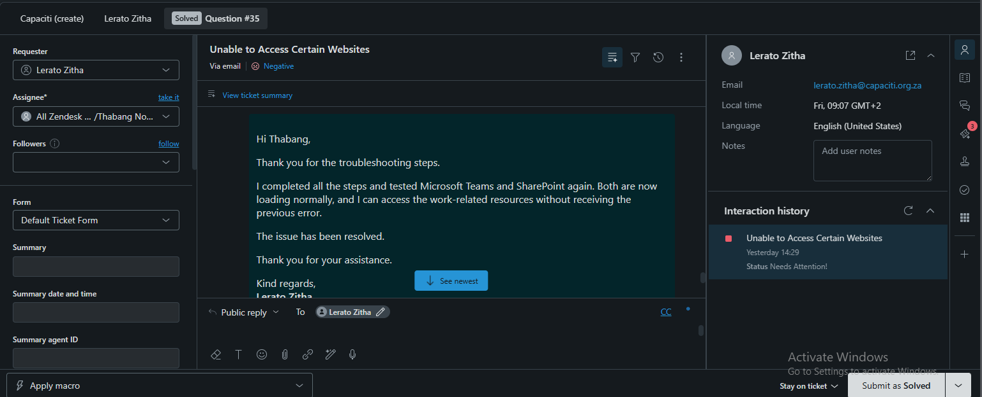
Evidence 12 — Final customer-facing closure message
image_(11)_1789114943990.png
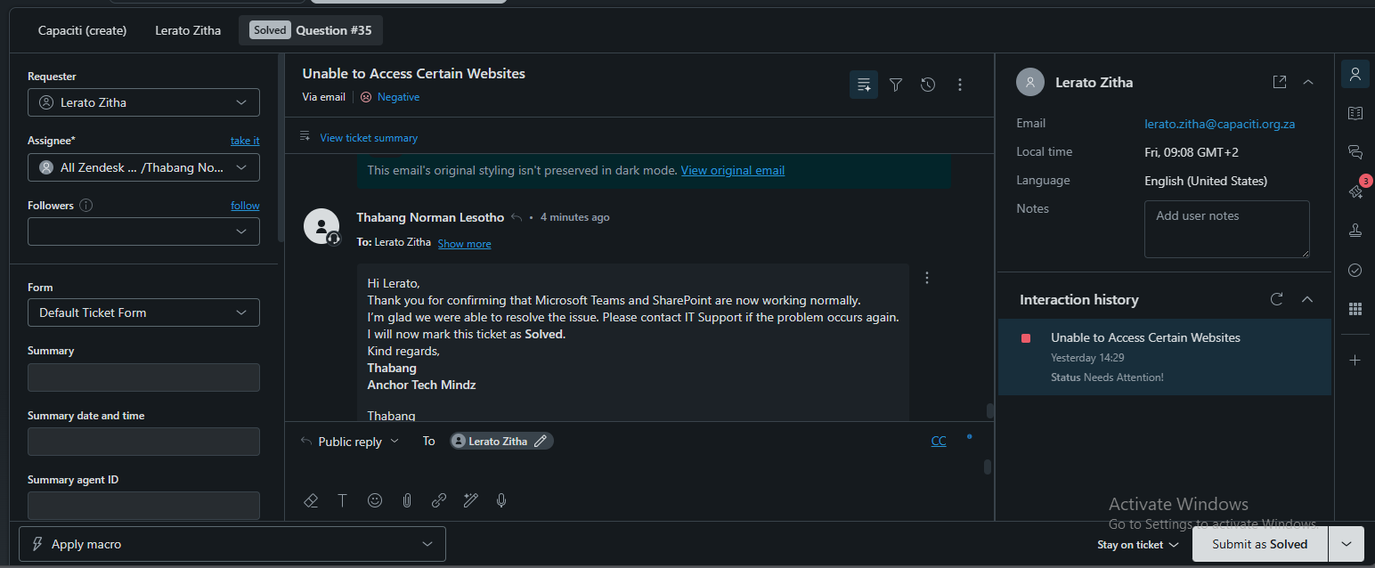

TICKET 5

Wi-Fi Keeps Disconnecting — Question #39
Scenario group | Network & Performance Support
Evidence order | Screenshots are arranged from initial report to investigation, troubleshooting, confirmation, and closure.

Issue summary
The customer reported that a laptop repeatedly disconnected from Wi-Fi. Other devices on the same Wi-Fi network were not affected, and the laptop remained connected when tested on another network.

IT Support Technician view

Investigation and findings
- The fault was isolated to one laptop rather than the entire Wi-Fi network.
- The customer reported repeated disconnections during normal use.
- The laptop was stable on another network, which reduced the likelihood of a general device failure.
- The customer later confirmed that the laptop remained connected after troubleshooting.

Troubleshooting performed
- Asked the customer to check the router or modem, restart it, and confirm that cables were secure.
- Asked whether other devices experienced the same disconnections.
- Asked the customer to test the laptop on another network or test the Wi-Fi connection with another device.
- Checked the laptop’s ability to reconnect automatically.
- Reviewed wireless signal and connection stability.
- Checked the laptop’s network configuration and Wi-Fi adapter settings.
- Disconnected and reconnected the laptop to the Wi-Fi network.
- Retested the connection to confirm that intermittent disconnections had stopped.

Research and technical reasoning
The investigation used device comparison and another-network testing to distinguish a laptop-specific problem from a wider access-point or internet problem. The internal note records checks of reconnection behavior, signal and connection stability, network configuration, and Wi-Fi adapter settings.

Tools and systems used
- Zendesk ticket conversation and internal notes
- Wi-Fi connection status
- Wireless router or modem checks
- Laptop network configuration
- Wi-Fi adapter and power-management settings
- Cross-device and alternate-network comparison

User-friendly explanation
Wi-Fi is like a phone call. If only one phone keeps dropping while other phones in the same room stay connected, the first step is to check that phone’s signal, settings, and ability to reconnect rather than replacing the entire telephone system.

Everyday analogy
The technician first acknowledged the disruption, supplied practical checks, recorded the internal investigation, asked focused follow-up questions, and closed the ticket only after the customer confirmed that the laptop stayed connected.

Customer communication
The laptop was losing its Wi-Fi connection while other devices stayed connected. The troubleshooting focused on the laptop’s wireless connection and configuration, and the customer confirmed that the connection became stable.

Resolution or escalation
Resolved at first line. The customer confirmed that the laptop remained connected and the issue was resolved.

Screenshot evidence — chronological order
The upload filenames are not chronological. The sequence below follows the support workflow shown in the Zendesk conversation. Each caption identifies the purpose of the screenshot in the ticket record.
Evidence 01 — Initial acknowledgement of the Wi-Fi disconnection report
image_(5)_1789114943988.png
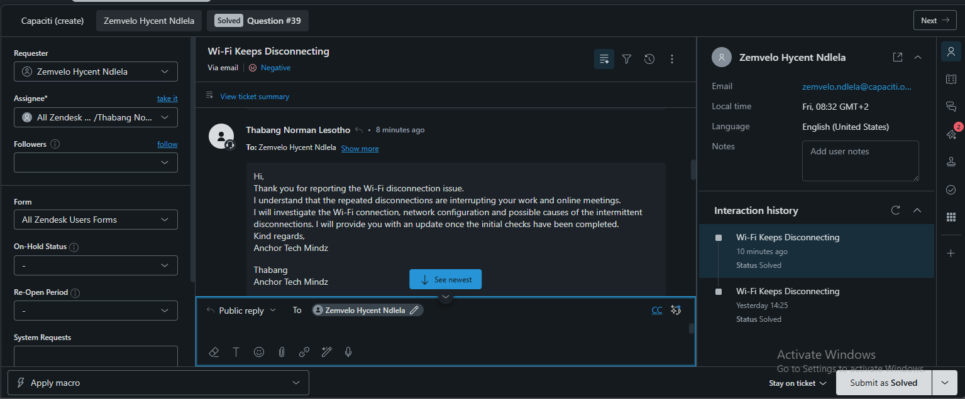
Evidence 02 — First troubleshooting instructions
image_(4)_1789114943987.png
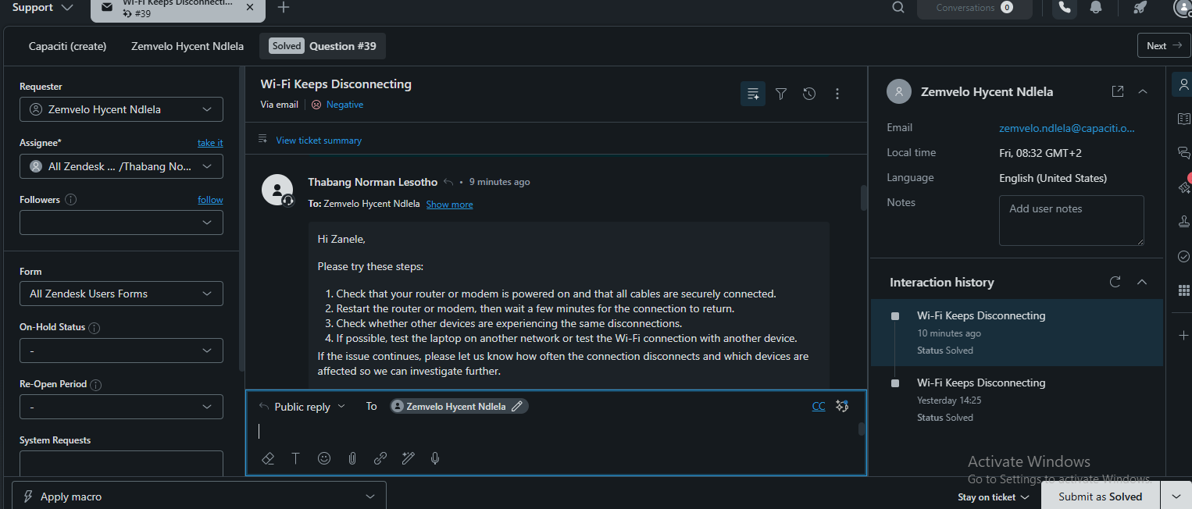
Evidence 03 — Internal troubleshooting record
image_(7)_1789114943988.png
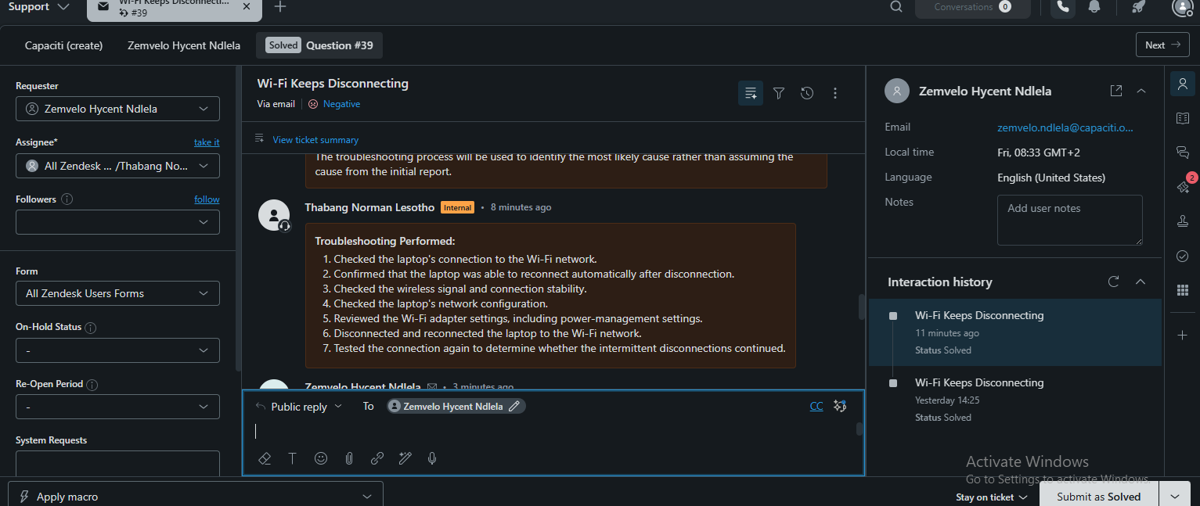
Evidence 04 — Follow-up questions to isolate the cause
image_(8)_1789114943989.png
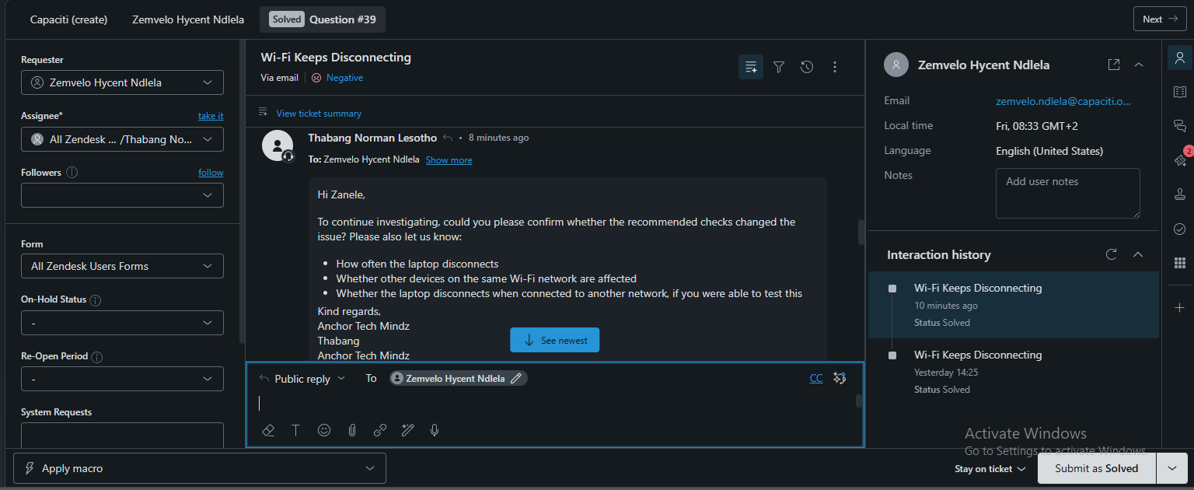
Evidence 05 — Customer confirms the recommended checks resolved the issue
image_(1)_1789114943985.png
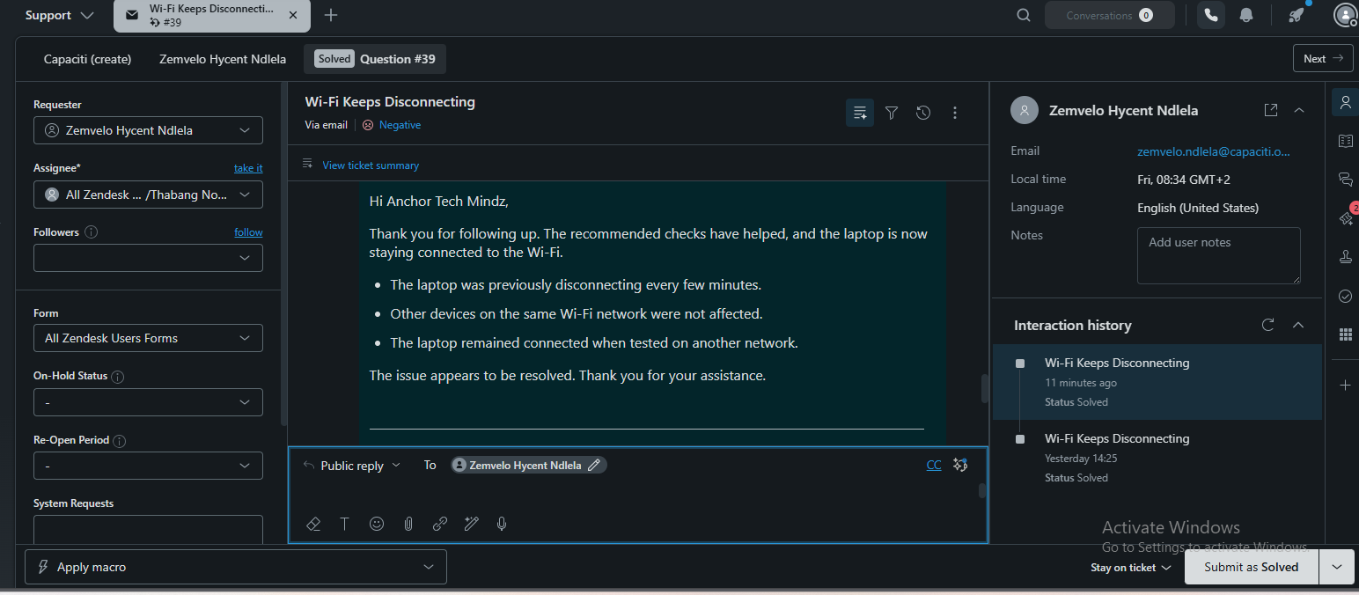
Evidence 06 — Final customer-facing closure message
image_(2)_1789114943986.png
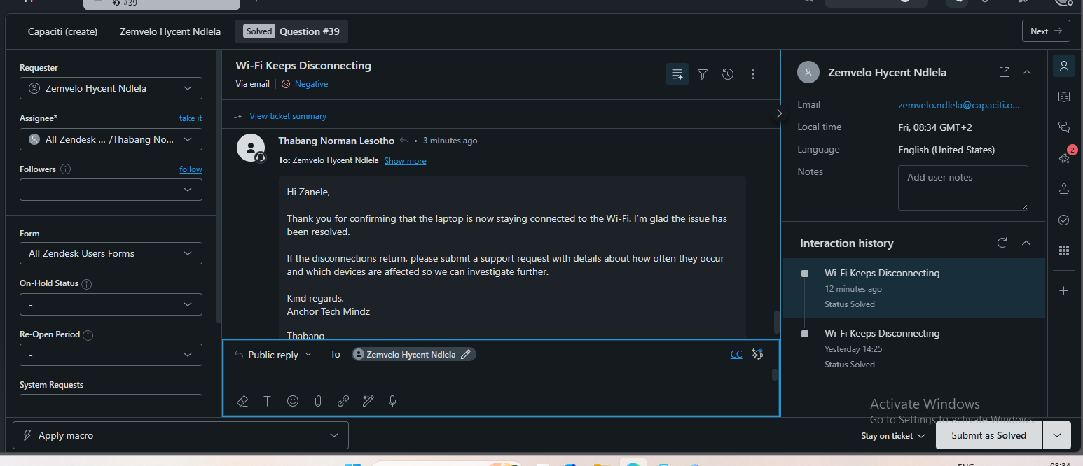

Completion checklist
- Two selected scenario groups are represented.
- Five completed Zendesk tickets are documented.
- Each ticket includes an issue description, investigation, troubleshooting, research or technical reasoning, tools, customer communication, and resolution.
- The screenshots are grouped by ticket and arranged in support-process order.
- The documentation distinguishes public customer replies from internal technician notes.
- Each ticket includes both a technical view and a plain-English explanation with an analogy.
- The strongest complex scenario for a presentation walkthrough is the SharePoint and Teams access issue because it shows staged investigation, research, unsuccessful first-line checks, DNS and network troubleshooting, customer confirmation, and closure.

Recommended complex scenario
The strongest presentation case is Question #35, Unable to Access Certain Websites. It demonstrates the clearest progression from symptom discovery to isolation, research, a failed initial attempt, DNS and network remediation, validation, and customer confirmation.

