

**INTERNET PROGRAMMING**

**(COMP342)**

Department of Computer Science and Information Systems

NAME: THABANG ONE

SURNAME: SAAKANE

ID: 17001132

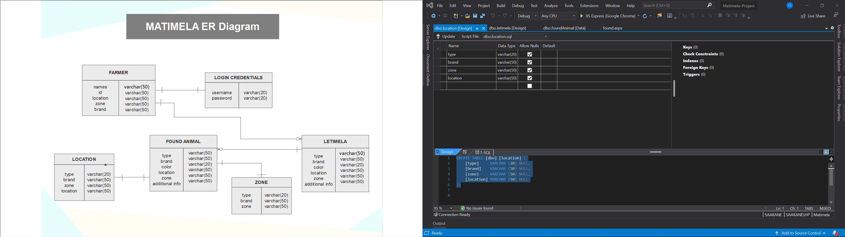

**RELATIONSHIP TABLES**

