SIYABONA Mobile IPS
Application Screenshots — Feature Demonstration
Prepared by: Thabani Ndlela
Date: 22 May 2026
Module: Security Assessment

1. Overview
The following screenshots demonstrate the SIYABONA Mobile IPS application actively detecting scams across three scan types: SMS messages, WhatsApp messages, and suspicious URLs. Each test uses a realistic South African scam scenario to show the detection engine in action.

2. SMS Scam Detection
Test message used: "CAPITEC: Your account has been suspended due to suspicious activity. Click https://capitec-secure-verify.co.za to restore access immediately. Failure to verify within 24 hours will result in permanent account closure."
This simulates a common Capitec bank phishing SMS that uses urgency tactics, brand impersonation, and a suspicious link — three of the most common scam signals in South Africa.

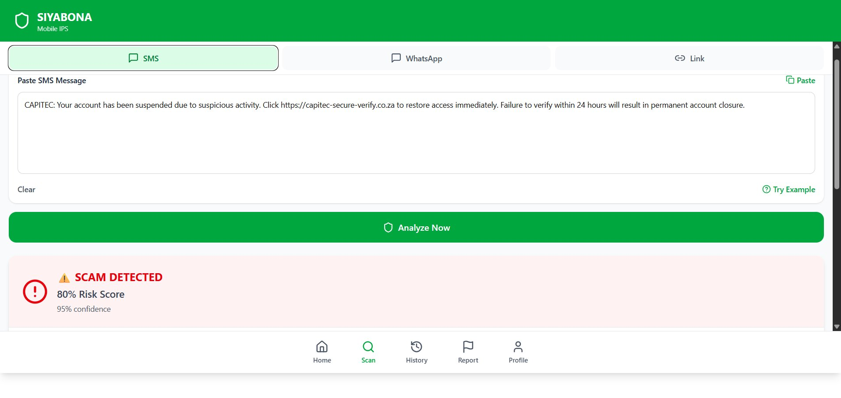
Figure 1: SMS scan tab showing the test message entered and the initial SCAM DETECTED banner (80% Risk Score, 95% confidence)

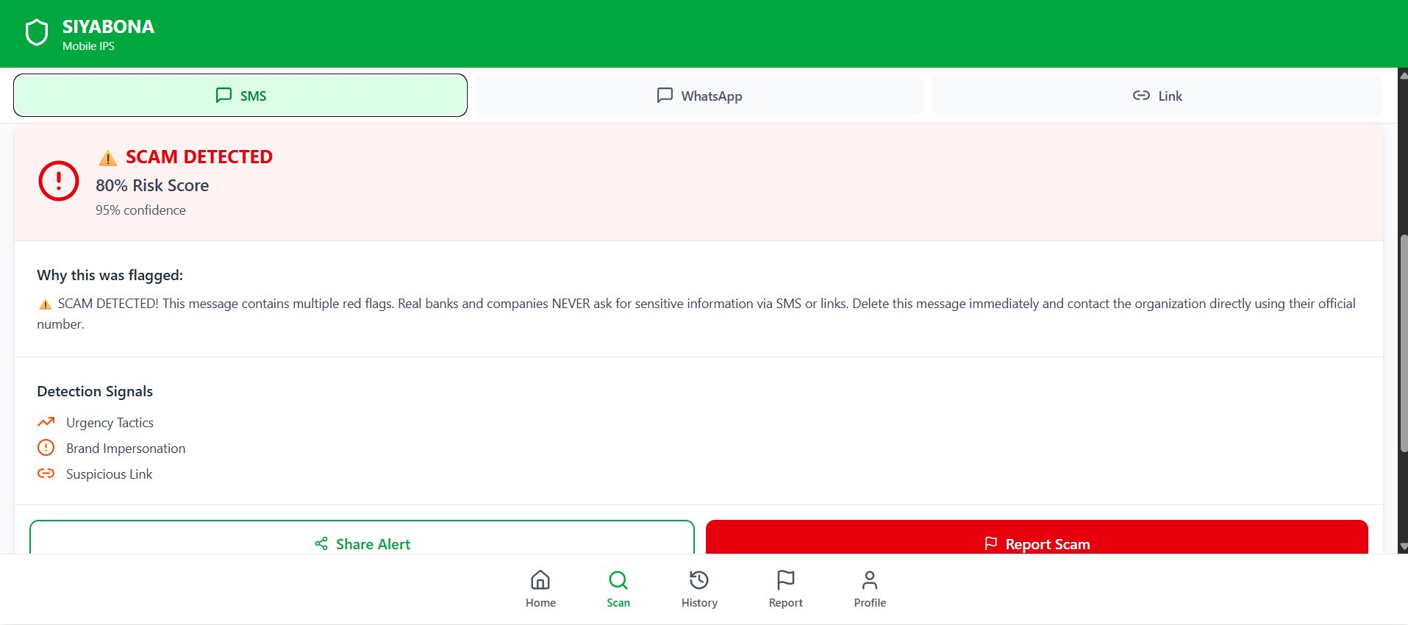
Figure 2: Detailed SMS scan result — detection signals identified: Urgency Tactics, Brand Impersonation, Suspicious Link. Includes advice and Share Alert / Report Scam actions.

3. WhatsApp Scam Detection
Test message used: "Hi Mom, it's me. I lost my phone and this is my new number. Please send R2000 urgently for an emergency. I'll explain later. Just send to this account: Capitec 1234567890"
This simulates the widely reported "Hi Mom/Dad" family impersonation scam which is one of the most prevalent WhatsApp scams targeting South African families.

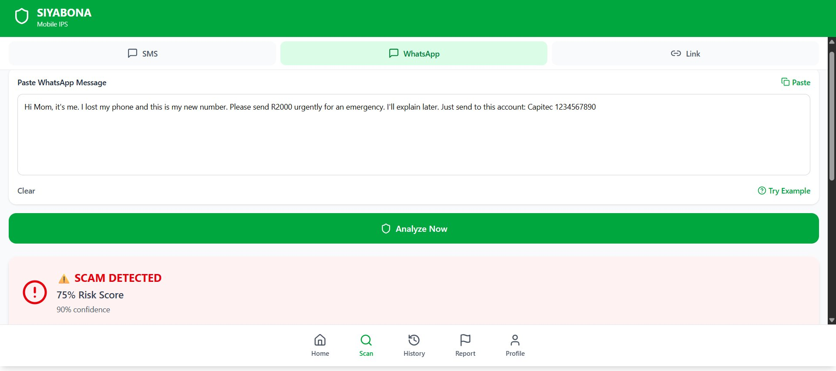
Figure 3: WhatsApp scan tab showing the family impersonation test message and the SCAM DETECTED banner (75% Risk Score, 90% confidence)

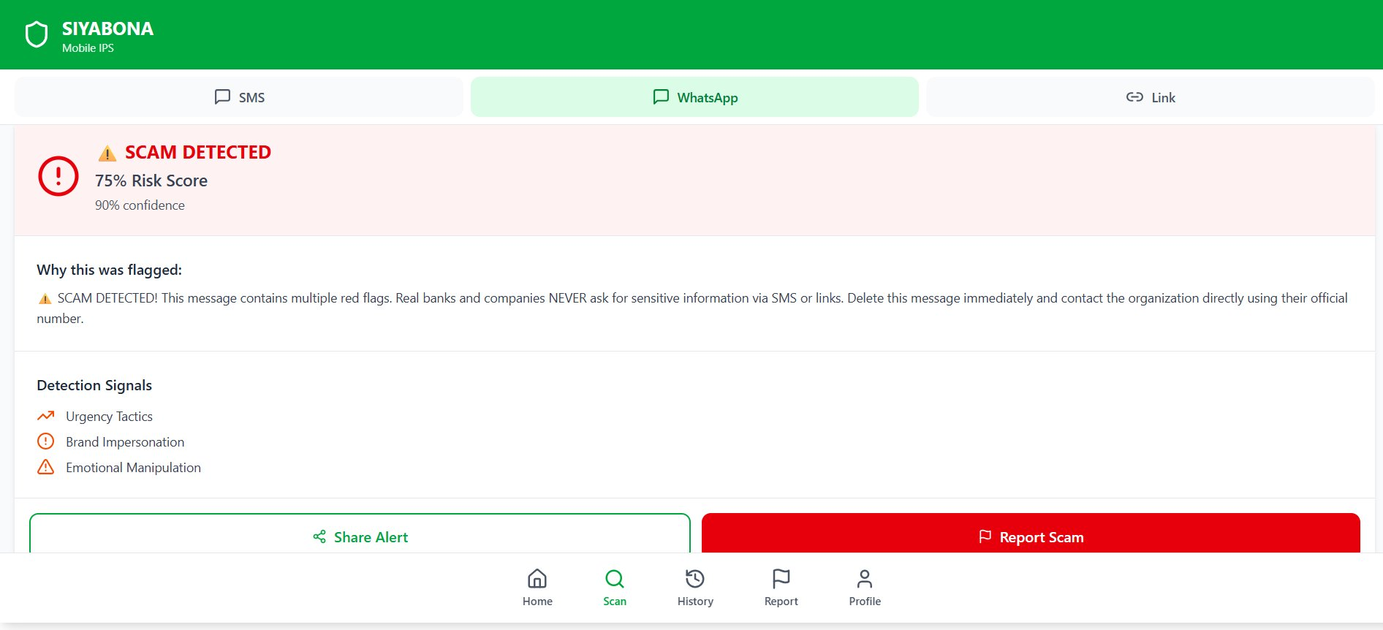
Figure 4: Detailed WhatsApp scan result — detection signals identified: Urgency Tactics, Brand Impersonation, Emotional Manipulation. These three signals are characteristic of the "Hi Mom" scam pattern.

4. Suspicious URL / Link Detection
Test URL used: https://capitecbank-verify-account.xyz/login
This simulates a typosquatting attack where a scammer registers a domain that looks like a legitimate bank's URL but uses a suspicious top-level domain (.xyz) to steal login credentials.

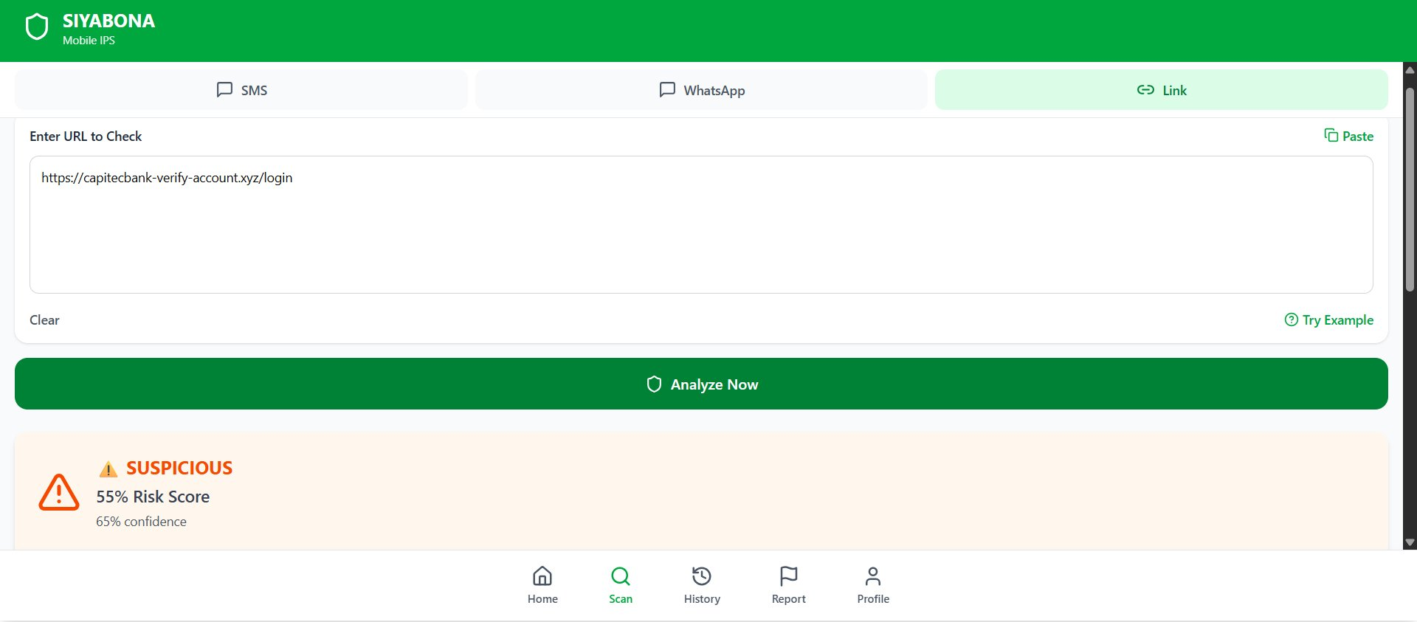
Figure 5: Link scan tab showing the suspicious URL and the SUSPICIOUS banner (55% Risk Score, 65% confidence) — lower than SMS/WhatsApp as the URL alone carries less context

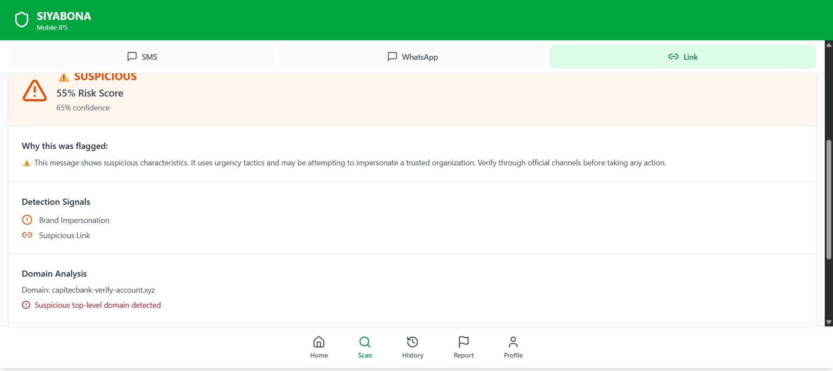
Figure 6: Detailed URL scan result — detection signals: Brand Impersonation, Suspicious Link. Domain Analysis section confirms the suspicious top-level domain (.xyz) was detected for capitecbank-verify-account.xyz

5. Summary of Test Results

Scan Type | Test Input | Result | Risk Score | Signals Detected
SMS | Capitec bank suspension phishing SMS | SCAM DETECTED | 80% / 95% | Urgency, Brand Impersonation, Suspicious Link
WhatsApp | "Hi Mom" family impersonation scam | SCAM DETECTED | 75% / 90% | Urgency, Brand Impersonation, Emotional Manipulation
URL/Link | Fake Capitec typosquatting domain (.xyz) | SUSPICIOUS | 55% / 65% | Brand Impersonation, Suspicious Link, Suspicious TLD

All three scan types successfully detected scam indicators in the test inputs. The SMS scanner achieved the highest risk score (80%) due to the combination of urgency language, a known SA bank name, and a suspicious URL in the same message. The URL scanner returned a lower score (55%) which is expected — a URL alone provides less context than a full message, but the domain analysis correctly flagged the suspicious .xyz top-level domain.

