Project: Distributed Movie Ticket Booking System
Author: Thabira Meher– Senior Java Full Stack Developer
Date: March 21, 2026
1. System Overview
The Movie Ticket Service is a high-concurrency booking platform designed with a Polyglot Persistence strategy. It handles user authentication, movie catalog management, and transactional seat bookings.
2. Architectural Design Patterns
- Layered Architecture: Clear separation between Web (REST), Service (Business Logic), and Persistence (JPA/Mongo) layers.
- Stateless Security: Implemented via Spring Security 6 and JWT, allowing the application to scale horizontally without session affinity.
- Polyglot Persistence:
  - MySQL (RDBMS): Used for ACID compliance in the Booking and Payment modules to prevent double-booking.
  - MongoDB (NoSQL): Used for the Movie Catalog to allow for a flexible, schema-less metadata structure (e.g., varying languages, cast details, and genres).
3. Technical Stack
Component | Technology
Backend | Java 17, Spring Boot 3.x
Security | JWT, Spring Security, BCrypt
Primary DB | MySQL 8.0 (Transactional data)
Secondary DB | MongoDB (Movie metadata)
Documentation | Swagger / OpenAPI 3.0
Deployment | Docker & Docker Compose
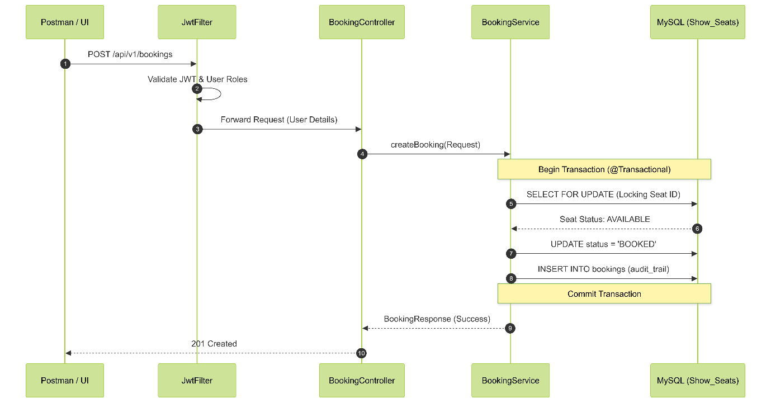

4. Database Schema & Data Modeling
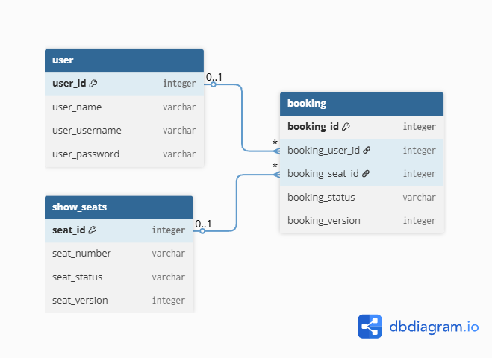

A. Relational Schema (MySQL)
- Users Table: Stores credentials and RBAC (Role-Based Access Control).
- Bookings Table: Tracks the lifecycle of a ticket (PENDING, CONFIRMED, CANCELLED).
- Show_Seats: Implements Pessimistic Locking (SELECT FOR UPDATE) to ensure thread-safe seat allocation during peak traffic.
B. Document Schema (MongoDB)
- Movies Collection: Stores rich movie data. Example document structure:
Ex –
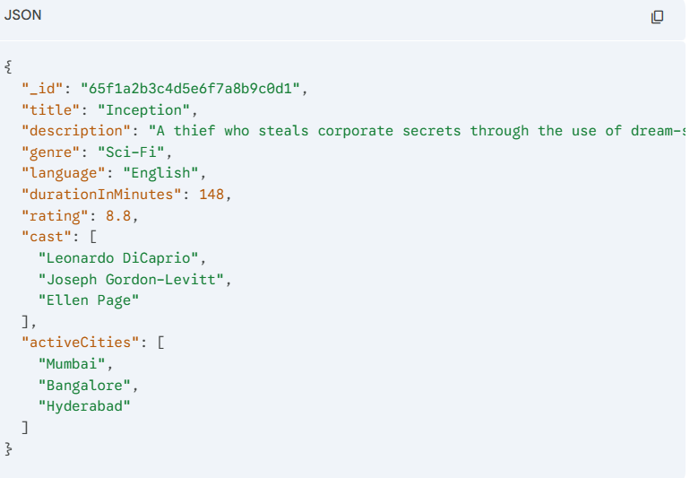

5. Key Design Decisions & Concurrency
- Race Condition Management: To handle 100+ concurrent users booking the same seat, we utilized Pessimistic Write Locking. This ensures that the first thread to access a seat row blocks others until the transaction commits.
- Containerization: The entire stack is orchestrated via Docker Compose, using a Bridge Network to allow the Java App to communicate with MySQL and MongoDB using service names instead of volatile IP addresses.
- Port Diversion: Port 9090 was selected for the host binding to avoid conflicts with local developer environments (ghost processes on 8080).

6. API Request Lifecycle
- Client sends a request to Port 9090.
- JwtFilter validates the token signature.
- Controller maps the request and triggers the Service Layer.
- Service manages the @Transactional boundary.
- Repository executes queries against MySQL/MongoDB.
- GlobalExceptionHandler catches any 400/404/500 errors and returns a standardized JSON response.
7. Future Scalability & Roadmap
- Caching Layer: To reduce read latency for high-traffic movie catalogs, Redis would be implemented as a distributed cache for MongoDB query results.
- Asynchronous Notifications: For processing high volumes of booking confirmations and email alerts, a message broker like Apache Kafka or RabbitMQ would be integrated to decouple the notification logic from the primary booking transaction.
- Monitoring & Observability: In a production environment, the stack would include Prometheus and Grafana to monitor JVM performance, database connection pool health, and custom application metrics.
8. Testing Strategy
- Unit Testing: Business logic in the Service Layer is validated using JUnit 5 and Mockito.
- Integration Testing: Docker-based Testcontainers are utilized to run integration tests against actual MySQL and MongoDB instances, ensuring database scripts and repository queries are production-ready.
- Concurrency Testing: Simulated load tests were performed to verify that Pessimistic Locking correctly prevents "double-booking" during simultaneous seat selection.
9. Error Handling & Resilience
- Global Exception Handling: A @RestControllerAdvice is implemented to intercept business-specific exceptions (e.g., BookingNotFoundException), ensuring the client receives a structured JSON response instead of a raw stack trace.
- Health Checks: Docker Compose includes health check parameters to ensure the Java application only starts once the MySQL and MongoDB services are fully initialized and ready for connections.

