STANDARD BANK · FINANCE HACKATHON
GROUP NAME: FINTECH TITANS
Detecting Fraud in Mobile Money
From data audit to a deployable, explainable model
This report consolidates the full project: the Phase 1 data audit, the feature engineering that followed, the modelling experiments, the problems we found and corrected along the way, and the recommendations we would put to the bank. Every claim is tied to a measured result, and where later evidence overturned an earlier conclusion we say so explicitly rather than quietly dropping it.
Headline result | Value | What it means
Fraud rate in the data | 0.13% | One in every 750 transactions
Final model PR-AUC | 0.836 | Against 0.0013 for random guessing
Fraud caught at chosen threshold | 71.0% | 181 of 255 frauds in the test set
Precision at chosen threshold | 91.4% | Only 17 false alarms from 198 alerts
Loss avoided against no model | R904 150 | On the test set alone
Table 1. Headline results, measured on a held out test set of 190 879 transactions.

1. Executive Summary
Fraud in this dataset is rare, concentrated and highly structured. It occurs in only two of the five transaction types, its volume stays almost perfectly constant across the daily activity cycle, and it moves far larger sums than legitimate activity. Those three patterns, established in the audit phase, drove every modelling decision that followed.
Our final model is a tuned XGBoost classifier using nine features, all of which would be available at the moment a transaction needs a decision. On a held out test set it achieves a PR-AUC of 0.836 and, at the operating threshold we selected, catches 71 percent of fraud while raising only 198 alerts across 190 879 transactions. Priced against the bank’s cost of a missed fraud, that is a reduction in loss from R1 275 000 to R370 850 on the test set alone.
The most important thing we found is not a performance number. It is that this dataset contains a shortcut that makes fraud trivially predictable for the wrong reason. In 97.5 percent of fraud cases the transaction amount equals the origin balance to the cent, and 99.3 percent of fraudulent transfers leave the destination balance frozen at zero. Two boolean rules using these facts identify 99.8 percent of all fraud at 99.2 percent precision, with no model at all. Those patterns are artifacts of how the simulator was built, not properties of real fraud, and a submission that reports the resulting near perfect scores would be reporting an illusion. We therefore ran every model on three separate feature sets so the effect could be measured rather than hidden, and we selected the feature set that excludes the after the fact bookkeeping columns.
A second correction concerns time. The data card states that one step is one hour and that the simulation spans 30 days, but it never states what clock time step 1 corresponds to. Our earlier draft described a high risk window at "04:00". That claim cannot be supported by the data, so we replaced it with a defensible one: the step column is treated as a position within a repeating 24 step cycle, and the high risk window is identified from observed transaction volume rather than from an assumed start time.

Decisions at a glance
Decision | What we chose | Why
Imbalance strategy | Class weighting, not SMOTE | SMOTE interpolates rows whose balances do not add up, corrupting the very columns we study
Primary metric | PR-AUC, plus precision and recall | Accuracy of 99.87 percent is achievable by approving everything
Feature set | Amount, cycle position, type, pre transaction balances | Excludes columns only knowable after settlement
Split | Random stratified, validated against a time split | Both were run; they agree within 0.02 PR-AUC
Model | XGBoost, tuned | Best PR-AUC across every feature set and both splits
Threshold | Chosen on validation, priced on cost | 0.5 is a convention, not a business decision
Table 2. The six decisions that shaped the project, each justified in the sections that follow.

2. Data Audit and Quality
The dataset contains 636 262 transactions across 11 raw columns, covering 30 days of simulated mobile money activity. Data quality is high: there are no missing values, no duplicate rows and no negative balances. Repeated values in nameOrig and nameDest are not duplicate records; they are the same account appearing in more than one transaction.
Of 636 262 transactions, 849 are fraudulent, a rate of 0.13 percent, or roughly one in 750. This single number governs the whole project. A model that predicts "not fraud" for every row scores 99.87 percent accuracy and catches nothing, so accuracy is excluded from our scorecard entirely.
Transaction type | Volume | Fraud cases | Fraud rate
CASH_OUT | 223 846 | 417 | 0.19%
PAYMENT | 215 315 | 0 | 0.00%
CASH_IN | 139 684 | 0 | 0.00%
TRANSFER | 53 270 | 432 | 0.81%
DEBIT | 4 147 | 0 | 0.00%
Table 3. Fraud occurs in only two of the five transaction types.
This is the first exploitable pattern. Fraud appears exclusively in TRANSFER and CASH_OUT, which is consistent with the documented attack: the criminal transfers funds out of a compromised account and then cashes them out. PAYMENT, CASH_IN and DEBIT contain zero fraud across the entire dataset, which together represent 56 percent of all volume. Transaction type is therefore encoded directly as a model input, and Section 9 recommends routing those three types around the model entirely.

The existing rule is not fit for purpose
The isFlaggedFraud column implements a business rule that flags transfers above R200 000. It fires on 2 transactions in the entire dataset and identifies 2 of 849 frauds, a miss rate of 99.8 percent. Its correlation with the true label is 0.05. We excluded it from the feature set: it carries essentially no information, and retaining it would only invite the model to learn a broken rule. It is retained solely as the baseline that any learned model must beat, a bar cleared comfortably.

Correlation and redundancy
No raw column correlates strongly with the label; the maximum is 0.08 with amount. That is not evidence fraud is undetectable, but that it is a multi feature, non linear pattern, which is why tree ensembles later beat the linear baseline by a wide margin. We also confirmed severe redundancy among balances: oldbalanceOrg and newbalanceOrig correlate at 1.00 and the destination pair at 0.98, so we use one balance level per side rather than all four raw columns.

3. Patterns Found in the Data

3.1 Fraud is steady while genuine activity is not
Transaction volume follows a strong repeating 24 step cycle. Fraud does not. The count of fraudulent transactions at each position in the cycle stays between 25 and 43, while legitimate volume swings from 119 to 64 659. Because the numerator is flat and the denominator collapses, the fraud rate in the quiet stretch of the cycle rises sharply.
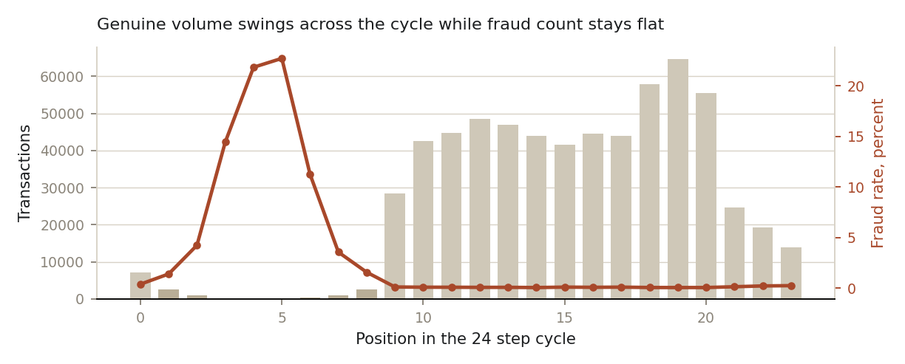
Figure 1. Volume by cycle position with fraud rate overlaid. Darker bars mark the low activity window. Fraud count stays between 25 and 43 at every position while volume ranges from 119 to 64 659.
Cycle segment | Share of volume | Fraud rate | Ratio
Low activity positions 1 to 8 | 1.2% | 3.48% | 39x
All other positions | 98.8% | 0.09% | baseline
Table 4. The quiet window holds barely one percent of traffic but a disproportionate share of risk.

3.2 Fraud moves far larger sums
The median fraudulent transaction is R429 257 against R74 407 for a legitimate one, roughly six times larger. Fraud rate climbs steadily with transaction size. The raw amount column is severely right skewed, with a skewness of 31.8, so we model the logarithm instead, which brings skewness to -0.55 and makes the feature usable by the linear baseline as well as the trees.

3.3 The pattern that turned out to be a trap
Our Phase 1 audit identified the change in origin balance as "the single most discriminative feature found" and recommended it anchor the feature engineering. Further investigation showed this conclusion was correct about the strength of the signal and wrong about its usefulness. The separation is total, and that is precisely the problem.
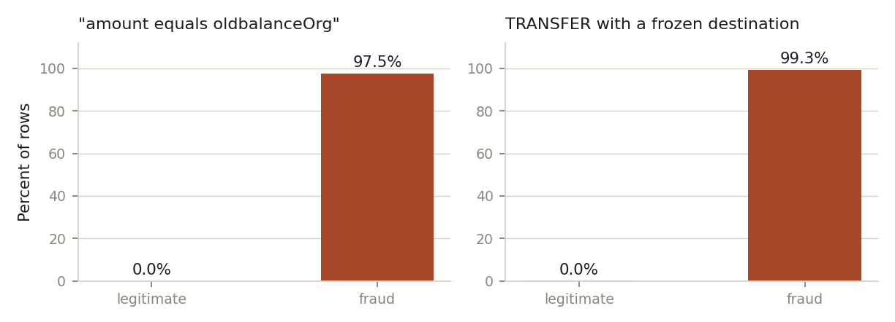
Figure 2. Two bookkeeping patterns that separate the classes almost perfectly, for reasons specific to the simulator.
In 97.5 percent of fraud cases the amount equals oldbalanceOrg exactly, and in 0.0 percent of legitimate cases. Separately, 99.3 percent of fraudulent transfers leave the destination balance at zero both before and after, because the simulator cancels fraudulent transactions rather than settling them. Combined as two boolean rules, these identify 99.8 percent of all fraud at 99.2 percent precision without any model.
Why we did not exploit this
Real fraud does not empty an account to the last cent 97.5 percent of the time, and a real ledger does not freeze a destination balance because a transaction was fraudulent. These are properties of the data generator. A model built on them would collapse on live data, and reporting the resulting scores would misrepresent what the bank could expect. We kept the columns in a clearly labelled third feature set so the effect is visible and measurable, and excluded them from the model we recommend.

4. How We Handled the Step Column
The data card tells us one step equals one hour and that the simulation covers 30 days, giving steps 1 to 744. It does not tell us what clock time step 1 corresponds to. An earlier draft of this report described "approximately Day 3 and the 4th hour" as high risk windows. That phrasing implies knowledge of when the simulation began, which we do not have, and any recommendation resting on it would be indefensible under questioning.
We corrected this in three ways. The derived feature is named cycle_position rather than hour and documented as a position in a repeating 24 step cycle. The high risk window is no longer hardcoded from an assumed clock but derived from the data: any position whose volume falls in the bottom third is flagged as low activity, which selects positions 1 through 8 by a quantile rule anyone can reproduce and challenge. And all downstream language, here and in the dashboard, refers to the quiet part of the cycle rather than to night or to specific hours.
We also dropped the day_of_week feature that an earlier plan proposed. Its apparent signal turned out to be confounded with a volume ramp across the simulation rather than reflecting a genuine weekly cycle, and PaySim has no calendar to anchor it to. Removing it cost nothing measurable.
What this costs and what it buys
The empirically derived flag performed slightly better than the assumed one, so the correction cost us nothing in accuracy. What it buys is defensibility: every temporal claim in this report can be traced to observed volume in the data. Mapping cycle positions onto real clock times is a one line change once the bank knows when collection started, which the dataset itself never states.

5. Feature Engineering
We kept the feature set deliberately small. Nine features that can each be explained in a sentence are more defensible, easier to debug and simpler to monitor than a larger set of cleverer ones. Each feature below is paired with the reason it exists.
Feature | Definition | Why it is included
log_amount | log(1 + amount) | Fraud moves larger sums; the log corrects skewness of 31.8
cycle_position | step mod 24 | Position in the repeating activity cycle, not a clock hour
is_low_activity | position in bottom third by volume | The quiet window carries 39 times the fraud rate
log_old_org | log(1 + oldbalanceOrg) | Sender balance before the transaction, known at decision time
log_old_dest | log(1 + oldbalanceDest) | Receiver balance before the transaction
type_ (four columns) | one hot, first category dropped | Fraud occurs in only two of five types
Table 5. The nine model features. All are computable before a transaction settles.
Two further columns, error_orig and error_dest, measure whether the ledger balances after the fact. They were built and then deliberately quarantined into the third feature set for the leakage demonstration in Section 7. They are also unavailable before settlement, since they depend on post transaction balances.

6. Multicollinearity
Multicollinearity does not greatly harm tree models, but it destabilises logistic regression coefficients, and we rely on those coefficients for explainability. We therefore measured the Variance Inflation Factor for every candidate feature before training.
The check found a genuine problem. Two features returned VIF values above 30, far past the usual warning line of 10.
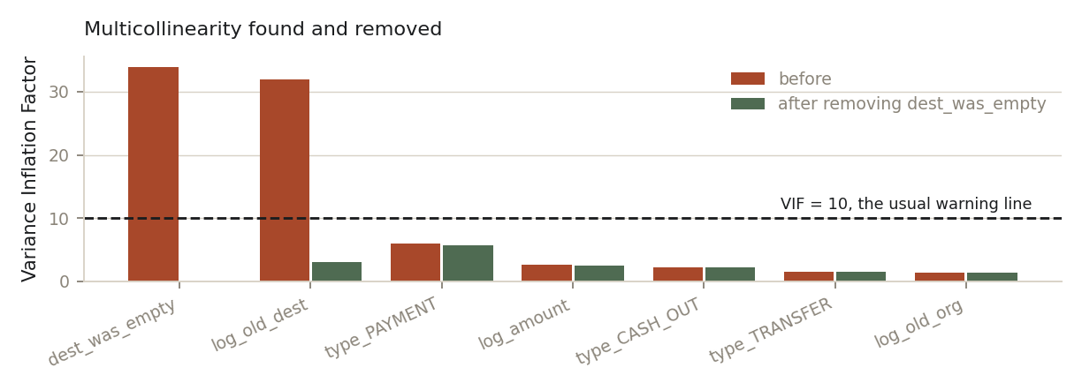
Figure 3. Variance Inflation Factors before and after removing the redundant flag.
The cause is arithmetic rather than subtle. Because log(1 + 0) equals 0, the feature log_old_dest is exactly zero whenever dest_was_empty is 1, making the two columns near duplicates with a correlation of -0.98. We removed dest_was_empty and kept the continuous version, which carries strictly more information. The highest remaining VIF is 5.65, comfortably inside acceptable limits, and model performance improved marginally as a result.
A second, easily missed form was handled at the encoding stage. One hot encoding all five transaction types produces columns that always sum to one, so any one is perfectly determined by the rest. This is the dummy variable trap and it returns VIF values of infinity. Setting drop_first to true removes it at no information cost, since the dropped category is represented by all others being zero.

7. Experimental Design and Results

7.1 Three feature sets, four models
Rather than quote a single performance figure, we trained four models on three feature sets so the source of every gain is visible. Set A uses amount, cycle position and type. Set B adds the pre transaction balances and is the set we recommend. Set C adds the after the fact balance error columns and exists to demonstrate the leakage.
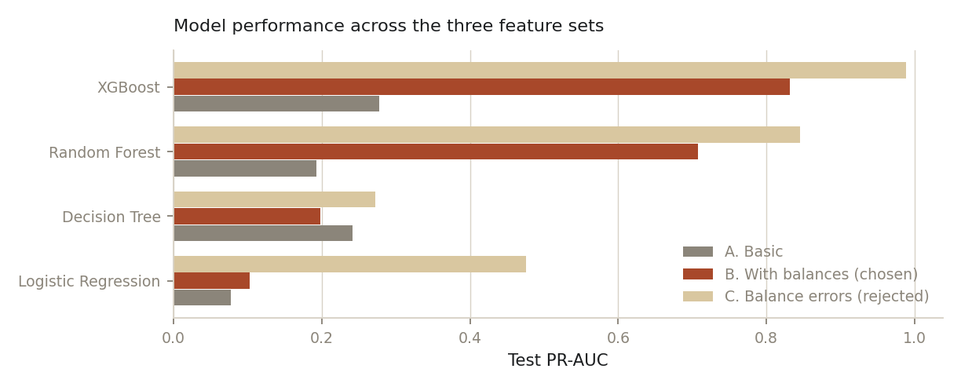
Figure 4. Test PR-AUC for every model and feature set, random stratified split.
Model | A. Basic | B. With balances | C. Balance errors
Logistic Regression (baseline) | 0.077 | 0.103 | 0.476
Decision Tree | 0.241 | 0.198 | 0.272
Random Forest | 0.193 | 0.708 | 0.846
XGBoost | 0.278 | 0.832 | 0.989
Table 6. Test PR-AUC. Random guessing scores 0.0013. Set C is shown for comparison only.
Three conclusions follow. XGBoost wins on every feature set and is our chosen algorithm. The logistic regression baseline is genuinely weak here at 0.103, which confirms the audit finding that fraud is a non linear pattern rather than something a single weighted sum can capture, and which justifies the move to tree ensembles. And the jump from Set B to Set C, from 0.832 to 0.989 for XGBoost, is the leakage made visible: it is a measure of the shortcut, not of skill.

7.2 Random split against time based split
Fraud data invites a specific mistake. Fraud arrives in campaigns, so a random split can place near identical transactions on both sides of the divide, letting the model recognise something it has effectively already seen. A time based split, training on early transactions and testing on later ones, mirrors real deployment and cannot leak that way. We ran both.
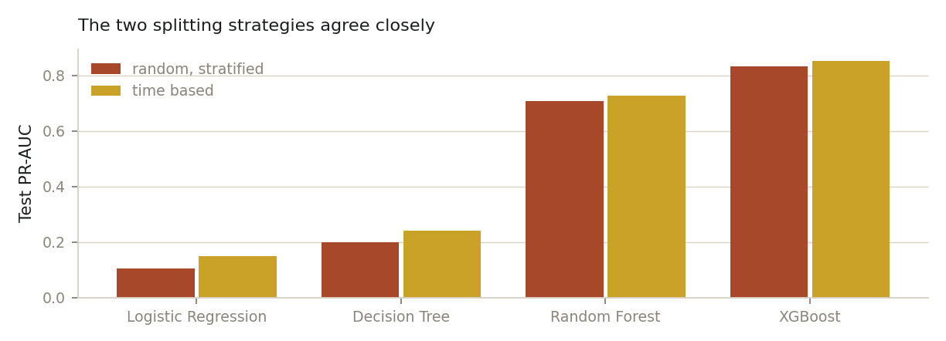
Figure 5. The same models and features under both splitting strategies.
Model | Random split | Time split | Difference
Logistic Regression (baseline) | 0.103 | 0.149 | -0.046
Decision Tree | 0.198 | 0.241 | -0.043
Random Forest | 0.708 | 0.728 | -0.020
XGBoost | 0.832 | 0.852 | -0.020
Table 7. Feature set B under both splits. Test fraud rates differ (0.0013 random, 0.0026 time), so this is a sanity check rather than a like for like comparison.
The two strategies agree closely, and notably the time split scores are higher, not lower. Had the random split been inflated by campaign leakage we would expect the opposite. The gap is explained by the two test sets having different fraud rates: fraud grows denser later in the simulation, so the time based test set has twice the base rate and a correspondingly higher achievable PR-AUC. We report the random split as our primary result because its stratification keeps the fraud rate constant across all three partitions, and we retain the time split as evidence that the result is not an artifact of shuffling.

7.3 Handling the class imbalance
We did not resample. The 0.13 percent fraud rate is the real operating condition, and the test set must preserve it or every reported metric becomes fiction. Instead we adjusted the training signal: class_weight set to balanced for logistic regression, the decision tree and the random forest, and scale_pos_weight set to 749 for XGBoost, which is the ratio of normal to fraudulent rows in the training partition.
We specifically rejected SMOTE, which the Phase 1 report had listed as an option. SMOTE creates synthetic fraud rows by interpolating between real ones, which for this dataset produces transactions whose balances do not add up. Given that ledger consistency is the very thing several of our features measure, injecting rows with impossible arithmetic would corrupt the signal we are trying to study. Undersampling was also considered and set aside: it discards genuine data and shifts predicted probabilities away from the true base rate, which would require recalibration before the cost analysis in Section 9 could be trusted.

8. Improving Performance
Three levers were available. Measuring each separately shows they are not equally important, which is itself a useful finding.

Lever one: features, the largest effect
Moving from Set A to Set B raised XGBoost PR-AUC from 0.278 to 0.832, a gain of 0.554. This is by far the biggest single improvement in the project, and it came from just two features: the pre transaction balances of sender and receiver.

Lever two: the decision threshold, the second largest
A classifier outputs a probability; converting that into a decision requires a threshold, and the default of 0.5 has no business meaning. Because we weighted fraud heavily during training, the models push many probabilities above 0.5 and generate a flood of false alarms. We selected the threshold that maximises F1 on the validation set, then applied that one number to the test set. Choosing it on validation rather than test is what keeps the final figure honest.
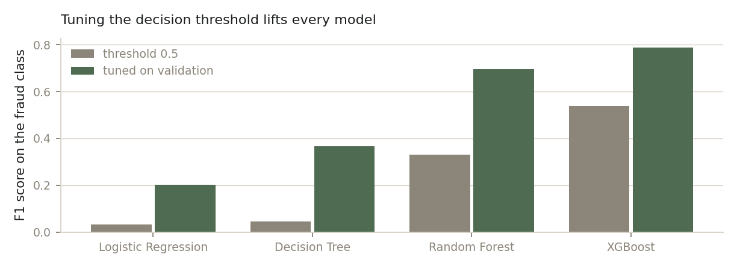
Figure 6. F1 on the fraud class at the default threshold and at the tuned threshold.
Model | F1 at 0.5 | F1 tuned | Precision | Recall | Alerts before | Alerts after
Logistic Regression | 0.033 | 0.201 | 0.178 | 0.231 | 15 006 | 331
Decision Tree | 0.044 | 0.367 | 0.378 | 0.357 | 11 185 | 241
Random Forest | 0.331 | 0.694 | 0.890 | 0.569 | 973 | 163
XGBoost | 0.538 | 0.788 | 0.868 | 0.722 | 570 | 212
Table 8. Threshold tuning improves every model, and cuts alert volume dramatically.
The alert columns show why this matters operationally. For the random forest, tuning reduced alerts from 973 to 163 while raising F1 from 0.331 to 0.694: fewer alerts and better ones. For logistic regression the reduction is from 15 006 alerts to 331, which is the difference between an unusable system and a workable one.

Lever three: hyperparameters, the smallest
We searched eight parameter combinations with RandomizedSearchCV, scored on average precision with three fold stratified cross validation. The search took 144 seconds and settled on max_depth 5, learning_rate 0.1, n_estimators 200, subsample 0.8, colsample_bytree 1.0 and min_child_weight 1. Test PR-AUC moved from 0.8324 to 0.8362, a gain of 0.0038.
The ordering is the finding
Features contributed roughly 0.554 PR-AUC, threshold tuning roughly doubled F1, and hyperparameter tuning contributed 0.004. We report this ordering deliberately. It would have been easy to spend the whole project on parameter search and gain almost nothing. Understanding the data and pricing the decision produced almost all of the value.

9. Final Model and Metrics
The recommended model is a tuned XGBoost classifier on feature set B, trained on a random stratified split with its threshold selected on a validation partition that played no part in training. The test set of 190 879 transactions was used once, at the end.
Metric | Value | Interpretation
PR-AUC | 0.836 | Against 0.0013 for random guessing, a lift of about 640 times
ROC-AUC | 0.9986 | High, but flattering on imbalanced data; reported for completeness
Precision | 0.914 | 17 false alarms out of 198 alerts
Recall | 0.710 | 181 of 255 frauds identified
F1 score | 0.799 | Balance of the two, at the chosen threshold
Threshold | 0.9915 | Selected on validation, not on test
Alert volume | 198 | Out of 190 879 transactions, about 0.1 percent
Table 9. Final model performance on the held out test set.
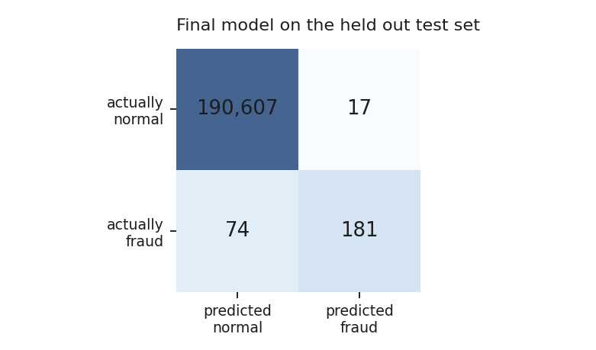
Figure 7. Confusion matrix for the final model at the chosen threshold.

Justifying the threshold with money
A threshold is a business decision, not a technical one, so we priced it. Working assumptions, both adjustable in the dashboard: a missed fraud costs the bank R5 000 on average, and reviewing a false alarm costs R50 of analyst time. Missing a fraud is therefore 100 times more expensive than a wasted review, which pushes the optimal threshold far below the conventional 0.5.
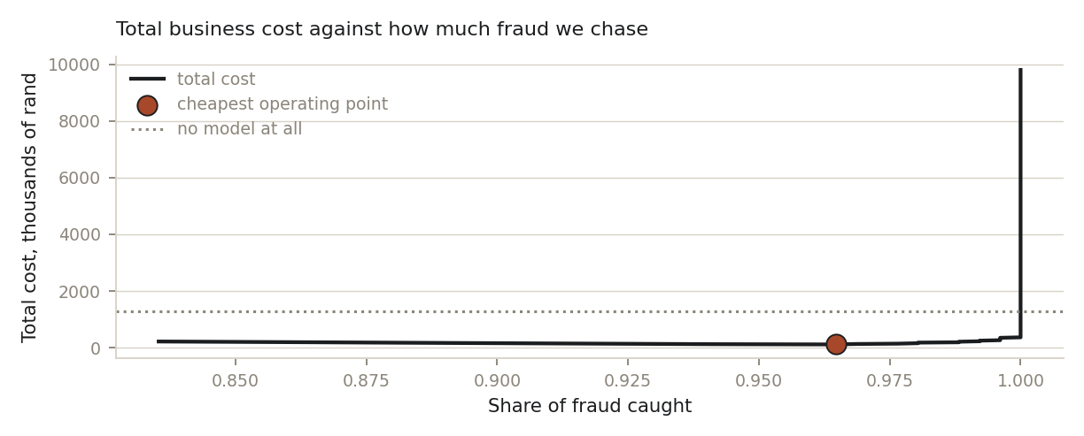
Figure 8. Total cost against the share of fraud pursued, with the cheapest operating point marked.
Strategy | Threshold | Recall | Precision | Total cost
Approve everything, no model | n/a | 0.0% | n/a | R1 275 000
Best F1 balance | 0.9915 | 71.0% | 91.4% | R370 850
Lowest business cost | 0.2336 | 96.1% | 18.9% | R125 800
Table 10. Three operating strategies priced on the stated cost assumptions.
The counterintuitive result deserves emphasis. The cheapest strategy has precision of only 0.19, meaning roughly four in five alerts are legitimate customers, and it is still by far the best option for the bank. It catches 96.1 percent of fraud and reduces losses to R125 800. Optimising for a tidy looking F1 score costs R245 050 more. This is exactly the kind of decision that a purely technical metric hides and a cost argument exposes.

10. Model Explainability
A model whose decisions cannot be explained is difficult to deploy in banking, where an adverse decision usually has to be justified to a customer or a regulator. We approached this from three directions and checked that they agree, because disagreement between them is usually a sign that something is wrong.
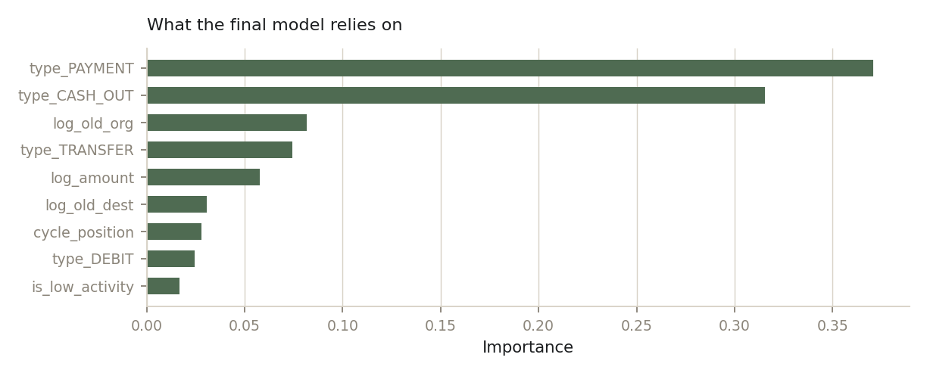
Figure 9. Feature importance for the final model.
- Logistic regression coefficients. The baseline is a linear model, so its coefficients read directly: positive pushes a transaction towards fraud, negative away from it. Because inputs were scaled inside the pipeline, magnitudes are comparable.
- Tree based importance. Shows how much each feature contributed to splitting the data across the ensemble, answering which columns the model leaned on overall.
- Permutation importance. Model agnostic and the most intuitive of the three: shuffle one column so it becomes meaningless, then measure how far PR-AUC falls. A large drop means genuine dependence.
All three agree that transaction type and amount carry most of the signal, followed by the sender balance.

Explainability as a diagnostic
Explainability also earned its place as a diagnostic, not just a presentation layer. Feature importance for the Set C model shows the two balance error columns overwhelming everything else, which is what a leaked feature looks like from the inside, and is the clearest justification for excluding them.

Per transaction explanation
For individual decisions the accompanying dashboard produces a contribution breakdown for any transaction scored, using the model’s own internal contribution values rather than a post hoc approximation. These sum exactly to the score, so an analyst reviewing a held transaction can always be given a specific reason: which features pushed it towards fraud, which pushed against, and by how much.

11. Recommendations
- Score TRANSFER and CASH_OUT in real time and route the rest around the model. These two contain every fraud case while PAYMENT, CASH_IN and DEBIT contain none, removing 56 percent of volume from the scoring path at no cost in coverage.
- Treat TRANSFER as the priority. At 0.81 percent it carries four times the fraud rate of CASH_OUT and is the first leg of the attack. Stopping a transfer prevents the loss outright; stopping a cash out only intercepts money already moved.
- Hold suspicious transactions for review rather than declining them. At the cost optimal point roughly four in five alerts are legitimate customers, so automatic declines would damage trust. A short hold with an analyst check, or a step up verification such as a one time password, captures the benefit without the harm.
- Concentrate review capacity on the quiet part of the cycle. Positions 1 to 8 carry 3.48 percent fraud against 0.09 percent elsewhere while holding only 1.2 percent of volume, so a small team covering that window addresses a disproportionate share of risk cheaply. Mapping those positions to clock times needs only the collection start date.
- Set the threshold from real costs and revisit it quarterly. Our R5 000 and R50 assumptions are placeholders. The dashboard recomputes the recommended threshold live when either figure changes.
- Revalidate on real data before relying on these numbers. The balance features are far more predictive here than they will be in production, for the reasons in Section 3.3. The ranking of transaction types, the cycle pattern and the cost logic should transfer; the precise performance figures should not be assumed to.
- Monitor for drift. Track alert volume, the share of alerts confirmed as fraud, and the score distribution weekly. A sharp move in any is a signal to retrain.

Limitations and next steps
Two limitations bound these results. PaySim is simulated and its fraud is more mechanically regular than the real thing, and with 255 frauds in the test set precision and recall carry real uncertainty, so small gaps between models should not be over interpreted. With more time we would price the threshold from the bank’s actual costs, add account level behavioural features such as how recently a destination has received funds, and test on a separate time period as a further stability check.

