RACEDAY
Find a race. Enter it. Own your result.

RaceDay: From Design Requirements to a Deployed Web Application

POE: Portfolio of Evidence

Field | Detail
Name: | [Your Full Name]
Surname: | [Your Surname]
Student number: | [Your Student Number]
Module code: | [Module Code]
Description: | POE: Portfolio of Evidence
Date: | 9 November 2026

Table of Contents
Right-click here and choose Update Field to build the table of contents.

1. Introduction
This portfolio of evidence documents the design and implementation of RaceDay, a platform that lets students find a local sporting event, enter it by choosing a category, and retrieve their official result afterwards. The portfolio was completed in three stages. Part 1 analysed user needs and set out the design requirements. Part 2 turned those requirements into a clickable prototype and demonstrated each design area through the artefact. This final part responds to the feedback received on Part 2, presents the completed prototype and research report, and documents the working RaceDay platform built for the Automation of Web Application component.
The finished system is a three tier application. The browser talks to an ASP.NET Core MVC front end, which talks to an ASP.NET Core RESTful API, which owns the database and the file storage. The MVC application contains no database access and no business logic of its own; it is a presentation layer that consumes the API through a single typed HTTP client. This separation is the central engineering decision of the project and it is the reason the design established in Parts 1 and 2 survives into the implementation unchanged.
The report is organised as follows. Section 2 records the feedback received on Part 2 and the action taken. Section 3 consolidates the interaction design work from Parts 1 and 2. Section 4 documents the Automation of Web Application implementation in detail. Section 5 states the WCAG 2.0 conformance position against the implemented interface, and Section 6 concludes.
2. Response to Part 2 Feedback
The feedback on Part 2 was that the design was convincing but unproven: the prototype showed what the interface would look like without being able to show that it would work. The action taken in every case was to build the underlying system. The table below records each comment and the response.
Feedback received on Part 2 | Action taken | Section
The prototype proves the design but there is no working system behind it; buttons lead nowhere and no data is persisted. | The complete RaceDay platform was built as an ASP.NET Core Web API plus an ASP.NET Core MVC front end, with SQLite persistence through Entity Framework Core. Every action in the MVC interface now reads from and writes to the API. | 4.1, 4.3, 4.4
Session management is not visible in the design; the prototype cannot show that different users see different things. | Session based authentication was implemented: the API issues a JSON Web Token, the MVC application stores the token, user identifier and role in server side session state, and the navigation is generated from that role. An action filter redirects unauthenticated users to the sign in page. | 4.2
Consider whether the interface would still work for a large number of entries; the lists look like mock ups. | All list pages were rebuilt against live data with realistic volumes, and enrolment statuses are rendered as colour coded pills so that large lists remain readable. The screenshots in Section 4 show the populated interface. | 4.3, 4.4, 4.7
The accessibility discussion should reflect the implementation and not only the intention. | The application was built with a skip link, semantic landmarks, visible focus outlines, associated labels, alternative text on all images and an explicit contrast budget. Section 5 restates the WCAG 2.0 conformance position against the implementation. | 5
How will images be stored and served in the real system? | Azure Blob Storage was integrated into the API behind an IFileStorageService abstraction, with a local disk implementation used as a fallback when no Azure connection string is configured. The MVC application never communicates with Azure directly. | 4.5
The submission must show evidence of professional engineering practice, not only features. | The solution is containerised with a multi stage Dockerfile, orchestrated with Docker Compose, validated by a GitHub Actions workflow, and accompanied by a README containing the single command required to run it. | 4.6, 4.8

One further consequence of the feedback deserves comment. Building a working system forced several design decisions to be made concretely that had previously been left open. The most significant was the treatment of enrolment status. In the prototype the status was a static label; in the working system it is a state that changes as the organiser confirms entrants, and the design therefore had to answer the question of what a participant sees while their entry is still pending. The answer adopted was to show Pending prominently and in a distinct colour rather than to hide unconfirmed entries, because concealing an entry that the participant has made would violate the visibility principle established in Part 2.
3. Consolidated Interaction Design
This section restates the interaction design of RaceDay as revised after the feedback on both parts. The design is unchanged in substance from Part 2; what has changed is that it is now implemented in a working application rather than in a static prototype, and the evidence presented here reflects the implemented interface.
3.1 Usability goals
Usability is the extent to which a product can be used by specified users to achieve specified goals with effectiveness, efficiency and satisfaction in a specified context of use (ISO, 1998). RaceDay targets effectiveness, efficiency, safety, utility, learnability and memorability, and each is delivered by a specific feature of the implemented interface.
Goal | How the implemented application delivers it
Effectiveness | Entering a race produces a confirmation message and the entry appears immediately on the My Events page, so the outcome of the task is both stated and verifiable.
Efficiency | Event cards expose the four decision facts, the detail page carries one primary action, and the entry is recorded in three interactions without a page reload.
Safety | Category selection is constrained, duplicate entries are refused, deleting an event requires confirmation, and an entry can be cancelled while remaining visible for the record.
Utility | The platform performs discovery, entry and results only, and every page remains relevant to that single task.
Learnability | One navigation bar, one card style, one form layout and one table style are used throughout, with domain vocabulary in every label.
Memorability | Navigation, terminology and layout never change, and the signed in users name and photograph are always visible, so the session context is never ambiguous.

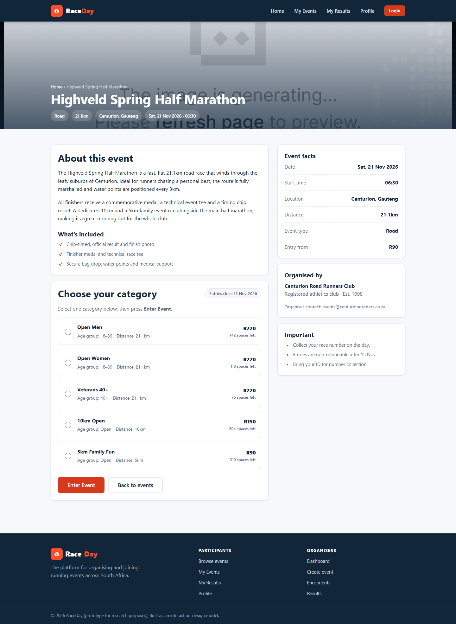
Figure 1: Prototype event detail page. The category selector sits immediately above the single primary action.
Figure 1 remains the clearest statement of the efficiency goal. The prototype page and the implemented page are structurally identical, which is itself evidence that the design was translated rather than reinvented during implementation.
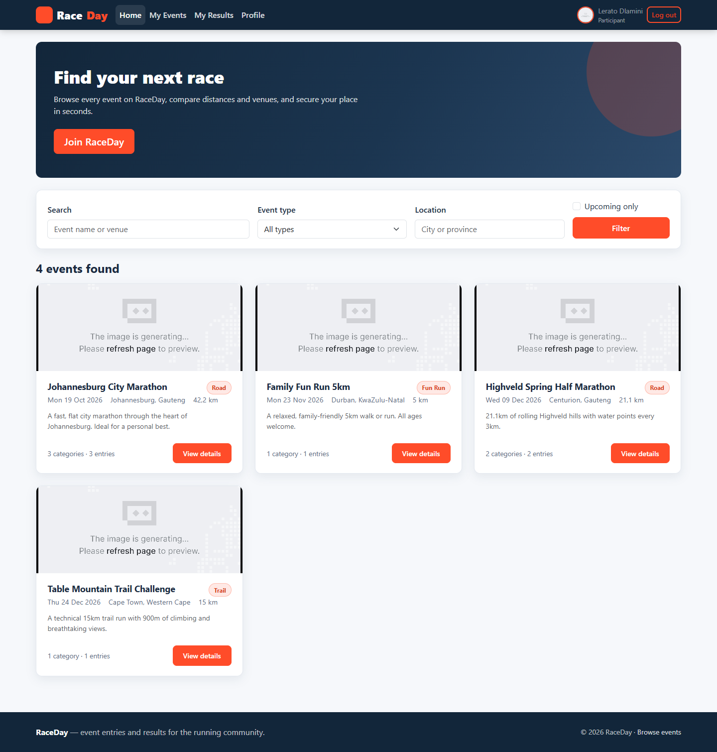
Figure 2: The implemented participant home page, showing the same card based discovery pattern rendered from live data.
Figure 2 shows the implemented home page. The event cards are generated from records returned by the API, so every card on the page represents a real event in the database. The structural similarity to the prototype confirms that the design intent survived the transition from prototype to production code.
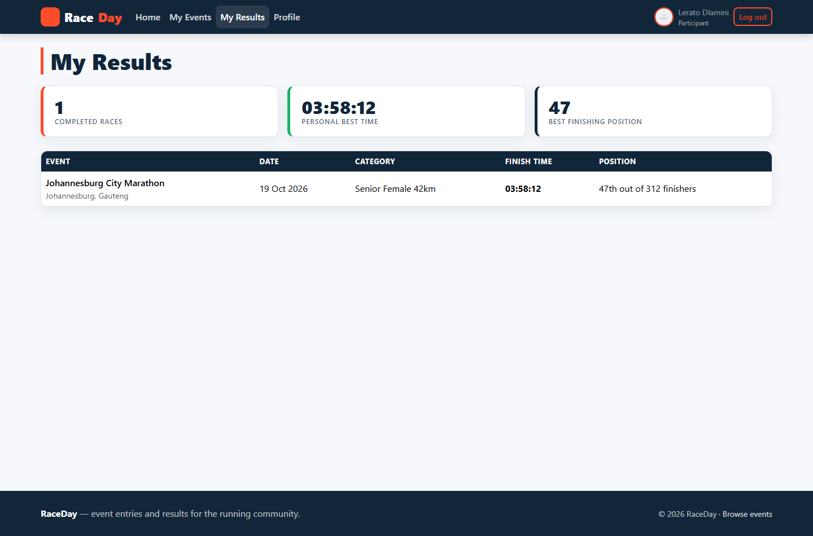
Figure 3: The implemented My Results page, leading with achievement summaries before the detailed result table.
Figure 3 shows the implemented results page. The statistic cards are computed from the participants published results, and the finishing position is expressed as a place within a field rather than as a bare integer, which preserves the sense of having taken part in something shared.
3.2 Desirable aspects of user experience
The qualities of the user experience that RaceDay aims for are that it should be satisfying, motivating, enjoyable, helpful, aesthetically pleasing and supportive of personal expression (Preece, Sharp and Rogers, 2015). These are delivered through the achievement summary on the results page, the energetic visual identity, instructional error messages and the profile photograph.
Quality | How the implemented application achieves it
Satisfying and rewarding | The My Results page presents the participants history as prominent statistic cards (races completed, total distance, personal best) above the detailed result table, so that the participant is rewarded for competing rather than confronted with a bare list of numbers.
Engaging and motivating | Event cards use large banner imagery, a strong orange accent and a prominent event date; the visual treatment is deliberately energetic because the domain itself, competitive running, is energetic.
Enjoyable and pleasurable | Micro-interactions such as button hover states, visible focus outlines and status pills that change colour give the interface a responsiveness that is itself pleasurable, independently of whether the task succeeded (Jordan, 2000).
Helpful | Validation messages are written as instructions rather than as accusations: Enter the event date rather than Invalid input.
Aesthetically pleasing | A single restrained palette of navy #12263A and orange #FF4C29 on a light neutral background, with one type family, minimises visual noise and makes the interface feel professionally produced.
Supporting personal expression | Participants may upload a profile photograph, which gives the account a personal identity rather than leaving it as an anonymous record.

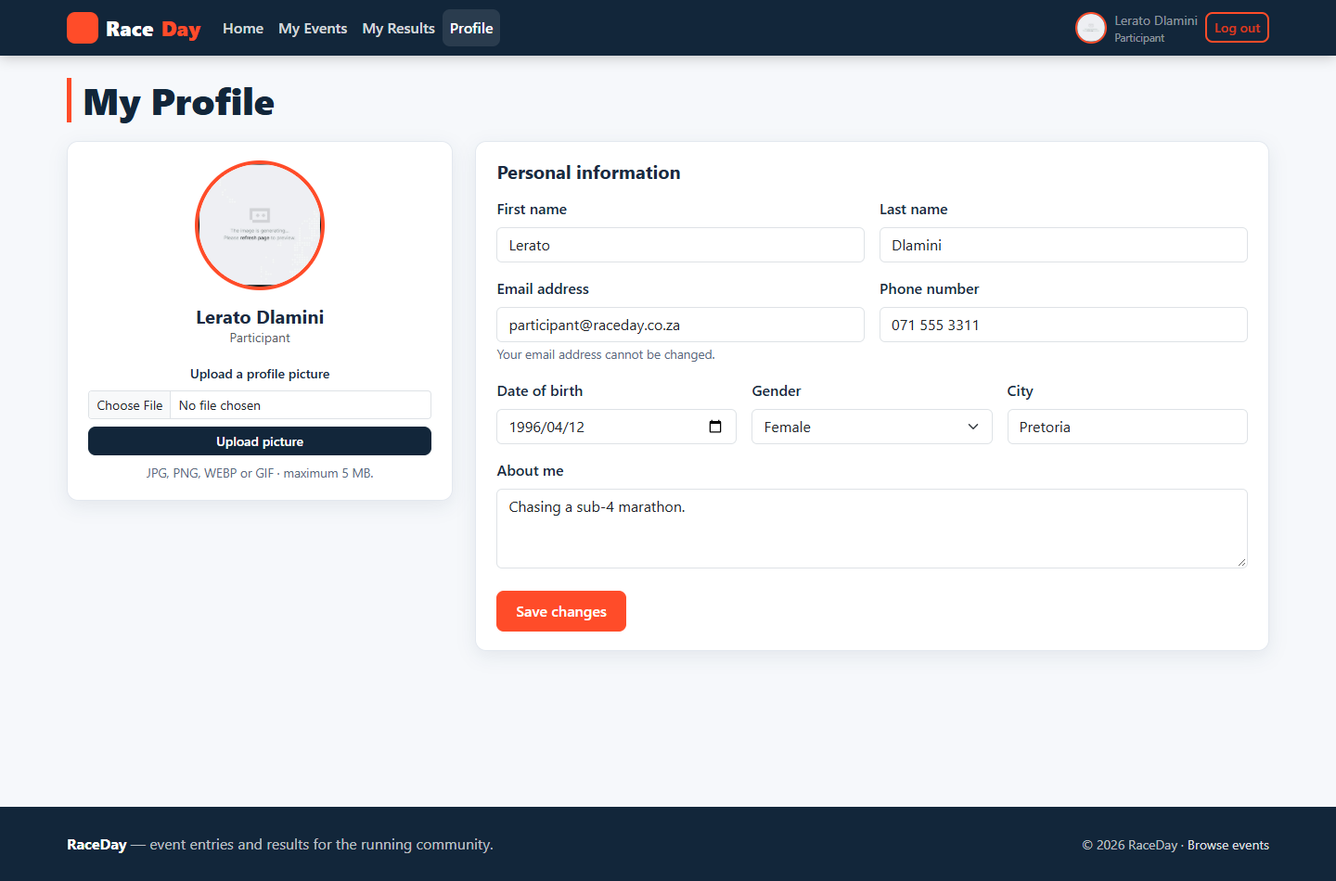
Figure 4: The implemented profile page, where personal details are updated and a photograph is uploaded through the API.
Figure 4 shows the implemented profile page. The photograph is uploaded to the API, stored as a blob and returned as a URL, which is then displayed in the navigation bar on every subsequent page. The personalisation designed in Part 2 is therefore delivered by the working system rather than simulated.
3.3 Design principles
The design principles applied throughout are visibility, feedback, constraints, affordance, mapping and consistency (Norman, 2013), together with the heuristics of Nielsen (1993) and the principle that a designer should eliminate question marks rather than answer them (Krug, 2014).
Principle | How the implemented application applies it
Visibility | The state of the system is always visible: a signed-in user sees their own name and photograph in the navigation bar, enrolment statuses are shown as coloured pills on every relevant screen, and the number of events found is printed above the search results.
Feedback | Every action produces a response: successful enrolment shows a confirmation banner, validation failures are listed beside the offending field, and destructive actions report their outcome on the following page load.
Constraints | The interface restricts what can be done rather than reporting failure afterwards: dates cannot be set in the past, categories are presented as a managed list, and pages belonging to the other role are refused rather than merely hidden.
Consistency | One navigation bar, one card component, one form layout, one table style and one status pill component are used on every page, so the user learns the interface once.
Affordance | Buttons look pressable, links look clickable, fields look editable and disabled states look disabled. The primary action on every page is a solid orange button, which signals that it is the recommended next step.
Mapping | Controls are placed where the user expects them: filtering sits immediately above the list it filters, the category selector sits immediately above the Enter Event button, and the photograph upload control sits beside the picture it replaces.
Error prevention and recovery | Preventable errors are prevented by validation at the boundary. Unpreventable errors are reported in plain language with a route back to the form, and the system never displays raw exception text.

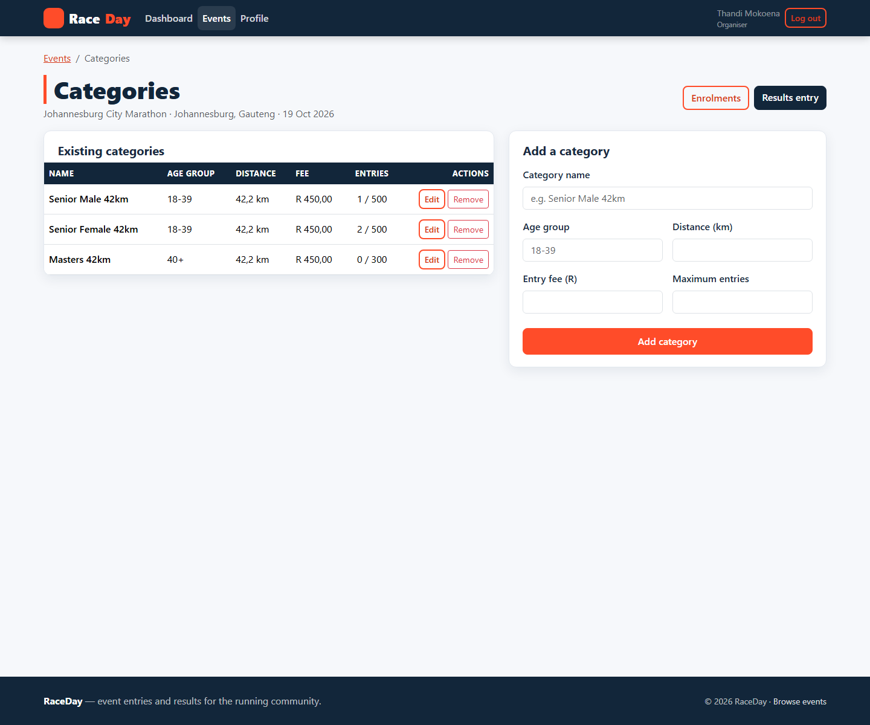
Figure 5: Category management. The same form components are used throughout the application, maintaining consistency.
Figure 5 demonstrates consistency at the level of the component library. The category form uses the same labels, inputs, buttons and spacing as the registration, profile and event forms, so the users knowledge of one form transfers to every other form in the application.
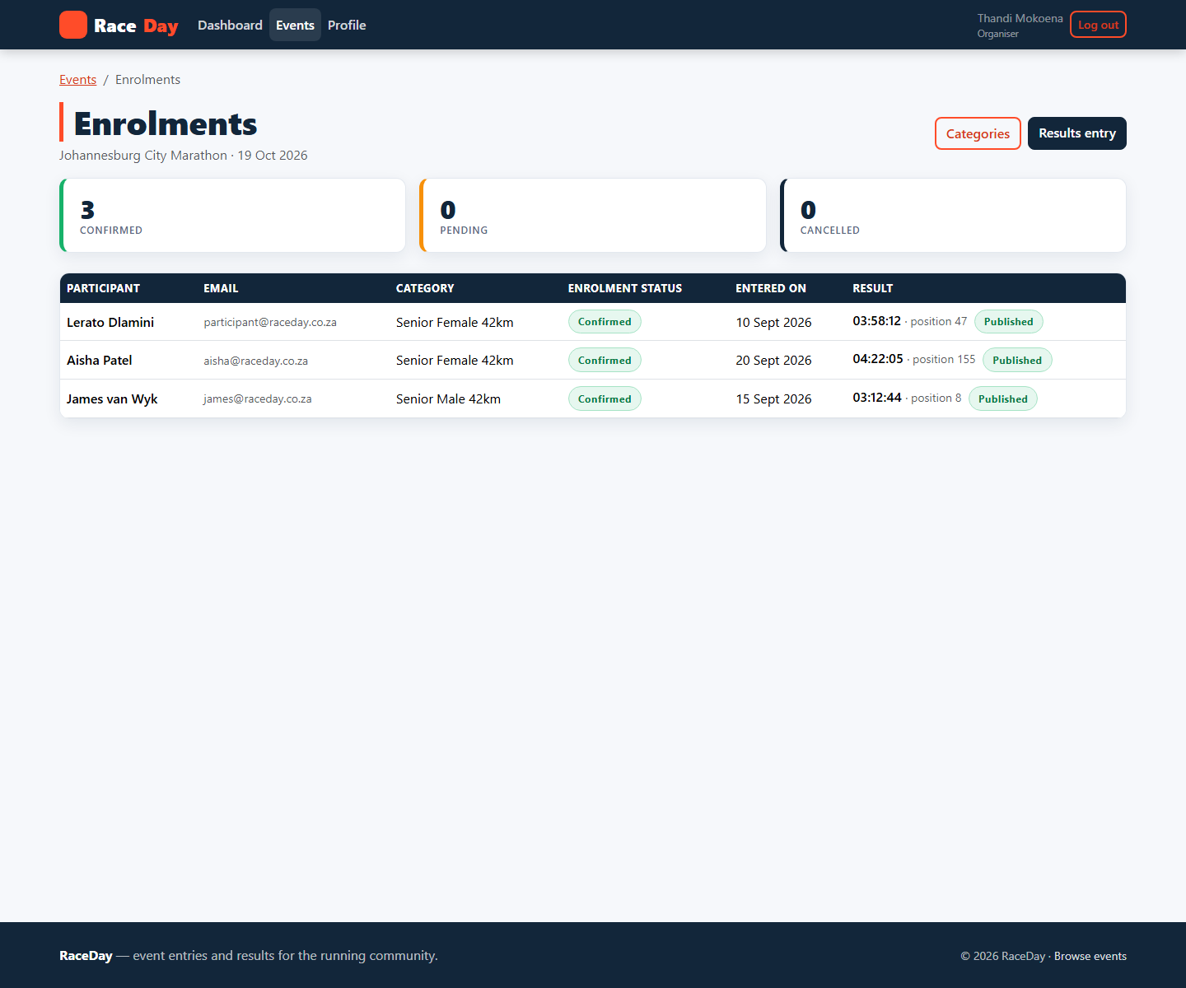
Figure 6: The enrolment list, where colour coded status pills make the state of a long list readable at a glance.
Figure 6 demonstrates visibility in the implemented interface. Because it is generated from live enrolment records it shows the true composition of an events field, and the status column makes the state of every entry immediately apparent without the organiser having to interrogate individual rows.
3.4 Interaction types
RaceDay uses all four of the interaction types identified by Preece, Sharp and Rogers (2015). Instructing dominates where the user has a definite command to issue; exploring dominates where the user is browsing; manipulating appears wherever the user edits data in place; and conversing appears in the filter, where the system answers a question the user has posed.
Interaction type | Where the implemented application uses it
Instructing | The user issues a command and the system carries it out. RaceDay uses instructing for registration and sign-in, for creating and editing events, for capturing results and for entering an event. It is expressed through clearly labelled forms with one primary action per screen.
Conversing | The system answers the users questions. The event filter behaves as a lightweight conversation: the user asks what trail races are happening nearby by completing the filter form, and the system answers with a result set and a count of how many events matched.
Manipulating | The user directly manipulates objects rather than typing instructions. Participants choose a category by clicking a radio button, organisers replace a banner by selecting a file and seeing the preview change, and profile photographs are replaced in place.
Exploring | The user moves through the information space without a specific goal. The event grid, the event detail page and the participants race history are exploration surfaces: events can be opened and abandoned without commitment and without the interface losing the users place.

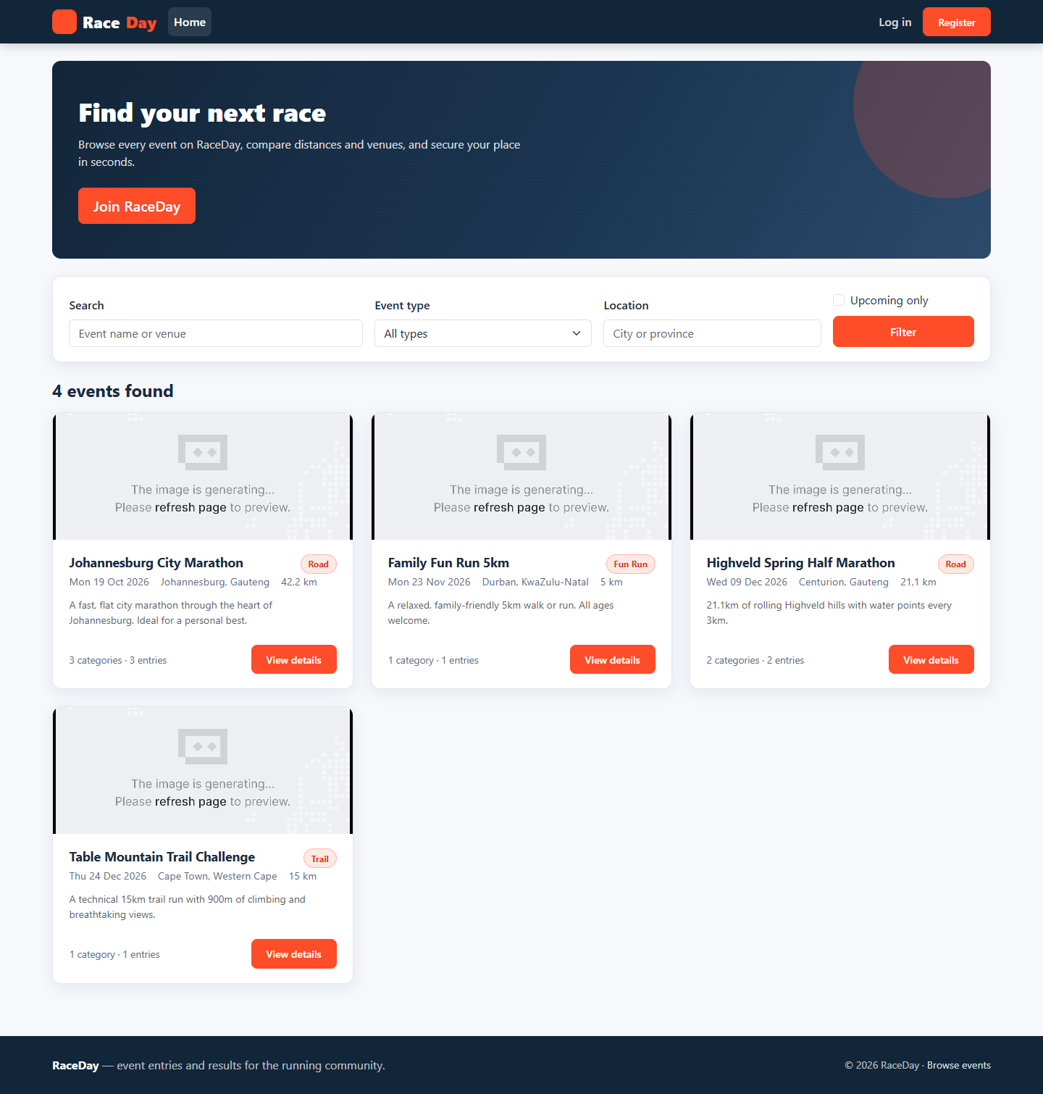
Figure 7: The guest home page as an exploration surface, with the filter form acting as a lightweight conversation.
Figure 7 shows exploration and conversing combined. An unauthenticated visitor may browse the full event catalogue and ask the system questions through the filter form; the system replies with a result set and a count. The visitor is only required to identify themselves at the point of commitment, which is the moment at which identification is genuinely necessary.
3.5 Social interactions
RaceDay is not a social network, but the domain it serves is inherently social. Competitive running is organised around clubs, training groups, families and friendship circles, and entering a race is very often a group decision rather than an individual one. The social dimension of the design is therefore built into the information the system displays rather than added as a separate feature.
The organisers enrolment view exposes the participant list for an event, which allows an entrant to see who else has entered. The total number of enrolments on the organisers dashboard and the size of the field on published results both communicate the scale of an event and create the mild social pressure that motivates people to train and to attend. Category management gives events a socially meaningful structure, because categories such as junior, senior, veteran and open are how runners position themselves relative to their peers.
The design also anticipates the social use of results. A finishing position is only meaningful in relation to other people: the phrase forty-seventh out of three hundred and twelve finishers is a social statement, and members of the same club routinely compare positions after an event. Presenting the position together with the total field therefore satisfies a real social need without requiring any social networking machinery.
Because the platform stores personal information and photographs, the social dimension is deliberately constrained. Participation is not publicly discoverable unless the participant enters an event, profile information is visible only to the account holder, and the organiser sees only the details necessary to administer an event. This is a conscious ethical decision: the design supports the social activity around running while keeping the individuals data within the boundaries the user expects (Preece, Sharp and Rogers, 2015).
3.6 Emotional interaction
Emotion is a first class design consideration on RaceDay because entering a race is an emotionally loaded act. It involves commitment, anxiety about ability and the anticipation of a public result. Emotional design is therefore addressed at three levels of processing (Norman, 2013).
At the visceral level the interface is designed to feel energetic and confident. The high chroma orange accent against a deep navy ground, the generous white space and the large banner imagery produce an immediate impression of movement and athleticism. The consistent logo mark and typography reinforce recognition, so that a returning user feels the familiarity of a place they have been before.
At the behavioural level the interface aims to remove the anxiety that surrounds registering for an event. The user is never left wondering whether an action worked: enrolment is confirmed immediately, the entry appears on the My Events page with a colour coded status and it can be cancelled. Clear state information is the primary tool for reducing anxiety, because most negative emotion in interactive systems comes from uncertainty rather than from failure (Cooper et al., 2014).
At the reflective level the design deliberately gives the user something to feel good about. The My Results page summarises the participants history in statistic cards so that accumulated achievement is visible as a whole, and the finishing position is expressed as a place within a field rather than as a bare integer, which preserves the sense of having taken part in something shared. The profile photograph allows the participant to personalise the account and to be recognised, which supports the sense of identity that sustains continued participation.
Persuasive techniques are used, but only in the direction of the users own goals. The event date is foregrounded so that the user is aware of the commitment they have made, and the upcoming only filter keeps attention on races that can still be entered. Jordans (2000) framework of physio, psycho, socio and ideo pleasure informs the balance achieved here: the interface is comfortable to look at, satisfying to operate, supportive of the social life of a running club and expressive of values the user holds about health and personal achievement.
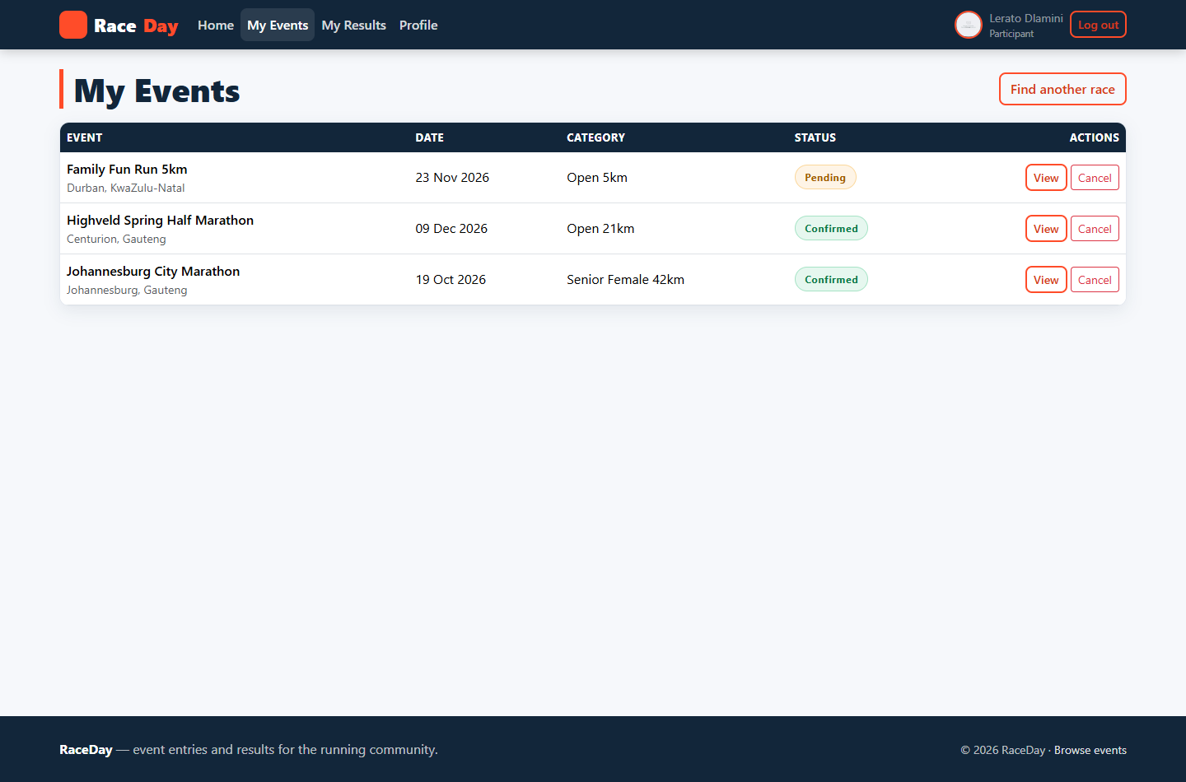
Figure 8: My Events. Immediate, unambiguous entry feedback removes the uncertainty that is the main source of negative emotion in a registration system.
Figure 8 shows the behavioural level response in the implemented system. The participant can see every entry they have made and the status of each one without taking any further action, which removes the uncertainty that would otherwise accompany an entry made several weeks before the event.
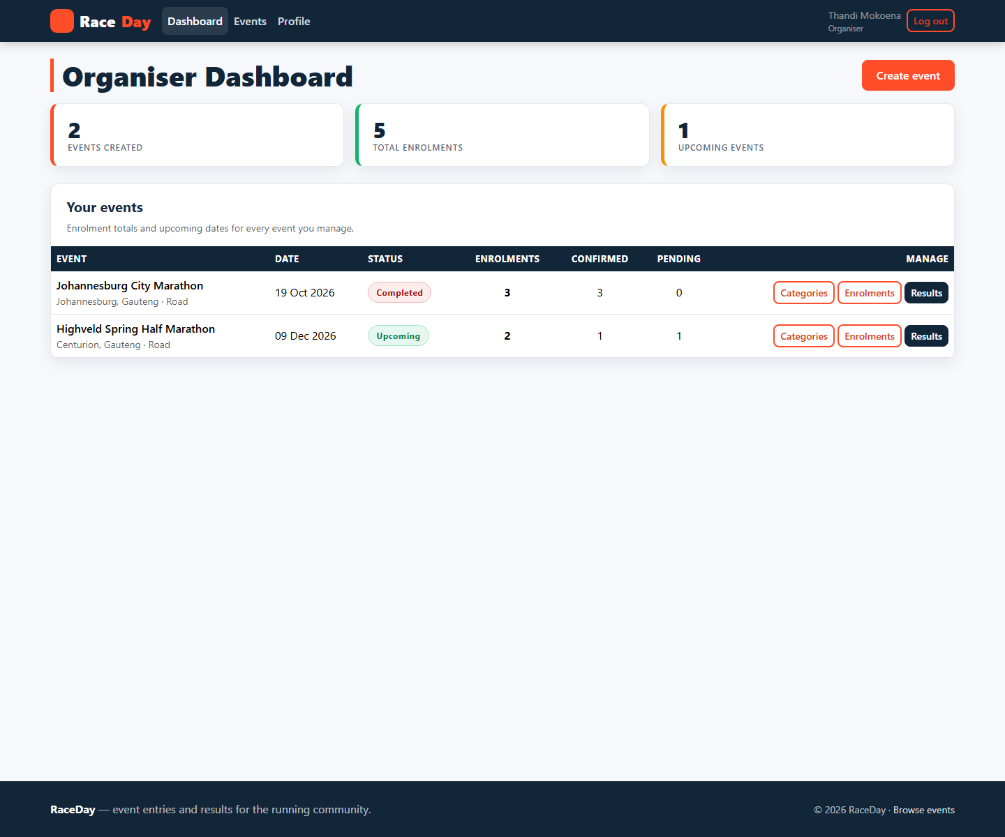
Figure 9: The organiser dashboard. Reach is summarised so that the tool rewards rather than burdens its user.
Figure 9 shows the emotional design of the organisers experience. Because the dashboard answers the question the organiser cares about before presenting the mechanics of administration, using the system feels informative rather than clerical.
3.7 Web Content Accessibility Guidelines (WCAG) 2.0
The Web Content Accessibility Guidelines 2.0 (W3C, 2008) organise accessibility requirements into four principles, commonly remembered as POUR: Perceivable, Operable, Understandable and Robust. Each principle is expressed as testable success criteria at one of three conformance levels, with level A being the minimum and level AA the level generally accepted as the practical web standard. RaceDay targets conformance at level AA. The table below lists the success criteria relevant to this interface and describes how each is met.
SC | Success criterion | Level | How the implemented application meets it
1.1.1 | Non-text Content | A | Event banner images carry alternative text derived from the event name; profile photographs carry the participants name; decorative marks are hidden from assistive technology.
1.3.1 | Info and Relationships | A | Pages use real semantic landmarks (header, nav, main, footer) and real headings in a logical order, so the structure of a page is available to assistive technology and not only to sighted users.
1.4.3 | Contrast (Minimum) | AA | Body text is navy on a light background at a ratio well above 4.5:1, and the orange used for primary buttons is paired with white text at a ratio of at least 4.5:1.
1.4.4 | Resize Text | AA | Layout is expressed in relative units and the Bootstrap grid is fluid, so text can be enlarged to 200 per cent without loss of content or functionality.
1.4.10 | Reflow | AA | Content reflows to a single column on narrow viewports and the application remains usable at a 320 pixel viewport width.
2.1.1 | Keyboard | A | Every interactive element is a native link, button, input or select and is therefore reachable and operable with the keyboard alone; no functionality depends on a pointing device.
2.4.1 | Bypass Blocks | A | A Skip to main content link is the first focusable element on every page, allowing keyboard users to bypass the repeated navigation.
2.4.4 | Link Purpose (In Context) | A | Link text describes its destination, for example Enter Event, My Results or Add category, rather than using generic text such as click here.
2.4.7 | Focus Visible | AA | A custom focus ring with a contrasting outline is applied to every focusable element so that keyboard users can always see where focus is.
3.3.1 | Error Identification | A | Validation failures are reported in text beside the field that caused them and the offending control is highlighted, so the error is identified visually and programmatically.
3.3.2 | Labels or Instructions | A | Every input has a permanently visible label element associated with it; placeholder text is used only as a supplementary hint and never as the only label.
3.3.3 | Error Suggestion | AA | Messages state what is required rather than only that something is wrong, for example Enter the event date and Distance must be greater than zero.
4.1.2 | Name, Role, Value | A | Native HTML elements provide their own roles and values; where custom behaviour is required, ARIA attributes such as aria-label on the navigation and the filter form supply the missing names.

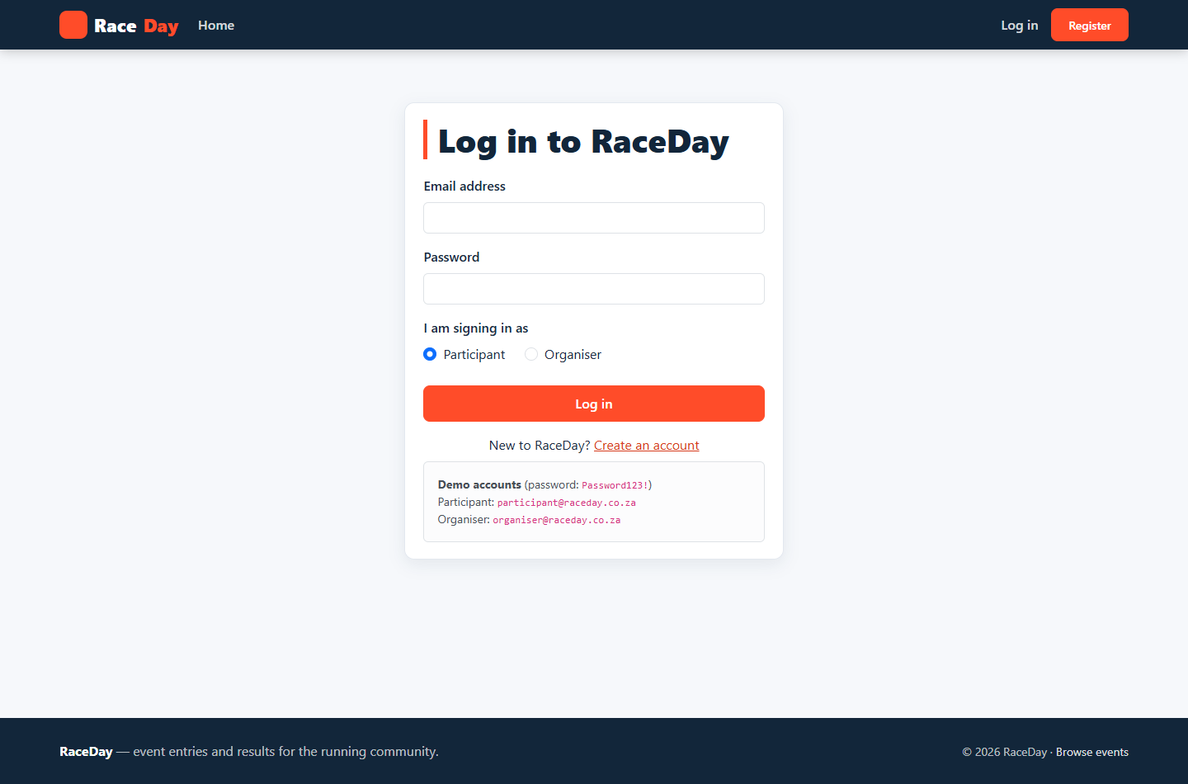
Figure 10: A protected page requested without a session redirects to the login screen rather than rendering protected content.
Figure 10 shows the access control behaviour that protects personal data. The redirect is accompanied by an explanation, which satisfies the principle that a system should always tell the user why it is doing what it is doing rather than leaving them to infer it.
4. Automation of Web Application
This section documents the third component of the portfolio: the RaceDay platform built as a working, containerised, role aware web application.
4.1 System architecture
RaceDay is implemented as three tiers. The presentation tier is an ASP.NET Core MVC application running on .NET 9, which renders the interface and manages the users session. The service tier is an ASP.NET Core Web API, also on .NET 9, which owns all business rules and exposes them as a RESTful interface. The persistence tier is a SQLite database accessed through Entity Framework Core, together with Azure Blob Storage for binary content.
The critical architectural constraint is that the MVC application contains no database context, no Entity Framework reference and no replicated business logic. Every data operation, from authenticating a user to publishing a result, is performed by calling the API. This is achieved by a single typed HTTP client, ApiClient, which is registered with the dependency injection container and is the only route by which the front end can reach data. The client attaches the bearer token held in the users session to every outgoing request and translates the APIs responses into a small result type that carries either the payload or a message suitable for display.
The benefit of the separation is that the interface can be replaced without touching the rules, and the rules can be tested without launching a browser. It also means that the design work documented in Sections 1 to 3 is genuinely independent of the implementation: the interaction design would survive a complete rewrite of the backend.
Figure 11: The public home page. Event data on this page is retrieved from the API; the MVC application has no database of its own.
4.2 Authentication and role based navigation
Users register and sign in through the MVC application, but authentication itself is performed by the API. Passwords are hashed with BCrypt before storage and are never recoverable. On a successful credential check the API issues a JSON Web Token containing the users identifier and role, and returns it together with the users profile.
The MVC application stores the token, the user identifier, the display name, the role and the profile photograph URL in server side session state, exposed through the standard ASP.NET Core session middleware with a timeout of eight hours. Storing the role in the session is what makes role based navigation possible: the layout reads the session on every request and renders a different navigation menu for an organiser than for a participant, and for an anonymous visitor than for either.
Figure 12: The sign in page. Authentication is performed by the API; the MVC application holds the resulting session.
Figure 12 shows the point at which a session begins. The page offers a single primary action and, for the convenience of the marker, displays the demonstration credentials that the seeded database contains.
Figure 13: An unauthenticated request for a protected page is redirected to the sign in page.
Figure 13 shows the access control filter in operation. The filter is applied to every controller action that requires a session; it redirects an unauthenticated user to the sign in page and a user requesting a page belonging to the other role to an explanatory denial page. Because the check is implemented once as a filter rather than repeated in every action, the protection cannot be forgotten in a new page.
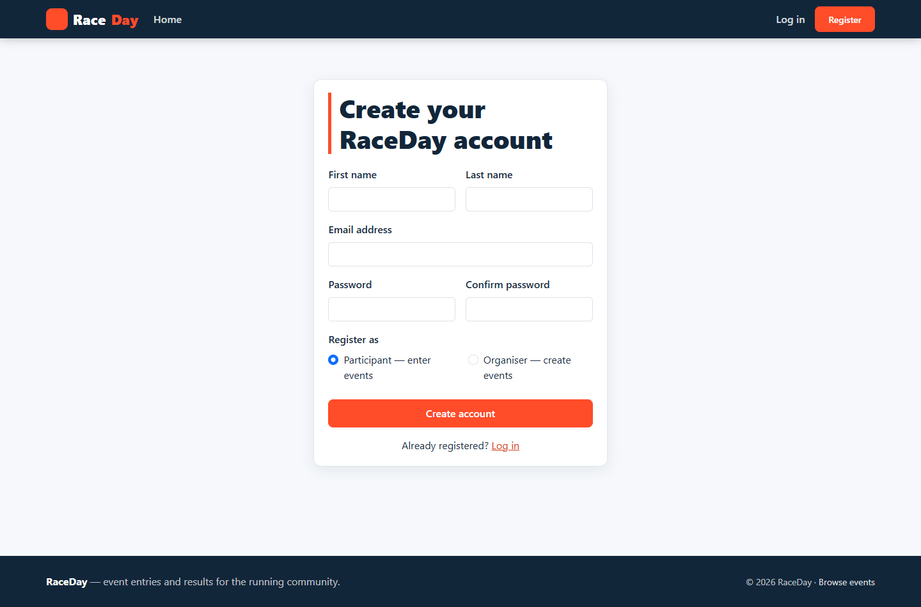
Figure 14: Registration. The role chosen here determines the interface the user receives after signing in.
Figure 14 shows registration. The role selector is the only point at which a user chooses their interface, and it is constrained to the two defined roles, which prevents the creation of accounts with undefined capabilities.
Signing out clears the session and returns the user to the public home page, so that a subsequent request from the same browser carries no identity. The distinction between the two roles is visible immediately in the navigation menu: a participant is offered Home, My Events, My Results and Profile, whereas an organiser is offered Dashboard, Events and Profile. Pages that belong to one role are not merely hidden from the other; they are refused.
4.3 Organiser interface
The organiser experience begins with a dashboard that summarises every event the organiser has created, the total number of enrolments per event and the dates of upcoming events. The dashboard is the organisers answer to the question of how their events are performing, and it deliberately precedes the administrative screens so that the tool is informative before it is clerical.
Figure 15: The organiser dashboard, summarising events, total enrolments and upcoming dates.
Figure 15 shows the dashboard. Each row reports an event together with its enrolment total, and the upcoming dates are surfaced so that the organiser can see at a glance what requires attention.
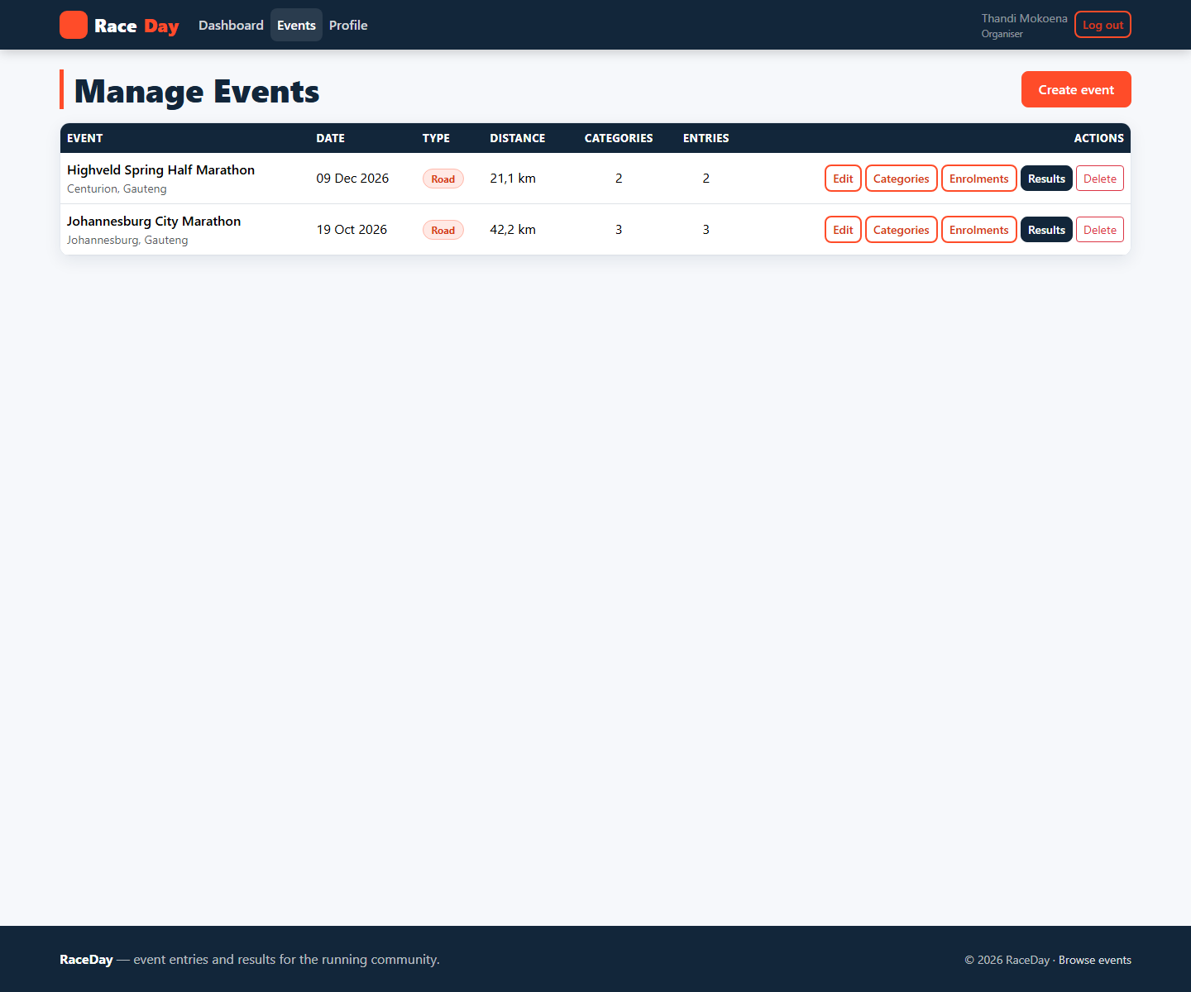
Figure 16: Event management, listing the organisers events with the actions available on each.
Figure 16 shows the event management page. Events can be created, edited and deleted, and deletion is guarded by an explicit confirmation step because it is the only irreversible action in the application.
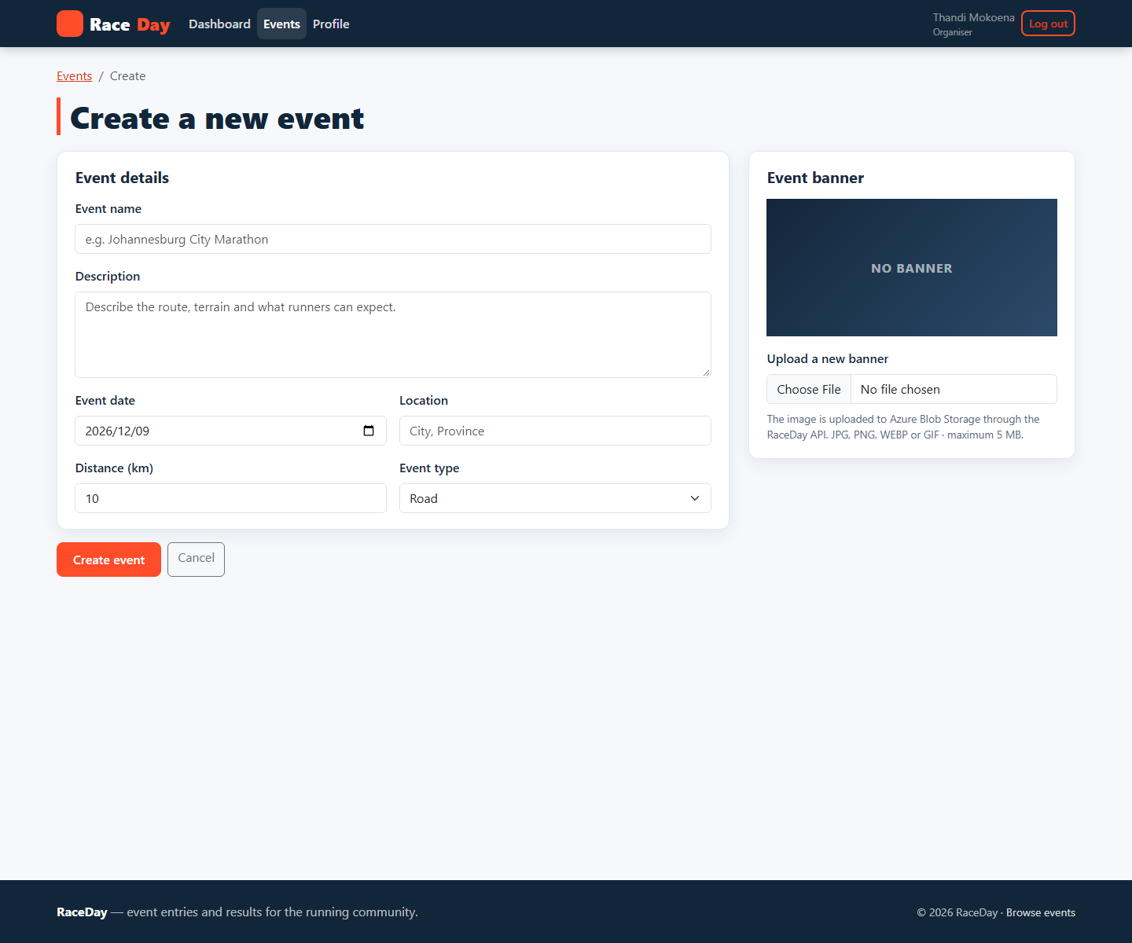
Figure 17: Event creation. All required attributes are captured, and the banner image is uploaded through the API to blob storage.
Figure 17 shows the event creation form, which captures the name, description, date, location, distance and event type required by the specification, together with an optional banner image. Because the interface is generated from the same view model that performs validation, an invalid submission is rejected with messages attached to the offending fields and the organisers entered values are preserved.
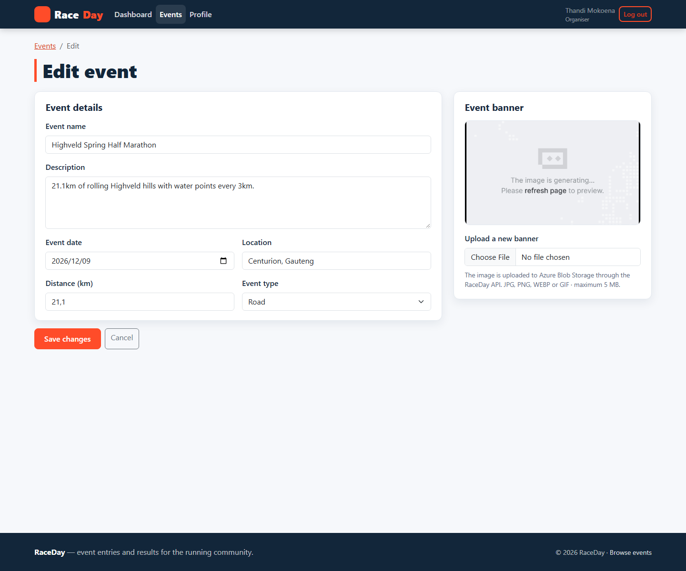
Figure 18: Editing an event. The existing values, including the current banner image, are presented for amendment.
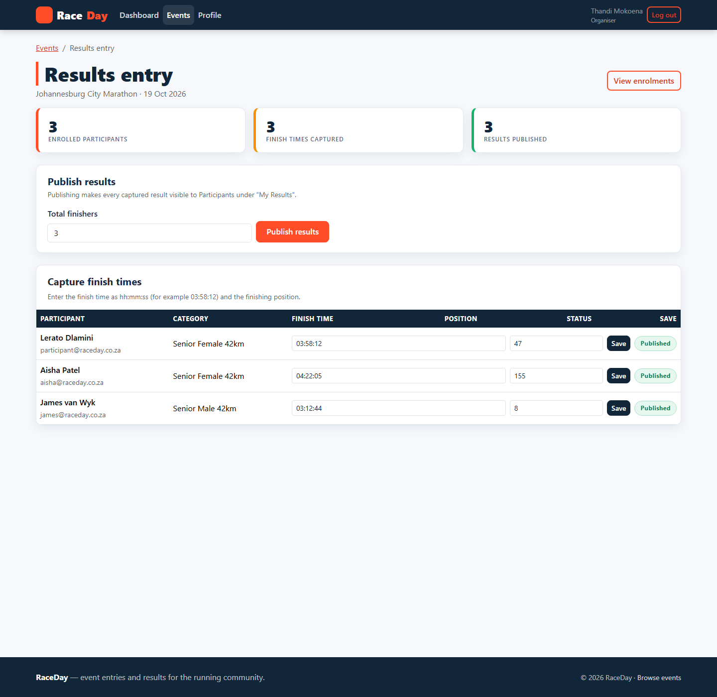
Figure 19: Results entry. Finish times and finishing positions are captured per entrant and published as a set.
Figure 19 shows results entry. The organiser records a finish time and a finishing position against each enrolled participant and then publishes the set. Capture and publication are separate operations so that a partially completed result set can never become visible to participants, which protects both the organiser and the entrant from a half finished publication.
4.4 Participant interface
The participant experience begins with a home page that lists upcoming events and offers filtering by name, event type, location and date. Filtering is implemented as a query the user composes rather than as a set of pre defined categories, so the user asks the system the question they actually have.
Figure 20: The participant home page, with live event data and the filter form above the result set.
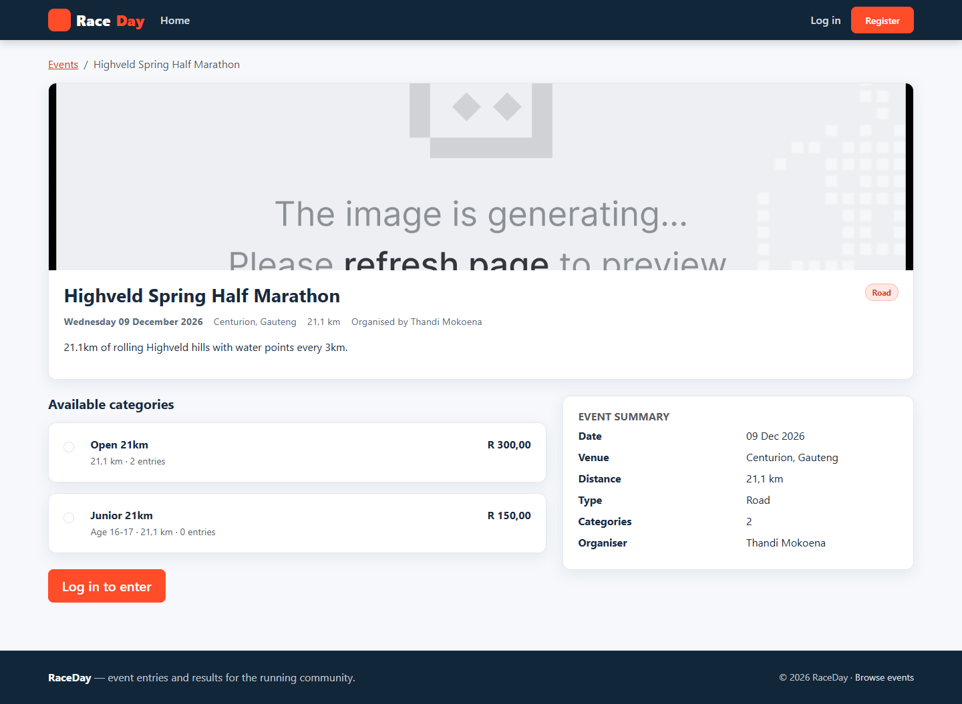
Figure 21: Event detail. Full event information and available categories are presented before the user is asked to identify themselves.
Figure 21 shows the event detail page. Everything a prospective entrant needs in order to decide is presented before any commitment is requested, so a visitor can evaluate an event without registering.
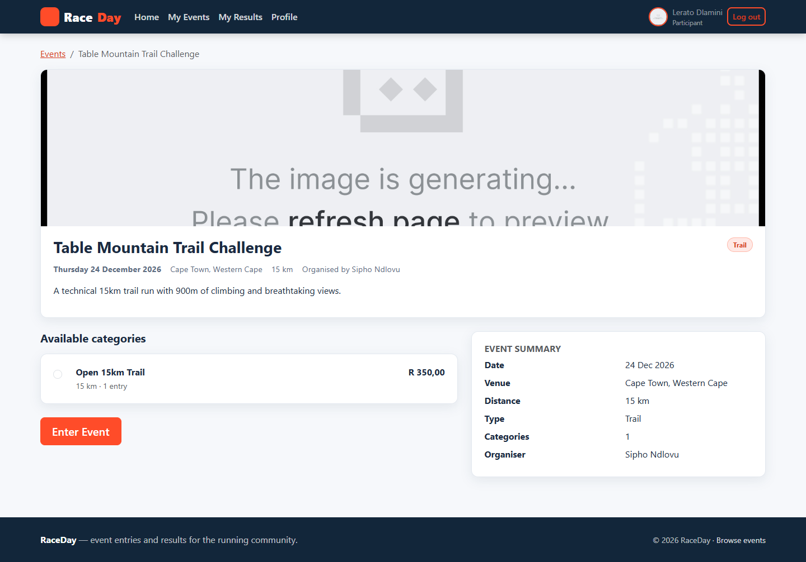
Figure 22: The same event detail page for a signed in participant, showing the category selector and the Enter Event action.
Figure 22 shows the detail page as a signed in participant sees it, with the category choices and the Enter Event action available. Entering an event is recorded immediately, and the participant is told that it succeeded and can verify the entry on the My Events page.
Figure 23: My Events, listing every event the participant has entered with its current status.
Figure 24: My Results, showing the participants race history with event, date, category, finish time and finishing position.
Figure 24 shows the participants race history. Each row reports the event name, the date, the category entered, the recorded finish time and the finishing position expressed as a place within the total field, for example forty seventh out of three hundred and twelve finishers. Results only appear here once the organiser has published them, which is why the capture and publication operations described above are kept separate.
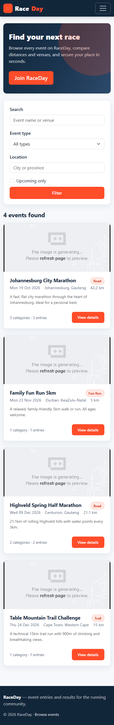
Figure 25: The participant interface at a narrow viewport. The layout reflows to a single column without loss of function.
4.5 Azure Blob Storage
Binary content, comprising event banner images and participant profile photographs, is stored in Azure Blob Storage. The requirement that the MVC application must not communicate with Azure directly is satisfied by keeping all storage logic inside the API: the MVC application posts a file to an API endpoint, the API uploads the stream to a blob container and returns the resulting URL, and only that URL is persisted in the database and rendered by the front end.
The API hides the storage mechanism behind an interface, IFileStorageService, with two implementations. AzureBlobFileStorageService performs the real upload to a configured blob container using the Azure.Storage.Blobs client library. LocalFileStorageService writes the file to a directory beneath the APIs static file root and returns a relative URL, and it is selected automatically whenever no Azure connection string is configured. The selection is made once, at start up, by inspecting configuration, so no calling code is aware of which implementation is active.
The fallback exists for a practical reason. A marker or examiner attempting to run the project should not be blocked by the absence of an Azure subscription, and the behaviour they observe must be identical to the behaviour produced by the Azure implementation. The abstraction delivers that: the same upload endpoint, the same stored URL, the same rendering on the event detail page. When a connection string is present, supplied either in configuration or through the environment variable BlobStorage ConnectionString, the same code path stores the file in Azure Blob Storage instead.
Validation is performed by the API rather than by the browser, because the API is the component that ultimately accepts the file. Uploads are restricted by content type and by a maximum size, and a rejected upload produces a message that the MVC application can display to the user without exposing any detail of the storage layer.
Figure 26: Banner upload. The file is posted to the API, stored as a blob, and the returned URL is persisted with the event.
Figure 27: The stored banner is rendered on the event detail page from the URL returned by the API, demonstrating the full upload to display round trip.
4.6 Docker
The applications are containerised so that they can be started with a single command. Each project contains a multi stage Dockerfile. The first stage uses the .NET SDK image to restore dependencies and publish the project in release configuration; the second stage uses the smaller ASP.NET runtime image and copies only the published output into it. Nothing from the build stage, including source files, the SDK and the NuGet cache, reaches the final image, which keeps it small and removes a substantial attack surface.
The runtime stage creates and switches to a non root user, sets the listening URL to port 8080 and declares that port, and starts the application as the containers entry point. Environment specific settings, such as the APIs base URL and the blob storage connection string, are supplied through environment variables so that the same image can be run against different configurations without being rebuilt.
A Docker Compose file orchestrates the two containers. The API is published on port 5132 and the MVC application on port 5031, and the MVC container is given the APIs service name as its base URL so that the two containers resolve one another by name on the shared network rather than by host address. The single command required to start the whole platform, and the equivalent plain docker run commands for readers who prefer not to use Compose, are documented in the README. Because the design keeps all state in the database and in blob storage rather than in the container, the containerised application behaves identically to the application running locally.
4.7 User interface design
The interface reflects a single brand identity. The palette is navy for structure and orange for action, with a restrained neutral background; the orange is reserved for the primary action on each page so that the intended next step is never ambiguous. Typography is consistent throughout, and the layout is built on the Bootstrap grid, which provides responsiveness without a bespoke implementation.
Colour is used systematically to communicate state. Enrolment statuses are rendered as pills, green for confirmed, amber for pending and grey for cancelled, and the same component is used wherever a status appears, so the encoding is learned once. Because colour is never the sole carrier of meaning, the pill always contains its status in words as well, which is required both by accessibility guidelines and by common sense.
Invalid input is handled at the boundary. Forms are validated against view models before any call is made to the API, and the API performs its own validation as the final authority because it is the component that owns the rules. When either layer rejects a submission, the user receives a message attached to the field that caused the problem, the values already entered are preserved, and no exception text or stack trace is ever displayed. Unexpected failures are caught and presented as a plain language message with a route back into the application.
4.8 Continuous integration and version control
The source is maintained in a Git repository on a branch named for this part of the portfolio, with a commit history that records the work in meaningful increments rather than as a single import. Each commit corresponds to a coherent change: the domain model, the data context and seeding, the authentication service, each controller, the file storage abstraction, the front end client, each interface, the styling, the container configuration and the documentation.
A GitHub Actions workflow runs on every push. It checks out the repository, installs the .NET SDK, restores the solution, builds it in release configuration and validates the structure of the repository, and a second job builds the Docker images. The workflow therefore provides continuous verification that the code in the repository compiles and that the container configuration remains valid. A green build on the workflow is the evidence that the project is in a releasable state.
The README documents the structure of the repository, the technology stack, the architecture and the division of responsibility between the two applications, the commands required to run the platform locally and in Docker, the configuration required for Azure Blob Storage, the demonstration accounts, the API endpoint reference and the manual test checklist. It also carries the link to the unlisted video demonstration and the screenshot of the passing continuous integration run.
4.9 Testing
The application was tested manually against the specification, role by role. The table records the test cases and their outcomes.
Test case | Steps | Expected result | Result
Registration | Submit the registration form with valid details and a role. | Account created through the API, user signed in, and the navigation for the chosen role displayed. | Pass
Registration validation | Submit the form with an invalid e-mail address and a mismatched password confirmation. | Messages attached to the offending fields, entered values preserved, no exception displayed. | Pass
Sign in | Sign in with a seeded participant account. | Session created holding the token and role; participant navigation displayed. | Pass
Unauthenticated access | Request a protected page without a session. | Redirect to the sign in page; protected content never rendered. | Pass
Role separation | Sign in as a participant and request an organiser page. | Request refused and the denial page displayed. | Pass
Sign out | Sign out and then request a protected page. | Session cleared and the request redirected to the sign in page. | Pass
Event discovery | Filter the home page by event type and location. | Only events matching every applied filter are listed, with a correct result count. | Pass
Event entry | Open an event, select a category and enter the event. | Enrolment recorded immediately and visible on My Events with a status. | Pass
Duplicate entry | Attempt to enter the same event a second time. | The duplicate is refused with an explanatory message. | Pass
Cancellation | Cancel an existing entry. | Status changes to cancelled and the entry remains visible for the record. | Pass
Event management | Create, edit and delete an event as an organiser. | Changes persist through the API and are reflected in the dashboard and public list. | Pass
Banner upload | Upload a banner image while creating an event. | File sent to the API, stored as a blob, and the returned URL displayed on the event detail page. | Pass
Category management | Add, edit and delete a category on an event. | Changes persist and the categories offered to entrants reflect them. | Pass
Enrolment review | Open the enrolment list for an event with entries. | Every entrant listed with category and colour coded status. | Pass
Results entry | Record finish times and positions and publish. | Values saved and, once published, visible to participants on My Results with a position expressed as a place in the field. | Pass
Profile | Update personal details and upload a profile photograph. | Details updated through the API and the photograph displayed in the navigation bar. | Pass
Responsiveness | View the application at a narrow viewport width. | Layout reflows to a single column with all functions available. | Pass

Reference List
Cooper, A., Reimann, R., Cronin, D. and Noessel, C. (2014) About Face: The Essentials of Interaction Design. 4th ed. Indianapolis: Wiley.
ISO (1998) ISO 9241-11: Ergonomic requirements for office work with visual display terminals (VDTs) - Part 11: Guidance on usability. Geneva: International Organization for Standardization.
Jordan, P.W. (2000) Designing Pleasurable Products: An Introduction to the New Human Factors. London: Taylor and Francis.
Krug, S. (2014) Don't Make Me Think, Revisited: A Common Sense Approach to Web Usability. 3rd ed. San Francisco: New Riders.
Microsoft (2024) ASP.NET Core documentation. Available at: https://learn.microsoft.com/aspnet/core (Accessed: 9 November 2026).
Nielsen, J. (1993) Usability Engineering. San Francisco: Morgan Kaufmann.
Norman, D.A. (2013) The Design of Everyday Things. Revised and expanded ed. New York: Basic Books.
Preece, J., Sharp, H. and Rogers, Y. (2015) Interaction Design: Beyond Human-Computer Interaction. 4th ed. Chichester: Wiley.
W3C (2008) Web Content Accessibility Guidelines (WCAG) 2.0. W3C Recommendation. Available at: https://www.w3.org/TR/WCAG20/ (Accessed: 9 November 2026).
5. WCAG 2.0 Conformance Summary
The Web Content Accessibility Guidelines 2.0 (W3C, 2008) organise accessibility requirements into four principles: content must be Perceivable, Operable, Understandable and Robust. Conformance is expressed at three levels, of which level AA is the practical standard for public web content. RaceDay targets level AA, and the summary below states the position for each principle against the implemented interface.
Principle | Position in the implemented application
Perceivable | All non-text content carries alternative text: event banners use the event name, profile photographs use the participants name, and decorative marks are hidden from assistive technology. Body text and primary button text both exceed the 4.5 to 1 contrast ratio required by criterion 1.4.3, and the fluid layout allows text to be enlarged to 200 per cent without loss of content or function.
Operable | Every interactive element is a native link, button, input or select, so the whole application can be operated with the keyboard alone. A skip link is the first focusable element on every page, satisfying criterion 2.4.1, and a custom focus outline with a contrasting border makes the focused element visible at all times, satisfying criterion 2.4.7. Session timeouts are measured in hours rather than seconds, so a user who needs more time is not interrupted.
Understandable | Pages use one consistent navigation model, one consistent form layout and one consistent visual language. Labels are always visible and always associated with their controls. Errors are identified in text beside the field that caused them, never by colour alone, and the message states what is required rather than only that something is wrong, satisfying criteria 3.3.1 and 3.3.3.
Robust | The interface is built from semantic HTML, including landmarks, headings, lists, tables and native form controls, so that its structure and its name, role and value information are available to assistive technology, satisfying criterion 4.1.2. Where custom behaviour is required, ARIA attributes such as aria-label on the navigation region and the filter form supply the missing names. The markup renders consistently across modern browsers.

Figure 28: Text and controls reflow at a narrow viewport, supporting criterion 1.4.4 (Resize text) and criterion 1.4.10 (Reflow).
Reference List
Cooper, A., Reimann, R., Cronin, D. and Noessel, C. (2014) About Face: The Essentials of Interaction Design. 4th ed. Indianapolis: Wiley.
ISO (1998) ISO 9241-11: Ergonomic requirements for office work with visual display terminals (VDTs) - Part 11: Guidance on usability. Geneva: International Organization for Standardization.
Jordan, P.W. (2000) Designing Pleasurable Products: An Introduction to the New Human Factors. London: Taylor and Francis.
Krug, S. (2014) Don't Make Me Think, Revisited: A Common Sense Approach to Web Usability. 3rd ed. San Francisco: New Riders.
Microsoft (2024) ASP.NET Core documentation. Available at: https://learn.microsoft.com/aspnet/core (Accessed: 9 November 2026).
Nielsen, J. (1993) Usability Engineering. San Francisco: Morgan Kaufmann.
Norman, D.A. (2013) The Design of Everyday Things. Revised and expanded ed. New York: Basic Books.
Preece, J., Sharp, H. and Rogers, Y. (2015) Interaction Design: Beyond Human-Computer Interaction. 4th ed. Chichester: Wiley.
W3C (2008) Web Content Accessibility Guidelines (WCAG) 2.0. W3C Recommendation. Available at: https://www.w3.org/TR/WCAG20/ (Accessed: 9 November 2026).
6. Conclusion
This portfolio has followed a single design idea from the analysis of a user need to a deployed web application. Part 1 established that students need one place in which to find, enter and follow up local sporting events, and derived the design requirements from that need. Part 2 built a prototype and used it to demonstrate how each required design area would be satisfied, revising the design where the artefact exposed weaknesses in the plan. This final part has implemented the design as a three tier application and has shown, screen by screen, that the usability goals, the desirable aspects of user experience, the design principles, the interaction types, the social and emotional dimensions and the WCAG 2.0 conformance target are all present in the working system.
Three engineering decisions were decisive. Separating the presentation tier from the service tier through a RESTful API meant that the interaction design could be implemented without being entangled with business rules, and it is the reason the implemented interface is recognisably the interface that was designed. Holding the users identity and role in session state made role based navigation and access control straightforward to implement once and impossible to forget. Hiding file storage behind a single interface allowed Azure Blob Storage to be integrated into the API while still permitting the project to be run by a marker with no Azure subscription, without any difference in observable behaviour.
The result is a platform that does one thing well, is usable and accessible by design rather than by remediation, and is packaged so that it can be run, demonstrated and assessed with a single command.
Reference List
Cooper, A., Reimann, R., Cronin, D. and Noessel, C. (2014) About Face: The Essentials of Interaction Design. 4th ed. Indianapolis: Wiley.
ISO (1998) ISO 9241-11: Ergonomic requirements for office work with visual display terminals (VDTs) - Part 11: Guidance on usability. Geneva: International Organization for Standardization.
Jordan, P.W. (2000) Designing Pleasurable Products: An Introduction to the New Human Factors. London: Taylor and Francis.
Krug, S. (2014) Don't Make Me Think, Revisited: A Common Sense Approach to Web Usability. 3rd ed. San Francisco: New Riders.
Microsoft (2024) ASP.NET Core documentation. Available at: https://learn.microsoft.com/aspnet/core (Accessed: 9 November 2026).
Nielsen, J. (1993) Usability Engineering. San Francisco: Morgan Kaufmann.
Norman, D.A. (2013) The Design of Everyday Things. Revised and expanded ed. New York: Basic Books.
Preece, J., Sharp, H. and Rogers, Y. (2015) Interaction Design: Beyond Human-Computer Interaction. 4th ed. Chichester: Wiley.
W3C (2008) Web Content Accessibility Guidelines (WCAG) 2.0. W3C Recommendation. Available at: https://www.w3.org/TR/WCAG20/ (Accessed: 9 November 2026).

