RACEDAY
Find a race. Enter it. Own your result.

RaceDay: Interaction Design and Prototype

Part 2: Interaction Design

Field | Detail
Name: | [Your Full Name]
Surname: | [Your Surname]
Student number: | [Your Student Number]
Module code: | [Module Code]
Description: | Part 2: Interaction Design
Date: | 9 November 2026

Table of Contents
Right-click here and choose Update Field to build the table of contents.

1. Introduction
RaceDay is a website that lets a student find an upcoming local sports event, enter it by selecting a category, and later retrieve an official result. Part 1 of this portfolio set out the design requirements for that website. Part 2 responds to the feedback received on Part 1, describes the prototype that was built to test those requirements, and demonstrates through the prototype itself how each of the seven required design areas has been implemented.
The report is structured so that the reader can see the design rather than only read about it. Every claim about the design is followed by a screenshot of the prototype page that implements it, and the figure number is referenced from the body text. Section 2 records the feedback received on Part 1 and the action taken in response. Sections 3 and 4 address the design areas in the order required by the brief. Section 5 concludes.
2. Response to Part 1 Feedback
The feedback received on Part 1 concerned the relationship between the written design and the artefact that was to be produced. In summary, the design requirements were considered sound, but the report described intentions rather than demonstrating outcomes, and several areas were treated less thoroughly than others. The table below records each comment and the action taken in response.
Feedback received on Part 1 | Action taken | Section
The usability goals were described in the abstract and were not connected to anything the user would actually see. | Each usability goal now names the specific interface element that delivers it, and each goal is illustrated with a prototype screen. | 4.1
There was no artefact to demonstrate that the design had been thought through beyond the discussion. | A fully linked HTML, CSS and JavaScript prototype of twelve pages was developed. Every claim in this report is now supported by a screenshot of the prototype. | All; Section 3
Accessibility was treated as a final consideration rather than a constraint on the design from the start. | WCAG 2.0 success criteria are now presented in a table with the concrete implementation for each, and accessibility features such as the skip link, visible focus, semantic landmarks and alternative text are visible in the screenshots. | 4.7
The social and emotional dimensions of the design were underdeveloped relative to the other areas. | Dedicated sections with prototype evidence were added for both social interactions and emotional interaction, and their relationship to the core task was explained. | 4.5, 4.6
The reference list was not consistently formatted. | All in-text citations and reference lists were re-formatted in the Harvard style, and a reference list now appears at the end of every major section. | All sections
The scope of the website was not clearly bounded. | Section 1 now states explicitly what RaceDay does not do and why, and Section 3 explains the deliberate exclusion of payments and messaging. | 1, 3

The most significant change is that the report is now built around a working prototype. This allowed several of the design claims made in Part 1 to be tested rather than asserted. For example, the claim that the core task could be completed in three interactions was verified by building the flow and counting them, and the claim that colour coded status pills would make enrolment state legible was verified by looking at a list of twenty entries rather than at a single example.
3. Prototype Overview
The prototype is a functioning, clickable front end built with hand written HTML5, CSS3 and JavaScript. It consists of twelve linked pages covering both user roles. No framework or build step is required, which means the prototype can be opened directly from the file system and demonstrated anywhere without a toolchain.
Styling is implemented with a single stylesheet that declares the brand palette as CSS custom properties, so that a colour or spacing decision made once propagates to every page. This is the mechanism that enforces the consistency the design principles require: the same navy, the same orange, the same corner radius and the same shadow are used by every card on every page because they are defined in one place.
The demo content is realistic rather than placeholder text, because plausibility is necessary in order to judge whether the design works. The prototype contains the Johannesburg City Marathon, the Highveld Spring Half Marathon, the Table Mountain Trail Challenge and a Family Fun Run 5 km, each with a date, a venue, a distance and a set of categories, together with sample entrants and sample results.
Prototype file | Purpose
index.html | Participant home page with event discovery and filtering
event-detail.html | Full event information, category selection and the Enter Event action
login.html | Sign-in screen
register.html | Account creation with role selection
my-events.html | The participants own entries and their statuses
my-results.html | Personal race history with finish times and finishing positions
profile.html | Personal information and profile photograph
organiser-dashboard.html | Organiser summary of events, enrolments and upcoming dates
organiser-event-form.html | Event creation and editing, including banner upload
organiser-enrolments.html | Entrants for a specific event with category and status
organiser-results.html | Capture and publication of finish times and positions
css/styles.css and js/app.js | Shared brand tokens, components and interaction behaviour

The prototype is located in the Part2-Prototype folder of the repository. Opening index.html in any modern browser is sufficient to explore it; the navigation links connect every page to every other page that a user of that role would be entitled to reach.
Reference List
Cooper, A., Reimann, R., Cronin, D. and Noessel, C. (2014) About Face: The Essentials of Interaction Design. 4th ed. Indianapolis: Wiley.
ISO (1998) ISO 9241-11: Ergonomic requirements for office work with visual display terminals (VDTs) - Part 11: Guidance on usability. Geneva: International Organization for Standardization.
Jordan, P.W. (2000) Designing Pleasurable Products: An Introduction to the New Human Factors. London: Taylor and Francis.
Krug, S. (2014) Don't Make Me Think, Revisited: A Common Sense Approach to Web Usability. 3rd ed. San Francisco: New Riders.
Microsoft (2024) ASP.NET Core documentation. Available at: https://learn.microsoft.com/aspnet/core (Accessed: 9 November 2026).
Nielsen, J. (1993) Usability Engineering. San Francisco: Morgan Kaufmann.
Norman, D.A. (2013) The Design of Everyday Things. Revised and expanded ed. New York: Basic Books.
Preece, J., Sharp, H. and Rogers, Y. (2015) Interaction Design: Beyond Human-Computer Interaction. 4th ed. Chichester: Wiley.
W3C (2008) Web Content Accessibility Guidelines (WCAG) 2.0. W3C Recommendation. Available at: https://www.w3.org/TR/WCAG20/ (Accessed: 9 November 2026).
4. Design Requirements Implemented in the Prototype
The subsections that follow correspond to the seven design areas required by the brief. Each describes what the design intends to achieve and then presents the prototype evidence for that intention.
4.1 Usability goals
Usability is the extent to which a product can be used by specified users to achieve specified goals with effectiveness, efficiency and satisfaction in a specified context of use (ISO, 1998). Preece, Sharp and Rogers (2015) expand that definition into a set of goals that can be designed for and verified. RaceDay adopts six: effectiveness, efficiency, safety, utility, learnability and memorability.
Goal | What it requires of RaceDay | How the prototype implements it
Effectiveness | A participant must be able to complete the core task of finding a race and entering it, and must reach a confirmation state that proves the task succeeded. | Every event entry produces an explicit confirmation message and the event appears immediately on the My Events page, so the outcome of the task is both stated and verifiable.
Efficiency | The task should be completable in as few steps and with as little reading as possible. | The home page lists events as scannable cards; the event detail page carries a single primary call to action, Enter Event; entering a race therefore takes three interactions.
Safety | Users should be protected from the consequences of mistakes without being asked to confirm every trivial action. | Category selection is a constrained choice rather than free text, duplicate entries are refused by the system, deleting an event requires an explicit confirmation step, and cancelling an entry is reversible.
Utility | The system must provide the functionality the user actually needs, not merely functionality that is technically interesting. | RaceDay does only discovery, entry and results. It is not a training platform, a social network or a shop, so every screen remains directly relevant to the single task.
Learnability | A first-time user should be able to complete the core task without training or documentation. | One navigation bar, one card style and one form style are used throughout, and labels use the vocabulary of the domain (distance, category, finish time) rather than system vocabulary.
Memorability | A returning user should not have to relearn the interface. | Navigation placement, terminology and layout never change between sessions or between roles, and the signed-in users name and photograph are always visible so that the session context is unambiguous.

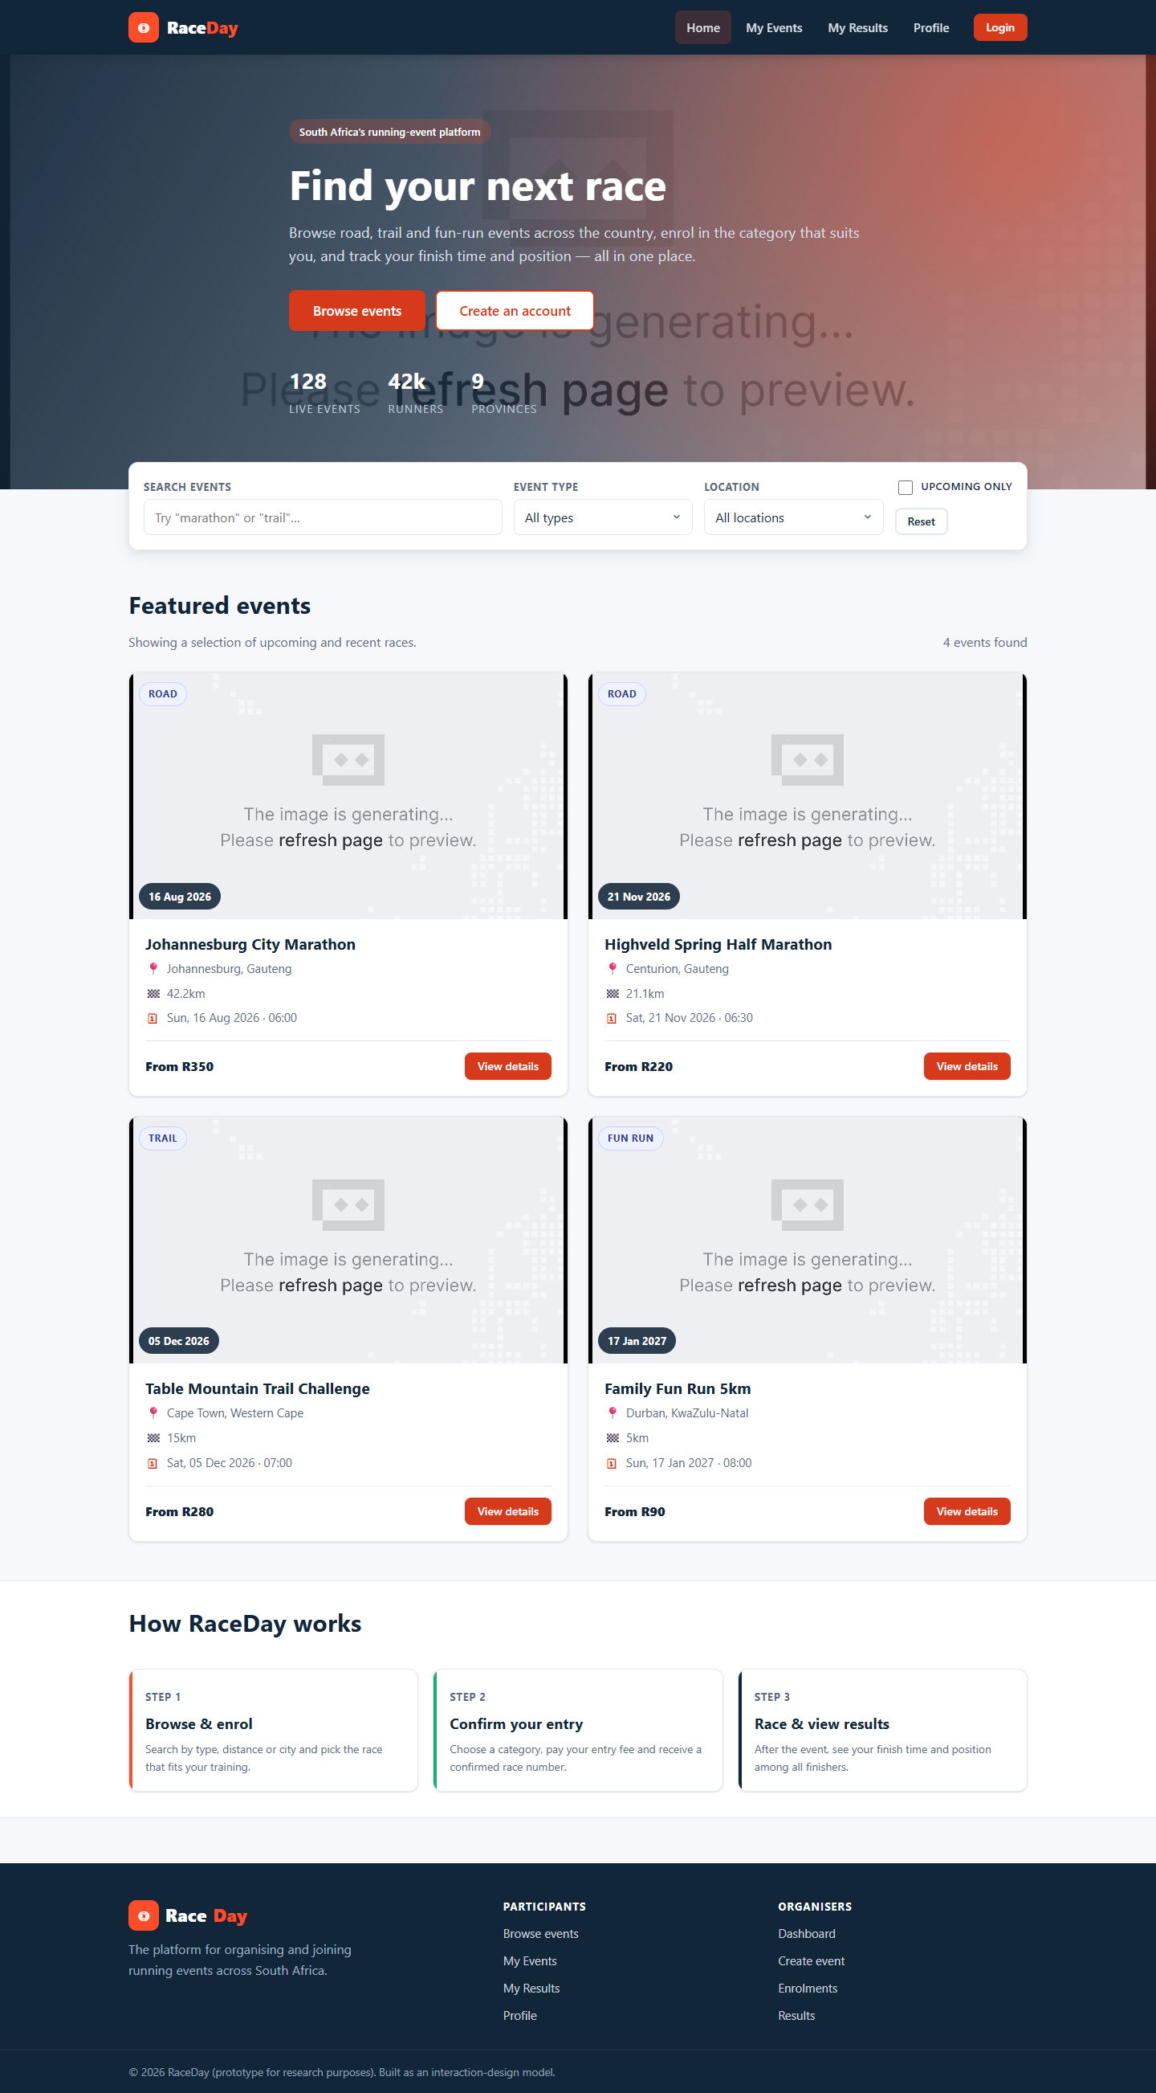
Figure 1: Prototype home page. Each event card exposes name, date, venue and distance, allowing an event to be assessed at a glance.
Figure 1 is the first evidence of efficiency. The four facts a runner needs in order to decide whether an event is worth considering are presented on the card itself, so the decision can be taken without opening the event. The filter control sits directly above the list it filters, which keeps the mapping between the control and its outcome explicit and is a direct application of the principle of mapping (Norman, 2013).
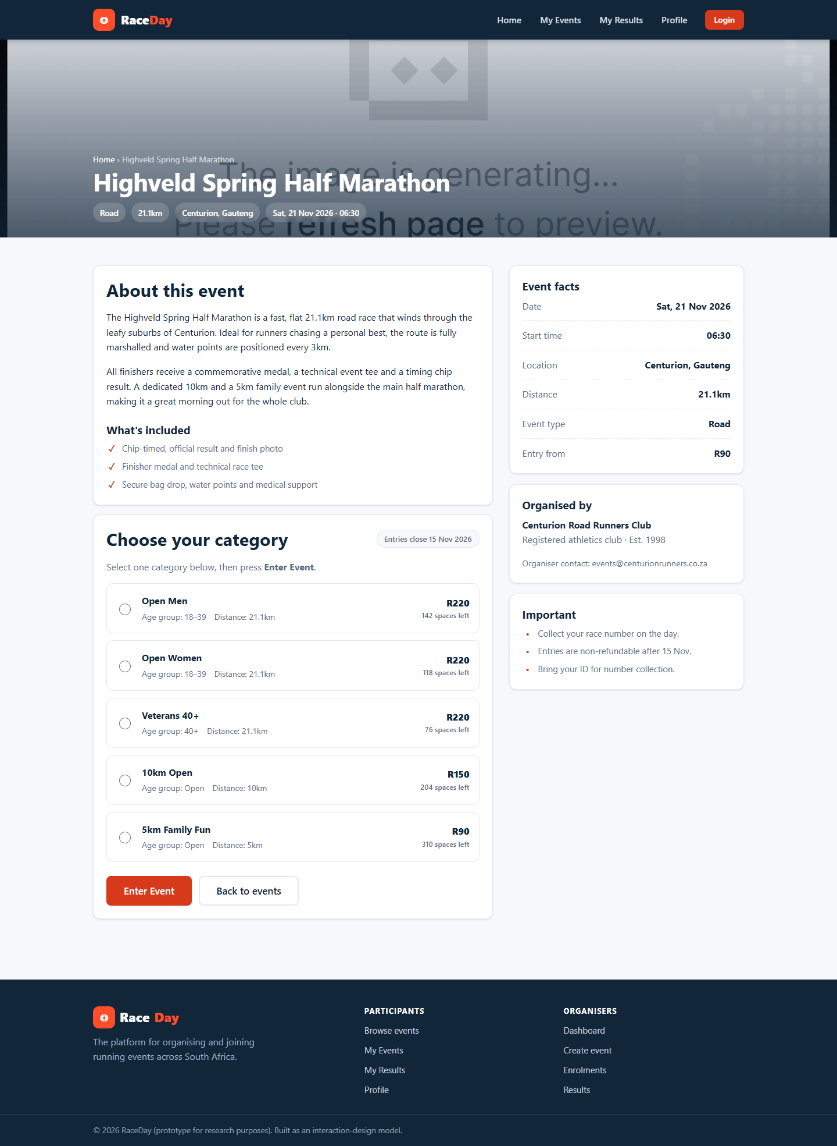
Figure 2: Event detail page. The category selector sits immediately above the single primary action, Enter Event.
Figure 2 shows the completion of the core task. The page offers exactly one primary action, rendered as a solid orange button so that its prominence is unmistakable, and the two decisions the user must make are made in one place rather than across two screens. This is the effectiveness goal: the user can complete the task on a page that explains itself.
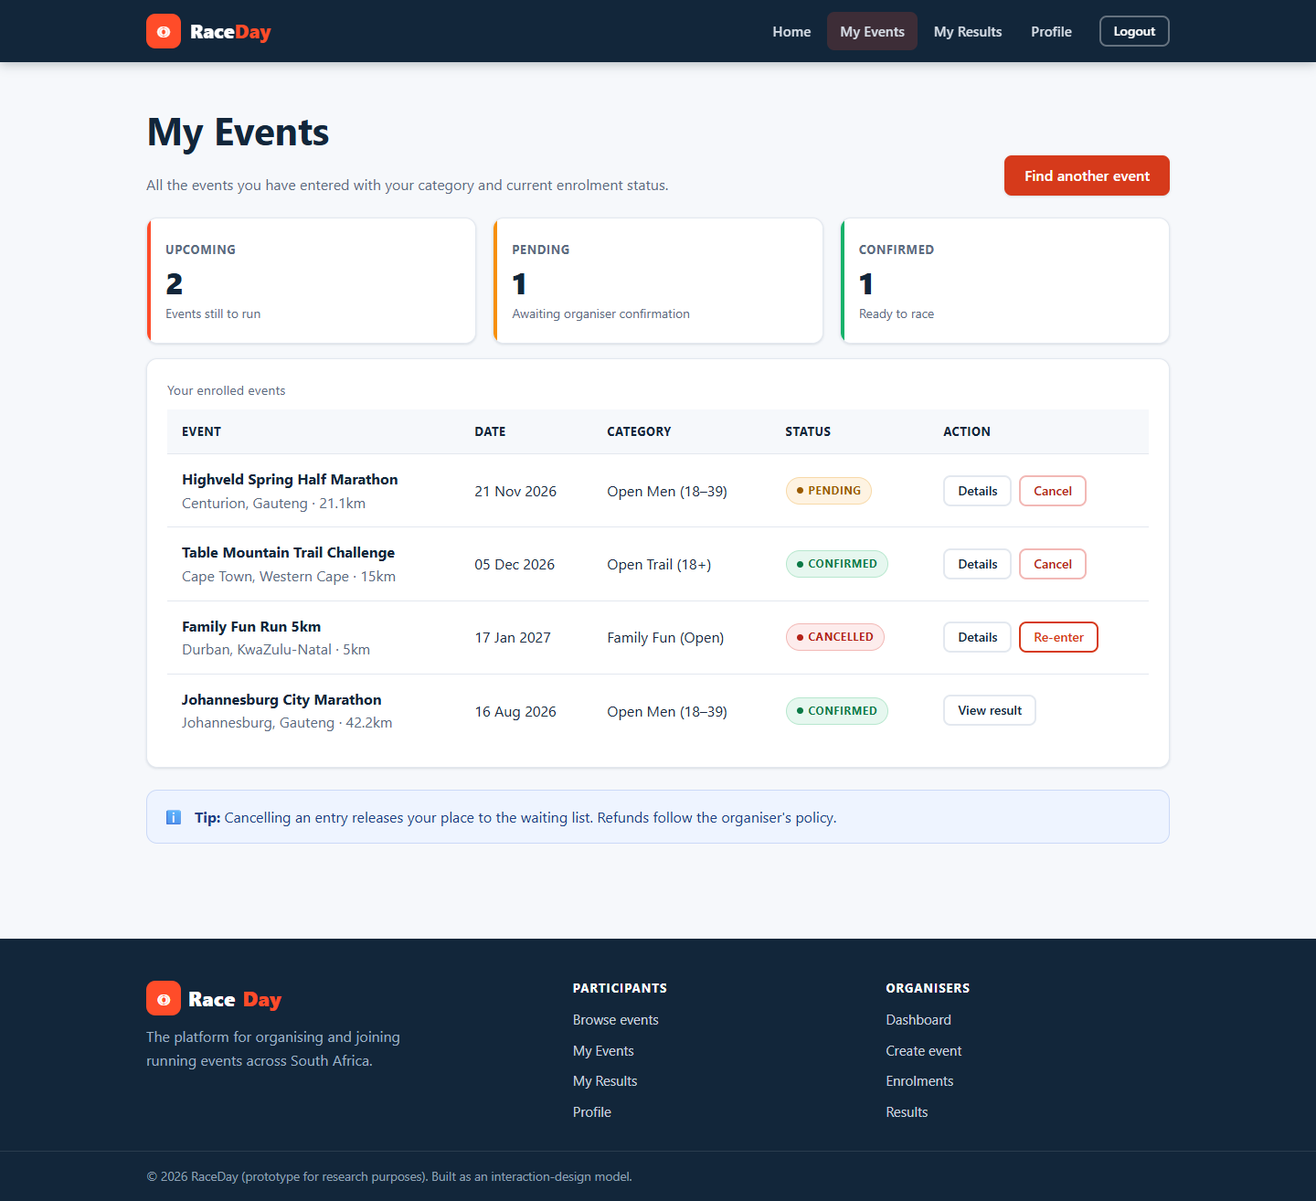
Figure 3: My Events page, where an entry can be verified immediately after it is made, and cancelled if it was a mistake.
Figure 3 satisfies the safety goal. The entry is visible as soon as it is made, which means the user can verify the outcome, and the cancel control provides a reversible exit from an error. Presenting cancel as a secondary control rather than a primary one reduces the chance of an accidental cancellation while keeping the escape route available.
Figure 4: The home page at a narrow viewport. Content reflows to a single column and touch targets remain full width.
Figure 4 demonstrates that the usability goals survive a change of context. Many students will enter races from a phone, and the reflowed layout preserves reading order, target size and the position of the primary action, so the efficiency gained on the desktop is not lost on the mobile device.
Reference List
Cooper, A., Reimann, R., Cronin, D. and Noessel, C. (2014) About Face: The Essentials of Interaction Design. 4th ed. Indianapolis: Wiley.
ISO (1998) ISO 9241-11: Ergonomic requirements for office work with visual display terminals (VDTs) - Part 11: Guidance on usability. Geneva: International Organization for Standardization.
Jordan, P.W. (2000) Designing Pleasurable Products: An Introduction to the New Human Factors. London: Taylor and Francis.
Krug, S. (2014) Don't Make Me Think, Revisited: A Common Sense Approach to Web Usability. 3rd ed. San Francisco: New Riders.
Microsoft (2024) ASP.NET Core documentation. Available at: https://learn.microsoft.com/aspnet/core (Accessed: 9 November 2026).
Nielsen, J. (1993) Usability Engineering. San Francisco: Morgan Kaufmann.
Norman, D.A. (2013) The Design of Everyday Things. Revised and expanded ed. New York: Basic Books.
Preece, J., Sharp, H. and Rogers, Y. (2015) Interaction Design: Beyond Human-Computer Interaction. 4th ed. Chichester: Wiley.
W3C (2008) Web Content Accessibility Guidelines (WCAG) 2.0. W3C Recommendation. Available at: https://www.w3.org/TR/WCAG20/ (Accessed: 9 November 2026).
4.2 Desirable aspects of user experience
Usability goals describe what the user must be able to do; the desirable aspects of user experience describe how the product should feel while the user does it. Preece, Sharp and Rogers (2015) list satisfying, enjoyable, engaging, pleasurable, exciting, entertaining, helpful, motivating, aesthetically pleasing, supportive of creativity and rewarding, and observe that selecting the appropriate subset is itself a design decision. For a website whose purpose is to persuade a student to commit to a physical challenge, the qualities that matter are satisfying, motivating, enjoyable, helpful, aesthetically pleasing and supportive of personal expression.
Quality | How the prototype achieves it
Satisfying and rewarding | The My Results page presents the participants history as prominent statistic cards (races completed, total distance, personal best) above the detailed result table, so that the participant is rewarded for competing rather than confronted with a bare list of numbers.
Engaging and motivating | Event cards use large banner imagery, a strong orange accent and a prominent event date; the visual treatment is deliberately energetic because the domain itself, competitive running, is energetic.
Enjoyable and pleasurable | Micro-interactions such as button hover states, visible focus outlines and status pills that change colour give the interface a responsiveness that is itself pleasurable, independently of whether the task succeeded (Jordan, 2000).
Helpful | Validation messages are written as instructions rather than as accusations: Enter the event date rather than Invalid input.
Aesthetically pleasing | A single restrained palette of navy #12263A and orange #FF4C29 on a light neutral background, with one type family, minimises visual noise and makes the interface feel professionally produced.
Supporting personal expression | Participants may upload a profile photograph, which gives the account a personal identity rather than leaving it as an anonymous record.

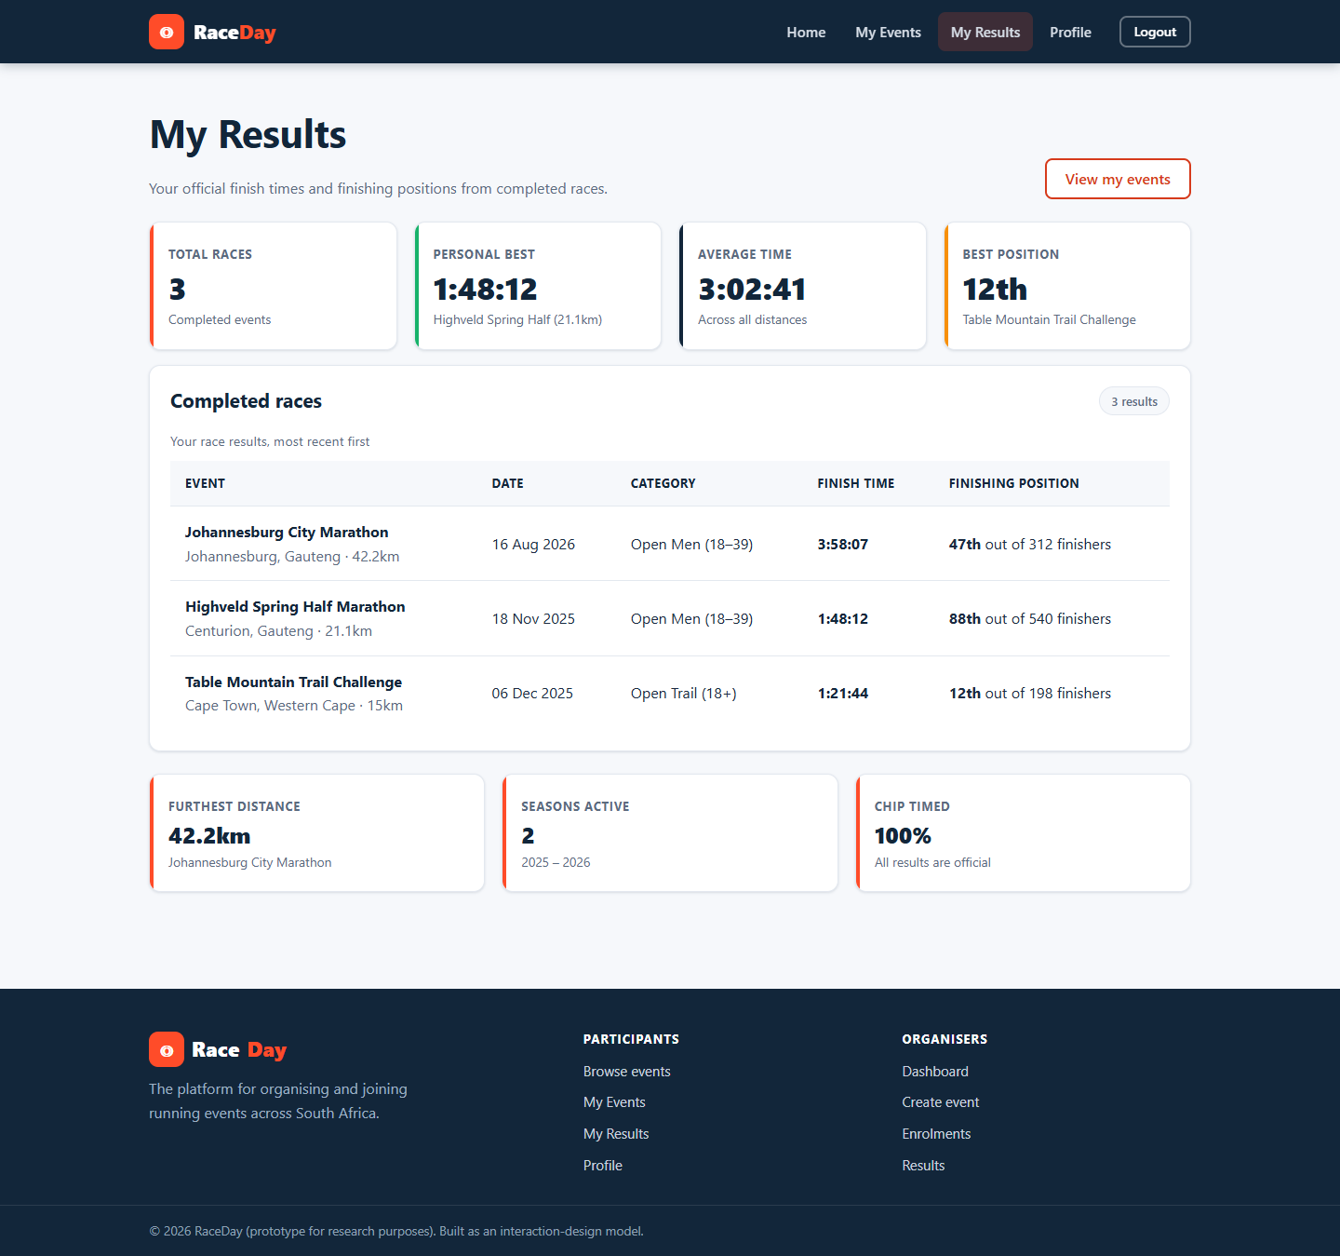
Figure 5: My Results. Achievement summary cards precede the detailed result table so that accomplishment is stated before administration.
Figure 5 is the strongest expression of the rewarding quality. A results page could legitimately consist of a table, but a table answers the organisers question rather than the runners. Leading with the number of races completed, the total distance covered and the personal best time answers the question the runner actually has and delivers the emotional reward for having competed.
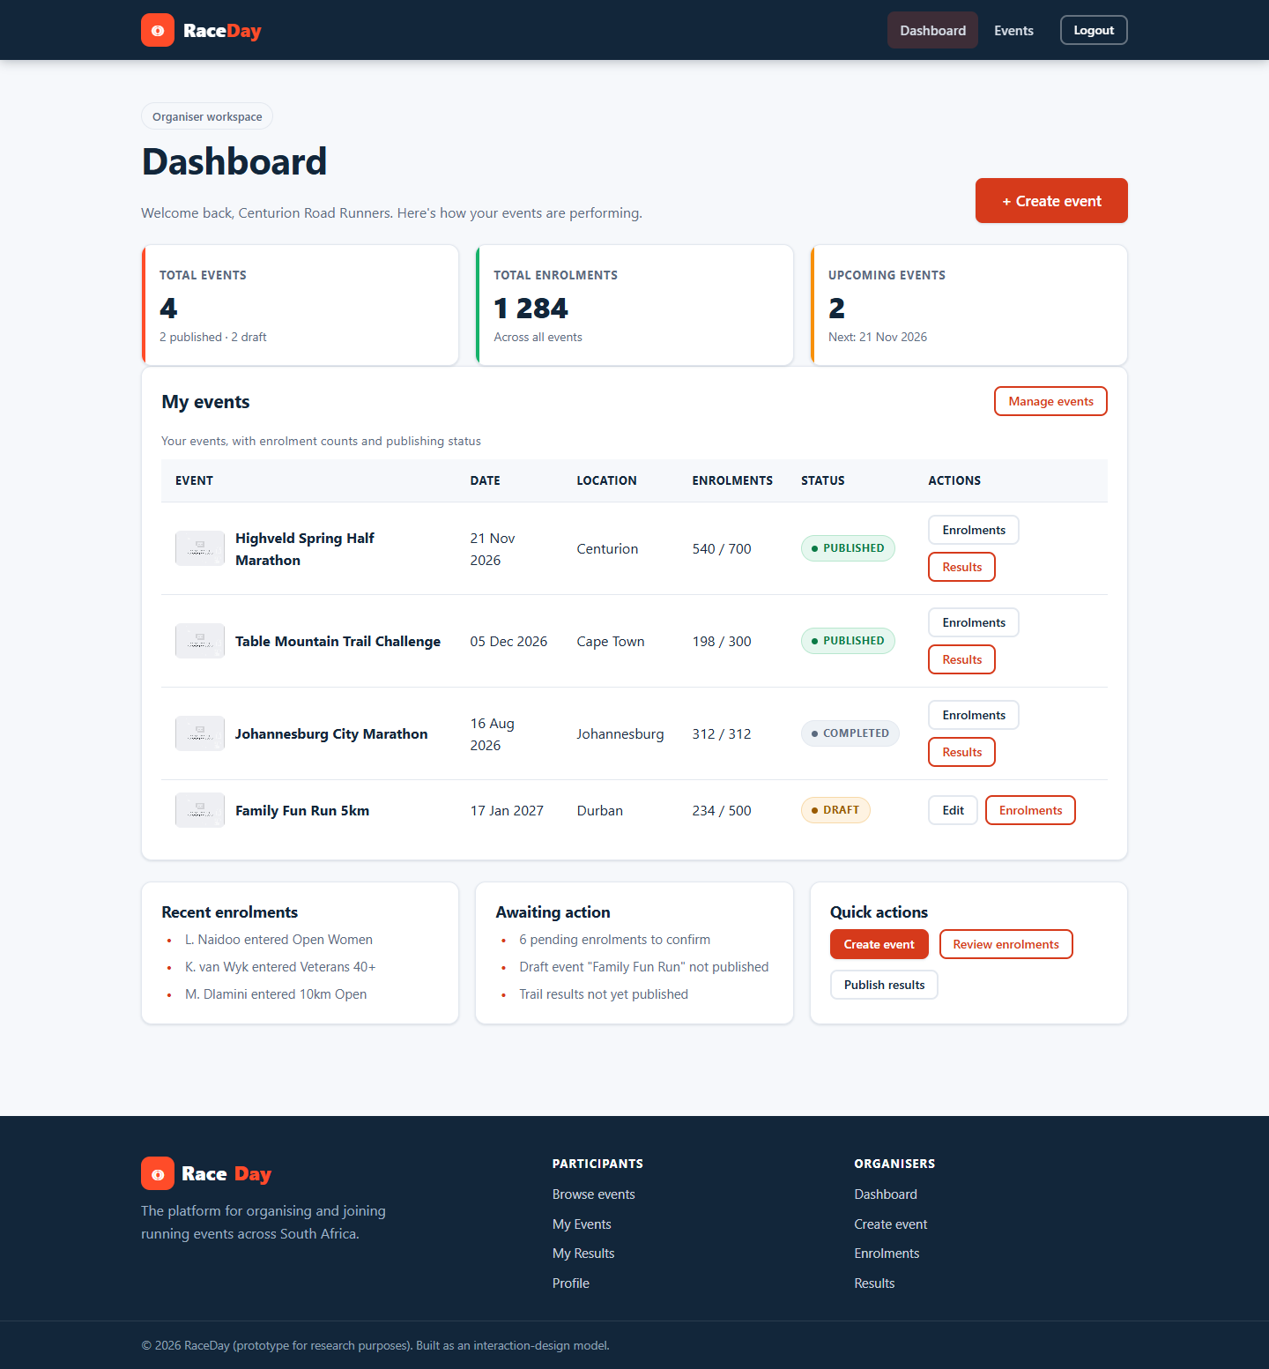
Figure 6: Organiser dashboard. Reach is summarised before the mechanics of event management are presented.
Figure 6 applies the same reasoning to the organiser. The dashboard leads with a summary of events created, total enrolments and upcoming dates, which is the information an organiser wants, and defers the mechanics of editing to the event management page. The effect is that the tool feels informative rather than administrative.
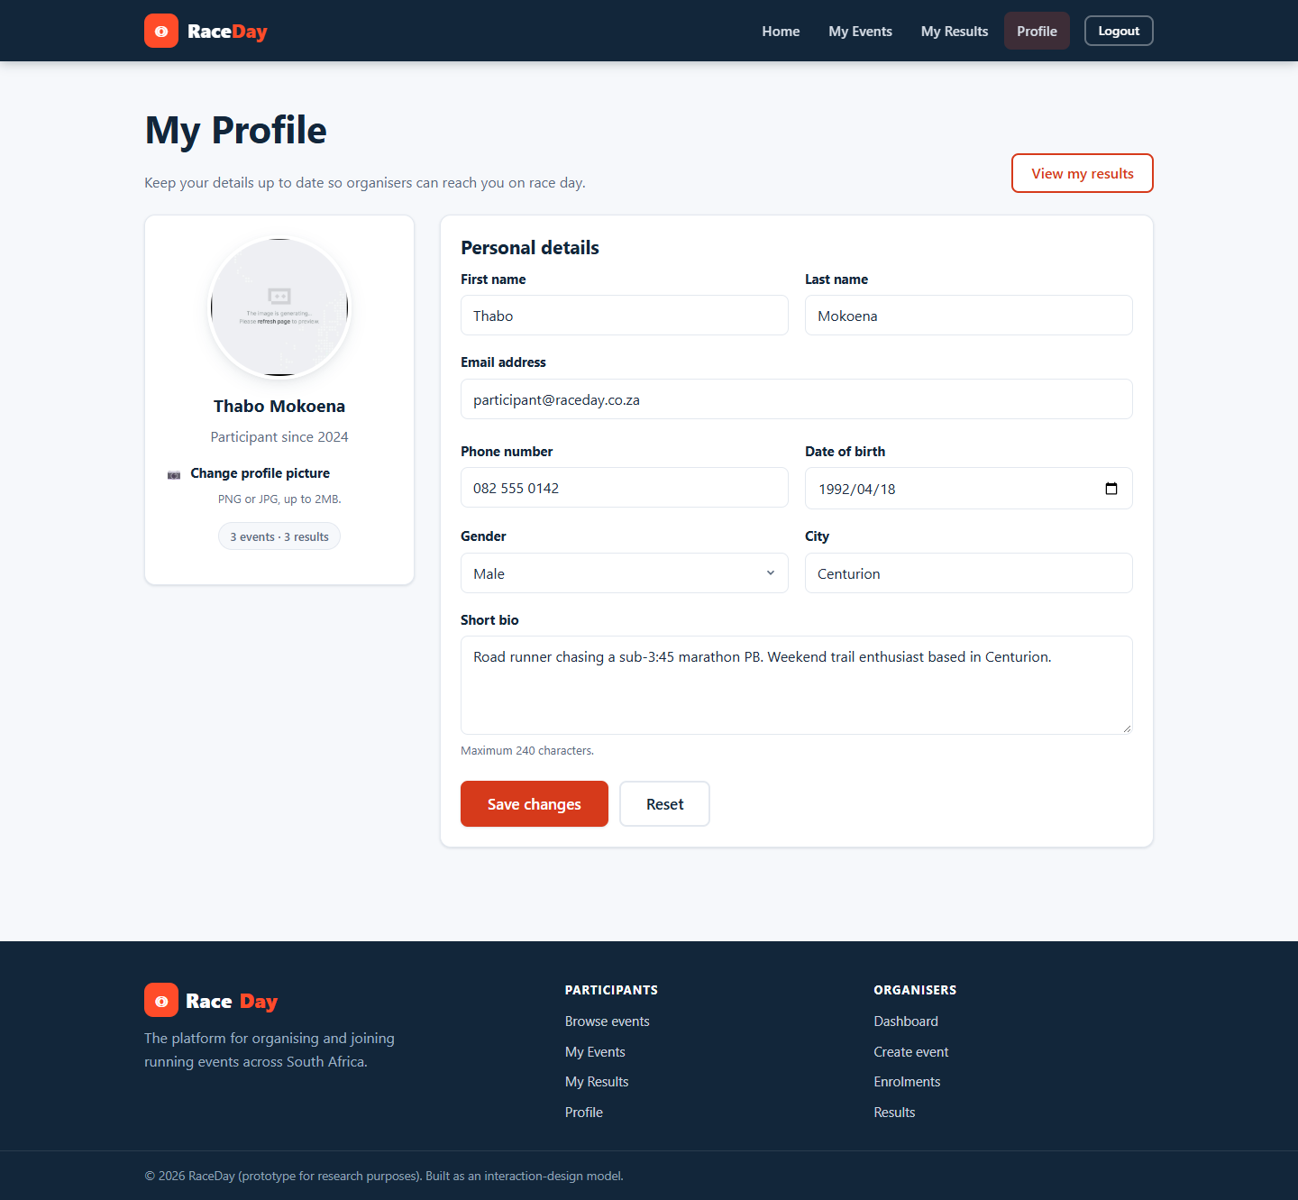
Figure 7: Profile page. The uploaded photograph follows the user into the navigation bar.
Figure 7 supports personal expression. The photograph is not merely stored; it is displayed in the navigation bar on every page, so the account acquires a visible identity. For a platform used by a student community this is a small but effective way of making a transactional website feel personal.
Reference List
Cooper, A., Reimann, R., Cronin, D. and Noessel, C. (2014) About Face: The Essentials of Interaction Design. 4th ed. Indianapolis: Wiley.
ISO (1998) ISO 9241-11: Ergonomic requirements for office work with visual display terminals (VDTs) - Part 11: Guidance on usability. Geneva: International Organization for Standardization.
Jordan, P.W. (2000) Designing Pleasurable Products: An Introduction to the New Human Factors. London: Taylor and Francis.
Krug, S. (2014) Don't Make Me Think, Revisited: A Common Sense Approach to Web Usability. 3rd ed. San Francisco: New Riders.
Microsoft (2024) ASP.NET Core documentation. Available at: https://learn.microsoft.com/aspnet/core (Accessed: 9 November 2026).
Nielsen, J. (1993) Usability Engineering. San Francisco: Morgan Kaufmann.
Norman, D.A. (2013) The Design of Everyday Things. Revised and expanded ed. New York: Basic Books.
Preece, J., Sharp, H. and Rogers, Y. (2015) Interaction Design: Beyond Human-Computer Interaction. 4th ed. Chichester: Wiley.
W3C (2008) Web Content Accessibility Guidelines (WCAG) 2.0. W3C Recommendation. Available at: https://www.w3.org/TR/WCAG20/ (Accessed: 9 November 2026).
4.3 Design principles
Design principles are general rules of thumb that determine whether a user can build an accurate mental model of a system. Norman (2013) identifies visibility, feedback, constraints, affordance, mapping and consistency; Nielsen (1993) supplies a complementary set of heuristics; and Krug (2014) contributes the principle that the designers task is to eliminate question marks rather than to answer them.
Principle | How it is applied in the prototype
Visibility | The state of the system is always visible: a signed-in user sees their own name and photograph in the navigation bar, enrolment statuses are shown as coloured pills on every relevant screen, and the number of events found is printed above the search results.
Feedback | Every action produces a response: successful enrolment shows a confirmation banner, validation failures are listed beside the offending field, and destructive actions report their outcome on the following page load.
Constraints | The interface restricts what can be done rather than reporting failure afterwards: dates cannot be set in the past, categories are presented as a managed list, and pages belonging to the other role are refused rather than merely hidden.
Consistency | One navigation bar, one card component, one form layout, one table style and one status pill component are used on every page, so the user learns the interface once.
Affordance | Buttons look pressable, links look clickable, fields look editable and disabled states look disabled. The primary action on every page is a solid orange button, which signals that it is the recommended next step.
Mapping | Controls are placed where the user expects them: filtering sits immediately above the list it filters, the category selector sits immediately above the Enter Event button, and the photograph upload control sits beside the picture it replaces.
Error prevention and recovery | Preventable errors are prevented by validation at the boundary. Unpreventable errors are reported in plain language with a route back to the form, and the system never displays raw exception text.

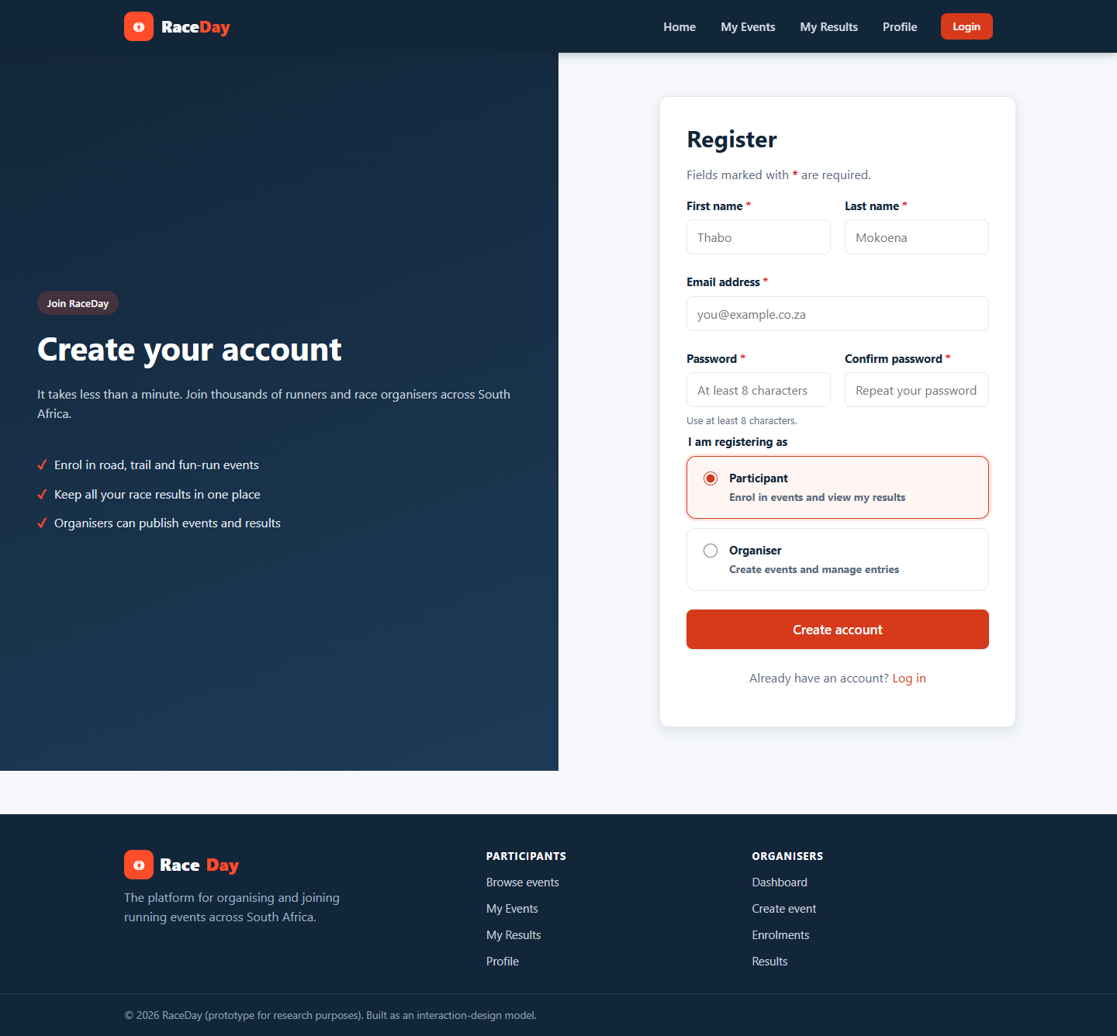
Figure 8: Registration form. Visible labels, a constrained role selector and instructional error messages.
Figure 8 is the clearest single example of constraints and error prevention. Because the role is chosen from a fixed set rather than typed, an account can never be created with an undefined role, which removes a whole class of error before it can occur. Every field has a permanently visible label and the guidance is written as an instruction rather than a prohibition, which reflects the principle that it is cheaper to prevent a mistake than to explain it afterwards.
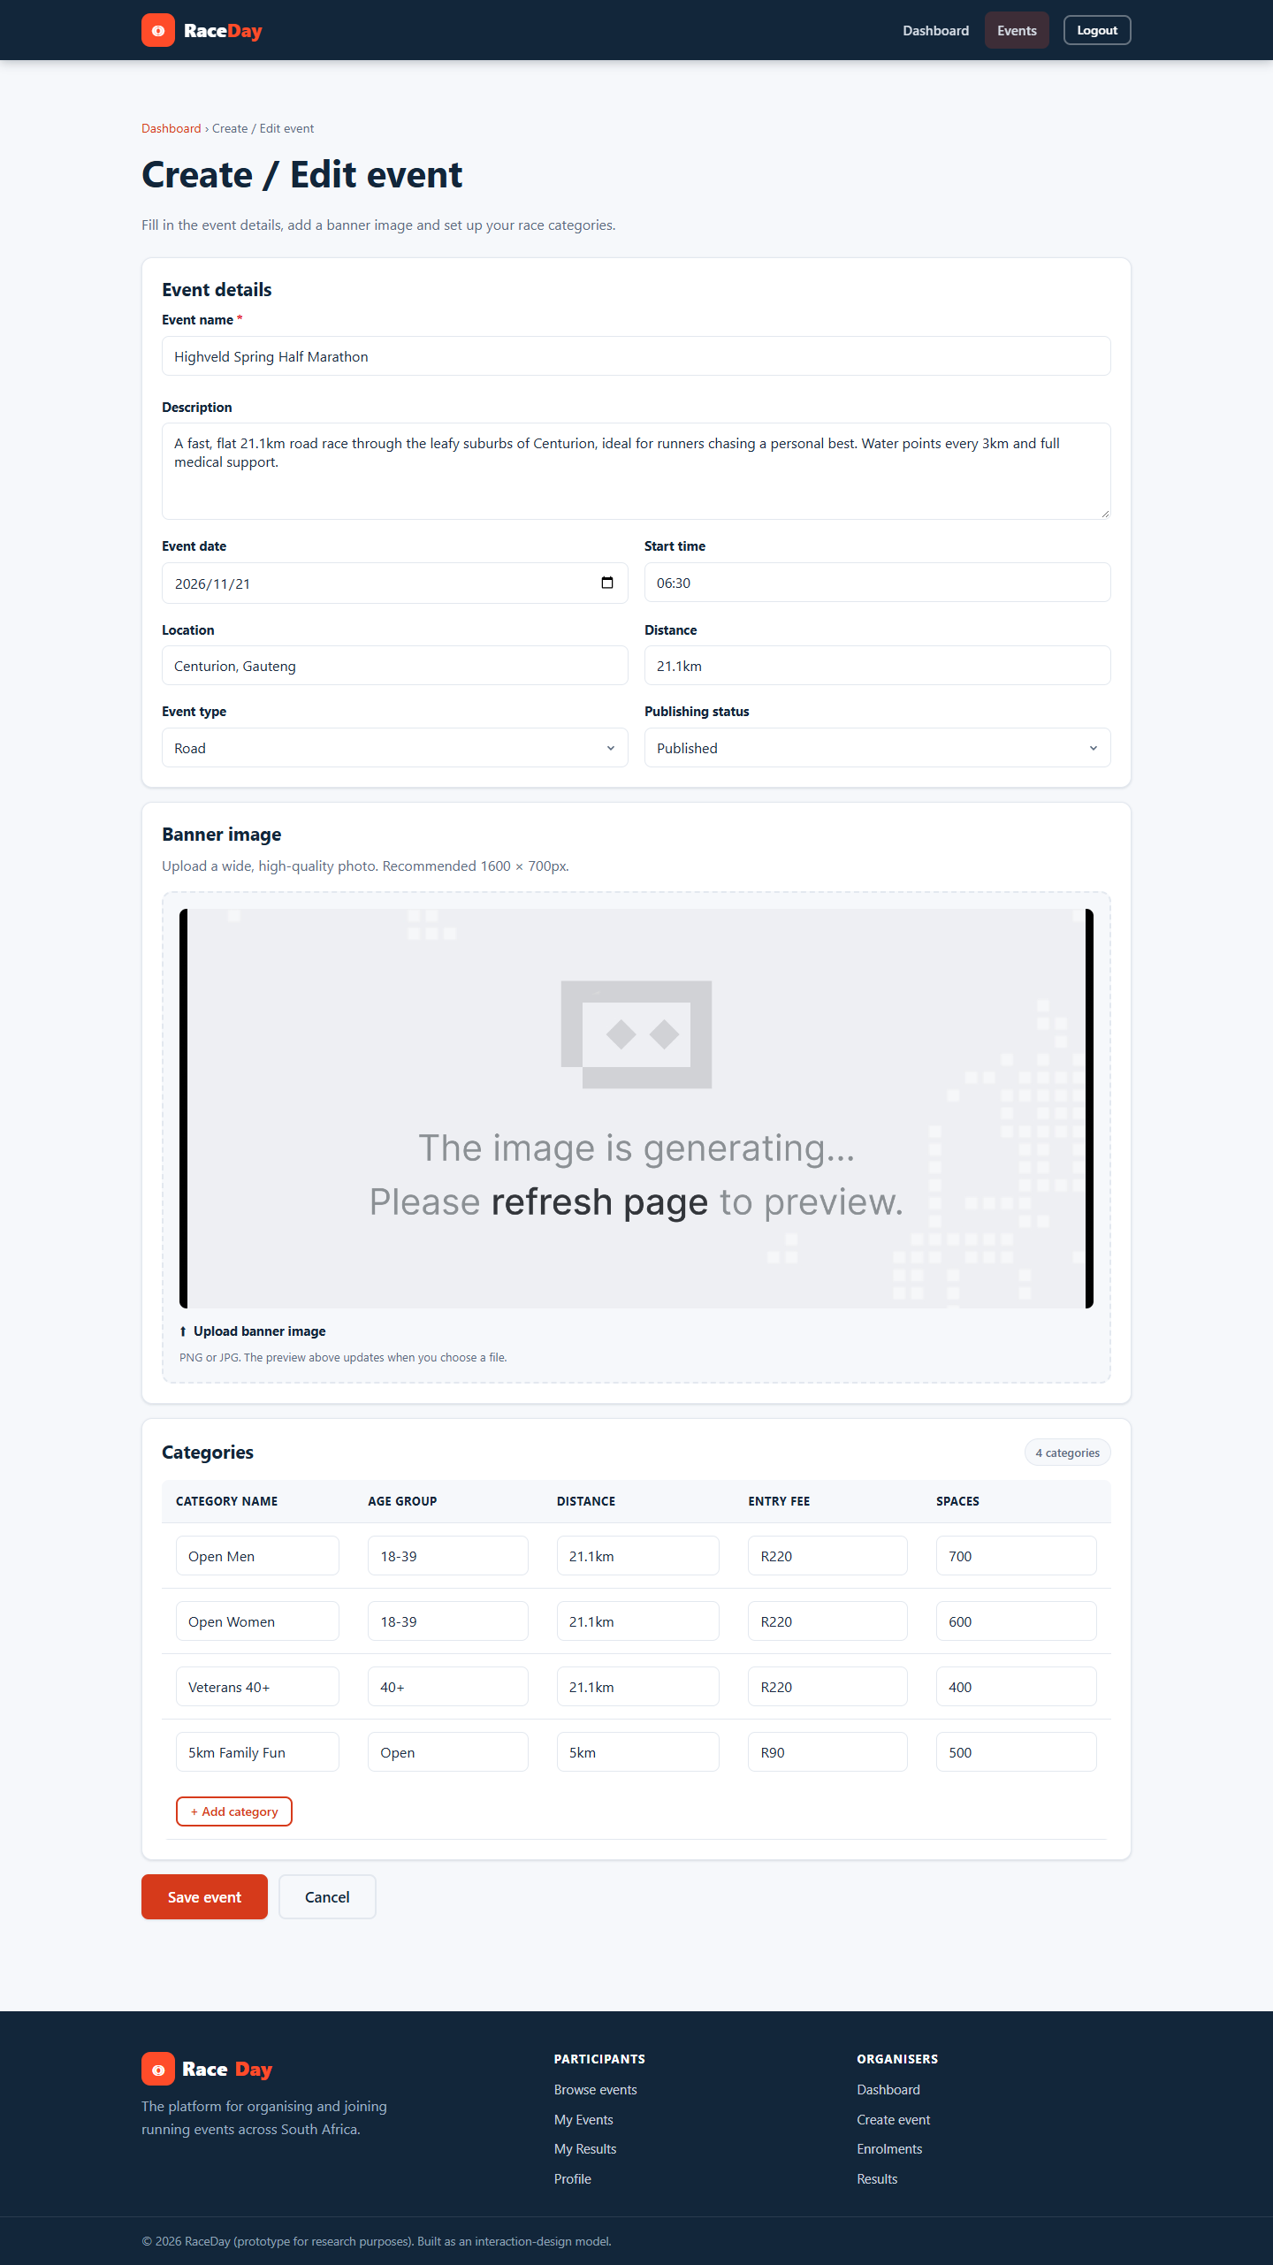
Figure 9: Event creation form. The same label, input and button components used on the registration form.
Figure 9 evidences consistency. The event form is structurally identical to the registration form in Figure 8, so a user who has registered already knows how to create an event. The banner upload control is placed among the other event attributes rather than in a separate settings area, which applies the principle of mapping by keeping the control next to the object it describes.
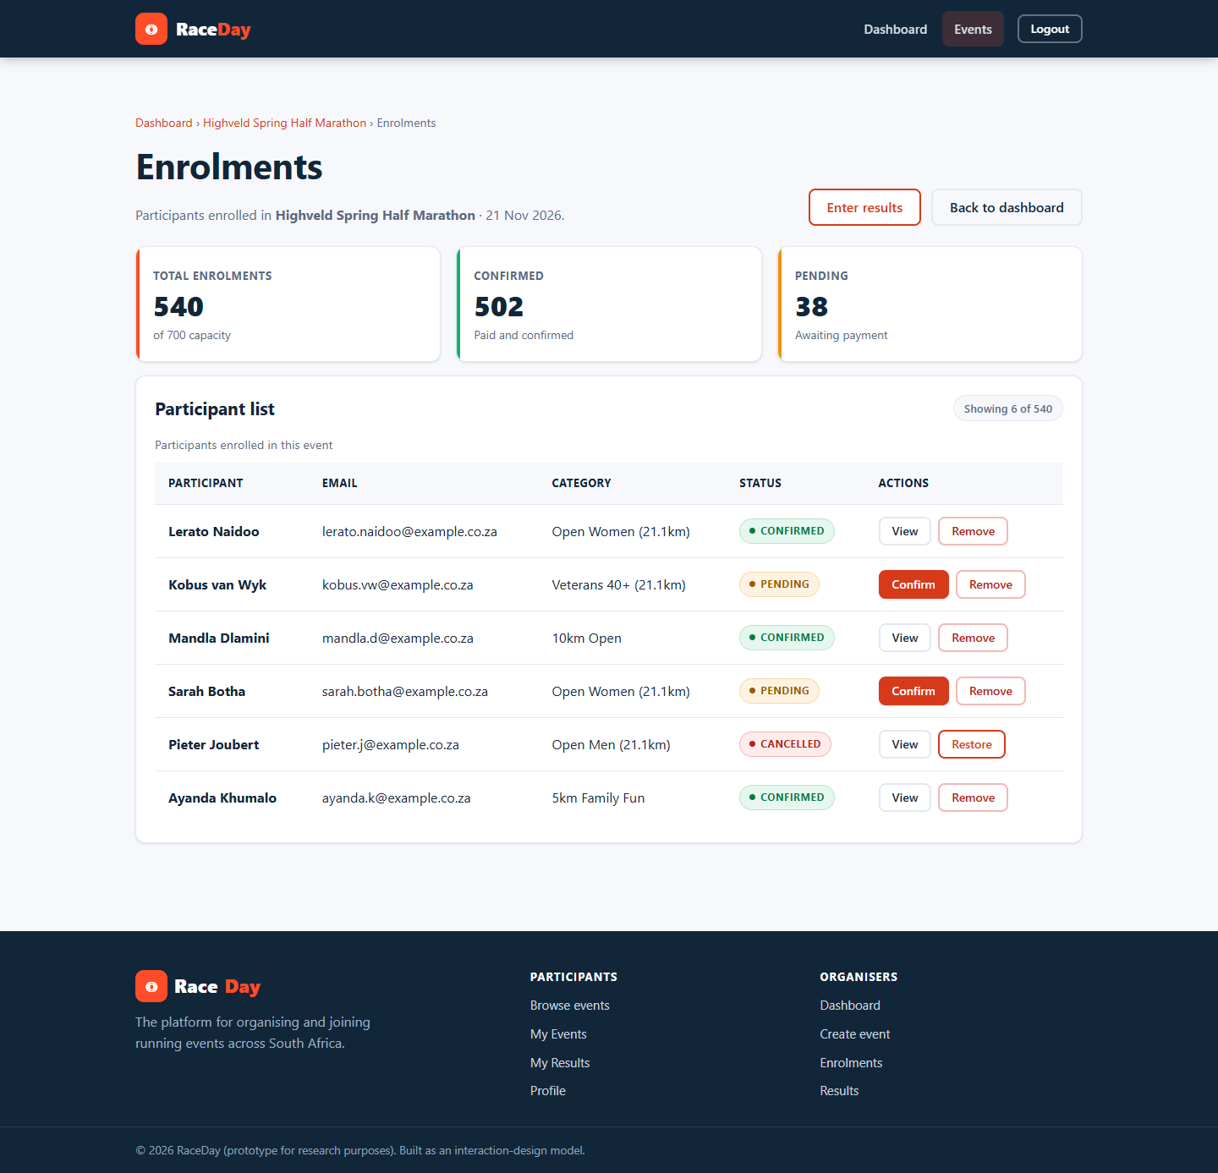
Figure 10: Enrolment list. Colour coded status pills make the state of every row visible without interrogation.
Figure 10 demonstrates visibility. Each entrants status is expressed as a coloured pill, so the state of the whole list can be apprehended at a glance instead of being read row by row. Feedback of this kind is what allows a user to monitor a system rather than to interrogate it, and it is the principle that makes the interface feel responsive even when nothing is happening.
Reference List
Cooper, A., Reimann, R., Cronin, D. and Noessel, C. (2014) About Face: The Essentials of Interaction Design. 4th ed. Indianapolis: Wiley.
ISO (1998) ISO 9241-11: Ergonomic requirements for office work with visual display terminals (VDTs) - Part 11: Guidance on usability. Geneva: International Organization for Standardization.
Jordan, P.W. (2000) Designing Pleasurable Products: An Introduction to the New Human Factors. London: Taylor and Francis.
Krug, S. (2014) Don't Make Me Think, Revisited: A Common Sense Approach to Web Usability. 3rd ed. San Francisco: New Riders.
Microsoft (2024) ASP.NET Core documentation. Available at: https://learn.microsoft.com/aspnet/core (Accessed: 9 November 2026).
Nielsen, J. (1993) Usability Engineering. San Francisco: Morgan Kaufmann.
Norman, D.A. (2013) The Design of Everyday Things. Revised and expanded ed. New York: Basic Books.
Preece, J., Sharp, H. and Rogers, Y. (2015) Interaction Design: Beyond Human-Computer Interaction. 4th ed. Chichester: Wiley.
W3C (2008) Web Content Accessibility Guidelines (WCAG) 2.0. W3C Recommendation. Available at: https://www.w3.org/TR/WCAG20/ (Accessed: 9 November 2026).
4.4 Interaction types
Preece, Sharp and Rogers (2015) distinguish four interaction types: instructing, conversing, manipulating and exploring. A well designed application employs more than one, choosing the type that matches the users intent at each moment. RaceDay makes use of all four, with each confined to the part of the task where it is most natural.
Interaction type | Where the prototype uses it
Instructing | The user issues a command and the system carries it out. RaceDay uses instructing for registration and sign-in, for creating and editing events, for capturing results and for entering an event. It is expressed through clearly labelled forms with one primary action per screen.
Conversing | The system answers the users questions. The event filter behaves as a lightweight conversation: the user asks what trail races are happening nearby by completing the filter form, and the system answers with a result set and a count of how many events matched.
Manipulating | The user directly manipulates objects rather than typing instructions. Participants choose a category by clicking a radio button, organisers replace a banner by selecting a file and seeing the preview change, and profile photographs are replaced in place.
Exploring | The user moves through the information space without a specific goal. The event grid, the event detail page and the participants race history are exploration surfaces: events can be opened and abandoned without commitment and without the interface losing the users place.

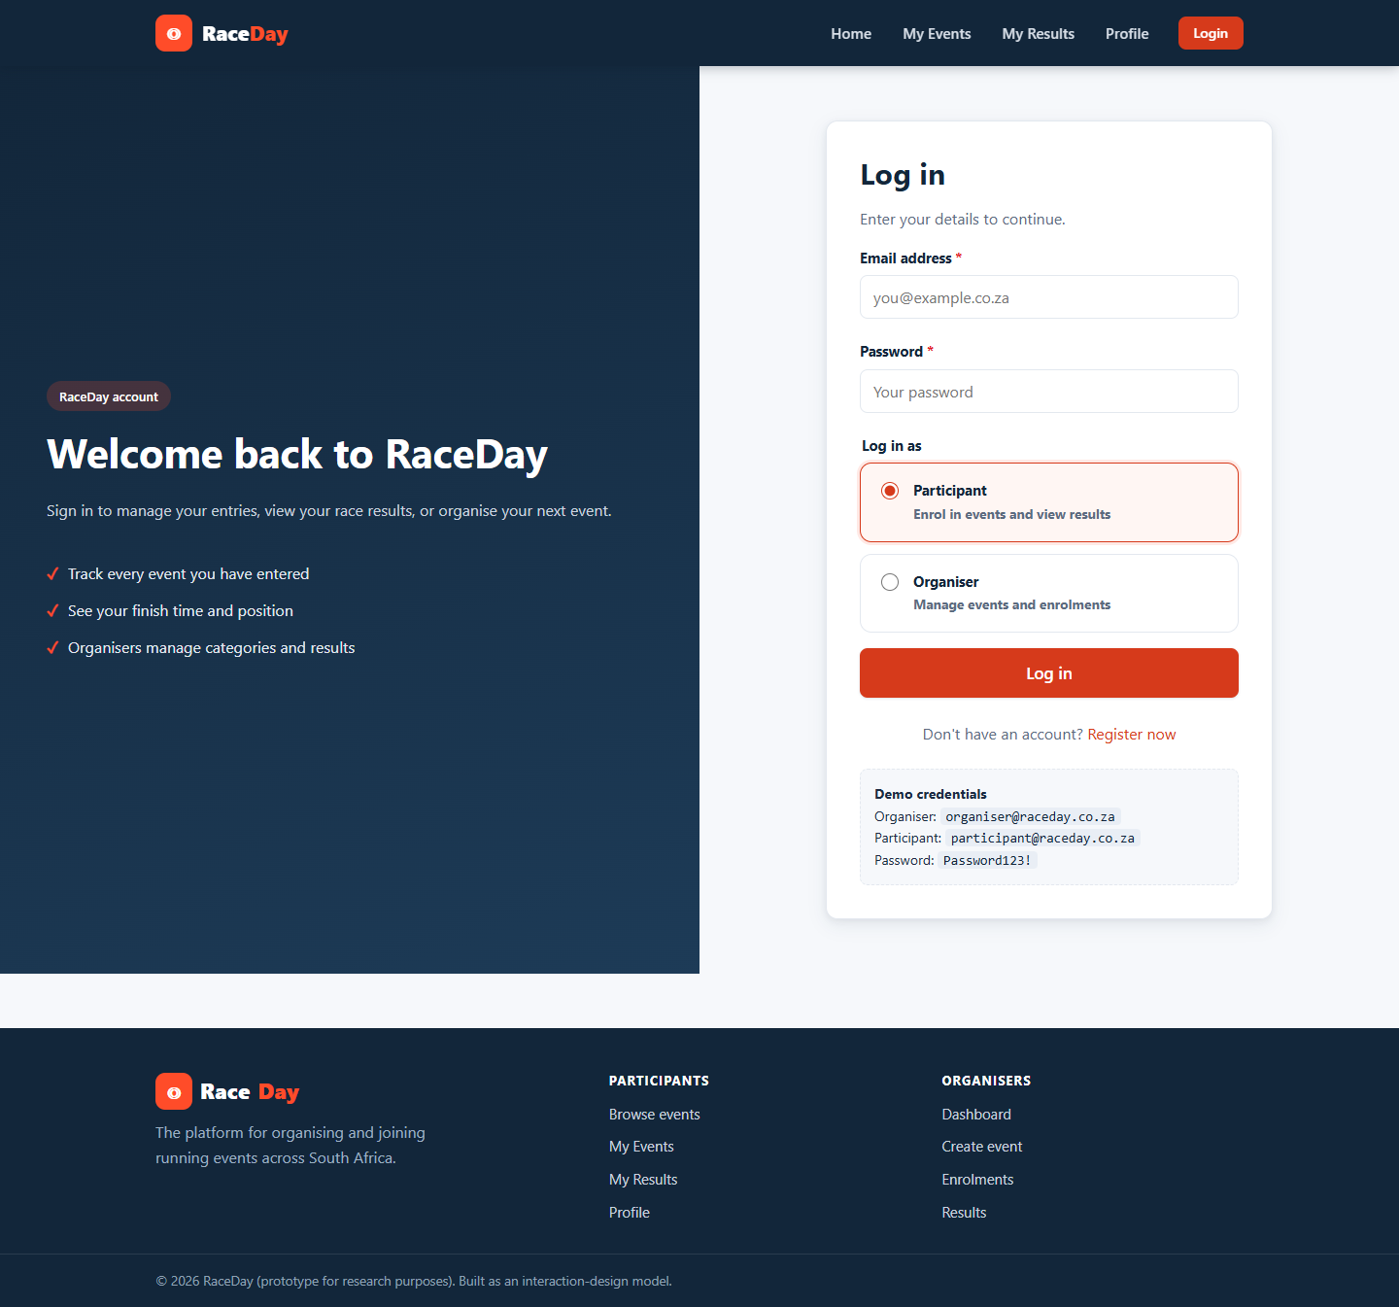
Figure 11: Login screen. A pure instructing interaction, reduced to the two values required.
Figure 11 is an instructing interaction in its purest form. The screen requests two values and one decision, and the sequence of the interaction is made obvious by the vertical arrangement of label, input and submit control. There is nothing to explore and nothing to manipulate, which is correct: the users intent at this moment is to issue a single command.
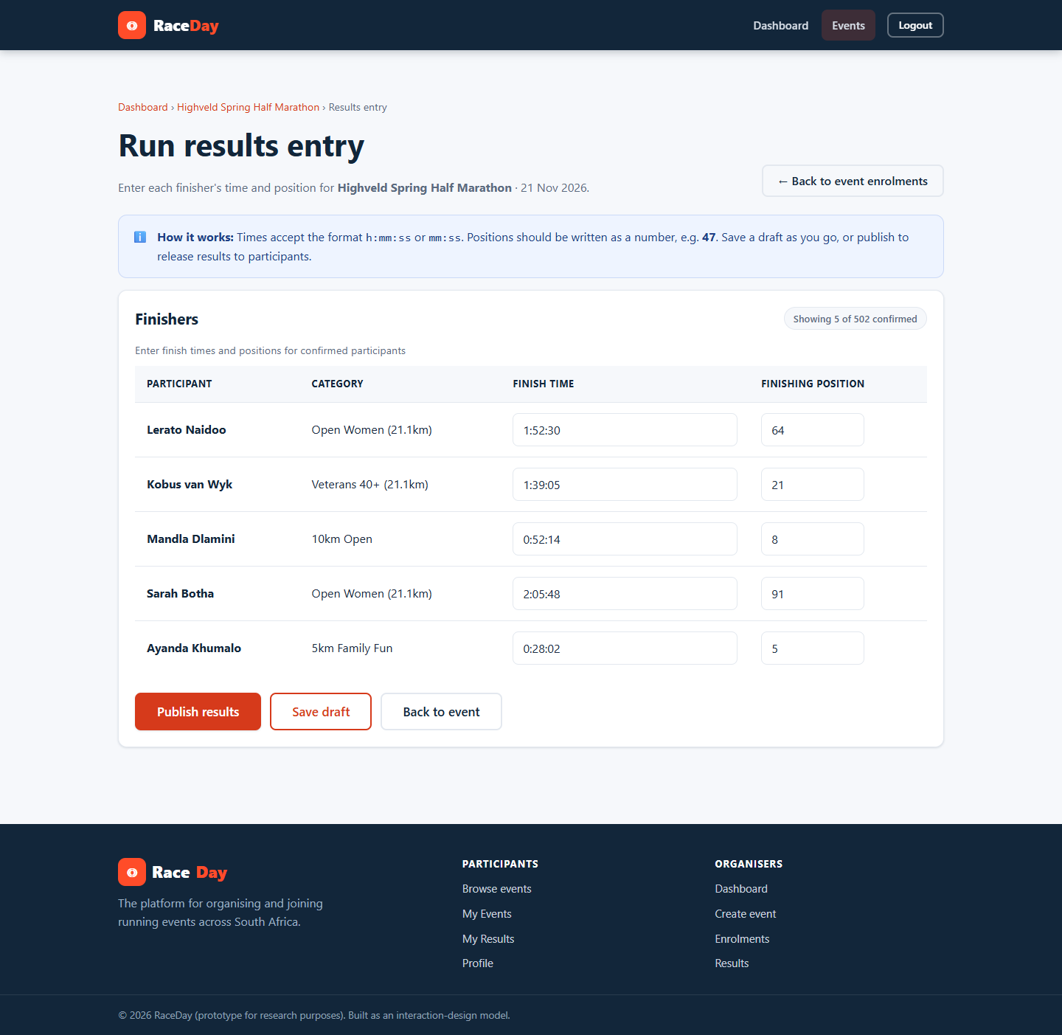
Figure 12: Results capture. Instructing and manipulating interactions are combined in a single workflow.
Figure 12 combines two interaction types. The organiser manipulates the table directly, entering finish times and positions into the rows that represent individual entrants, and then issues an instruction, Publish, to commit the data to the participants view. Separating capture from publication in this way is important: it allows the organiser to manipulate freely without any risk of a half completed result set becoming visible to participants.
Figure 13: The home page as an exploration surface. Events can be browsed, opened and abandoned without commitment.
Figure 13 is the principal exploration surface. A prospective participant who has not yet decided to enter anything can move between events freely, and the design supports that by never requiring a commitment in order to see more information. Browsing is a legitimate use of the platform in its own right, and treating it as such is what makes the eventual entry feel voluntary rather than forced.
Reference List
Cooper, A., Reimann, R., Cronin, D. and Noessel, C. (2014) About Face: The Essentials of Interaction Design. 4th ed. Indianapolis: Wiley.
ISO (1998) ISO 9241-11: Ergonomic requirements for office work with visual display terminals (VDTs) - Part 11: Guidance on usability. Geneva: International Organization for Standardization.
Jordan, P.W. (2000) Designing Pleasurable Products: An Introduction to the New Human Factors. London: Taylor and Francis.
Krug, S. (2014) Don't Make Me Think, Revisited: A Common Sense Approach to Web Usability. 3rd ed. San Francisco: New Riders.
Microsoft (2024) ASP.NET Core documentation. Available at: https://learn.microsoft.com/aspnet/core (Accessed: 9 November 2026).
Nielsen, J. (1993) Usability Engineering. San Francisco: Morgan Kaufmann.
Norman, D.A. (2013) The Design of Everyday Things. Revised and expanded ed. New York: Basic Books.
Preece, J., Sharp, H. and Rogers, Y. (2015) Interaction Design: Beyond Human-Computer Interaction. 4th ed. Chichester: Wiley.
W3C (2008) Web Content Accessibility Guidelines (WCAG) 2.0. W3C Recommendation. Available at: https://www.w3.org/TR/WCAG20/ (Accessed: 9 November 2026).
4.5 Social interactions
RaceDay is not a social network, but the domain it serves is inherently social. Competitive running is organised around clubs, training groups, families and friendship circles, and entering a race is very often a group decision rather than an individual one. The social dimension of the design is therefore built into the information the system displays rather than added as a separate feature.
The organisers enrolment view exposes the participant list for an event, which allows an entrant to see who else has entered. The total number of enrolments on the organisers dashboard and the size of the field on published results both communicate the scale of an event and create the mild social pressure that motivates people to train and to attend. Category management gives events a socially meaningful structure, because categories such as junior, senior, veteran and open are how runners position themselves relative to their peers.
The design also anticipates the social use of results. A finishing position is only meaningful in relation to other people: the phrase forty-seventh out of three hundred and twelve finishers is a social statement, and members of the same club routinely compare positions after an event. Presenting the position together with the total field therefore satisfies a real social need without requiring any social networking machinery.
Because the platform stores personal information and photographs, the social dimension is deliberately constrained. Participation is not publicly discoverable unless the participant enters an event, profile information is visible only to the account holder, and the organiser sees only the details necessary to administer an event. This is a conscious ethical decision: the design supports the social activity around running while keeping the individuals data within the boundaries the user expects (Preece, Sharp and Rogers, 2015).
Figure 14: The enrolment list converts an abstract event into a concrete group of people.
Figure 14 is the evidence for the social dimension. Seeing the list of entrants is what makes an event feel real, and the presence of other people is consistently a stronger motivator than any incentive the platform itself can offer. The category column is equally important socially, because it is how a runner positions themselves against their peers. The design stops short of exposing contact details, which keeps the social benefit without imposing a privacy cost that the participant has not agreed to.
Reference List
Cooper, A., Reimann, R., Cronin, D. and Noessel, C. (2014) About Face: The Essentials of Interaction Design. 4th ed. Indianapolis: Wiley.
ISO (1998) ISO 9241-11: Ergonomic requirements for office work with visual display terminals (VDTs) - Part 11: Guidance on usability. Geneva: International Organization for Standardization.
Jordan, P.W. (2000) Designing Pleasurable Products: An Introduction to the New Human Factors. London: Taylor and Francis.
Krug, S. (2014) Don't Make Me Think, Revisited: A Common Sense Approach to Web Usability. 3rd ed. San Francisco: New Riders.
Microsoft (2024) ASP.NET Core documentation. Available at: https://learn.microsoft.com/aspnet/core (Accessed: 9 November 2026).
Nielsen, J. (1993) Usability Engineering. San Francisco: Morgan Kaufmann.
Norman, D.A. (2013) The Design of Everyday Things. Revised and expanded ed. New York: Basic Books.
Preece, J., Sharp, H. and Rogers, Y. (2015) Interaction Design: Beyond Human-Computer Interaction. 4th ed. Chichester: Wiley.
W3C (2008) Web Content Accessibility Guidelines (WCAG) 2.0. W3C Recommendation. Available at: https://www.w3.org/TR/WCAG20/ (Accessed: 9 November 2026).
4.6 Emotional interaction
Emotion is a first class design consideration on RaceDay because entering a race is an emotionally loaded act. It involves commitment, anxiety about ability and the anticipation of a public result. Emotional design is therefore addressed at three levels of processing (Norman, 2013).
At the visceral level the interface is designed to feel energetic and confident. The high chroma orange accent against a deep navy ground, the generous white space and the large banner imagery produce an immediate impression of movement and athleticism. The consistent logo mark and typography reinforce recognition, so that a returning user feels the familiarity of a place they have been before.
At the behavioural level the interface aims to remove the anxiety that surrounds registering for an event. The user is never left wondering whether an action worked: enrolment is confirmed immediately, the entry appears on the My Events page with a colour coded status and it can be cancelled. Clear state information is the primary tool for reducing anxiety, because most negative emotion in interactive systems comes from uncertainty rather than from failure (Cooper et al., 2014).
At the reflective level the design deliberately gives the user something to feel good about. The My Results page summarises the participants history in statistic cards so that accumulated achievement is visible as a whole, and the finishing position is expressed as a place within a field rather than as a bare integer, which preserves the sense of having taken part in something shared. The profile photograph allows the participant to personalise the account and to be recognised, which supports the sense of identity that sustains continued participation.
Persuasive techniques are used, but only in the direction of the users own goals. The event date is foregrounded so that the user is aware of the commitment they have made, and the upcoming only filter keeps attention on races that can still be entered. Jordans (2000) framework of physio, psycho, socio and ideo pleasure informs the balance achieved here: the interface is comfortable to look at, satisfying to operate, supportive of the social life of a running club and expressive of values the user holds about health and personal achievement.
Figure 15: Achievement summary cards produce a reflective level emotional response to a set of otherwise impersonal numbers.
Figure 15 shows reflective level design in practice. A list of finish times is emotionally neutral; the same data accompanied by a personal best card and a total distance card becomes a record of improvement. The difference is not in the data but in the framing, which is precisely the point of designing for the reflective level.
Figure 16: Hero imagery and the orange accent establish an energetic impression within the first second of viewing.
Figure 16 provides the visceral level evidence. The energetic photographic imagery and the high contrast orange accent are not decoration; they establish immediately, and without language, that this is a platform for people who take part in sport. Because the impression is formed before any reading occurs, it sets the emotional frame for everything that follows.
Figure 17: Clear status information reduces the anxiety that accompanies an uncertain registration.
Figure 17 addresses the behavioural level. The most common source of negative emotion in a registration system is not failure but uncertainty, because the user does not know whether the entry was recorded. Showing the entry and its status immediately removes that uncertainty, and the ability to cancel it restores control to the user, which is itself an emotional safeguard.
Reference List
Cooper, A., Reimann, R., Cronin, D. and Noessel, C. (2014) About Face: The Essentials of Interaction Design. 4th ed. Indianapolis: Wiley.
ISO (1998) ISO 9241-11: Ergonomic requirements for office work with visual display terminals (VDTs) - Part 11: Guidance on usability. Geneva: International Organization for Standardization.
Jordan, P.W. (2000) Designing Pleasurable Products: An Introduction to the New Human Factors. London: Taylor and Francis.
Krug, S. (2014) Don't Make Me Think, Revisited: A Common Sense Approach to Web Usability. 3rd ed. San Francisco: New Riders.
Microsoft (2024) ASP.NET Core documentation. Available at: https://learn.microsoft.com/aspnet/core (Accessed: 9 November 2026).
Nielsen, J. (1993) Usability Engineering. San Francisco: Morgan Kaufmann.
Norman, D.A. (2013) The Design of Everyday Things. Revised and expanded ed. New York: Basic Books.
Preece, J., Sharp, H. and Rogers, Y. (2015) Interaction Design: Beyond Human-Computer Interaction. 4th ed. Chichester: Wiley.
W3C (2008) Web Content Accessibility Guidelines (WCAG) 2.0. W3C Recommendation. Available at: https://www.w3.org/TR/WCAG20/ (Accessed: 9 November 2026).
4.7 Web Content Accessibility Guidelines (WCAG) 2.0
The Web Content Accessibility Guidelines 2.0 (W3C, 2008) organise accessibility requirements into four principles, commonly remembered as POUR: Perceivable, Operable, Understandable and Robust. Each principle is expressed as testable success criteria at one of three conformance levels, with level A being the minimum and level AA the level generally accepted as the practical web standard. RaceDay targets conformance at level AA. The table below lists the success criteria relevant to this interface and describes how each is met.
SC | Success criterion | Level | How the prototype meets it
1.1.1 | Non-text Content | A | Event banner images carry alternative text derived from the event name; profile photographs carry the participants name; decorative marks are hidden from assistive technology.
1.3.1 | Info and Relationships | A | Pages use real semantic landmarks (header, nav, main, footer) and real headings in a logical order, so the structure of a page is available to assistive technology and not only to sighted users.
1.4.3 | Contrast (Minimum) | AA | Body text is navy on a light background at a ratio well above 4.5:1, and the orange used for primary buttons is paired with white text at a ratio of at least 4.5:1.
1.4.4 | Resize Text | AA | Layout is expressed in relative units and the Bootstrap grid is fluid, so text can be enlarged to 200 per cent without loss of content or functionality.
1.4.10 | Reflow | AA | Content reflows to a single column on narrow viewports and the application remains usable at a 320 pixel viewport width.
2.1.1 | Keyboard | A | Every interactive element is a native link, button, input or select and is therefore reachable and operable with the keyboard alone; no functionality depends on a pointing device.
2.4.1 | Bypass Blocks | A | A Skip to main content link is the first focusable element on every page, allowing keyboard users to bypass the repeated navigation.
2.4.4 | Link Purpose (In Context) | A | Link text describes its destination, for example Enter Event, My Results or Add category, rather than using generic text such as click here.
2.4.7 | Focus Visible | AA | A custom focus ring with a contrasting outline is applied to every focusable element so that keyboard users can always see where focus is.
3.3.1 | Error Identification | A | Validation failures are reported in text beside the field that caused them and the offending control is highlighted, so the error is identified visually and programmatically.
3.3.2 | Labels or Instructions | A | Every input has a permanently visible label element associated with it; placeholder text is used only as a supplementary hint and never as the only label.
3.3.3 | Error Suggestion | AA | Messages state what is required rather than only that something is wrong, for example Enter the event date and Distance must be greater than zero.
4.1.2 | Name, Role, Value | A | Native HTML elements provide their own roles and values; where custom behaviour is required, ARIA attributes such as aria-label on the navigation and the filter form supply the missing names.

Figure 18: Registration form. Every control has a permanently visible, associated label and errors are described in text.
Figure 18 evidences success criteria 3.3.1, 3.3.2 and 2.4.4. Each input is paired with a label element rather than relying on placeholder text, which means the label survives after the user begins typing; errors are described beside the field that caused them; and links are worded so that their purpose is evident from the link text in isolation.
Figure 19: Event detail page. The banner carries alternative text and the primary action is a native, keyboard operable button.
Figure 19 evidences success criteria 1.1.1 and 2.1.1. The event banner is supplied with alternative text derived from the event name so that a screen reader user receives the same information as a sighted user, and the Enter Event control is a native button element, which means it is reachable by tabbing and activatable with the keyboard without any scripted assistance.
Figure 20: Home page. Semantic landmarks, a skip link as the first focusable element and a contrast ratio well above the level AA minimum.
Figure 20 evidences the remaining criteria. The page is built from semantic landmarks so that assistive technology can present the structure of the page; a skip link is placed as the first focusable element so that keyboard users can bypass the repeated navigation; and the navy text on the light background and the white text on the orange buttons both exceed the 4.5 to 1 contrast ratio required by success criterion 1.4.3.
Reference List
Cooper, A., Reimann, R., Cronin, D. and Noessel, C. (2014) About Face: The Essentials of Interaction Design. 4th ed. Indianapolis: Wiley.
ISO (1998) ISO 9241-11: Ergonomic requirements for office work with visual display terminals (VDTs) - Part 11: Guidance on usability. Geneva: International Organization for Standardization.
Jordan, P.W. (2000) Designing Pleasurable Products: An Introduction to the New Human Factors. London: Taylor and Francis.
Krug, S. (2014) Don't Make Me Think, Revisited: A Common Sense Approach to Web Usability. 3rd ed. San Francisco: New Riders.
Microsoft (2024) ASP.NET Core documentation. Available at: https://learn.microsoft.com/aspnet/core (Accessed: 9 November 2026).
Nielsen, J. (1993) Usability Engineering. San Francisco: Morgan Kaufmann.
Norman, D.A. (2013) The Design of Everyday Things. Revised and expanded ed. New York: Basic Books.
Preece, J., Sharp, H. and Rogers, Y. (2015) Interaction Design: Beyond Human-Computer Interaction. 4th ed. Chichester: Wiley.
W3C (2008) Web Content Accessibility Guidelines (WCAG) 2.0. W3C Recommendation. Available at: https://www.w3.org/TR/WCAG20/ (Accessed: 9 November 2026).
5. Conclusion
Part 2 has responded to the feedback received on Part 1 and has demonstrated, rather than asserted, how the seven required design areas are implemented. Twelve prototype pages covering both the participant and the organiser experience were built with hand written HTML, CSS and JavaScript, and every design claim in this report is supported by a screenshot of the interface that implements it.
The exercise also produced a useful finding about the relationship between the design documentation and the artefact. Several claims made confidently in Part 1 required adjustment once the interface existed. The most significant was the discovery that the enrolment status needed to be visible in the event list as well as on the participants own page, because a list of entries without their statuses is not actually informative. Findings of this kind are the main argument for prototyping, and they are carried forward into the final version of the project.
The prototype now provides the design foundation for the third part of this portfolio, in which the same interaction model is implemented as a working web application with an API, persistent storage, role based authentication, cloud file storage and a containerised deployment.
Reference List
Cooper, A., Reimann, R., Cronin, D. and Noessel, C. (2014) About Face: The Essentials of Interaction Design. 4th ed. Indianapolis: Wiley.
ISO (1998) ISO 9241-11: Ergonomic requirements for office work with visual display terminals (VDTs) - Part 11: Guidance on usability. Geneva: International Organization for Standardization.
Jordan, P.W. (2000) Designing Pleasurable Products: An Introduction to the New Human Factors. London: Taylor and Francis.
Krug, S. (2014) Don't Make Me Think, Revisited: A Common Sense Approach to Web Usability. 3rd ed. San Francisco: New Riders.
Microsoft (2024) ASP.NET Core documentation. Available at: https://learn.microsoft.com/aspnet/core (Accessed: 9 November 2026).
Nielsen, J. (1993) Usability Engineering. San Francisco: Morgan Kaufmann.
Norman, D.A. (2013) The Design of Everyday Things. Revised and expanded ed. New York: Basic Books.
Preece, J., Sharp, H. and Rogers, Y. (2015) Interaction Design: Beyond Human-Computer Interaction. 4th ed. Chichester: Wiley.
W3C (2008) Web Content Accessibility Guidelines (WCAG) 2.0. W3C Recommendation. Available at: https://www.w3.org/TR/WCAG20/ (Accessed: 9 November 2026).

