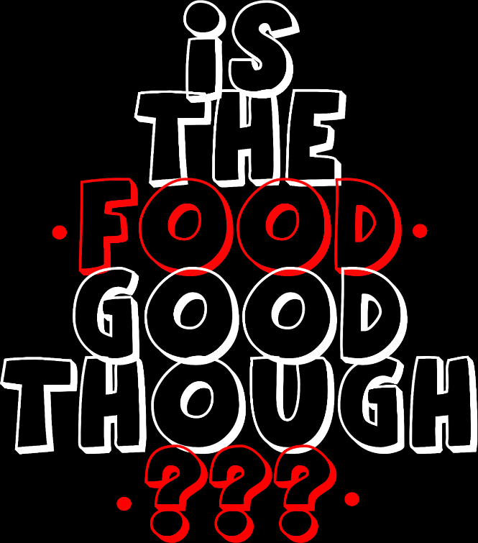
SPONSORSHIP PROPOSAL
PREPARED FOR WILD MEDIA AGENCY
Asado Dining Experience & Food Carnival
August 28 – 29, 2026 | Off-Road Extreme, Matebeleng
Prepared for: Wild Media Agency
Prepared by: Genirol & Is The Food Good Though
Date: August 28 & 29, 2026
IS THE FOOD GOOD THOUGH: OFFICIAL SPONSORSHIP PROPOSAL

EVENT BACKGROUND
Is The Food Good Though originated from a video in which Patrick Kabamba, popularly known as Genirol, challenged the declining standards of food quality, customer service, and consistency within Botswana's food industry. Rather than simply criticizing businesses, the video called on food vendors and restaurants to return to the fundamentals of quality ingredients, exceptional service, and memorable dining experiences.
The message resonated with thousands of viewers, and the phrase "Is The Food Good Though?" quickly became a community slogan, frequently used by followers when discussing restaurants and food experiences across social media.
As Genirol's online community grew, two clear requests emerged from his followers: to experience his cooking firsthand and to bring together the restaurants, food vendors, and culinary entrepreneurs he had featured into one food festival.
These requests inspired the creation of Is The Food Good Though, a two-day culinary experience that combines an intimate dining event with a vibrant food carnival. The event celebrates Botswana's diverse food culture, showcases local culinary talent, creates opportunities for businesses to connect with new audiences, and promotes higher standards of food quality and customer experience.
More than a food festival, Is The Food Good Though is a community-driven movement that celebrates great food, supports local businesses, and encourages excellence within Botswana's culinary industry.
EVENT INTRODUCTION
Is The Food Good Though is a two-day food event welcoming attendees into two distinct experiences. Day 1 invites guests into an intimate, communal Asado Dining Experience, while Day 2 opens up into a high-energy, all-ages Food Carnival. Together, the two days set the tone for an event that is as much about culture and connection as it is about great food.
Day 1, Asado Dining Experience with Genirol
A traditional South American-style barbecue experience centered on slow-cooked, fire-grilled meat and communal dining. The event follows the classic asado format: starters like chorizo, morcilla, and grilled provoleta, followed by main cuts of beef (short ribs, sirloin, ribeye), with pork, chicken, or lamb also featured. Sides include fresh salads, grilled vegetables, and chimichurri, paired with wine and other drinks, all served in a relaxed, communal, long-table dining setting. Approximately 500 guests are expected.

Day 2, Genirol & Friends Food Carnival
A lively, festival-style celebration of food featuring multiple vendors, live cooking demonstrations, a cooking competition, and entertainment such as live music and family activities. The carnival format creates an interactive, all-ages atmosphere with diverse food offerings, tastings, and hands-on experiences. Day 2 is expected to draw approximately 2,500 attendees.

MAIN ATTRACTION PROFILE
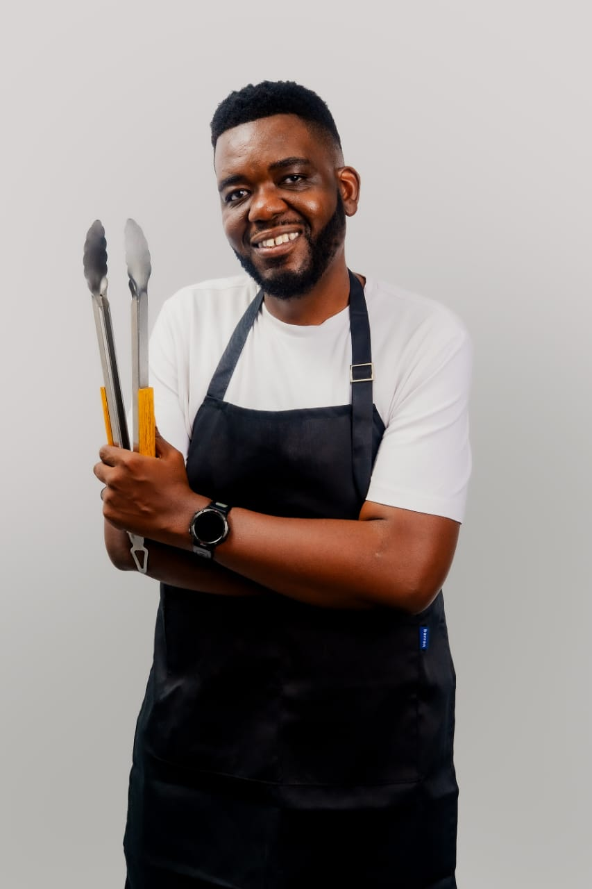 | Patrick Kabamba, "Genirol"  Genirol is a food content creator with a growing following across Instagram, TikTok, and Facebook, known for discovering and showcasing the best culinary experiences. Through authentic reviews of restaurants, food vendors, cafés, and food festivals, alongside engaging cooking vlogs, he connects audiences with great food while helping food businesses increase their visibility and reach. His content is informative, entertaining, and designed to inspire food lovers to explore new dining experiences.

PARTNERSHIP PROPOSAL
Exclusive Corporate Brand Facilitation Partner
Is The Food Good Though Food Festival 2026
THE OPPORTUNITY
Is The Food Good Though invites Wild Media Agency to partner as the Exclusive Corporate Brand Facilitation Partner for the 2026 festival.
This partnership positions Wild Media Agency as the official agency responsible for bringing leading corporate brands into Botswana's premier culinary experience while creating engaging brand activations that enhance the visitor experience.
As the exclusive corporate brand facilitator, Wild Media Agency will play a strategic role in connecting brands with consumers through creative experiences, product engagement, and meaningful collaborations with food vendors.
SCOPE OF PARTNERSHIP
As the Exclusive Corporate Brand Facilitation Partner, Wild Media Agency will:
- Secure and onboard up to 20 non-competing corporate brands to participate in the festival.
- Ensure that invited brands do not conflict with existing event partners. Current confirmed and strategic partners include Parmalat, Tuka, Commercial Motors Botswana (BMC), and Yarona FM, together with any additional exclusive category sponsors secured by the event.
- Conceptualise, coordinate and manage corporate brand activations during the Day 2 Food Carnival.
- Develop interactive competitions, games and audience engagement activities for participating brands.
- Work closely with the event team to create memorable consumer experiences that increase brand visibility and engagement.
- Facilitate collaborations between food vendors and corporate brands. For example, a ketchup manufacturer partnering with a fatcake vendor to create branded menu items or tasting experiences.
- Coordinate communication and engagement between participating brands and the event organisers before and during the festival.
EVENT SUPPORT
To enable successful execution, Is The Food Good Though? will:
- Allocate a dedicated activation zone for Wild Media Agency.
- Reserve exhibition space for all brands secured by the agency.
- Integrate Wild Media Agency into the official event programme as the Exclusive Corporate Brand Facilitation Partner.
- Work collaboratively with the agency to ensure seamless planning and execution of all corporate activations.
PARTNERSHIP BENEFITS
As the Exclusive Corporate Brand Facilitation Partner, Wild Media Agency will receive:
- Exclusive partner status for the festival.
- Official recognition across event communications and marketing material.
- Brand visibility across all Is The Food Good Though? social media platforms and promotional campaigns.
- A dedicated promotional content shoot showcasing Wild Media Agency's involvement in the event.
- Five complimentary tickets to the exclusive Day 1 Asado Dining Experience.
- The opportunity to manage corporate relationships and facilitate payments from participating brands in accordance with agreed partnership terms.
- The freedom to charge participating brands professional management, activation and coordination fees for services rendered.
- Priority consideration for future editions of the festival.
A PARTNERSHIP THAT CREATES VALUE
This collaboration combines Wild Media Agency's expertise in brand management with the reach and influence of Is The Food Good Though? to deliver meaningful brand experiences, strengthen corporate participation, and create new commercial opportunities for brands, vendors and the festival alike.
Together, we can transform the Food Carnival into Botswana's leading platform where brands, food businesses and consumers connect through unforgettable experiences.

