Specification Details:

Project Name: ProjeckTracker

Project Details

1. Project No
2. Project Name
3. Project Client
4. Project Manager( is the who managed that project)
5. Developer(is who developed that project)
6. Designer(is who designed the project prototype)
7. Type(Type of the project)
8. Status(Analysis, Development, Testing, Deplyment, Test, QAL, ive, Decomissioned)
9. BackUp_Plan (is the back for the project done)
10. Value(How much is the project value)

Funtionality

User can Login/Logout/Register

Register:

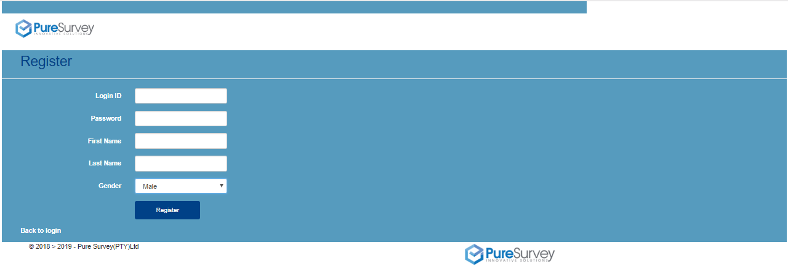

Login page: 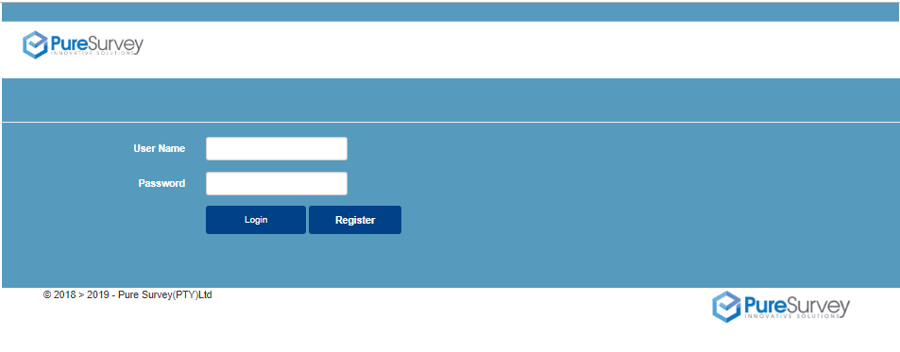

After login/Registering the user is taken to its projects that he/she has rights of access into: Taken to this page:

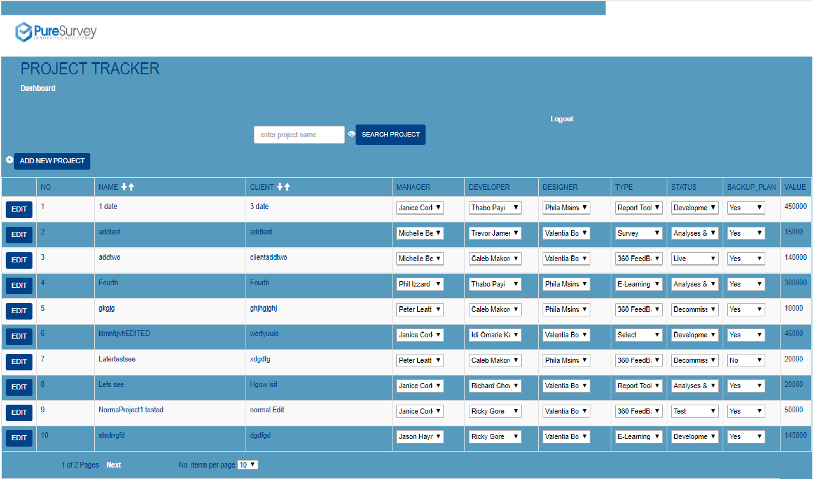

On this main Page:

1. You can add new project

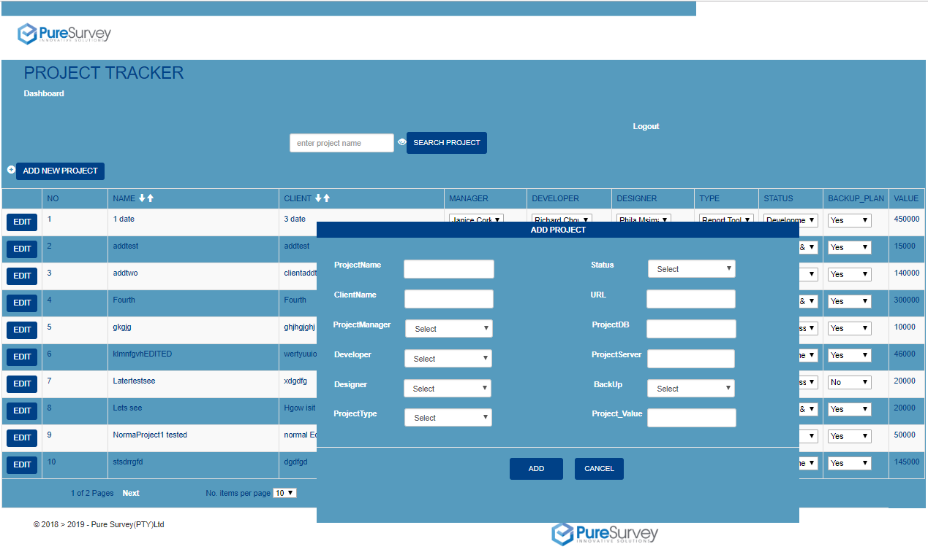

1. Edit project

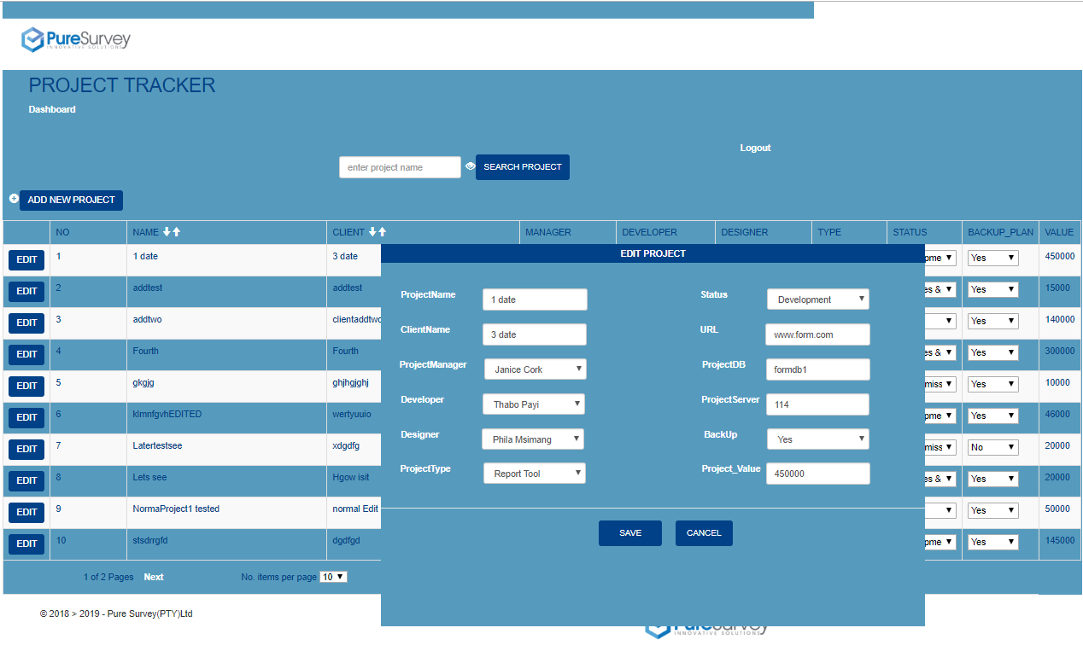

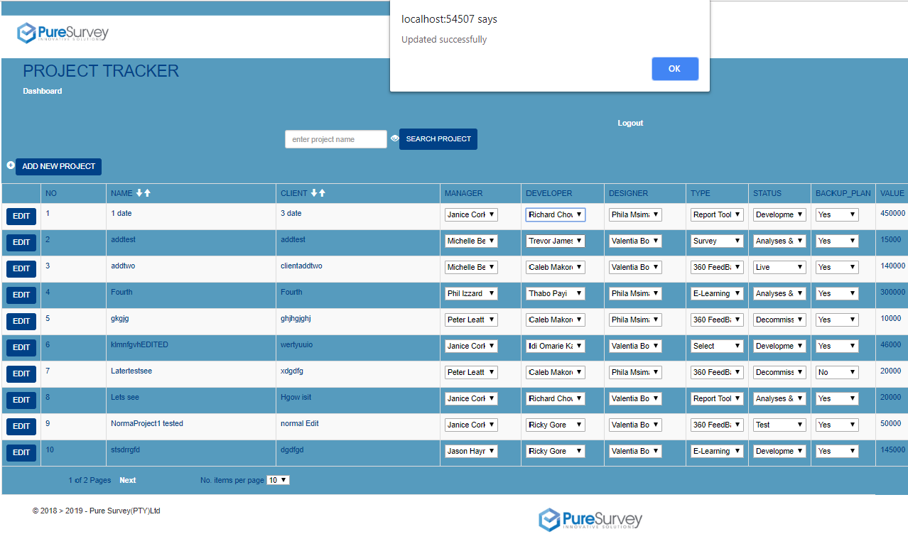

1. Search project

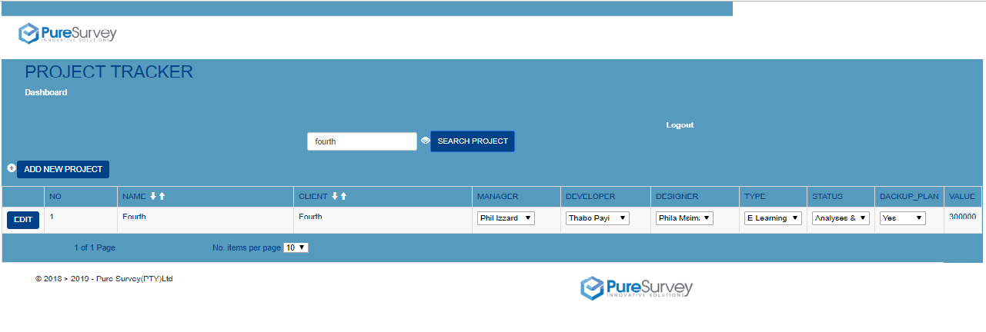

1. Can Change project status/type/designer/manager/developer/

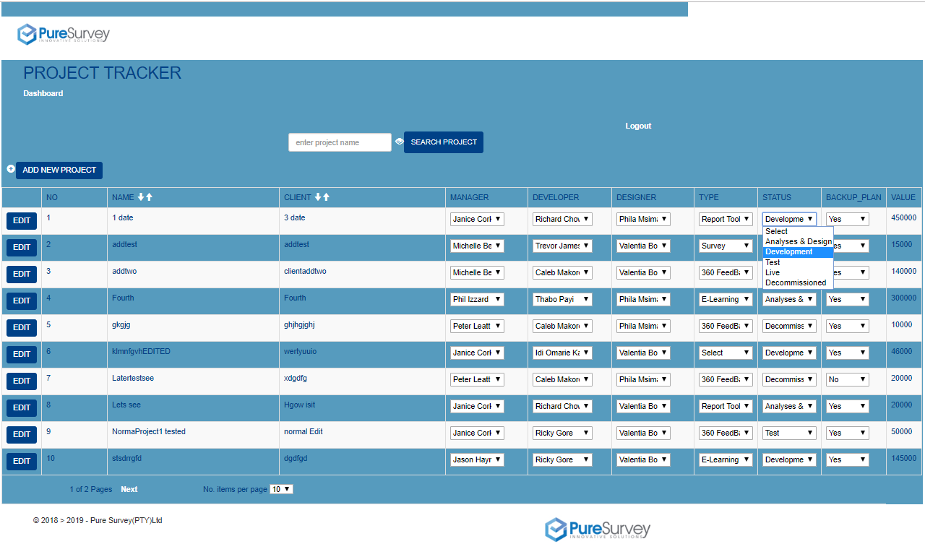

1. Can set the no of projects per page:

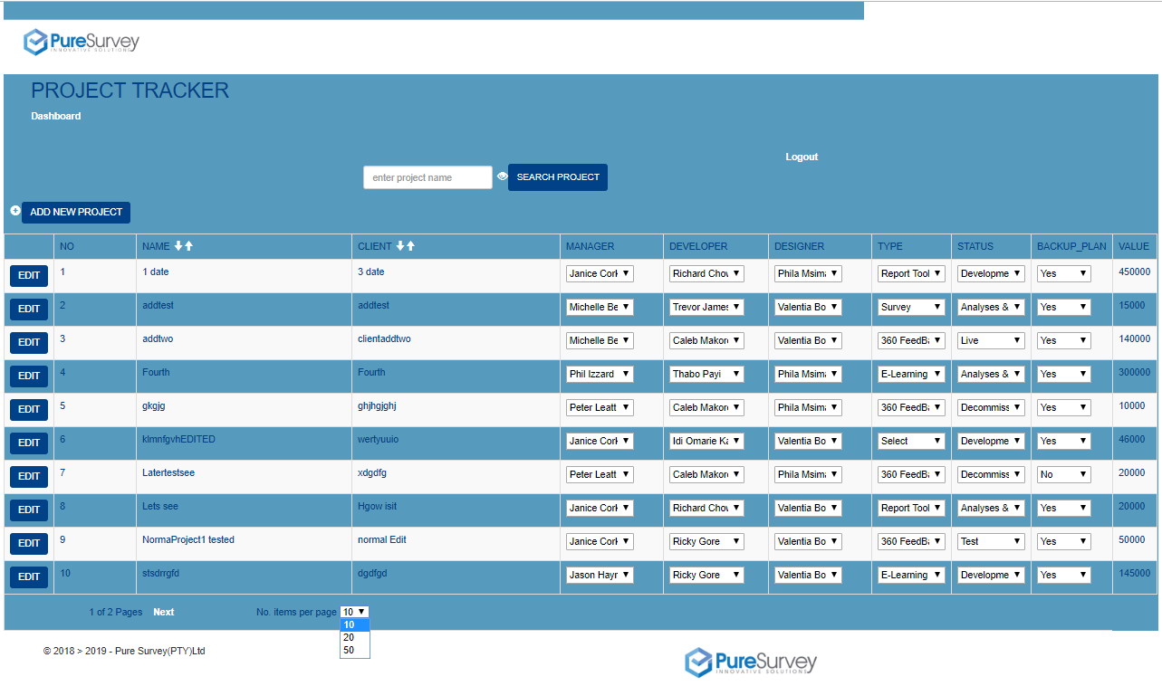

1. User can do paging:

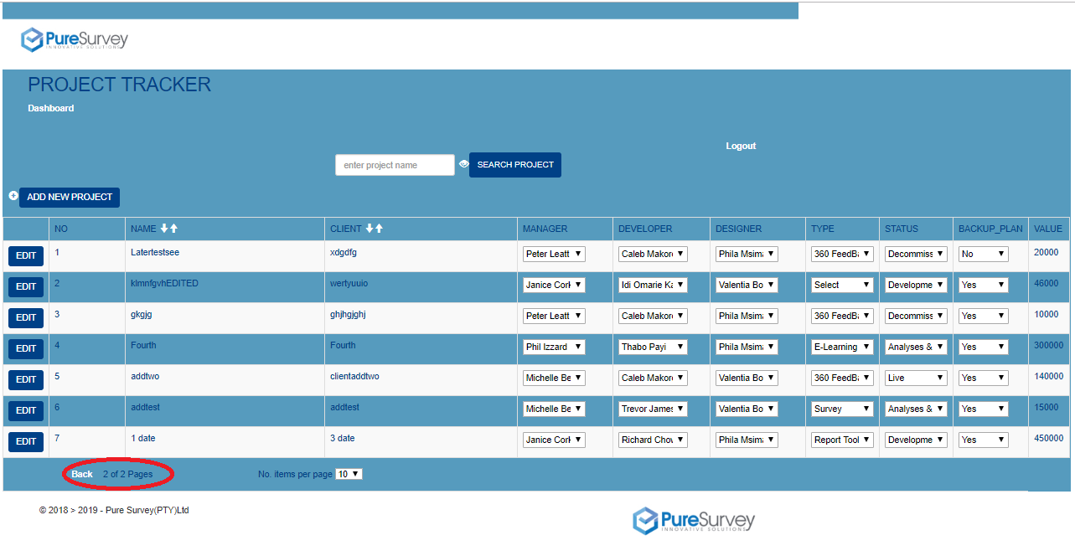

1. Can sort the project based on the field of choice, and in that filed order(ascending or descending) of choice

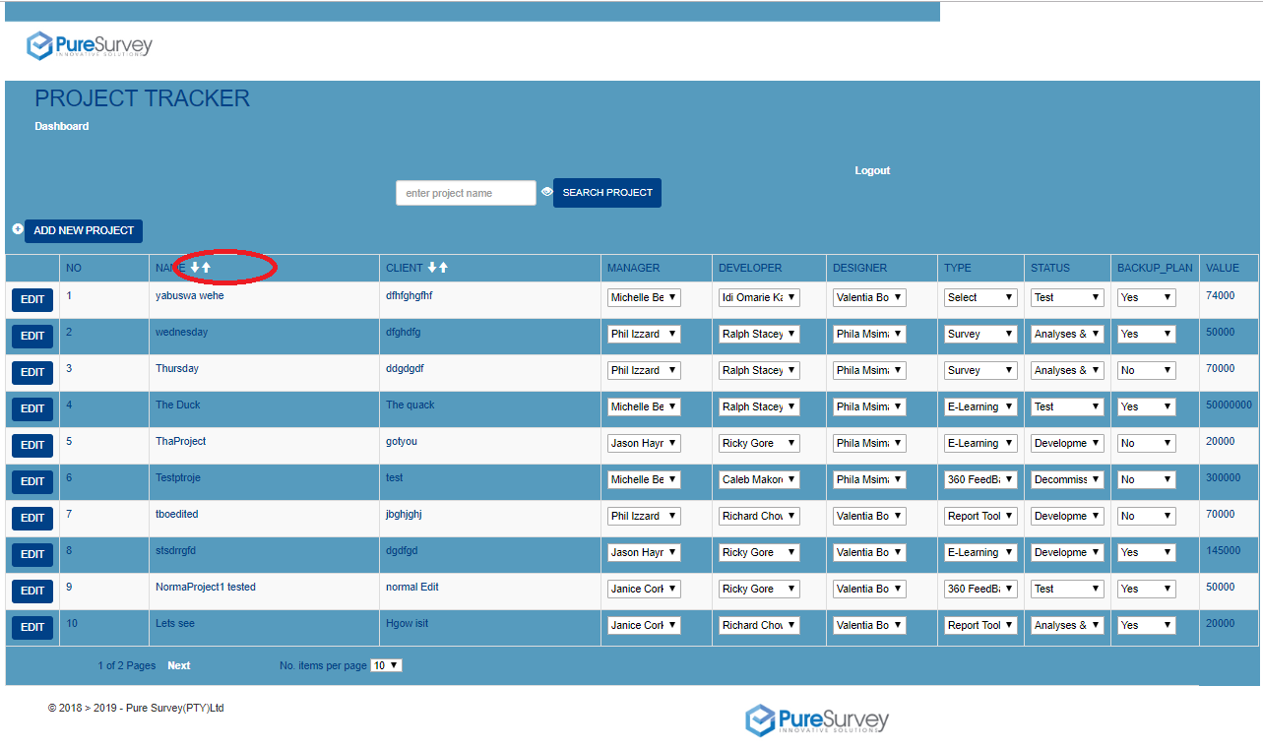

1. When user clicks logout he/she is taken back to login page



//--------------------------------------------------------------------------------------------------------------------------------//