Pre-Coding Study Notes
What This Project Really Tests:
- Context Window Economics - You need to understand that LLMs have limited context windows, and every token counts. This is about making smart trade-offs and always think of caching data(output).
- Prioritization Logic - When I exceed a budget, what gets cut? Recent info? Less relevant retrieval? This will show my decision-making.
- RAG Architecture - Not just "throw everything at the LLM" but deliberately structured retrieval and context assembly for better querying and output retrieval .
- System Design - Clean separation of concerns, extensibility, error handling(very import expect whenever I code).
Context Window Structure (Budget: ~3,215 tokens total)
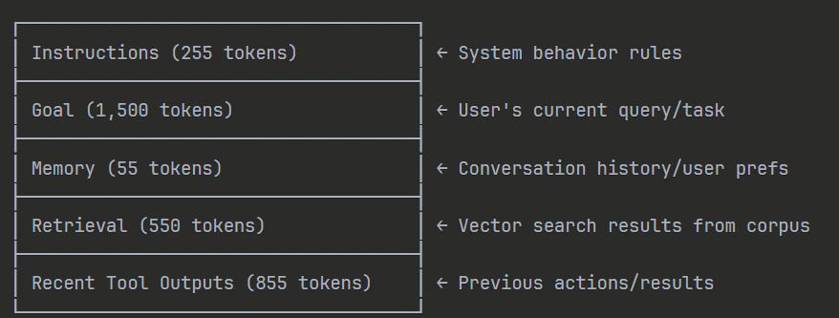
Memory vs Retrieval - Critical Distinction:
- Memory: Short-term conversation state, user preferences, session context
- Retrieval: Long-term knowledge from your corpus via vector search
Budget Overflow Strategies:
- Instructions: NEVER truncate (core system behaviour)
- Goal: Truncate from middle (keep start/end context)
- Memory: Keep most recent (FIFO queue)
- Retrieval: Rank by relevance score, take top chunks
- Tool Outputs: Keep most recent successful outputs

context-aware-rag/

├── src/
│ ├── __init__.py
│ │
│ ├── core/ # Core business logic
│ │ ├── __init__.py
│ │ ├── context_assembler.py # Main context assembly logic
│ │ ├── budget_manager.py # Token counting & budget enforcement
│ │ └── prioritizer.py # Truncation & prioritization strategies
│ │
│ ├── retrieval/ # RAG components
│ │ ├── __init__.py
│ │ ├── vector_store.py # Vector DB operations
│ │ ├── embeddings.py # Embedding generation
│ │ └── retriever.py # Search & ranking logic
│ │
│ ├── memory/ # Memory management
│ │ ├── __init__.py
│ │ ├── conversation_memory.py # Short-term memory
│ │ └── user_preferences.py # User context
│ │
│ ├── tools/ # Tool outputs simulation
│ │ ├── __init__.py
│ │ └── tool_manager.py # Mock tool execution & storage
│ │
│ ├── llm/ # LLM integration
│ │ ├── __init__.py
│ │ └── client.py # LLM API wrapper
│ │
│ └── utils/ # Utilities
│ ├── __init__.py
│ ├── token_counter.py # tiktoken wrapper
│ └── logger.py # Structured logging
│
├── cli/ # CLI interface
│ ├── __init__.py
│ └── main.py # CLI entry point
│
├── data/ # Data storage
│ ├── corpus/ # Document corpus
│ │ ├── doc1.txt
│ │ ├── doc2.txt
│ │ └── doc3.txt
│ ├── vectorstore/ # ChromaDB storage
│ └── memory/ # Persistent memory files
│
├── tests/ # Unit tests
│ ├── __init__.py
│ ├── test_context_assembler.py
│ ├── test_budget_manager.py
│ └── test_retrieval.py
│
├── diagrams/ # Architecture diagrams
│ ├── context_assembly_flow.png
│ └── budget_overflow_handling.png
│
└── examples/ # Example runs & screenshots
├── example_run_1.txt
├── example_run_2_overflow.txt
└── screenshots/

Design Principles We'll Follow:
- Single Responsibility Principle (SRP): Each module has ONE job
- Dependency Injection: Components receive dependencies, not hardcoded
- Interface Segregation: Small, focused interfaces
- Composition over Inheritance: Build complex behaviour from simple parts
- Fail-Safe Defaults: System degrades gracefully when budgets exceeded
Configuration:
- Vector DB: ChromaDB
- Interface: CLI—I will attempt to have a better UI when the system is working in an Ideal manner
- LLM: OpenAI GPT –I’m still checking so I might change this one
- API: OpenAI only—currently

Model tha us used for embedding-- Google gemini model
models/text-embedding-004
- Google Gemini embedding model
- Produces 768-dimensional vectors
- Optimized for semantic search, RAG, clustering, similarity
- Correctly matches your get_embedding_dimension() method

