Họ và tên: Thạch Trần Tín Kì thi kết thúc học phần

MSSV:19H1040051 HP: Kỹ thuật phần mềm và ứng dụng

Lớp: DV19CLC MHP: 0104032238

Question 1

Code

def is_prime(n):

    if n < 2: return False

    for x in range(2, int(n ** 0.5) + 1):

        if not n % x: return False

    return True

arr = [int(x) for x in input().split()]

print(sum(1 for x in arr if is_prime(x)) >= 2)

arr = [2,3]

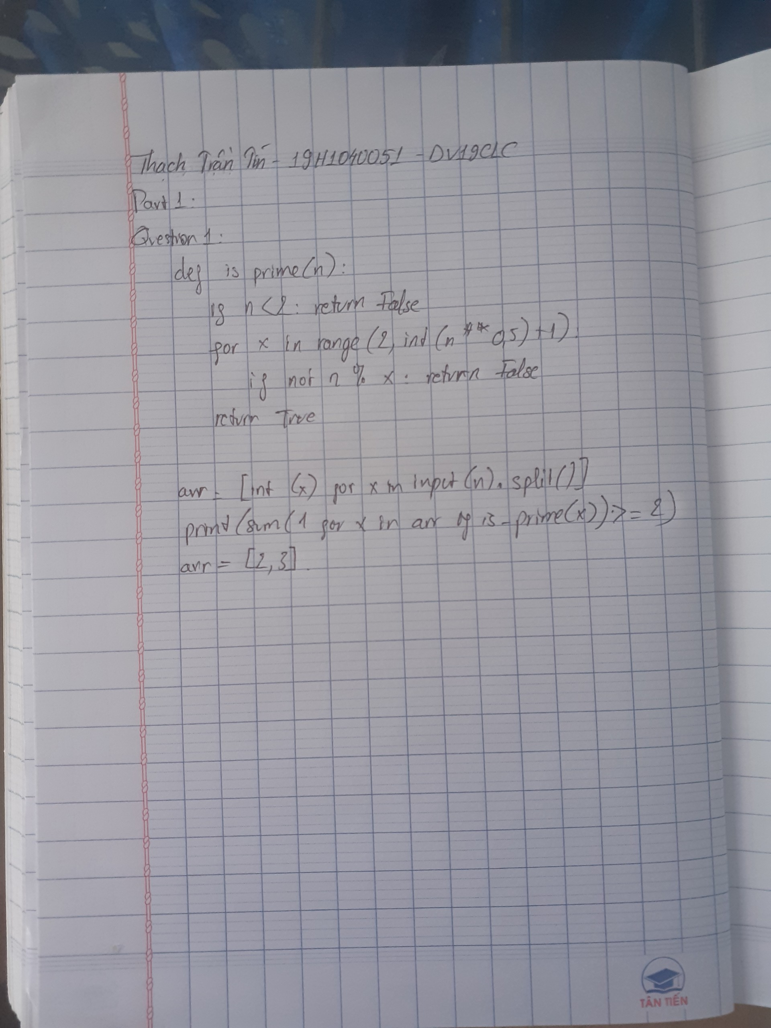

b) An array has no prime

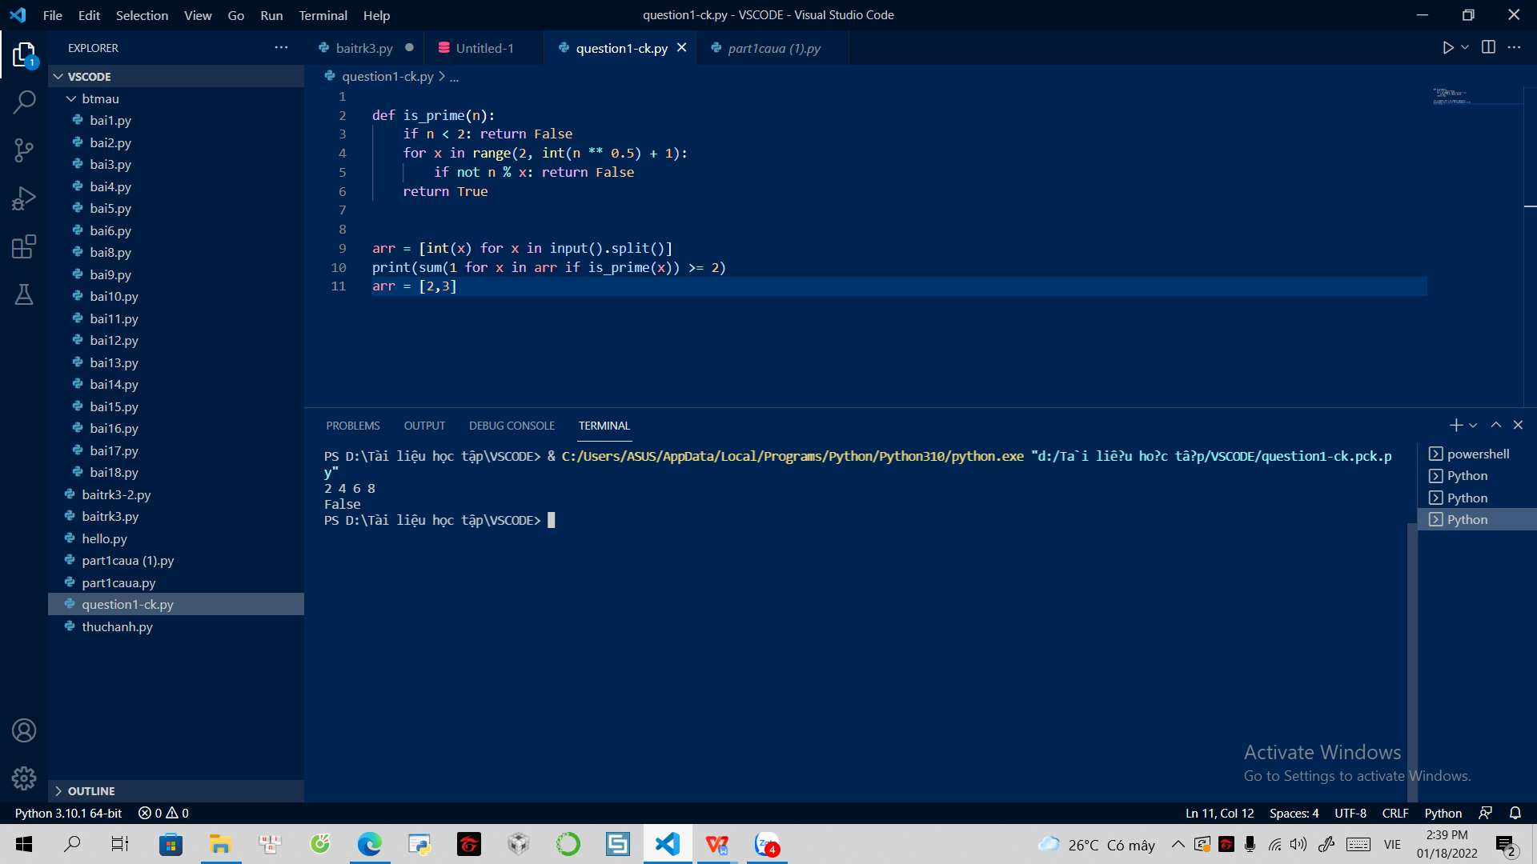

An array has one prime

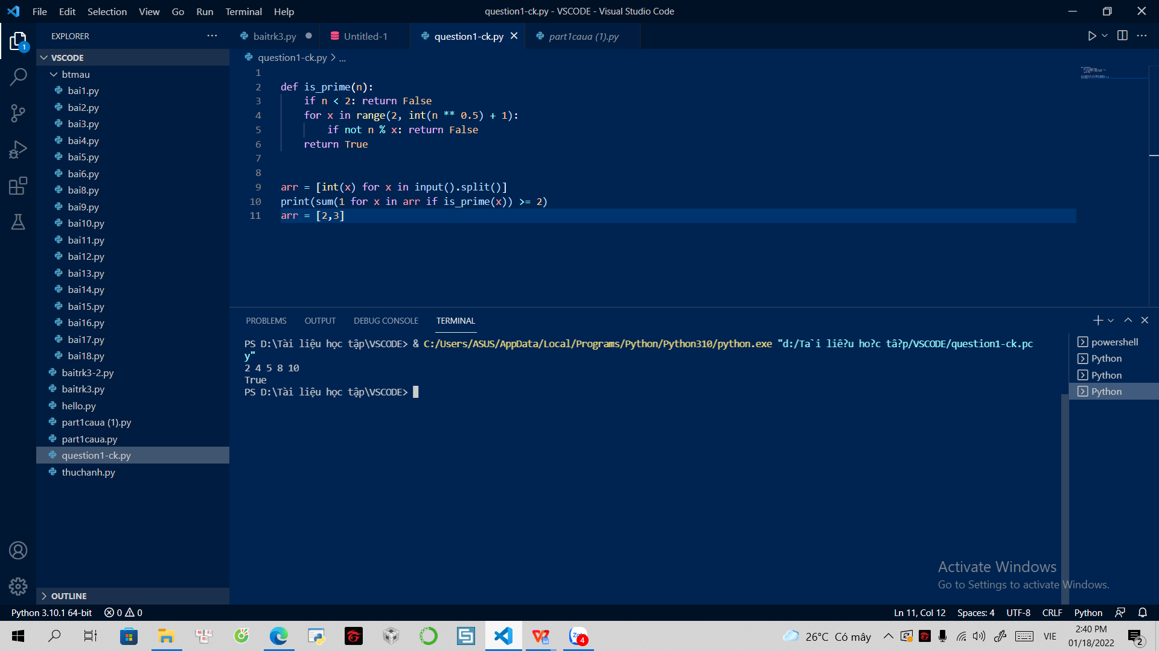

An array has more than one primes

