Problem Set 1 – Probability & Engineering Economy

1.24:
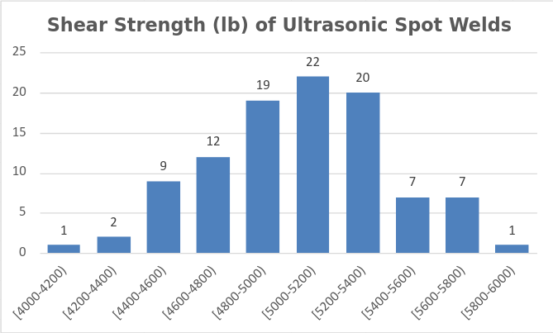
Fig 1: Shear Strength Histogram for 1.24
This data seems to be unimodal, though it is slightly back skewed as the mean is to the right of the median. There don’t seem to be any outliers, as there are no gaps in the histogram.
1.31:
Bins | Frequency | Cumulative Frequency | Relative Frequency | Relative Cumulative Frequency
[4000-4200) | 1 | 1 | 0.01 | 0.01
[4200-4400) | 2 | 3 | 0.02 | 0.03
[4400-4600) | 9 | 12 | 0.09 | 0.12
[4600-4800) | 12 | 24 | 0.12 | 0.24
[4800-5000) | 19 | 43 | 0.19 | 0.43
[5000-5200) | 22 | 65 | 0.22 | 0.65
[5200-5400) | 20 | 85 | 0.2 | 0.85
[5400-5600) | 7 | 92 | 0.07 | 0.92
[5600-5800) | 7 | 99 | 0.07 | 0.99
[5800-6000) | 1 | 100 | 0.01 | 1
Table 1: Frequency relative to bins for 1.31

1.39a: The mean of the data set is 1.029687 and the Median is 0.995.
1.39b:The value the maximum sample could be reduced by before it would change the median is 0.387, as up to 0.387 the count of the samples with a higher value as compared to the samples in the median calculation does not change, and when the maximum number is reduced by 0.387 it would be the same as the number it would be replacing in the median calculation. After this point any further reduction would lower the median, up until it gets low enough to no longer be included in the two numbers in the middle used to calculate the median.

1.42a: If a constant is added to each sample in a set the mean will increase by the same amount as the constant, as will the median. For the mean, as the constant is added to each variable once, it is added by the same number as the sum of the samples is being divided by. This allows the expression to be separated out into two terms, the first term is then simplified to c, meaning that the mean becomes the original term for the mean, with c added to it. For the median, the ordering of the values stays the same as all of them have the same constant added to them. This means that the sample(s) used to get the median are the same. In the case of one sample, the constant is added to it. In the case of the two samples it is the exact same situation as the mean, with the only difference being that n = 2.

1.42b: The mean and median would be multiplied by the constant. This is true of the mean as which is the original term multiplied by c, after c is factored out of each x term. As for the median, each term is either multiplied by 0 or a non-zero constant, in the case of 0 the median is 0, which is the former median multiplied by the constant. In the case of a non-zero constant the ordering of the samples values is either the same or reversed. In either case the middle value(s) remain the same. In the case of one value the result is simply the sample multiplied by the constant. In the case of there being two middle values the equation is reduced to
which is clearly the original median multiplied by c.

1.46a:
 | Mean | Median | Mode
Cooler | 1.706 | 1.76 | N/A
Control | 1.752727273 | 1.9 | N/A
Warmer | 2.076428571 | 2.305 | N/A
Table 2: Measures of center 1.46a
In each case there was no mode, as there were no repeat values between each number. For the cooler sample the mean and median differed the least, implying that it has less skew as compared to the other sample sets. As the sample sets got warmer the difference between mean and median increased, implying the skew is increasing as well.

1.46b:
Cooler | Control | Warmer
0.400834843 | 0.531320824 | 0.77787291
Table 3: Standard Deviations for 1.46b
The standard deviations increased as the warmness of the sample increased, though it should be noted that this cannot be deemed to be caused by the increase in warmness. A potential cause is the shade tarp placed over the soil making the temperature less responsive to changes in sunlight via cloud cover changes while the plastic wrap amplified the effects of changes in the sun.

1.46c:
Cooler | Control | Warmer
0.39 | 0.365 | 0.6775
Table 4: Fourth Spread for 1.46c
This data provides a different perspective on the spread of each of the sample sets. The cooler set seems to be slightly more spread out than the control sample, with the warmer sample having far more spread than either the cooler sample or the control.

1.46d:
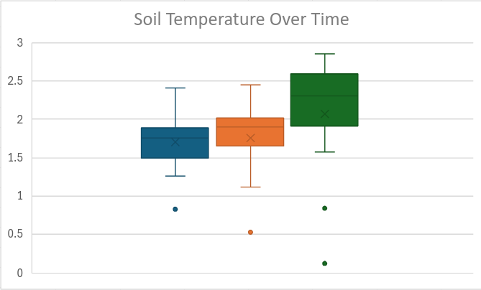
Fig 2: Boxplot of Soil Temperatures. Cooler (Blue), Control (Orange), Warmer (Green)
All of the outliers from all of the samples were lower than the mean. For the cooler and control samples the third quartile had significantly less range as compared to the second quartile, implying that the spread increases for cooler values among these sample sets.

1.69a: and
1.69b: The mean is 189.5 F, and the standard deviation is 3.3696
2.3a: The outcomes are that 1 & 2 or 1 & 3 are functional, and the system is operable, or 2 & 3 are functional and the system is inoperable.
2.3b: All outcomes described in 2.3a are included in event B, making event A a subset of B. Additionally, all 3 components can function.
2.3c: The outcomes contained in C are that 1&2, 1&3, or all three components are functional.
2.3d: C’: 1 is not functional, 2 and 3 can be any combination of success or failure in this case. One being functional and 2 & 3 not being functional is another case included in C’.
AUC: the same outcome set as B.
A∩C: 1&2 are functional and 1 & 3 are functional.
BUC: the same outcome set as B, as C is a subset of B.
B∩C: the same outcome set as C, as C is a subset of B.
2.13a: The probability the company gets either project 1 or 2. The probability is .36.
2.13b: The probability the company doesn’t get project 1 or 2. The probability is .64.
2.13c: The probability the company gets at least one of the three contracts. The probability is .53.
2.13d: The probability the company gets none of the contracts. The probability is .47.
2.13e: The probability the company only gets contract 3. The probability is .17.
2.13f: The probability the company gets contract 3 with or without any of the other contracts, or doesn’t get any contracts at all. The probability is .75.
2.22a: The probability he must stop at both signals is .2.
2.22b: The probability he must stop at the first signal and not the second one is also .2
2.22c: The probability he must stop at exactly one signal is .5.

