INTERNET OF THINGS · LAB 1
Getting Started with CoreIOT
Create an account, a device and a dashboard on the CoreIOT IoT platform
Item | Details
Course | Embedded Systems — From the Arduino Uno to the ESP32-S3 and Raspberry Pi with AI
Platform | CoreIOT cloud (app.coreiot.io) · Python 3 simulated device (later: ESP32-S3 / Raspberry Pi)
Estimated time | About 90 minutes
Deliverables | Public dashboard link, screenshots, your Python script and short answers (see Section 10)

Learning objectives
By the end of this lab you will be able to:
- Create a CoreIOT account and log in as a Tenant administrator.
- Create a device, read its connectivity settings, manage its credentials and organise devices into groups.
- Send simulated telemetry from a Python MQTT client and verify it on the platform.
- Build a dashboard with value cards, RPC-controlled switches and a time-series chart.
- Share the dashboard through a public link.

1. Before You Start
- A Google account (used to sign in to CoreIOT).
- A computer with a modern web browser and Python 3.8 or newer.
- Internet access with outgoing TCP port 1883 (MQTT) allowed. Some campus or company networks block it — a phone hotspot is a quick workaround.
- Optional: the manual videos listed in Section 11.

2. Background: CoreIOT in a Nutshell
CoreIOT is an open-source IoT platform for data collection, processing, visualization and device management. Devices connect with standard IoT protocols — MQTT, CoAP and HTTP — and the platform can run in the cloud or on-premises. Its web interface is based on the open-source ThingsBoard platform, so the ThingsBoard documentation generally applies as well (the original slides use both names).
Figure 1 shows the data flow you will build in this lab: the device publishes telemetry to CoreIOT, the dashboard displays it, and when you toggle a switch on the dashboard CoreIOT sends an RPC request back to the device.
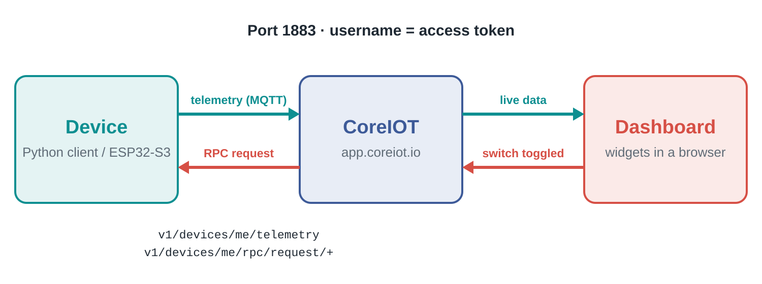
Figure 1. Data flow in LAB 1: telemetry goes up, RPC commands come down.

2.1 Key concepts
Concept | Meaning | Example in this lab
Device | A physical or simulated thing that connects to CoreIOT. | MY_DEVICE_1
Access token | The device's secret credential. With MQTT it is sent as the username. | Copied from Manage credentials
Telemetry | Time-stamped measurements stored in a time-series database and shown in charts. | temperature, humidity
Client attribute | State or configuration reported by the device; read-only from the dashboard. | led_state published by the script
Shared attribute | Set by the server, readable and updatable by both sides; used to configure device behaviour. | A threshold or a mode (not used yet)
Server attribute | Managed only by the server: server-side metadata such as ownership or last configuration change. | Not used in this lab
RPC | Remote Procedure Call: a command sent from the platform to the device, which executes it and replies. | setStateLED(true)
Dashboard / widget | A web page made of widgets (cards, charts, switches) bound to device data. | “IoT Dashboard demo”

2.2 MQTT topics used by a device
Topic | Direction | Purpose
v1/devices/me/telemetry | device → platform | Publish telemetry as JSON, e.g. {"temperature": 30}
v1/devices/me/attributes | device → platform | Publish client attributes
v1/devices/me/rpc/request/+ | platform → device | Subscribe to receive RPC requests; the last topic level is the request id
v1/devices/me/rpc/response/{id} | device → platform | Publish the result of the RPC request with that id

3. Part A — Create a CoreIOT Account
An account with the administrator role is required to log in to the CoreIOT platform. The first time you sign in, CoreIOT creates a tenant for you and you become its Tenant administrator.
- Open https://www.coreiot.io and click Start Now.
- Choose Login with Google and sign in with your Google account.
- After signing in, the top-right corner shows your name and the role Tenant administrator.
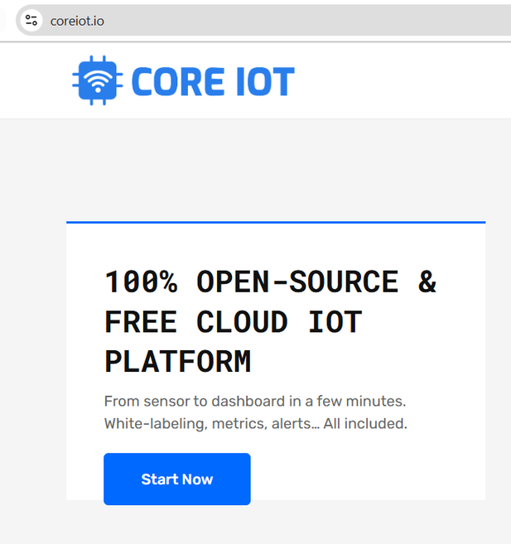  Figure 2. coreiot.io — click Start Now | 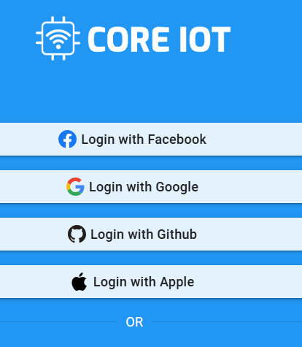  Figure 3. Log in with Google | 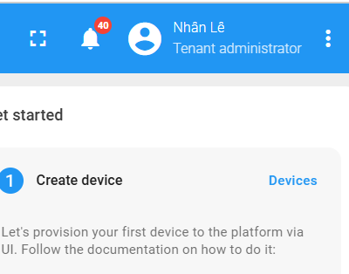  Figure 4. You are now Tenant administrator

4. Part B — Create a Device and Its Credentials

4.1 Add a new device
- In the left menu open Entities → Devices.
- Click the + (Add) icon in the top-right corner of the device list.
- Choose Add new device.
- Enter a Name (for example MY_DEVICE_1; in class use LAB1_<your student ID> so devices are easy to tell apart). Keep the Device profile as default, then click Add.
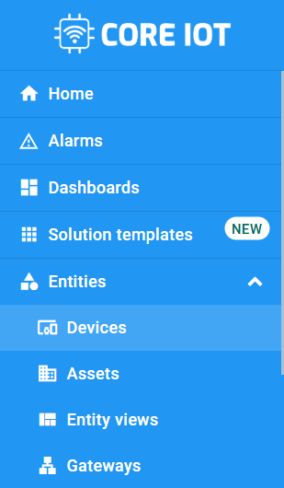  Figure 5. Entities → Devices | 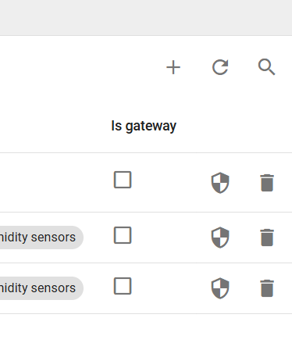  Figure 6. Add icon (top-right) | 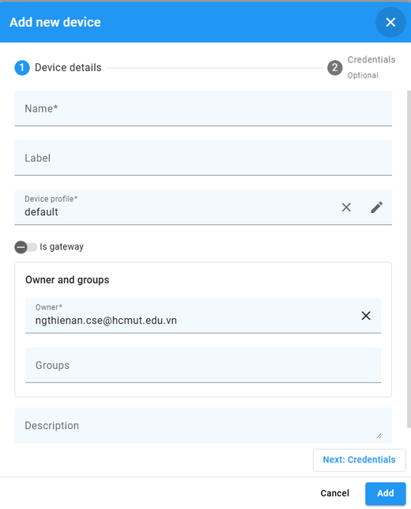  Figure 7. Add new device

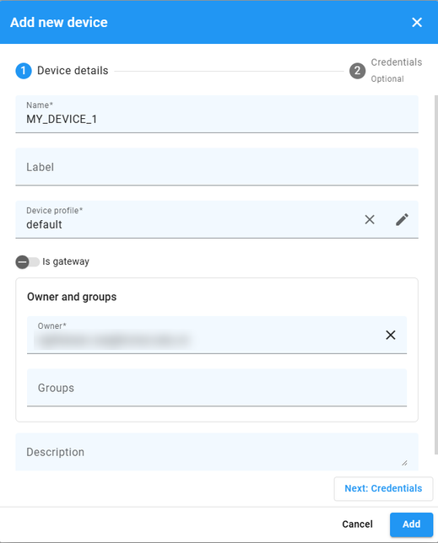  Figure 8. Device details: name and profile | 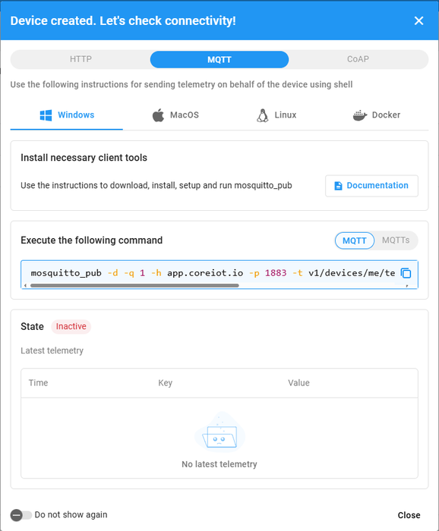  Figure 9. Connectivity check after creation

4.2 Check the connectivity settings
Right after the device is created, CoreIOT shows the dialog “Device created. Let's check connectivity!” (Figure 9). It lists ready-made commands for HTTP, MQTT and CoAP on Windows, macOS, Linux and Docker. Note the host app.coreiot.io and port 1883, then click Close.
Click the device row to open its details (Figure 10). The tabs you will use most are Details, Attributes and Latest telemetry; the buttons Copy access token and Manage credentials give you the credential needed in Part C.
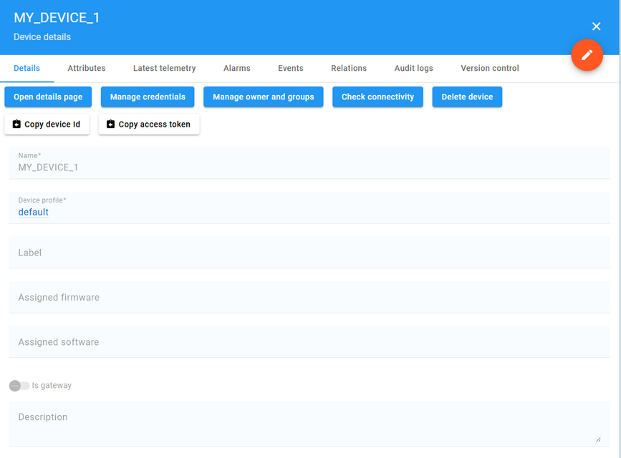
Figure 10. Device details page

4.3 Manage credentials
- On the device details page click Manage credentials.
- The default type is Access token (Figure 11). You can keep the generated token or type your own, then Save. Copy it — you will paste it into the Python script.
- Alternatively choose MQTT Basic and set a Client ID, User Name and Password (Figure 12). This lab uses the access token.
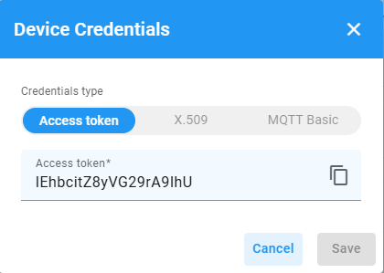  Figure 11. Access token credential | 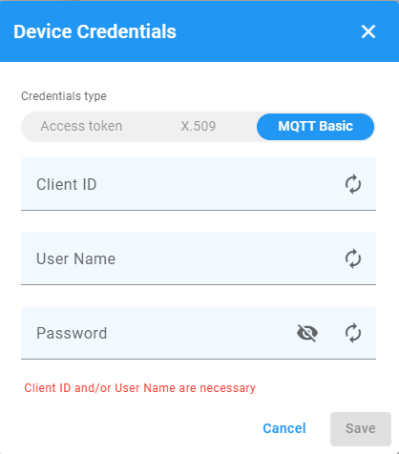  Figure 12. MQTT Basic: ID and password

Treat the access token like a password
Anyone who has the token can send data as your device. Do not post it in a public chat or commit it to a public Git repository.

4.4 Organise devices into groups
- Open the Groups tab of the device list and click + to create a group (Figure 13). Give it a name, for example LAB1 devices.
- Open the All group, tick your device(s) and click Add to group (Figures 14–15), then choose your new group.
- In the group list, the Share menu of each group lets you Make public or Make private (Figures 16–17). A public device group is needed later when you share the dashboard (Part E).
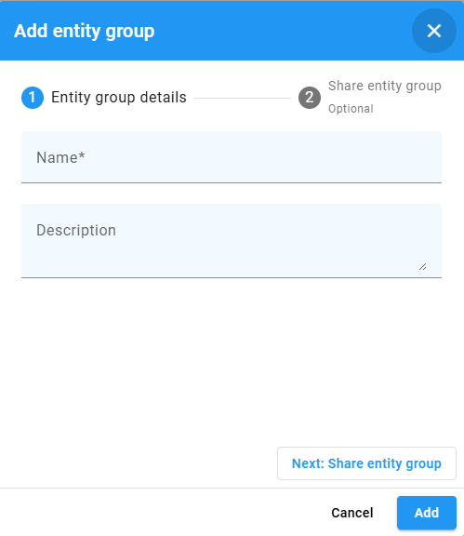  Figure 13. Add entity group | 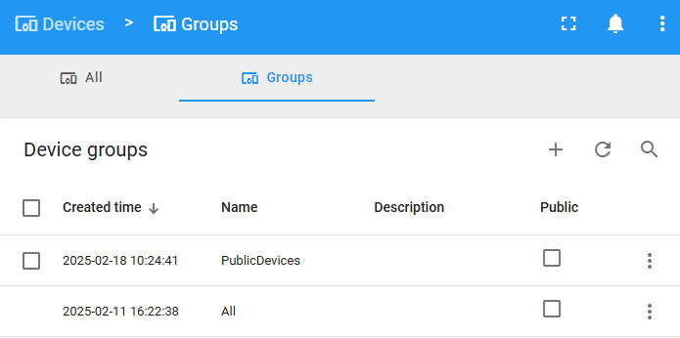  Figure 14. Device groups: the “All” group | 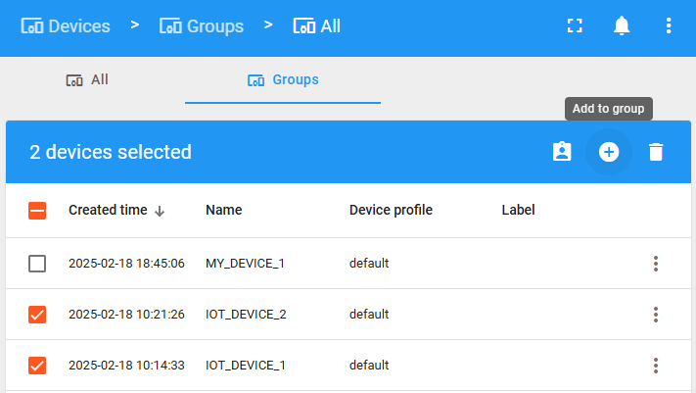  Figure 15. Select devices → Add to group

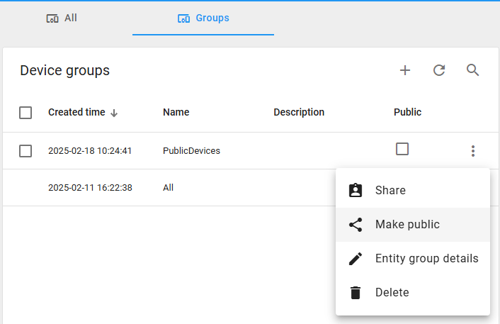  Figure 16. Make a group public | 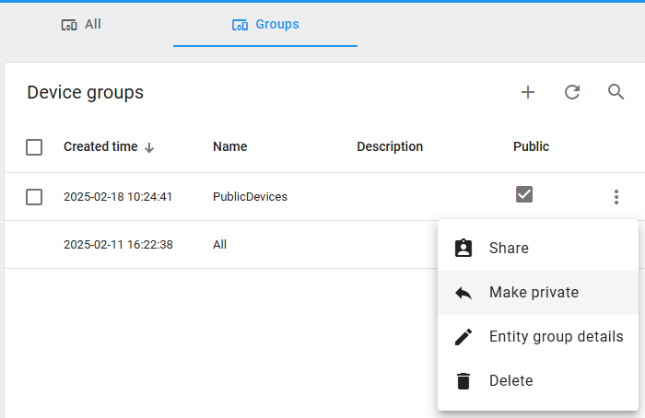  Figure 17. …or private

5. Part C — Send Test Data with a Simulated Python Device
Before building the dashboard, make the device send some data. The telemetry keys then appear in the widget editors, and the dashboard switches have a device that answers them.

5.1 Install the MQTT library
● ● ● terminal
# Windows / macOS / Linux PC
$ pip install "paho-mqtt>=2.0"

# Raspberry Pi OS (Bookworm) blocks system-wide pip: use a virtual environment
$ python3 -m venv ~/lab1-env
$ source ~/lab1-env/bin/activate
$ pip install "paho-mqtt>=2.0"

5.2 The device script
Save the following file as lab1_device.py and replace PASTE_YOUR_ACCESS_TOKEN_HERE with the token from Section 4.3. The script sends random temperature and humidity values every 5 seconds and answers the four RPC methods used by the dashboard switches in Part D: getStateLED, setStateLED, getStatePUMP and setStatePUMP.
● ● ● lab1_device.py
# LAB 1 - Simulated CoreIOT device (paho-mqtt 2.x)
# Sends temperature/humidity telemetry every 5 s and answers the
# RPC calls of the two dashboard switches (LED and PUMP).
import json
import random
import time

import paho.mqtt.client as mqtt

BROKER = "app.coreiot.io"
PORT = 1883
ACCESS_TOKEN = "PASTE_YOUR_ACCESS_TOKEN_HERE" # Manage credentials

state = {"LED": False, "PUMP": False} # simulated outputs

def on_connect(client, userdata, flags, reason_code, properties):
if reason_code == 0:
print("Connected to CoreIOT")
client.subscribe("v1/devices/me/rpc/request/+")
else:
print("Connection failed:", reason_code)

def on_message(client, userdata, msg):
request_id = msg.topic.split("/")[-1]
try:
req = json.loads(msg.payload)
except json.JSONDecodeError:
print("Invalid RPC payload:", msg.payload)
return
method, params = req.get("method", ""), req.get("params")
print("RPC:", method, params)

result = None
if method.startswith("getState"): # getStateLED / getStatePUMP
result = state.get(method[len("getState"):])
elif method.startswith("setState"): # setStateLED / setStatePUMP
name = method[len("setState"):]
if name in state:
state[name] = bool(params)
result = state[name]
client.publish("v1/devices/me/attributes",
json.dumps({name.lower() + "_state": result}))
# Reply so the switch widget knows the command succeeded
client.publish("v1/devices/me/rpc/response/" + request_id,
json.dumps(result))

client = mqtt.Client(mqtt.CallbackAPIVersion.VERSION2,
client_id="LAB1_PYTHON_DEVICE")
client.username_pw_set(ACCESS_TOKEN) # token = username
client.on_connect = on_connect
client.on_message = on_message
client.connect(BROKER, PORT, keepalive=60)
client.loop_start()

try:
while True:
data = {"temperature": round(random.uniform(25, 35), 1),
"humidity": round(random.uniform(50, 85), 1)}
client.publish("v1/devices/me/telemetry", json.dumps(data), qos=1)
print("Sent:", data)
time.sleep(5)
except KeyboardInterrupt:
print("Stopping...")
finally:
client.loop_stop()
client.disconnect()

Changes compared with the original thingsboard.py
The script is based on the sample client linked in the slides (thingsboard.py, branch CoreIOT_Lab1), with these corrections:
- paho-mqtt 2.x: mqtt.Client("IOT_DEVICE_2") fails on version 2 because the first argument is now the callback API version. The script passes CallbackAPIVersion.VERSION2 and uses the matching callback signatures.
- RPC methods match the dashboard: the original only handled a method called setValue, while the dashboard switches call getStateLED/setStateLED and getStatePUMP/setStatePUMP.
- RPC response: the original published an attribute instead of a reply, so the switch widget would report a timeout. The script now publishes the result to v1/devices/me/rpc/response/{id}.
- Robustness: callbacks are registered before connect(), a bare except was replaced by json.JSONDecodeError, and Ctrl+C disconnects cleanly.
- Credentials: with an access token the token is the MQTT username and no password is needed.

5.3 Run and verify
● ● ● expected output
$ python lab1_device.py
Connected to CoreIOT
Sent: {'temperature': 29.4, 'humidity': 71.2}
Sent: {'temperature': 33.1, 'humidity': 58.7}
...

- Run the script and wait for Connected to CoreIOT.
- In CoreIOT open your device and select the Latest telemetry tab: the keys temperature and humidity appear and update every 5 seconds.
- Leave the script running for the rest of the lab.

6. Part D — Build the Dashboard
About the screenshots
The screenshots come from the original Vietnamese class material, so the switch labels read “Đèn LED” (LED) and “Máy bơm” (Pump). In this guide we label them LED and Pump; the settings are otherwise identical.

6.1 Create an empty dashboard
- In the left menu select Dashboards.
- Click the + (Add) icon and choose Create new dashboard.
- Enter the Title IoT Dashboard demo and click Add. Open the new dashboard; it starts in edit mode.
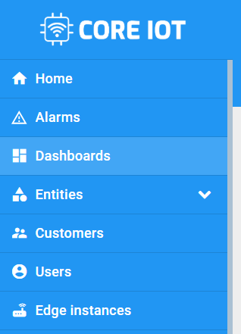  Figure 18. Select Dashboards | 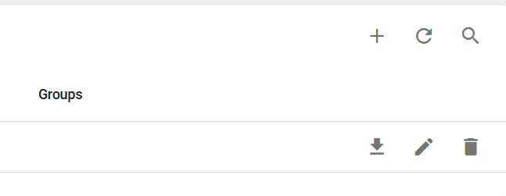  Figure 19. Add icon | 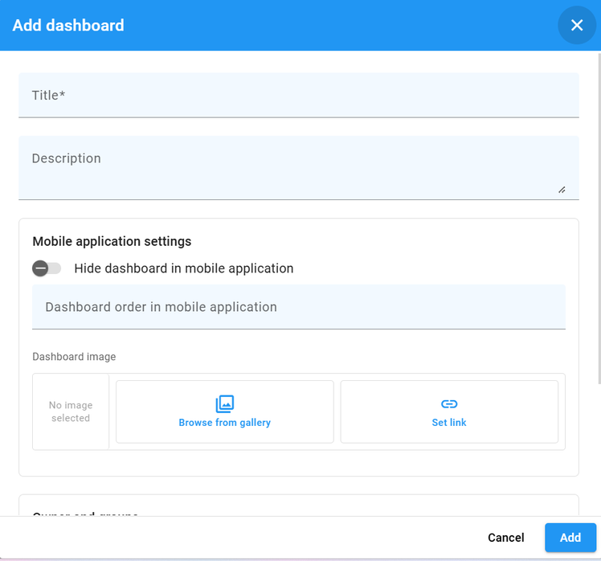  Figure 20. Add dashboard dialog

6.2 Temperature value card
- Click Add widget (Figure 21) to open the widget library (Figure 22).
- Open the Cards bundle (Figure 23) and select Value card (Figure 24).
- Under Datasource choose your device (Figure 25) and select the data key temperature (Figure 26).
- In Appearance set the label to Temperature and the units to °C, then click Add.
- To change a widget later, enter edit mode and click its pencil (Edit) icon (Figure 27).
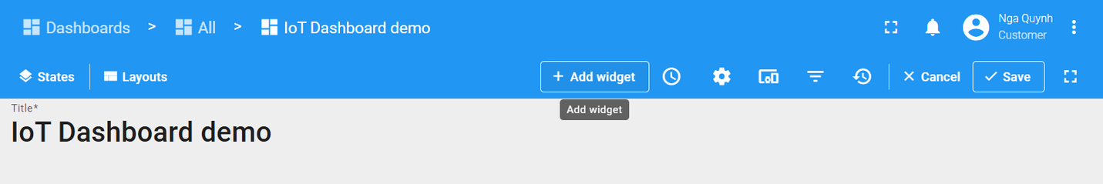
Figure 21. Add widget
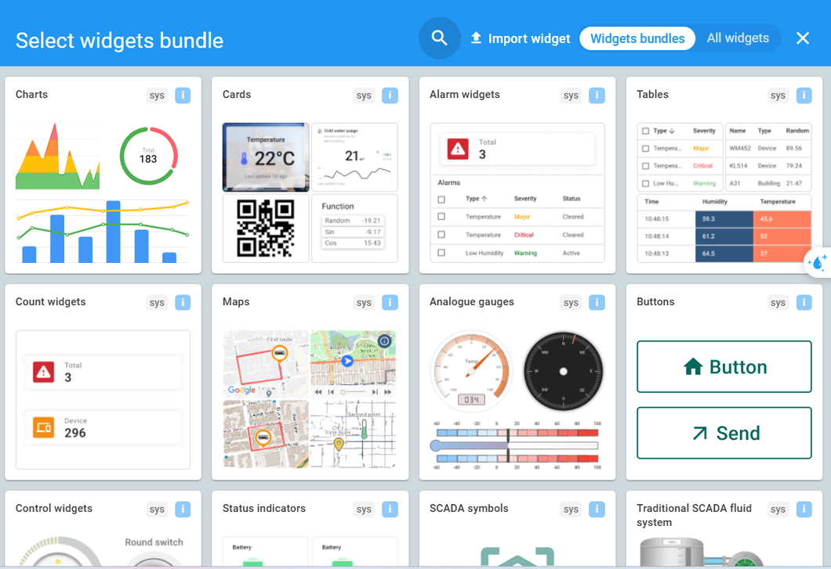
Figure 22. Select widgets bundle
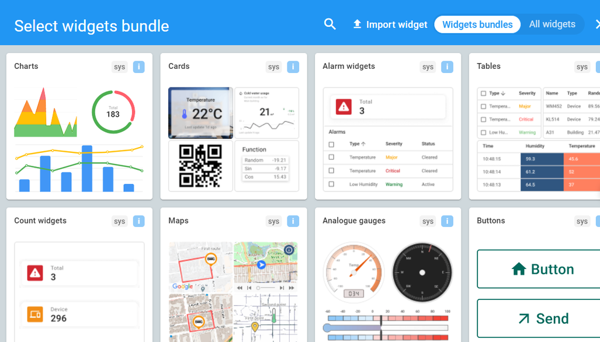  Figure 23. The “Cards” bundle | 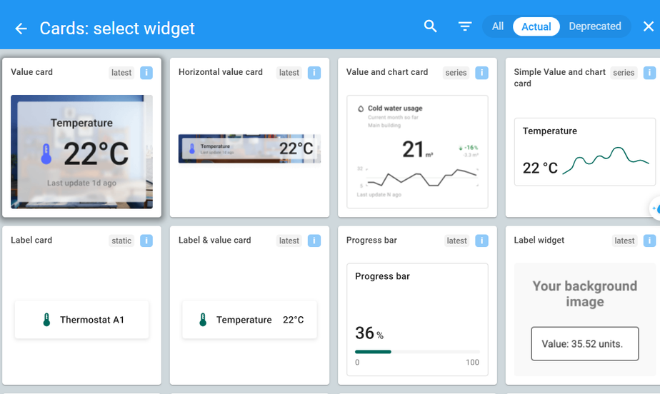  Figure 24. Choose “Value card”

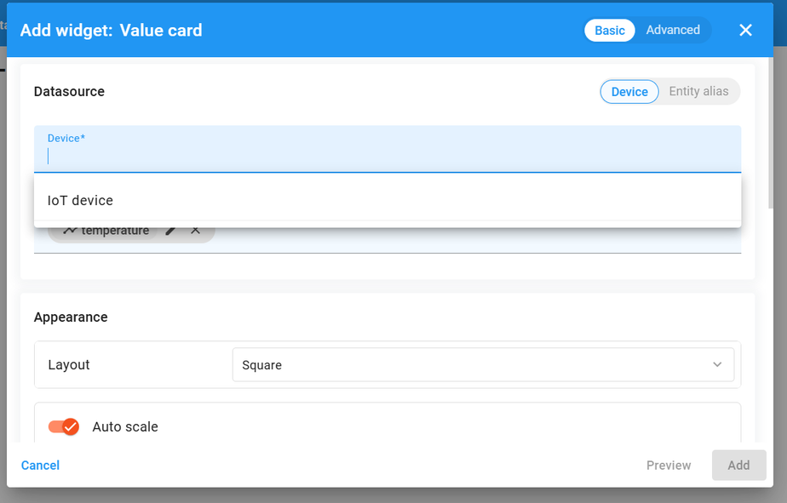  Figure 25. Choose your device | 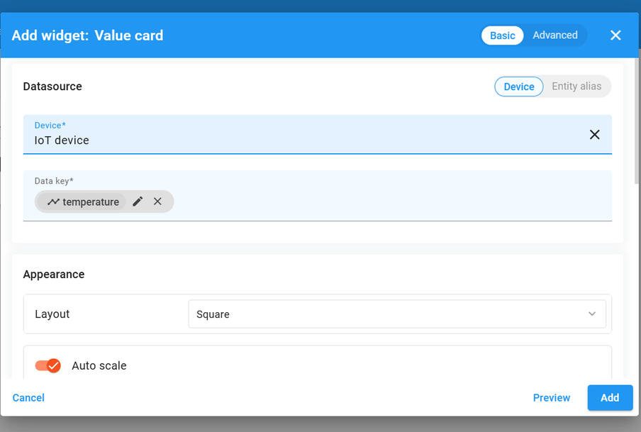  Figure 26. Select the data key

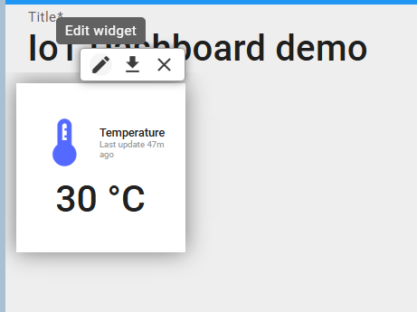
Figure 27. Edit an existing widget
Data key not in the list?
Keys are listed only after the device has sent them at least once. Check that the script from Part C is running, or type the key name exactly as the script sends it (temperature, humidity).

6.3 Humidity value card
- Add another Value card and select the key humidity (Figure 28).
- In Appearance set the label to Humidity, the units to % and pick a suitable icon (Figure 29), then click Add.
- The dashboard now shows two cards (Figure 30).
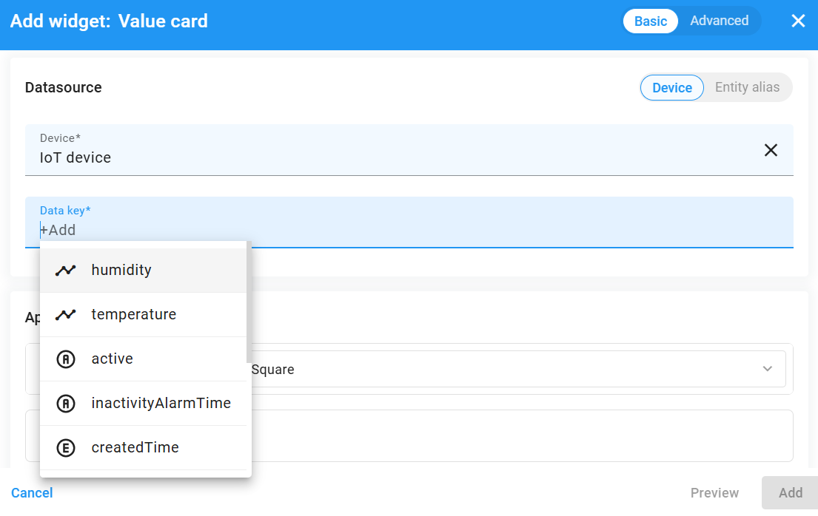
Figure 28. Select “humidity”
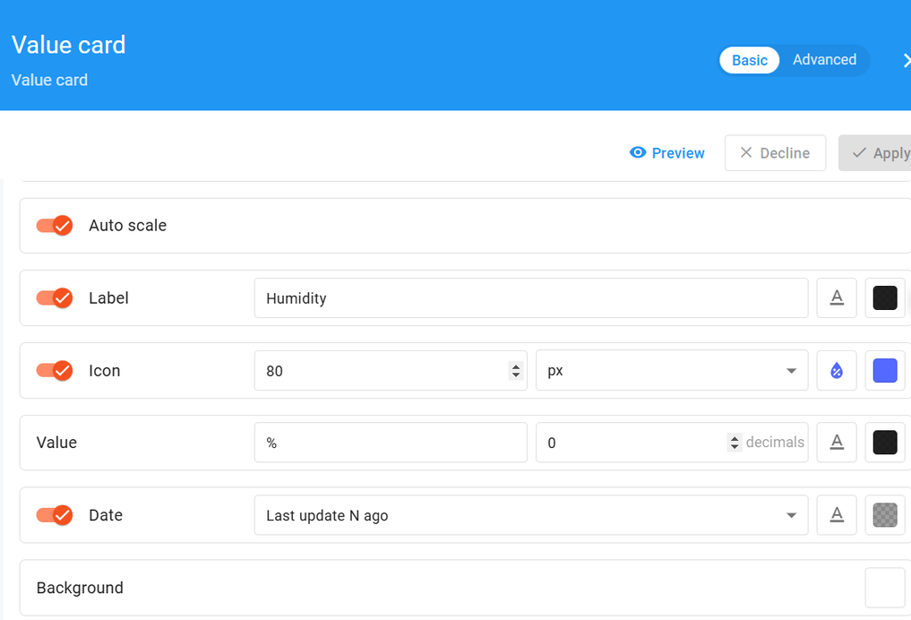  Figure 29. Change the appearance | 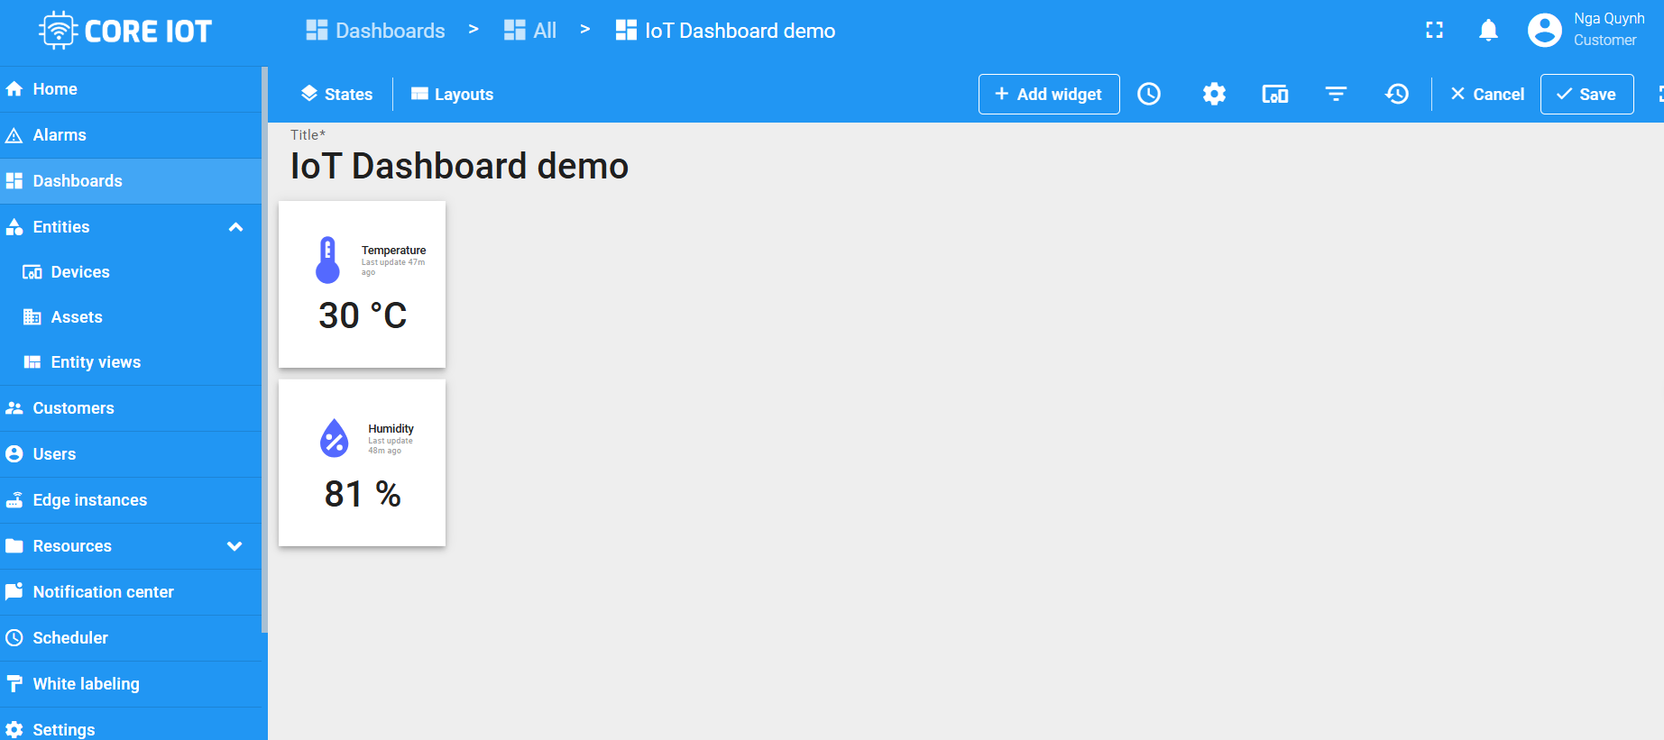  Figure 30. Two widgets created

6.4 LED control switch (RPC)
- Click Add widget, open Control widgets and choose Single Switch (Figures 31–32).
- Set Target device to your device (Figure 33).
- Under Behavior, edit Initial state: Action Execute RPC, Method getStateLED, and 'On' when result is Boolean → True (Figure 34). Click Apply.
- Edit Turn 'On' to execute RPC method setStateLED with value true, and Turn 'Off' to execute setStateLED with value false (Figure 35).
- Set the label to LED and click Add (Figure 36). The switch appears on the dashboard (Figure 37).
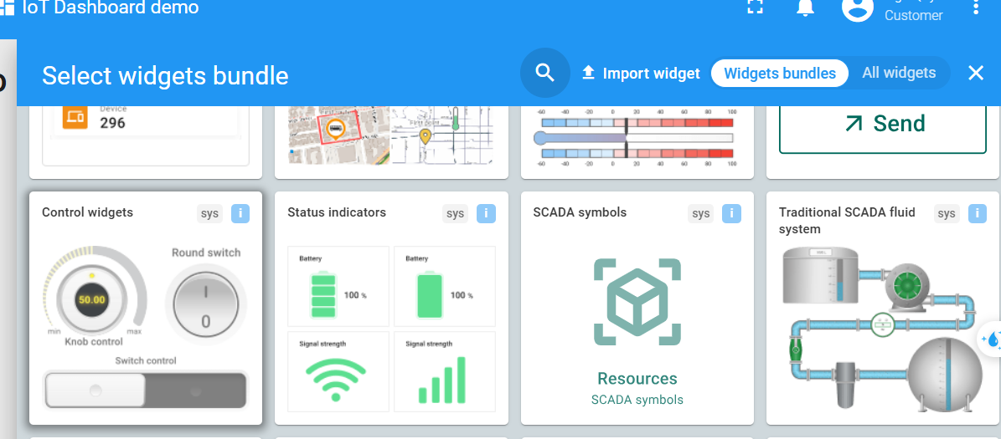  Figure 31. Control widgets bundle | 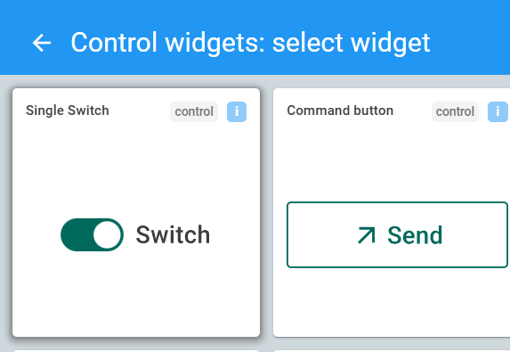  Figure 32. Single Switch

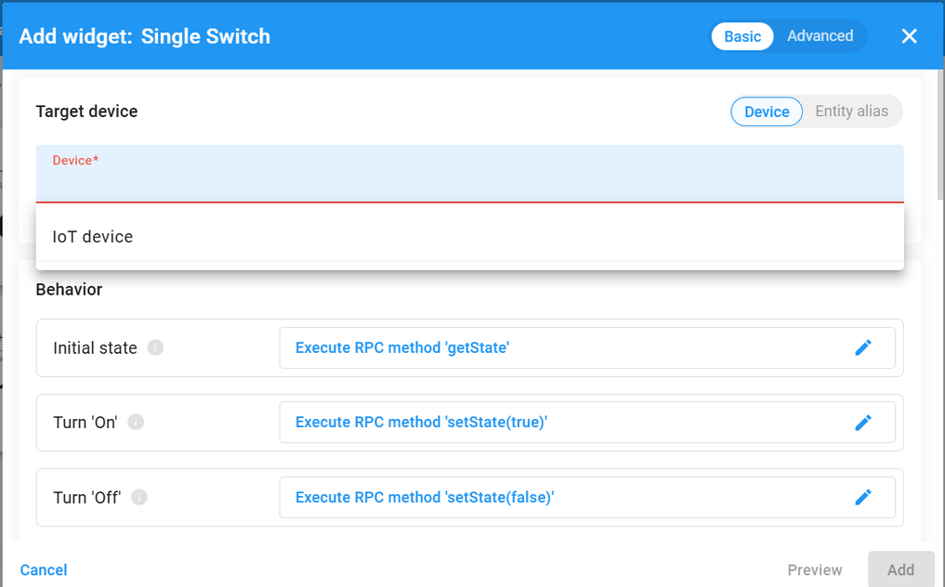  Figure 33. Target device | 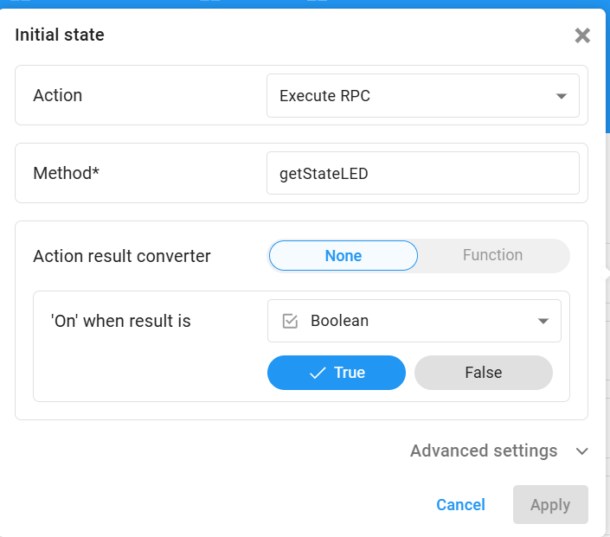  Figure 34. Initial state: getStateLED

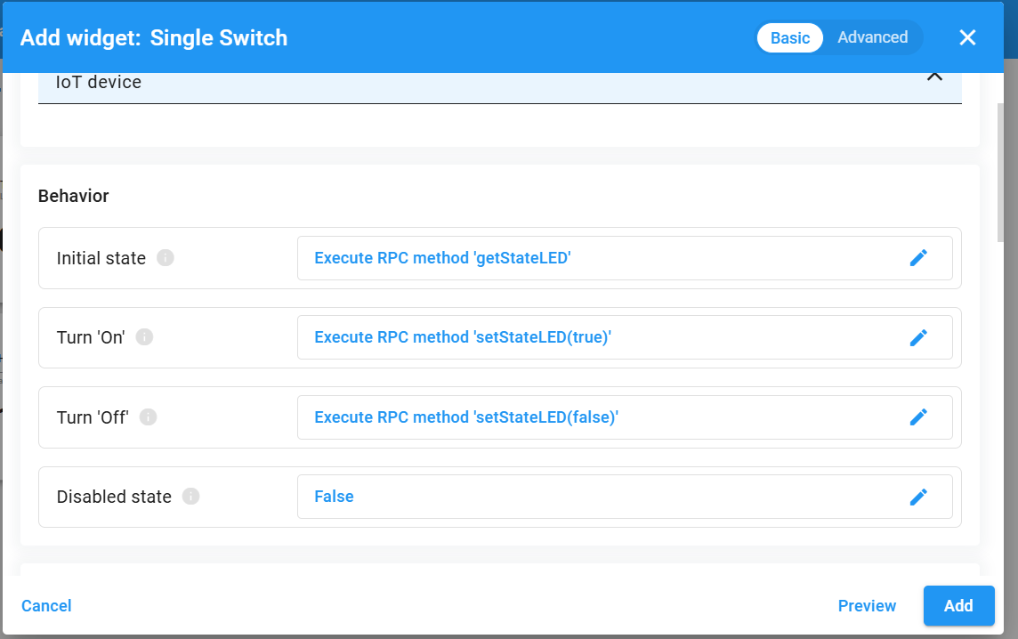  Figure 35. Turn On / Off RPC methods | 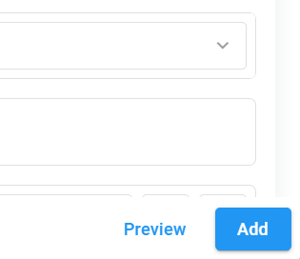  Figure 36. Click Add

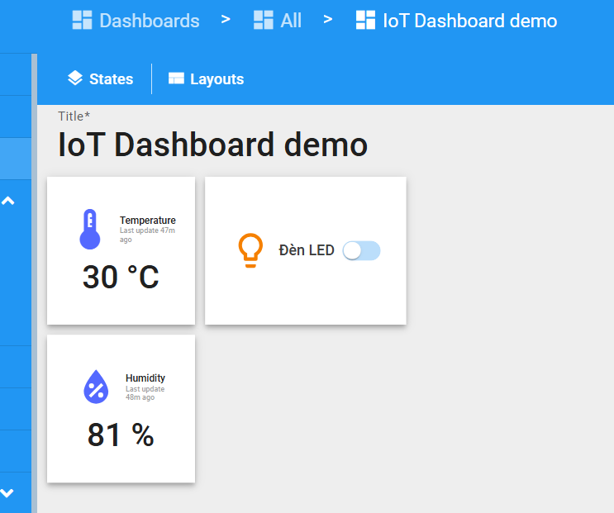
Figure 37. Dashboard with the LED switch

6.5 Pump control switch
Create a second Single Switch in the same way, replacing LED with PUMP in all three method names and labelling it Pump:
Setting | LED switch | Pump switch
Initial state | getStateLED → 'On' when result is True | getStatePUMP → 'On' when result is True
Turn 'On' | setStateLED with true | setStatePUMP with true
Turn 'Off' | setStateLED with false | setStatePUMP with false
Label | LED | Pump

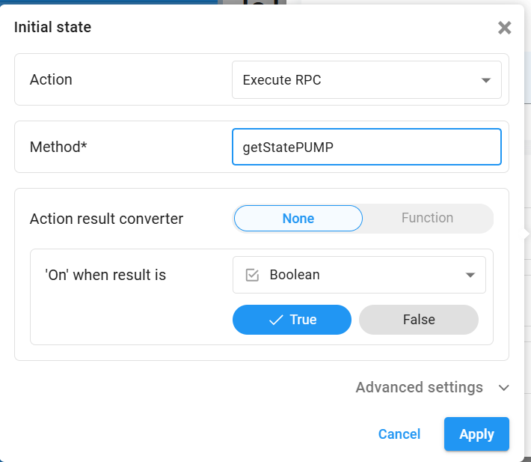  Figure 38. Initial state: getStatePUMP | 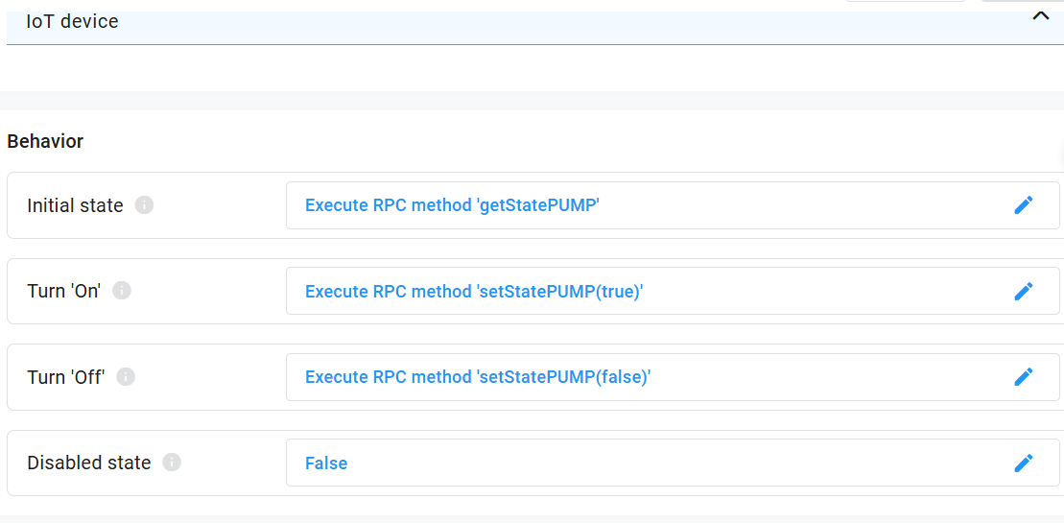  Figure 39. Pump RPC methods

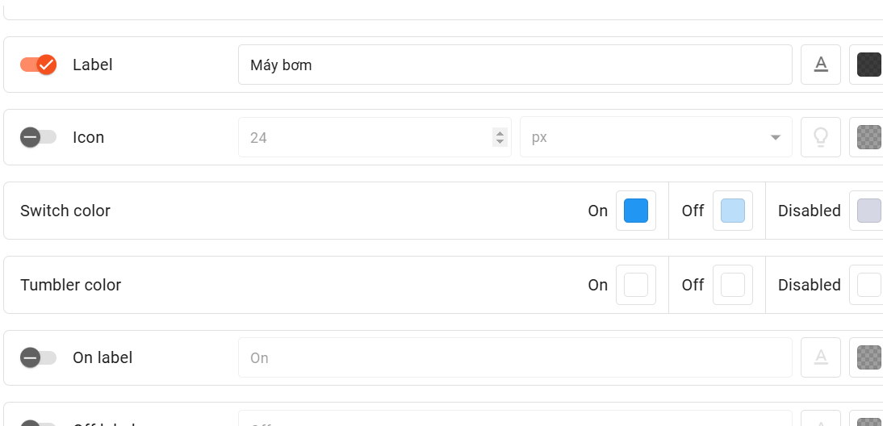
Figure 40. Set the label and click Add
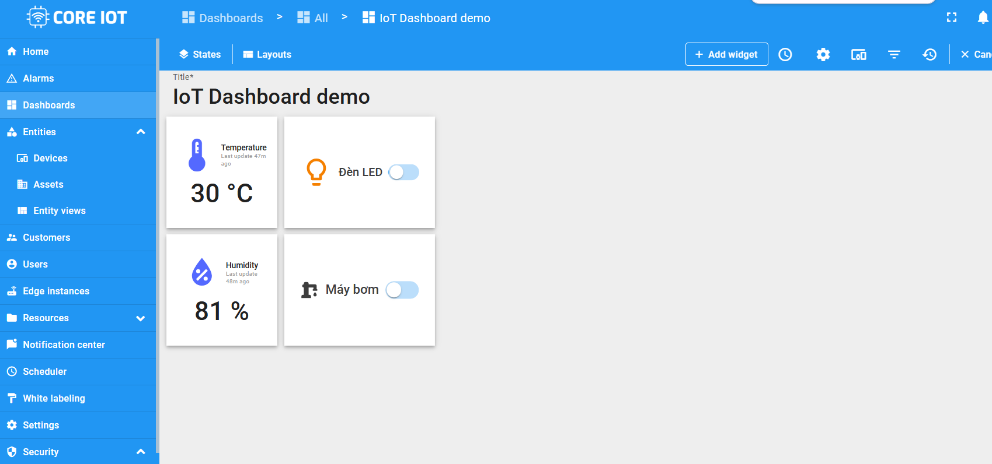
Figure 41. Dashboard with both switches

6.6 Time-series chart
- Click Add widget, open the Charts bundle and choose Time series chart (Figures 42–43).
- Under Datasource select your device (Figure 44). The first series is temperature.
- Click Add series, choose humidity (Figure 45) and click Add (Figure 46).
- Arrange the widgets, then click Save in the top-right corner. Unsaved changes are lost when you leave the page.
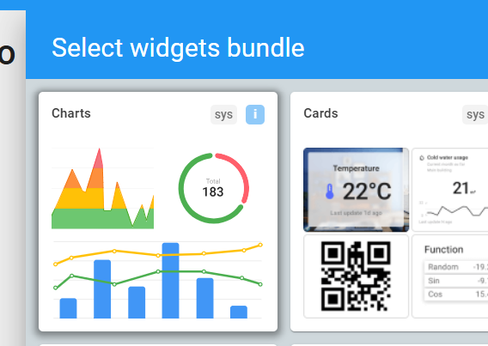  Figure 42. Charts bundle | 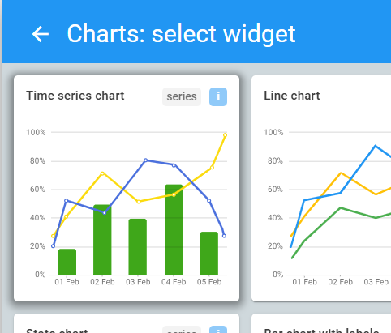  Figure 43. Time series chart

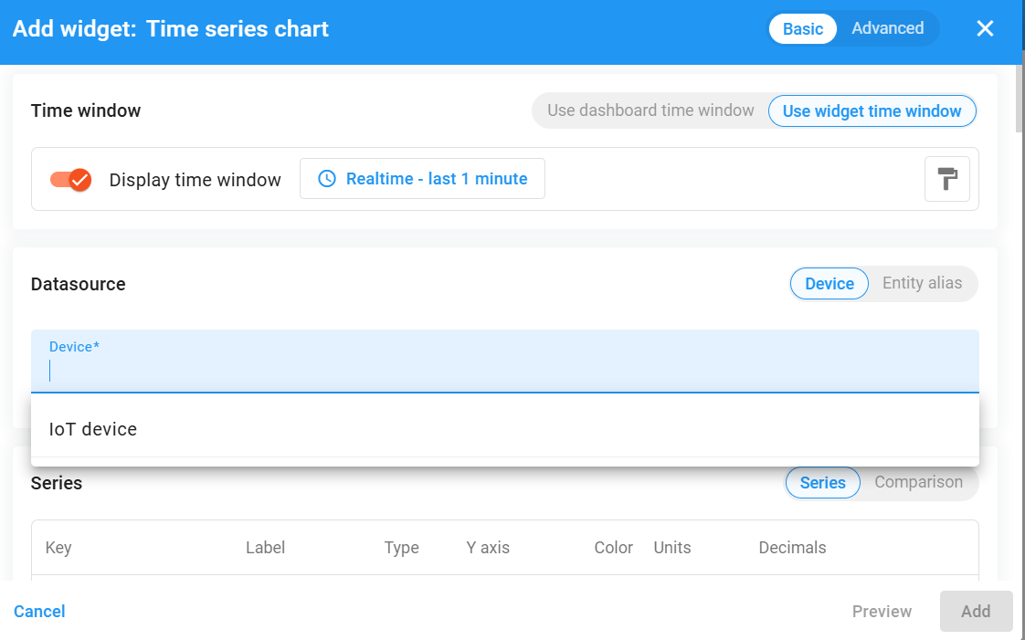
Figure 44. Select your device
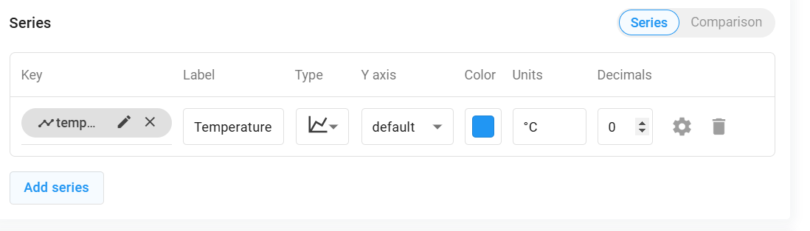
Figure 45. Add series
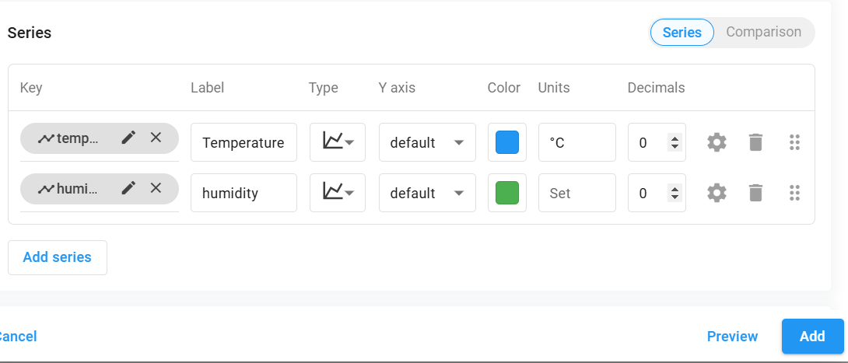
Figure 46. Add “humidity”, then Add
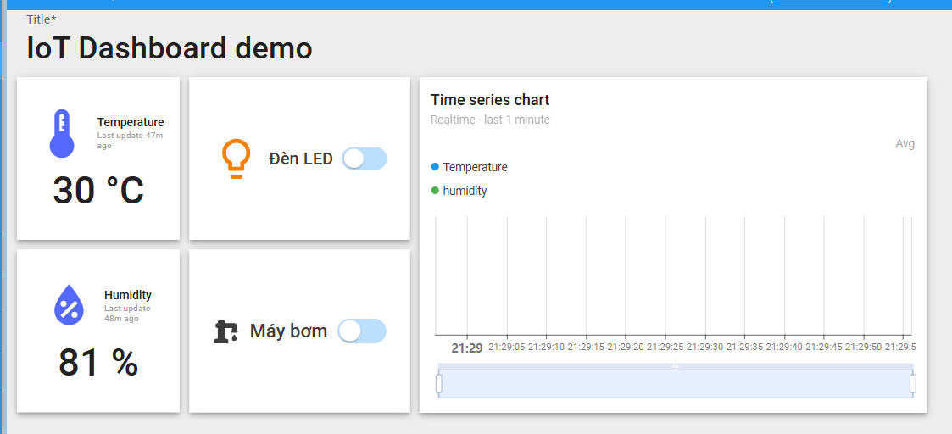
Figure 47. Example of the finished dashboard

6.7 Test the switches
- Toggle the LED switch. The terminal running lab1_device.py prints RPC: setStateLED True (or False).
- Reload the dashboard. The switch keeps its position because the widget calls getStateLED and the script answers with the stored state.
- Stop the script (Ctrl+C) and toggle the switch again: after a few seconds the widget reports an error, because no device replies to the RPC. Restart the script before continuing.

7. Part E — Share Your Dashboard
- Select Dashboards and open the Groups tab (Figure 48).
- Click the Make public (share) icon of the group that contains your dashboard (Figure 49).
- Copy the public link shown in the dialog (Figure 50) and open it in a private browser window to test it.
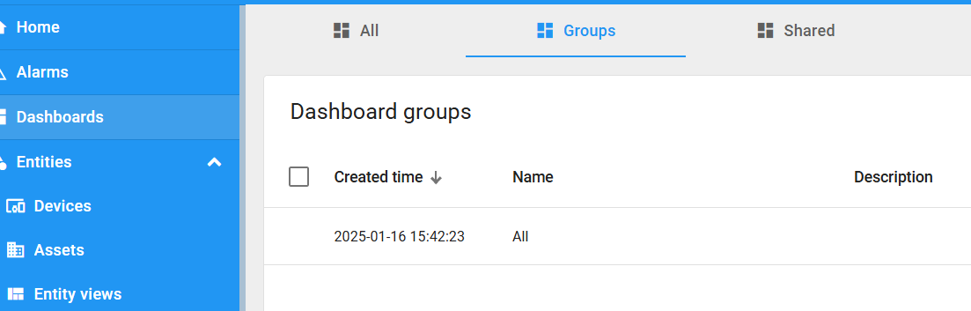
Figure 48. Dashboards → Groups
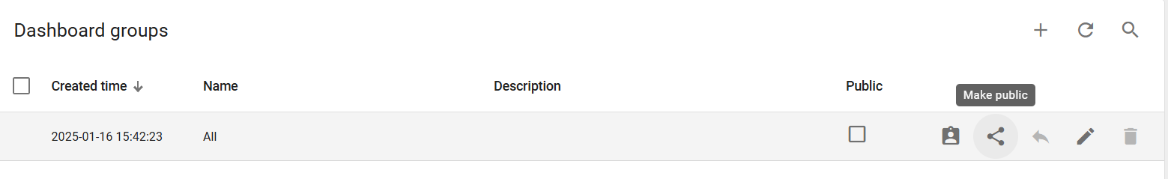
Figure 49. The “Make public” icon
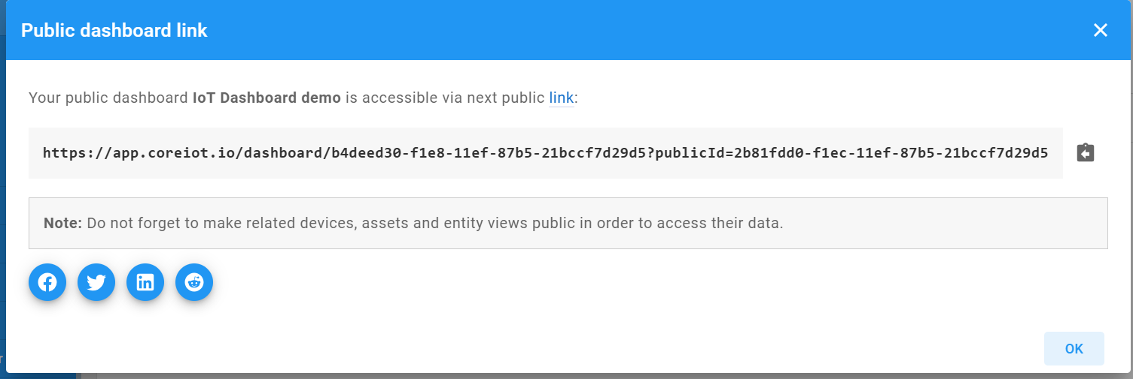
Figure 50. The public link of your dashboard
Make both the dashboard AND the device public
A public dashboard only shows data from entities that are public too. If the public link shows empty widgets, make the device group from Section 4.4 public as well. Do not make other private dashboards, assets or devices public by mistake.

8. Troubleshooting
Symptom | Likely cause | Fix
Connection failed: Not authorized | Wrong access token, or the token was set as the password. | Copy the token again from Manage credentials; pass it as the username only.
The script hangs at connect() or times out | Port 1883 is blocked by the network. | Try another network (for example a phone hotspot).
ValueError / Unsupported callback API version | Old example code with paho-mqtt 2.x. | Use the script in Section 5.2 (it passes CallbackAPIVersion.VERSION2).
Latest telemetry stays empty | Script not running, or wrong device token. | Check the terminal output; make sure the token belongs to this device.
A widget shows “No data” | Data key name differs from the key sent by the script. | Use exactly temperature and humidity.
Switch shows a timeout or error | Device offline, method name mismatch, or no reply on the response topic. | Keep the script running; compare method names with the table in 6.5.
Public link shows empty widgets | The device is not public. | Make the device group public (Section 4.4).

9. Exercises
- Complete the dashboard. Build the full dashboard from Part D: two value cards, two switches and one time-series chart. Take a screenshot.
- Add a light sensor. Extend the script to send a third key, light (random values from 0 to 1000). Add a value card for it and add it as a third series in the chart.
- Change the sending period. Send data every 2 seconds instead of 5. Describe what changes in the chart.
- Observe the attributes. Toggle both switches and open the Attributes tab of your device. Which attributes appear, what is their scope (client, shared or server), and why?
- Think ahead. In later labs the ESP32-S3 will replace this Python script. Which parts of the script (topics, JSON format, RPC handling) must the firmware reproduce?

10. Submission Checklist
- The public link of your dashboard (it must show live data).
- Screenshots of: the device details page, Latest telemetry, and the finished dashboard.
- Your final lab1_device.py with the access token removed.
- Short answers to Exercises 3–5 (a few sentences each).

11. References
Manual videos from the original CoreIOT quick-start slides:
- https://www.youtube.com/watch?v=l7AqpsF1ByQ
- https://www.youtube.com/watch?v=bigeRVU2iSE
- https://www.youtube.com/watch?v=Qdan24IpoH4
- https://www.youtube.com/watch?v=c5fX7SeRQsQ
CoreIOT platform: https://www.coreiot.io
Original sample client: https://github.com/nhanksd85/CoreIOT/blob/CoreIOT_Lab1/thingsboard.py

