

Question:
Enterprise Application Development in Java EE - Exam Paper Duration: 90 minutes | Marks: 15

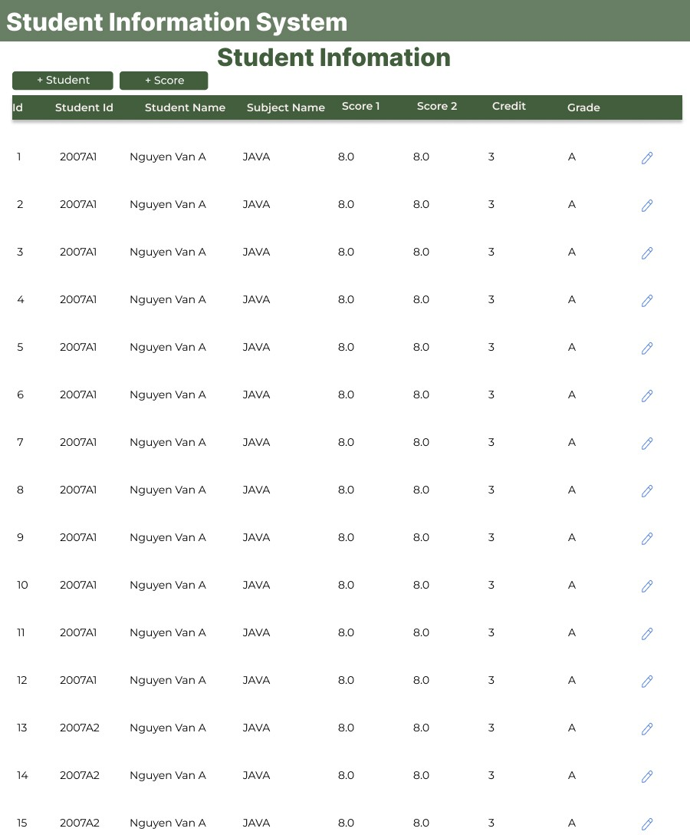
In 2006, Hanoi University of Science and Technology have plan to build system : Student Information System(sis), to manage all student with some information below:

- Student information include: student id, student name, address.
- Score of student include: student id, subject id, score 1, score 2.
- Subject include: subject id, subject name, credit .
Using knowledge in subject Enterprise Application Development in Java EE to development this system.
- A Employee of Training department inserts students (when clicked (+ Student)).
- A Employee of Training department inserts the score of subjects for any student (when clicked (+Score)).
- Display student information on the website like the picture below. Each student and a subject have Grade = 0.3×score 1 + 0.7 × score2. with table convert Score to Grade below.

Score | Grade
8.0 to 10 | A
6.0 to 7.9 | B
4.0 to 5.9 | D
less than 4.0 | F
Database information:
Database Name: sis
Script to create table and data:
// create table script
create table student_t (
student_id int auto_increment primary key, student_code varchar(20) not null, full_name varchar(100) not null,
address varchar(255)
);
create table subject_t (
subject_id int auto_increment primary key, subject_code varchar(20) not null, subject_name varchar(100) not null,
credit int not null
);
create table student_score_t (
student_score_id int auto_increment primary key, student_id int,
subject_id int,
score1 decimal(5,2), score2 decimal(5,2),
constraint fk_student_id foreign key (student_id) references
student_t(student_id),
constraint fk_subject_id foreign key (subject_id) references
subject_t(subject_id)
);
// Insert sample data
insert into subject_t (subject_code, subject_name, credit) VALUES ('JAVA', 'Java Programming', 4),
('PHP', 'PHP Programming', 3),
('WDA', 'Web Development and Applications', 3); insert into student_t (student_code, full_name, address)
VALUES ('2007A10', 'Nguyễn Văn A', 'Hà Nội');
insert into student_score_t (student_id, subject_id, score1,score2) VALUES (1, 1, 8.5,7.0);
Marking Schema:
Question | Mark
Question 1  Create Entity Subject Create Entity Student | 3
Question 1  Insert Student from website | 3
Question 2  Create Entity Score | 3
Question 2  Insert Score from website | 3
Question 3  Display information student | 1
Question 3  Convert score to Grade | 1
Bonus Point: Design good UI/UX | 1
Total | 15

