|  |
| --- |
| **ĐẠI HỌC BÁCH KHOA HÀ NỘI**  **TRƯỜNG CÔNG NGHỆ THÔNG TIN VÀ TRUYỀN THÔNG**            BÀI THỰC HÀNH 5      Họ và tên sv:Phạm Nguyên Việt  MSSV: 20225776  Lớp: Việt Nhật 01            Hà Nội 11/2024 |

# Swing and AWT Accumulator

## 1.1. Implement AWTAccumulator

### Code

*Figure 1 AWT accumulator*

## 1.2. Implement SwingAccumulator

### Code

*Figure 2 Swing accumulator*

## 1.3. Compare Swing and AWT

# Number Grid with Swing

# 2.1. Implement the NumberGrid Class

## Code

*Figure 3 NumberGrid Class*

# 3. View Store Screen

## 3.1 Implement MediaStore

## Code

*Figure 7 Disc class*

## 3.2 Implement StoreScreen

## Code

*Figure 8 Track class*

## 3.3 Test the code

## Result

*Figure 9 CompactDisc class*

# 4. JavaFX Painter Application

## 4.1 Create the JavaFX Painter Application

## Code

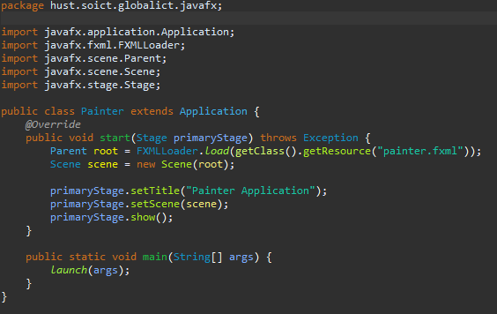

*Figure 10 Playable interface*

## 4.2 Create PainterController.java

## Code

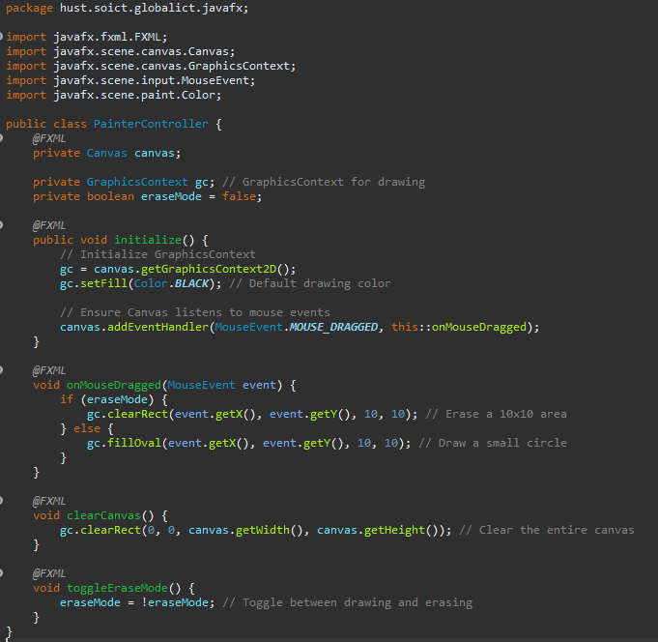

*Figure 11 Implementation*

## 4.3 Create painter.fxml

## Code

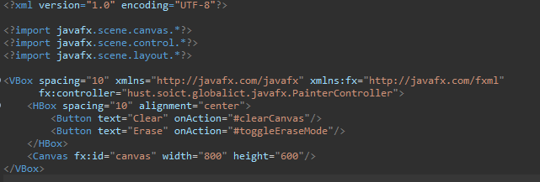

## 4.4 Result

# 5. View Cart Screen for AIMS

## 5.1 Create the CartScreen Class

## Code

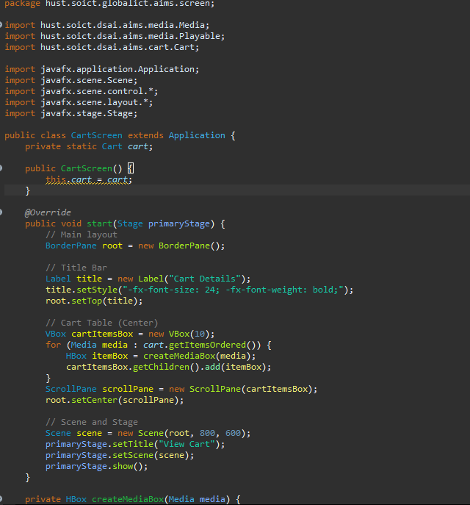

*Figure 12 Updated Cart class*

## 5.2 Result

# 6. Add Button Functionality to View Cart and Store Screen

## 6.1 Update StoreScreen to Add "View Cart" Button

## Code

*Figure 13 Updated Store class*

## 6.2 Update CartScreen to Add "Back to Store" Button

## Code

## 6.3 Result

# 7. Dynamically Display Store Items and Add to Cart

## 7.1 "Add to Cart" button for each item, allowing users to add items to the cart.

## Code

## Result

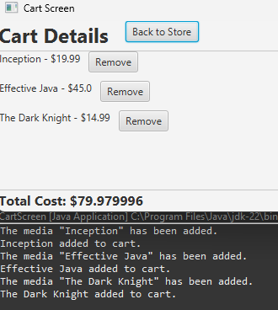

*Figure 15 Comparator for sorting*

# 8. Diagrams

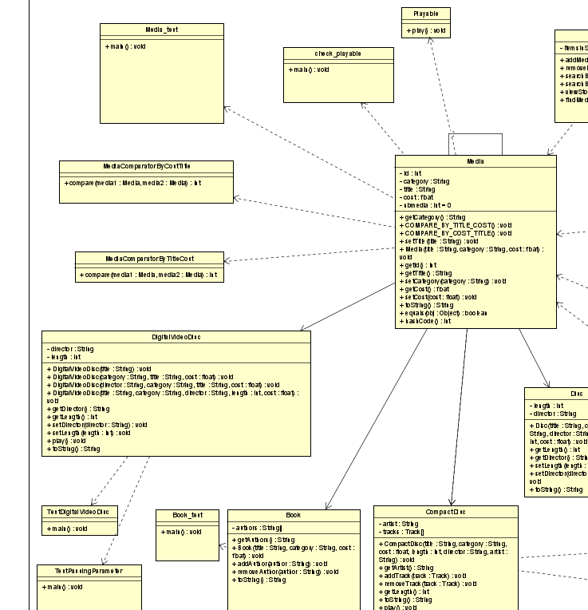

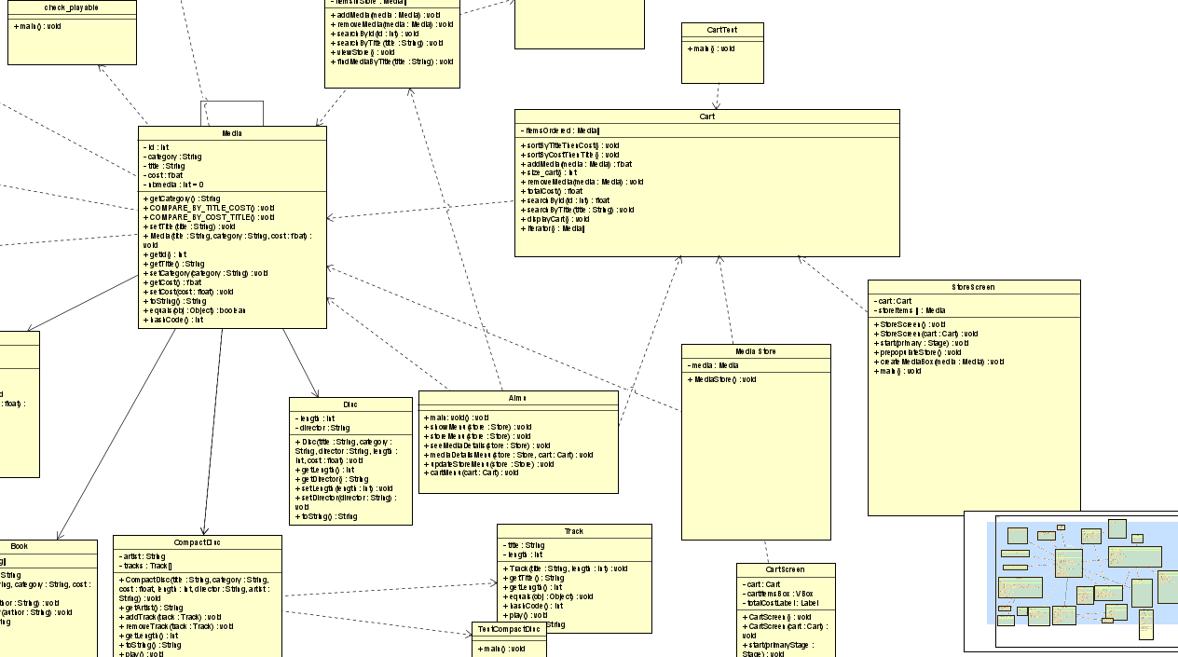

*Figure 16 Class Diagram*

*Figure 17 UseCase Diagram*