Evaluation Warning: The document was created with Spire.Doc for .NET.
Hello World!
Id | fname | lname | bdate | gender | phone | address | picture
1231 | sdfasf |  | 3/26/2000 10:13:52 AM | Female | 13123 | wetqw | 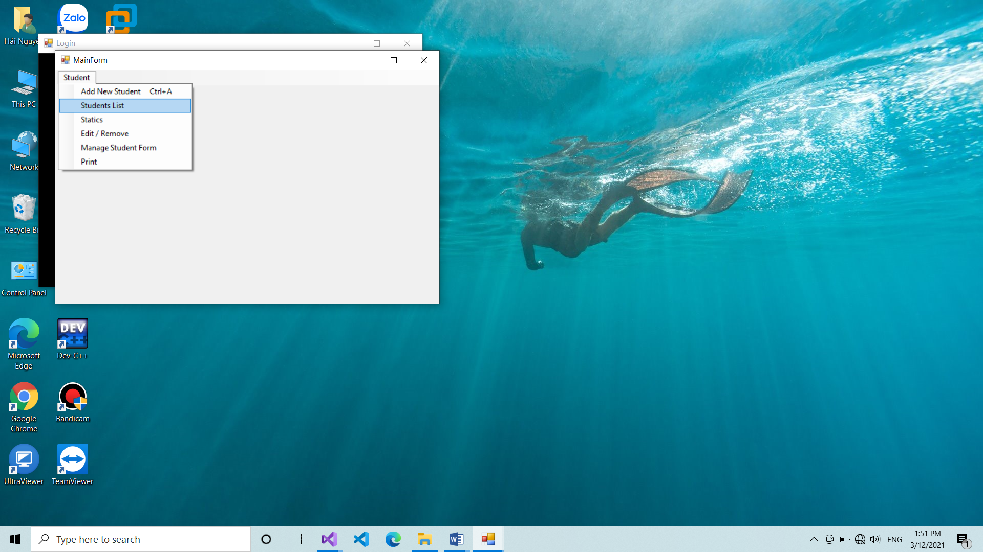
12312 | dfsaga |  | 3/26/2001 3:29:33 PM | Female | 34234 | dsfaf
12345678 | BBBBBB |  | 3/18/2001 8:05:33 PM | Male | 0934524234 | Ha Noi | 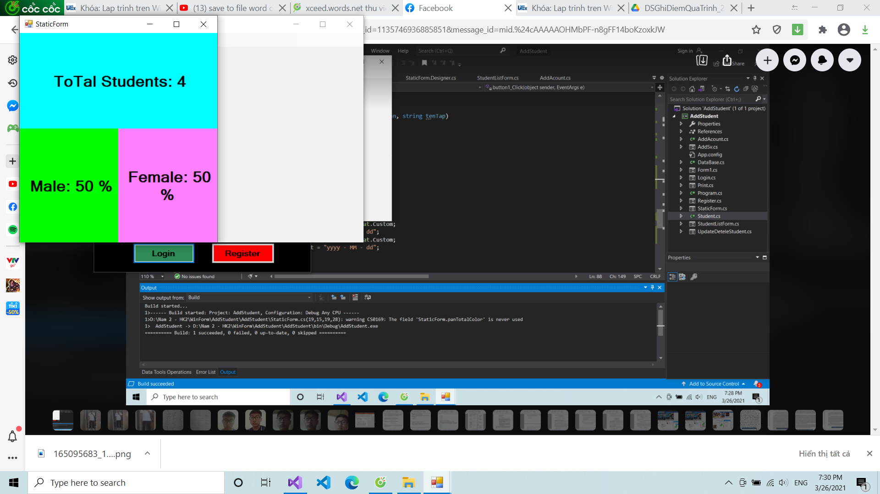
19110356 | Hai |  | 6/10/2001 1:01:10 PM | Male | 0979409568 | Tp. HCM | 

