

International School

Capstone Project 1
CMU-SE 450
Project Proposal
Version 1.0
Date: September 29, 2026
OpenAid – Transparent In-Kind Donation & Volunteer Coordination System
Created by C1SE.102
Hoa, Phan Vinh Thai
Hoang, Tran Le
Tinh, Ta Quang
Tuong, Dang Phuoc
Approved by
ThS. Hieu, Vo Dinh
Proposal Review Panel Representative:

Name Signature Date
Capstone Project 1- Mentor:

Name Signature Date

Project acronym | OpenAid
Project Title | OpenAid – Transparent In-Kind Donation & Volunteer Coordination System
Start Date |  | End Date
Lead Institution | International School, Duy Tan University
Project Mentor | ThS. Hieu, Vo Dinh
Scrum master  / Project Leader & contact details | Name: Hoa, Phan Vinh Thai  Email: thaihoaa246@gmail.com  Tel: 0389289452  ID: 29211153917
Partner Organization | Duy Tan University
Project Web URL | N/A
Team members | Name | Email |  | Tel
 | Hoang, Tran Le | tlhoang2611@gmail.com |  | 0776283644
 | Tinh, Ta Quang | taquangtinh2005gl@gmail.com |  | 0373763660
 | Tuong, Dang Phuoc | tuongido5@gmail.com |  | 0359639381

DOCUMENT APPROVALS
The following signatures are required for approval of this document.
Hoa, Phan Vinh Thai  Student ID: 29211153917  Scrum Master / Project Leader | Signature | Date
Hoang, Tran Le  Student ID: 28212703240  Team Member | Signature | Date
Tinh, Ta Quang  Student ID: 29219051994  Team Member | Signature | Date
Tuong, Dang Phuoc  Student ID: 25213109843  Team Member | Signature | Date

PROJECT PROPOSAL DOCUMENT
Document Title | OpenAid – Transparent In-Kind Donation & Volunteer Coordination System
Author(s) | C1SE.102 Team
Role | Team Member, Scrum Master
Date |  | File name: | C1SE.102_ProjectProposal_v1.0.docx

REVISION HISTORY
Version | Date | Comments | Author
1.0 | September 2026 | Initial Proposal Document | C1SE.102  Team

TABLE OF CONTENTS
1. Project Title 5
2. Project Overview 5
3. Project Background and Motivation 6
3.1 Background 6
3.2 Motivation 7
4. Problem Statement 8
4.1 Real-World Problem 8
4.2 Impact 9
4.3 Why the Team Chose This Problem 9
4.4 Research / Engineering Problem 10
5. Survey / Existing Solutions 10
6. Objectives and Scope 12
6.1 General Objective 12
6.2 Specific Objectives 12
6.3 In Scope 13
6.4 Out of Scope 15
7. Key Features & Requirements 17
7.1 Key Features 17
7.2 Functional Requirements 18
7.3 Non-Functional Requirements 21
8. Constraints and Assumptions 22
8.1 Constraints 22
8.2 Assumptions 22
9. Target Users / Stakeholders 23
10. Technology Stack 24
10.1 Core Technology Stack 24
10.2 Supporting Technologies 25
11. Methodology & Development Plan 25
11.1 Methodology 25
11.2 Team Roles Used in the Plan 26
11.3 12-Week Sprint Plan 29
12. System Architecture Overview 31
12.1 System Context Diagram 31
12.2 System Architecture 33
12.3 Core Workflows 34
12.4 Data Model Overview 35
13. Potential Risks and Mitigation Strategies 36
14. Expected Outcomes / Deliverables 38
Expected Outcomes 38
Demo Scenario 39
Expected Deliverables 41
15. References 41

1. Project Title
OpenAid – Transparent In-Kind Donation & Volunteer Coordination System.
OpenAid is a web-based platform that acts as an intermediary between charitable organizations, volunteers, and donors. It helps organizations publish events, recruit participants, announce in-kind donation needs, receive and manage contributions, create distribution trips, and record evidence so that donors can follow how their support is used.
Within the scope of Capstone Project 1, the system focuses on three core business areas:
- Volunteer Management: events, volunteer roles, registration, approval, and attendance;
- Donation & Inventory: in-kind donation needs, Tracking ID, Inventory, and Donation Batch;
- Distribution & Transparency: Distribution Trip, distribution confirmation, Evidence, Transparency Timeline, and reports.
The system is designed with a Modular Monolith architecture, so that future extensions (notifications, advanced organization verification, GPS, payments, etc.) can be added without significantly changing the core architecture.

2. Project Overview
OpenAid is built to address the fragmented, opaque, and hard-to-track information and processes of charitable activities.
In practice, volunteer recruitment posts, calls for in-kind donations, registration lists, and distribution results are usually scattered across Facebook, Zalo, Google Forms, Excel files, or chat messages. Organizers have to consolidate everything manually, while donors usually only know that they sent their goods and can hardly tell whether the goods have been received, stored, transported, or distributed.
OpenAid provides a unified platform in which the Event is the center: Volunteers join events; Donors contribute to events; the Organization receives goods, groups them into Donation Batches, creates Distribution Trips, and updates distribution evidence. Transparency in OpenAid means traceability, auditability, and accountability: every important step is recorded with who did it, when, in which status, and with which evidence. The system does not automatically verify that submitted evidence is genuine.
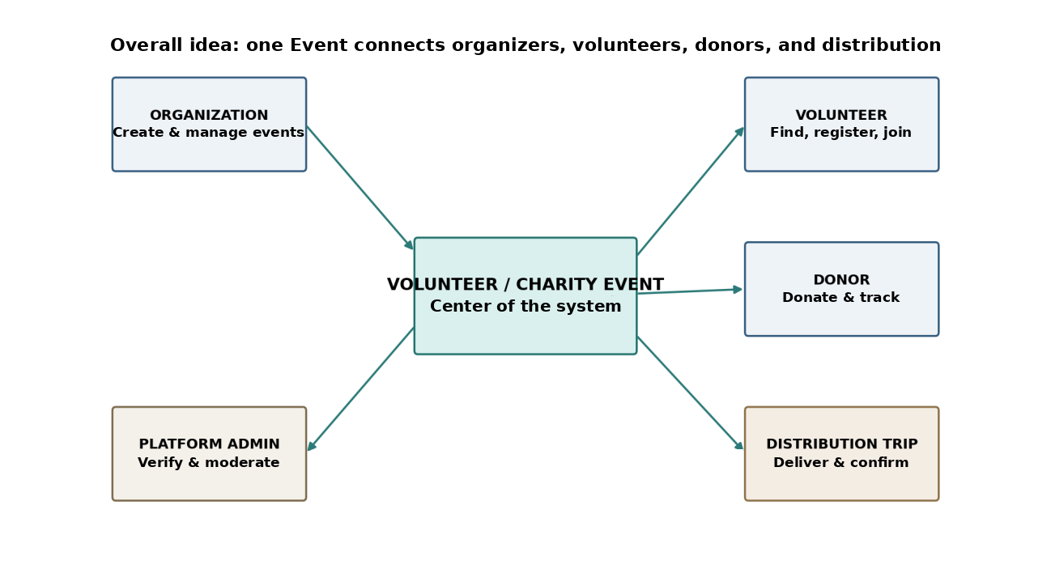
Figure 1. Overall model of the system.
The most important point of the project is not to have a large number of features, but to complete one end-to-end business chain:
Event → Volunteer / Donation → Inventory → Donation Batch → Distribution Trip → Distribution Confirmation → Evidence → Transparency Timeline → Report
Therefore, the first version deliberately leaves out heavy technologies and features such as Live GPS, Payment Gateway, AI, or Blockchain from the MVP; these are recorded in the Future Roadmap.
Capstone Project 1 focuses on building OpenAid Version 1.0 (MVP), in order to demonstrate the feasibility of the business model, the system architecture, and end-to-end, batch-level data traceability from event creation to distribution evidence.

3. Project Background and Motivation

3.1 Background
Charitable and community-support activities (disaster relief, gift giving, support for people in difficult circumstances, etc.) are becoming increasingly common. Most small groups and organizations currently operate with general-purpose tools that were not designed for charity work.
The information channels and tools commonly used include:
- social networks (Facebook, Zalo) for posting calls for help and receiving registrations;
- Google Forms or Excel files for collecting lists of volunteers and donors;
- group chats for coordinating people, vehicles, and goods;
- photos and wrap-up posts after a program to report back to donors.
Because the data is stored in many places and is not linked together, information is easily lost, hard to search, and hard to verify. For example, a donor's rice contribution may be recorded in a message, the warehouse list may sit in Excel, and the photos of the gift distribution may be in another post. To prove that a contribution was used properly, organizers have to cross-check multiple sources by hand.
Beyond fragmentation, charitable activities also face a problem of trust: donors want to know where their contribution has gone, while organizations need recorded, auditable evidence to maintain their reputation. A supporting system therefore needs to do more than manage events; it must also provide a mechanism for tracking, auditability, and accountability of contributions.

3.2 Motivation
The motivation for building OpenAid comes from the need for a central place that connects three groups – organizations, volunteers, and donors – within one unified data flow.
Instead of building just a posting board or a plain CRUD system, the project aims at a value chain:
- Publish: organizations announce events and their needs for people and in-kind goods;
- Participate: volunteers register, get approved, and check in;
- Donate: donors register in-kind donations and receive a Tracking ID;
- Manage: organizations manage inventory, group goods into Donation Batches, and coordinate Distribution Trips;
- Record: the distributed quantities and evidence photos are recorded, so that the process can be audited;
- Report: the Transparency Timeline and summary reports are displayed.
One of the project's design principles is to track by Batch rather than by individual small items. For example, 20 kg + 50 kg + 30 kg of rice from three donors can be grouped into RICE-BATCH-001 = 100 kg; each donor can still see which Batch and which Trip their contribution belongs to and at which Distribution Points that Batch was distributed. This approach is more practical than tagging every bottle of water or every kilogram of rice. The traceability level is therefore batch-level, not item-level physical traceability: a donor can follow Donation → Batch → Trip → Distribution Point → Evidence, but the system does not claim that a specific 20 kg of rice from Donor A was physically handed out at a specific point, because the goods of several donations are mixed inside one Batch.

4. Problem Statement

4.1 Real-World Problem
Charitable activities today are organized without a central tool, with scattered data that is hard to trace from donation to distribution. The real-world problems include:
- Volunteer information is scattered across Facebook, Zalo, Google Forms, or messages, making it hard to find and manage in one place.
- Volunteers may not know clearly how many people an event needs, which roles are still open, or the time, location, and person in charge.
- Donors usually know that they have sent goods, but find it hard to track whether the goods have been received, stored, transported, or distributed.
- Organizers have to manage many files, forms, and group chats themselves, which leads to mistakes or a lack of evidence after the program.
When summarizing a charity program, organizers usually have to:
- Post event information on multiple channels;
- Collect registration lists through forms or messages;
- Review and contact each volunteer;
- Record received goods in an Excel file;
- Compare the quantities of goods against the needs;
- Coordinate vehicles, people, and goods for the gift distribution trip;
- Collect photos and figures after the distribution;
- Compile a report to send back to donors.
This process has several limitations:
- First, managing everything manually across many channels is time-consuming and error-prone.
- Second, there is no common Tracking ID that lets donors check the status of their contribution.
- Third, there is no data link between the goods received, the Batch, the Distribution Trip, and the distribution evidence.
- Fourth, distribution evidence (photos, quantities) is usually disconnected and not tied to specific contributions.
- Fifth, small organizations do not have enough resources to build their own system.

4.2 Impact
These problems can lead to the following impacts:
- Reduced donor trust: it is impossible to verify whether contributions were used for their intended purpose.
- High coordination effort: organizers spend a lot of time consolidating and reconciling data manually.
- Higher risk of discrepancies and losses: in-kind data is recorded in fragments, with no control over status.
- Missed volunteers: event information is hard to reach, and the roles and numbers needed are unclear.
- Difficult to review and improve: the lack of centralized data makes it hard to produce reports and draw lessons for later programs.

4.3 Why the Team Chose This Problem
The team chose this problem for three main reasons.
- First, it is a problem with clear practical and social value, which users can easily picture and whose value they can easily assess.
- Second, it has an end-to-end business flow with many linked entities and states (Event, Volunteer, Donation, Batch, Trip, Evidence), which is well suited to applying the full Software Engineering process, from requirements analysis and design to implementation and testing.
- Third, the scope is controllable: it does not depend on difficult technologies such as real-time GPS, payment gateways, or AI, which allows the team to complete the product within one semester. The results can be evaluated using criteria such as:
- Functional Test Coverage of the main workflows;
- The ability to demo end-to-end following a complete scenario;
- Response time of the main operations;
- The degree of completion of the MVP features.

4.4 Research / Engineering Problem
The main engineering problem of the project is defined as follows: How can we design and build a web platform that connects charitable organizations, volunteers, and donors, and that allows in-kind contributions to be tracked and audited (batch-level traceability) from registration to distribution evidence, within a scope small enough for a team of four students to complete?
The problem is divided into four main issues:
- Event & Volunteer Management: How can events, roles, and the volunteer registration – approval – attendance process be managed?
- Donation Tracking: How can in-kind goods be tracked by Tracking ID, Inventory, and Donation Batch while keeping the solution simple and practical?
- Distribution & Evidence: How can a Batch be linked to a Distribution Trip, with the distributed quantities and evidence photos recorded?
- Transparency: How can the above steps be consolidated into a Transparency Timeline that can be publicly looked up, together with a final summary report?

5. Survey / Existing Solutions
Many groups of solutions currently support volunteering and donations. The survey below presents the representative groups and how OpenAid differs from them.
Social networks and general-purpose tools (Facebook, Zalo, Google Forms, Excel): This is the most common approach because it is easy to use and free. However, these tools were not designed for charity work: the data is separated, hard to search, hard to manage by status, and there is no mechanism to trace a contribution from donation to distribution.
Volunteer-matching platforms (e.g., VolunteerMatch, GivePulse): These platforms focus on posting volunteer opportunities, registration, and tracking volunteer hours. Their strength is volunteer management. VolunteerMatch focuses on recruiting volunteers and managing shifts [13]. GivePulse also supports donation drives and the tracking of in-kind donations [14]; however, the sources reviewed do not describe batch-level inventory, distribution trips, or per-distribution evidence tied to each contribution.
Online fundraising platforms (e.g., GoFundMe) and donation features in e-wallets: These solutions focus on donating money, with online payment [15]. They handle collecting money well but do not manage the workflow of in-kind goods, volunteers, and on-site distribution trips.
General inventory and logistics systems: They offer professional-grade inventory and transport management but are complex, expensive, and lack the charity context (events, donors, public transparency).
Table 1. Feature comparison of OpenAid with existing groups of solutions.
Solution group | Volunteer management | In-kind donation | Inventory | Distribution trip | Donor-facing tracking | Public timeline
Facebook / Zalo / Google Form / Excel | Partial (manual) | Partial (manual) | Partial (Excel) | – | – | –
Volunteer platforms (VolunteerMatch, GivePulse) | ✓ | Partial (GivePulse: donation drives) | – | – | – | –
Fundraising platforms / e-wallets (money) | – | – | – | – | Partial (money only) | –
Inventory / logistics systems | – | – | ✓ | ✓ | Partial | –
OpenAid (planned MVP) | ✓ | ✓ | ✓ | ✓ | ✓ (batch-level) | ✓

Position of OpenAid: OpenAid does not aim to replace fundraising platforms or professional logistics systems, nor is it a charity fund. The system focuses on the role of an intermediary digital infrastructure for verified charitable organizations, and its point of difference is the traceability chain from in-kind contributions to distribution evidence (Donation Batch + Distribution Trip + Transparency Timeline).
Note: the marks in Table 1 are based on the public sources listed in References [13]–[15] and on the common practice of the tool groups; “–” means the feature was not found in the reviewed sources or is not the focus of the tool. The team will verify each claim in more detail, with specific sources, during the Literature Review stage (Deliverable D02).

6. Objectives and Scope

6.1 General Objective
The general objective of the project is to design and build OpenAid Version 1.0 – a web platform that helps charitable organizations publish and manage events, recruit and check in volunteers, receive and manage in-kind contributions through Inventory and Donation Batches, organize distribution trips, and make the whole process traceable and auditable through Tracking IDs, distribution evidence, and the Transparency Timeline.

6.2 Specific Objectives
The project sets the following specific objectives:
Table 2. List of specific objectives.
ID | Specific Objective
OBJ01 | Analyze requirements and identify the actors, use cases, and main workflows for the participants (Organizer, Volunteer, Donor, Admin).
OBJ02 | Design the Modular Monolith architecture and the Data Model to support the end-to-end workflow.
OBJ03 | Build the Account, Organization, and Admin module (registration, login, profile, authorization, Admin enabling an Organization to operate).
OBJ04 | Build the Event Management & Discovery module (event CRUD, volunteer roles, donation needs, search and filter).
OBJ05 | Build the Volunteer module (role registration, approve/reject, My Activities, check-in/check-out by QR or a confirmation button).
OBJ06 | Build the Donation, Tracking ID, and Inventory module (in-kind registration, receipt confirmation, adding to stock and reserving stock for Batches).
OBJ07 | Build the Donation Batch module (grouping donations of the same Event, type, and unit into a batch and updating its status).
OBJ08 | Build the Distribution Trip module (create a trip, assign volunteers, batches, and distribution points, and update the Trip and Distribution Point statuses).
OBJ09 | Build the Distribution Confirmation and Evidence functions (distributed quantities and evidence photos).
OBJ10 | Build the Transparency Timeline, Public Tracking, and a basic Dashboard/Report.
OBJ11 | Build the REST API Backend and the Web Application; package them with Docker.
OBJ12 | Test the main workflows and prepare the data and the end-to-end demo scenario.
OBJ13 | Complete OpenAid Version 1.0 and the related technical documentation.

6.3 In Scope

6.3.1 Account, Organization & Admin
Includes:
- Registration, login, and profile management (no social login);
- Creating an Organization profile; the Platform Admin enables the Organization to operate (its ORGANIZER members can then publish Events);
- Basic management of users, organizations, and events;
- Simple authorization: system roles USER and ADMIN; Organizer is an organization-scoped role (OrganizationMember: MEMBER or ORGANIZER); Volunteer/Donor functions are determined by the action performed.

6.3.2 Event Management & Discovery
- Creating and managing an Event: name, description, time, location, contact person;
- Declaring volunteer needs (role, quantity) and in-kind needs (type, quantity, as a target);
- Event Discovery: list, search, and filter by area, time, and type of support;
- Only an Organization/Organizer approved by the Admin can publish an Event.

6.3.3 Volunteer Participation
- A Volunteer chooses a role and submits an application; the Organizer approves or rejects it;
- My Volunteer Activities: view the events the volunteer has registered for or been approved for;
- Check-in/Check-out by QR or a basic confirmation button; GPS is not required.

6.3.4 Donation, Inventory & Donation Batch
- A Donor views Donation Needs, registers in-kind goods, and receives a unique, non-sequential Tracking ID (e.g., DON-2026-7K3Q9X);
- The Organization confirms receipt of the goods; the quantity is added to Inventory by unit (kg, box, bottle, meal, etc.) as Available stock;
- The Organizer groups donations of the same Event, goods type, and unit into a Donation Batch (e.g., RICE-BATCH-001 = 100 kg); the quantity moves from Available to Reserved, and the Organizer updates the Batch status. A Donation belongs to at most one Batch.

6.3.5 Distribution Trip & Proof of Distribution
- Creating a Distribution Trip for one Event: date and time, departure point, destination, volunteers (approved for that Event, one of them designated Trip Leader), batches of that Event to carry, and Distribution Points;
- Updating the Trip Status (Scheduled → Preparing → In Transit → Completed, or Cancelled) and, separately, the status of each Distribution Point (Pending → Arrived → Distributed, or Skipped); only the Organizer or the Trip Leader can update them;
- At each distribution point, entering the distributed quantity for each Batch and uploading evidence photos (with limits on size and format; public display only after privacy confirmation and Organizer review).

6.3.6 Transparency, Dashboard & Report
- The Transparency Log consists of time, updater, old status, new status, and evidence; it is displayed as the Transparency Timeline;
- Public Tracking: enter a Tracking ID to view the public status of the Donation, its Batch, Trip, Distribution Points, and public Evidence (no login required);
- Basic Dashboard & Report: summary of volunteers, donations, batches, trips, and Needed / Pledged / Received / Distributed quantities; final transparency summary (generated by queries over existing data, without a separate Report entity).

6.3.7 Web Application
The Web Application includes: Login/Register, Profile, Event List/Detail, Volunteer Forms, My Activities, Donation Form, My Donations, Public Tracking, Organizer Console (Inventory, Batch, Trip), Distribution Update, Timeline, Dashboard, and Admin Console.

6.4 Out of Scope
The following items are outside the main implementation scope of Capstone Project 1 (Future Roadmap):
- Live GPS & ETA: no real-time location tracking; the MVP only uses locations as text or map links.
- Donor pickup: no workflow for dispatching vehicles/volunteers to collect goods from donors.
- Real-money donations / Payment Gateway: the system does not hold money and has no payment integration in the MVP.
- Beneficiary 1-to-1: individual beneficiaries are not verified, due to personal-data risks.
- Full Social Network: no like/comment/share/follow; an Event Discovery Feed replaces a forum.
- Micro-volunteering, Group Pooling, Rating / E-certificate / Gamification.
- AI Recommendation, Fraud/Anomaly Detection.
- Blockchain / Smart Contract: a database with an audit log (Transparency Log) is sufficient for the MVP.
- Route Optimization / Logistics Integration: requires external APIs and complex routing logic.
- Advanced Organization Verification (eKYC): in the MVP, the Admin only performs basic manual approval.
- Native Mobile App: the MVP is a responsive Web Application.
In addition, the platform is a digital infrastructure that supports its users: it does not launch charity appeals in its own name, does not decide who the beneficiaries are, does not transport goods itself, and does not take over the organizations' real-world responsibilities.

Phase 2 (if time permits) and Future Roadmap
Phase 2 starts only after the entire MVP has been tested with one complete scenario: in-system Notifications; Organization Verification with document upload (manual Admin approval); Volunteer Skill Profile; Donation Progress Bar; Issue Reporting; Evidence Gallery; and QR codes for Donation Batches at checkpoints.
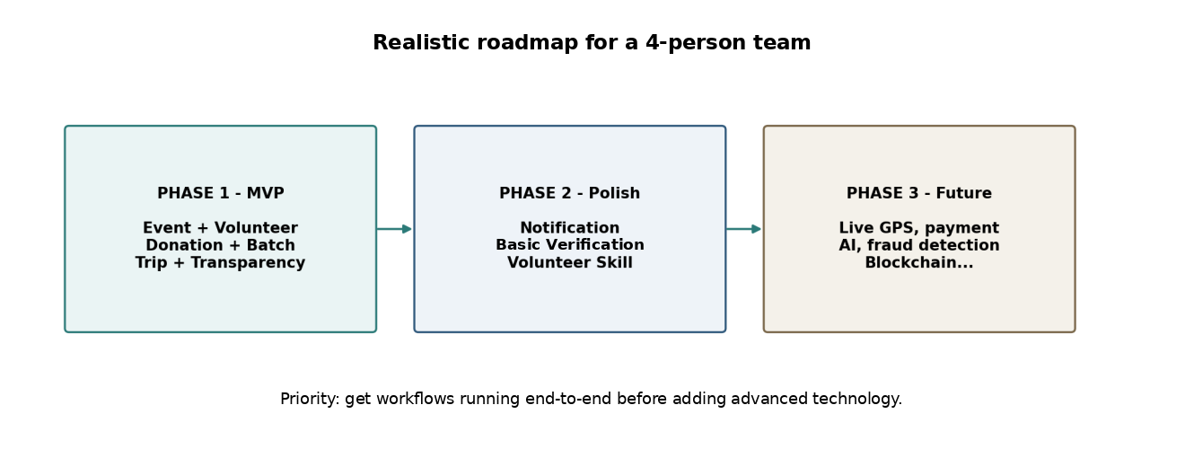
Figure 2. Development roadmap matched to the team's capabilities.

7. Key Features & Requirements

7.1 Key Features
Table 3. List of Key Features.
ID | Feature | Description
KF01 | Account & Profile | Registration, login, and user profile management
KF02 | Organization Management | Organization profile; Admin enables the Organization to operate
KF03 | Event Management | Create and manage events, volunteer roles, and donation needs
KF04 | Event Discovery | Event list, search, and filter
KF05 | Volunteer Registration | Choose a role, submit an application; Organizer approves/rejects
KF06 | My Volunteer Activities | Track the events a volunteer has registered for or been approved for
KF07 | Check-in / Check-out | Attendance by QR or a confirmation button
KF08 | Donation & Tracking ID | Register in-kind goods and receive a tracking code
KF09 | Inventory | Manage stock by unit (Available / Reserved)
KF10 | Donation Batch | Group donations of the same Event, type, and unit into a batch
KF11 | Distribution Trip | Create a trip, assign volunteers, batches, and distribution points; trip and point statuses
KF12 | Distribution Confirmation | Enter distributed quantities and evidence photos
KF13 | Transparency Timeline | Store and display a log by time, actor, old/new status, and evidence
KF14 | Public Tracking | Look up the public status by Tracking ID
KF15 | Dashboard & Report | Summarize figures and the final transparency summary
KF16 | Admin Console | Basic management of users, organizations, and events
KF17 | REST API | Communication between Frontend and Backend
Priority within the 17 Key Features: KF01–KF03, KF05, and KF08–KF14 form the end-to-end core chain and are never dropped. If the schedule slips, KF07 (QR check-in, replaced by a confirmation button), KF16 (Admin moderation), and secondary parts of KF15 (Dashboard & Report) are reduced first. KF17 (REST API) is a technical enabler rather than a user-facing feature.

7.2 Functional Requirements
The system must meet the following functional requirements:
Table 4. List of Functional Requirements.
ID | Functional Requirement | Description | Priority
FR01 | User Authentication | Users register, log in, and log out; passwords are stored as hashes. | High
FR02 | Profile Management | Users view and update their basic personal information. | Medium
FR03 | Role-based Access Control | The system enforces two system roles on each account (USER, ADMIN) and an organization-scoped role on OrganizationMember (MEMBER, ORGANIZER). Organizer permissions apply only to the Organization(s) in which the user is an ORGANIZER. Volunteer and Donor are not permanent roles; they are determined by the user's actions. | High
FR04 | Organization Management | Users create an Organization profile; the Admin enables or disables the Organization's right to operate. | High
FR05 | Event Management | An Organizer creates, edits, publishes, and closes or cancels an Event with name, description, time, location, and contact person; only an approved Organization can publish. Event status: Draft → Published → Closed, or Published → Cancelled. A Draft Event can be deleted; a Published Event that has applications, donations, or trips is never physically deleted. | High
FR06 | Volunteer Roles & Donation Needs | An Organizer declares the roles to be recruited (with quantities) and the list of in-kind goods needed (type, target quantity, unit, chosen from a standard list of goods types and units) for an Event. | High
FR07 | Event Discovery | Users view the Event list and search and filter by area, time, and type of support. | High
FR08 | Volunteer Application | A Volunteer chooses a role and submits an application to join an Event. | High
FR09 | Application Review | An Organizer views the list of applications and approves or rejects them. | High
FR10 | My Volunteer Activities | A Volunteer views the Events they have registered for or been approved for, along with their status. | High
FR11 | Check-in / Check-out | The system records a Volunteer's check-in/check-out by QR or a confirmation button. | Medium
FR12 | Create Donation | A Donor selects a Donation Need of an Event, enters the quantity, and may attach a photo; the system generates a unique, non-sequential Tracking ID. The Donation Need is a target: the total pledged quantity may exceed it, in which case the system only shows a warning. The Event page and Dashboard show Needed / Pledged / Received / Distributed quantities (Pledged = registered and not rejected/cancelled; Received = confirmed by the Organization). | High
FR13 | My Donations | A Donor views the list and status of their own donations. | High
FR14 | Confirm Donation Received | The Organization confirms receipt of the goods, or marks the donation as rejected/not received; the system updates the Donation status. | High
FR15 | Inventory Management | When receipt is confirmed, the system adds the quantity to the Organization's Inventory as Available (each item linked to the Event it was donated for). When goods are assigned to a Donation Batch, the quantity moves from Available to Reserved (committed to that Batch and no longer available for other Batches; it stays Reserved while the Trip is being prepared or is in transit). When distribution is confirmed, the Reserved quantity becomes Distributed; any remaining or returned quantity goes back to Available, and any lost quantity is recorded as Lost/Written-off with a note. Assigning a Batch to a Trip does not change the quantities again. | High
FR16 | Donation Batch | An Organizer creates a Batch for one Event, adds donations of that same Event with the same goods type and the same unit (a Donation belongs to at most one Batch), and updates the Batch status. Donation.eventId = Batch.eventId must always hold. | High
FR17 | Distribution Trip | An Organizer creates a Trip for one Event with date and time, departure point, volunteer list, batches, and an ordered list of Distribution Points (destinations). Batch.eventId = Trip.eventId must hold, and only volunteers whose application for that Event is APPROVED can be assigned; one assigned volunteer is designated Trip Leader, the others are Members. | High
FR18 | Trip Status | An Organizer or the Trip Leader updates the Trip status; the system enforces the order Scheduled → Preparing → In Transit → Completed (a Trip can also be Cancelled). Each Distribution Point has its own status, enforced in the order Pending → Arrived → Distributed (or Skipped). The Trip can be Completed only when all its points are Distributed or Skipped. A Trip can be Cancelled only before any of its Distribution Points is Distributed; when it is cancelled, its Batch(es) are unassigned (Batch status Assigned → Ready), their quantities remain Reserved, and they can be assigned to another Trip. A Batch belongs to at most one non-cancelled Trip at a time. | High
FR19 | Distribution Confirmation | The Trip Leader or an Organizer records the distributed quantity for each Batch at each Distribution Point (one DistributionRecord = one Batch + one Distribution Point + distributedQuantity; e.g., Point A receives 40 kg of rice from RICE-BATCH-001 and 200 bottles of water from WATER-BATCH-001). The total distributed for a Batch cannot exceed its quantity. Any difference between the Batch quantity and the total distributed (remaining, returned, or lost) is recorded per Batch with a note. Any assigned volunteer (Leader or Member) may upload related evidence photos. | High
FR20 | Transparency Log | The system automatically logs (time, actor, old status, new status, evidence) every important status change. | High
FR21 | Transparency Timeline | The system displays the Timeline of a Donation/Batch/Trip in chronological order. | High
FR22 | Public Tracking | Anyone who enters a valid Tracking ID can view the public status of that Donation, its related Batch, Distribution Trip, Distribution Points, and public Evidence (only Evidence approved for public display), without exposing personal data. | High
FR23 | Dashboard & Report | The system summarizes the number of volunteers, donations, batches, trips, and the Needed / Pledged / Received / Distributed quantities, and produces the final transparency summary. Reports are generated by queries over existing data (no separate Report entity). | Medium
FR24 | Admin Management | The Admin manages users, organizations, and events, and handles reports/moderation at a basic level. | Medium
FR25 | File Upload Validation | The system restricts the format and size of uploaded image files; the uploader must confirm, before upload, that identifiable beneficiaries are cropped or blurred, or that consent has been obtained. Evidence follows the flow Upload → privacy confirmation → Organizer review → public display, and only Evidence approved by the Organizer is shown in Public Tracking and on the public Timeline. | Medium
FR26 | Error Handling & Logging | The system displays clear error messages and logs important errors. | Medium

7.3 Non-Functional Requirements
Table 5. List of Non-Functional Requirements.
ID | Requirement | Target
NFR01 | Performance | Common API operations (list, detail, create, status update) respond in under 3 seconds in the staging/demo environment (single Docker Compose deployment with the seed dataset)
NFR02 | Security | JWT authentication, password hashing, role-based access control; input validation
NFR03 | Privacy | Public Tracking does not display personal information of donors/volunteers; evidence photos become public only after the uploader confirms that identifiable beneficiaries are cropped or blurred before upload (or that consent has been obtained) and the Organizer reviews and approves the Evidence for public display; the MVP does not perform automatic face detection or image processing
NFR04 | Usability | Responsive interface (desktop and mobile widths); each main task (apply for a volunteer role, create a donation, update a Distribution Point) is completed in at most 5 steps from the home page
NFR05 | Data Integrity | For every Inventory item, Received = Available + Reserved + Distributed + Lost/Written-off at all times (returned goods go back to Available); Donation, Batch, Trip, and Distribution Point statuses change only in the allowed order (invalid transitions are rejected)
NFR06 | Traceability | Every important status change has a Transparency Log entry storing actor, time, old status, and new status (and evidence if any)
NFR07 | Maintainability | Modular Monolith with clear module boundaries, following coding conventions
NFR08 | Reliability | Error handling and logging in place; demo data can be restored (seed data); the main end-to-end workflow can be completed without manual database edits
NFR09 | Deployment | Can be deployed with Docker (1 backend + 1 database + frontend)
NFR10 | Documentation | API Documentation (Swagger/OpenAPI) and Technical Documentation are provided

8. Constraints and Assumptions

8.1 Constraints
Time Constraints: The project is carried out within one Capstone Project 1 semester (12-week plan).
Team Constraints: The team has four members of average skill level; each member takes charge of one main group of functions but must support the others during integration.
Technical Constraints: The system must run in a resource-limited environment; a simple, easy-to-debug architecture is preferred (no microservices, no message queue).
Scope Constraints: Medium/Low-priority functions (Table 4) and Phase 2 items will not be pursued until all High-priority MVP functions are complete; no new features are added before the end-to-end MVP works.
Financial Constraints: No real money is handled; there is no payment gateway in the MVP.
Data Constraints: Simulated (seed/synthetic) data is used for the demo; no real personal data of users is used.
Infrastructure Constraints: Locations are shown only as text or map links; no real-time map is integrated.

8.2 Assumptions
- Participating Organizations are manually verified by the Platform Admin at a basic level before they can publish Events.
- Users have a device and an Internet connection to use the Web Application.
- Donors and Organizations are responsible for transporting goods to the receiving point; the system only records information.
- Evidence photos uploaded by volunteers/organizers are assumed to be genuine; the system does not automatically verify photo content.
- Demo data (events, donations, batches, trips) is prepared by the team following a complete scenario.
- QR libraries and file-storage services are available, free or low-cost.
- The system is evaluated in a prototype environment rather than in production.

9. Target Users / Stakeholders
Table 6. User groups and stakeholders.
Stakeholder | Needs
Organizer / Organization | Publish and manage events; approve volunteers; confirm donations; manage inventory, batches, and trips; update evidence and reports
Volunteer | Find suitable events; register for roles; view past activities; check in/out; join trips
Donor | View in-kind needs; register contributions; receive a Tracking ID; follow the contribution timeline
Platform Admin | Manage accounts; approve organizations; moderate events; handle reports
Public Visitor | Look up the public status by Tracking ID
Mentor / Review Panel | Assess feasibility, design quality, and the final product
Project Team | Develop, test, and evaluate the system

One account can take part in several roles at different times (for example, a volunteer in one event and a donor in another). The Organizer permission is an organization-scoped role (OrganizationMember: MEMBER or ORGANIZER), not a global user role; the system-level roles are only USER and ADMIN.

10. Technology Stack

10.1 Core Technology Stack
Table 7. Core Technology Stack.
Layer | Technology | Purpose
Frontend | Next.js (React) | Web Application
UI | TailwindCSS | User Interface
Backend | Node.js + NestJS (TypeScript) | REST API, Modular Monolith
ORM | Prisma | Data access, migrations
Database | PostgreSQL | Business data
File Storage | Local storage (dev) / Cloud Object Storage (deploy) | Evidence photos, donation photos
QR | QR generation/reading libraries (qrcode, html5-qrcode) | Check-in
Authentication | JWT | Authentication and authorization
API Documentation | Swagger / OpenAPI | API documentation
API Testing | Postman, Jest | API testing and unit testing
Container | Docker, Docker Compose | Packaging and deployment
CI/CD | GitHub Actions | Automated build/test
Version Control | Git / GitHub | Source code management, Git workflow
UI Design | Figma | UI/UX
Diagram | draw.io | Architecture diagrams, ERD
Project Management | Jira / GitHub Projects | Product Backlog, Sprint tracking

Note: the technology stack is fixed as Next.js + NestJS + Prisma + PostgreSQL + Docker; the Backend will not be replaced during the project. Microservices are not used in the early stage.

10.2 Supporting Technologies
Table 8. Supporting Technologies.
Technology | Role in OpenAid | Notes
Map link (Google Maps link) | Display event/distribution point locations via a link | No real-time tracking in the MVP
Multer / file upload middleware | Upload evidence photos, with limits on size and format | No advanced media processing
class-validator | Validate input data on the Backend | Reduce data errors and security risks
bcrypt | Hash user passwords | Account security

11. Methodology & Development Plan

11.1 Methodology
The team applies the Agile/Scrum software development methodology with short development cycles (2-week Sprints). This approach suits OpenAid thanks to its flexibility: it allows the modules of the Modular Monolith architecture to be developed in parallel and integrated early, workflow by workflow.
Each Sprint delivers a testable goal, including:
- Foundation & Design: Requirement Baseline, Data Model, API contract, wireframes, and the Next.js/NestJS project skeleton (Sprint 1, weeks 1–2);
- Identity & Event: Account, Organization, authorization, Event, and Discovery (Sprint 2, weeks 3–4);
- Volunteer & Donation: registration – approval – check-in, Donation, Tracking ID, and receipt confirmation (Sprint 3, weeks 5–6);
- Inventory, Batch & Trip: Inventory, Donation Batch, Distribution Trip, and Trip Status (Sprint 4, weeks 7–8);
- Transparency & Final Integration: Distribution Confirmation, Evidence, Timeline, Public Tracking, Dashboard and Admin screens, and final system integration (Sprint 5, weeks 9–10);
- Testing & Finalization: end-to-end testing, bug fixing, completing the documentation, and the demo (Sprint 6, weeks 11–12).
Before coding, the team agrees on the database model, API contract, Git workflow, coding conventions, and Definition of Done. The team codes scenario by scenario and tests each small workflow before connecting them. As assigned in Section 11.2, the two Backend members (M2, M3) develop the APIs in parallel across two groups of modules; the Frontend Lead (M1) builds the user interface and connects to the APIs as soon as each module is ready; M4 supports M1 on the user interface and tests the APIs in Postman before handing them over to the Frontend. Members support one another during integration so that every workflow runs end-to-end. From Sprint 2 onwards, each Sprint ends with an integration checkpoint in which the workflows completed so far are tested end-to-end, instead of leaving integration to the last Sprints. In the 12-week plan below, M1–M4 correspond to members No. 1–4 in Table 9.

11.2 Team Roles Used in the Plan
The project follows the Scrum model with three main groups of responsibility: Product Owner, Scrum Master, and Developers. Because the team has four members, the Product Owner and Scrum Master responsibilities are each taken on by one member in addition to technical work.
Table 9. Member roles in the plan.
No. | Member | Scrum Role | Main Responsibilities | Technical Responsibilities
1 | Hoa, Phan Vinh Thai | Scrum Master (SM) | Coordinate Scrum events (Sprint Planning, Standup, Review); track Sprint progress; remove technical obstacles; agree on the Definition of Done (DoD). | Frontend Lead; Next.js; TailwindCSS; UI/UX; API Contracts; Database Schema; System Integration
2 | Tinh, Ta Quang | Developer | Develop the Backend modules for identity and participant management according to the Product Backlog; work with the Frontend to integrate the APIs; write the Swagger API documentation. | Backend Development; NestJS; Auth; Organization; Event CRUD; Volunteer Management; Swagger API
3 | Hoang, Tran Le | Developer | Develop the Backend modules for in-kind goods, inventory, and distribution according to the Product Backlog; handle file storage and the transparency log; work with the Frontend to integrate the APIs. | Backend Development; NestJS; Donation; Inventory; Batching; Distribution Trip; File Upload; Transparency Log
4 | Tuong, Dang Phuoc | Product Owner (PO) | Manage the Product Backlog; prioritize requirements per Sprint; define the Acceptance Criteria for the 17 Key Features; represent stakeholder needs; prepare the CMU academic documents. | QA Lead; SRS Documentation; System Architecture; Test Plan; Postman API Testing; Seed Data; Final Demo; Frontend Support (assisting M1 with UI screens)

11.3 12-Week Sprint Plan
Table 10. 12-week plan.
Week | Main Activities | Expected Result
W1 | Requirement Analysis, Scope, identify actors and use cases (whole team; M4: Product Backlog, Acceptance Criteria) | Requirement Baseline
W2 | Design the architecture, Data Model, API contract, and UI wireframes; set up the environment (M1: API contract, wireframes, Next.js skeleton; M2, M3: NestJS skeleton; M1, M2, M3: Data Model and Prisma schema, agreed together; M4: SRS, Test Plan) | Design Baseline & Project Skeleton
W3 | Account, Organization, authorization (BE: M2; FE: M1); M3 prepares the shared components: file upload, TransparencyLog, Tracking ID generation | Auth & Organization Module
W4 | Event Management and Event Discovery (BE: M2; FE: M1); M3 develops the Donation and Tracking ID APIs | Event Module
W5 | Volunteer Application, Approval, My Activities, Check-in/out (BE: M2; FE: M1); M3 develops the receipt confirmation and Inventory APIs | Volunteer Module; Checkpoint 1: Auth → Event → Volunteer tested end-to-end
W6 | Donation Needs, Donation, Tracking ID, receipt confirmation (FE: M1 connects to M3's APIs); M3 develops the Donation Batch API; M2 develops the Admin API | Donation Module
W7 | Inventory (Available/Reserved) and Donation Batch (FE: M1); M3 finalizes Batch and starts the Trip API; M2 supports M3 on Inventory and Batch testing and starts the Dashboard & Report queries | Inventory & Batch Module; Checkpoint 2: Donation → Inventory → Batch tested end-to-end
W8 | Distribution Trip, Trip and Distribution Point statuses (BE: M3; FE: M1); M2 finalizes the Dashboard & Report API and supports M3 | Trip Module; Checkpoint 3: Batch → Trip tested end-to-end
W9 | Distribution Confirmation, Evidence, Transparency Log/Timeline, Public Tracking (BE: M3, with M2 supporting; FE: M1) | Transparency Module; Checkpoint 4: Trip → Distribution → Evidence tested end-to-end
W10 | Dashboard and Admin screens; final integration of Timeline and Public Tracking with the other modules (FE: M1 completes the Dashboard and Admin screens; whole team integrates) | Integrated Prototype; Checkpoint 5: full end-to-end demo scenario
W11 | End-to-end testing, bug fixing, preparing demo data (M4 coordinates testing and seed data; whole team fixes bugs) | Test Report
W12 | Bug Fixing, Documentation, Demo (M4 coordinates the demo script; M1 runs the Sprint Review) | OpenAid Version 1.0

If the schedule slips, the team drops QR check-in (replaced by a confirmation button), Admin moderation, secondary Dashboard/Report parts, and secondary UI parts first; Donation Batch, Distribution Trip, and Transparency Timeline are never dropped because they give the project its depth.

12. System Architecture Overview
OpenAid uses a Modular Monolith architecture: the backend is deployed as a single application, but its source code is clearly divided into modules. This choice suits a team of four because it avoids the configuration, deployment, inter-service communication, and debugging complexity of microservices.

12.1 System Context Diagram
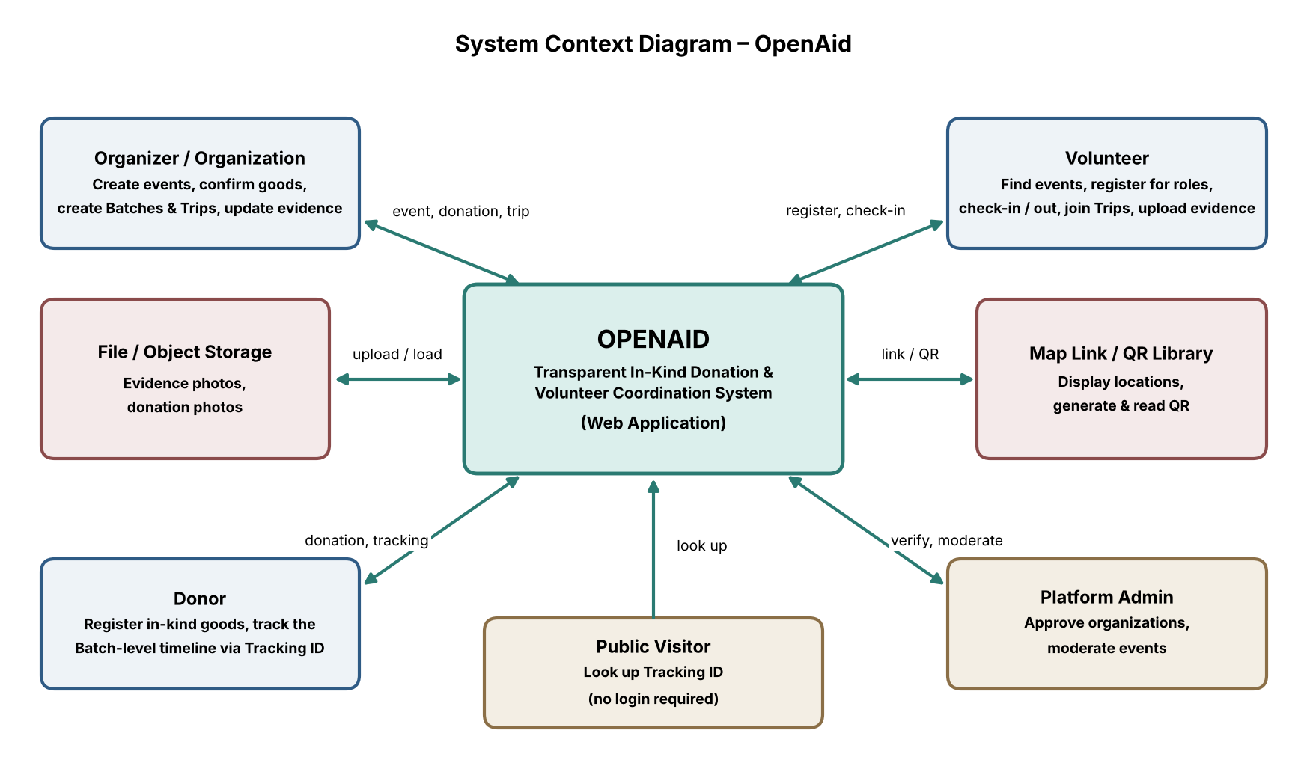
Figure 3. System Context Diagram of OpenAid.
In the diagram, OpenAid sits at the center as an intermediary platform that receives, manages, and makes charitable activities transparent. The actors and external systems interact with it as follows:
Organizer / Organization
- create and manage Events, and declare volunteer and in-kind needs;
- approve volunteers, confirm donations, and create Batches and Trips;
- update distribution evidence and view the Dashboard/Report.
Volunteer
- find Events and register for roles;
- view My Activities, check-in/check-out;
- join Trips when assigned and upload evidence; the Trip Leader updates statuses and quantities.
Donor
- view Donation Needs and register in-kind goods;
- receive a Tracking ID and follow the batch-level timeline of the contribution.
Platform Admin
- manage accounts, approve Organizations, moderate Events, and handle reports.
Public Visitor
- look up the public status by Tracking ID without logging in.
External Services
- File / Object Storage stores evidence photos and donation photos;
- Map link / QR Library displays locations and generates/reads QR codes.

12.2 System Architecture
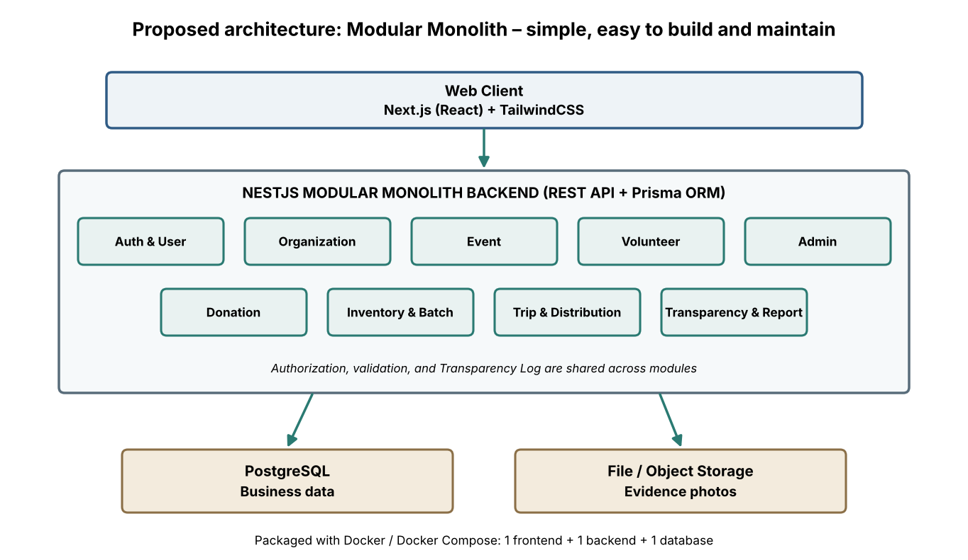
Figure 4. Modular Monolith architecture of OpenAid.
Presentation Layer
Next.js provides: Event List/Detail, Volunteer Forms, Donation Form, Public Tracking, Organizer Console (Inventory, Batch, Trip), Timeline, and Dashboard.
Backend / Application Layer
NestJS provides the REST API, organized into the following modules:
- Auth & User; Organization;
- Event; Volunteer;
- Donation; Inventory & Batch;
- Trip & Distribution; Transparency & Report;
- Admin.
Data Layer
- PostgreSQL stores the business data;
- File / Object Storage stores evidence photos (local during development, cloud when deployed).
Deployment
One backend + one database + one frontend, packaged with Docker/Docker Compose; simplicity and ease of debugging are prioritized.

12.3 Core Workflows
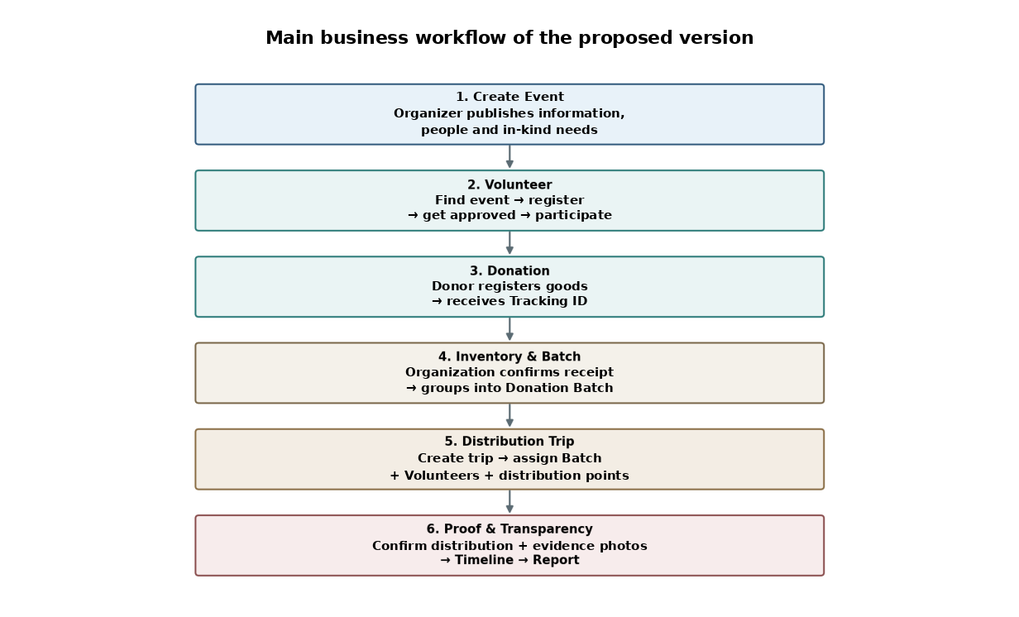
Figure 5. Main business workflows of the system.
Volunteer Workflow
- Discover Event
- View Event Detail
- Choose Volunteer Role
- Submit Application
- Organizer Approve / Reject
- Check-in
- Participate
- Check-out / Complete
Donation Workflow
- View Donation Needs
- Create Donation
- Receive Tracking ID
- Organization confirms received
- Add to Inventory (Available)
- Assign to Donation Batch (Available → Reserved)
- Assign Batch to Distribution Trip
- Distribute
- Upload Evidence
- Donation / Batch becomes Distributed (confirmed by distribution evidence)
Distribution Workflow
- Organizer creates Trip
- Assign approved volunteers (one Trip Leader)
- Assign donation batches
- Start Trip
- Update Trip Status
- Mark Distribution Point as Arrived
- Confirm quantity distributed (point becomes Distributed)
- Upload evidence
- Complete Trip (all points Distributed or Skipped)
- Generate transparency summary

12.4 Data Model Overview
The team starts with the entities that directly serve the workflows and adds more only when truly needed; no entities are designed for Future features from the start.
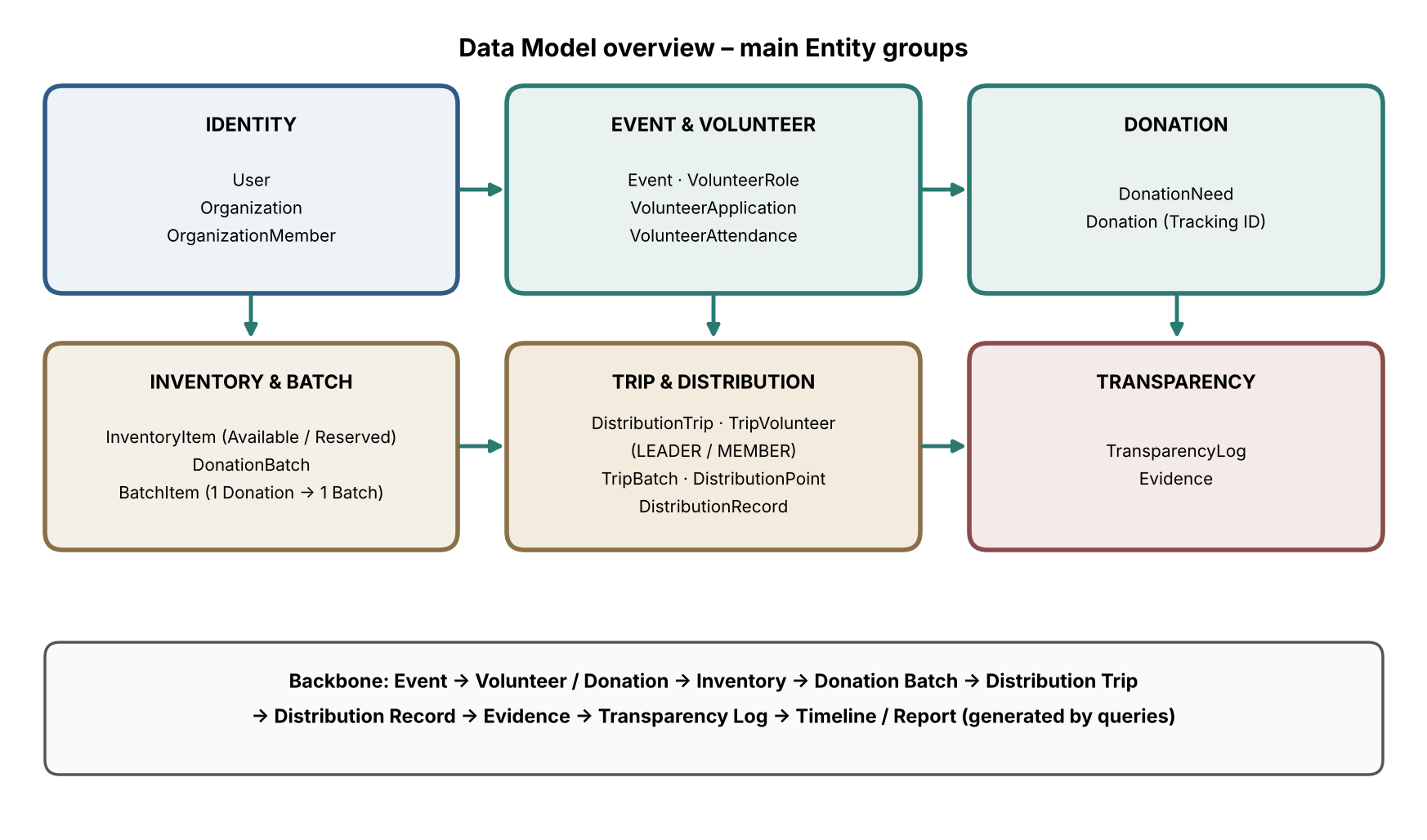
Figure 6. Data Model overview.
Table 11. Entity groups of the Data Model.
Domain | Suggested entities
Identity | User (systemRole), Organization, OrganizationMember (role)
Event & Volunteer | Event, VolunteerRole, VolunteerApplication, VolunteerAttendance
Donation | DonationNeed, Donation
Inventory & Batch | InventoryItem, DonationBatch, BatchItem
Trip & Distribution | DistributionTrip, TripVolunteer, TripBatch, DistributionPoint, DistributionRecord
Transparency | TransparencyLog, Evidence
Reporting & Notification | No separate entity in the MVP: Dashboard & Report are generated by queries over existing data; Notification is a Phase 2 item
Key business rules enforced by the Backend (database constraints and status checks):
- Same Event: Donation.eventId = DonationBatch.eventId = DistributionTrip.eventId. A Batch never mixes Donations of different Events, goods types, or units.
- One Donation, one Batch: a Donation is assigned to at most one Batch (no splitting), which keeps the chain Donation → Batch → Trip → Distribution Point → Evidence unambiguous.
- Inventory quantities: Available → Reserved (when a Batch is created) → Distributed (when distribution is confirmed); remaining or returned goods go back to Available, and lost goods are recorded as Lost/Written-off with a note, so that Received = Available + Reserved + Distributed + Lost/Written-off.
- Trip staffing: only volunteers whose VolunteerApplication for the same Event has status APPROVED can be assigned to a Trip; each TripVolunteer has a role of LEADER or MEMBER.
- Trip authorization: only an Organizer (an ORGANIZER of the Event's Organization) or the Trip Leader changes Trip and Distribution Point statuses and confirms distributed quantities; Members can view and upload evidence.
- Distribution records: each DistributionRecord stores one Batch, one Distribution Point, and the distributed quantity; the total distributed for a Batch across all points cannot exceed the Batch quantity, and the remaining, returned, or lost quantity is recorded per Batch.
- Cancelled Trip: a Trip can be cancelled only before any Distribution Point is Distributed; its Batch(es) return from Assigned to Ready, stay Reserved, and can be assigned to another Trip (Trip A Cancelled → Batch still Reserved → Trip B). Each unassignment is logged in the Transparency Log.
- Statuses: Event Draft → Published → Closed (or Published → Cancelled); Trip Scheduled → Preparing → In Transit → Completed (or Cancelled); Distribution Point Pending → Arrived → Distributed (or Skipped). Every change is logged with actor, time, old status, and new status.
- Donation Need is a target, not a hard cap: pledges above the target are allowed with a warning; Needed / Pledged / Received / Distributed are shown separately because pledged does not mean received.
- Traceability level: batch-level, not item-level physical traceability; the system records who did what, when, and with which evidence, but does not verify that evidence is genuine.

13. Potential Risks and Mitigation Strategies
During the development of OpenAid, the team may face risks related to scope, technology, team capability, and schedule. The main risks and their mitigation strategies are identified as follows:
Table 12. Risks and mitigation strategies.
Risk | Probability | Impact | Mitigation
Overly broad scope (Scope Creep) | High | High | Lock the MVP scope; do not add new features before the end-to-end MVP works
Schedule delays | Medium | High | Prioritize High-priority functions (Table 4); if behind, drop QR check-in (use a confirmation button instead), Admin moderation, and secondary Dashboard parts first
Team is weak in domain knowledge / technical skills | Medium | High | Code scenario by scenario and test each small workflow before connecting them; the stack is fixed from Sprint 1 and learned through small, early workflows
Too many statuses | Medium | Medium | Use only the statuses truly needed for the UI and reports: Donation (Pending → Received / Rejected → In Batch → Distributed; or Cancelled), Batch (Draft → Ready → Assigned → Distributed; back to Ready if its Trip is cancelled), Event (Draft → Published → Closed, or Published → Cancelled), Trip (Scheduled → Preparing → In Transit → Completed / Cancelled), Distribution Point (Pending → Arrived → Distributed / Skipped), Application (Pending → Approved / Rejected)
Map/GPS consumes too much time | Medium | Medium | The MVP uses location text/map links; real-time features are left for the Future
QR is too complex | Low | Medium | Use QR only for check-in (QR for Batches is left to Phase 2); no QR for individual items
Evidence file errors | Medium | Medium | Limit image size and format; no advanced media processing
Messy authorization | Medium | High | Use simple system roles (USER/ADMIN) plus an organization-scoped Organizer role through OrganizationMember; Volunteer/Donor functions are determined by the action performed; only the Organizer or Trip Leader can change Trip statuses
Difficult module integration | Medium | High | Agree on the API contract and Git workflow; integrate early in each Sprint
Inconsistent data (Inventory, Batch) | Medium | High | Database constraints (same Event, one Donation per Batch), status checks on the Backend, and tests for the Available → Reserved → Distributed quantity flow
Trust risk / fake data | Medium | Medium | Admin approves Organizations; only approved Organizers can publish Events; keep a Transparency Log; OpenAid provides traceability and accountability (who did what, when, with which evidence) and does not claim to prove that evidence is genuine
Difficult deployment | Medium | Medium | No microservices/message queue; use Docker Compose and simple CI/CD

14. Expected Outcomes / Deliverables

Expected Outcomes
After completing Capstone Project 1, the team expects to deliver OpenAid Version 1.0 with the following main capabilities:
Volunteer Management
- Event Management & Discovery;
- Volunteer Application, Approval, My Activities;
- Check-in / Check-out.
Donation & Inventory
- Donation Needs, Donation, and Tracking ID;
- Receipt confirmation and Inventory;
- Donation Batch.
Distribution & Transparency
- Distribution Trip, Trip Status, and Distribution Point Status;
- Distribution Confirmation and Evidence;
- Transparency Timeline and Public Tracking.
Web Application
- Interfaces for Organizer, Volunteer, Donor, and Admin;
- Basic Dashboard and Report.
Evaluation
- Functional correctness of the main workflows;
- End-to-end demo scenario;
- Performance and data consistency.
Demo success criterion: viewers can trace from Event → Volunteer → Donation → Batch → Trip → Distribution → Evidence → Report without anyone having to explain that “the team hasn't connected this part yet”.

Demo Scenario
Planned demo scenario: the Event “Support for the Hòa Vang Flood Area”.
Table 13. Final demo scenario.
Step | Demo
1 | The Organizer creates an Event: 20 volunteers, 500 kg of rice, and 1,000 bottles of water needed.
2 | Volunteer A registers for Transportation; Volunteer B registers for Distribution; the Organizer approves.
3 | Donor A contributes 20 kg of rice, Donor B 50 kg, and Donor C 30 kg; the system generates Tracking IDs, and the Event page shows Needed 500 kg / Pledged 100 kg.
4 | The Organization confirms receipt; Inventory shows 100 kg of rice Available (Received 100 kg).
5 | The Organizer creates RICE-BATCH-001 = 100 kg (Inventory: Available 0 kg, Reserved 100 kg).
6 | The Organizer creates TRIP-001 to Hòa Bắc and assigns the Batch and two approved Volunteers (one as Trip Leader).
7 | The Trip Leader moves the Trip to Preparing → In Transit; each Distribution Point moves Pending → Arrived → Distributed, with the quantity and photos updated (Reserved becomes Distributed); the Trip then becomes Completed.
8 | The Batch completes distribution; the Transparency Timeline displays the steps.
9 | A Donor enters a Tracking ID to see which Batch, Trip, and Distribution Points their donation went through, with the public evidence.
10 | The Organizer opens the Dashboard and generates the final transparency summary.

Expected Deliverables
Table 14. List of Deliverables.
ID | Deliverable
D01 | Project Proposal
D02 | Literature Review
D03 | Requirements Specification
D04 | System Architecture Document
D05 | Data Model (ERD)
D06 | UI/UX Design (Figma)
D07 | Account, Organization & Admin Module
D08 | Event & Discovery Module
D09 | Volunteer Module
D10 | Donation & Inventory Module
D11 | Donation Batch Module
D12 | Distribution Trip Module
D13 | Transparency Module (Timeline, Public Tracking)
D14 | Dashboard & Report
D15 | REST API Backend (NestJS)
D16 | Web Application (Next.js)
D17 | Demo Dataset (seed data)
D18 | Test Plan & Test Report
D19 | API Documentation
D20 | Technical Documentation
D21 | Source Code
D22 | OpenAid Version 1.0
D23 | Final Demonstration

15. References
- Schwaber, K., Sutherland, J. “The Scrum Guide.” 2020.
- Sommerville, I. “Software Engineering.” 10th Edition, Pearson, 2016.
- Fowler, M. “Patterns of Enterprise Application Architecture.” Addison-Wesley, 2002.
- ISO/IEC/IEEE 29148:2018. “Systems and software engineering – Life cycle processes – Requirements engineering.”
- Jones, M., Bradley, J., Sakimura, N. “JSON Web Token (JWT).” RFC 7519, IETF, 2015.
- OWASP Foundation. “OWASP Top 10 Web Application Security Risks.”
- Next.js Documentation.
- NestJS Documentation.
- PostgreSQL Documentation.
- Prisma Documentation.
- Docker Documentation.
- VolunteerMatch, GivePulse, GoFundMe – public documentation and product pages (supporting the survey in Section 5).
- VolunteerMatch – features for recruiting volunteers and managing shifts, as summarized in Instrumentl, “Best Volunteer Recruitment Platforms for Nonprofits”. https://www.instrumentl.com/blog/best-volunteer-recruitment-platforms-for-nonprofits (accessed October 2026).
- GivePulse – Ohio University, “About GivePulse”. https://www.ohio.edu/student-success/community-engagement/givepulse (accessed October 2026).
- GoFundMe – “How fundraising on GoFundMe works”. https://gofundme.com/tour (accessed October 2026).

