**UNIVERSITY OF INFORMATION TECHNOLOGY**

**Faculty of Information Systems**

# 

PROJECT FINAL REPORT

MSIS4263.N22.CTTT

**Decision support and business**

**intelligence applications**

**Instructors: Prof.Do Phuc  
M.Nguyen Thi Kim Phung**

**Group member:**

Nguyễn Đức Thông Thái – 19522188

Nguyễn Đức Trọng – 19522409

Contents

1. About Dataset 2

1.1. Source Page 2

1.2. Describe the Original Dataset 2

1.2.1. Data description 2

1.2.2. Attribute Description 2

1.3. Describe the Atributes of Each Table in Star Schema 3

1.3.1. APPLICANT_DIM 3

1.3.2. FACT 4

1.3.3. GENDER_DIM 4

1.3.4. JOB_CITY_DIM 4

1.3.5. JOB_DIM 4

1.3.6. JOB_INDUSTRY_DIM 5

1.3.7. JOB_OWNERSHIP_DIM 5

1.3.8. JOB_TYPE_DIM 5

1.3.9. RACE_DIM 5

1.3.10. RECEIVED_CALL_DIM 5

1.3.11. RESUME_QUALITY_DIM 5

1.4. Snowflake Schema 5

2. SSIS Process 7

2.1 Create database to import data 7

2.2 Create SSIS project 9

2.3 Create Foreign Key and Primary Key 21

3. SSAS Process 22

3.1 Create Cube 22

3.2 SSAS Query 40

4. Pivot Table 47

5. MDX 55

6. PowerBI 58

# **1. Dataset**

## **1.1. Source Page**

Link: <https://www.kaggle.com/datasets/utkarshx27/which-resume-attributes-drive-job-callbacks?fbclid=IwAR1Jht7zncmU0TxAcrl_P_QiIO7dTQ8HYL3UOeiG3vsydHwxnMWhypXNZMo>

## **1.2. Describe the Original Dataset**

### **1.2.1. Data description**

This experiment data comes from a study that sought to understand the influence of race and gender on job application callback rates. The study monitored job postings in Boston and Chicago for several months during 2001 and 2002 and used this to build up a set of test cases. Over this time period, the researchers randomly generating resumes to go out to a job posting, such as years of experience and education details, to create a realistic-looking resume. They then randomly assigned a name to the resume that would communicate the applicant's gender and race. The first names chosen for the study were selected so that the names would predominantly be recognized as belonging to black or white individuals. For example, Lakisha was a name that their survey indicated would be interpreted as a black woman, while Greg was a name that would generally be interpreted to be associated with a white male.

### **1.2.2. Attribute Description**

File Dataset: resume (contain 4870 lines)

|  |  |
| --- | --- |
| Column | Description |
| job_ad_id | Unique ID associated with the advertisement. |
| job_city | City where the job was located. |
| job_industry | Industry of the job. |
| job_type | Type of role. |
| job_fed_contractor | Indicator for if the employer is a federal contractor. |
| job_equal_opp_employer | Indicator for if the employer is an Equal Opportunity Employer. |
| job_ownership | The type of company, e.g. a nonprofit or a private company. |
| job_req_any | Indicator for if any job requirements are listed. If so, the other job_req_* fields give more detail. |
| job_req_communication | Indicator for if communication skills are required. |
| job_req_education | Indicator for if some level of education is required. |
| job_req_min_experience | Amount of experience required. |
| job_req_computer | Indicator for if computer skills are required. |
| job_req_organization | Indicator for if organization skills are required. |
| job_req_school | Level of education required. |
| received_callback | Indicator for if there was a callback from the job posting for the person listed on this resume. |
| firstname | The first name used on the resume. |
| race | Inferred race associated with the first name on the resume. |
| gender | Inferred gender associated with the first name on the resume. |
| years_college | Years of college education listed on the resume. |
| college_degree | Indicator for if the resume listed a college degree. |
| honors | Indicator for if the resume listed that the candidate has been awarded some honors. |
| worked_during_school | Indicator for if the resume listed working while in school. |
| years_experience | Years of experience listed on the resume. |
| computer_skills | Indicator for if computer skills were listed on the resume. These skills were adapted for listings, though the skills were assigned independently of other details on the resume. |
| special_skills | Indicator for if any special skills were listed on the resume. |
| volunteer | Indicator for if volunteering was listed on the resume. |
| military | Indicator for if military experience was listed on the resume. |
| employment_holes | Indicator for if there were holes in the person's employment history. |
| has_email_address | Indicator for if the resume lists an email address. |
| job_ad_id | Each resume was generally classified as either lower or higher quality. |

## 1.3. Describe the Attributes of Each Table in Star Schema

### 1.3.1. FACT

|  |  |
| --- | --- |
| Column | Description |
| id | Listing ID |
| job_ad_id | Unique ID associated with the advertisement |
| applicant_id | Listing ID of applicant |
| received_callback_id | Listing ID of received callback |
| resume_quality_id | Listing ID of resume quality |

### 1.3.2. APPLICANT_DIM

|  |  |
| --- | --- |
| Column | Description |
| applicant_id |  |
| firstname | Listing ID of applicant. |
| race_id | Inferred race associated with the first name on the resume. |
| gender_id | Inferred gender associated with the first name on the resume. |
| years_college | Years of college education listed on the resume. |
| college_degree | Indicator for if the resume listed a college degree. |
| honors | Indicator for if the resume listed that the candidate has been awarded some honors. |
| worked_during_school | Indicator for if the resume listed working while in school. |
| years_experience | Years of experience listed on the resume. |
| computer_skills | Indicator for if computer skills were listed on the resume. These skills were adapted for listings, though the skills were assigned independently of other details on the resume. |
| special_skills | Indicator for if any special skills were listed on the resume. |
| volunteer | Indicator for if volunteering was listed on the resume. |
| military | Indicator for if military experience was listed on the resume. |
| employment_holes | Indicator for if there were holes in the person's employment history. |
| has_email_address | Indicator for if the resume lists an email address. |

### 1.3.3. GENDER_DIM

|  |  |
| --- | --- |
| Column | Description |
| gender_id | Listing ID of gender |
| gender | Inferred gender associated with the first name on the resume |

### 1.3.4. JOB_CITY_DIM

|  |  |
| --- | --- |
| Column | Description |
| job_city_id | Listing ID of job city |
| job_city | City where the job was located |

### 1.3.5. JOB_DIM

|  |  |
| --- | --- |
| Column | Description |
| job_ad_id | Unique ID associated with the advertisement |
| job_city_id | Listing ID of job city |
| job_industry_id | Listing ID of job industry |
| job_type_id | Listing ID of job type |
| job_ownership_id | Listing ID of job ownership |
| job_fed_contractor | Indicator for if the employer is a federal contractor. |
| job_equal_oop_employer | Indicator for if the employer is an Equal Opportunity Employer. |
| job_req_any | Indicator for if any job requirements are listed. If so, the other job_req_* fields give more detail. |
| job_req_communication | Indicator for if communication skills are required. |
| job_req_education | Indicator for if some level of education is required. |
| job_req_min_experience | Amount of experience required. |
| job_req_computer | Indicator for if computer skills are required. |
| job_req_organization | Indicator for if organization skills are required. |
| job_req_school | Level of education required. |

### 1.3.6. JOB_INDUSTRY_DIM

|  |  |
| --- | --- |
| Column | Description |
| job_industry_id | Listing ID of job industry |
| job_industry | Industry of the job |

### 1.3.7. JOB_OWNERSHIP_DIM

|  |  |
| --- | --- |
| Column | Desciption |
| job_ownership_id | Listing ID of job ownership |
| job_ownership | The type of company, e.g. a nonprofit or a private company. |

### 1.3.8. JOB_TYPE_DIM

|  |  |
| --- | --- |
| Column | Description |
| job_type_id | Listing ID of job type |
| job_type | Type of role |

### 1.3.9. RACE_DIM

|  |  |
| --- | --- |
| Column | Description |
| race_id | Listing ID of race |
| race | Inferred race associated with the first name on the resume. |

### 1.3.10. RECEIVED_CALL_DIM

|  |  |
| --- | --- |
| Column | Description |
| received_call_back_id | Listing ID of received call back |
| received_callback | Indicator for if there was a callback from the job posting for the person listed on this resume. |

### 1.3.11. RESUME_QUALITY_DIM

|  |  |
| --- | --- |
| Column | Description |
| resume_quality_id | Listing ID of resume quality |
| resume_quality | Each resume was generally classified as either lower or higher quality. |

## 1.4. Snowflake Schema

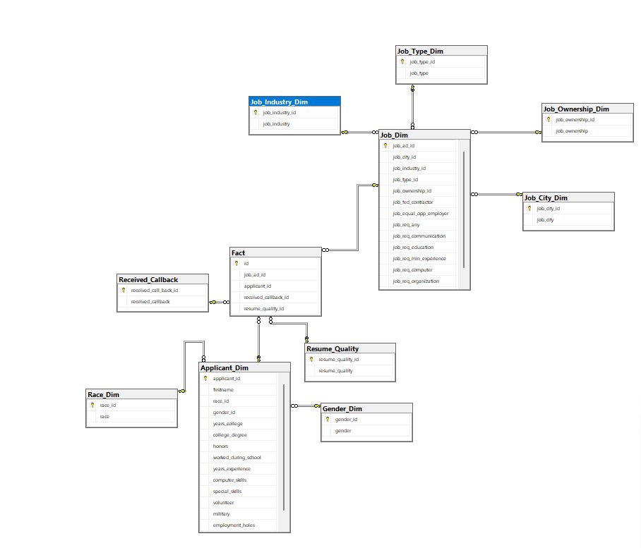

# 2. SSIS Process

## Create database to import data

* Start Microsoft SQL Server
* A screenshot of a computer

  Description automatically generatedCreate database name Resume

## 2.2 Create SSIS project

* After creating database, then we create a SSIS project in Visual Studio
* Click on “Integration Service Project” to create a SSIS project

* In the “Project name” field, type your project name

* We will have a screen like below . After that, choose “Data flow” tab, then drag the “Flat File Source” option to the Data Flow window

* Right click on the “Flat File Source”, choose “Edit” option and browse to your data directory

* Add “Multicast”, “OLE DB Destination” and “Sort” to the “Data Flow” window, then connect them (note: the number of them is dependent on your data)

* Use “OLE DB Destination” to define Fact and Dimension tables based on your data

* Right click on “Sort”, then choose the attribute that you want to sort by. For example, I chose sort for Job_Dim, so I chose job_ad_id to sort the table by that job_ad_id attribute. Ater that, click on “Remove rows with duplicate sort value” to remove duplicate value, then click on OK

* Click on a “OLE DB Destination”, choose “Edit” option. Click on “New”, it will show a window. Click on “New” button, another window will pop up .In the Provider filed, choose the option like in the image below, type in your SQL Server Name to the “Server Name” field, then choose the database we created in the previous steps. Click on OK

* Then, you will be brough back to the “OLE DB Destination Editor”. Click on New (second button) to create table, in this case, I am creating table for Job_Dim. Then Click on “Mapping option” to see if the table was created successfully. Do the same for the remaining tables

* After creating all the tables, it will look like this, then those table will be created in the SQL Server

* Click “Run” button to see if the data is imported successfully

## 2.3 Create Foreign Key and Primary Key

* When we created tables in 2.2, we also set primary key for those tables, so we don’t need to do it anymore.
* To add foreign key for the tables, we use Foreign Key constraint in SQL Server

# 3. SSAS Process

## 3.1 Create Cube

* Create a new project with Visual Studio and choose “Analysis Services Multidimensional Project”

* In the “Solution Explorer”, right click on “Data Sources” and choose “New Data Source”. Then click on “Next” button in “Data Source Wizard” window. After that, choose “New”

* In the “Connection Manager” window, config the setting like the image below (in “Server Name” and “Database” fields, alternate with your server name and database name)

* After establishing a connection to the database, then, click on “Next” button in “Data Source Wizard” window. After that, create a username and password to login into SSAS, then click on finish

* Then we will create a Data Source View by clicking on it and choose “New Data Source View”. In the “Data Source View Wizard”, click on Next

* Then choose your data source and click on “Next” button

* Now, we add all the tables in the data source, then click on “Next”

* Preview the tables one more time and click on “Finish” button

* Then, click on Cubes and choose “New Cube” to create Cube

* In Cube Wizard, click on “Next”, then we choose Fact table as Measures, click on “Next”

* Now, we choose Dimensions, then click on “Next”

* Preview Measure and Dimensions one more time

* We will have a Cube Structure like the image below

* You can add more attributes to a dimension by dragging arbitrary attribute from Data Source view (right side) to Dimension structure (right side)

* Now, click on Start button to deploy it

* Now right click on the cube and choose “Process” to process it

* Main screen of SSAS

## 3.2 SSAS Query

**Question 1 :** What is the distribution of job applicants across different races and genders? Are there any noticeable imbalances or biases?

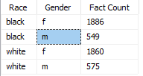

**Question 2 :** Is there a significant difference in callback rates based on race, gender, and resume quality combined per type of job?

**Question 3 :** Are there any particular job industries or types that have a higher likelihood of having employment holes in

**Question 4 :** How does the presence of certain special skills impact the likelihood of being called back for different job types ?

**Question 5**: Are there any notable differences in callback rates for applicants with volunteer or military experience compared to those without?

**Question 6** : Is there a correlation between resume quality and the likelihood of receiving a call back?

**Question 7 :** What factors contribute to a high-quality resume?

**Question 8:** Is there a disparity in callback rates based on "race" and "gender"?

**Question 9 :** Is there any correlation between the level of computer skills required and the job industry? Do certain industries tend to require more computer skills?

**Question 10 :** Do applicants with higher levels of education tend to have higher resume quality?

# 4. Pivot Table

**Question 1:** What is the distribution of job applicants across different races and genders? Are there any noticeable imbalances or biases?

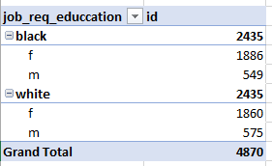

**Question 2:** Is there a significant difference in callback rates based on race, gender, and resume quality combined per type of job ?

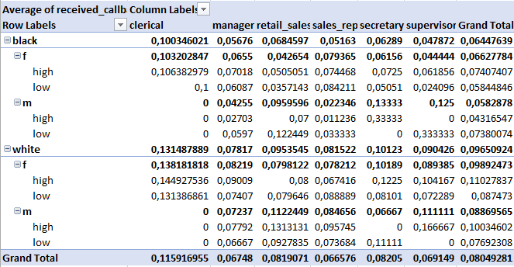

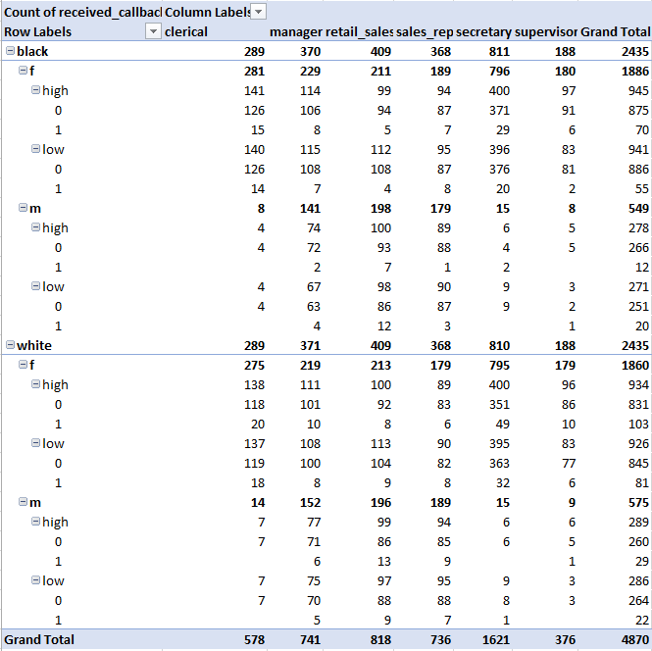

**Question 3:** Are there any particular job industries or types that have a higher likelihood of having employment holes in the applicants' work history ?

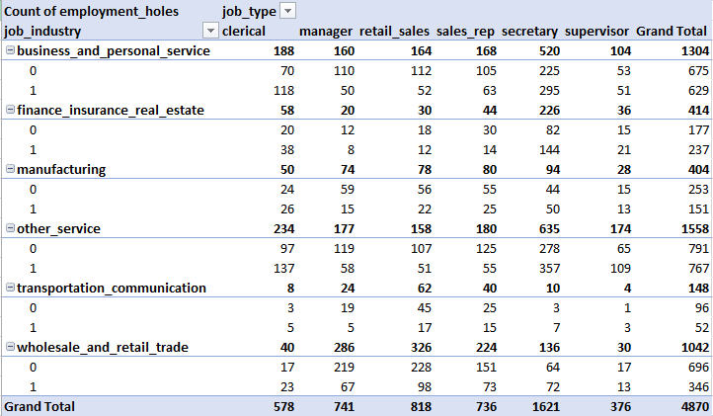

**Question 4:** How does the presence of certain special skills impact the likelihood of being called back for different job types?

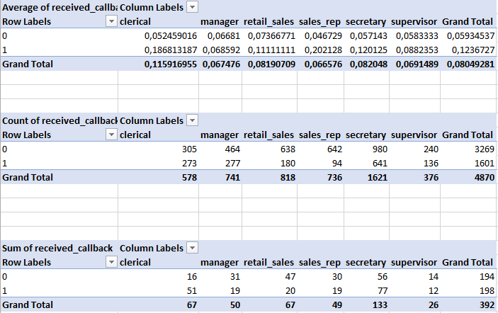

**Question 5:** Are there any notable differences in callback rates for applicants with volunteer or military experience compared to those without?

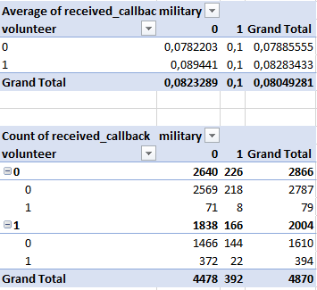

**Question 6:** Is there a correlation between resume quality and the likelihood of receiving a callback?

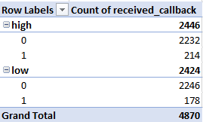

**Question 7:** What factors contribute to a high-quality resume?

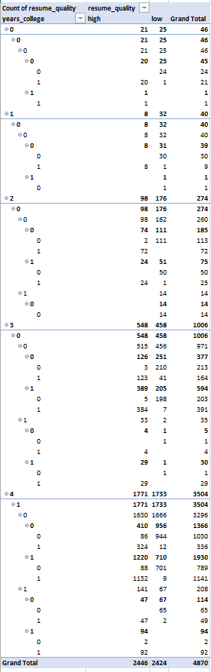

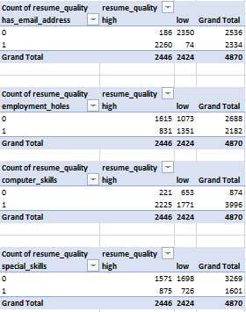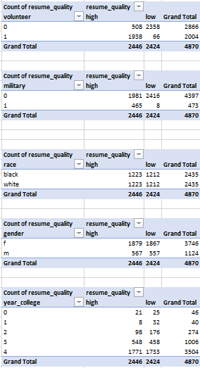

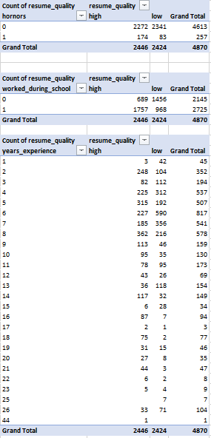

**Question 8:** Is there a disparity in callback rates based on "race" and "gender"?

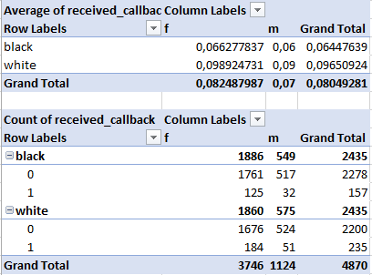

**Question 9:** Is there any correlation between the level of computer skills required and the job industry? Do certain industries tend to require more computer skills?

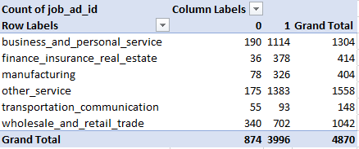

**Question 10:** Do applicants with higher levels of education tend to have higher resume quality?

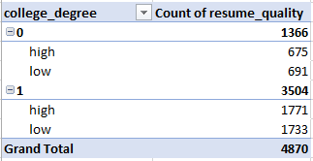

# 5. MDX

**Question 1:** What is the distribution of job applicants across different races and genders? Are there any noticeable imbalances or biases?

SELECT NON EMPTY { [Measures].[Fact Count] } ON COLUMNS, NON EMPTY { ([Applicant Dim].[Race].[Race].ALLMEMBERS * [Applicant Dim].[Gender].[Gender].ALLMEMBERS ) } DIMENSION PROPERTIES MEMBER_CAPTION, MEMBER_UNIQUE_NAME ON ROWS FROM [Resume] CELL PROPERTIES VALUE, BACK_COLOR, FORE_COLOR, FORMATTED_VALUE, FORMAT_STRING, FONT_NAME, FONT_SIZE, FONT_FLAGS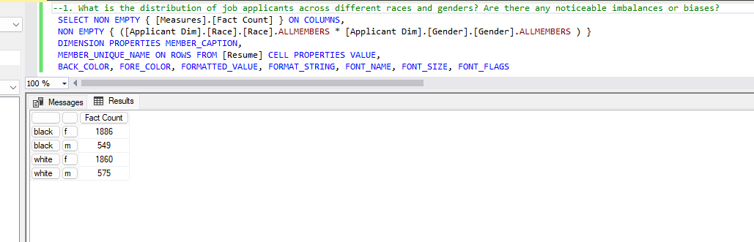

**Question 2:** Is there a significant difference in callback rates based on race, gender, and resume quality combined per type of job?

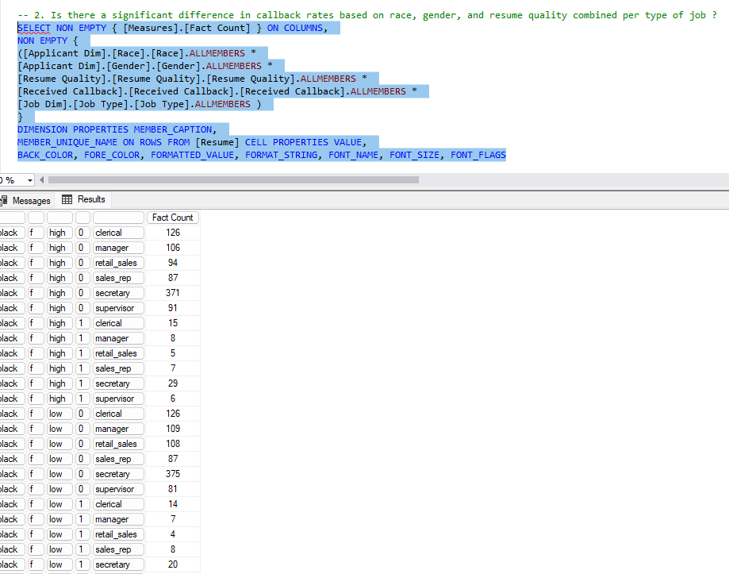

SELECT NON EMPTY { [Measures].[Fact Count] } ON COLUMNS, NON EMPTY { ([Applicant Dim].[Race].[Race].ALLMEMBERS * [Applicant Dim].[Gender].[Gender].ALLMEMBERS * [Resume Quality].[Resume Quality].[Resume Quality].ALLMEMBERS * [Received Callback].[Received Callback].[Received Callback].ALLMEMBERS * [Job Dim].[Job Type].[Job Type].ALLMEMBERS ) } DIMENSION PROPERTIES MEMBER_CAPTION, MEMBER_UNIQUE_NAME ON ROWS FROM [Resume] CELL PROPERTIES VALUE, BACK_COLOR, FORE_COLOR, FORMATTED_VALUE, FORMAT_STRING, FONT_NAME, FONT_SIZE, FONT_FLAGS

**Question 3:** Are there any particular job industries or types that have a higher likelihood of having employment holes in the applicants' work history?

SELECT NON EMPTY { [Measures].[Fact Count] } ON COLUMNS, NON EMPTY { ([Job Dim].[Job Type].[Job Type].ALLMEMBERS * [Job Dim].[Job Industry].[Job Industry].ALLMEMBERS * [Applicant Dim].[Employment Holes].[Employment Holes].ALLMEMBERS ) } DIMENSION PROPERTIES MEMBER_CAPTION, MEMBER_UNIQUE_NAME ON ROWS FROM [Resume] CELL PROPERTIES VALUE, BACK_COLOR, FORE_COLOR, FORMATTED_VALUE, FORMAT_STRING, FONT_NAME, FONT_SIZE, FONT_FLAGS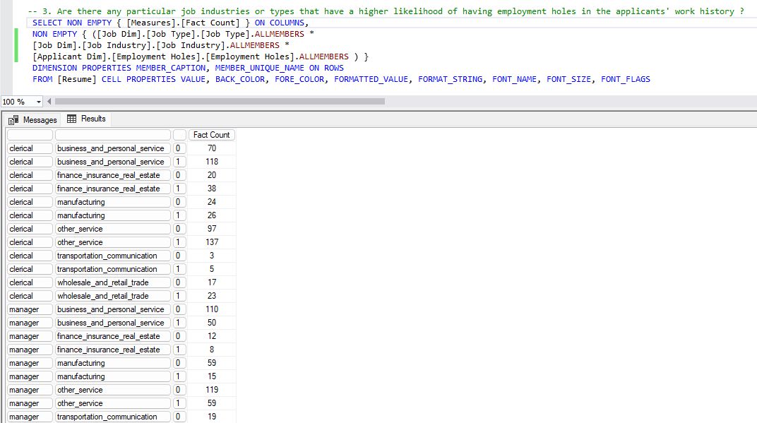

**Question 4:** How does the presence of certain special skills impact the likelihood of being called back for different job types?

SELECT NON EMPTY { [Measures].[Fact Count] } ON COLUMNS, NON EMPTY { ([Job Dim].[Job Type].[Job Type].ALLMEMBERS * [Applicant Dim].[Special Skills].[Special Skills].ALLMEMBERS * [Received Callback].[Received Callback].[Received Callback].ALLMEMBERS ) } DIMENSION PROPERTIES MEMBER_CAPTION, MEMBER_UNIQUE_NAME ON ROWS FROM [Resume] CELL PROPERTIES VALUE, BACK_COLOR, FORE_COLOR, FORMATTED_VALUE, FORMAT_STRING, FONT_NAME, FONT_SIZE, FONT_FLAGS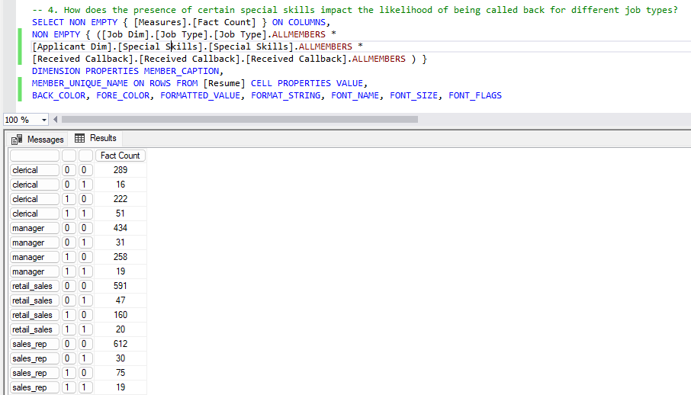

**Question 5:** Are there any notable differences in callback rates for applicants with volunteer or military experience compared to those without?

SELECT NON EMPTY { [Measures].[Fact Count] } ON COLUMNS, NON EMPTY { ([Applicant Dim].[Volunteer].[Volunteer].ALLMEMBERS * [Applicant Dim].[Military].[Military].ALLMEMBERS * [Received Callback].[Received Callback].[Received Callback].ALLMEMBERS ) } DIMENSION PROPERTIES MEMBER_CAPTION, MEMBER_UNIQUE_NAME ON ROWS FROM [Resume] CELL PROPERTIES VALUE, BACK_COLOR, FORE_COLOR, FORMATTED_VALUE, FORMAT_STRING, FONT_NAME, FONT_SIZE, FONT_FLAGS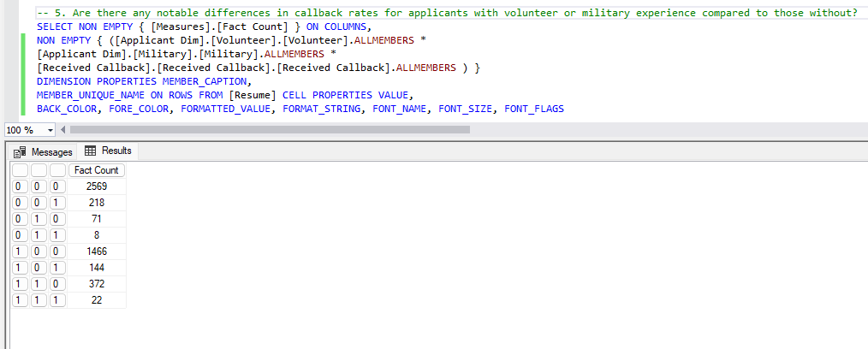

**Question 6:** Is there a correlation between resume quality and the likelihood of receiving a callback?

SELECT NON EMPTY { [Measures].[Fact Count] } ON COLUMNS, NON EMPTY { ([Resume Quality].[Resume Quality].[Resume Quality].ALLMEMBERS * [Received Callback].[Received Callback].[Received Callback].ALLMEMBERS ) } DIMENSION PROPERTIES MEMBER_CAPTION, MEMBER_UNIQUE_NAME ON ROWS FROM [Resume] CELL PROPERTIES VALUE, BACK_COLOR, FORE_COLOR, FORMATTED_VALUE, FORMAT_STRING, FONT_NAME, FONT_SIZE, FONT_FLAGS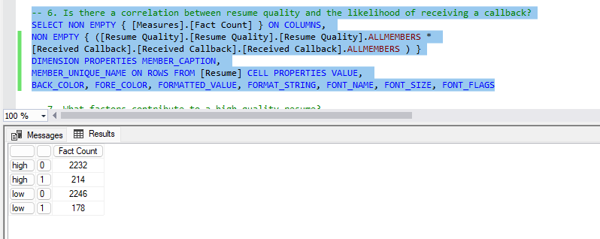

**Question 7:** What factors contribute to a high-quality resume?

SELECT NON EMPTY { [Measures].[Fact Count] } ON COLUMNS, NON EMPTY { ([Applicant Dim].[Has Email Address].[Has Email Address].ALLMEMBERS * [Resume Quality].[Resume Quality].[Resume Quality].ALLMEMBERS ) } DIMENSION PROPERTIES MEMBER_CAPTION, MEMBER_UNIQUE_NAME ON ROWS FROM [Resume] CELL PROPERTIES VALUE, BACK_COLOR, FORE_COLOR, FORMATTED_VALUE, FORMAT_STRING, FONT_NAME, FONT_SIZE, FONT_FLAGS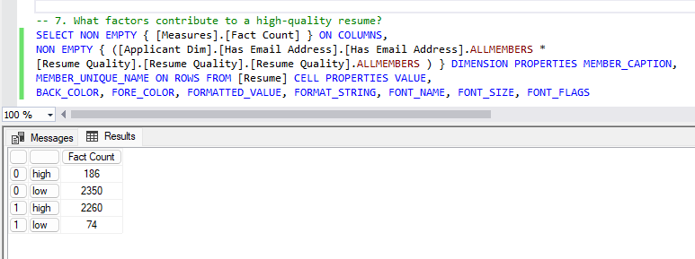

SELECT NON EMPTY { [Measures].[Fact Count] } ON COLUMNS, NON EMPTY { ([Applicant Dim].[Honors].[Honors].ALLMEMBERS * [Resume Quality].[Resume Quality].[Resume Quality].ALLMEMBERS ) } DIMENSION PROPERTIES MEMBER_CAPTION, MEMBER_UNIQUE_NAME ON ROWS FROM [Resume] CELL PROPERTIES VALUE, BACK_COLOR, FORE_COLOR, FORMATTED_VALUE, FORMAT_STRING, FONT_NAME, FONT_SIZE, FONT_FLAGS

SELECT NON EMPTY { [Measures].[Fact Count] } ON COLUMNS, NON EMPTY { ([Applicant Dim].[Military].[Military].ALLMEMBERS * [Resume Quality].[Resume Quality].[Resume Quality].ALLMEMBERS ) } DIMENSION PROPERTIES MEMBER_CAPTION, MEMBER_UNIQUE_NAME ON ROWS FROM [Resume] CELL PROPERTIES VALUE, BACK_COLOR, FORE_COLOR, FORMATTED_VALUE, FORMAT_STRING, FONT_NAME, FONT_SIZE, FONT_FLAGS

SELECT NON EMPTY { [Measures].[Fact Count] } ON COLUMNS, NON EMPTY { ([Applicant Dim].[Special Skills].[Special Skills].ALLMEMBERS * [Resume Quality].[Resume Quality].[Resume Quality].ALLMEMBERS ) } DIMENSION PROPERTIES MEMBER_CAPTION, MEMBER_UNIQUE_NAME ON ROWS FROM [Resume] CELL PROPERTIES VALUE, BACK_COLOR, FORE_COLOR, FORMATTED_VALUE, FORMAT_STRING, FONT_NAME, FONT_SIZE, FONT_FLAGS

SELECT NON EMPTY { [Measures].[Fact Count] } ON COLUMNS, NON EMPTY { ([Applicant Dim].[Volunteer].[Volunteer].ALLMEMBERS * [Resume Quality].[Resume Quality].[Resume Quality].ALLMEMBERS ) } DIMENSION PROPERTIES MEMBER_CAPTION, MEMBER_UNIQUE_NAME ON ROWS FROM [Resume] CELL PROPERTIES VALUE, BACK_COLOR, FORE_COLOR, FORMATTED_VALUE, FORMAT_STRING, FONT_NAME, FONT_SIZE, FONT_FLAGS

SELECT NON EMPTY { [Measures].[Fact Count] } ON COLUMNS, NON EMPTY { ([Applicant Dim].[Worked During School].[Worked During School].ALLMEMBERS * [Resume Quality].[Resume Quality].[Resume Quality].ALLMEMBERS ) } DIMENSION PROPERTIES MEMBER_CAPTION, MEMBER_UNIQUE_NAME ON ROWS FROM [Resume] CELL PROPERTIES VALUE, BACK_COLOR, FORE_COLOR, FORMATTED_VALUE, FORMAT_STRING, FONT_NAME, FONT_SIZE, FONT_FLAGS

SELECT NON EMPTY { [Measures].[Fact Count] } ON COLUMNS, NON EMPTY { ([Applicant Dim].[Years College].[Years College].ALLMEMBERS * [Resume Quality].[Resume Quality].[Resume Quality].ALLMEMBERS ) } DIMENSION PROPERTIES MEMBER_CAPTION, MEMBER_UNIQUE_NAME ON ROWS FROM [Resume] CELL PROPERTIES VALUE, BACK_COLOR, FORE_COLOR, FORMATTED_VALUE, FORMAT_STRING, FONT_NAME, FONT_SIZE, FONT_FLAGS

SELECT NON EMPTY { [Measures].[Fact Count] } ON COLUMNS, NON EMPTY { ([Applicant Dim].[Years Experience].[Years Experience].ALLMEMBERS * [Resume Quality].[Resume Quality].[Resume Quality].ALLMEMBERS ) } DIMENSION PROPERTIES MEMBER_CAPTION, MEMBER_UNIQUE_NAME ON ROWS FROM [Resume] CELL PROPERTIES VALUE, BACK_COLOR, FORE_COLOR, FORMATTED_VALUE, FORMAT_STRING, FONT_NAME, FONT_SIZE, FONT_FLAGS

SELECT NON EMPTY { [Measures].[Fact Count] } ON COLUMNS, NON EMPTY { ([Applicant Dim].[College Degree].[College Degree].ALLMEMBERS * [Resume Quality].[Resume Quality].[Resume Quality].ALLMEMBERS ) } DIMENSION PROPERTIES MEMBER_CAPTION, MEMBER_UNIQUE_NAME ON ROWS FROM [Resume] CELL PROPERTIES VALUE, BACK_COLOR, FORE_COLOR, FORMATTED_VALUE, FORMAT_STRING, FONT_NAME, FONT_SIZE, FONT_FLAGS

SELECT NON EMPTY { [Measures].[Fact Count] } ON COLUMNS, NON EMPTY { ([Applicant Dim].[Computer Skills].[Computer Skills].ALLMEMBERS * [Resume Quality].[Resume Quality].[Resume Quality].ALLMEMBERS ) } DIMENSION PROPERTIES MEMBER_CAPTION, MEMBER_UNIQUE_NAME ON ROWS FROM [Resume] CELL PROPERTIES VALUE, BACK_COLOR, FORE_COLOR, FORMATTED_VALUE, FORMAT_STRING, FONT_NAME, FONT_SIZE, FONT_FLAGS

**Question 8:** Is there a disparity in callback rates based on "race" and "gender"?

SELECT NON EMPTY { [Measures].[Fact Count] } ON COLUMNS, NON EMPTY { ([Applicant Dim].[Race].[Race].ALLMEMBERS * [Applicant Dim].[Gender].[Gender].ALLMEMBERS * [Received Callback].[Received Callback].[Received Callback].ALLMEMBERS ) } DIMENSION PROPERTIES MEMBER_CAPTION, MEMBER_UNIQUE_NAME ON ROWS FROM [Resume] CELL PROPERTIES VALUE, BACK_COLOR, FORE_COLOR, FORMATTED_VALUE, FORMAT_STRING, FONT_NAME, FONT_SIZE, FONT_FLAGS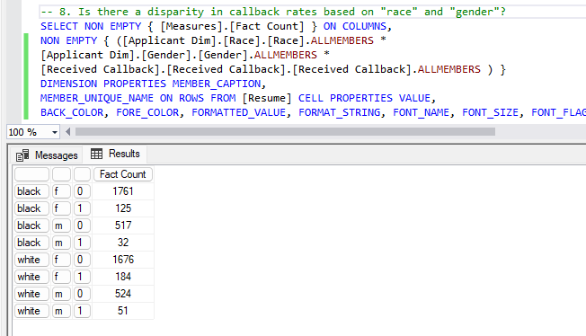

**Question 9:** Is there any correlation between the level of computer skills required and the job industry? Do certain industries tend to require more computer skills?

SELECT NON EMPTY { [Measures].[Fact Count] } ON COLUMNS, NON EMPTY { ([Applicant Dim].[Computer Skills].[Computer Skills].ALLMEMBERS * [Job Dim].[Job Industry].[Job Industry].ALLMEMBERS ) } DIMENSION PROPERTIES MEMBER_CAPTION, MEMBER_UNIQUE_NAME ON ROWS FROM [Resume] CELL PROPERTIES VALUE, BACK_COLOR, FORE_COLOR, FORMATTED_VALUE, FORMAT_STRING, FONT_NAME, FONT_S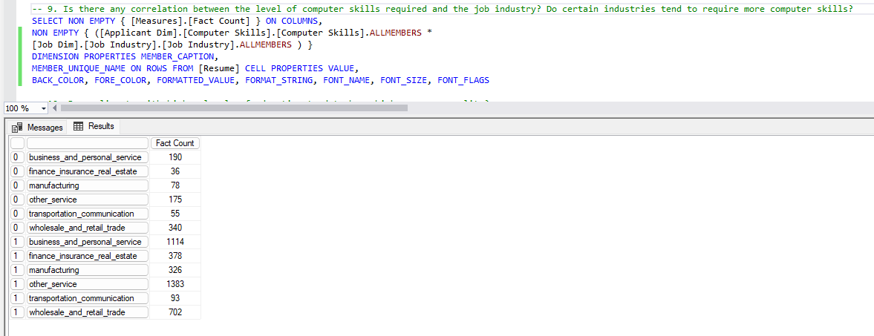IZE, FONT_FLAGS

**Question 10:** Do applicants with higher levels of education tend to have higher resume quality?

SELECT NON EMPTY { [Measures].[Fact Count] } ON COLUMNS, NON EMPTY { ([Resume Quality].[Resume Quality].[Resume Quality].ALLMEMBERS * [Applicant Dim].[College Degree].[College Degree].ALLMEMBERS ) } DIMENSION PROPERTIES MEMBER_CAPTION, MEMBER_UNIQUE_NAME ON ROWS FROM [Resume] CELL PROPERTIES VALUE, BACK_COLOR, FORE_COLOR, FORMATTED_VALUE, FORMAT_STRING, FONT_NAME, FONT_SIZE, FONT_FLAGS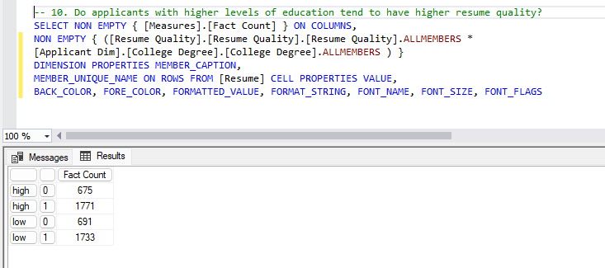

# 6. PowerBI

**Question 1:** What is the distribution of job applicants across different races and genders? Are there any noticeable imbalances or biases?

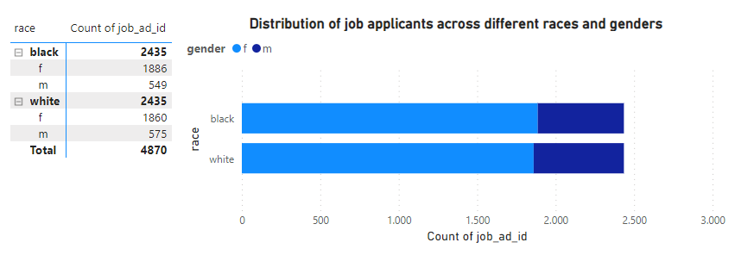

**Question 2:** Is there a significant difference in callback rates based on race, gender, and resume quality combined per type of job?

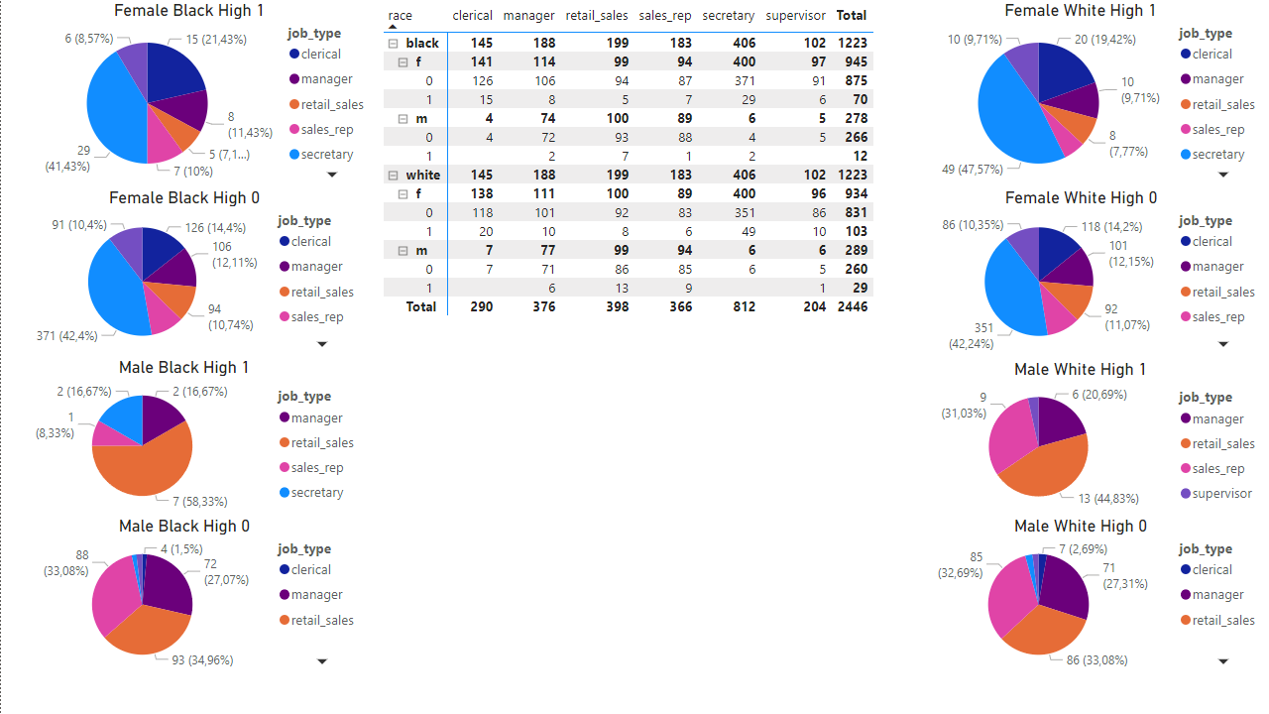

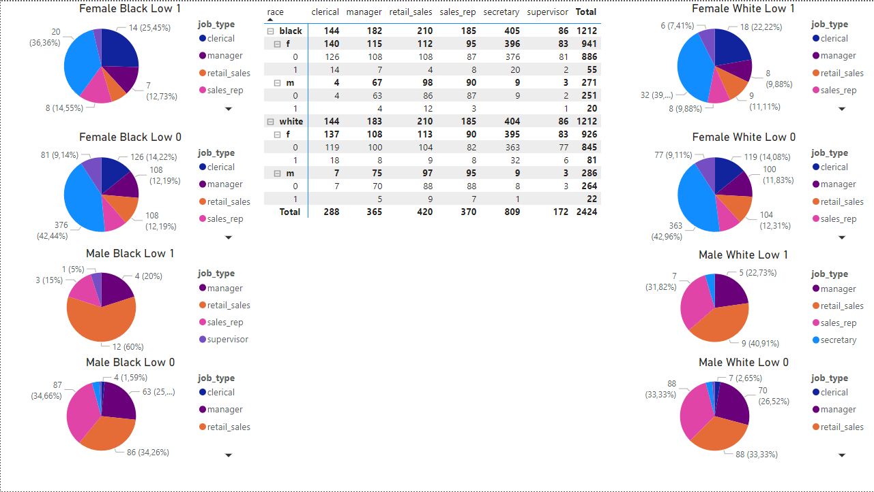

**Question 3:** Are there any particular job industries or types that have a higher likelihood of having employment holes in the applicants' work history?

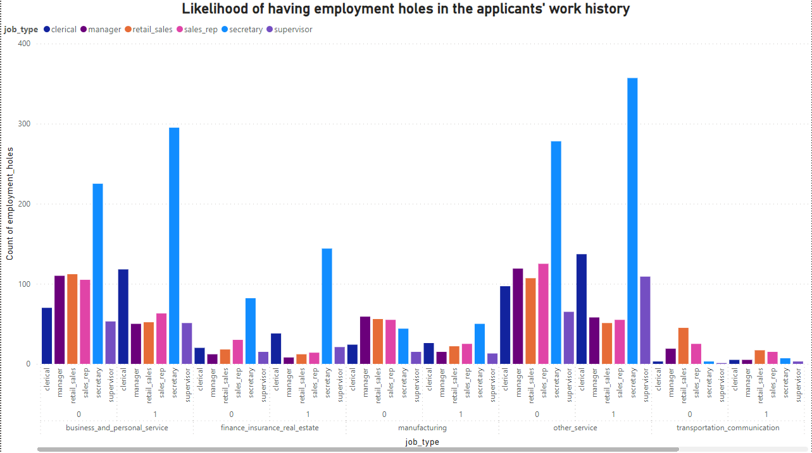

**Question 4:** How does the presence of certain special skills impact the likelihood of being called back for different job types?

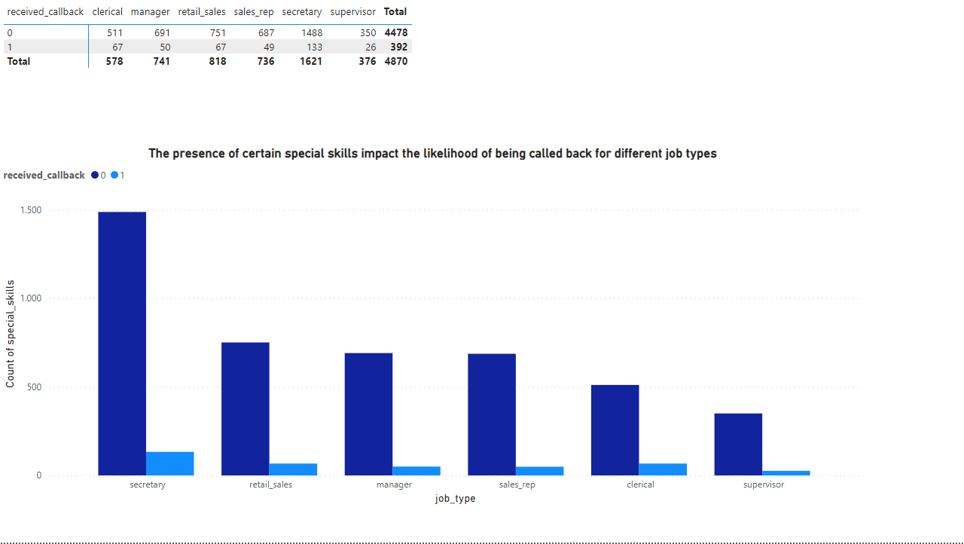

**Question 5:** Are there any notable differences in callback rates for applicants with volunteer or military experience compared to those without?

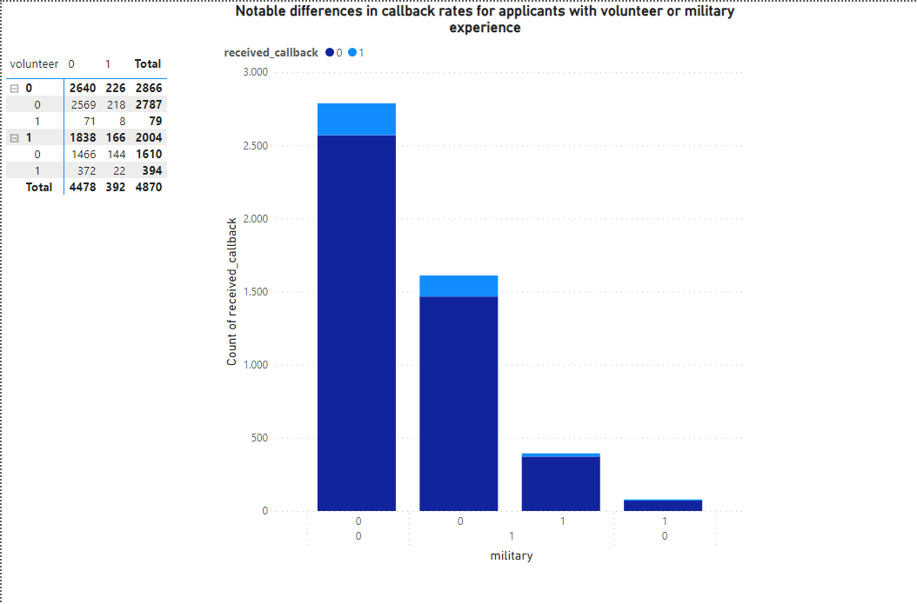

**Question 6:** Is there a correlation between resume quality and the likelihood of receiving a callback?

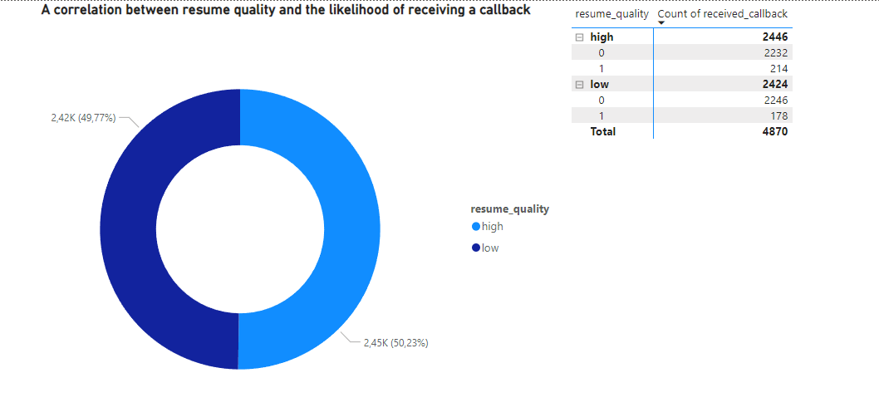

**Question 7:** What factors contribute to a high-quality resume?

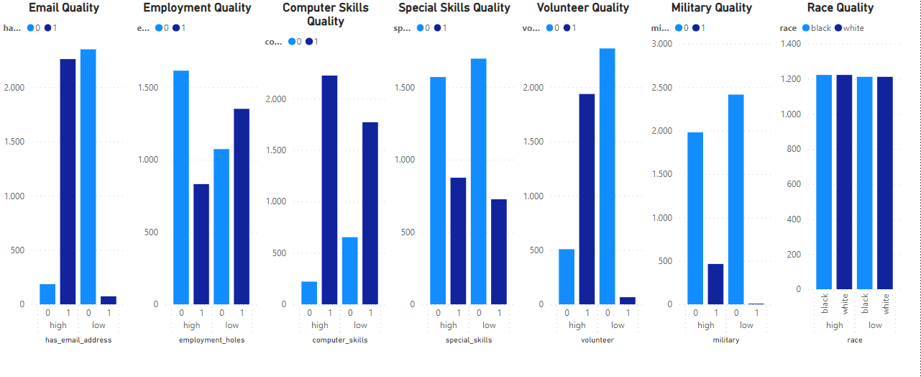

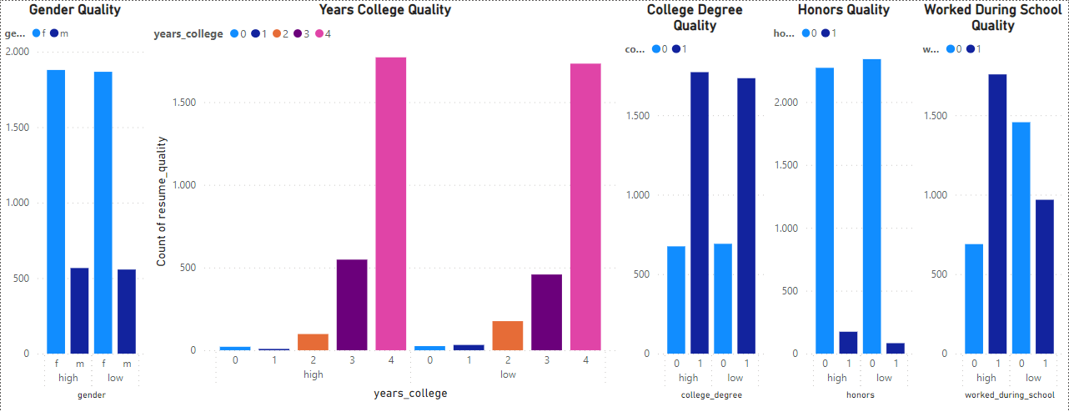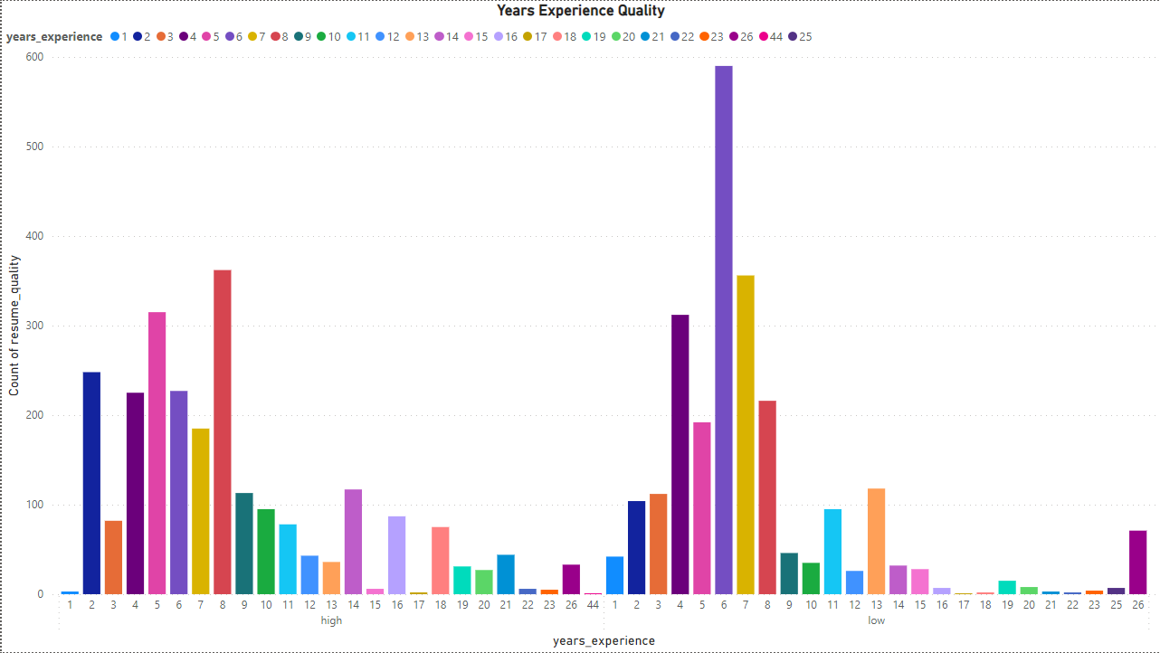

**Question 8:** Is there a disparity in callback rates based on "race" and "gender"?

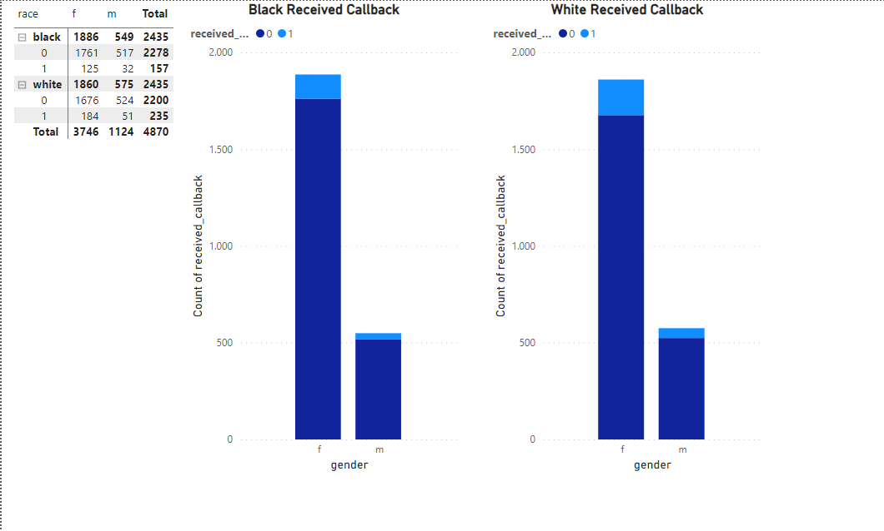

**Question 9:** Is there any correlation between the level of computer skills required and the job industry? Do certain industries tend to require more computer skills?

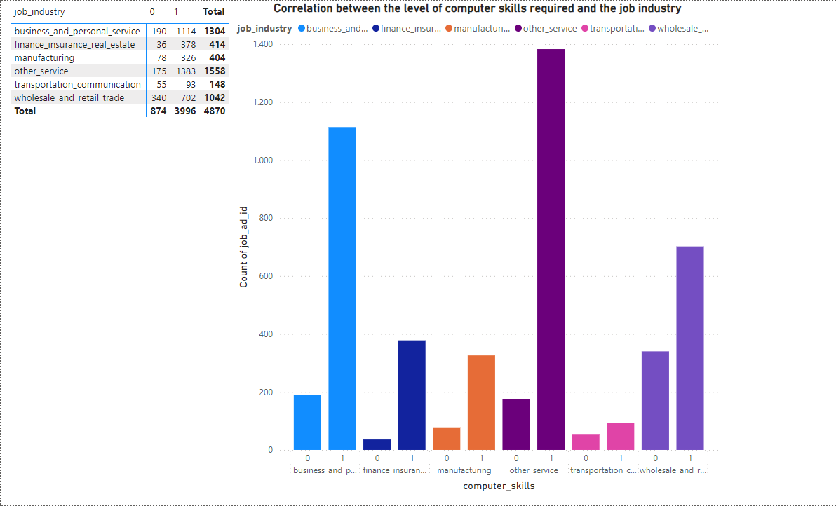

**Question 10:** Do applicants with higher levels of education tend to have higher resume quality?

