**APTECH COMPUTER EDUCATION CENTER**



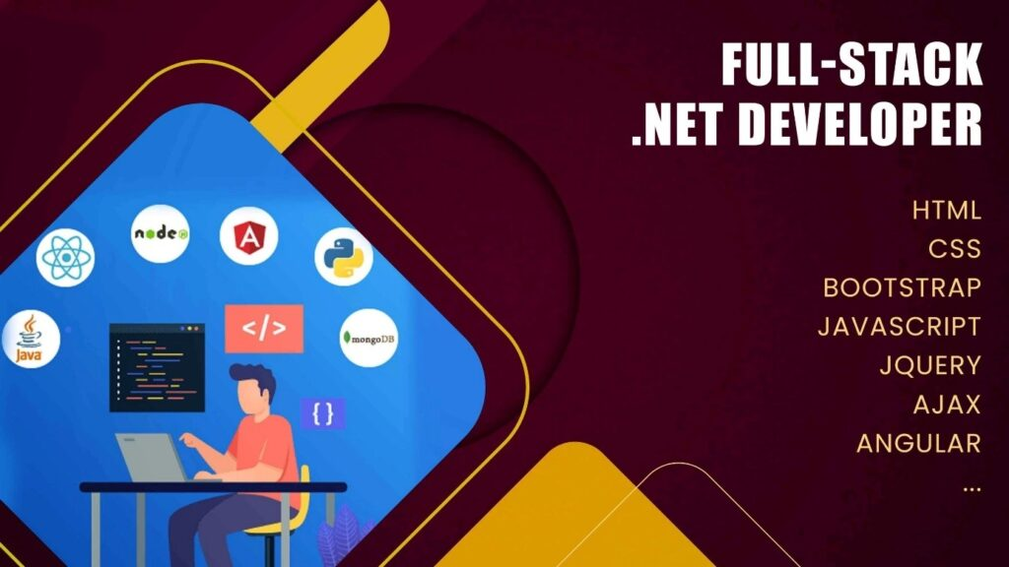

PROJECT DOCUMENT

**Project Name: Fashion Shop Management System**

***Class : .NET Batch 170-172***

***Name :* Đặng Trần Thái**

***Trainer : Lê Thiện Nhật Quang***

***Đà Nẵng 07/07/2023***

**PREFACE**

*In the strong development trend of e-commerce in the world, Vietnamese enterprises, especially small and medium enterprises, account for a large proportion of the total number of Vietnamese enterprises, have also initially realized the benefits and importance of e-commerce application.*

*Nowadays, online stores appear more and more. Online store will bring many benefits to users. For businesses, saving product display space, saving human resources, saving space costs... For customers, saving travel time, can choose the preferred products This is also the reason for me to choose the topic: "Building an e-commerce fashion website" as the subject of the subject "SEM 3".*

*I would like to express my deep gratitude to* ***Mr. Quang*** *,* ***my brother*** *and* ***classmates*** *who have enthusiastically guided, guided and suggested solutions when I encountered difficulties, helping me to complete the thesis on schedule.*

**TABLE OF CONTENTS**

1. Introduction 3

2. System Document 4

3. Analysis Document 5

4. Requirement Sepecification 8

5. Design Document 19

6. Implementation 32

7. Conclusions and expand 32

8. References 32

## Introduction

* 1. **Research Technology**

1. Programming techniques with C# language.
2. Web Application Framework ASP.NET CORE MVC.
3. Web API ASP.NET CORE
4. ASP.NET Identity
5. Learn HTML, CSS, JavaScript/jQuery
6. Learn Sevices Repositories Pattern
7. Dependency Injection Design Pattern in C#
8. Learn how SQL Server database management system data is stored.
9. Survey and gather information from relevant documents and databases.
10. Access a number of available sales websites. <https://shopee.vn/> or <https://yody.vn/> ….
    1. **Project Description**

* Provide Website so Admin can manage products, categories and orders
* Building Website helps admin manage information in an intuitive and convenient way.
* Building a website that brings convenience to users, saving time when there is a need to buy a fashion product
* Provide a Website for users to register for membership and order online and pay via the internet
  1. **Objectives**

|  |  |  |
| --- | --- | --- |
| STT | Actor | Use Case |
| 1 | Admin | * Login * Product management * Manage categories * Order Management |
| 2 | Customer | * Login * Logout * Register * Shopping Cart * Pay Online |

* 1. **Brief of requirements**
     1. **On the customer side**

1. Allow customers to register members in the system

1. Allow member customers to log in to the management system and view information
2. Customer can order online through the fashion’s website
3. Allow member customers to view account information, update personal information including: Full name, address, avatar and change password
4. Allow member customers to view the cart, add products to the cart, update the number of products in the cart, remove products from the cart
5. Allow customers to pay by COD or via bank card, credit
   * 1. **On the admin side**
6. Product Management: Allows Admin to add, edit, delete, products
7. Allows administrators to view product catalog listings and perform add product categories, update product catalog information, and lock and activate product categories
8. Permissions: Allows administrators to assign permissions to employee types
   1. **Scope**

*The project will provide a website system with basic functions for customers to order and use Online Services, and a management website so that Admin staff can manage Customers as well as Managers can manage customer can keep track of everything in the system*

* 1. **Non-functional requirements of the website**
* Beautiful interface, simple, user-friendly.
* The interface of the website is simple enough for users to use it easily after 5 to 10 minutes of getting used to it.
* Page response speed under 10 seconds.
* Performance: Stable running on browsers: Chrome
  1. **Introduction to ASP.NET Core technology**
     1. **What is it ASP.NET Core**

ASP.NET is a popular web-development framework for building web apps on the .NET platform.

ASP.NET Core is the open-source version of ASP.NET, that runs on macOS, Linux, and Windows. ASP.NET Core was first released in 2016 and is a re-design of earlier Windows-only versions of ASP.NET.

ASP.NET apps can be developed and run on Windows, Linux, macOS, and Docker.

The Visual Studio family of products has tools for building .NET apps on any operating system. There are also command-line tools and extensions for many popular editors.

* + 1. **Difference between .NET Core and .NET Framework**

The .NET Framework is an older environment and has existed on Windows for many years now .NET Core supports features in a subset of the .NET Framework. Features like WebForms, Windows Forms, WPF have not been brought to .NET Core. .NET Framework only runs on Windows while .NET Core can run **cross-platform**

* + 1. **Important Features of ASP.NET Core**

1. You can build and run cross-platform ASP.NET applications on Windows, Mac, and Linux (open source and community developmen
2. ASP.NET Core merges ASP.NET MVC and ASP.NET Web API.
3. Can host on IIS or self-host.
4. Dependency Injection is available.
5. Easy to integrate with frontend frameworks like Angular, Knockout...
6. Configuration support for multiple environments.
7. New HTTP Request pipeline mechanism.
8. Support version management
9. Share the entire Nuget Package.
   * 1. **Dependency Injection (DI) in ASP.NET CORE**

Dependency Injection is now the default official component of ASP.NET Core. It helps us to meet the loosely coupled nature, readability and maintainability of the code.

Is a design pattern supported by ASP.Net. This is a technique to realize the Inversion of Control Pattern (it can be considered as a separate design pattern). Dependency modules will be injected into the top-level module. It can be easily understood as follows:

* Modules do not communicate directly with each other, but through interfaces. Low-level module will implement interface, high-level module will call low-level module through interface.
* Initialization of low-level modules will be done by DI Container
* DI is used to reduce dependencies between modules, making it easier to change modules, maintain code, and test.

**Service lifecycle management**

* Transient: A new instance is always created, every time it is requested.
* Scoped: Create a new instance for all scopes (Each request is a scope). In scope, the service is reused
* Singleton: Service is created only once.

## System Document

* 1. **Solution Architecture**

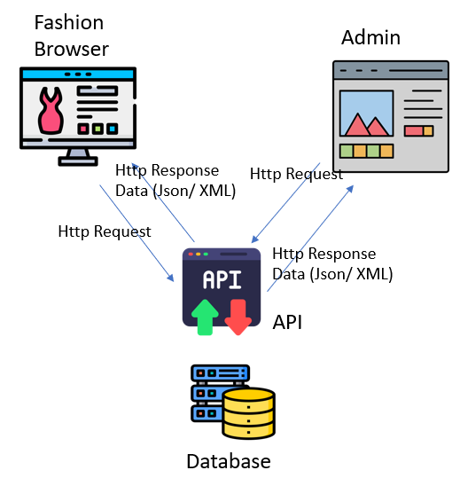

***Figure 2-1. Fashion Solution Architecture***

* **The project consists of 3 separate solutions**
  + - Web API : link data from database
    - Web MVC Fashion Browser Client
    - Web MVC Admin

*Description :*

* *Web API allows different applications to connect, get data, or update a database They will communicate by exchanging data back and forth between software systems. The data is then returned by the Web API as JSON over HTTP or HTTPS.*
* *For example : When the admin page needs to get the product list from the database, it doesn't get the product list directly from the database, but makes an call API by sending an http request to the web API, the Web API gets the product list from the database and then return the data product list admin page formatted with Json over HTTP or HTTPs. The Fashion Browser page also works the same way*
  1. **System Architecture**

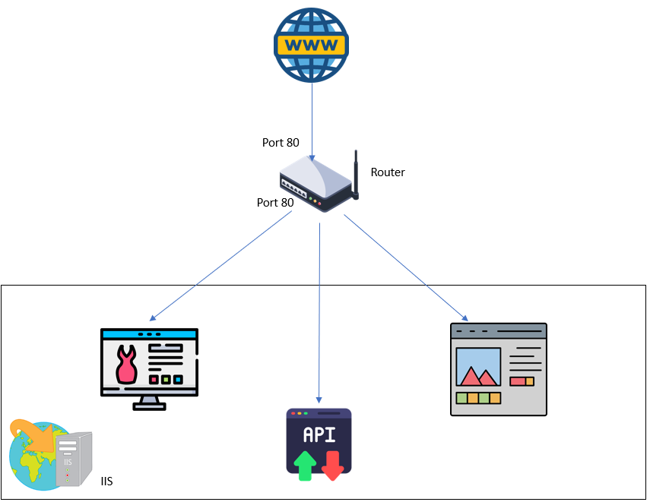

***Figure 2-2. System Solution Architecture***

* 1. **Business Architecture**

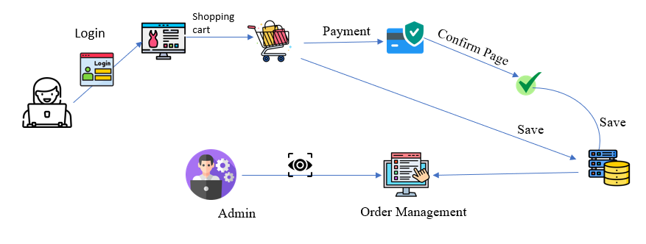

*Description :*

1. *Customers looking for favorite fashion products*
2. *To add products to the cart, customers need to log in to the system*