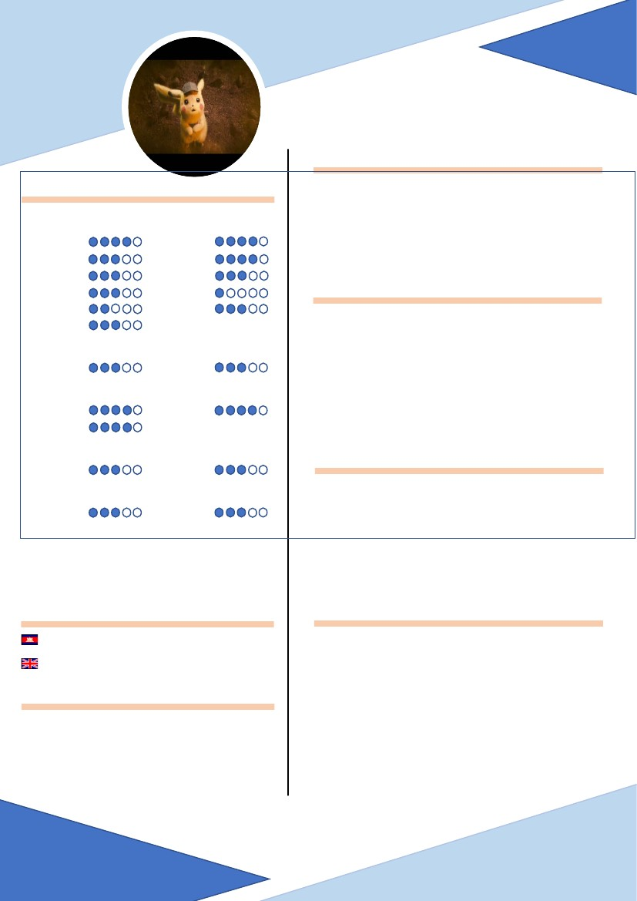
THAISAN UN
WEB DEVELOPER
PERSONAL
Programming and Languages
PHP
JAVA
C/C++
XML
Ajax
SQL
COMPUTER SKILL
Photoshop
CCNA1
Git
Graphic Design
Word
Power Point
HTML5
CSS3
JavaScript
JQuery
Python
27/01/1998; 21 years old
#2nd Bridge PreK Leap, National Road Number 6A,
Phnom Penh, Kingdom of Cambodia.
EDUCATION
Network Skill
Computer Office (Microsoft)
Control Source Code Tool
Additional Tools
Illustrator
Excel
Linux
2018-Presently: Student at National Institute of
Posts, Telecommunications and ICT (NIPTICT).
mr.thaisan1213@gmail.com
(+855) 967362510
2012-2018: Hight School Graduated (Sok An Kvav
High School, Takeo Province).
2006-2012: Complete Secondary School (Somler
School, Takeo Province).
LANGUAGES
Khmer
English
IDE As Intellij Standard, Visual Studio Code,
Star UML, Python IDE And Code Block
Phpmyadmin, Wamperser And Xampp
Mother tongue
Intermediate
GitHub
August,2018: Join Volunteer Cambodia ICT Volunteer
2018 (CIV) That Prepare by Ministry of Posts and
Telecommunications of Cambodia (MPTC) and
NIPTICT at Countryside of Cambodia.
ACHIEVEMENT
HABBIES
Mr. Chuor Porchourng
Lecture and Researcher, School of Computer Science
(+855) 70 789 686
porchourng@gmail.com
Mr. Sopheakmanith Chhuon
Program Coordinator, School of Computer Science
(+855) 11 263 777
manith.chhuon@niptit.edu.kh
REFERENCES
March, 2019: Join Volunteer Couple Run 2019 That
Prepare by Ice-Watch at Aeon Mall Sen Sok City.

