A template for writing manuscripts in Rmarkdown

Thaise Ricardo de Freitas1*, Elisabeth Alve1, Silvia Hess1, Paul Renaud2,3

1 Department of Geosciences, University of Oslo, PO Box 1047 Blindern, 0316 Oslo, Norway

2 Akvaplan-niva, Fram Centre for Climate and the Environment, 9296 Tromsø, Norway

3 University Centre on Svalbard, 9171 Longyearbyen, Norway

* Corresponding author: [thaiser@uio.no](mailto:thaiser@uio.no)

# ABSTRACT

Write your abstract here.

*Keywords*: Rmarkdown, reproducible science

# INTRODUCTION

* Overall importance of Barents Sea in terms of carbon sink and carbon accumulation.
* What has been documented on carbon accumulation, and carbon sources in the region.
* “Few studies have paid attention to the origin of the OM in the studied area from the vertical perspective of time” Não que seja vdd para a regiao, mas é um ponto de partida.
* What knowledge gaps about seasonal / bathymetry related changes in sedimentation etc.
* Our hypothesis / our goal is to investigate environmental pressures on TOC and it’s potential sources. And how the pressures may influence storage capacity on these ecosystems in a temporal perspective.

# METHODS

## Study area and sampling

Sediment sampling was performed during three cruises with R/V Kronprins Haakon in 2018 and 2019 (Table 1). Sediment cores with 40 cm length (40x10 cm) were retrieved at nine stations (NPAL04 to NPAL19) with a four-tube multicorer and immediately sliced to 1 cm layers, placed into plastic jars and frozen on board. Twenty-eight cores with 6 cm length (6x5 cm) cores were subsampled from a box corer at six stations (P1 to SICE4) and immediately sliced to 1 cm layers, placed into plastic jars and frozen on board. In the laboratory all samples were freeze-dried under vacuum and homogenized for stable isotopes and organic carbon content analysis.

| Core ID | Region | Sampling date | Latitude | Longitude | Station | Depth (m) | Analysis |
| --- | --- | --- | --- | --- | --- | --- | --- |
| KH18-10-04-MC3-C | Southern Olga Strait | 28 Sept. 2018 | 77.91000 | 31.30000 | NPAL04 | 232.00 | 210Pb, c |
| KH18-10-05-MC2-B | Northern Olga Strait | 29 Sept. 2018 | 78.77000 | 33.99000 | NPAL05 | 301.00 | 210Pb, c |
| KH18-10-07-MC2-A | strait SE Kvitøya | 30 Sept. 2018 | 79.68000 | 33.81000 | NPAL07 | 353.00 | 210Pb, c |
| KH18-10-08-MC1-D | strait SE Kvitøya | 2 Oct. 2018 | 79.72000 | 32.31000 | NPAL08 | 364.00 | 210Pb, c |
| KH18-10-12-MC2-A | Erik Eriksen Strait | 4 Oct. 2018 | 79.47000 | 28.53000 | NPAL12 | 329.00 | 210Pb, c |
| KH18-10-14-MC2-B | East Nordaustlandet | 6 Oct. 2018 | 80.69000 | 28.95000 | NPAL14 | 552.00 | 210Pb, c |
| KH18-10-15-MC1-C | upper Kvitøya Trough Mouth Fan | 8 Oct. 2018 | 81.57000 | 31.61000 | NPAL15 | 859.00 | 210Pb, c |
| KH18-10-17-MC3-C | Arctic abyssal plain | 11 Oct. 2018 | 83.27000 | 30.95000 | NPAL17 | 3,896.00 | 210Pb, c |
| KH18-10-19-MC1-A | lower Kvitøya Trough Mouth | 15 Oct. 2018 | 81.93000 | 27.52000 | NPAL19 | 3,283.00 | 210Pb, c |
| Q3P1-1 | South Polar Front | 9 Aug. 2019 | 75.99970 | 31.21530 | P1 | 326.11 | c |
| Q3P1-2 | South Polar Front | 9 Aug. 2019 | 75.99980 | 31.21540 | P1 | 325.90 | c |
| Q3P1-3 | South Polar Front | 9 Aug. 2019 | 75.99970 | 31.21540 | P1 | 324.81 | c |
| Q3P2-1 | Storbanken | 12 Aug. 2019 | 77.49940 | 34.00080 | P2 | 188.46 | c |
| Q3P2-2 | Storbanken | 12 Aug. 2019 | 77.49940 | 34.00080 | P2 | 188.60 | c |
| Q3P2-3 | Storbanken | 12 Aug. 2019 | 77.49950 | 34.00070 | P2 | 188.78 | c |
| Q3P4-1 | SE Kvitøya | 15 Aug. 2019 | 79.74570 | 34.01690 | P4 | 333.83 | c |
| Q3P4-2 | SE Kvitøya | 15 Aug. 2019 | 79.74340 | 33.99610 | P4 | 332.70 | c |
| Q3P4-3 | SE Kvitøya | 15 Aug. 2019 | 79.75180 | 34.02820 | P4 | 331.05 | c |
| Q3P6-1 | upper Kvitøya Trough Mouth Fan | 19 Aug. 2019 | 81.54520 | 30.84750 | P6 | 856.66 | c |
| Q3P6-2 | upper Kvitøya Trough Mouth Fan | 19 Aug. 2019 | 81.54000 | 30.87590 | P6 | 829.08 | c |
| Q3P6-3 | upper Kvitøya Trough Mouth Fan | 19 Aug. 2019 | 81.53460 | 30.95700 | P6 | 806.30 | c |
| Q3P7-1 | lower Kvitøya Trough Mouth | 22 Aug. 2019 | 81.72760 | 28.67120 | P7 | 2,648.91 | c |
| Q3P7-2 | lower Kvitøya Trough Mouth | 22 Aug. 2019 | 81.67070 | 28.78900 | P7 | 2,349.31 | c |
| Q3P7-3 | lower Kvitøya Trough Mouth | 22 Aug. 2019 | 81.66830 | 28.81180 | P7 | 2,329.02 | c |
| Q3S4-1 | Arctic abyssal plain | 23 Aug. 2019 | 81.98510 | 24.53010 | S4 | 3,603.75 | c |
| Q3S4-2 | Arctic abyssal plain | 23 Aug. 2019 | 81.98880 | 24.73580 | S4 | 3,603.75 | c |
| Q3S4-3 | Arctic abyssal plain | 23 Aug. 2019 | 81.98580 | 24.80450 | S4 | 3,604.08 | c |
| Q4P2-1 | Storbanken | 10 Dec. 2019 | 77.49100 | 33.96900 | P2 | 190.00 | c |
| Q4P2-2 | Storbanken | 10 Dec. 2019 | 77.48600 | 33.96100 | P2 | 189.00 | c |
| Q4P4-1 | SE Kvitøya | 9 Dec. 2019 | 79.75900 | 33.99500 | P4 | 330.00 | c |
| Q4P4-2 | SE Kvitøya | 9 Dec. 2019 | 79.75000 | 34.00300 | P4 | 337.00 | c |
| Q4P4-3 | SE Kvitøya | 9 Dec. 2019 | 79.73900 | 34.00400 | P4 | 338.00 | c |
| Q4P6-1 | upper Kvitøya Trough Mouth Fan | 5 Dec. 2019 | 81.54284 | 30.94241 | P6 | 848.00 | c |
| Q4P6-2 | upper Kvitøya Trough Mouth Fan | 5 Dec. 2019 | 81.54692 | 30.86334 | P6 | 879.00 | c |
| Q4P6-3 | upper Kvitøya Trough Mouth Fan | 5 Dec. 2019 | 81.55005 | 30.89197 | P6 | 870.00 | c |

## Age determination

We worked in a **beautiful** place with lots of trees, like *Quercus suber* and *Laurus nobilis*.

## Bulk geochemistry analyses

bulk analyses

## Characterization of sedimentary OM

We applied a linear model where

$$OC_{terr}(\%)=\left(\frac{δ^{13}Ci−δ^{13}CM}{δ^{13}CT−δ^{13}CM}\right)*100$$

## Statistical methods

* Shapiro - Wilk Normality test
* Kruskal wallis analysis of variance among regions, environmental conditions, sedimentary environments
* Latitude relationship with parameters with linear regression or other family (glm)
* Temporal trend (Mann-Kendall, Pettit, Sen slope estimator)

# RESULTS

Trees in forest *A* grew taller than those in forest *B* (mean height: 25 versus 13 m).

And many more cool results that get updated dynamically, e.g. see Table and Fig. 1. Note Tables and Figures are cross-linked and numbered automatically.

| Sepal.Length | Sepal.Width | Petal.Length | Petal.Width | Species |
| --- | --- | --- | --- | --- |
| 5.1 | 3.5 | 1.4 | 0.2 | setosa |
| 4.9 | 3.0 | 1.4 | 0.2 | setosa |
| 4.7 | 3.2 | 1.3 | 0.2 | setosa |
| 4.6 | 3.1 | 1.5 | 0.2 | setosa |
| 5.0 | 3.6 | 1.4 | 0.2 | setosa |
| 5.4 | 3.9 | 1.7 | 0.4 | setosa |

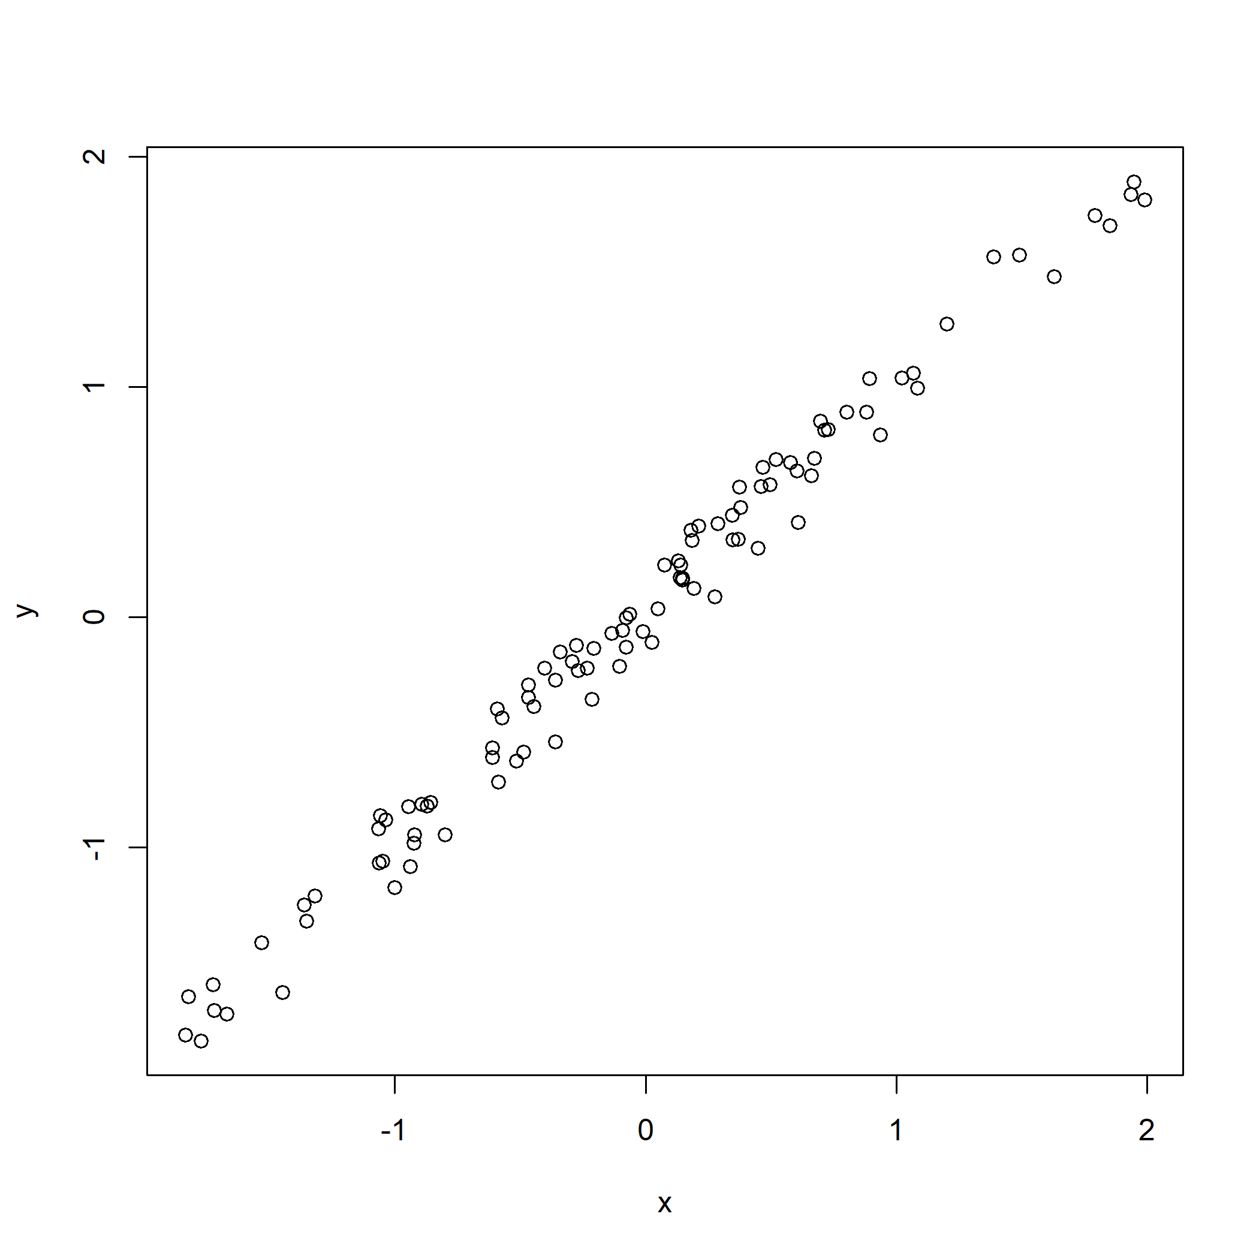

Figure 1: Just my first figure with a very fantastic caption.

# DISCUSSION

Discuss.

# CONCLUSIONS

Wrap up

# ACKNOWLEDGEMENTS

On the shoulders of giants.

# REFERENCES

###### Supplementary Table (on new page)

Table 1: Now a subset of mtcars dataset.

|  |  |  |  |  |  |  |  |  |  |  |  |
| --- | --- | --- | --- | --- | --- | --- | --- | --- | --- | --- | --- |
|  | mpg | cyl | disp | hp | drat | wt | qsec | vs | am | gear | carb |
| Merc 280 | 19.2 | 6 | 167.6 | 123 | 3.92 | 3.440 | 18.30 | 1 | 0 | 4 | 4 |
| Merc 280C | 17.8 | 6 | 167.6 | 123 | 3.92 | 3.440 | 18.90 | 1 | 0 | 4 | 4 |
| Merc 450SE | 16.4 | 8 | 275.8 | 180 | 3.07 | 4.070 | 17.40 | 0 | 0 | 3 | 3 |
| Merc 450SL | 17.3 | 8 | 275.8 | 180 | 3.07 | 3.730 | 17.60 | 0 | 0 | 3 | 3 |
| Merc 450SLC | 15.2 | 8 | 275.8 | 180 | 3.07 | 3.780 | 18.00 | 0 | 0 | 3 | 3 |
| Cadillac Fleetwood | 10.4 | 8 | 472.0 | 205 | 2.93 | 5.250 | 17.98 | 0 | 0 | 3 | 4 |
| Lincoln Continental | 10.4 | 8 | 460.0 | 215 | 3.00 | 5.424 | 17.82 | 0 | 0 | 3 | 4 |

###### Supplementary Figure (on new page)

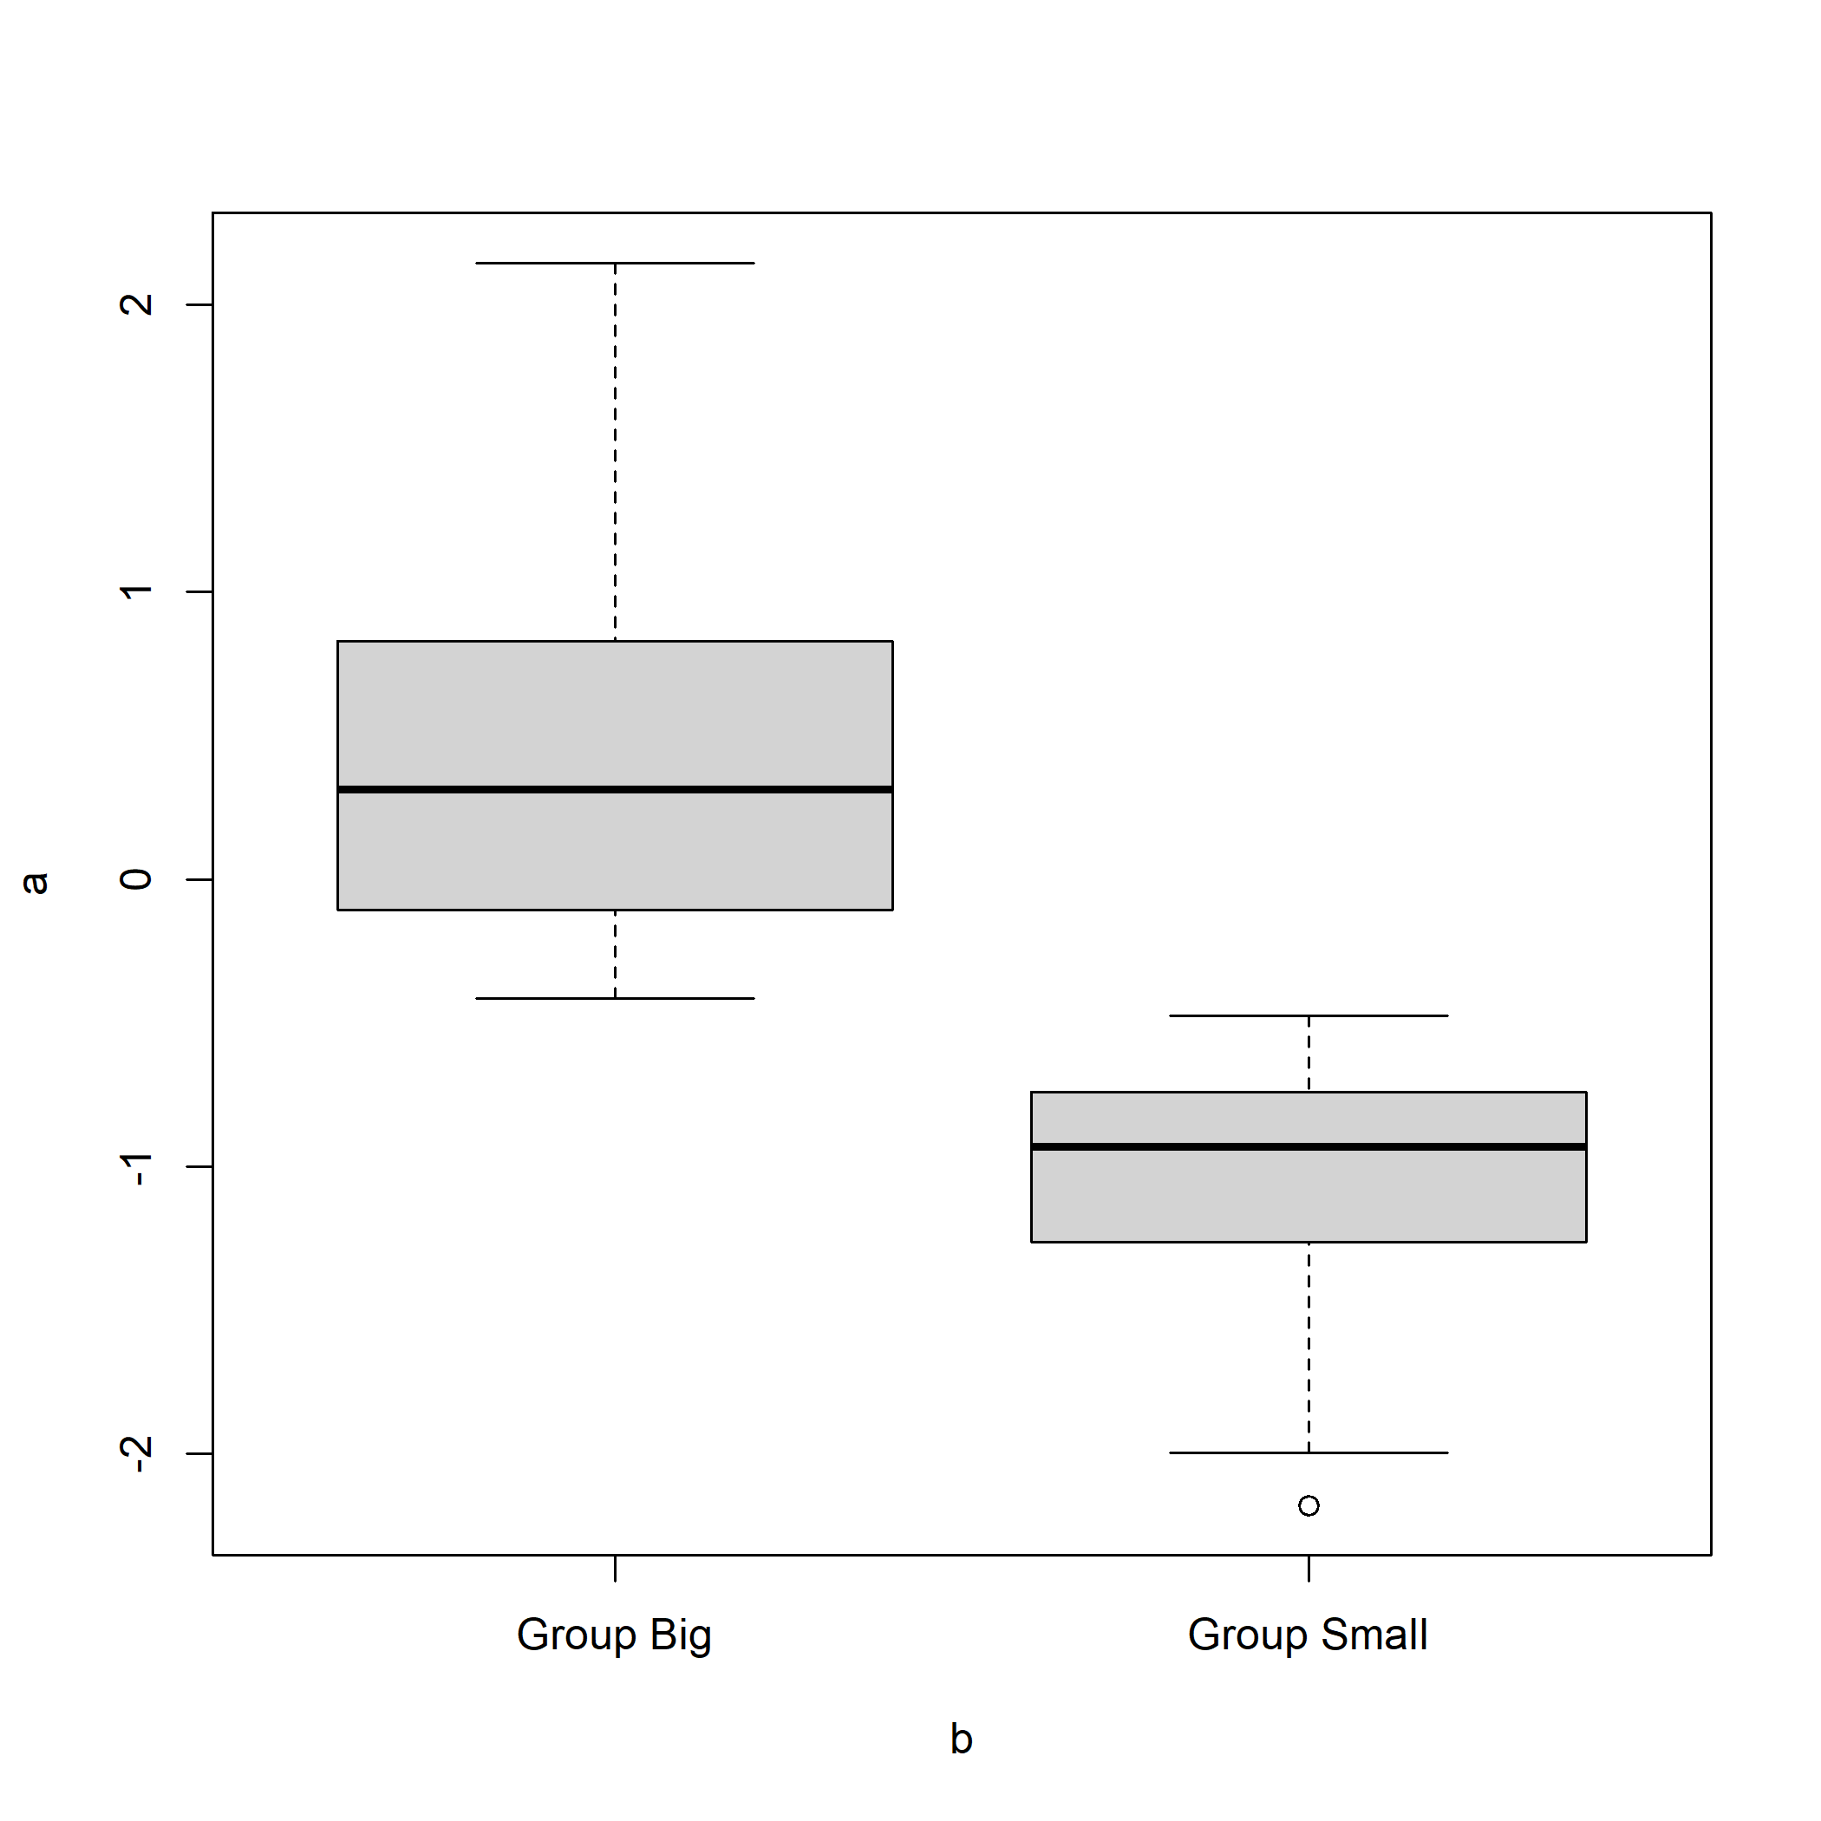

Figure 2: A boxplot.