# Attractor analysis with scBONITA

## Step 0: You will need:

* The results of an scBonita rule inference workflow for a single-cell dataset & at least one network
* A metadata file for your training data set

## Step 1: import other pieces of scBonita and required Python packages

# import other pieces of scBonita  
from singleCell import *  
from ruleMaker import *  
from testData import *  
  
# import packages  
import pickle, re, glob, os, copy, os.path, umap, random, requests, deap, gc  
import pandas as pd, seaborn as sns, matplotlib.pyplot as plt, matplotlib.cm as cm, matplotlib.pyplot as plt, scipy.spatial.distance as ssd, networkx as nx, numpy as np, multiprocessing as mp  
from os import path  
from ast import literal_eval  
from random import seed, sample  
from time import sleep  
from matplotlib.patches import Patch  
from scipy.stats import ttest_ind, chi2_contingency  
from statsmodels.stats.multitest import multipletests  
from matplotlib.colors import ListedColormap, LinearSegmentedColormap

/gpfs/fs2/scratch/mpalshik/scBONITA-main/scBonita_package/src/scBONITA/singleCell.py:1437: SyntaxWarning: "is not" with a literal. Did you mean "!="?  
 if frequencyGrouping is not "":

# Step 2: import the files you need

testData = scBonita_testData() # test data set of 100 cells  
# pickle.load(open("data/trainingData.csvscTest.pickle", "rb")).sampleList

### 2a: Import the metadata file and an ‘embeddings’ file that contains a PCA projection of the original training dataset (this is optional)

metaData = testData["metaData"] # pd.read_csv("conditions.txt", sep="\t", index_col=0)  
embeddingData = testData[  
 "embeddings"  
] # pd.read_csv("cell_embeddings.csv", index_col=0)

### 2b: Reconstruct the singleCell object generated by the rule inference pipeline

scObject = testData[  
 "scObject"  
] # objectFile = glob.glob("*.binscTest.pickle")#pickle.load(open(objectFile[0], "rb"))  
scObject.sampleList

['Cell0',  
 'Cell1',  
 'Cell2',  
 'Cell3',  
 'Cell4',  
 'Cell5',  
 'Cell6',  
 'Cell7',  
 'Cell8',  
 'Cell9',  
 'Cell10',  
 'Cell11',  
 'Cell12',  
 'Cell13',  
 'Cell14',  
 'Cell15',  
 'Cell16',  
 'Cell17',  
 'Cell18',  
 'Cell19',  
 'Cell20',  
 'Cell21',  
 'Cell22',  
 'Cell23',  
 'Cell24',  
 'Cell25',  
 'Cell26',  
 'Cell27',  
 'Cell28',  
 'Cell29',  
 'Cell30',  
 'Cell31',  
 'Cell32',  
 'Cell33',  
 'Cell34',  
 'Cell35',  
 'Cell36',  
 'Cell37',  
 'Cell38',  
 'Cell39',  
 'Cell40',  
 'Cell41',  
 'Cell42',  
 'Cell43',  
 'Cell44',  
 'Cell45',  
 'Cell46',  
 'Cell47',  
 'Cell48',  
 'Cell49',  
 'Cell50',  
 'Cell51',  
 'Cell52',  
 'Cell53',  
 'Cell54',  
 'Cell55',  
 'Cell56',  
 'Cell57',  
 'Cell58',  
 'Cell59',  
 'Cell60',  
 'Cell61',  
 'Cell62',  
 'Cell63',  
 'Cell64',  
 'Cell65',  
 'Cell66',  
 'Cell67',  
 'Cell68',  
 'Cell69',  
 'Cell70',  
 'Cell71',  
 'Cell72',  
 'Cell73',  
 'Cell74',  
 'Cell75',  
 'Cell76',  
 'Cell77',  
 'Cell78',  
 'Cell79',  
 'Cell80',  
 'Cell81',  
 'Cell82',  
 'Cell83',  
 'Cell84',  
 'Cell85',  
 'Cell86',  
 'Cell87',  
 'Cell88',  
 'Cell89',  
 'Cell90',  
 'Cell91',  
 'Cell92',  
 'Cell93',  
 'Cell94',  
 'Cell95',  
 'Cell96',  
 'Cell97',  
 'Cell98',  
 'Cell99']

### 2c: Get the list of network files for which you want to identify attractors

currentDir = os.path.dirname(os.path.abspath("Attractor_Analysis_With_scBONITA.ipynb"))  
networkList = [os.path.join(currentDir, "data", "hsa00010.graphml_processed.graphml")]

## Step 3: Assign attractors - generate a dataframe of assigned attractors and an output file in the current working directory

distanceDF = scObject.assignAttractors(pathwayFiles=networkList)  
# distanceDF = pd.read_csv("data/hsa00010.graphml_processed.graphml_attractorDistance.csv", index_col = 0)

## Step 4: Visualization and analysis

### 4a: Generate UMAP embedding for visualization (optional)

reducer = umap.UMAP()  
embedding = reducer.fit_transform(embeddingData.values)  
plottingData = pd.DataFrame(  
 embedding,  
 columns=["UMAP dimension 1", "UMAP dimension 2"],  
 index=embeddingData.index,  
)  
plottingData["Condition"] = [  
 metaData.loc[temp, "Conditions"] for temp in plottingData.index  
]  
# plottingData["Sample"] = [  
# metaData.loc[temp, "batchid"] for temp in plottingData.index  
# ]

plottingData.head()

### 4b: Make UMAP and attractor frequency plots

#### Make UMAP and attractor frequency plots without a faceting variable

scObject.makeAttractorAnalysisPlots(  
 plottingData,  
 distanceDF,  
 allAttractors=True,  
 numberOfAttractorsToShow=2,  
 cmap="colorblind",  
 makeFrequencyPlots=True,  
 freqplotsFile="freqPlots_test.pdf",  
 makeUMAP=True,  
 umapFile="umapPlots_test.pdf",  
)

[6, 5, 3]  
  
  
  
<Figure size 360x360 with 0 Axes>

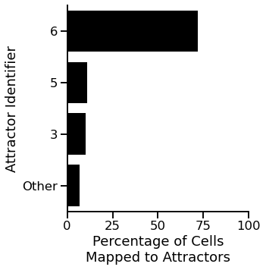

png

<Figure size 432x288 with 0 Axes>  
  
  
  
<Figure size 360x360 with 0 Axes>

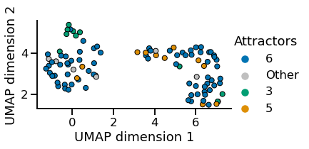

png

<Figure size 432x288 with 0 Axes>

#### Make UMAP and attractor frequency plots with a faceting variable

scObject.makeAttractorAnalysisPlots(  
 plottingData,  
 distanceDF,  
 allAttractors=True,  
 numberOfAttractorsToShow=2,  
 cmap="colorblind",  
 makeFrequencyPlots=True,  
 frequencyGrouping="Condition",  
 freqplotsFile="freqPlots_test.pdf",  
 makeUMAP=True,  
 umapFile="umapPlots_test.pdf",  
)

[6, 5, 3]  
  
  
  
<Figure size 360x360 with 0 Axes>

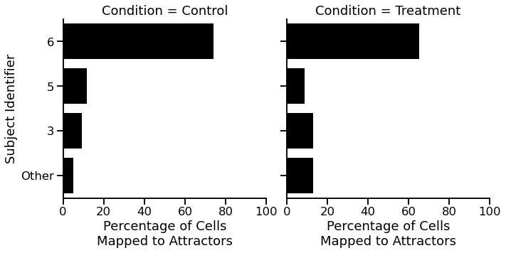

png

<Figure size 432x288 with 0 Axes>  
  
  
  
<Figure size 360x360 with 0 Axes>

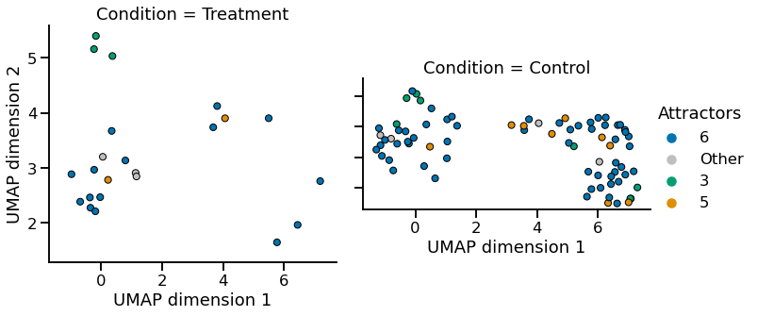

png

<Figure size 432x288 with 0 Axes>

### Make heatmaps of attractors

#### Show all identified attractors that map to cells in the training dataset

scObject.makeAttractorHeatmaps(  
 distanceDF=distanceDF,  
 network="hsa00010.graphml",  
 width=10,  
 height=6,  
 allAttractors=True,  
)

Attractor cell counts:   
1 1  
2 2  
35 72  
9 3  
12 10  
19 1  
20 11  
  
  
  
<Figure size 720x432 with 0 Axes>

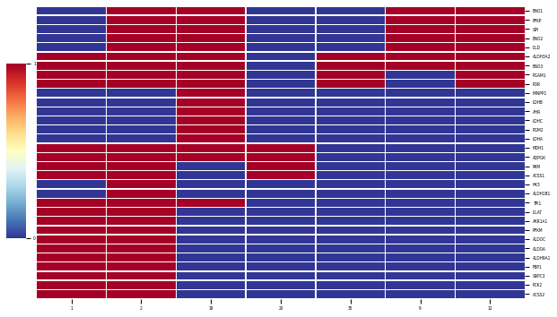

png

( 1 2 9 12 19 20 35  
 HK3 0 1 0 0 0 0 0  
 PCK2 1 1 0 0 0 0 0  
 ACSS2 1 1 0 0 0 0 0  
 MDH1 1 1 0 0 1 1 0  
 TPI1 1 1 0 0 1 0 0  
 ENO2 0 1 1 1 1 0 0  
 G6PC3 1 1 0 0 0 0 0  
 PGM2 0 0 0 0 1 0 0  
 FBP1 1 1 0 0 0 0 0  
 ALDH3A2 1 1 1 1 1 0 1  
 ALDH9A1 1 1 0 0 0 0 0  
 PGAM1 1 1 0 1 1 0 1  
 POR 1 1 0 1 1 0 1  
 ALDH1B1 0 1 0 0 0 0 0  
 ALDOA 1 1 0 0 0 0 0  
 ALDOC 1 1 0 0 0 0 0  
 PFKM 1 1 0 0 0 0 0  
 AKR1A1 1 1 0 0 0 0 0  
 PKM 1 1 0 0 0 1 0  
 DLAT 1 1 0 0 0 0 0  
 ACSS1 1 1 0 0 0 1 0  
 ADPGK 1 1 0 0 1 1 0  
 DLD 0 1 1 1 1 0 0  
 GPI 0 1 1 1 1 0 0  
 PFKP 0 1 1 1 1 0 0  
 ENO1 0 1 1 1 1 0 0  
 LDHA 0 0 0 0 1 0 0  
 LDHC 0 0 0 0 1 0 0  
 AHR 0 0 0 0 1 0 0  
 LDHB 0 0 0 0 1 0 0  
 MINPP1 0 0 0 0 1 0 0  
 ENO3 1 1 1 1 1 0 1,  
 <seaborn.matrix.ClusterGrid at 0x2af40b9110a0>)  
  
  
  
  
<Figure size 432x288 with 0 Axes>

#### Show only the top 3 attractors (ranked by the number of cells they map to)

scObject.makeAttractorHeatmaps(  
 distanceDF=distanceDF,  
 network="hsa00010.graphml",  
 width=10,  
 height=6,  
 allAttractors=False,  
 numberOfAttractorsToShow=3,  
 cmap="vlag",  
)

Attractor cell counts:   
1 1  
2 2  
35 72  
9 3  
12 10  
19 1  
20 11  
  
  
  
<Figure size 720x432 with 0 Axes>

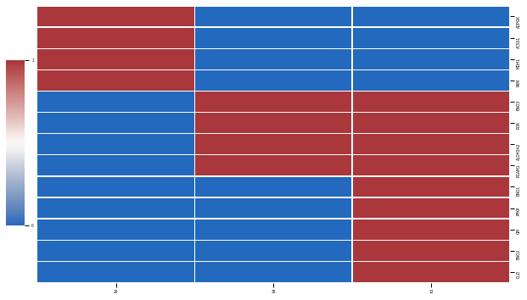

png

( 1 2 9 12 19 20 35  
 HK3 0 1 0 0 0 0 0  
 PCK2 1 1 0 0 0 0 0  
 ACSS2 1 1 0 0 0 0 0  
 MDH1 1 1 0 0 1 1 0  
 TPI1 1 1 0 0 1 0 0  
 ENO2 0 1 1 1 1 0 0  
 G6PC3 1 1 0 0 0 0 0  
 PGM2 0 0 0 0 1 0 0  
 FBP1 1 1 0 0 0 0 0  
 ALDH3A2 1 1 1 1 1 0 1  
 ALDH9A1 1 1 0 0 0 0 0  
 PGAM1 1 1 0 1 1 0 1  
 POR 1 1 0 1 1 0 1  
 ALDH1B1 0 1 0 0 0 0 0  
 ALDOA 1 1 0 0 0 0 0  
 ALDOC 1 1 0 0 0 0 0  
 PFKM 1 1 0 0 0 0 0  
 AKR1A1 1 1 0 0 0 0 0  
 PKM 1 1 0 0 0 1 0  
 DLAT 1 1 0 0 0 0 0  
 ACSS1 1 1 0 0 0 1 0  
 ADPGK 1 1 0 0 1 1 0  
 DLD 0 1 1 1 1 0 0  
 GPI 0 1 1 1 1 0 0  
 PFKP 0 1 1 1 1 0 0  
 ENO1 0 1 1 1 1 0 0  
 LDHA 0 0 0 0 1 0 0  
 LDHC 0 0 0 0 1 0 0  
 AHR 0 0 0 0 1 0 0  
 LDHB 0 0 0 0 1 0 0  
 MINPP1 0 0 0 0 1 0 0  
 ENO3 1 1 1 1 1 0 1,  
 <seaborn.matrix.ClusterGrid at 0x2af41d2087c0>)  
  
  
  
  
<Figure size 432x288 with 0 Axes>