**Software Engineering Assignment**

**Module : 1**

**SE – Overview of IT Industry**

1. **What is software? What is software engineering?**

**Software** :

**The software is a computer program that provides a set of instructions to execute a user’s commands and tell the computer what to do. For example like MS-Word, MS-Excel, PowerPoint, etc.**

**Software engineering :**

Software Engineering is the process of designing, developing, testing, and maintaining software. It is a systematic and disciplined approach to software development that aims to create high-quality, reliable, and maintainable software.

**2. Explain types of software**

**Types of Software :**

1. **System Software**: **Manages hardware and basic system operations (e.g., Windows, macOS).**

1. **Application Software**: **Helps users perform tasks like writing, browsing, and editing (e.g., Microsoft Word, Chrome).**

1. **Development Software**: **Tools for writing and testing code (e.g., Visual Studio).**

1. **Driver Software**: **Enables communication between the computer and hardware devices (e.g., printer drivers).**

**3. What is SDLC? Explain each phase of SDLC**

**The Software Development Life Cycle (SDLC) is a process used to design, develop, and test high-quality software. It ensures that software is built systematically and efficiently. The SDLC consists of several key phases like :**

1. **Planning: Decide the project’s goals and check If it is doable within**

**Time and budget.**

1. **Requirements : Gather detailed information on what the software needs to accomplish. Talk to stakeholders to understand their needs and document them**
2. **Design: Create a detailed plan of how the software will look and work.**
3. **Implementation : Write the actual code based on the design plan.**
4. **Testing: Check the software for bugs and make sure it works properly or not.**
5. **Deployment: Make the software available for users to use.**
6. **Maintenance: Fix issues, Updates properly, and improve the software time to time after it’s been deployed.**

**This process helps ensure that the final product will being high-quality and it will complete user’s expectations.**

**4. What is DFD? Create a DFD diagram on Flipkart**

**DFD stands for Data Flow Diagram. It represents the flow of data within information systems. DFD provide a graphical representation of the data flow of a system that can be understood by both technical and non-technical users. The models enable software engineers, customers, and users to work together effectively during the analysis and specification of requirements.**

**0 - level DFD Diagram**

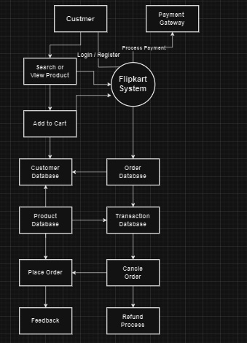

**DFD Diagram on Flipkart System**

1. **- level DFD Diagram**

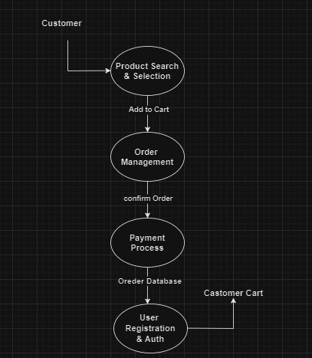

**02 – level DFD Diagram**

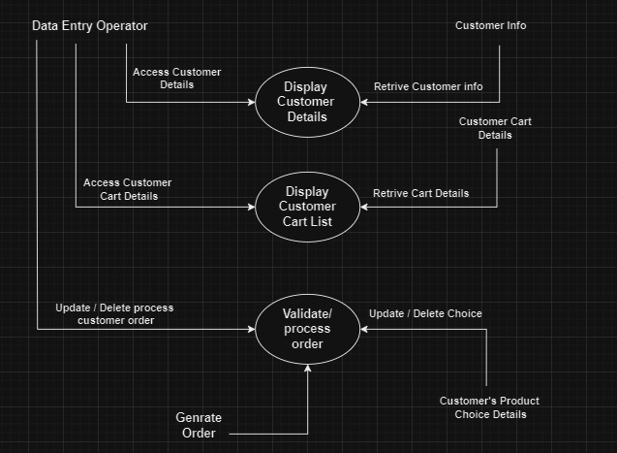

**5. What is Flow chart? Create a flowchart to make addition of two numbers**

**Flow Chart :**

Flowcharts **are nothing but the graphical representation of the data or the algorithm for a better understanding of the code visually. It displays step-by-step solutions to a problem, algorithm, or process.**

**flowchart to make addition of two numbers :**

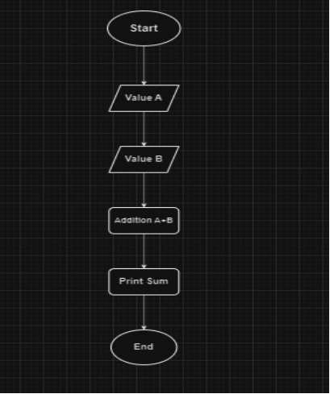

**6. What is Use case Diagram? Create a use-case on bill payment on paytm.**

**A Use Case Diagram is a vital tool in any system design, It provides a visual representation of how user interact with a syatem. It servers as a blueprint for understanding the functional requirements of a system from a user’s perspective.**

**Use-Case on bill payment on paytm**

