**Que – 1). Create Table Name : Student and Exam**

Ans – 1) Create Database =

[CREATE](http://localhost/phpmyadmin/url.php?url=https://dev.mysql.com/doc/refman/8.0/en/create-database.html) [DATABASE](http://localhost/phpmyadmin/url.php?url=https://dev.mysql.com/doc/refman/8.0/en/create-database.html) student_db;

* create Student table =

[CREATE](http://localhost/phpmyadmin/url.php?url=https://dev.mysql.com/doc/refman/8.0/en/create-table.html) [TABLE](http://localhost/phpmyadmin/url.php?url=https://dev.mysql.com/doc/refman/8.0/en/create-table.html) student( Rollno int PRIMARY KEY,

Name varchar(20) [NOT](http://localhost/phpmyadmin/url.php?url=https://dev.mysql.com/doc/refman/8.0/en/logical-operators.html%23operator_not) NULL,

Branch varchar(20) [NOT](http://localhost/phpmyadmin/url.php?url=https://dev.mysql.com/doc/refman/8.0/en/logical-operators.html%23operator_not) NULL );

* insert data in student table =

INSERT INTO student VALUES (1, 'Jay', 'Computer Science');

INSERT INTO student VALUES (2, 'Suhani', 'Electronic and Com');

INSERT INTO student VALUES (3, 'Kriti', 'Electronic and Com');

* create table Exam using foreign key =

[CREATE](http://localhost/phpmyadmin/url.php?url=https://dev.mysql.com/doc/refman/8.0/en/create-table.html) [TABLE](http://localhost/phpmyadmin/url.php?url=https://dev.mysql.com/doc/refman/8.0/en/create-table.html) Exam ( Rollno int [NOT](http://localhost/phpmyadmin/url.php?url=https://dev.mysql.com/doc/refman/8.0/en/logical-operators.html%23operator_not) NULL,

S_code varchar(10),

Marks int, P_code varchar(3),

FOREIGN KEY (Rollno) REFERENCES student(Rollno) );

* insert data into Exam table =

INSERT INTO Exam (Rollno, S_code, Marks, P_code) VALUES

(1, 'CS11', 50, 'CS'), (1, 'CS12', 60, 'CS'),

(2, 'EC101', 66, 'EC'), (2, 'EC102', 70, 'EC'),

(3, 'EC101', 45, 'EC'), (3, 'EC102', 50, 'EC');

Student Table =

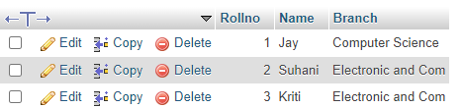

Exam Table =

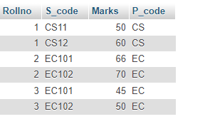

**Que – 2). Create table given below: Employee and IncentiveTable**

**Ans – 2).** create database name Employee_db =

CREATE DATABASE Employee_db;

* create table name Employee =

CREATE TABLE employee ( Employee_id int, First_name varchar(20),

Last_name varchar(20), Salary int,

Joining_date datetime,Department varchar(20));

* Insert value =

INSERT INTO employee VALUES (1, 'John', 'Abraham', 1000000, '2013-01-13 12.00.00', 'Banking');

INSERT INTO employee VALUES (2, 'Michael', 'Clarke', 800000, '2013-01-13 12.00.00', 'Insurance');

INSERT INTO employee VALUES (3, 'Roy', 'Thomas', 700000, '2013-01-13 12.00.00', 'Banking’);

INSERT INTO employee VALUES (4, 'Torm', 'Jose', 600000, '2013-02-13 12.00.00', 'Insurance');

INSERT INTO employee VALUES (5, 'Jerry', 'Pinto', 650000, '2013-02-01 12.00.00', 'Insurance');

INSERT INTO employee VALUES (6, 'Philip', 'Mathew', 750000, '2013-01-01 12.00.00', 'Services');

INSERT INTO employee VALUES (7, 'TestName1', '123', 650000, '2013-01-01 12.00.00', 'Services');

INSERT INTO employee VALUES (8, 'TestName2', 'Lname%', 650000, '2013-02-01 12.00.00', 'Insurance');

Step-4) Create the Incentive Table:

CREATE TABLE Incentive (

Employee_ref_id int,

Incentive_date date,

Incentive_amount int,

FOREIGN KEY(Employee_ref_id) REFERENCE employee(Employee_id)

);

Step-5) Insert Data into Incentive table =

INSERT INTO incentive VALUES

(1, '2013-02-01', 5000),

(2, '2013-02-01', 3000),

(3, '2013-02-01', 4000),

(1, '2013-01-01', 4500),

(2, '2013-01-01', 3500);

* Employee Table

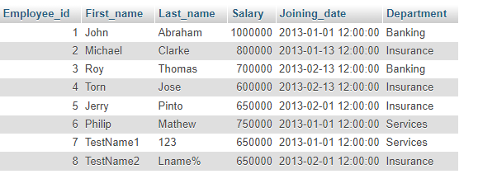

* Incentive Table

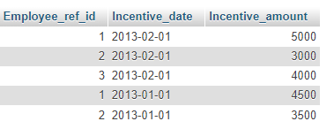

**Que – 3). Get First_Name from employee table using Tom name “Employee Name”.**

Ans – 3) SELECT First_name FROM employee WHERE First_name LIKE '%Tom%';



**Que - 4). Get FIRST_NAME, Joining Date, and Salary from employee table.**

Ans – 4) SELECT First_name, Joining_date, Salary FROM employee;

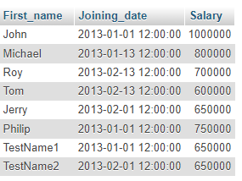

**Que – 5). Get all employee details from the employee table order by First_Name Ascending and Salary descending?**

Ans – 5) SELECT * FROM employee ORDER by First_name ASC, Salary DESC;

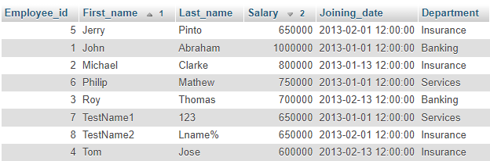

**Que - 6). Get employee details from employee table whose first name contains ‘J’**

Ans – 6)

[SELECT](http://localhost/phpmyadmin/url.php?url=https://dev.mysql.com/doc/refman/8.0/en/select.html) * FROM Employee WHERE First_name [LIKE](http://localhost/phpmyadmin/url.php?url=https://dev.mysql.com/doc/refman/8.0/en/string-comparison-functions.html%23operator_like) '%J%';

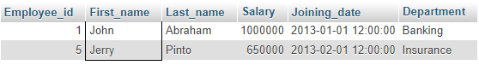

**Que – 7). Get department wise maximum salary from employee table order by**

Ans – 7)

SELECT Department , MAX(Salary) AS MaxSalary FROM employee GROUP by Department ORDER by Salary DESC;

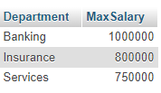

**Que – 8). salaryascending?**

Ans – 8)

Query -->

SELECT * FROM `employee` ORDER by Salary;

Output -->

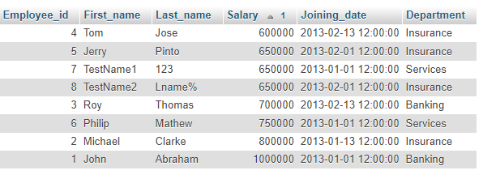

**Que – 9). Select first_name, incentive amount from employee and incentives table forthose employees who have incentives and incentive amount greater than 3000**

Ans – 9) SELECT e.first_name, i.Incentive_amount

FROM employee

INNER JOIN incentive i ON e.employee_id = i.Employee_ref_id

WHERE i.incentive_amount > 3000;

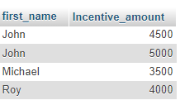

**Que – 10). Create After Insert trigger on Employee table which insert records in viewtable**

Ans – 10) Create Database :

CREATE DATABASE TRIGGER_db;

* Create table Employee :

CREATE TABLE Employee( id int, Ename varchar(20), Salary int);

* Create table Viewtable :

CREATE TABLE Viewtable( id int, name varchar(20),

Salary int, action_perform text);

* Create Trigger :

DELIMITER $$

CREATE TRIGGER viewtable AFTER INSERT on employee for EACH ROW

BEGIN

INSERT INTO viewtable(id, name, Salary, action_perform)

VALUES(new.id, new.Ename, new.Salary, 'Record Inserted');

END

* Insert Record in Employee Table :

INSERT INTO employee VALUES (1, 'Devarsh', 50000);

INSERT INTO employee VALUES (2, 'Yash', 100000);

INSERT INTO employee VALUES (3, 'Dev', 150000);

INSERT INTO employee VALUES (4, 'Ayush', 200000);

* Viewtable Data :

Employee Table :

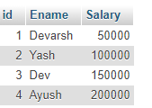

Viewtable :

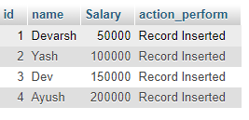

**Que – 11).Create table given below: Salesperson and Customer**

Ans – 11) Create Database :

CREATE DATABASE bussiness_db;

🡪 Create Table Salesperson :

CREATE TABLE Salesperson (

SNo int, SNAME varchar(10), CITY varchar(10),

COMM int, PRIMARY KEY(SNo) );

🡪 Create Table Customer :

CREATE TABLE CUSTOMER (

CNM int, CNAME VARCHAR(15), CITY VARCHAR(15),

RATING INT, SNo int, PRIMARY KEY (CNM),

FOREIGN KEY (SNo) REFERENCES salesperson (SNo) );

🡪 Insert Data in Salesman table :

INSERT INTO salesperson VALUES (1001, 'Peel', 'London', 12);

INSERT INTO salesperson VALUES (1002, 'Serres', 'San Jose', 13);

INSERT INTO salesperson VALUES (1004, 'Motika', 'London', 11);

INSERT INTO salesperson VALUES (1007, 'Rafkin', 'Barcelona', 15);

INSERT INTO salesperson VALUES (1003, 'Axelord', 'New York', 1);

--> Insert Data into Customer Table :

INSERT INTO customer VALUES (201, 'Hoffman', 'London', 100, 1001);

INSERT INTO customer VALUES (202, 'Giovanne', 'Roe', 200, 1003);

INSERT INTO customer VALUES (203, 'Liu', 'San Jose', 300, 1002);

INSERT INTO customer VALUES (204, 'Grass', 'Barcelona', 100, 1002);

INSERT INTO customer VALUES (206, 'Clemens', 'London', 300, 1007);

INSERT INTO customer VALUES (207, 'Pereia', 'Roe', 100, 1004);

🡪 Salesperson Table :

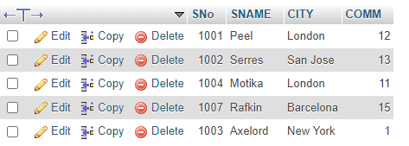

🡪 Customer Table :

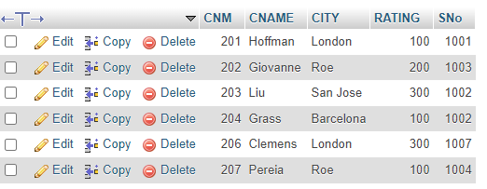

**Que – 13). All orders for more than $100.**

Ans – 13)

SELECT * FROM `customer` WHERE RATING > 100;

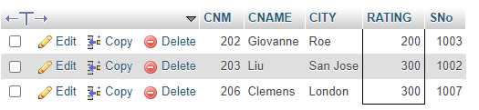

**Que – 14).Names and cities of all salespeople in London with commission above 0.12**

Ans – 14)

SELECT * FROM `salesperson` WHERE CITY = 'London' AND COMM >= 12;



**Que – 15).All salespeople either in Barcelona or in London.**

Ans – 15)

SELECT * FROM `salesperson` WHERE CITY='Barcelona' OR CITY='London';

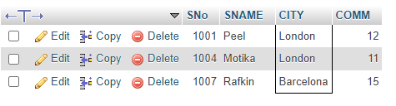

**Que – 16 ) . All salespeople with commission between 0.10 and 0.12. (Boundary valuesshould be excluded).**

Ans – 16 )

SELECT * FROM `salesperson` WHERE COMM > 10 and COMM < 12;

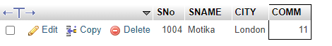

**Que – 17) . All customers excluding those with rating <= 100 unless they are located in Rome**

Ans – 17 ) SELECT * FROM `customer` WHERE CITY = 'Roe' or RATING <=100;

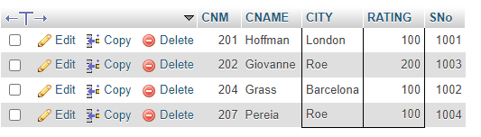

**Que – 18 ).Write a SQL statement that displays all the information about all**

**Salespeople**

Ans – 18 )

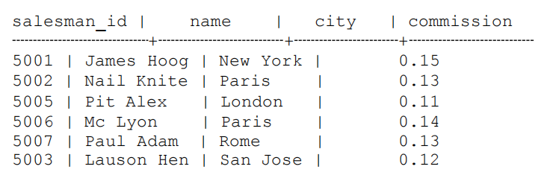

CREATE TABLE Salespeople (

salesman_id int,

name varchar(20),

city varchar(20),

commision int);

INSERT INTO salespeople VALUES

( 5001, 'James Hoog', 'New York', 0.15 ),

( 5002, 'Nail Knite', 'Paris', 0.13),

( 5005, 'Pit Alex', 'London', 0.11),

( 5006, 'Mc Lyon', 'Paris', 0.14),

( 5007, 'Paul Adam', 'Rome', 0.13),

( 5003, 'Lauson Hen', 'San Jose', 0.12);

SELECT * FROM `salespeople`;

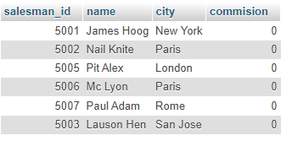

**Que – 19).From the following table, write a SQL query to find orders that are delivered by a salesperson with ID. 5001. Return ord_no, ord_date, purch_amt.**

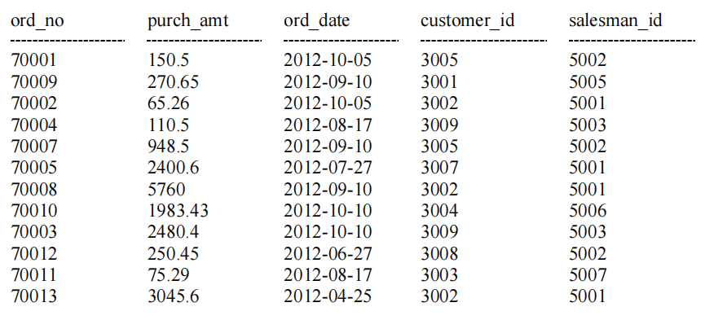

Ans – 19 )

CREATE TABLE orders (

ord_no INT PRIMARY KEY,

purch_amt DECIMAL(10,2),

ord_date DATE,

customer_id INT,

salesman_id INT

);

INSERT INTO orders VALUES

(70001, 150.50, '2012-10-05', 3005, 5002),

(70009, 270.65, '2012-09-10', 3001, 5005),

(70002, 65.26, '2012-10-05', 3002, 5001),

(70004, 110.50, '2012-08-17', 3009, 5003),

(70007, 948.50, '2012-09-10', 3005, 5002),

(70005, 2400.60, '2012-07-27', 3007, 5001),

(70008, 5760.00, '2012-09-10', 3002, 5001),

(70010, 1983.43, '2012-10-10', 3004, 5006),

(70003, 2480.40, '2012-10-10', 3009, 5003),

(70012, 250.45, '2012-06-27', 3008, 5002),

(70011, 75.29, '2012-08-17', 3009, 5007),

(70013, 3045.60, '2012-04-25', 3002, 5001);

SELECT ord_no, ord_date, purch_amt FROM orders WHERE salesman_id = 5001;

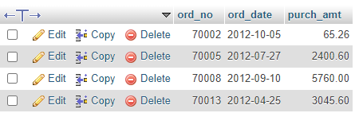

**Que – 20).From the following table, write a SQL query to select a range of products whose price is in the range Rs.200 to Rs.600. Begin and end values are included. Return pro_id, pro_name, pro_price, and pro_com.**

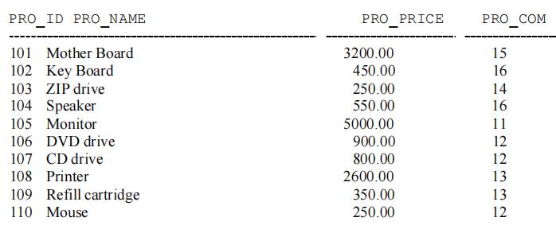

Ans – 20) CREATE TABLE Products (

PRO_ID INT PRIMARY KEY,

PRO_NAME VARCHAR(50),

PRO_PRICE DECIMAL(10, 2),

PRO_COM INT

);

INSERT INTO Products VALUES

(101, 'Mother Board', 3200.00, 15),

(102, 'Key Board', 450.00, 16),

(103, 'ZIP drive', 250.00, 14),

(104, 'Speaker', 550.00, 16),

(105, 'Monitor', 5000.00, 11),

(106, 'DVD drive', 900.00, 12),

(107, 'CD drive', 800.00, 12),

(108, 'Printer', 2600.00, 13),

(109, 'Refill cartridge', 350.00, 13),

(110, 'Mouse', 250.00, 12);

SELECT * FROM `products` WHERE PRO_PRICE BETWEEN 200 AND 600;

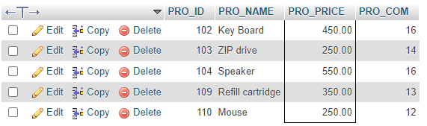

**Que – 21) .From the following table, write a SQL query to calculate the averageprice for a manufacturer code of 16. Return avg.**

Ans – 21 )

CREATE TABLE Products (

PRO_ID INT PRIMARY KEY,

PRO_NAME VARCHAR(50),

PRO_PRICE DECIMAL(10, 2),

PRO_COM INT

);

INSERT INTO Products VALUES

(101, 'Mother Board', 3200.00, 15),

(102, 'Key Board', 450.00, 16),

(103, 'ZIP drive', 250.00, 14),

(104, 'Speaker', 550.00, 16),

(105, 'Monitor', 5000.00, 11),

(106, 'DVD drive', 900.00, 12),

(107, 'CD drive', 800.00, 12),

(108, 'Printer', 2600.00, 13),

(109, 'Refill cartridge', 350.00, 13),

(110, 'Mouse', 250.00, 12);

SELECT AVG(PRO_PRICE) AS avg_price FROM product WHERE PRO_COM = 16;



**Que – 22) .From the following table, write a SQL query to display the pro_nameas 'Item Name' and pro_priceas 'Price in Rs.'**

***Sample table*: item_mast**

Ans – 22 )SELECT PRO_NAME AS 'Item_Names', PRO_PRICE AS 'Price in RS' FROM product;

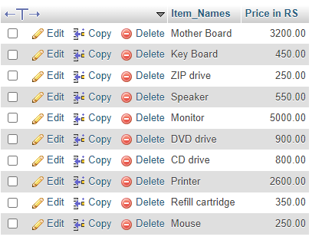

**Que - 23.From the following table, write a SQL query to find the items whose prices are higher than or equal to $250. Order the result by product price in descending, then product name in ascending. Return pro_name and pro_price.**

Ans – 23)SELECT PRO_NAME , PRO_PRICE FROM product WHERE PRO_PRICE >= 250 ORDER by PRO_PRICE DESC, PRO_NAME ASC;

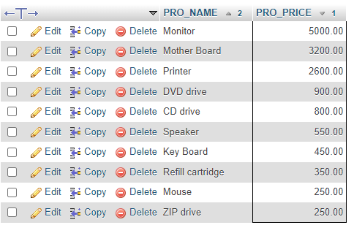

**Que – 24).From the following table, write a SQL query to calculate average price ofthe items for each company. Return average price and companycode.**

Ans – 24 ) SELECT AVG(PRO_PRICE) AS average_price, PRO_COM AS companycode FROM product GROUP by PRO_COM;

