Real-world Data Project (Finance - Stock Analysis)

1. Objective
This project aims to analyze real-world stock data to identify trends, patterns, and market behavior using data analysis techniques.

2. Dataset Description
The dataset used in this project is stock price data of Apple (AAPL), collected using the yfinance library. It includes columns such as Open, High, Low, Close, Volume, and Date.

3. Data Collection
Data was collected directly from online financial sources using the yfinance library, which provides real-time and historical stock market data.

4. Data Exploration
Basic exploration was performed using functions like info(), describe(), and checking for missing values to understand the dataset structure.

5. Data Visualization
Various visualizations were created including stock closing price trends, trading volume analysis, and moving average plots to understand market behavior.
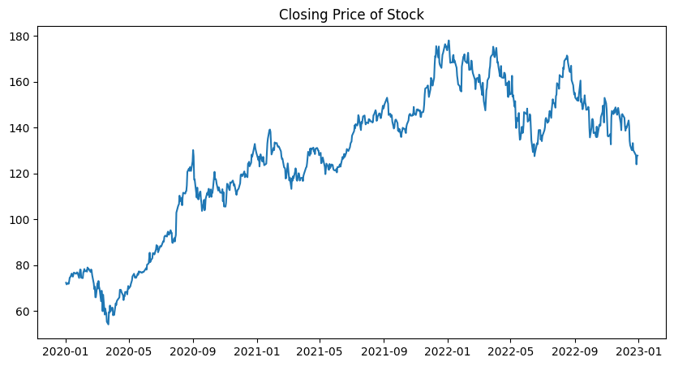
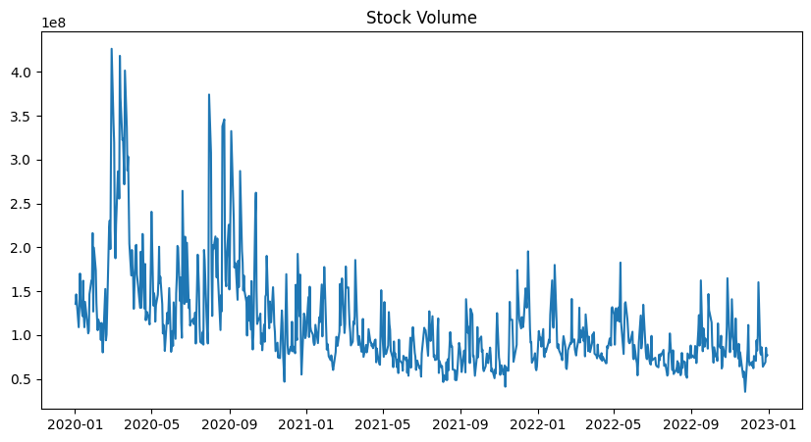

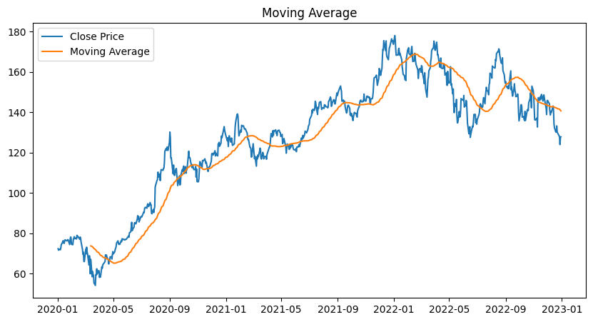

6. Key Insights
The stock shows an overall increasing trend over time. There are fluctuations indicating market volatility. Moving averages help smooth trends and identify long-term patterns. High trading volumes indicate active market participation.

7. Conclusion
This project demonstrates how real-world financial data can be analyzed to extract meaningful insights. Visualization techniques help understand stock trends and support decision-making.

8. Author
Vaishnavi

