|  |  |  |
| --- | --- | --- |
| **1305104 Object-Oriented Design and Programming Laboratory** |  | |
| **Laboratory 11:** Exception | **School of Information Technology** | |
| **Name:** | **ID:** | **Section:** |
| **Date:** | **Due date:** | |

**Exception**

Exception is the problem found during the execution of the program. It is the problem that can be handled and then the program can continue.

Example 1

Try the program below.

|  |
| --- |
| public class MyException {  public void run(){  System.out.println(5/0);  }  } |

|  |
| --- |
| public class Main  {  public static void main(String[] args){  MyException me = new MyException();  me.run();  }  } |

Question

1. What is the problem after running class Main? What type of exception is found?

|  |
| --- |
|  |

Then try to handle this exception by changing codes of class MyException as follow.

|  |
| --- |
| public class myException {  public void run(){  try {  System.out.println(5/0);  }  catch(ArithmeticException e){  System.out.println("Cannot divide by zero");  }  }  } |

1. What is the new result?

|  |
| --- |
|  |

Example 2

Try the program below.

|  |
| --- |
| import java.util.Scanner;  public class InputException {  public void run(){  Scanner sc = new Scanner(System.in);  System.out.print("Enter an integer...");  int num = sc.nextInt();  System.out.println("You input "+num);  }  } |

|  |
| --- |
| public class Main {  public static void main(String[] args){  InputException ie = new InputException();  ie.run();  }  } |

Question

1. What is the problem after running class Main and enter “a”? What type of exception is found?

|  |
| --- |
|  |

Then try to handle this exception by changing codes of class MyException as follow.

|  |
| --- |
| import java.util.Scanner;  import java.util.InputMismatchException;  public class InputException {  public void run(){  Scanner sc = new Scanner(System.in);  boolean goodInput = false;  do {  try {  System.out.print("Enter an integer...");  int num = sc.nextInt();  System.out.println("You input "+num);  goodInput = true;  }  catch(InputMismatchException e){  sc.nextLine(); //to clear \n from scanner  System.out.println("Input is not a number");  System.out.println("Try again");  }  }while(goodInput==false);  }  } |

1. Now, what is the problem after running class Main and enter “a”?

|  |
| --- |
|  |

Example 3

This example shows how to throw exception in computing factorial. Here we cannot compute factorial of negative number. So we throw the exception for it.

|  |
| --- |
| public class Factorial  {  public void computeFactorial(int num) throws Exception {  if(num<0){  System.out.println("Cannot find factorial of negative numbers");  throw new Exception();  }  Else {  int fac = 1;  for(int i=1;i<=num;i++)  fac *= i;  System.out.println("Factorial of "+num+" = "+fac);  }  }  } |

|  |
| --- |
| public class Main {  public static void main(String[] args){  Factorial ft = new Factorial();  Try {  ft.computeFactorial(5);  ft.computeFactorial(-5);  }  catch(Exception e){  System.out.println("Computation Error");  }  }  } |

Question

1. What is the result?

|  |
| --- |
|  |

Question 11.1

Create a calculator program following the class diagram below.

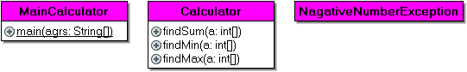

The program must include

* Array of 3 input numbers (enter from keyboard with using loop)
* InputMismatchException and Your own exception.
* throws/throw/ try+catch

Expected output:

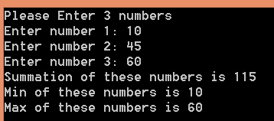

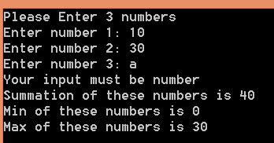

Put the complete code :

//import statements

package lab11_ex;

import java.util.Scanner;

import java.util.InputMismatchException;

/**

*

* @author S1LAB

*/

class NagativeNumberException extends Exception{

}

class Calculator1{

public void findSum(int a[]) throws NagativeNumberException{

int sum = 0;

for(int i=0;i<a.length;i++){

if(a[i]<0){

throw new NagativeNumberException();

}else{

sum = a[i]+sum;

}

}

System.out.println("Summation of three number is "+sum);

}

public void findMin(int a[]) throws NagativeNumberException{

int min = a[0];

for(int i = 0;i<a.length;i++){

if(a[i]<0){

throw new NagativeNumberException();

}else{

if(min>a[i]){

min=a[i];

}

}

}

System.out.println("Min of these number is "+min);

}

public void findMax(int a[]) throws NagativeNumberException{

int max = a[0];

for(int i = 0;i<a.length;i++){

if(a[i]<0){

throw new NagativeNumberException();

}else{

if(max<a[i]){

max=a[i];

}

}

}

System.out.println("Min of these number is "+max);

}

}

public class MainCalculator {

public static void main(String[] agrs){

Calculator1 cal = new Calculator1();

Scanner sc = new Scanner(System.in);

int data[] = new int[3];

System.out.println("Please Enter 3 numbers");

for(int i=0; i<data.length; i++){

System.out.print("Enter number "+(i+1)+": ");

try{

data[i]=sc.nextInt();

}catch(InputMismatchException e){

System.out.println("Your input must be number ");

}

}

try{

cal.findSum(data);

cal.findMin(data);

cal.findMax(data);

}catch(NagativeNumberException e){

System.out.println("Numbers cannot be nagative ");

}

}

}

Question 11.2

Create a calculatorGUI program that performs as shown in the figures below.

Hint:

- Use findMax(),findMin(),and FindSum() from the previous question and add them to class “CalculatorGUI” (save as CalculatorGUI.java)

- Use keyword “string to array of int java” to search the appropriate java method() to convert string to array of integer numbers.

- Apply the appropriate Exception when you input string rather than integer.

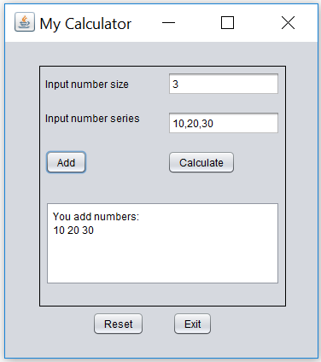

Click **Add** then show these input numbers

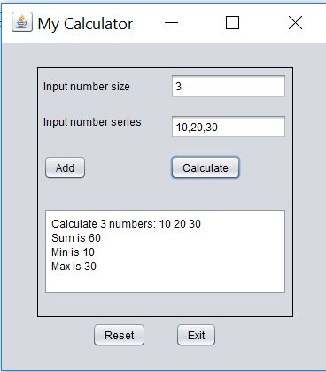

Click **Calculate** then show sum,min,and max results

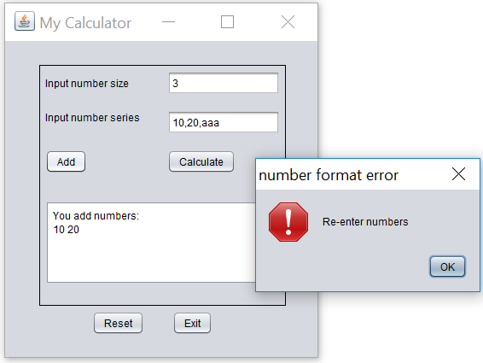

Input a string, click **Add**, and then show error in the message dialog as shown

**CalculatorGUI.java**

import java.util.Scanner;

import java.util.InputMismatchException;

class Calculate {

public int findSum(int a[]) {

int sum = 0;

for (int i = 0; i < a.length; i++) {

sum = a[i] + sum;

}

return sum;

}

public int findMin(int a[]) {

int min = a[0];

for (int i = 0; i < a.length; i++) {

if (min > a[i]) {

min = a[i];

}

}

return min;

}

public int findMax(int a[]) {

int max = a[0];

for (int i = 0; i < a.length; i++) {

if (max < a[i]) {

max = a[i];

}

}

return max;

}

}

JFrame code parts:

Put import statements and variable declaration (top of the program)

Calculate cal = new Calculate();

int[] data;

Put “Add” button code

data = new int[Integer.parseInt(txtSize.getText())];

String string = txtSeries.getText();

String[] num = string.split(",");

for(int i=0; i<data.length; i++){

try{

data[i] = Integer.parseInt(num[i]);

}catch(InputMismatchException e){

JOptionPane.showMessageDialog(null, "Your input must be number", "number input error", 0);

System.out.println("Your input must be number ");

}catch(NumberFormatException e){

JOptionPane.showMessageDialog(null, "Re-enter numbers", "number format error", 0);

}

}

txtShow.append("You add numbers:\n");

for(int i =0;i<data.length;i++){

txtShow.append(String.valueOf(data[i])+" ");

}

Put “Calculate” button code

txtShow.setText("");

txtShow.append("Calculate "+data.length+" numbers: ");

for(int i =0;i<data.length;i++){

txtShow.append(String.valueOf(data[i])+" ");

}

txtShow.append("\nSum is "+cal.findSum(data));

txtShow.append("\nMin is "+cal.findMin(data));

txtShow.append("\nMax is "+cal.findMax(data));

Show the result here:

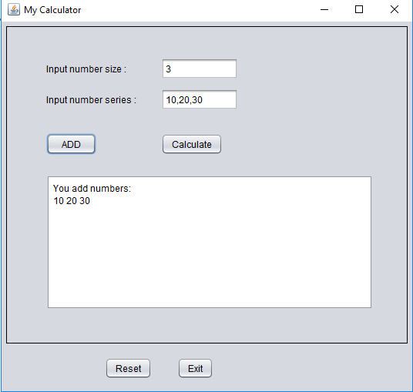

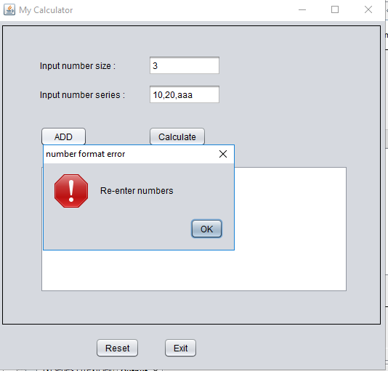

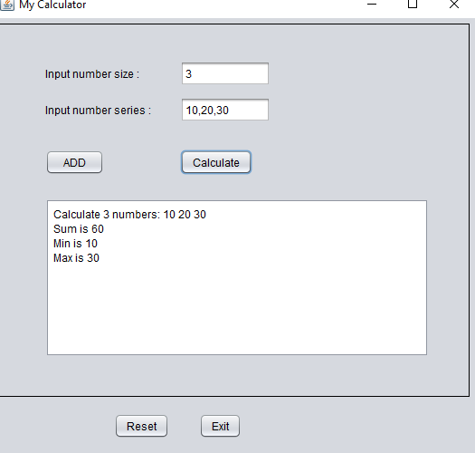

**Sending Method:**

* Save this document file that contains you all answers as “**OODP_Lab11_yourID.docx and Lab11_YourID.jar**” (Do not zip the files)
* And upload it to the google classroom.