*Indian Institute Of Technology(ISM),Dhanbad*

**Model Predictive Speed Control Of PMSM/BLDC Drive**

by Raunak Thakur , Electrical Engineering

**Title**-Model Predictive Speed Control Of PMSM/BLDC Motor using Discrete PI(z) Controller in Simulink

**Objectives-**

* To achieve precise speed control of PMSM motor( trapezoidal back emf) within precision of 1% .
* To realise the operating principles behind Model Predictive speed Control methods.
* To visualise the plot of speed and torque responses using simunlink tools.

**Project Overview-**

This project Consists of Simulink model of PMSM(Permanent Magnet Synchronous Motor) drive having trapezoidal back EMF. It demonstrates the Model Predictive Speed Control Technique.It has been implemented using Simscape( Specialised PS Library).It consists of following subsystem blocks-

* Speed Control block-It consists of PI(z) controller,Current Limiter etc to implement the control strategy.
* MPC_Innerloop-It contains Matlab_Function Block which outputs a switching vector[1*6].This vector is fed into gate of Inverter bridge .
* BLDC plant Subsystem -It contains DC Supply(400 V),Universal Bridge(3 ph Inverter),PMSM block(trapezoidal Back EMF),Measuremnt Blocks.
* Sensor_ Transformation-It Contains Park Transformation Block and receive inputs from measurement blocks.
* KPI_Logger -It contains Scope and display blocks to display measured outputs.

**Operating Principle-**

* **Prediction** – Future current is predicted using the discrete motor model:

*did/dt=(vd+weLqiq+Rsid)/Ld*

*diq/dt=(vq-weLdid-Rsiq-wef)/Lq*

*id1 = id0 + Ts* did/dt*

*iq1 = iq0 + Ts* diq/dt*

* **Optimization** – A cost function is evaluated for all inverter voltage vectors:

*J=αi*((id1-idref)2+(iq1-iqref)2)+ αsw*(ui-uprev)2*

* **Control Action** – The switching state that minimizes J is applied at each sampling step (receding horizon principle).

**Block Diagram**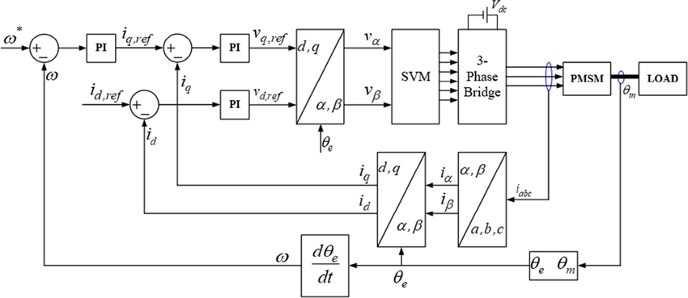

Image downloaded from researchgate.net

**Key Outcomes-**

* Acquired Speed Precision with steady state error within 1 %.
* Achieved Fine tuning of PI parameters of PI(z) controller.
* Simulated the Speed Response Plot for various speed Reference Inputs.