TradeOff
Core Idea:
The goal of TradeOff is to help users make smarter financial decisions by translating the price of a purchase into the amount of time they must work to afford it, based on their salary/stipend and working hours. The app focuses on psychological clarity rather than complex financial advice.

Functionality:
Users enter their income and work details during onboarding. When they want to buy something, they input the item price and category (need/want/luxury). The app shows a mini report: hours of work required, percentage of income, and overall impact level.

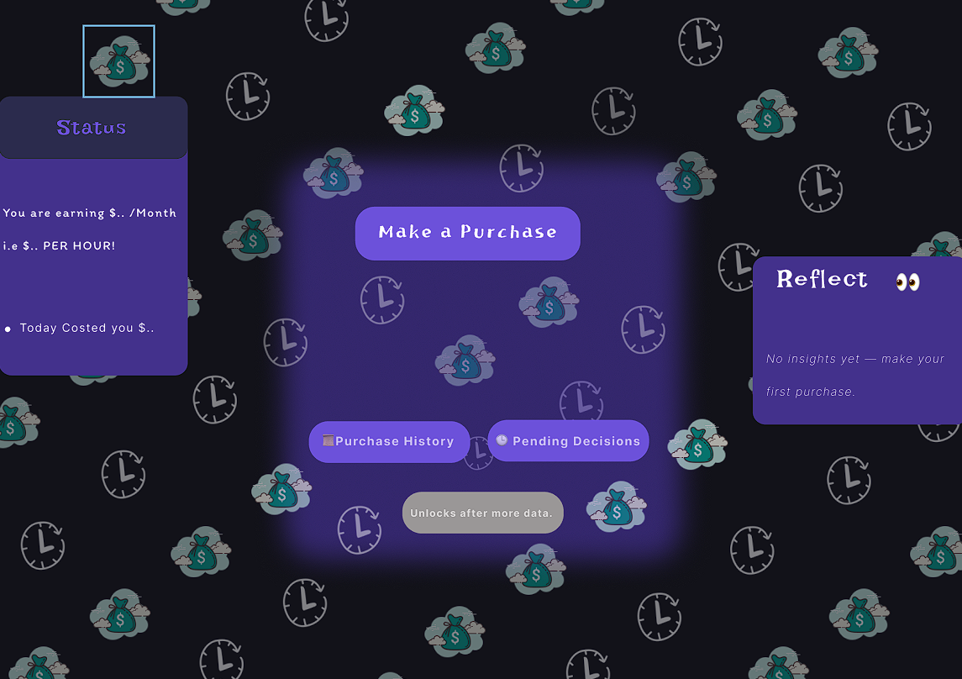

Key MVP features:
Onboarding flow (name, income, work hours, profession – minimal and smooth)
Core “Make a Purchase” flow Time-based cost calculation (hourly worth)
Decision step: buy now or wait 24 hours Pending purchases (greyed out with reflective prompts)
Purchase history panel Design & UX direction: Dark theme (near-black) with purple/blue accents Calm, modern, reflective UI Subtle animations (no clutter)( theme we can alternate as per our liking)

Reason for this project:
As a student/early on career guy, I often find myself buying impulsively or most of the times overcomplicating a purchase’s worth, this eventually leads to unnecessary calculations and mindless surfing to make the “Optimal” purchase decision, so I came up with this product – Tradeoff, it assists my purchasing decisions through telling me the actual worth of that thing i.e not money but my Time, it not only calculates the time to money value of a product but also will help in avoiding impulsive buying decisions whose worth is a bit high(time), it is not a financial or a analytical project but more like a reflection/phycological clarity aimed project, it shows facts about your purchase decisions, track them, avoid impulse buying and at times helps you reflect too. This is not a product but a tool I believe every person must use while spending their money(time).
Todo

1 – validation for the signup/login page
2 – loading screen for the signup/login page
3 – auto scroll when checking the price

