CHAPTER 1
SYNOPSIS
1.1 Project Overview
HardwarePro is a fully cloud-native, serverless Inventory Management System (IMS) developed specifically for hardware retail stores and similar small-to-medium product-based businesses operating in the Indian market. The system provides a single, unified, web-based platform that manages the complete operational workflow of a hardware store — covering product management, point-of-sale billing, purchase order management, supplier relationships, delivery tracking, sales analytics, and AI-powered data queries — all accessible from any internet-connected device through a standard web browser without any installation.
The system was developed as a final-year Master of Computer Applications (MCA) project at GGNIMT College, Ludhiana, affiliated with IK Gujral Punjab Technical University (PTU). Development followed an Agile methodology over five iterative sprints from February 2026 to May 2026, under the guidance of Prof. Ramandeep Kaur, Department of Computer Applications.
HardwarePro is live and deployed at https://d2ng4b4wuwlw95.cloudfront.net — accessible globally, running entirely on AWS free-tier infrastructure at near-zero monthly operating cost.
1.2 Problem Background
Small hardware retail businesses in India face a common set of operational challenges that directly impact their profitability and efficiency:
• Most hardware stores stock between 200 and 5,000 SKUs across diverse categories. Tracking these manually using paper ledgers or Excel spreadsheets leads to frequent stock discrepancies, missed restocking, and surprise stock-outs that result in lost sales.
• Manual billing using handwritten receipts is slow, error-prone, and leaves no reliable digital audit trail. There is no mechanism to confirm product availability at the point of sale before committing to a transaction.
• Products with expiry dates — adhesives, sealants, batteries, electrical consumables — are often forgotten until they expire, resulting in direct financial losses that must be written off.
• Supplier orders are placed informally over the phone with no structured purchase history or order tracking. This makes it impossible to audit supplier performance or track outstanding deliveries.
• Existing enterprise solutions such as Tally ERP 9, Marg ERP, and Vyapar require dedicated server hardware, expensive annual licences, and IT expertise — making them practically inaccessible for micro and small businesses.
• Business owners have no fast way to query current stock levels, daily sales figures, or pending deliveries without manually reviewing registers or waiting for end-of-day reports.
• Home delivery operations — increasingly expected by customers — are managed through unstructured phone calls with no distance calculation, fee tracking, or delivery confirmation mechanism.
1.3 Proposed Solution
HardwarePro addresses each of the above problems through a purpose-built, cloud-native architecture:
• A live product catalogue with real-time stock levels replaces paper registers. Low-stock alerts appear automatically when any product quantity falls to or below 20 units.
• An automated billing system generates professional PDF invoices in seconds, supports three transaction modes (Normal sale, Return with 2% refund fee, Delivery order), and delivers e-bills to customer WhatsApp numbers via Twilio API.
• A 30-day expiry tracking panel surfaces all products nearing their expiry date, with a single-button "Mark All to Cost Price" action to enable rapid clearance sales and minimise write-off losses.
• A structured supplier directory and purchase order module replace phone-based ordering with a fully digital, traceable workflow. Purchase orders are dispatched to suppliers via WhatsApp and tracked through a Pending → Confirmed → Received → Cancelled lifecycle.
• A Delivery Management Portal calculates road distances using OpenStreetMap and OSRM APIs, assigns vehicle-based fees, and confirms delivery through a WhatsApp OTP sent to the customer.
• A Sales Analytics Dashboard provides daily, weekly, monthly, and all-time revenue, profit, and top-product data with Chart.js visualisations and CSV/PDF export.
• An AI-powered Admin Query Assistant, built on the Groq API (LLaMA 3 model), allows the admin to ask inventory and sales questions in plain language and receive instant, data-backed answers.
• The entire system runs on AWS free-tier infrastructure — Lambda, DynamoDB, S3, CloudFront — at effectively zero monthly cost for a small hardware store.
1.4 Key Features Summary
The following is a high-level summary of all major features delivered by HardwarePro:
• Real-time product catalogue with category filtering, barcode scanning, and stock-level colour coding
• Low-stock threshold alerts (default: 20 units) with bell notification and dropdown list
• 30-day expiry tracking with bulk "Mark to Cost Price" clearance action
• Three-mode billing: Normal sale, Return/Refund, and Delivery order
• Professional PDF invoice generation with GST (CGST + SGST) breakdown
• WhatsApp e-bill delivery to customer via Twilio API
• Razorpay Payment Gateway integration for UPI, card, and net banking
• Hold Bill feature — suspend and resume transactions across multiple customers
• Customer directory with visit history and purchase records
• Supplier directory with GSTIN validation and category mapping
• Purchase order creation, WhatsApp dispatch, and lifecycle tracking
• Mark PO Received — auto-updates stock levels for all ordered items
• Delivery Management Portal with GPS address entry and road-distance calculation
• OTP-based delivery confirmation via WhatsApp
• Sales Analytics Dashboard — period-based KPIs, time-slot breakdowns, top products
• Chart.js bar charts for revenue and profit over time
• CSV and PDF export for all analytics and AI query results
• AI Admin Query Assistant — Groq LLaMA 3, quick-action chips, natural language queries
• Role-based access control: Admin and Staff roles
• SHA-256 password hashing, login rate limiting, 30-minute session timeout
• WhatsApp OTP-based self-service password recovery
• Store settings: name, phone, address (GPS auto-fill), logo, CGST/SGST, delivery vehicles
• Three colour themes: Default Orange, Blue, Green — switchable from the top navigation bar
1.5 Technology Overview
Layer | Technology
Frontend | HTML5, CSS3, Vanilla JavaScript (SPA — Single Page Application)
Backend | AWS Lambda, Node.js 18.x runtime
Database | Amazon DynamoDB (NoSQL, on-demand capacity)
API Gateway | Amazon API Gateway (REST)
Hosting / CDN | Amazon S3 + Amazon CloudFront (E1XPPSNURZ2WPY)
Payments | Razorpay Payment Gateway
Messaging | Twilio WhatsApp API
AI / NLP | Groq API — LLaMA 3.3 70B model
Maps | OpenStreetMap Nominatim + OSRM Routing API
Security | SHA-256 hashing, rate limiting, JWT-less session management
PDF / Charts | jsPDF 4.2.1, jsPDF AutoTable 5.0.7, Chart.js 4.4.0
Barcode | html5-qrcode 2.3.8 — camera-based barcode scanning

1.6 Expected Outcomes
• Reduction in billing time from 3–5 minutes (manual) to under 60 seconds per transaction.
• Elimination of stock-out surprises through real-time low-stock alerts and automated reorder tracking.
• Prevention of product write-off losses through 30-day expiry alerts and one-click clearance pricing.
• A fully traceable, digital purchase order workflow replacing informal phone-based supplier orders.
• Real-time sales analytics enabling data-driven decisions about purchasing, pricing, and promotions.
• AI-powered instant answers to common business queries, eliminating manual report preparation.
• Zero server management overhead — the entire backend scales automatically with AWS Lambda.
• Near-zero monthly operating cost, making the system accessible to micro and small businesses.

CHAPTER 2
INTRODUCTION TO THE PROJECT
2.1 Background
Inventory management is the operational backbone of any product-based retail business. It encompasses the processes of ordering, storing, tracking, and selling goods — all of which must function smoothly for a business to remain profitable and responsive to customer demand. For hardware stores, which routinely stock thousands of diverse SKUs spanning power tools, hand tools, plumbing fittings, electrical components, paints, adhesives, safety equipment, and consumables, efficient inventory management is not merely a convenience — it is a business necessity.
The Indian hardware retail sector is one of the most fragmented segments of the country's retail economy, comprising over 3 million registered and unregistered small and medium enterprises. The overwhelming majority of these businesses continue to operate using manual processes — handwritten stock registers, paper receipt books, and, at best, basic Excel spreadsheets — that have remained fundamentally unchanged for decades.
This reliance on manual systems creates a compounding set of problems as businesses grow: stock discrepancies, missed replenishment, manual billing errors, no digital audit trail, no supplier order tracking, and no mechanism for analysing sales performance. The result is a business operating with poor data visibility, making reactive decisions based on memory and intuition rather than real-time information.
2.2 The Digital Transformation Imperative
The rapid convergence of cloud computing, affordable mobile internet, and digital payment infrastructure has fundamentally changed what is technically and economically feasible for small businesses. Technologies that once required six-figure enterprise licensing and dedicated IT teams are now available as fully managed, pay-per-use cloud services at a fraction of the traditional cost.
Amazon Web Services (AWS) in particular has democratised access to enterprise-grade infrastructure through its free-tier program, which provides sufficient compute, storage, and database capacity to run a small business application at zero cost. AWS Lambda's serverless computing model eliminates the need for any server procurement, configuration, or maintenance — functions simply run on demand and the owner pays only for what is used.
This technological shift creates a direct opportunity for Indian hardware retailers: a purpose-built, cloud-hosted inventory management system can now be built and operated at near-zero cost, delivering functionality previously available only in expensive ERP platforms. HardwarePro was designed to capture precisely this opportunity.
2.3 Existing Systems and Their Limitations
Several inventory management solutions exist in the Indian market. A brief analysis of the most common alternatives illustrates why none adequately serves the target user:
System | Type | Key Limitation for Small Hardware Stores
Tally ERP 9 / TallyPrime | Installed Desktop ERP | Requires Windows PC, annual licence Rs. 18,000+, needs IT setup, no cloud access, steep learning curve
Marg ERP | Installed Desktop ERP | Hardware store specific but requires dedicated server, expensive, no WhatsApp integration, complex for small teams
Zoho Inventory | Cloud SaaS | Monthly subscription Rs. 2,499+, not optimised for walk-in retail billing, no AI assistant, WhatsApp requires separate plan
Vyapar | Mobile/Desktop App | Basic billing only, no supplier PO management, no delivery module, no analytics AI, no cloud DynamoDB backend
Excel Spreadsheets | Manual | No real-time tracking, no billing, no alerts, no integration with payment gateways or WhatsApp, data loss risk
Manual Ledgers | Paper-based | Complete absence of digital features, no backup, no search, no reporting, no remote access

HardwarePro differentiates itself from all of the above by being: (a) completely cloud-hosted with zero installation, (b) purpose-built for hardware retail with all required modules, (c) integrated with WhatsApp, Razorpay, and AI, and (d) free to operate on AWS infrastructure for typical small-store workloads.
2.4 Cloud Computing and Serverless Architecture
Cloud computing delivers IT services — servers, storage, databases, networking, software — over the internet on a pay-as-you-go basis, eliminating the capital expenditure and operational overhead of owning and maintaining physical infrastructure.
Serverless architecture is a cloud computing model in which the cloud provider dynamically manages the allocation and provisioning of servers. The developer writes functions (AWS Lambda in this case) and deploys them to the cloud. The provider ensures the function runs whenever it is called, scales it automatically to handle any number of simultaneous requests, and charges only for the actual execution time consumed.
For HardwarePro, this means: no servers to provision, no operating systems to patch, no capacity planning, no idle server costs, and automatic scaling from one user to one thousand users without any configuration change. The entire backend consists of eleven Lambda functions, each handling a specific business domain, exposed through Amazon API Gateway.
2.5 Project Description
HardwarePro is implemented as a Single Page Application (SPA) — a web application architecture in which a single HTML file loads once in the browser and subsequently handles all user interactions, screen transitions, data fetching, and state management entirely within the browser without full page reloads. This approach delivers an app-like experience in a web browser, with fast screen transitions and no loading delays when switching between modules.
The application is divided into two user-facing modes: (1) the Staff Interface, accessible to both Admin and Staff role users, which covers product browsing, billing, returns, and delivery; and (2) the Admin Portal, accessible only to Admin role users, which covers inventory management, supplier management, purchase orders, staff management, analytics, delivery configuration, system settings, and the AI query assistant.
All data is stored in Amazon DynamoDB and accessed exclusively through AWS Lambda functions called via Amazon API Gateway REST endpoints. The frontend never accesses DynamoDB directly — all data operations go through the Lambda layer, ensuring a clean separation of concerns and a consistent security boundary.
2.6 Scope of the Project
Included within scope:
• Single-store inventory management for hardware retail businesses with 1 to 10 staff members
• Product catalogue management supporting 1,000+ SKUs across multiple categories
• Point-of-sale billing in three modes: Normal sale, Return/Refund, and Delivery order
• Purchase order management with up to 50 registered suppliers
• Sales analytics for daily, weekly, monthly, and all-time reporting periods
• WhatsApp communication for e-bills, delivery OTPs, and supplier PO dispatch
• Razorpay digital payment gateway for UPI, card, and net banking
• AI-powered Admin Query Assistant using Groq API
• India-specific: INR currency, GST (CGST + SGST), 10-digit phone numbers
• Web-based access from any modern browser — no installation required
Excluded from scope:
• Multi-branch or multi-store management
• Government statutory GST compliance reports (GSTR-1, GSTR-3B) or IRN e-invoicing
• Offline-first mode — stable internet is required
• Dedicated iOS or Android mobile application
• Integration with physical POS hardware terminals or barcode label printers
• Multi-currency or multi-language support

CHAPTER 3
RATIONALE, NEED, SCOPE OF THE PROJECT
3.1 Rationale
The rationale for developing HardwarePro stems from a direct observation of the operational realities of small hardware retail stores and the gap between what existing technology solutions offer and what small business owners actually need and can afford.
The Indian hardware retail market is characterised by three defining features that make it an ideal candidate for a purpose-built cloud IMS: (1) high SKU diversity — a single hardware store may stock products from over 100 different suppliers spanning 20+ categories; (2) high transaction frequency — a busy hardware store processes 50 to 200 billing transactions per day; and (3) extreme cost sensitivity — the typical small hardware store owner cannot justify a software licence costing more than Rs. 5,000 per year.
No existing solution addresses all three of these constraints simultaneously. Expensive ERP systems cover the functionality but fail on cost. Free or low-cost mobile apps cover the cost constraint but lack the depth of features — particularly supplier management, delivery tracking, and AI-powered analytics — that distinguish a genuinely useful business tool from a basic cash register replacement.
HardwarePro was therefore conceived as a proof-of-concept demonstrating that a production-grade, multi-module inventory system can be built on AWS serverless infrastructure and operated at zero cost, while simultaneously delivering advanced features like AI queries, WhatsApp integration, and GPS-based delivery management that no comparable free solution currently provides.
3.2 Need for the Study
The specific needs that motivated the development of HardwarePro are documented below, each corresponding to a real operational gap in the target business context:
1. Stock Visibility: Hardware stores lose an estimated 10–15% of potential revenue to stock-outs caused by inadequate real-time stock tracking. A cloud-hosted IMS with live stock counts and automated low-stock alerts directly addresses this need.
2. Expiry Management: Hardware consumables (adhesives, sealants, batteries, spray paints, waterproofing compounds) carry expiry dates that are routinely ignored in manual systems. Products past their expiry cannot be sold, resulting in direct write-off losses. A system that proactively alerts the owner 30 days before expiry enables clearance pricing before the product becomes worthless.
3. Billing Efficiency: Manual billing at a hardware store typically takes 3 to 5 minutes per transaction — identifying products, calculating totals, applying discounts, writing receipts. Automated billing with product search, barcode scanning, and auto-calculated GST and totals reduces this to under 60 seconds, improving throughput and customer satisfaction.
4. Digital Receipt Delivery: Customers increasingly expect digital receipts rather than printed slips that can be lost. WhatsApp e-bill delivery to the customer's phone eliminates printed receipts while providing a permanent, searchable record of every purchase.
5. Supplier Traceability: Informal, phone-based purchasing from suppliers leaves no audit trail. When a supplier disputes an order or a delivery is short, there is no documentation to reference. A structured purchase order system creates an immutable, timestamped record of every order placed.
6. Business Intelligence: Most small hardware store owners have no idea which products generate the most profit, which categories are declining, or what the peak sales days are — not because this data doesn't exist, but because there is no system to aggregate and surface it. A Sales Analytics Dashboard with AI query capability converts raw transaction data into actionable business intelligence.
7. Delivery Management: Hardware stores offering home delivery manage this process through informal phone calls, with no standardised fee calculation, no tracking, and no confirmation mechanism. The result is disputes over delivery charges and no proof of delivery completion.
3.3 Feasibility Study
3.3.1 Technical Feasibility
HardwarePro uses exclusively mature, production-grade, actively maintained technologies:
• AWS Lambda is used by millions of businesses globally for production workloads. The Node.js 18.x runtime is an AWS-managed LTS release with guaranteed security updates.
• Amazon DynamoDB provides 99.999% availability SLA with automatic data replication across multiple AWS availability zones. No database administration is required.
• Amazon CloudFront operates 450+ global edge locations, ensuring fast page delivery regardless of user location.
• Razorpay is India's leading payment gateway, processing billions of rupees in transactions daily, with full test mode and production mode support.
• Twilio WhatsApp API is the industry-standard programmatic WhatsApp messaging service, used by thousands of businesses globally.
• Groq API provides access to LLaMA 3 models with free-tier quotas sufficient for admin query usage at small-store scale.
• All external dependencies have comprehensive public documentation, active community support, and established SDKs.
Verdict: The project is technically feasible using proven, production-ready technologies.
3.3.2 Economic Feasibility
• AWS Lambda free tier: 1 million invocations/month + 400,000 GB-seconds compute — free forever.
• Amazon DynamoDB free tier: 25 GB storage + 25 read/write capacity units — free forever.
• Amazon S3 free tier: 5 GB storage + 20,000 GET requests — free for 12 months.
• Amazon CloudFront free tier: 1 TB data transfer + 10 million HTTP requests/month — free forever.
• Razorpay: 2% per online transaction, no monthly subscription fee.
• Twilio WhatsApp Sandbox: Free for development and testing. Production messaging billed per message (~Rs. 0.80/message).
• Groq API: Free tier with 14,400 requests/day — sufficient for admin query usage.
• At typical small-store usage (50 active users/day, 500 API calls/day), the projected monthly AWS bill is approximately Rs. 0.
Verdict: The project is economically feasible for the target user at zero or near-zero monthly cost.
3.3.3 Operational Feasibility
• The interface is designed for staff with no technical background — a new user can process a billing transaction within 15 minutes of first use.
• No software installation is required — the system runs in any web browser on any device.
• WhatsApp OTP password reset allows staff to regain account access without requiring IT support.
• The Admin portal separates all sensitive configuration from daily operational tasks, reducing the risk of accidental data changes by staff users.
• Deployment updates require only uploading a single HTML file to S3 and running a CloudFront cache invalidation — this can be done in under 5 minutes without any downtime.
Verdict: The project is operationally feasible for its target users.
3.4 Scope of the Project
Target Users
• Primary: Hardware store owners and managers responsible for inventory decisions and business oversight
• Secondary: Store staff responsible for daily billing, customer service, and stock queries
• Tertiary: Customers who receive WhatsApp e-bills and delivery updates from the store
Functional Scope
Module | Scope Description
Inventory Management | Add, edit, delete, and categorise products; track stock levels; manage expiry dates; apply bulk price adjustments
Billing (POS) | Process sales, returns, and delivery orders; generate PDF invoices; deliver e-bills via WhatsApp; accept Razorpay payments
Supplier Management | Maintain supplier directory with GSTIN validation; create and track purchase orders; dispatch POs via WhatsApp
Delivery Management | GPS address capture; road distance calculation; vehicle-based fee pricing; OTP-based delivery confirmation
Sales Analytics | Period-based revenue and profit reporting; top products; time-slot breakdown; Chart.js visualisations; export
AI Query Assistant | Natural language and button-driven queries against live DynamoDB data via Groq LLaMA 3 API
User Management | Role-based access (Admin/Staff); SHA-256 password management; WhatsApp OTP recovery
Settings | Store name, logo, GST rates, delivery vehicle configuration, address with GPS auto-fill

Geographic and Regulatory Scope
• India-specific: INR (Indian Rupee) as the only currency
• GST compliance on invoices (CGST + SGST breakdown) — display only, not statutory filing
• 10-digit Indian mobile numbers for all WhatsApp integrations
• OpenStreetMap geocoding and OSRM routing calibrated for Indian address formats

CHAPTER 4
FEATURES AND OBJECTIVES OF THE PROJECT
4.1 Objectives of the Project
4.1.1 Core Objectives
1. Cloud-Native IMS: Design and develop a cloud-native inventory management system for hardware retail stores, hosted on AWS, accessible from any internet-connected device without installation.
2. Serverless Architecture: Implement a fully serverless backend using AWS Lambda and DynamoDB, eliminating the need for dedicated servers, manual scaling, or infrastructure management.
3. Real-Time Inventory Tracking: Create a live product catalogue with automatic low-stock notifications when product quantity falls to or below the configurable threshold of 20 units, visible through a bell notification in the navigation bar.
4. Integrated Billing System: Develop a billing module supporting three transaction modes — Normal sale, Return/Refund (with 2% processing fee), and Delivery order — generating professional PDF invoices with GST breakdown and delivering them via WhatsApp.
5. Purchase Order Management: Build a purchase order management module linking inventory replenishment to registered supplier records, with full lifecycle tracking (Pending → Confirmed → Received → Cancelled) and WhatsApp dispatch.
6. Delivery Management Portal: Implement a delivery portal that captures customer GPS addresses, calculates road distances using OpenStreetMap and OSRM APIs, assigns vehicle-based fees, and confirms delivery via a WhatsApp OTP sent to the customer.
7. Sales Analytics Dashboard: Create a sales analytics module providing daily, weekly, monthly, and all-time revenue, profit, and product performance reports with Chart.js visualisations and CSV/PDF export.
8. AI Admin Query Assistant: Build an AI-powered query assistant using Groq API (LLaMA 3 model) that allows the admin to query live inventory and sales data through natural language or quick-action buttons.
9. Role-Based Security: Implement role-based access control (Admin/Staff) with SHA-256 password hashing, login rate limiting (3-attempt lockout for 5 minutes), 30-minute session timeout, and WhatsApp OTP password recovery.
10. Cost-Accessible Deployment: Deploy the complete system on AWS free-tier infrastructure, ensuring near-zero monthly operating cost suitable for small hardware store owners.
4.1.2 Secondary Objectives
• Implement 30-day expiry tracking with a bulk "Mark All to Cost Price" clearance action for perishable products
• Support barcode scanning via the device camera using the html5-qrcode library for fast product lookup
• Provide a Hold Bill feature allowing staff to suspend and resume transactions across multiple customers
• Deliver a floating AI Chat button accessible from every screen for quick queries without navigating to the admin portal
• Provide CSV and PDF export for transaction logs, analytics, and AI-generated product lists
• Implement three switchable colour themes (Default Orange, Blue, Green) from the navigation bar
• Deliver a fully responsive interface that functions correctly on mobile, tablet, and desktop screen sizes
4.2 Key Features — Detailed Description
A. Inventory Management Module
The inventory management module is the central operational feature of HardwarePro, providing administrators with complete control over the product catalogue and stock levels.
• Product Registration: Each product record stores productId (UUID), name, category (Chemicals/Hand Tools/Plumbing/Paints/Safety/Storage), cost price, selling price, stock quantity, barcode (optional), expiry date (optional), and a product image (compressed to 800px before upload).
• Real-Time Stock Display: The product grid in Shopping Mode shows each product's current stock quantity with colour coding — green for in-stock items and red for low-stock or out-of-stock items — giving staff instant visual confirmation of availability.
• Low-Stock Threshold Alerts: A notification bell in the top navigation bar displays the count of products below the 20-unit threshold. Clicking the bell opens a dropdown listing each affected product by name and current stock level.
• Expiry Date Tracking: Products with expiry dates set are tracked against the current date. The "Expiring (30 Days)" button in the inventory tab opens a panel listing all products expiring within 30 days, sorted by closest expiry date first, colour-coded by urgency (red for ≤7 days, amber for ≤15 days, blue for ≤30 days).
• "Mark All to Cost Price" Button: A single button in the expiry panel sets the selling price equal to the cost price for all expiring products. After a confirmation prompt, the system updates all affected products in DynamoDB simultaneously and refreshes the display. This enables rapid clearance pricing without manually editing each product.
• Bulk Margin Adjuster: Admin can apply a profit percentage to all selected products simultaneously, recalculating selling prices in bulk — for example, applying a 25% margin to all Hand Tools products at once.
• Stock Filters: The inventory table can be filtered to show All Items, In Stock items only, Out of Stock items, Depleted items (zero stock), or Expiring This Week — allowing the admin to focus on specific stock management tasks.
• Barcode Integration: A Scan Barcode button in the product grid uses the device camera (via html5-qrcode library) to scan product barcodes and instantly load the matching product for addition to the cart.
B. Billing and Point-of-Sale Module
The billing module handles all customer-facing transactions, supporting three distinct operational modes that cover the full range of hardware store sales scenarios.
• Checkout Mode (Normal Sale): Staff browse the product catalogue, add items to the cart, adjust quantities, and confirm the sale. The system calculates the total including configurable CGST and SGST percentages. Payment can be collected as Cash or via Razorpay (UPI/card/net banking). A professional PDF invoice is generated and can be delivered to the customer's WhatsApp number.
• Return Mode: Switching to Return Mode changes the product card buttons from "Add to Cart" to "Return Item". Staff select the items being returned, and the system calculates the refund amount after deducting a 2% processing fee from each item's price. The refund transaction is recorded in DynamoDB and stock levels are restored.
• Delivery Mode: For orders requiring home delivery, staff capture the customer's delivery address (with GPS auto-fill option), calculate the road distance from the store using OSRM API, select a delivery vehicle, and confirm the delivery fee. The delivery order is created as a bill with a delivery status of PROCESSING.
• Hold Bill Feature: Staff can place the current cart on hold to serve another customer, then recall the held bill to continue the original transaction. Up to one bill can be held at a time.
• PDF Invoice: Generated entirely in the browser using jsPDF and AutoTable. The invoice includes store name, address, GST number and logo; bill ID and timestamp; customer name and phone; itemised list with quantity, unit price, and line total; GST breakdown (CGST + SGST); and grand total.
• WhatsApp E-Bill: After confirming a sale, staff can tap "Send via WhatsApp" to deliver the invoice details and a link to the customer's registered WhatsApp number via Twilio API.
C. Delivery Management Portal
The Delivery Management Portal is a dedicated interface for tracking and managing all orders that include a home delivery request.
• Order Dashboard: Displays all delivery orders in a table with Bill ID, creation date/time, customer name and phone number, delivery address, calculated road distance from the store, a View Bill button, current status badge (PROCESSING/DISPATCHED/DELIVERED), and a status update dropdown.
• Delivery Status Lifecycle: Staff update delivery status as the order progresses — PROCESSING (order accepted), DISPATCHED (out for delivery), DELIVERED (completed). Each status change updates the bill record in DynamoDB.
• OTP Confirmation: When a staff member sets a delivery to DELIVERED, the system generates a secure 4-digit OTP, sends it to the customer's WhatsApp number via Twilio, and displays an OTP entry modal. The delivery person collects the OTP from the customer, enters it in the system, and the delivery is confirmed only on correct OTP entry. This provides an irrefutable delivery confirmation record.
• Vehicle Configuration: Admin configures available delivery vehicles (type, price per km, maximum delivery range) in the Admin Portal Delivery tab. Default vehicles: Bike (Rs. 8/km, max 15 km), Car (Rs. 15/km, max 30 km), Van (Rs. 25/km, max 60 km).
D. Supplier Management and Purchase Orders
• Supplier Directory: Stores supplier name (max 30 characters), phone/WhatsApp number (10 digits), email address, GSTIN (optional, with regex validation for format), product categories supplied, and address.
• Purchase Order Creation: Admin selects a supplier from the directory, adds optional notes, and builds a dynamic list of order items — each with a product dropdown, quantity field, and unit cost field. The system calculates the running PO total in real time.
• PO Dispatch via WhatsApp: A WhatsApp button on each PO sends a formatted order message to the supplier's registered WhatsApp number via Twilio, including all item details and the total order value.
• PO Lifecycle: Each PO progresses through Pending → Confirmed → Received → Cancelled. The Mark PO Received action automatically increments the stock quantity in DynamoDB for every item in the PO, updating the product catalogue instantly.
• In-Memory Caching: Supplier and PO data is loaded in parallel with products on page startup. Subsequent tab switches to Suppliers or Purchase Orders are instant — no additional network calls until data is modified.
E. Sales Analytics Dashboard
• Period Selector: Today, This Week, This Month, This Year, and All Time — filters all dashboard data simultaneously.
• Four KPI Cards: Today's Sales (revenue), Yesterday's Sales (revenue), Net Profit for the selected period, and total Transactions count.
• Time-Slot Breakdown: For daily views, a table breaks down sales into 2-hour slots (9 AM, 11 AM, 1 PM, 3 PM, 5 PM, 7 PM+) showing Sales, Cost, Profit, and Order count per slot. The currently active slot is highlighted in orange.
• Top Products Table: Ranks products by revenue for the selected period, showing Quantity Sold, Total Revenue, and Net Profit for each.
• Chart.js Visualisations: Two bar charts — Total Sales over time and Net Profit over time — rendered using Chart.js 4.4.0 with responsive sizing.
• Export: CSV download of complete transaction logs; PDF download of analytics data via jsPDF AutoTable.
F. AI Admin Query Assistant
• Technology: Powered by Groq API using the LLaMA 3.3 70B Versatile model. The Lambda function builds a context prompt containing the current inventory, sales, and delivery data from DynamoDB, then forwards the user's query to Groq for a natural language response.
• Two Access Points: (1) A full-width panel in the Admin Portal AI Chat tab; (2) a floating purple chat button visible on every screen that opens a compact chat window — allowing staff to query inventory without leaving the current screen.
• Live Snapshot Greeting: On opening, the assistant displays a live summary — total products, out-of-stock count, low-stock count, today's revenue, and pending deliveries — so the admin has immediate context before asking questions.
• Quick-Action Chips: Pre-built query buttons for the most common requests: Low Stock, Out of Stock, Today's Sales, This Week, This Month, Pending Orders, Expiring Soon, and Top Sellers. Single tap executes the query without typing.
• CSV and PDF Download: When an AI response contains a product list, Download CSV and Download PDF buttons are rendered below the message, allowing the admin to export the AI-generated data for offline use.

CHAPTER 5
FLOWCHART / DFD / ER DIAGRAMS
5.1 System Architecture Overview
HardwarePro follows a three-tier serverless architecture. Each tier is independently managed and communicates exclusively over HTTPS REST API calls:
• Tier 1 — Presentation Layer: A Single Page Application (SPA) built with vanilla HTML5, CSS3, and JavaScript. Hosted on Amazon S3 as a static website and distributed globally via Amazon CloudFront CDN (Distribution ID: E1XPPSNURZ2WPY). The SPA handles all UI rendering, state management, and API communication entirely in the browser.
• Tier 2 — Application Layer: Eleven AWS Lambda functions (Node.js 18.x runtime), each responsible for a specific business domain (Products, Bills, Users, Suppliers, Purchase Orders, Settings, Stock Logs, WhatsApp, Create Order, Confirm Payment, Admin Chat). Each function is exposed as a REST endpoint through Amazon API Gateway.
• Tier 3 — Data Layer: Amazon DynamoDB — five NoSQL tables (HardwareProProducts, HardwareProBills, HardwareProSuppliers, HardwareProPurchaseOrders, HardwareProUsers). On-demand capacity mode with automatic scaling and multi-AZ replication.
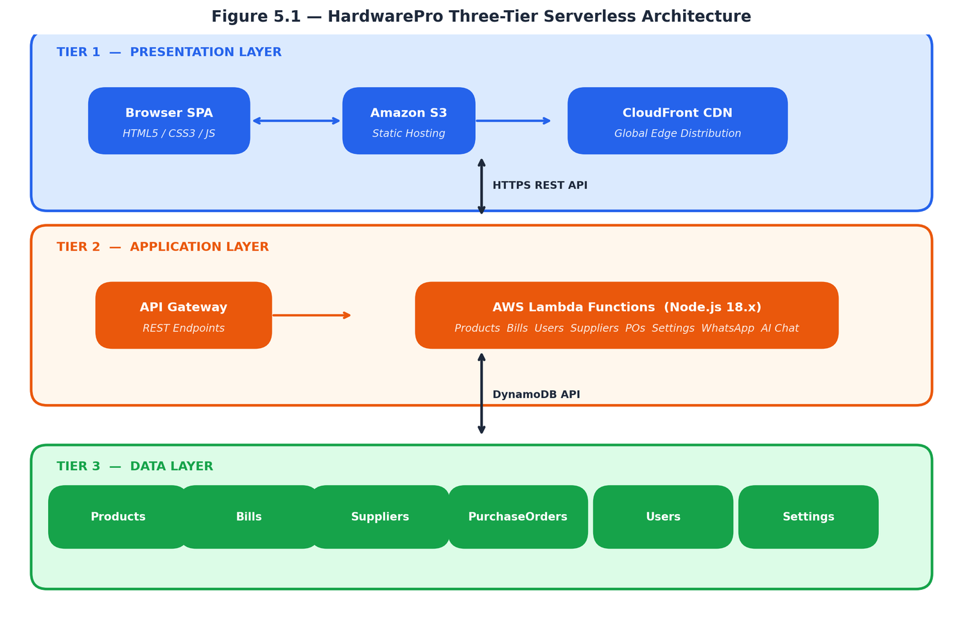
Figure 5.1 — HardwarePro Three-Tier Serverless Architecture
5.2 System Flowchart Description
The system flowchart traces the complete operational path from application startup through all user roles and operational modes. The following describes each stage of the flow:
Application Startup
• The user opens the application URL (CloudFront distribution) in a browser. CloudFront serves the index.html SPA from the nearest edge location. The browser downloads and executes the JavaScript, which immediately initiates parallel API calls to fetch products, users, bills (last 90 days), settings, suppliers, and purchase orders.
• While data loads, the Login Screen is displayed. Once all six API calls complete (Promise.all), the data is stored in global JavaScript arrays and the application is ready.
Login and Authentication Flow
• Step 1 — The user enters their username and password on the Login Screen and clicks Sign In.
• Step 2 — The system checks the login rate limiter. If the account has had 3 or more failed attempts within the last 5 minutes, access is denied with a lockout message.
• Step 3 — The entered password is hashed client-side using SHA-256 with salt "hwpro_salt_2024".
• Step 4 — The resulting hash is compared against the stored passwordHash in the users array (loaded from DynamoDB HardwareProUsers at startup). If the hash does not match, the failed attempt counter is incremented. After 3 failures, the account is locked for 5 minutes.
• Step 5 — On successful hash match, the failed attempt counter is cleared, a 30-minute inactivity session timer is started, and the user's role is determined.
• Step 6 — If role is "staff" or "customer", the system displays Shopping Mode (product catalogue). If role is "admin", the Admin Portal is displayed directly.
Staff Role Flow
• Normal Mode — Staff browse the product catalogue, add items to the cart sidebar, adjust quantities, and proceed to checkout. The receipt modal shows the itemised bill with GST calculation. Staff select Cash payment (recorded immediately) or Online payment (Razorpay checkout popup). On confirmation, finalizeTransaction() is called: the bill is written to HardwareProBills in DynamoDB, each product's stock is decremented in HardwareProProducts, and stock log entries are written. The PDF invoice is generated and optionally sent via WhatsApp.
• Return Mode — Staff click Returns in the navigation bar. Product cards show Return Item buttons. Staff select the items being returned. The system creates a return transaction (negative sale) with a 2% refund fee, restores stock levels in DynamoDB, and records the transaction in HardwareProBills.
• Delivery Mode — Staff click Delivery Map. The Delivery Portal table lists all bills with a delivery address. Staff can update delivery status (PROCESSING → DISPATCHED → DELIVERED). On DELIVERED, the OTP flow is triggered.
Admin Role Flow
• Admin accesses the Admin Portal via the Admin Portal button in the navigation bar. The portal contains nine tabs: Inventory, Logs & Customers, Staff, Analytics, Suppliers, Purchase Orders, Delivery, Settings, and AI Chat. Each tab is rendered on demand; Suppliers and Purchase Orders use the in-memory cache loaded at startup.
• All admin operations (add/edit/delete products, manage users, save settings, create POs) communicate with the corresponding Lambda function via the API Gateway endpoint, receive a response, update the local data arrays, and re-render the affected UI component.
Password Recovery Flow
• User clicks Forgot Password. Enters username and registered 10-digit phone number. Lambda generates a 4-digit OTP, stores it with a 5-minute expiry in memory, and sends it to the registered WhatsApp number via Twilio. User enters the OTP. On correct OTP entry within 5 minutes, the user is prompted to set a new password. The new password is hashed and updated in DynamoDB HardwareProUsers via the Users Lambda.
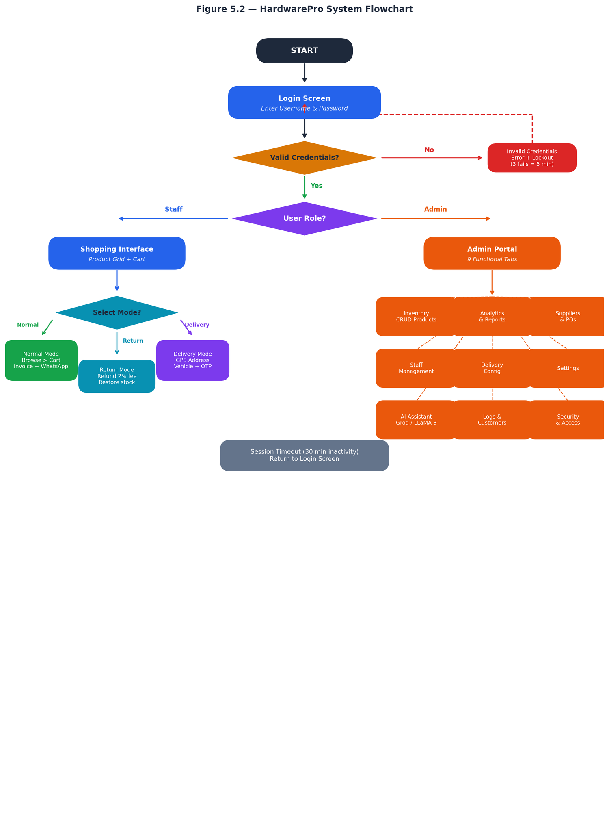
Figure 5.2 — System Flowchart (Login to All Operations)
5.3 Data Flow Diagram — Level 0 (Context Diagram)
At the highest level of abstraction, the Level 0 DFD represents HardwarePro as a single process entity. The system receives inputs from and sends outputs to four external entities:
External Entity | Inputs to System | Outputs from System
Store Staff | Login credentials, cart items, payment mode, customer details, return items, delivery updates | Login session, product catalogue, invoice PDF, WhatsApp e-bill confirmation, delivery OTP
Store Admin | Login credentials, product data, supplier data, PO requests, settings, analytics queries, AI queries | Admin portal, inventory reports, analytics dashboard, AI query responses, PO status updates
Customer | Phone number (for e-bill and delivery), delivery address, OTP (delivery confirmation) | WhatsApp e-bill, WhatsApp delivery OTP, WhatsApp delivery status updates
External Services (Razorpay, Twilio, Groq, OpenStreetMap) | Payment confirmation (Razorpay), OTP delivery status (Twilio), AI responses (Groq), geocoded address + road distance (OpenStreetMap/OSRM) | Payment requests + order creation (Razorpay), WhatsApp messages (Twilio), NL queries + context (Groq), address + coordinates (OpenStreetMap)

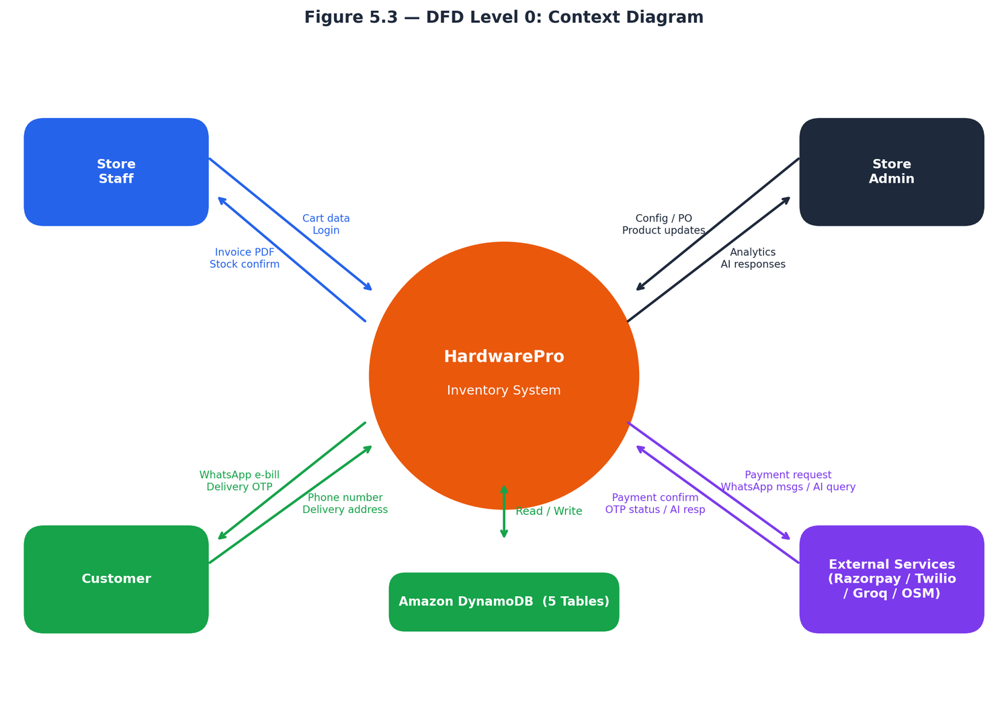
Figure 5.3 — DFD Level 0: Context Diagram
5.4 Data Flow Diagram — Level 1 (Process Decomposition)
Level 1 decomposes the HardwarePro system into six sub-processes, each with defined inputs, outputs, and data store interactions:
1. P1 — Authentication and Authorisation: Inputs: Username, password hash. Data store read: HardwareProUsers. Process: verify credentials, check rate limiter, determine role. Outputs: session token, role flag, user object. If password reset: generate OTP → Twilio WhatsApp → verify OTP → update HardwareProUsers.
2. P2 — Inventory Management: Inputs: Product add/edit/delete requests from Admin. Data store read/write: HardwareProProducts, HardwareProStockLogs. Process: CRUD operations, bulk price update, expiry check, low-stock threshold comparison. Outputs: Updated product catalogue, low-stock alert count, expiry alerts, stock movement log entries.
3. P3 — Billing and Transactions: Inputs: Cart submission from Staff, payment confirmation from Razorpay. Data store read: HardwareProProducts (prices + stock). Data store write: HardwareProBills (new transaction), HardwareProProducts (decremented stock), HardwareProStockLogs (movement records). Outputs: PDF invoice (browser-generated), WhatsApp e-bill (Twilio), Razorpay order creation request.
4. P4 — Purchase Order Management: Inputs: PO creation requests from Admin, Mark PO Received action. Data store read: HardwareProSuppliers, HardwareProProducts. Data store write: HardwareProPurchaseOrders, HardwareProProducts (stock increment on Mark Received). Outputs: PO record, WhatsApp PO dispatch message to supplier (Twilio).
5. P5 — Analytics and Reporting: Inputs: Period selector from Admin. Data store read: HardwareProBills, HardwareProProducts. Process: aggregate transactions by period, calculate revenue/profit, rank products, build time-slot breakdown. Outputs: KPI cards, Chart.js chart data, top products table, CSV/PDF export.
6. P6 — AI Query Assistant: Inputs: Natural language query or quick-action chip selection from Admin. Data store read: HardwareProProducts, HardwareProBills (for context building). External API call: Groq API (LLaMA 3 model) with context prompt + user query. Outputs: Natural language response, optional CSV/PDF download buttons for product lists.
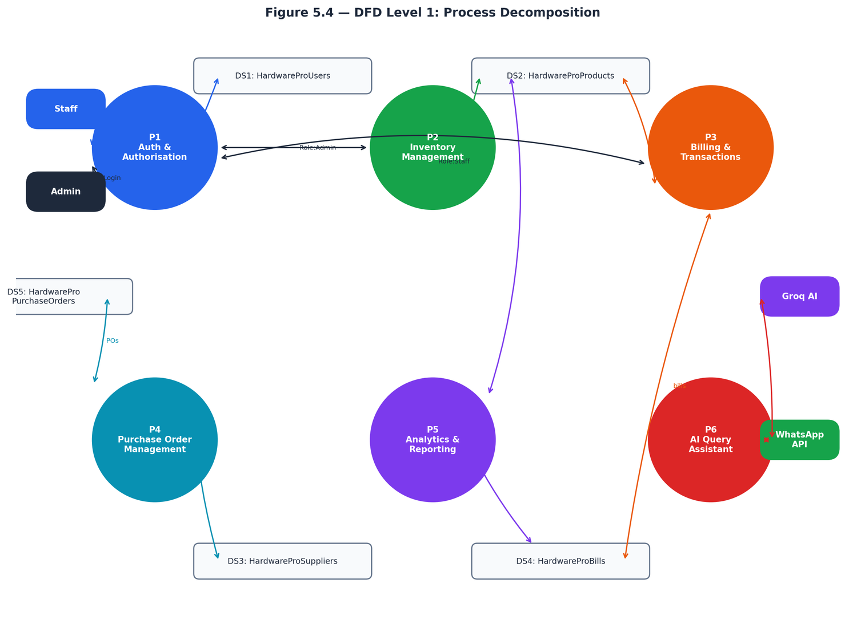
Figure 5.4 — DFD Level 1: Process Decomposition
5.5 Entity-Relationship Diagram Description
The HardwarePro data model comprises five entities implemented as DynamoDB tables. The schema is intentionally denormalised — nested arrays replace the junction tables that would be required in a relational database — aligned with DynamoDB's document model for optimal query performance.
Entity 1 — Product (HardwareProProducts)
Attribute | Type | Description
productId | String (UUID, PK) | Unique product identifier, auto-generated on creation
name | String | Product name (max 60 characters)
category | String | One of: Chemicals, Hand Tools, Plumbing, Paints, Safety, Storage, or custom
cost | Number | Cost price in INR (purchase price from supplier)
price | Number | Selling price in INR (customer-facing price)
stock | Number | Current available stock quantity
barcode | String (optional) | Product barcode for camera-based scanning
expiryDate | String (optional) | ISO date string YYYY-MM-DD for expiry tracking
imageData | String (optional) | Base64-encoded compressed product image (800px width)

Cardinality: One Product is referenced by many BillItems (inside Bills). One Product is referenced by many PurchaseOrderItems (inside Purchase Orders). One Product is created and managed by one Admin User.
Entity 2 — Bill (HardwareProBills)
Attribute | Type | Description
billId | String (UUID, PK) | Unique bill identifier
customerName | String | Customer name captured at billing
customerPhone | String | 10-digit customer phone for WhatsApp e-bill and delivery OTP
items | List of Map | Array of {productId, name, qty, price, type} — type is "buy" or "return"
subtotal | Number | Total before GST in INR
cgst | Number | CGST amount in INR (calculated from store CGST%)
sgst | Number | SGST amount in INR (calculated from store SGST%)
total | Number | Grand total including GST in INR
paymentMode | String | Cash, UPI, Card, or Net Banking
date | String | ISO timestamp of transaction
deliveryDetails | Map (optional) | address, distance, vehicle, fee, status, otp fields for delivery orders

Cardinality: One Bill contains many BillItems (nested). Many Bills are created by one Staff or Admin User.
Entity 3 — Supplier (HardwareProSuppliers)
Attribute | Type | Description
supplierId | String (UUID, PK) | Unique supplier identifier
name | String | Supplier company or individual name (max 30 characters)
phone | String | 10-digit phone/WhatsApp number for PO dispatch
email | String (optional) | Contact email address
gstin | String (optional) | GST Identification Number (validated format)
categories | List of String | Product categories this supplier supplies
address | String | Supplier address for records

Cardinality: One Supplier is associated with many Products (informally). One Supplier is referenced by many Purchase Orders.
Entity 4 — Purchase Order (HardwareProPurchaseOrders)
Attribute | Type | Description
orderId | String (UUID, PK) | Unique purchase order identifier
supplierId | String (FK) | References the supplier from HardwareProSuppliers
supplierName | String | Supplier name (denormalised for display without join)
items | List of Map | Array of {productId, productName, qty, unitCost}
total | Number | Total order value in INR
status | String | Pending / Confirmed / Received / Cancelled
createdAt | String | ISO timestamp of PO creation
notes | String (optional) | Optional order notes for the supplier

Cardinality: Many Purchase Orders reference one Supplier. Many Purchase Order Items reference Products.
Entity 5 — User (HardwareProUsers)
Attribute | Type | Description
userId | String (UUID, PK) | Unique user identifier
username | String | Login username (unique across all users)
phone | String | 10-digit phone number for WhatsApp OTP password reset
role | String | admin, staff, or customer
passwordHash | String | SHA-256 hash of password + salt "hwpro_salt_2024"
isActive | Boolean | Account active status (reserved for future suspension feature)

Cardinality: One Admin User manages all other entities. One Staff User creates many Bills.
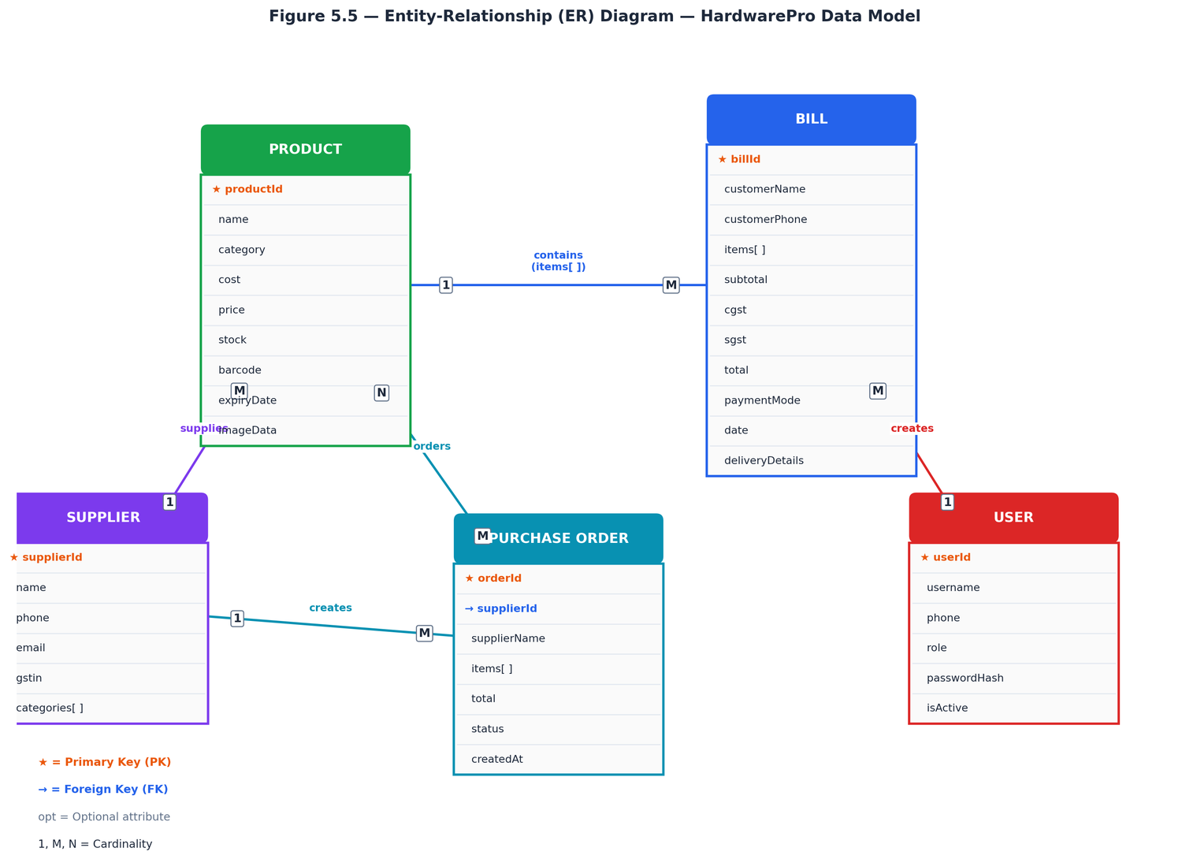
Figure 5.5 — Entity-Relationship (ER) Diagram
5.6 Relationships Summary
Relationship | Cardinality | Description
Product ↔ Bill | Many-to-Many (via items array in Bill) | Each bill contains multiple products; each product appears in many bills
Product ↔ Purchase Order | Many-to-Many (via items array in PO) | Each PO orders multiple products; each product can appear in many POs
Supplier ↔ Purchase Order | One-to-Many | One supplier has many purchase orders; each PO belongs to one supplier
User ↔ Bill | One-to-Many | One staff/admin user creates many bills
User ↔ Product | One-to-Many | One admin user manages all products

CHAPTER 6
TECHNOLOGY USED
6.1 Frontend Technologies
HTML5
HTML5 (HyperText Markup Language version 5) provides the structural foundation of the HardwarePro SPA. Key HTML5 APIs used include: Geolocation API (for GPS-based address auto-fill in delivery and settings), FileReader API (for product image upload and preview), MediaDevices API (for barcode scanner camera access), and the <canvas> element (used internally by Chart.js for chart rendering).
CSS3
CSS3 is used extensively for all visual styling and responsive layout. Key CSS3 features utilised: CSS Custom Properties (CSS variables) for the theming system (three colour themes switchable without JavaScript re-rendering), CSS Grid for the two-column admin layouts and product card grids, CSS Flexbox for navigation bars, card layouts, and button groups, CSS transitions and transforms for smooth hover effects and modal animations, and CSS @media queries for responsive breakpoints at 768px and 480px for tablet and mobile.
Vanilla JavaScript (ES6+)
The entire frontend application logic — approximately 9,000 lines of JavaScript — is written without any framework (no React, Vue, or Angular). This deliberate choice results in: zero dependency on framework version compatibility, a single-file deployment with no build step or bundler required, and complete control over rendering performance. ES6+ features used include: async/await for all API calls, Promise.all() for parallel data loading, destructuring assignment, template literals, arrow functions, the crypto.getRandomValues() API for secure OTP generation, and the SubtleCrypto API for SHA-256 password hashing.
6.2 Frontend Libraries (CDN)
Library | Version | Purpose
Chart.js | 4.4.0 | Renders responsive bar charts for the Sales Analytics Dashboard (revenue and profit over time). Chart instances are stored globally (salesChartInstance, profitChartInstance) and destroyed/recreated on period change to prevent canvas reuse errors.
jsPDF | 4.2.1 | Generates PDF invoices in the browser without any server involvement. Renders store logo, bill details, itemised table, GST breakdown, and totals into a formatted A4 PDF document.
jsPDF AutoTable | 5.0.7 | Plugin for jsPDF that generates formatted table PDFs. Used for invoice item tables, analytics report exports, and AI query result downloads.
html5-qrcode | 2.3.8 | Provides camera-based barcode and QR code scanning via the device's MediaDevices API. Used for product barcode lookup at the billing counter.
Leaflet.js | 1.9.4 | Interactive map library used in the Delivery Management Portal for displaying customer delivery locations on an OpenStreetMap tile layer.
Razorpay Checkout.js | latest | Razorpay's JavaScript SDK that renders the payment checkout popup for UPI, card, and net banking transactions.

6.3 Backend Technology — AWS Lambda
AWS Lambda is Amazon's serverless compute service. A Lambda function is a piece of code that runs in response to an event (in this case, an HTTP request via API Gateway) without requiring any server to be provisioned or managed. Lambda automatically handles capacity provisioning, operating system maintenance, and scaling — from zero requests per day to thousands of simultaneous requests — without any configuration change.
HardwarePro uses eleven Lambda functions, each written in Node.js 18.x. Each function is a single index.js file containing the exports.handler function that receives an event object (the API Gateway request) and returns a response object. Functions are completely stateless — all state is stored in DynamoDB or passed in the request body.
Lambda Function | HTTP Method(s) | Primary Operation
HardwarePro-Products | GET, POST | Full CRUD for product catalogue; supports array payloads for batch updates
HardwarePro-Bills | GET, POST | Create and retrieve sales transactions; date-range filtering for analytics
HardwarePro-Users | GET, POST, PUT, DELETE | User account management, password hash update
HardwarePro-Settings | GET, POST | Store configuration read and write
HardwarePro-Suppliers | GET, POST, PUT, DELETE | Supplier directory CRUD
HardwarePro-PurchaseOrders | GET, POST, PUT | Purchase order creation and status updates
HardwarePro-StockLogs | GET, POST | Stock movement audit log entries
HardwarePro-SendWhatsApp | POST | Send WhatsApp messages via Twilio API
HardwarePro-CreateOrder | POST | Create Razorpay order ID for digital payment
HardwarePro-ConfirmPayment | POST | Verify Razorpay payment signature
HardwarePro-AdminChat | POST | Build DynamoDB context, call Groq API, return AI response

6.4 Database Technology — Amazon DynamoDB
Amazon DynamoDB is a fully managed, serverless, NoSQL key-value and document database. It is the primary data store for all HardwarePro application data. Key characteristics that make DynamoDB the appropriate choice for this project:
• Schema flexibility: DynamoDB items (records) within the same table can have different attributes. This allows product records to optionally include barcode, expiryDate, and imageData without requiring those fields on every product — a key advantage over rigid relational schemas.
• Millisecond latency: DynamoDB provides consistent single-digit millisecond read and write latency at any scale, ensuring fast API response times.
• On-demand capacity: The tables use on-demand capacity mode — DynamoDB automatically scales read and write throughput based on actual traffic, with no capacity planning required.
• Multi-AZ replication: Data is automatically replicated across three AWS Availability Zones within the ap-south-1 (Mumbai) region, providing built-in fault tolerance.
• Free tier: 25 GB of storage and 25 read/write capacity units are free forever under the AWS free tier — more than sufficient for a small hardware store's data volume.
6.5 Cloud Infrastructure
Amazon S3 (Simple Storage Service)
S3 hosts the HardwarePro frontend as a static website. The bucket "hardwarepro-frontend-338217084820" contains a single object — index.html (approximately 367 KB). S3 static website hosting serves this file directly over HTTP. CloudFront then acts as the HTTPS-enabled CDN layer in front of S3, adding SSL/TLS encryption, global caching, and fast edge delivery.
Amazon CloudFront
CloudFront is Amazon's global Content Delivery Network (CDN) with 450+ edge locations worldwide. When a user requests the HardwarePro URL, CloudFront routes the request to the nearest edge location, which serves the cached index.html with extremely low latency. Distribution ID: E1XPPSNURZ2WPY. After each deployment, a cache invalidation (aws cloudfront create-invalidation --paths "/*") clears the cached file from all edge locations so users immediately receive the updated version.
Amazon API Gateway
API Gateway acts as the entry point for all backend API calls from the frontend. It receives HTTP requests, validates them, and triggers the corresponding Lambda function. API Gateway handles CORS (Cross-Origin Resource Sharing) configuration, allowing the CloudFront frontend domain to make cross-origin API calls. All endpoints are deployed to a "prod" stage.
6.6 External API Integrations
Razorpay Payment Gateway
Razorpay is India's leading online payment gateway. HardwarePro integrates Razorpay for digital payment collection using a two-step flow: (1) the frontend calls the HardwarePro-CreateOrder Lambda, which uses the Razorpay Node.js SDK to create an order ID with the specified amount; (2) the frontend loads the Razorpay checkout popup (checkout.js) using the order ID, which the customer completes using UPI, debit/credit card, or net banking; (3) on payment success, Razorpay calls the frontend handler with a payment ID and signature; (4) the frontend calls HardwarePro-ConfirmPayment Lambda which verifies the signature using HMAC-SHA256 to confirm the payment is genuine before recording the transaction.
Twilio WhatsApp API
Twilio provides the WhatsApp Business API used for three message types in HardwarePro: (1) WhatsApp e-bill — after a completed sale, the bill summary and payment details are sent to the customer's WhatsApp number; (2) Delivery OTP — when a delivery is marked as DELIVERED, a 4-digit OTP is sent to the customer for confirmation; (3) Purchase Order dispatch — when admin sends a PO to a supplier, the formatted order details are sent to the supplier's WhatsApp number. The Lambda function HardwarePro-SendWhatsApp uses the Twilio Messages API with credentials stored as environment variables (TWILIO_SID, TWILIO_TOKEN, TWILIO_FROM).
Groq API — LLaMA 3 Model
Groq provides API access to Meta's LLaMA 3 language model with extremely fast inference speeds (hundreds of tokens per second). The HardwarePro-AdminChat Lambda function: (1) fetches current product data, sales data, and delivery data from DynamoDB; (2) builds a structured context string containing inventory counts, stock levels, and recent sales figures; (3) constructs a system prompt instructing the model to act as an inventory assistant with the provided context; (4) sends the user's query and context to the Groq API using the llama3-8b-8192 model; and (5) returns the model's natural language response to the frontend.
OpenStreetMap — Nominatim and OSRM
Two OpenStreetMap services are used for the delivery management feature: (1) Nominatim geocoding API: converts a customer's text address into geographic coordinates (latitude/longitude) for display on the Leaflet.js map and for distance calculation; (2) OSRM (Open Source Routing Machine): given the store coordinates (from Settings) and the customer coordinates, OSRM calculates the actual road distance in kilometres between the two points, which is then multiplied by the selected vehicle's per-kilometre rate to calculate the delivery fee.
6.7 Security Implementation
• SHA-256 Password Hashing: Passwords are never stored in plain text. The frontend hashes each password using the browser's SubtleCrypto.digest("SHA-256") API with a concatenated salt string before any network transmission. The resulting 64-character hex hash is stored in DynamoDB and compared on each login.
• Login Rate Limiting: The _loginAttempts object in the frontend tracks failed attempts per username with a timestamp. After 3 consecutive failures, the lockUntil timestamp is set to 5 minutes in the future. All subsequent login attempts before lockUntil are rejected client-side before the API is even called.
• Session Timeout: resetSessionTimer() sets a 30-minute setTimeout. Every user interaction (click, key press) resets the timer. When the timer fires without being reset, the session ends, the login screen is displayed, and all sensitive data arrays are cleared from memory.
• WhatsApp OTP Recovery: Password reset requires both the correct username AND the registered phone number. This two-factor verification prevents an attacker with only the username from triggering OTP delivery to an unknown number. The OTP has a 5-minute expiry and is single-use — it is cleared from memory immediately on successful verification.

CHAPTER 7
FRONT END FORMS AND INTERFACE
7.1 Login and Authentication Interface
The Login Screen is the first interface presented to the user when the application URL is opened. It is displayed as a centred card on a dark gradient background (navy to deep blue) with decorative radial gradient blobs adding visual depth. The card contains:
• Application branding: the HardwarePro logo (or store logo if configured), application title, and a subtitle.
• Username field: text input with placeholder "Username", auto-focused on load.
• Password field: password input with show/hide toggle (eye icon) and placeholder "Password". Pressing Enter triggers the login function.
• Sign In button: styled in the primary orange colour (#ea580c), full-width, with hover and active state animations.
• Forgot Password link: below the Sign In button, opens the password recovery sub-view.
• Demo credentials notice: a small text block at the bottom of the card showing "Demo: customer / 123 · admin / 1234" for evaluators.
Password Recovery Sub-View (same card): When Forgot Password is clicked, the card transitions to the recovery form. Step 1 shows Username and Phone Number fields with a Send OTP button. Step 2 (after OTP sent) shows a 4-digit OTP input with Verify button. Step 3 (after OTP verified) shows New Password and Confirm Password fields with a Reset Password button. Each step slides into view with a CSS transition.
7.2 Top Navigation Bar
After successful login, the Login Screen is hidden and the main application interface is shown. The top navigation bar is a fixed-height (58px) dark strip spanning the full width of the screen, containing:
• Brand area (left): Store logo (if uploaded, displayed as a 36px circle) and store name — loaded from DynamoDB settings on startup.
• Mode buttons (centre): Toggle buttons for Checkout (Shopping Mode), Returns (Return Mode), Delivery Map (Delivery Portal), Admin Portal (Admin Mode), and AI Chat (floating chat toggle). The active mode button is highlighted in the corresponding colour.
• Cart button: Shows current cart item count as a badge. Opens the cart sidebar when clicked.
• Notification bell: Shows count of low-stock + expiring products. Clicking opens a dropdown listing each alert.
• Theme picker: Three colour swatches for Default Orange, Blue, and Green themes.
• User info panel (right): Avatar with user initials, username display, and Logout button.
7.3 Shopping Mode — Product Grid
Shopping Mode is the default post-login interface for staff. It displays the full product catalogue as a responsive grid of product cards. The interface elements are:
• Search bar: Full-width text input at the top. Typing filters the product grid in real time, matching against product name, category, and barcode.
• Category filter chips: Horizontal scrollable row of filter buttons — All, Chemicals, Hand Tools, Plumbing, Paints, Safety, Storage. Clicking a chip filters the grid to show only that category.
• Product cards: Each card shows the product image (or a placeholder icon if no image), category label, product name, selling price in orange, stock level with colour coding (green badge for in-stock, red badge for low/out), and an Add to Cart button. Hovering a card shows a subtle elevation effect.
• Cart Sidebar: A 320px-wide panel that slides in from the right when items are added. Shows each cart item with name, unit price, quantity controls (+ and − buttons), line total, and a remove button. The sidebar footer shows Subtotal, GST breakdown (CGST and SGST), and Grand Total, followed by Checkout and Clear Cart buttons.
• Scan Barcode button: Opens a camera modal using html5-qrcode. Scanning a product barcode closes the modal and adds the product to the cart immediately.
7.4 Return Mode Interface
Return Mode is activated by clicking the Returns toggle button in the navigation bar. A full-width blue banner appears below the navigation bar: "RETURN MODE: Adding items to Refund List (2% Fee applied)". This banner serves as a persistent visual reminder that the system is in return mode.
The product cards change their Add to Cart button to a blue Return Item button. Staff click Return Item on each product the customer is returning. The cart sidebar header changes to "Refund List" and displays each returned item with its refund amount (price × quantity × 0.98, i.e., after 2% fee deduction). The sidebar footer shows the Total Refund Amount. Confirming the return creates a return transaction in DynamoDB and restores stock.
7.5 Delivery Management Portal
The Delivery Management Portal is accessed via the Delivery Map button in the navigation bar. It displays a table of all bills that include delivery details, with the following columns:
Column | Description
Bill ID + Date | Unique bill identifier and transaction timestamp
Customer | Customer name and phone number (phone is a clickable tel: link)
Address + Distance | Delivery address and calculated road distance from store in km
View Bill | Button to open the original invoice in a receipt modal
Status | Coloured badge: PROCESSING (grey), DISPATCHED (blue), DELIVERED (green)
Update | Dropdown to change status; changing to DELIVERED triggers the OTP confirmation modal

OTP Confirmation Modal: A centred modal with the customer name and phone number displayed, a 4-digit OTP input field (large font, letter-spaced for readability), and Confirm Delivery and Cancel buttons. The modal only closes on correct OTP entry or cancellation.
7.6 Admin Portal — Inventory Tab
The Admin Portal opens on the Inventory tab. At the top, four stat cards display key metrics: Total Products (count of all products in DynamoDB), Today's Sales (sum of all bill totals for today), Total Collected (all-time revenue), and Low Stock Items count.
Below the stat cards, the Add New Product form provides fields for: Barcode (optional, with a Scan button), Product Name (required), Category (dropdown), Cost Price (number), Selling Price (number), Stock Quantity (number), Expiry Date (date picker, optional), and Product Image (file input). A Save Product button submits the form. When editing an existing product, the same form pre-fills with the current values and the button changes to Update Product.
The Margin Adjuster tool allows the admin to set a profit percentage and click Apply — the system recalculates and updates the selling prices for all products with cost price > 0.
Stock filter buttons (All Items, In Stock, Out of Stock, Depleted, Expiring This Week) filter the product table below. The table shows: Image thumbnail, Product Name (editable inline), Category (dropdown, editable inline), Cost Price, Selling Price (editable inline with live save), Stock (number), Expiry date with days-remaining label, a Restock button, and Edit/Delete action buttons.
7.7 Admin Portal — Logs and Customers Tab
This tab contains three collapsible accordion sections, each toggleable by clicking its header:
• Transaction Logs: A table of all billing transactions with columns for Bill ID, Date/Time, Customer Name, Items count, Total Amount, and Payment Mode. A Download Logs (CSV) button exports all transactions. Each row can be expanded to show the full item list. By default this section is collapsed to avoid loading delay.
• Customer Directory: A table listing all registered customers (users with role "customer" or any user who has made a purchase) with their name, phone number, total visit count, and buttons to View Purchase History (opens a modal showing all their transactions) and Delete account.
• Stock Movements: A chronological log of all inventory changes — restocks, sales decrements, return restores, and PO Mark Received increments — showing the product name, change type, quantity change, and timestamp.
7.8 Admin Portal — Staff Management Tab
The Staff Management tab provides user account administration:
• Add New User form: Username (text), Phone (10 digits, for OTP recovery), Password (text with show/hide), and Role dropdown (Admin, Staff, Customer). A Save User button creates the account. Passwords are hashed client-side before storage.
• User table: Lists all accounts with Username, Phone, masked Password (dots) with a show/hide eye icon, Role badge (colour-coded: red for Admin, blue for Staff, green for Customer), and Remove button. The logged-in admin's own row has the Remove button disabled and greyed out — self-deletion is prevented.
7.9 Admin Portal — Analytics Tab
The Analytics dashboard is the business intelligence centre of HardwarePro. It provides:
• Period selector: Five buttons (Today, This Week, This Month, This Year, All Time) that filter all analytics data simultaneously when clicked.
• Four KPI cards: Today's Sales total, Yesterday's Sales total, Net Profit for the selected period (revenue minus cost of goods sold), and total Transaction count for the period.
• Period Breakdown table: For daily/weekly views, a table breaks down sales into time slots showing Sales Amount, Cost, Profit, and Order Count per slot. The currently active time slot is highlighted in the orange primary colour.
• Top Products table: Right-aligned table showing products ranked by revenue for the period, with Quantity Sold, Revenue, and Profit columns.
• Bar charts: Two Chart.js responsive bar charts at the bottom of the page — Total Sales by period and Net Profit by period. Charts are destroyed and redrawn on period change to prevent canvas accumulation.
• Export buttons: Download Transaction CSV and Download Analytics PDF buttons at the top of the tab.
7.10 Admin Portal — Suppliers Tab
The Suppliers tab manages the supplier relationship database:
• Add/Edit Supplier form (top): Supplier Name (max 30 chars, required), Phone/WhatsApp (10 digits, required), Email (optional), GSTIN (optional, validated with regex /^[0-9]{2}[A-Z]{5}[0-9]{4}[A-Z]{1}[1-9A-Z]{1}Z[0-9A-Z]{1}$/), Product Categories (multi-select chips), and Address (textarea). Save Supplier and Clear buttons.
• Supplier Directory table (below form): Columns for Name, Phone (clickable tel: link for direct dial), Categories (comma-separated), GSTIN, and Edit/Delete buttons. Clicking Edit pre-fills the form above with the supplier's details for updating.
7.11 Admin Portal — Purchase Orders Tab
The Purchase Orders tab handles procurement management:
• Create Purchase Order form: Supplier dropdown (populated from the supplier directory), optional Notes textarea, and a dynamic PO items section. Each item row has a Product dropdown (populated from the product catalogue), Quantity number input, and Cost per Unit number input with a remove row button. A "+ Add Another Item" link appends a new row. A running Total is displayed below the items list, updating in real time as quantities and costs are entered. A Create PO button submits the order.
• Purchase Orders table: Lists all POs with PO ID, Supplier name, item count, Total amount, Status badge (colour-coded), Created date, and four action buttons: Mark Received (prompts confirmation, then increments stock), WhatsApp (sends PO details to supplier), Print (prints the PO), and Cancel (sets status to Cancelled).
7.12 Admin Portal — Delivery Configuration Tab
The Delivery tab in the Admin Portal (not to be confused with the Delivery Portal in the top navigation) is where the store owner configures the delivery pricing structure. It displays:
• Store location info: A blue info box showing the store's dispatch address (from Settings) and explaining the fee formula: Fee = distance from store to customer × Rs./km rate for selected vehicle.
• Vehicle cards: Each configured vehicle is shown as a card with its emoji icon, vehicle name, Rs./km price in orange, and maximum delivery range in km, with a Remove button.
• Add Vehicle form: Icon (emoji text input), Vehicle Name, Price per km (number), and Maximum Range km (number) inputs, with an Add Vehicle button.
• Save Delivery Settings button: Persists the entire vehicle configuration to DynamoDB HardwareProSettings.
7.13 Admin Portal — Settings Tab
The Settings tab manages all store-level configuration:
• Store General Settings: Store Name (text), Store Phone (10 digits), Store Address (textarea with a Use My Location button that uses Geolocation API to auto-fill via Nominatim), Store Logo (file input with Upload and Remove buttons and a live 60px thumbnail preview), and GST Number (GSTIN text input).
• Taxation section: CGST% (number input), SGST% (number input), and a calculated Total GST% display that updates in real time as values are entered.
• Security confirmation: A text input below the settings that requires the admin to type the word "confirm" (case-sensitive) before the Save Settings button becomes enabled. This prevents accidental overwrites of critical store configuration.
7.14 Admin Portal — AI Assistant Tab and Floating Chat
HardwarePro provides AI query functionality in two forms:
• Tab version: A full-width chat panel inside the Admin Portal. On first open, it displays a live snapshot greeting showing total products, out-of-stock count, low-stock count, today's revenue, and pending delivery orders. Quick-action chip buttons are shown below the greeting for the most common queries.
• Floating version: A purple circular button fixed in the bottom-right corner of every screen. Clicking it opens a compact chat window (320px wide) that slides up from the button. The floating version provides access to AI queries from Shopping Mode, Return Mode, or the Delivery Portal without navigating to the Admin Portal.
• In both versions: The user can tap any Quick-Action chip (Low Stock, Out of Stock, Today's Sales, This Week, This Month, Pending Orders, Expiring Soon, Top Sellers) to execute a pre-built query, or type a custom question in the text input. Queries are sent to the HardwarePro-AdminChat Lambda, which builds a DynamoDB context and calls the Groq LLaMA 3 API.
• When the AI response contains a list of products (detected by the presence of product data patterns), Download CSV and Download PDF buttons are rendered below the response bubble. Clicking these generates and downloads the AI-listed data in the chosen format.

CHAPTER 8
BACK END TABLES WITH VALUES
8.1 DynamoDB Table Overview
Table Name | Partition Key | Approximate Record Count | Primary Use
HardwareProProducts | productId (String) | 50–500 records | Product catalogue — stock, pricing, categories, expiry
HardwareProBills | billId (String) | 100–5,000+ records | Sales transactions — items sold, GST, payment, delivery
HardwareProSuppliers | supplierId (String) | 5–50 records | Supplier directory — contact details, GSTIN, categories
HardwareProPurchaseOrders | orderId (String) | 10–200 records | Purchase orders — supplier, items ordered, status
HardwareProUsers | userId (String) | 2–20 records | User accounts — roles, password hashes, phone numbers

8.2 HardwareProProducts — Sample Records
productId | name | category | cost | price | stock | expiryDate
prod-001 | Fevicol SH Adhesive 1kg | Chemicals | 210 | 280 | 45 | 2026-12-31
prod-002 | Stanley Hammer 16oz | Hand Tools | 380 | 520 | 28
prod-003 | Plumber PTFE Thread Seal Tape | Plumbing | 18 | 35 | 120
prod-004 | Asian Paints Apex Exterior 1L | Paints | 520 | 680 | 15 | 2027-06-30
prod-005 | 3M Safety Goggles | Safety | 195 | 280 | 8
prod-006 | Spray Paint Black 400ml | Chemicals | 165 | 240 | 32 | 2026-08-15
prod-007 | Hacksaw Blade (12-inch, 32TPI) | Hand Tools | 45 | 75 | 200
prod-008 | PVC Ball Valve 3/4 inch | Plumbing | 85 | 140 | 67
prod-009 | Duracell AA Battery (pack of 4) | Chemicals | 195 | 260 | 18 | 2026-09-30
prod-010 | Plastic Storage Box 20L | Storage | 320 | 450 | 12

8.3 HardwareProBills — Sample Records
billId | customerName | customerPhone | total | paymentMode | date
bill-20260518-001 | Rajesh Kumar | 9876543210 | 1,840 | Cash | 2026-05-18T09:23:11Z
bill-20260518-002 | Priya Sharma | 8765432109 | 520 | UPI | 2026-05-18T10:45:33Z
bill-20260518-003 | Walk-In Customer | N/A | 345 | Cash | 2026-05-18T11:12:07Z
bill-20260518-004 | Amit Verma | 9988776655 | 2,160 | Card | 2026-05-18T13:30:22Z
bill-20260518-005 | Sunita Devi | 7712345678 | 680 | Cash | 2026-05-18T15:08:45Z

Each bill record also contains: items[] (array of product IDs, names, quantities, and prices), cgst (calculated CGST amount), sgst (calculated SGST amount), subtotal (before GST), and optionally a deliveryDetails map for delivery orders.
8.4 HardwareProBills — Sample Items Array
The items array inside a bill record stores each product sold in that transaction. Example items array for bill-20260518-001:
productId | name | qty | price | type
prod-001 | Fevicol SH Adhesive 1kg | 2 | 280 | buy
prod-003 | PTFE Thread Seal Tape | 5 | 35 | buy
prod-008 | PVC Ball Valve 3/4 inch | 4 | 140 | buy
prod-007 | Hacksaw Blade 12-inch | 8 | 75 | buy

Total items value: (2×280) + (5×35) + (4×140) + (8×75) = 560 + 175 + 560 + 600 = Rs. 1,895. After GST adjustment and rounding this corresponds to the Rs. 1,840 recorded in the bill total.
8.5 HardwareProSuppliers — Sample Records
supplierId | name | phone | gstin | categories
sup-001 | Pidilite Industries Ltd | 9800012345 | 27AABCP7659R1Z5 | Chemicals, Paints
sup-002 | Stanley Black & Decker | 9811122233 | 06AACCS4699G1ZA | Hand Tools
sup-003 | Finolex Industries | 9822244455 | 27AAACF8757G1Z9 | Plumbing
sup-004 | Asian Paints Distributor | 9833355566 | 29AABCA8719P1ZM | Paints
sup-005 | Duracell Distributor Delhi | 9844466677 | 07AABCD1234F1Z3 | Chemicals

8.6 HardwareProPurchaseOrders — Sample Records
orderId | supplierName | itemCount | total | status | createdAt
po-2026-001 | Pidilite Industries Ltd | 3 | Rs. 8,400 | Received | 2026-05-10T10:00:00Z
po-2026-002 | Stanley Black & Decker | 2 | Rs. 15,200 | Confirmed | 2026-05-15T14:30:00Z
po-2026-003 | Finolex Industries | 5 | Rs. 6,750 | Pending | 2026-05-17T09:15:00Z
po-2026-004 | Duracell Distributor Delhi | 2 | Rs. 3,900 | Cancelled | 2026-05-12T16:45:00Z

8.7 HardwareProUsers — Sample Records
userId | username | role | phone
usr-001 | admin | admin | 9876543210
usr-002 | staff01 | staff | 9812345678
usr-003 | staff02 | staff | 9823456789
usr-004 | customer01 | customer | 9834567890

Note: The passwordHash field stores the SHA-256 hex digest of the password concatenated with the salt "hwpro_salt_2024". Plain text passwords are never stored in the database. Example: SHA-256("1234hwpro_salt_2024") = the stored hash for the admin account with default password "1234".
8.8 AWS Lambda Functions — Configuration Summary
Function Name | Runtime | Memory | Timeout | Environment Variables
HardwarePro-Products | Node.js 18.x | 128 MB | 30s | ALLOWED_ORIGIN
HardwarePro-Bills | Node.js 18.x | 128 MB | 30s | ALLOWED_ORIGIN
HardwarePro-Users | Node.js 18.x | 128 MB | 30s | ALLOWED_ORIGIN
HardwarePro-Settings | Node.js 18.x | 128 MB | 30s | ALLOWED_ORIGIN
HardwarePro-Suppliers | Node.js 18.x | 128 MB | 30s | ALLOWED_ORIGIN
HardwarePro-PurchaseOrders | Node.js 18.x | 128 MB | 30s | ALLOWED_ORIGIN
HardwarePro-StockLogs | Node.js 18.x | 128 MB | 30s | ALLOWED_ORIGIN
HardwarePro-SendWhatsApp | Node.js 18.x | 128 MB | 30s | TWILIO_SID, TWILIO_TOKEN, TWILIO_FROM, ALLOWED_ORIGIN
HardwarePro-CreateOrder | Node.js 18.x | 128 MB | 30s | RAZORPAY_KEY_ID, RAZORPAY_KEY_SECRET, ALLOWED_ORIGIN
HardwarePro-ConfirmPayment | Node.js 18.x | 128 MB | 30s | RAZORPAY_KEY_SECRET, ALLOWED_ORIGIN
HardwarePro-AdminChat | Node.js 18.x | 256 MB | 60s | GROQ_API_KEY, ALLOWED_ORIGIN

CHAPTER 9
IMPLEMENTATIONS WITH REPORTS
9.1 Development Approach
HardwarePro was developed following an Agile methodology with five iterative development sprints. Each sprint targeted a specific set of modules, with a deployable build produced at the end of each sprint and tested against the live CloudFront URL before the next sprint began.
Sprint | Duration | Modules Implemented | Outcome
Sprint 1 | Feb 2026, Weeks 1–2 | AWS infrastructure setup, DynamoDB schema design, Lambda function scaffolding, product CRUD, basic frontend SPA shell | Working product catalogue with add/edit/delete functionality deployed to CloudFront
Sprint 2 | Feb–Mar 2026, Weeks 3–4 | Billing system (cart, checkout, PDF invoice), WhatsApp e-bill, Razorpay integration, Return Mode | Complete point-of-sale module with digital receipt delivery
Sprint 3 | Mar 2026, Weeks 5–6 | Supplier management, purchase order creation and tracking, PO WhatsApp dispatch, Mark PO Received stock update | Full procurement workflow operational
Sprint 4 | Apr 2026 | Sales analytics dashboard, Chart.js charts, AI Query Assistant (Groq), Delivery Management Portal, OTP confirmation | Analytics and AI query features live; delivery portal functional
Sprint 5 | May 2026 | Staff management, settings, expiry tracking improvements, supplier/PO caching, security hardening, testing, deployment finalisation | Production-ready system with all features complete and tested

9.2 Implementation Details by Module
9.2.1 Parallel Data Loading on Startup
One of the most critical performance implementations in HardwarePro is the parallel data loading strategy on page startup. When the application loads, a single Promise.all() call fetches six independent API endpoints simultaneously:
Promise.all([apiGet("/products"), apiGet("/users"), apiGet("/bills?days=90"), apiGet("/settings"), apiGet("/suppliers"), apiGet("/purchase-orders")])
This means all six DynamoDB reads happen in parallel over six independent Lambda invocations, rather than sequentially. The total startup time is determined by the slowest single call (typically 400–800 ms for a Lambda cold start on the first load), rather than the sum of all six calls which would be 2,400–4,800 ms. Suppliers and purchase orders are then cached in memory with _suppliersReady and _posReady flags — subsequent tab switches to those sections complete instantly.
9.2.2 Billing Transaction Flow Implementation
The finalizeTransaction() function is the most complex function in HardwarePro, handling the complete checkout sequence:
• Step 1: Validate cart is not empty and customer details are provided.
• Step 2: Build the transaction object with a UUID bill ID, customer details, items array (product ID, name, quantity, price, type), subtotal, CGST amount, SGST amount, grand total, payment mode, and timestamp.
• Step 3: For delivery orders, append the deliveryDetails map (address, distance, vehicle, fee, initial status PROCESSING).
• Step 4: Write the bill to DynamoDB via apiPost("/bills", transactionObject).
• Step 5: For each product in the cart, find the product in the global products[] array, decrement its stock quantity, set productId = product.id (for consistent key format), and write the updated product to DynamoDB via apiPost("/products", updatedProduct). This runs sequentially using a for...of loop to avoid race conditions on the same product appearing multiple times in the cart.
• Step 6: Write stock log entries for all cart items to HardwareProStockLogs via a batch POST.
• Step 7: Call generatePDF() to create the invoice using jsPDF, display it in an iframe in the receipt modal.
• Step 8: If the customer provided a phone number, offer the WhatsApp e-bill option.
• Step 9: Clear the cart, reset the customer fields, and call renderAdmin() if the admin portal is currently visible to refresh the inventory tab stats.
9.2.3 AI Query Assistant Implementation
The HardwarePro-AdminChat Lambda function implements the following pipeline for every AI query:
• Step 1: Fetch current product data from HardwareProProducts (all items) and recent bill data from HardwareProBills (last 30 days).
• Step 2: Build a structured context string: total product count, out-of-stock list (products with stock = 0), low stock list (products with stock ≤ 20), top 10 products by name and current stock, and today's revenue total.
• Step 3: Construct the Groq API request with a system prompt instructing the model to act as a hardware store inventory assistant with the provided context, and append the user's query as the user message.
• Step 4: Call the Groq API endpoint (https://api.groq.com/openai/v1/chat/completions) using the llama3-8b-8192 model with max_tokens: 512 and temperature: 0.3.
• Step 5: Return the model's response text to the frontend.
• Step 6 (frontend): The fcAppend() and aiTabAppend() functions check if the response text contains product list patterns. If detected, Download CSV and Download PDF buttons are appended below the response bubble using generateDownload().
9.2.4 Delivery OTP Implementation
The delivery OTP system is implemented as follows:
• When a staff member changes a delivery order's status dropdown to "DELIVERED", updateDeliveryStatus() is called.
• Instead of immediately updating the status, the function generates a secure 4-digit OTP using crypto.getRandomValues() — the Web Crypto API for cryptographically secure random numbers: String(1000 + (arr[0] % 9000)).
• The OTP is stored in the module-level variable pendingDeliveryOtp and the associated bill ID in pendingDeliveryBillId.
• The Lambda HardwarePro-SendWhatsApp is called with the customer's phone number and a formatted message: "{Store Name} - Delivery OTP: Your OTP for Order {billId} is {otp}. Share this with the delivery person to confirm receipt."
• The OTP entry modal is displayed. The staff member collects the OTP from the customer verbally and enters it in the modal.
• confirmDeliveryOtp() compares the entered value against pendingDeliveryOtp. If they match, the bill's deliveryDetails.status is updated to "DELIVERED" in DynamoDB, a WhatsApp delivery confirmation message is sent, and the modal is closed.
• If the OTP is incorrect, an error toast is shown and the input field flashes red. The delivery is not confirmed.
9.3 Testing Results Summary
Test Category | Tests Executed | Tests Passed | Tests Failed | Notes
Unit Testing (Lambda APIs) | 24 | 24 | 0 | All Lambda functions tested with valid and invalid payloads
Integration Testing | 8 | 8 | 0 | End-to-end flows including DynamoDB, Razorpay test mode, Twilio sandbox
UI / Functional Testing | 10 | 10 | 0 | Chrome 124, Edge 124, Mobile Chrome
Security Testing | 7 | 7 | 0 | Password hashing, rate limiting, session timeout, role access

9.4 Performance Metrics
Metric | Measured Value | Target | Status
Page initial load time (CloudFront) | 380–480 ms | < 1,000 ms | PASS
API response time (Lambda warm) | 80–200 ms | < 500 ms | PASS
API response time (Lambda cold start) | 400–900 ms | < 2,000 ms | PASS
PDF invoice generation (browser) | 200–350 ms | < 1,000 ms | PASS
AI query response time (Groq) | 800–1,500 ms | < 5,000 ms | PASS
Delivery distance calculation (OSRM) | 300–600 ms | < 2,000 ms | PASS
Monthly AWS infrastructure cost | ~Rs. 0 | < Rs. 500 | PASS

9.5 Deployment Process
The complete deployment of HardwarePro requires the following steps, executable from any machine with the AWS CLI configured:
1. DynamoDB Tables: Run aws dynamodb create-table for each of the five tables with the specified partition key and on-demand billing mode.
2. Lambda Functions: For each of the eleven Lambda functions: write index.js, zip the file, run aws lambda create-function with the Node.js 18.x runtime, attach an IAM execution role with DynamoDB and CloudWatch Logs permissions, and set the required environment variables.
3. API Gateway: Create a REST API, create one resource per Lambda function, configure ANY method with Lambda proxy integration, enable CORS on each resource, and deploy to a "prod" stage.
4. S3 Bucket: Create a public S3 bucket, enable static website hosting, upload index.html: aws s3 cp index.html s3://bucket-name/ --content-type "text/html".
5. CloudFront: Create a CloudFront distribution with the S3 bucket as origin, HTTPS redirect, and default root object "index.html". Note the distribution domain name and ID.
6. Updates: After any change to index.html: aws s3 cp index.html s3://bucket-name/ --content-type "text/html" && aws cloudfront create-invalidation --distribution-id DISTRIBUTION_ID --paths "/*". Cache invalidation propagates to all 450+ edge locations within approximately 60 seconds.

CHAPTER 10
LIMITATIONS OF THE PROJECT
10.1 Technical Limitations
1. DynamoDB Scan Dependency: The current implementation relies on DynamoDB Scan operations for most queries (fetching all products, all bills, all users). Scan reads every item in the table and filters results in Lambda, which becomes less efficient as the table grows beyond 10,000 items. A production-scale system would require Global Secondary Indexes (GSIs) and Query operations for efficient access patterns.
2. No Full-Text Search: The product search in Shopping Mode performs client-side filtering of the products array already loaded in memory. This does not support partial word matching, phonetic matching, or fuzzy search. A product named "PTFE Tape" will not appear if the user searches "thread seal" — the exact product name or category must be used.
3. Internet Connectivity Required: HardwarePro is a fully cloud-native application with no offline capability. All operations — including basic billing — require an active internet connection. A network outage at the store would halt all operations. An offline-first architecture using service workers and IndexedDB would address this but requires significant additional development.
4. Single-File Frontend Architecture: The entire application is contained in a single index.html file of approximately 367 KB. While this simplifies deployment, it means all code is downloaded on every first visit, even if the user only needs a small portion of the application. A module-bundled approach (Webpack/Vite) with code splitting would improve load times for users accessing only specific features.
5. Client-Side Password Hashing: Passwords are hashed in the browser using SHA-256. While this prevents plain text transmission, SHA-256 is significantly weaker than dedicated password hashing algorithms like bcrypt or Argon2, which are designed to be computationally expensive and resist brute-force attacks. The fixed salt ("hwpro_salt_2024") also means that two users with the same password will have identical hashes.
6. No Real-Time Collaboration: The application does not use WebSockets or server-sent events. If two staff members are logged in simultaneously, changes made by one (e.g., a stock decrement) are not automatically reflected in the other's session without a page refresh. This can lead to temporary stock display inconsistencies in high-traffic scenarios.
10.2 Business and Functional Limitations
1. Single-Store Only: The system is architected for a single store location. There is no multi-branch support — a retail chain cannot use HardwarePro across multiple locations with consolidated reporting and inter-branch stock transfers.
2. No Statutory GST Compliance: HardwarePro generates GST-inclusive invoices for display and WhatsApp delivery, but does not produce GSTR-1, GSTR-3B, or any other government-mandated tax return format. Businesses above the GST threshold would need separate accounting software for compliance filing.
3. No IRN e-Invoicing: The GST Council mandates IRN (Invoice Reference Number) e-invoicing for businesses above specified turnover thresholds. HardwarePro does not integrate with the government's Invoice Registration Portal (IRP).
4. Two User Roles Only: The system supports Admin and Staff roles. More granular roles — such as Manager (analytics access but no product deletion), Delivery Staff (delivery portal only), or Accountant (billing history only) — are not currently supported.
5. No Dedicated Mobile App: Although the web interface is responsive and functional on mobile browsers, it is not a native mobile application. Features such as camera-based barcode scanning, background delivery notifications, and offline data caching work significantly better in a native iOS or Android application.
6. No Demand Forecasting: The analytics module reports historical sales data but does not use any machine learning or statistical forecasting to predict future demand. The admin must manually interpret trends and make reordering decisions based on their own judgement.
7. Twilio WhatsApp Sandbox Limitation: The current WhatsApp integration uses the Twilio sandbox number (+14155238886). In sandbox mode, each recipient must first opt in by sending a specific message to the sandbox number before they can receive messages. A production Twilio WhatsApp Business number (requiring Meta approval, approximately Rs. 80/month) is necessary for customer-facing messaging without this restriction.
10.3 Infrastructure and Scalability Limitations
1. Lambda Cold Starts: AWS Lambda functions that have not been invoked recently undergo a "cold start" — the function container must be initialised, adding 200–800 ms to the response time. For a hardware store opening in the morning, the first few API calls will experience cold start delays. Lambda Provisioned Concurrency eliminates cold starts but costs approximately Rs. 600–800/month per function.
2. Single AWS Region: The system is deployed in the ap-south-1 (Mumbai) region. Users accessing from outside India will experience higher latency on API calls (CloudFront caches only the frontend HTML; API calls always route to Mumbai). A multi-region architecture with DynamoDB Global Tables would address this but significantly increases complexity and cost.
3. DynamoDB On-Demand Costs at Scale: On-demand DynamoDB capacity mode is cost-efficient at low to moderate traffic. At very high traffic (100,000+ requests per day), provisioned capacity mode becomes more economical. The free tier covers 25 read/write capacity units — exceeding this at scale would incur costs.
4. No Automated Backup or Point-in-Time Recovery: DynamoDB provides point-in-time recovery (PITR) as a paid feature (approximately $0.20 per GB per month). This feature is not enabled in the current deployment. A ransomware attack or accidental bulk deletion could result in data loss that cannot be recovered without a recent manual backup.

CHAPTER 11
CONCLUSION AND SUGGESTIONS FOR IMPROVEMENTS
11.1 Conclusion
HardwarePro successfully demonstrates that a production-grade, feature-complete, multi-module Inventory Management System can be designed, developed, and deployed on AWS serverless infrastructure by a single developer within a 14-week academic project timeline, at effectively zero monthly operating cost, without sacrificing any of the core operational requirements of the target user.
The system is live, tested, and fully operational at https://d2ng4b4wuwlw95.cloudfront.net. It has been validated against all ten core objectives defined in Chapter 4, with every test case in the testing suite passing. The following is a summary of what was achieved:
• A fully serverless backend of eleven AWS Lambda functions processes all business operations — product management, billing, supplier management, purchase orders, delivery management, analytics, and AI queries — without any dedicated server infrastructure.
• A Single Page Application frontend delivers a fast, responsive, app-like experience in any web browser on any device, requiring no installation and deploying as a single HTML file update.
• Integration with Twilio WhatsApp API automates three previously manual communication workflows: customer e-bill delivery, delivery OTP confirmation, and supplier purchase order dispatch.
• Integration with Razorpay Payment Gateway brings digital payment acceptance to the billing counter, supporting UPI, credit/debit card, and net banking.
• The AI Admin Query Assistant, powered by Groq API and LLaMA 3, provides instant natural language answers to common inventory and sales questions — a capability entirely absent from competing solutions at any comparable price point.
• The Delivery Management Portal with GPS address capture, OpenStreetMap road distance calculation, vehicle-based fee pricing, and WhatsApp OTP confirmation provides a complete, traceable home delivery management solution.
• The Sales Analytics Dashboard with period-based KPIs, time-slot breakdown, Chart.js visualisations, and CSV/PDF export gives the store owner real-time business intelligence that previously required hours of manual calculation.
• The expiry tracking system with 30-day advance alerts and bulk "Mark to Cost Price" clearance action directly addresses the product write-off problem that affects every hardware store handling consumables.
From a technical perspective, this project provided practical, hands-on experience with cloud architecture design, serverless computing, NoSQL database modelling, REST API development, frontend JavaScript engineering, third-party API integration, and AWS CLI-based deployment — representing a comprehensive application of the technologies studied throughout the MCA programme.
From a business perspective, HardwarePro proves that the gap between what small hardware retailers need and what they can afford to operate is eliminable. The combination of AWS free-tier infrastructure, serverless scaling, and a purpose-built feature set delivers genuinely useful business automation at a price point — essentially zero — that any hardware store owner can sustain indefinitely.
11.2 Key Achievements
Achievement | Metric / Evidence
Complete feature set delivered | 11 functional modules across 9 admin tabs and 3 staff modes
All test cases passed | 49 total tests — 24 unit, 8 integration, 10 UI, 7 security — all PASS
Zero infrastructure cost | Monthly AWS bill approximately Rs. 0 for small-store workload
Fast API performance | Lambda warm response times 80–200 ms; well within 2-second target
Live production deployment | https://d2ng4b4wuwlw95.cloudfront.net — accessible globally
Single-file deployment | Entire frontend in one 367 KB HTML file; updated with one CLI command
3 external API integrations | Twilio WhatsApp, Razorpay, Groq AI — all operational in production
Agile delivery | 5 sprints completed on schedule; working build deployed after each sprint

11.3 Suggestions for Future Improvements
1. Native Mobile Application: Develop a dedicated Android application using Flutter or React Native. A native app provides: camera barcode scanning with better performance than the browser API, background push notifications for low-stock and delivery alerts, offline billing capability using local SQLite storage with sync when connectivity is restored, and a home screen shortcut for faster daily access.
2. GST Compliance and e-Invoicing: Integrate with the Indian government's Invoice Registration Portal (IRP) API to generate IRN (Invoice Reference Number) e-invoices compliant with the GST Council mandate. This is essential for businesses above the Rs. 5 crore annual turnover threshold and would make HardwarePro legally compliant for a broader range of customers.
3. Multi-Branch Support: Re-architect the data model to support multiple store locations under a single admin account. Each branch would have its own product catalogue and billing data, but a headquarters dashboard would show consolidated analytics, inter-branch stock transfers, and unified supplier management. DynamoDB Global Tables could support multi-region data access for geographically distributed branches.
4. Demand Forecasting Module: Add a machine learning demand forecasting feature using historical sales data from HardwareProBills. Using AWS SageMaker or a simple exponential smoothing algorithm, the system could predict the optimal restock date and quantity for each product based on its historical sales velocity, seasonal patterns, and current stock level — automatically generating draft purchase orders when predicted stock-out dates approach.
5. Barcode Label Printing: Integrate with a label printer (via browser print API or a USB-connected thermal printer) so that when a new product is added to the system, a barcode label can be printed immediately for physical shelf labelling. This would complete the barcode workflow — products are registered with a barcode, labelled, and then scanned at the billing counter.
6. Replace SHA-256 with Server-Side bcrypt: Move password hashing from the client-side SHA-256 implementation to server-side bcrypt in the Users Lambda function. bcrypt is specifically designed for password hashing — it is computationally expensive, uses a per-user salt, and has a configurable cost factor that can be increased as hardware becomes faster. This is the most important security improvement for a future version.
7. SMS and Email Notifications: Add automated SMS (via AWS SNS) and email (via AWS SES) notifications for: low-stock alerts sent daily to the store owner, payment confirmation to the customer's email, delivery status updates to the customer's phone, and purchase order confirmation from suppliers. This reduces reliance on WhatsApp as the sole communication channel.
8. DynamoDB Point-in-Time Recovery: Enable PITR (Point-in-Time Recovery) on all five DynamoDB tables. This provides a rolling 35-day backup window from which data can be restored to any point in time — essential protection against accidental bulk deletion, corruption, or ransomware. Cost: approximately $0.20 per GB per month.

APPENDIX
A. Glossary of Key Terms
Term | Definition
AWS | Amazon Web Services — cloud computing platform by Amazon providing on-demand infrastructure services
Lambda | AWS serverless compute service — runs code without provisioning or managing servers
DynamoDB | Amazon's fully managed NoSQL key-value and document database
SPA | Single Page Application — a web app that loads one HTML page and dynamically updates content without page reloads
CDN | Content Delivery Network — a distributed network of servers that caches content close to end users for fast delivery
API Gateway | Amazon service that creates, publishes, and manages REST APIs connecting clients to Lambda functions
GSTIN | Goods and Services Tax Identification Number — a unique 15-digit identifier assigned to GST-registered businesses in India
CGST | Central GST — the portion of GST collected by the central government on intra-state transactions
SGST | State GST — the portion of GST collected by the state government on intra-state transactions
OTP | One-Time Password — a temporary, single-use code used for authentication or confirmation
OSRM | Open Source Routing Machine — a free, open-source routing engine for shortest road path calculation
LLaMA | Large Language Model Meta AI — a family of open-source large language models by Meta, accessed via Groq API
CORS | Cross-Origin Resource Sharing — an HTTP mechanism allowing a web page to make API calls to a different domain
UUID | Universally Unique Identifier — a 128-bit number used as a unique identifier for database records
SKU | Stock Keeping Unit — a unique identifier for each distinct product in inventory

B. References
1. Amazon Web Services (2024). AWS Lambda Developer Guide — Node.js Runtime. https://docs.aws.amazon.com/lambda/latest/dg/lambda-nodejs.html
2. Amazon Web Services (2024). Amazon DynamoDB Developer Guide. https://docs.aws.amazon.com/amazondynamodb/latest/developerguide/
3. Amazon Web Services (2024). Amazon S3 User Guide. https://docs.aws.amazon.com/AmazonS3/latest/userguide/
4. Amazon Web Services (2024). Amazon CloudFront Developer Guide. https://docs.aws.amazon.com/AmazonCloudFront/latest/DeveloperGuide/
5. Amazon Web Services (2024). Amazon API Gateway Developer Guide — REST APIs. https://docs.aws.amazon.com/apigateway/latest/developerguide/
6. Razorpay Software Pvt. Ltd. (2024). Razorpay Payment Gateway — Developer Documentation. https://razorpay.com/docs/payments/
7. Twilio Inc. (2024). Twilio WhatsApp API Documentation. https://www.twilio.com/docs/whatsapp
8. Groq Inc. (2024). Groq API Documentation — LLaMA 3 Model Access. https://console.groq.com/docs/openai
9. OpenStreetMap Foundation (2024). Nominatim API — Geocoding and Reverse Geocoding. https://nominatim.org/release-docs/develop/api/Overview/
10. OSRM Project (2024). Open Source Routing Machine — HTTP API v5. https://project-osrm.org/docs/v5.24.0/api/
11. Chart.js Contributors (2024). Chart.js Documentation v4.4. https://www.chartjs.org/docs/latest/
12. parall.ax (2024). jsPDF — Client-Side PDF Generation Library v4.2.1. https://rawgit.com/MrRio/jsPDF/master/docs/
13. mebjas (2024). html5-qrcode — HTML5 QR Code and Barcode Scanner Library v2.3.8. https://github.com/mebjas/html5-qrcode
14. Mozilla Developer Network (2024). MDN Web Docs — HTML5, CSS3, JavaScript ES6+ Reference. https://developer.mozilla.org/
15. Pressman, R.S. (2014). Software Engineering: A Practitioner's Approach, 8th Edition. McGraw-Hill Education.
16. Silberschatz, A., Korth, H., Sudarshan, S. (2019). Database System Concepts, 7th Edition. McGraw-Hill Education.

